Project Setup

I created a structured project folder system for the Get Fit with Drishti business analytics project. The purpose of this setup is to keep raw data, cleaned data, Python notebooks, SQL files, Tableau dashboard files, Excel files, charts, and final portfolio files organized separately.

The original raw dataset will be stored without modification in the raw data folder. All cleaned and transformed versions of the data will be saved separately to maintain data integrity and make the project easy to audit, reproduce, and present professionally.
Sql setup
I set up the required Python libraries for the SQL phase and defined the project file paths. This helped connect the cleaned dataset location with the SQLite database location, making the workflow organized and reproducible.
I loaded the cleaned client dataset into Python using pandas. I verified the dataset shape and previewed the first few records to confirm that the cleaned data was ready to be transferred into SQLite for SQL analysis.
SQL database creation
I created a SQLite database named nutricoach.db and loaded the cleaned Get Fit with Drishti dataset into a SQL table called clients. This created the main SQL layer for the project, allowing me to run structured business analysis queries on client acquisition, retention, engagement, completion, and referrals. The SQLite database name and location were defined using a file path variable called db_path. When sqlite3.connect(db_path) was executed, Python created or opened the nutricoach.db file inside the 04_sql_database folder. This made the database location clear and reusable throughout the project.
SQL row count verification and sql table preview
I verified the SQLite table by running a SQL row count query on the clients table. The result confirmed that all 3,000 cleaned client records were successfully loaded into the database, which means the SQL layer is ready for business analysis.
I previewed the first five records from the clients table using SQL. This confirmed that the cleaned dataset was not only loaded into SQLite, but also readable as a structured SQL table with all expected client fields available for analysis.
Table structure check and closing sqllite data connection
I checked the structure of the clients table using SQLite’s PRAGMA table_info command. This confirmed that all cleaned dataset columns were available inside the SQL database and ready to be used for business analysis queries. After verifying the SQL table structure, I closed the SQLite database connection. This completed the database setup process and ensured the nutricoach.db file was safely saved and ready for the SQL analysis stage.

I completed the SQL setup by creating a SQLite database named nutricoach.db and loading the cleaned dataset into a clients table. I verified that all 3,000 client records were loaded correctly, previewed the table, checked the column structure, and safely closed the database connection. This completed the technical setup needed before writing business analysis SQL queries.

SQL Query files setup
I created a separate SQL file named phase_2_business_analysis_queries.sql inside the 05_sql_queries folder. This file will store all business analysis queries used in Phase 2, keeping the SQL work organized, reusable, and easy to include in my final portfolio.
Before starting the SQL business analysis queries, I reconnected Python to the nutricoach.db SQLite database. This allowed me to run SQL queries directly on the cleaned clients table.
query 1:
I analyzed the distribution of client goals using SQL. I grouped clients by Goal_Type, counted the number of clients in each goal category, and calculated each category as a percentage of the total client base. This helped identify the strongest demand area for Get Fit with Drishti.
Story: Weight Loss is the strongest demand area for Get Fit with Drishti, representing exactly half of all clients. Body Transformation is also a major segment, making up nearly one-third of the client base. This means most marketing content, testimonials, and program messaging should focus on weight loss and transformation outcomes, while still keeping weight gain as a smaller but important niche.

I saved the Goal Type Breakdown query into the phase_2_business_analysis_queries.sql file. This keeps the final SQL code organized separately from the working notebook and makes the analysis easier to review, reuse, and include in the final portfolio.

Query 2: lead source completion rate
I analyzed completion rate by lead source using SQL. I grouped clients by Lead_Source, counted total clients from each channel, counted how many completed the program, and calculated the completion rate percentage. This helped identify which acquisition channels bring clients with stronger follow-through and program completion behavior.lead source completion rate.
Referral clients have the strongest completion behavior, with an 84.84% completion rate. TikTok brings the highest number of clients and still maintains a strong completion rate, making it the best growth channel by volume. Instagram has the lowest completion rate, so clients coming from Instagram may need stronger expectation-setting before they start. The SQL analysis showed that referral clients had the highest completion rate at 84.84%, making referrals the strongest quality lead source. TikTok brought the largest number of clients with 1,614 total clients and still maintained a strong completion rate of 80.36%. Instagram had the lowest completion rate at 77.31%, suggesting that Instagram leads may need better onboarding or expectation-setting.
Query 3
Average Check-in Rate by Goal Type and Motivation Level
I analyzed average check-in rate by combining Goal_Type and Motivation_Level_Start. This helped compare engagement patterns across different client goals and motivation levels, showing which client groups were more likely to stay involved through weekly check-ins.
Query 4 — Goal Achievement Rate by Diet Type
I analyzed goal achievement rate by Diet_Type using SQL. I grouped clients by their diet type, counted total clients in each group, counted how many fully achieved their goal, and calculated the success rate percentage. This helped compare whether different diet preferences were associated with different client outcomes.
Goal achievement rates are very similar across all diet types, ranging from 50.00% to 52.56%. Vegetarian clients had the highest success rate, but the gap is small. This suggests that Drishti’s personalized coaching works consistently across different diet preferences, and client success is likely influenced more by engagement, motivation, and check-ins than diet type alone.

Query 5: Country breakdown
I analyzed client performance by country using SQL. I grouped clients by Country, calculated total client count, completion rate, and goal achievement rate for each country. This helped compare both business growth and client success across different geographic markets.
The SQL analysis showed that Australia was the largest client market with 1,079 clients, followed by the USA with 902 clients and Nepal with 571 clients. UAE had the strongest completion rate among major countries at 83.18%, while Canada had the highest goal achievement rate at 55.56%. The USA had the lowest goal achievement rate at 48.56%, suggesting that clients from this market may need better onboarding, expectation-setting, or follow-up support.

Query 6 — Monthly Client Acquisition Trend
I analyzed monthly client acquisition using the Payment_Date column. I grouped clients by payment month and counted how many new clients joined each month. This helped show the growth trend of Get Fit with Drishti over time.

The SQL analysis showed strong year-over-year client acquisition growth. In 2022, monthly sign-ups were mostly between 30 and 48 clients. In 2023, monthly acquisition increased to around 68 to 95 clients. In 2024, the business reached its strongest growth period, with most months bringing in more than 120 clients. October 2024 was the highest month with 146 new clients.

Query 7 — Week 3 Activity and Completion
I analyzed Week3_Still_Active as an early warning signal using SQL. I compared clients who were still active at week 3 against those who were not, then calculated each group’s total count, percentage of the client base, completed clients, and completion rate. This helped evaluate whether week 3 activity can predict program completion risk.
The SQL analysis showed that Week3_Still_Active is a powerful early warning signal. Clients who were still active at week 3 had a 90.81% completion rate, while clients who were not active at week 3 had a 0.00% completion rate. This suggests that clients showing inactivity before or around week 3 should be flagged for immediate follow-up to prevent dropout.
Query 8 — Second Round Analysis
I analyzed second-round signups among completed clients using SQL. I filtered the data to completed clients only, grouped them by Goal_Type, counted how many signed up again, and calculated the second-round rate. This helped identify which successful client groups were most likely to continue with the business after completing the program.
The SQL analysis showed that completed Weight Loss clients had the highest second-round signup rate at 10.35%. Body Transformation clients followed at 8.70%, while Weight Gain clients had the lowest repeat rate at 8.20%. This suggests that Weight Loss clients may be the strongest audience for follow-up coaching, maintenance programs, or second-round offers.

Query 9 — Ghost Client Profile
I analyzed ghost clients by filtering for clients with a 0% check-in rate. I grouped these clients by goal type, lead source, and country, then calculated the number of ghost clients and their average age. This helped identify which client profiles may need stronger onboarding and early follow-up support.
The SQL analysis showed that ghost clients were most concentrated among TikTok leads from Australia and the USA, especially in the Weight Loss and Body Transformation goal groups. The largest ghost-client profile was Weight Loss clients from TikTok in Australia, with 15 ghost clients. This suggests that high-volume TikTok leads should receive stronger onboarding and early follow-up to reduce the chance of disappearing after payment.
Query 10 — Payment Speed by Lead Source
I analyzed payment speed by lead source using SQL. I grouped clients by Lead_Source and calculated the average number of days from first contact to payment for each channel. This helped identify which acquisition channels convert potential clients into paying clients the fastest.
The SQL analysis showed that TikTok is the strongest practical conversion channel because it brought the highest client volume and converted clients in an average of 2.90 days. Other had the fastest average payment speed at 2.67 days, but with a smaller client base. Instagram had the slowest average payment speed at 3.18 days, suggesting that Instagram leads may need stronger follow-up before payment.

Query 11 — Health Condition vs Healthy Clients
I compared clients with health conditions against clients without health conditions using SQL. I grouped clients into two categories, calculated total clients, completion rate, and goal achievement rate for each group. This helped evaluate whether health conditions affected client completion and success outcomes.
After checking the Health_Condition column, I found that clients with no health condition were stored as missing values rather than text. I corrected the SQL query by using Health_Condition IS NULL to group these clients as No Health Condition. This made the comparison between clients with and without health conditions accurate.
The SQL analysis showed that clients with health conditions performed almost as well as clients without health conditions. Clients without health conditions had an 81.31% completion rate and 51.73% goal achievement rate, while clients with health conditions had an 80.54% completion rate and 50.23% goal achievement rate. Since the gap was small, this suggests that the personalized coaching model works consistently for both groups.

Query 12: win-back analysis
I analyzed dropout recovery behavior using SQL. I filtered the dataset to clients with a dropout reason, grouped them by Dropout_Reason, counted how many returned after dropping out, calculated the return rate, and measured the average weeks before return. This helped identify which dropout groups are most likely to come back after disengaging.
The SQL analysis showed that dropout clients have strong win-back potential. Health Issue dropouts had a 100.00% return rate, although the group was small. Busy Schedule was the largest dropout reason with 41 clients and had a strong 78.05% return rate. Laziness had the lowest return rate at 63.64%. This suggests that many dropout clients are not permanently lost and can be brought back with the right follow-up strategy.
Query 13: Referal Value
I analyzed the value of referred clients compared with non-referred clients using SQL. I grouped clients based on whether they were referred, then compared total client count, average revenue, completion rate, and second-round signup rate. This helped evaluate whether referrals bring higher-quality clients to the business.
The SQL analysis showed that referred clients are significantly more valuable than non-referred clients. Referred clients had a higher completion rate of 84.84% compared with 79.71% for non-referred clients. The biggest difference was in second-round signup rate, where referred clients reached 35.49% compared with only 6.91% for non-referred clients. This suggests that referrals are one of the strongest growth and retention opportunities for the business.

I saved all 13 finalized SQL business analysis queries into one organized SQL file named phase_2_business_analysis_queries.sql. Each query includes a clear business question and is structured to answer key business problems related to client goals, lead quality, engagement, completion, retention, win-back behavior, and referral value. This file serves as the final SQL deliverable for Phase 2.
SQL File Verification
I verified the saved SQL file by reading it back into the notebook and previewing the contents. This confirmed that the final SQL query file was created correctly and included the finalized business analysis queries.
SQL ANALysis summary
In Phase 2, I built the SQL analysis layer for the Get Fit with Drishti project by loading the cleaned dataset into a SQLite database named nutricoach.db and creating a clients table. I wrote 13 SQL queries to answer real business questions about client goals, lead quality, engagement, goal achievement, country performance, acquisition trends, week 3 activity, second-round signups, ghost clients, payment speed, health conditions, win-back behavior, and referral value. The analysis showed that weight loss is the strongest demand area, referrals bring the highest-quality clients, week 3 activity is a strong early warning signal for completion, and referred clients are much more likely to sign up again. These SQL insights will support the next phase of the project, where I will create visual storytelling charts and deeper business recommendations.

Phase 3
For Phase 3, I created a separate EDA notebook inside the 03_python_notebooks folder. I connected the notebook to the cleaned dataset stored in 02_cleaned_data and set 06_eda_charts as the output folder for all exported chart images. I also defined a consistent color palette to keep the analysis visually professional and easy to follow across all charts.

Chart 1: Goal Type Distribution

I created a donut chart to understand what goals clients joined Get Fit with Drishti for. The chart shows that most clients joined for weight loss, followed by body transformation and weight gain. This means the business mainly attracts clients who want visible physical transformation. This insight can help Drishti create better social media content, onboarding questions, and coaching strategies around the most common client goals.
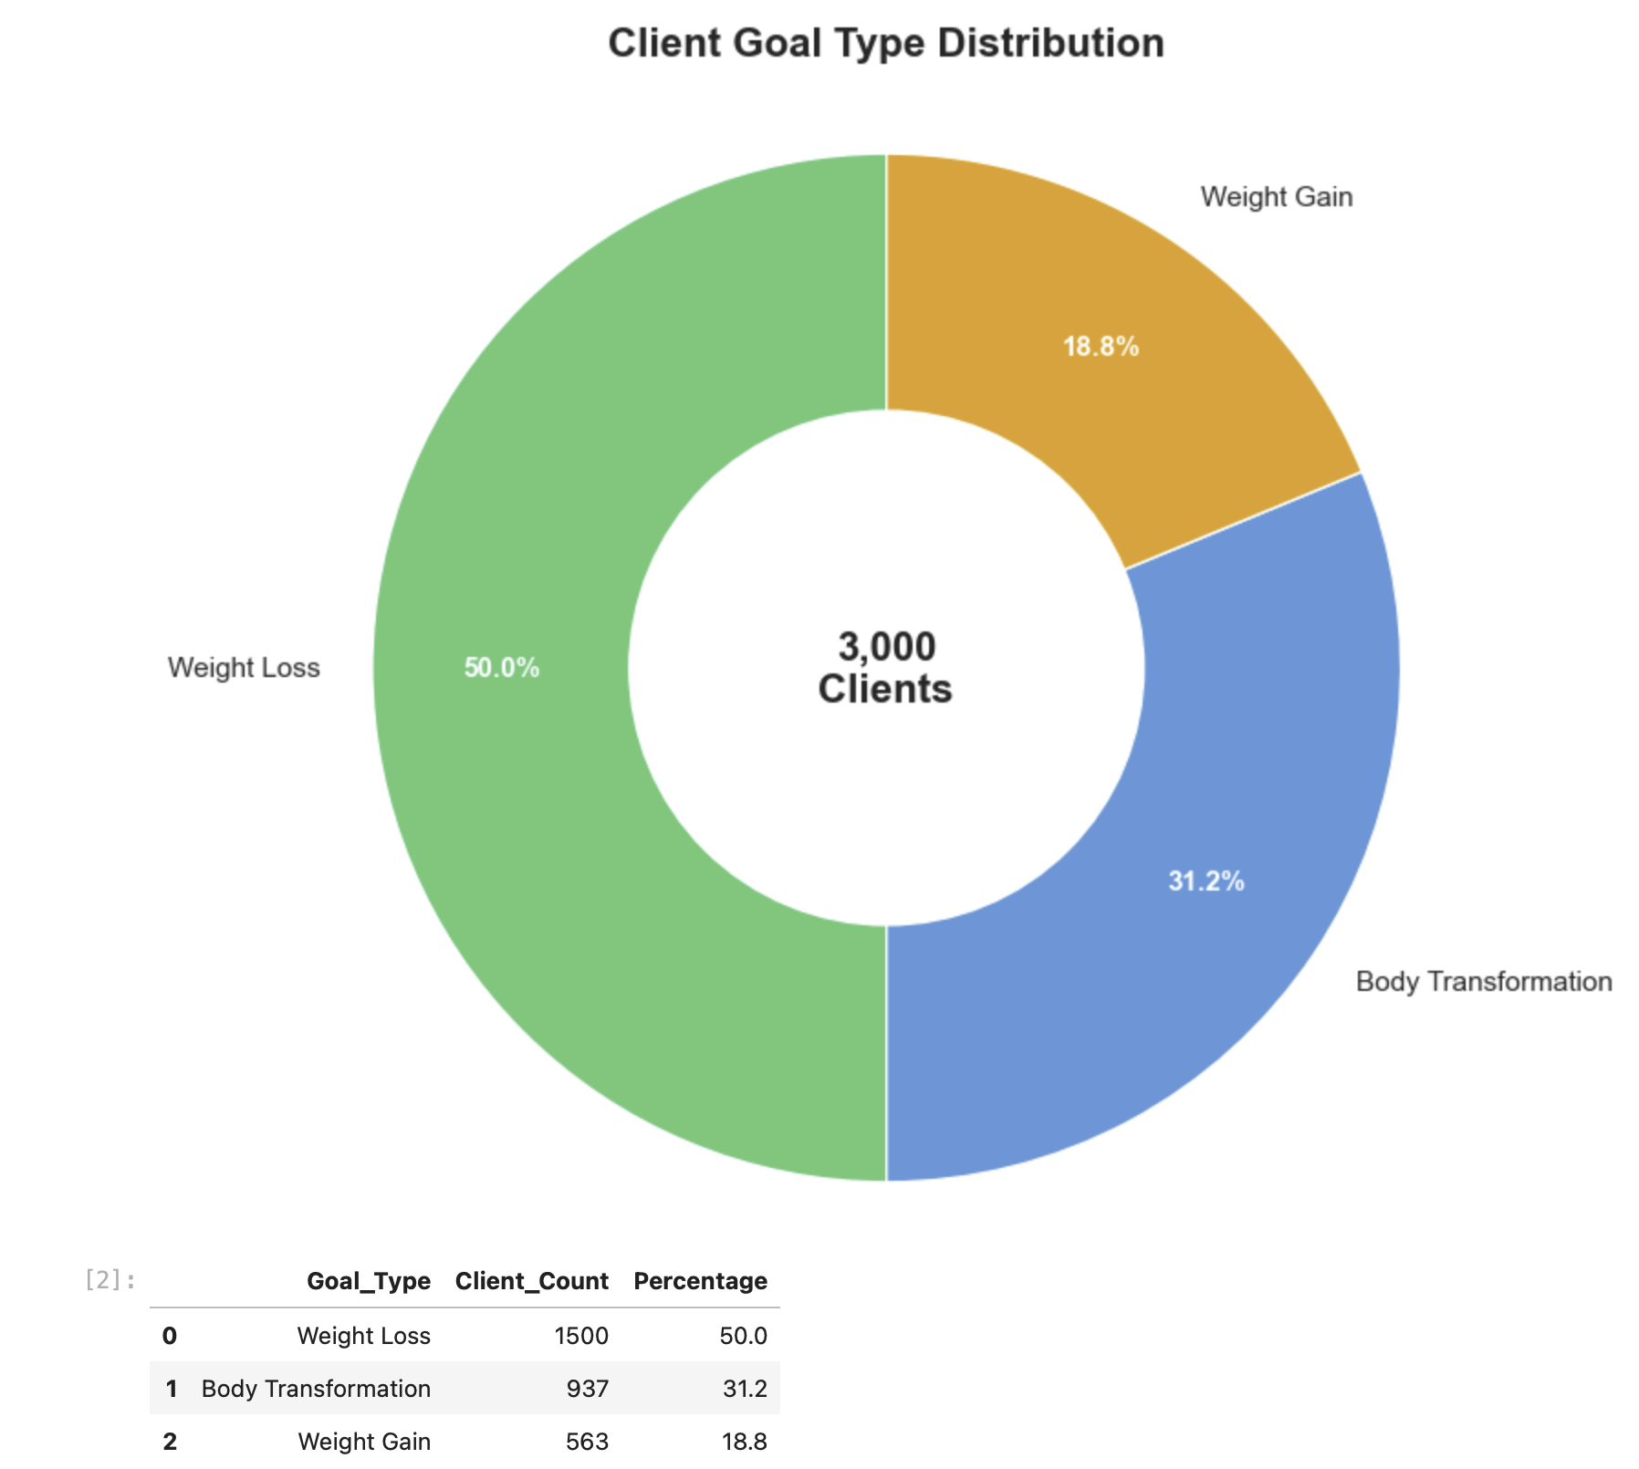

Chart 2 compares lead sources by completion rate and goal achievement rate.
This helped me evaluate the quality of clients from each channel, not just the number of clients each channel brings. The chart shows which sources are more likely to bring clients who complete the program and achieve their goals. This insight can help Drishti focus her marketing effort on channels that bring stronger, more committed clients.
Chart 2 compares each lead source by completion rate and goal achievement rate. Referral clients had the strongest outcomes, with the highest completion rate and goal achievement rate. TikTok brought the highest number of clients while still maintaining strong completion and success rates, making it the main growth channel for the business. Instagram had the lowest performance, which suggests that clients from this channel may need stronger onboarding, expectation-setting, or follow-up support. This insight shows that Drishti should continue using TikTok for growth while building a stronger referral system to attract more high-quality clients.
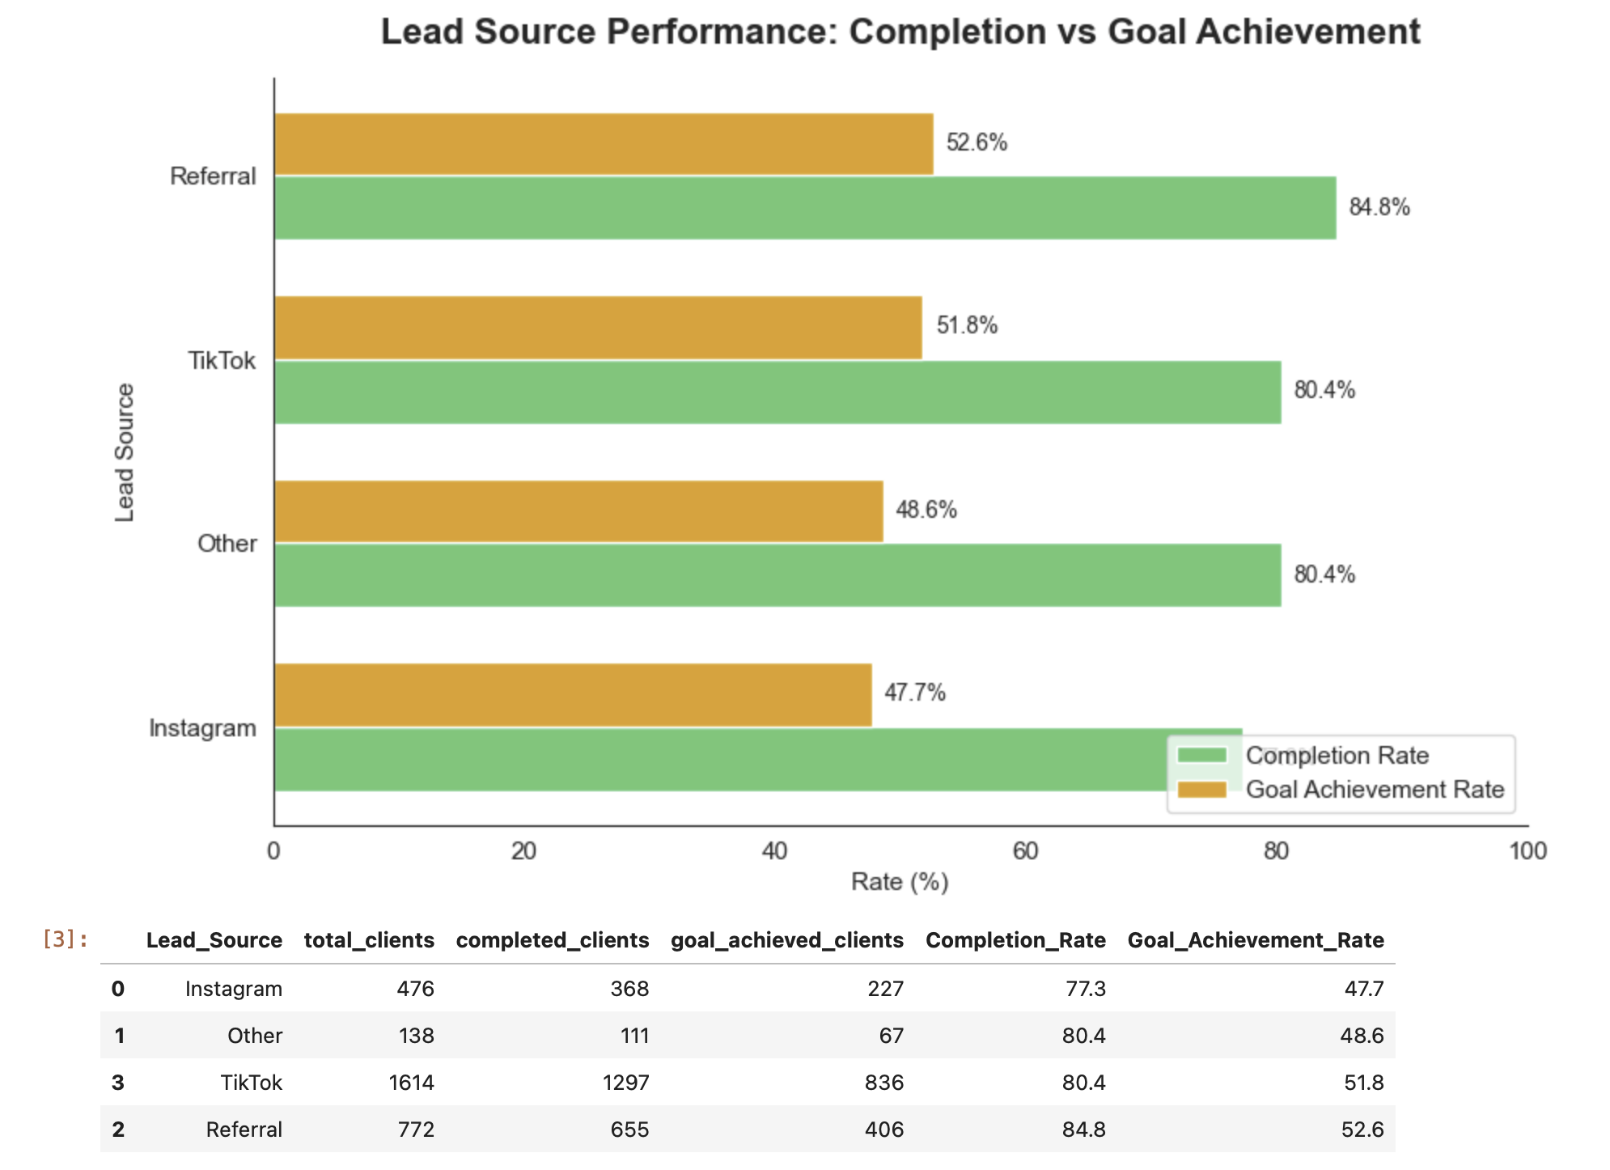

Chart 3 analyzes the age distribution of clients across different goal types.
Chart 3 analyzes client age distribution across different goal types. The chart shows how age varies among clients joining for weight loss, body transformation, and weight gain. This helps identify whether certain goals are more common in specific age groups. Understanding age patterns can help Drishti personalize marketing messages, coaching examples, and transformation stories for the client groups she attracts most often.
Most clients are concentrated between their mid-20s and mid-30s, and the average age is very similar across weight loss, body transformation, and weight gain clients. Weight loss has the largest client count, but all three goals appear across the full age range. This shows that Drishti’s coaching is not limited to one age group, but her strongest audience is adults around 25–35 who are likely looking for practical and sustainable physical transformation.
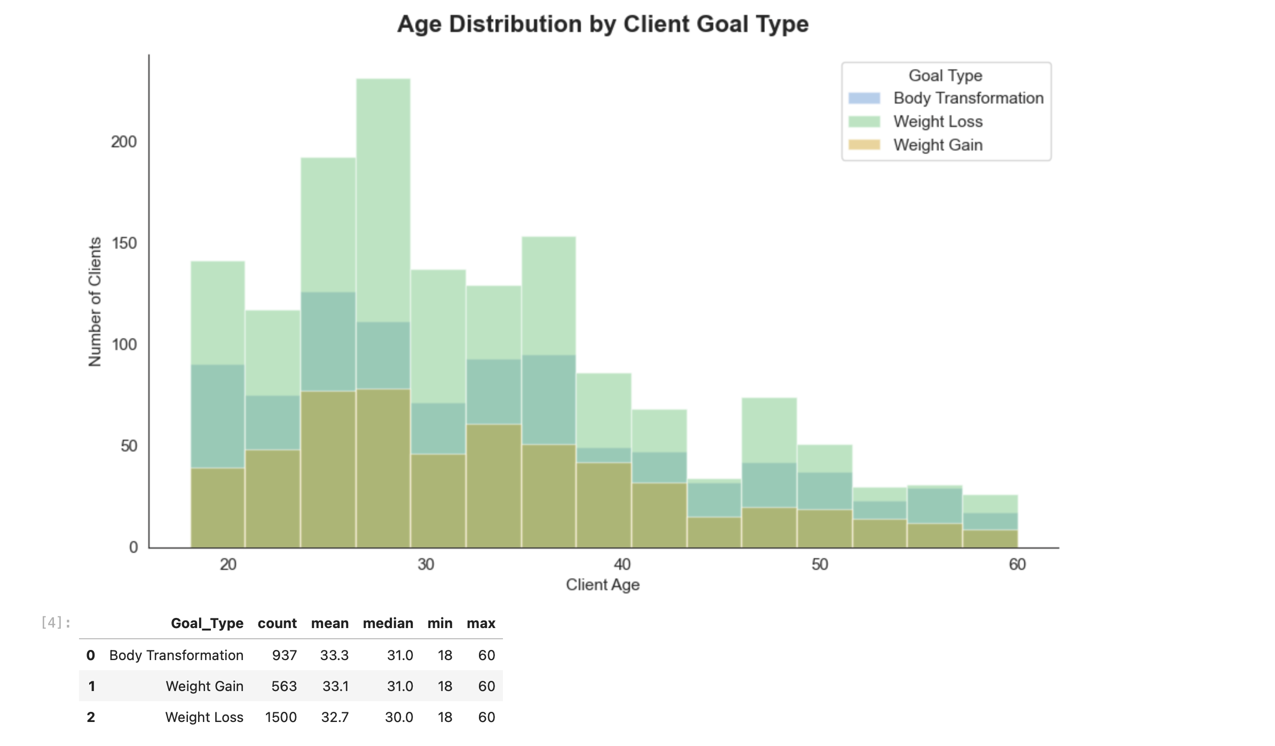

Phase 3 — Chart 4: Goal Achievement Within Each Goal Type
Chart 4 compares goal achievement outcomes within each client goal type. I used a percentage stacked bar chart to compare success fairly across weight loss, body transformation, and weight gain clients. This chart helps identify which goals have stronger full achievement, partial achievement, no achievement, or ongoing outcomes. The insight is important because it shows where the coaching program is performing strongest and where certain client goal types may need additional support.
Chart 4 compares goal achievement outcomes within each goal type. Body transformation clients had the highest full goal achievement rate at 52.8%, followed by weight gain at 51.0% and weight loss at 50.3%. The success rates are fairly close across all three goal types, which shows that the coaching program performs consistently across different client goals. However, weight gain clients had the highest no-achievement rate, while weight loss clients had the highest ongoing rate. This suggests that weight gain clients may need more specialized support, while weight loss clients may need longer-term progress tracking.
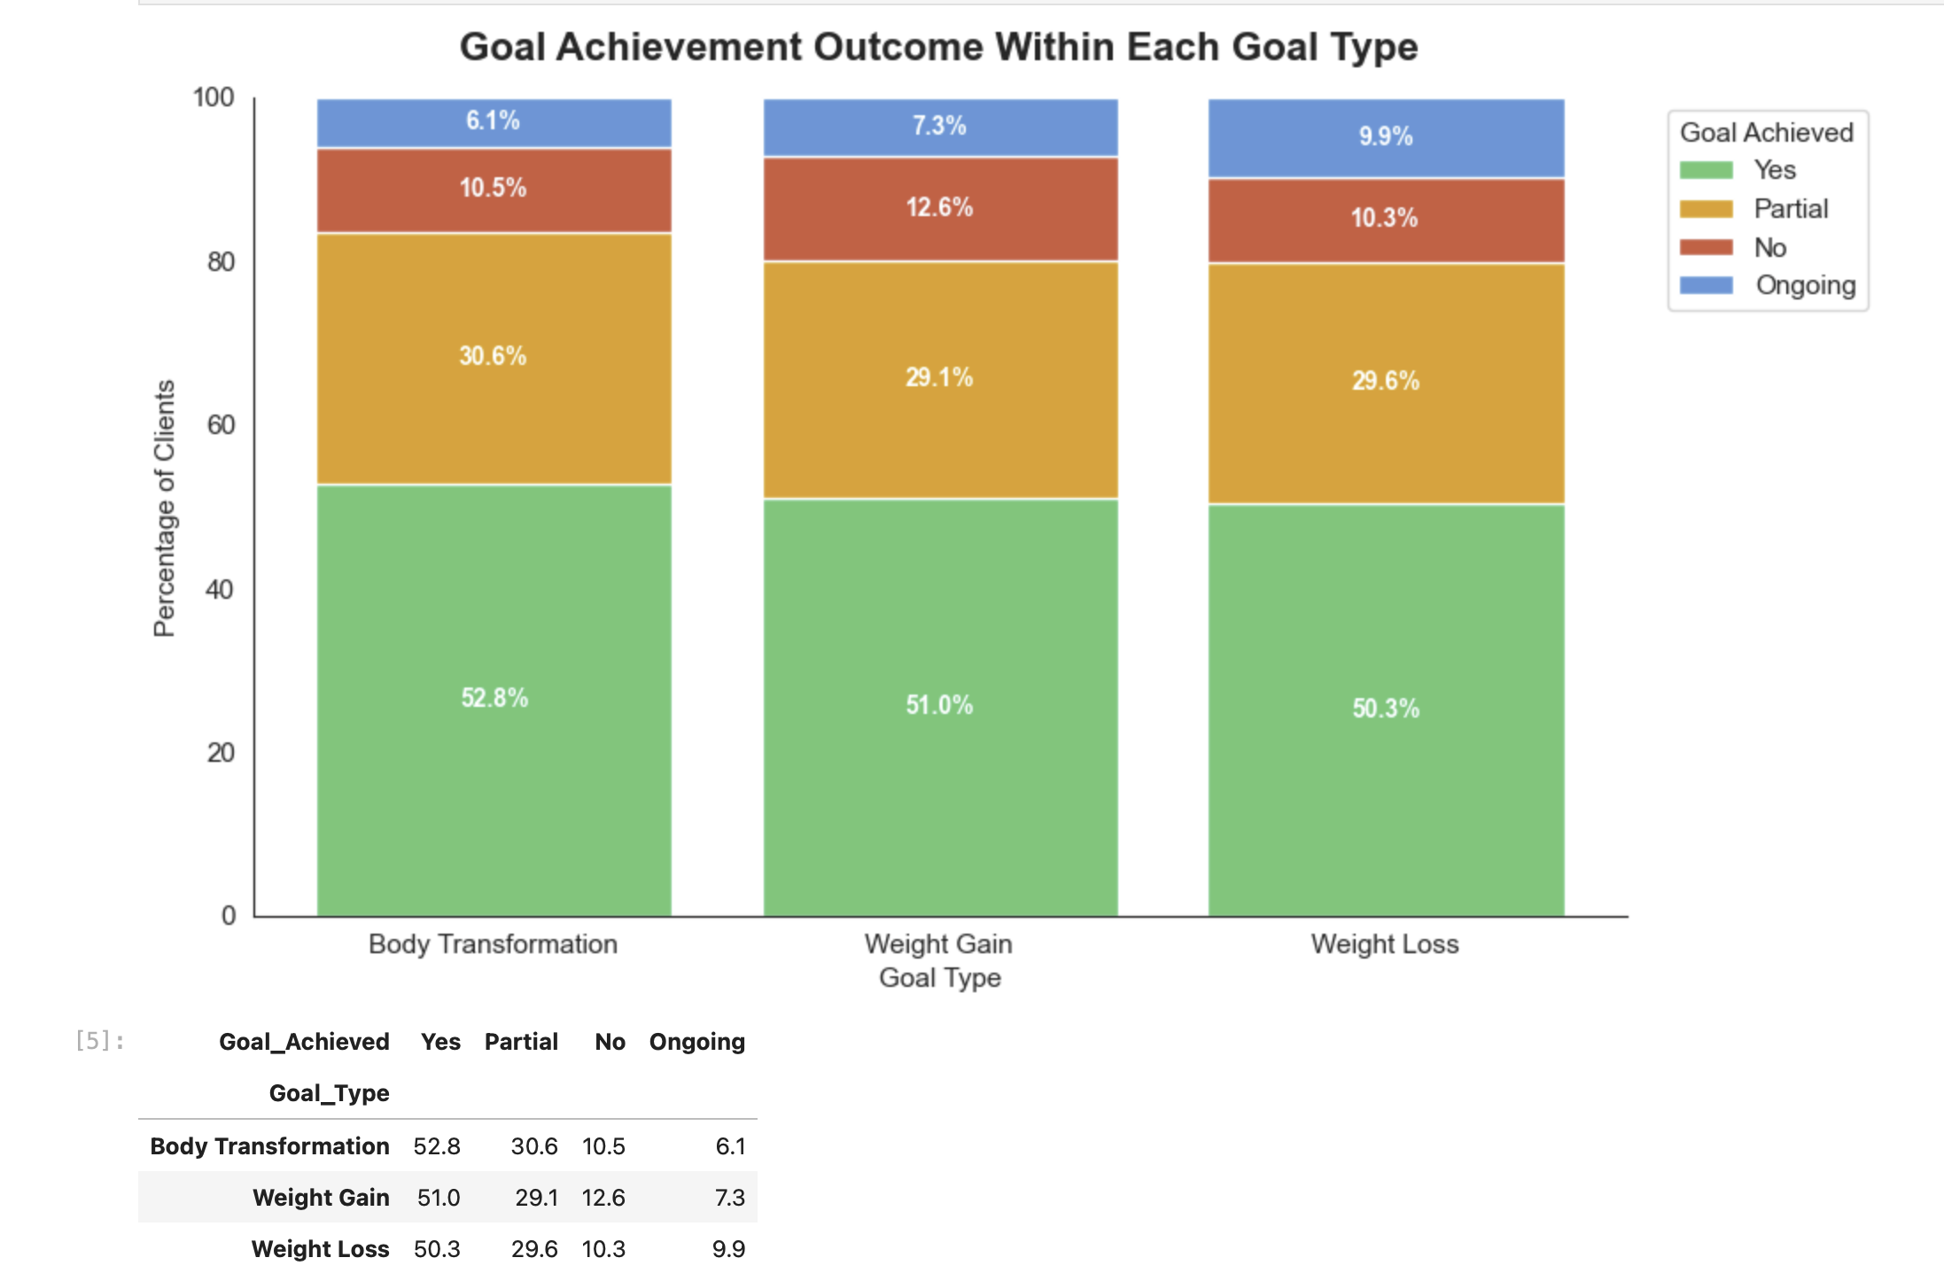

Phase 3 — Chart 5: Check-in Rate Heatmap
Chart 5 analyzes average check-in rate by daily schedule and starting motivation level. I used a heatmap to identify which client groups are most consistent with weekly check-ins. This chart helps show how lifestyle and initial motivation may affect client engagement. The insight is useful because Drishti can use it to identify client groups that may need stronger follow-up, reminders, or accountability support during the program.
Chart 5 analyzes average check-in rate by daily schedule and starting motivation level. Homemakers with medium motivation had the highest check-in rate at 80.8%, while flexible-schedule clients also showed very strong engagement across medium and high motivation levels. Clients with 9–5 jobs became more consistent as motivation increased. Shift work clients had the lowest check-in rates across all motivation levels, even when motivation was high. This suggests that schedule flexibility plays a major role in engagement, and shift work clients may need a separate accountability system with more flexible check-in timing and reminders.
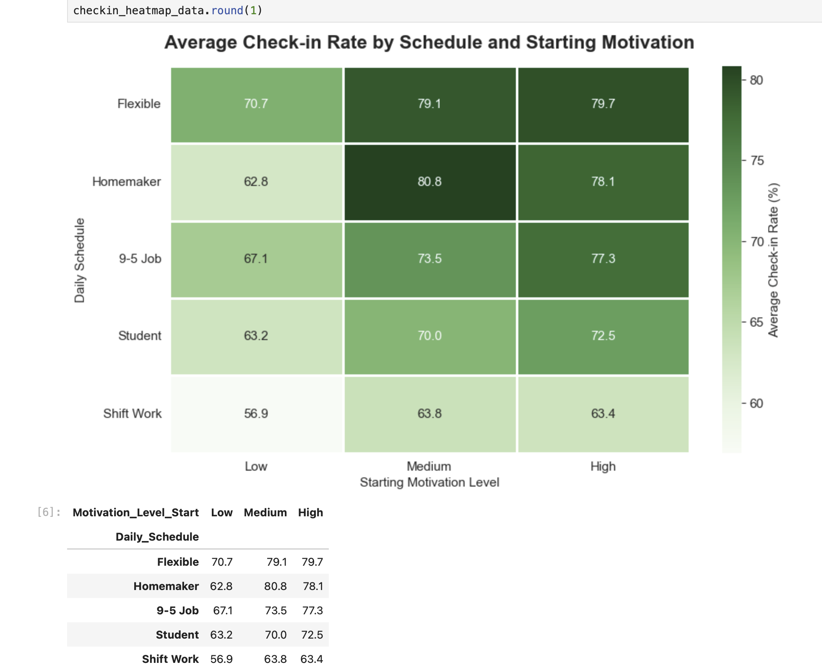

Chart 6: Client Journey Funnel

Chart 6 analyzes the full client journey from payment to second-round signup. I created a funnel chart to track how many clients moved through each key stage: paid, ever engaged, active at week 3, completed the program, achieved their goal, and signed up for a second round. The chart also calculates the percentage of paid clients remaining at each stage and the drop-off between stages. This chart answers where clients are being lost in the business journey. It is important because Get Fit with Drishti receives payment upfront, so revenue loss is not the main issue. The bigger business problem is client success, retention, goal achievement, and repeat coaching. This funnel helps identify where Drishti should focus follow-up systems, reminders, early intervention, and post-program retention strategies.
Chart 6 analyzes the full client journey from payment to second-round signup. Out of 3,000 paid clients, 2,867 engaged at least once, 2,677 were still active at week 3, and 2,431 completed the program. This shows that initial engagement and completion are strong. However, only 1,536 clients fully achieved their goal, meaning there is a major gap between completing the program and reaching the desired outcome. The largest drop happens between goal achievement and second-round signup, where only 428 clients returned for another round. This shows that Drishti’s biggest opportunity is not just preventing dropout, but improving goal achievement and creating a stronger post-program follow-up system to increase repeat clients.
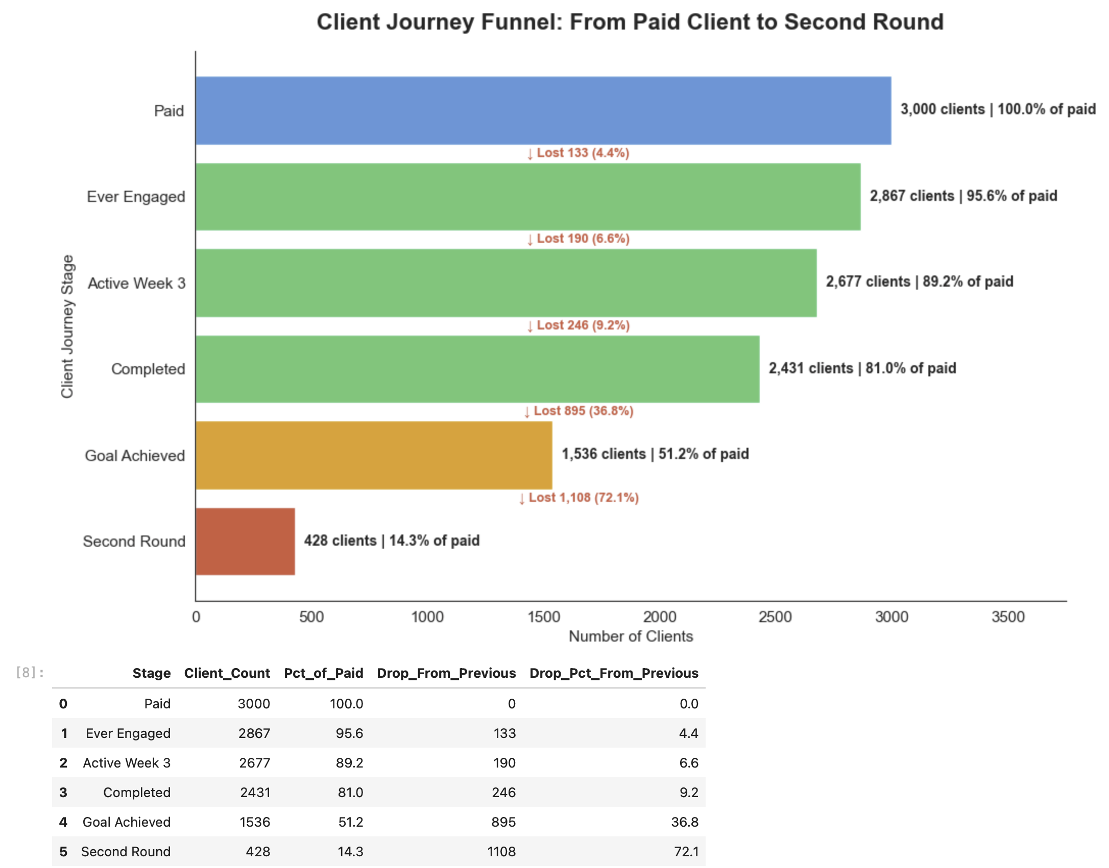

Chart 7: Dropout Reasons + Win-Back Rate

Chart 7 analyzes dropout reasons and win-back rate. I created a bar chart to rank dropout reasons by count and added a second-axis line to show the percentage of dropped clients who returned. This chart helps identify not only why clients leave, but also which dropout reasons are most recoverable. The insight is useful because Drishti can design targeted recovery messages, follow-up systems, and support strategies based on the specific reason a client dropped out.

Chart 7 analyzes why clients dropped out and how often they returned after dropping. Busy schedule was the most common dropout reason, with 41 clients, but 78.0% of those clients came back. Laziness was the second most common reason, with a 63.6% win-back rate. Health issue had the highest win-back rate at 100.0%, although the sample size was smaller. This shows that dropout does not always mean the client is permanently lost. Many clients are recoverable if Drishti uses the right follow-up strategy. Busy clients may need flexible check-ins and restart reminders, while health-related dropouts may need supportive recovery-based follow-up.
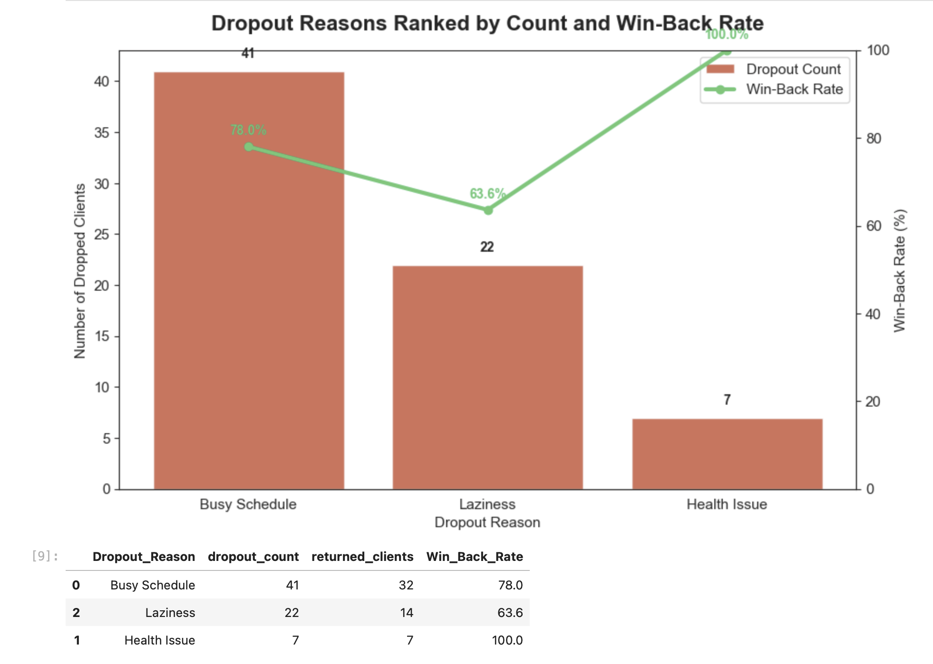
Chart 8: Check-in Rate vs Goal Achievement
Chart 8 analyzes the relationship between client engagement and goal achievement. I converted goal achievement into a numeric score and compared it with check-in rate. The scatter plot helps show whether clients with higher check-in rates are more likely to partially or fully achieve their goals. This chart is important because it tests one of the main assumptions of the project: that consistent engagement is a key driver of client success.
Chart 8 analyzes the relationship between client engagement and goal achievement. I converted goal achievement into a numeric outcome and compared it against each client’s check-in rate. The chart shows a very strong relationship between engagement and success. Clients who did not achieve their goal had an average check-in rate of only 5.8%, while clients who partially or fully achieved their goal had average check-in rates above 89%. This confirms that check-in behavior is one of the strongest success signals in the business. For Get Fit with Drishti, this means check-in rate should be used as an early warning metric to identify clients who may need reminders, accountability, or personal follow-up before they fail or drop out.
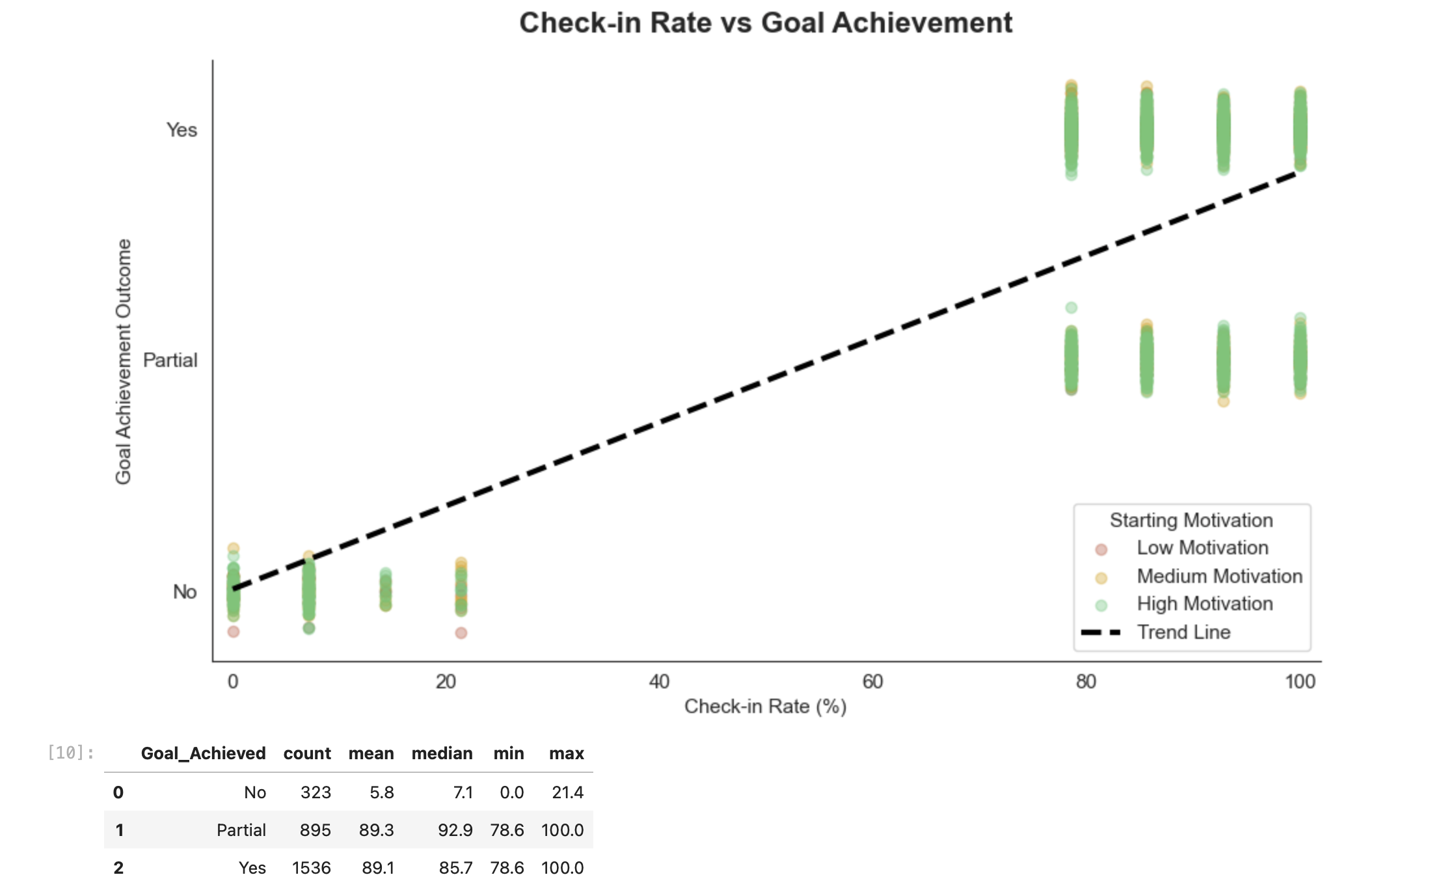

Chart 9: Health Condition vs No Health Condition
Chart 9 compares clients with health conditions against clients with no recorded health condition. I first corrected the grouping logic because clients without health conditions were stored as blank values rather than “N/A”. After separating the clients into two groups, I compared their completion rate and goal achievement rate.

This chart helps evaluate whether clients with health conditions are underserved or whether they are performing at a similar level to other clients. The insight is important because clients with PCOS, thyroid issues, back pain, diabetes, or other conditions may need more personalized onboarding, flexible expectations, and closer follow-up. If their completion or goal achievement rate is lower, Drishti can create a support system specifically for health-condition clients.
Chart 9 compares clients with health conditions against clients with no recorded health condition. I corrected the grouping logic because clients without health conditions were stored as blank values, then separated clients into two groups. Clients without health conditions had an 81.3% completion rate and 51.7% goal achievement rate, while clients with health conditions had an 80.5% completion rate and 50.2% goal achievement rate.
The results show that clients with health conditions perform almost as well as clients without health conditions. The difference in completion rate is only 0.8 percentage points, and the difference in goal achievement rate is 1.5 percentage points. This suggests that Drishti’s coaching system is already supporting health-condition clients well. However, their slightly lower goal achievement rate shows an opportunity to add more personalized tracking, expectation-setting, and follow-up for clients with PCOS, thyroid issues, back pain, diabetes, or other conditions.
Data note: In the cleaned dataset, clients with no health condition were stored as blank values, so I used missing-value logic to separate “No Health Condition” from “Has Health Condition.”

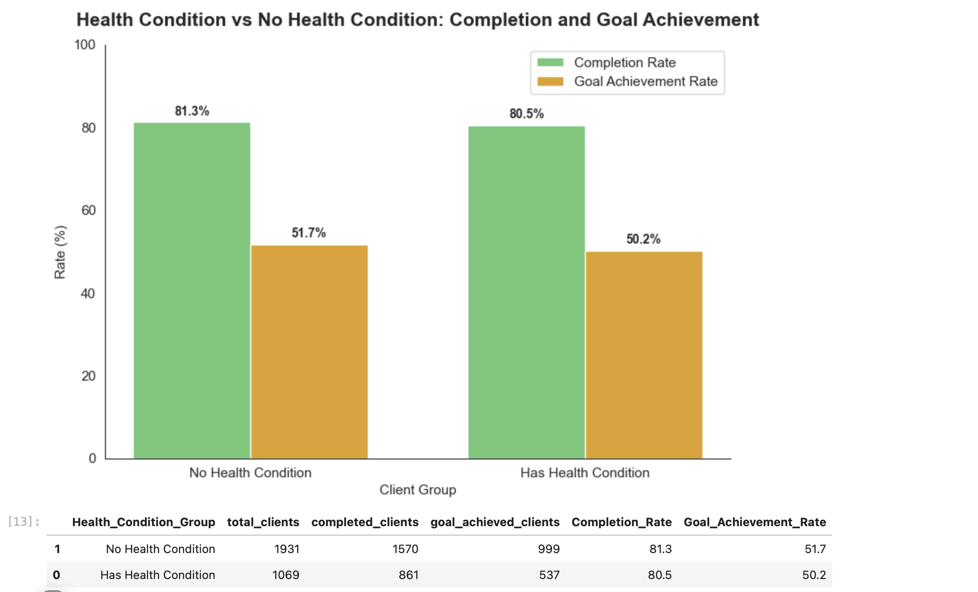

Chart 10: Monthly New Clients by Lead Source
Chart 10 analyzes monthly client growth by lead source. I used payment date to group clients by month and then broke each month down by TikTok, referral, Instagram, and other sources. This chart helps show how the business grew over time and which marketing channels contributed most to that growth. It is useful because Drishti can see whether growth is mainly coming from TikTok, referrals, Instagram, or other channels, and use that insight to plan future marketing efforts.

Chart 10 analyzes monthly new client growth by lead source from 2022 to 2024. The chart shows that client volume increased strongly over time, with 2024 being the highest-growth year. TikTok is the main growth driver across most months, confirming that social media discovery is central to the business. Referrals also contribute consistent monthly volume, showing that satisfied clients are already helping the business grow through word of mouth. The highest month shown is October 2024 with 146 new clients. This insight suggests that Drishti should continue using TikTok for client acquisition while building a stronger referral system to turn happy clients into a more predictable growth channel.

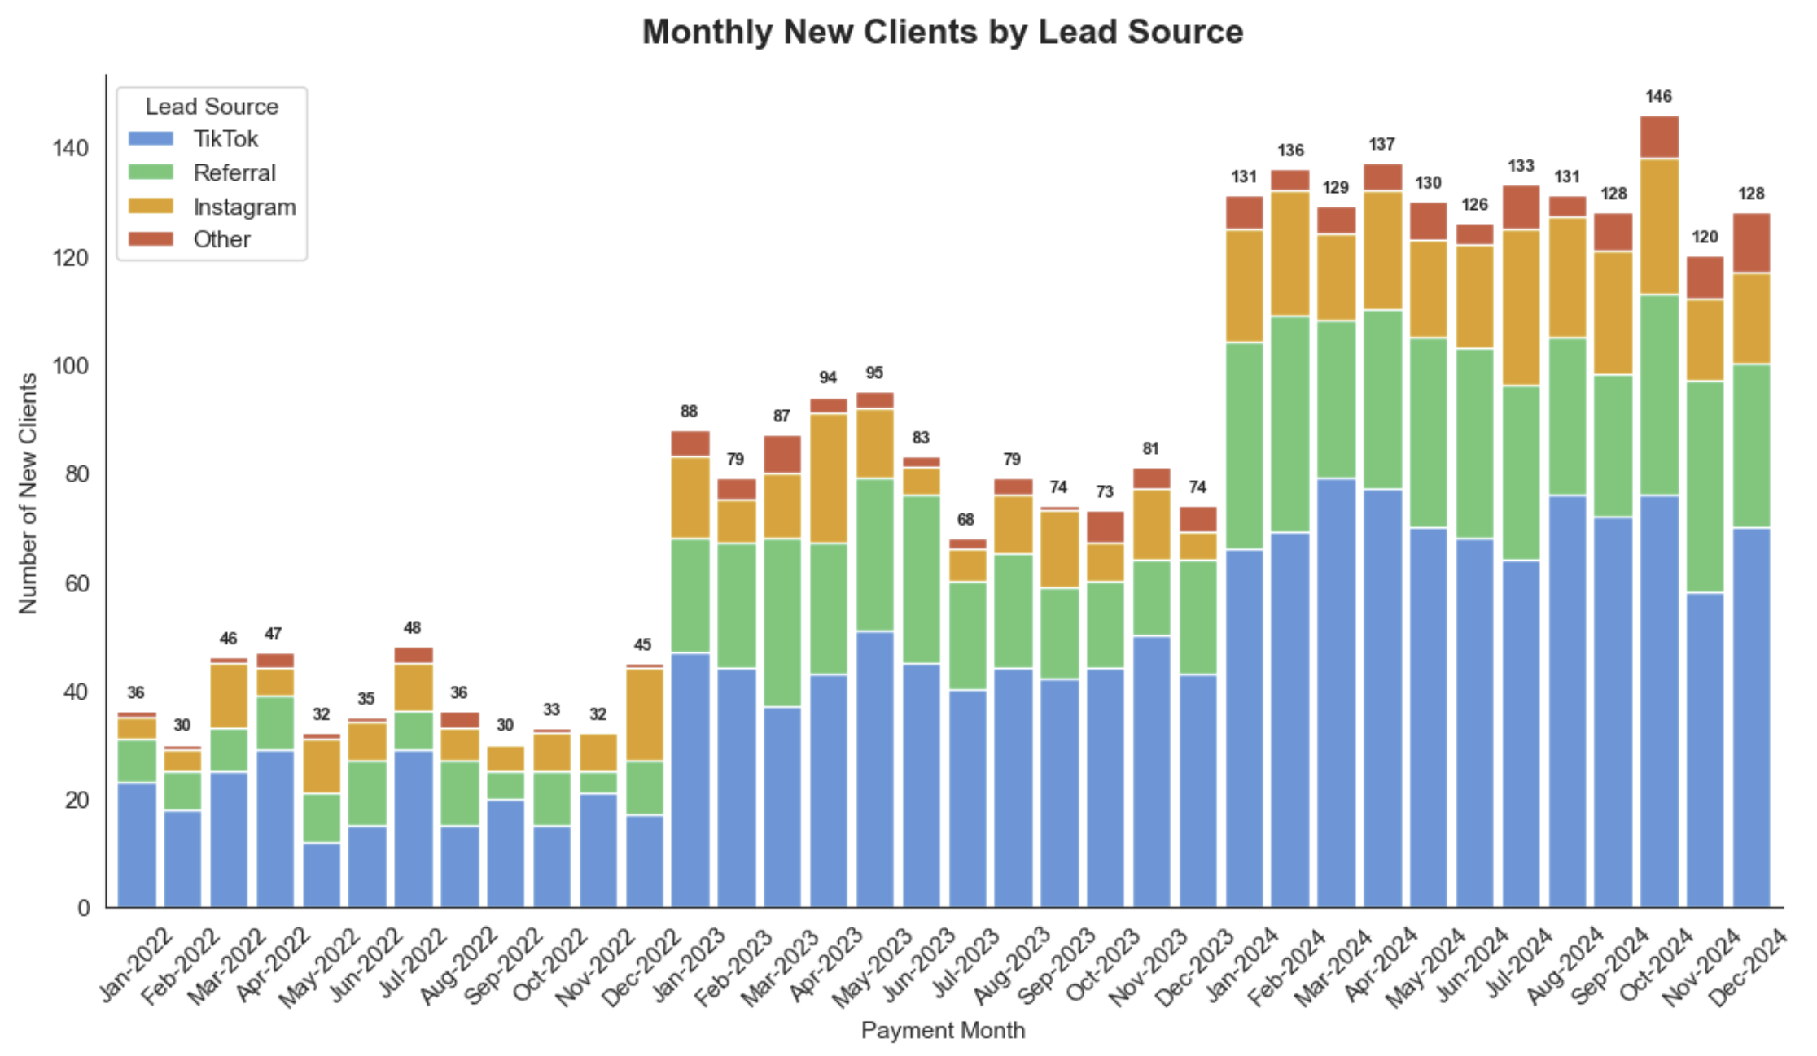

Chart 11: Second Round Client Comparison

Chart 11 compares clients who signed up for a second round with clients who did not. I compared both groups using average check-in rate, goal achievement rate, average age, and the percentage who referred someone else. I also corrected the referral metric to measure clients who referred another person, not clients who originally came through referral.

The results show that second-round clients had a lower average check-in rate at 50.1% compared to 79.0% for non-second-round clients. They also had a lower goal achievement rate at 32.0% compared to 54.4%. Average age was similar between both groups. However, second-round clients had a slightly higher referral rate, with 24.8% referring someone compared to 22.4% of non-second-round clients.

This suggests that repeat coaching may not only come from the most successful clients. Some clients may return because they still need support, accountability, or another attempt to reach their goal. This insight can help Drishti design second-round offers for clients who did not fully achieve their goal in the first round.
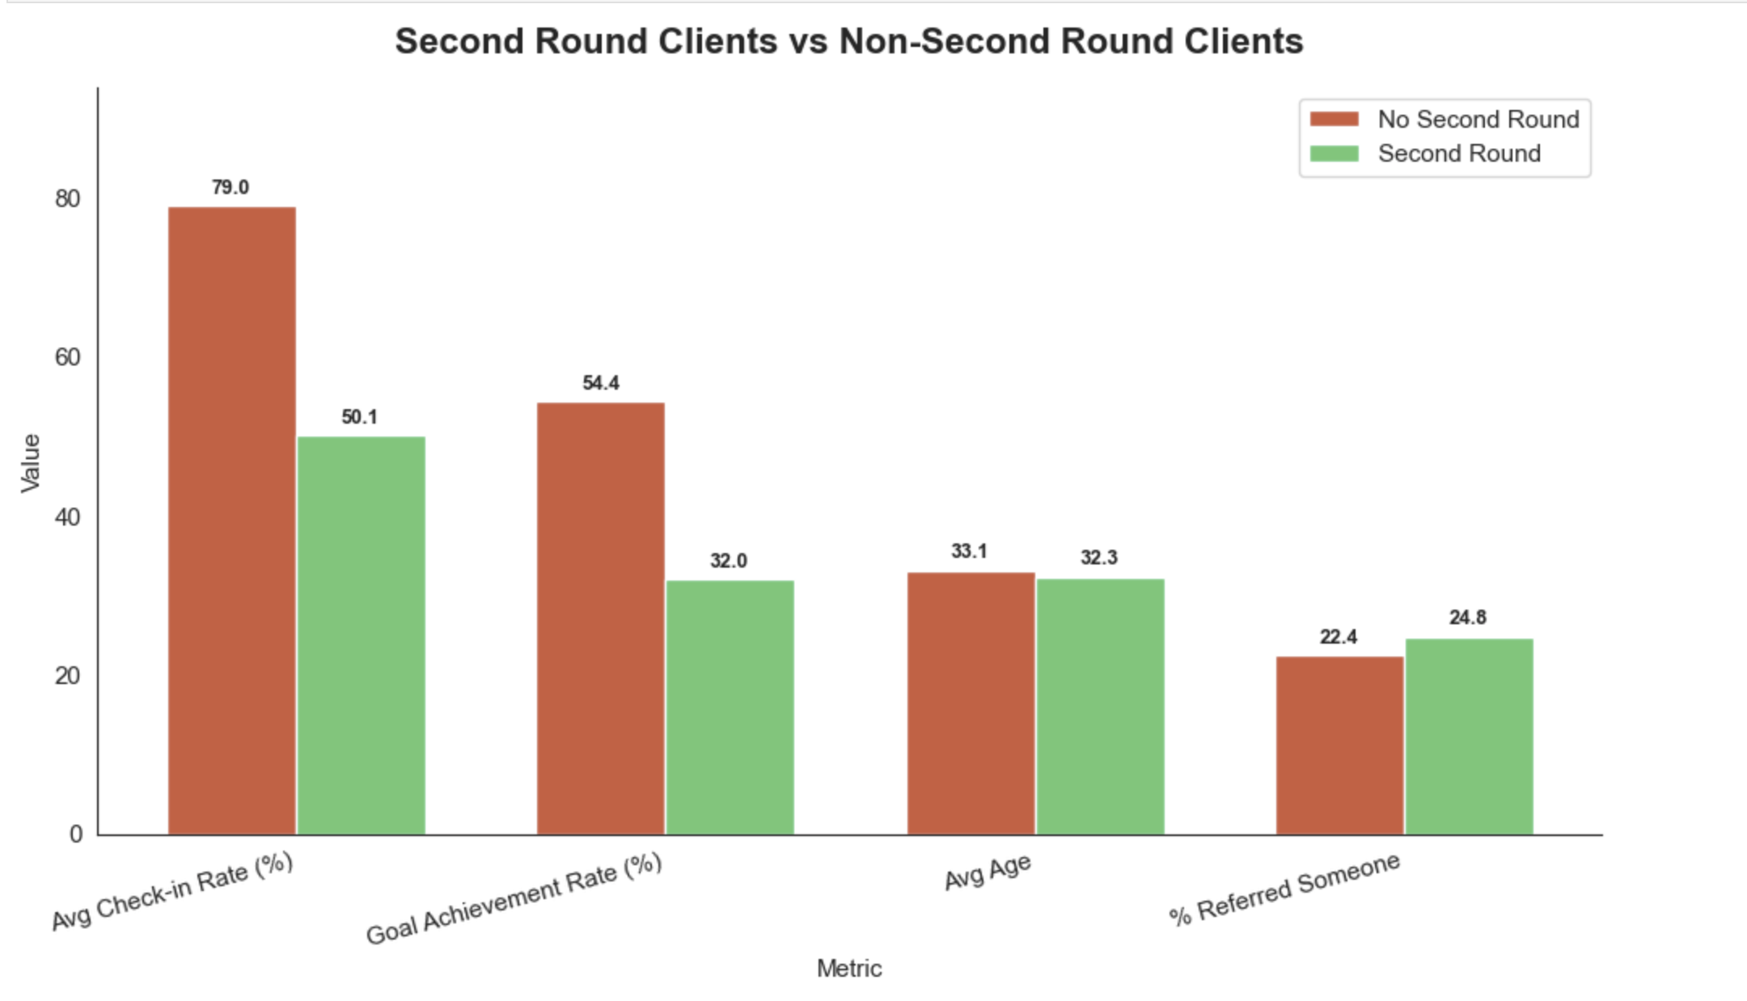

Chart 12: Program Duration by Client Status

Chart 12 compares program duration across completed, ghost, inactive, and quit clients. I used a box plot to show the spread, median, and range of program duration for each client status. This chart helps identify whether unsuccessful clients leave early or stay in the program for a longer period before becoming inactive or quitting. The insight is useful because it helps Drishti understand when client risk appears during the program and whether different client statuses need different follow-up strategies.
Chart 12: Program Duration by Client Status

Chart 12 compares program duration across completed, ghost, inactive, and quit clients. I used a box plot to show how long clients stayed in the program under each status group. The results show clear differences in dropout timing. Completed clients stayed the full 100-day program. Ghost clients left very early, with a median duration of 8 days, while quit clients stayed slightly longer, with a median of 18.5 days. Inactive clients remained in the program much longer, with a median duration of 50 days, showing that they often disengaged around the middle of the program rather than at the beginning.

This insight shows that churn is not one pattern. Ghost clients need immediate early follow-up, quit clients may need stronger first-month support, and inactive clients may need re-engagement strategies around the midpoint of the program.

Ghost clients disappear almost immediately, quit clients leave early, and inactive clients tend to fade around the middle of the program. This means Drishti should use different intervention strategies for different churn behaviors.
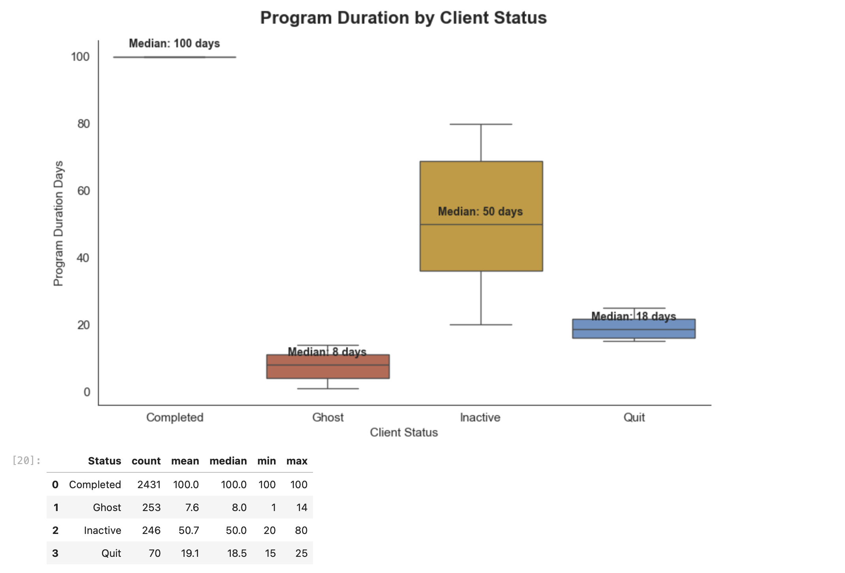

Key Findings

The EDA shows that Get Fit with Drishti has strong client demand, high completion, and a major opportunity to improve goal achievement and repeat coaching. Most clients join for weight loss, followed by body transformation and weight gain, showing that the business mainly attracts clients seeking visible physical transformation. TikTok is the biggest growth channel, while referrals bring the strongest-quality clients based on completion and goal achievement. Engagement is the clearest success signal: clients who did not achieve their goal had an average check-in rate of only 5.8%, while clients who partially or fully achieved their goal had average check-in rates above 89%. The client journey funnel shows strong completion at 81.0%, but only 51.2% fully achieved their goal and 14.3% returned for a second round. Churn also follows different patterns: ghost clients disappear early, quit clients leave in the first month, and inactive clients fade around the midpoint.

Phase 4 part A
Phase 4 began by defining an “ideal client” as someone who completed the program, achieved their goal, and maintained at least an 80% check-in rate. I created a new Ideal_Client flag to separate these high-success clients from all other clients. This flag will be used to compare behaviors, lead sources, goals, and engagement patterns to understand what types of clients are most likely to succeed with Drishti’s coaching.
I defined an ideal client as someone who completed the program, achieved their goal, and maintained at least an 80% check-in rate. Based on this definition, 1,144 out of 3,000 clients, or 38.13%, qualified as ideal clients. This group represents Drishti’s highest-success clients and will be used as the benchmark for identifying patterns in client background, behavior, lead source, and engagement. After that, I compared ideal clients against all other clients across major categorical variables such as gender, country, goal type, lead source, diet type, daily schedule, motivation level, referral status, and engagement behavior. For each category, I calculated the percentage of ideal clients and other clients, then measured the difference and likelihood ratio. This helped identify which characteristics are overrepresented among Drishti’s highest-success clients. The categorical comparison showed that ideal clients are most strongly differentiated by engagement behavior. Ideal clients were 1.39 times more likely to share progress photos and 1.21 times more likely to communicate daily compared to other clients. They were also slightly more likely to have a body transformation goal, come through referral, and have high starting motivation. This suggests that Drishti’s highest-success clients are not defined only by demographics, but by active participation, consistent communication, and visible progress tracking.

I compared ideal clients and other clients across numeric variables including age, goal gap, payment speed, days to first engagement, check-in rate, weekly check-ins completed, program duration, and revenue. This helped identify whether successful clients behave differently in measurable ways, such as engaging faster, checking in more often, or having different goal sizes. The numeric comparison showed that ideal clients behave very differently from other clients. Ideal clients had an average check-in rate of 92.73% compared to 63.94% for other clients, and they completed about 4 more weekly check-ins on average. They also paid slightly faster and had slightly smaller goal gaps. Revenue was almost identical between both groups, showing that the key difference between successful and unsuccessful clients is not payment value, but engagement quality, communication consistency, and early participation.
Similarly, I converted the categorical comparison results into plain-language insight statements. These statements explain how much more likely ideal clients are to show specific characteristics, such as sharing progress photos, communicating daily, coming from referrals, or having certain goal types. This makes the analysis easier to use in Drishti’s business strategy and final portfolio report. Like wise, I converted the ideal client comparison into plain-language insight statements. The strongest patterns showed that ideal clients are much more likely to share progress photos, communicate daily, engage early, and complete more weekly check-ins. Smaller demographic differences such as gender, country, or diet type were present but weaker, so the main success profile is based more on behavior and engagement than background.

Important business note
Do not over-focus on tiny differences like:
Female: 1.02x
Australia: 1.05x
Vegetarian: 1.04x
Those are weak differences.
The strongest and most useful success signals are:
Progress photos
Daily communication
Early engagement
High check-in rate
More completed check-ins
That is the real story.
Finally,I created the Ideal Client Profile by combining the strongest categorical and numeric differences between ideal clients and other clients. The profile showed that Drishti’s best clients are not mainly defined by demographics, but by behavior. Ideal clients engage early, communicate daily, share progress photos, and maintain very high check-in consistency. This profile can help Drishti improve her content, onboarding, and messaging toward clients who are more likely to complete the program and achieve their goals.

Step 5: Write the Ideal Client Profile Paragraph
Now we turn the analysis into a business-ready paragraph Drishti can actually use for TikTok, Instagram messaging, and client targeting.
Based on your results, the strongest ideal-client pattern is behavior, not demographics.
Use this in your documentation/report:
Drishti’s ideal client is most likely a female client in her early 30s, often based in Australia, with a body transformation or weight-related goal. She usually engages quickly after payment, communicates daily, shares progress photos, and completes almost all weekly check-ins. Compared to other clients, ideal clients are 1.39 times more likely to share progress photos and 1.21 times more likely to communicate daily. They also maintain a much higher average check-in rate of 92.73% compared to 63.94% for other clients. This shows that Drishti’s best-fit clients are not only defined by age, country, or goal type, but by their willingness to participate, respond, track progress, and stay consistent throughout the program.

Shorter version for portfolio slide
The ideal client is not just someone with a specific demographic profile — she is an active participant. Drishti’s highest-success clients engage early, communicate daily, share progress photos, and complete nearly all check-ins. Ideal clients are 1.39x more likely to share progress photos, 1.21x more likely to communicate daily, and average a 92.73% check-in rate. This means the strongest success driver is consistent engagement, not just client background.

What this means for Drishti’s business
Drishti should attract more clients who are ready to:
Reply daily
Send progress photos
Start quickly
Stay accountable
Track visible progress
Her TikTok and Instagram content should speak directly to people who want structure, accountability, and visible transformation — not just meal plans.
Lastly, I saved the Ideal Client Profile analysis outputs as CSV files so they can be reused later in Excel, Tableau, and the final project report. These files include the ideal client count summary, categorical comparison results, numeric comparison results, and plain-language insight sentences. This keeps the analysis organized and makes the results easier to use in later phases of the project.
In Part A, I defined Drishti’s ideal client as someone who completed the program, achieved their goal, and maintained at least an 80% check-in rate. I found that 1,144 out of 3,000 clients, or 38.13%, fit this definition. The analysis showed that ideal clients are mainly differentiated by behavior, not demographics. They are more likely to share progress photos, communicate daily, engage early, and complete more weekly check-ins. I saved all comparison tables and insight outputs for use in the final dashboard and portfolio report.

Part B

Step 1: Prepare Data for K-Means Clustering

I prepared the dataset for K-Means segmentation by selecting behavioral, engagement, and client profile features. I excluded clients with Days_To_First_Engagement coded as 999 because this value represents clients who never engaged and would distort the clustering model. I encoded motivation level, converted referral and engagement fields into binary values, filled remaining missing values, and scaled all features using StandardScaler so that K-Means could compare variables fairly.
I prepared the data for K-Means clustering by selecting 9 features related to client profile, engagement, motivation, referral behavior, and program activity. I excluded 133 clients whose Days_To_First_Engagement value was coded as 999 because this represented clients who never engaged rather than a real number of days. The final clustering dataset included 2,867 clients with no missing values, and all features were scaled using StandardScaler to make them comparable for K-Means.
I also, tested K-Means cluster counts from 2 to 10 using both the elbow method and silhouette score. The elbow curve helped identify where adding more clusters stopped creating major improvement, while the silhouette score helped evaluate how clearly separated the clusters were. Since the project goal is to create four actionable client personas for Drishti, I used these charts to confirm whether k = 4 was a reasonable and business-friendly segmentation choice.
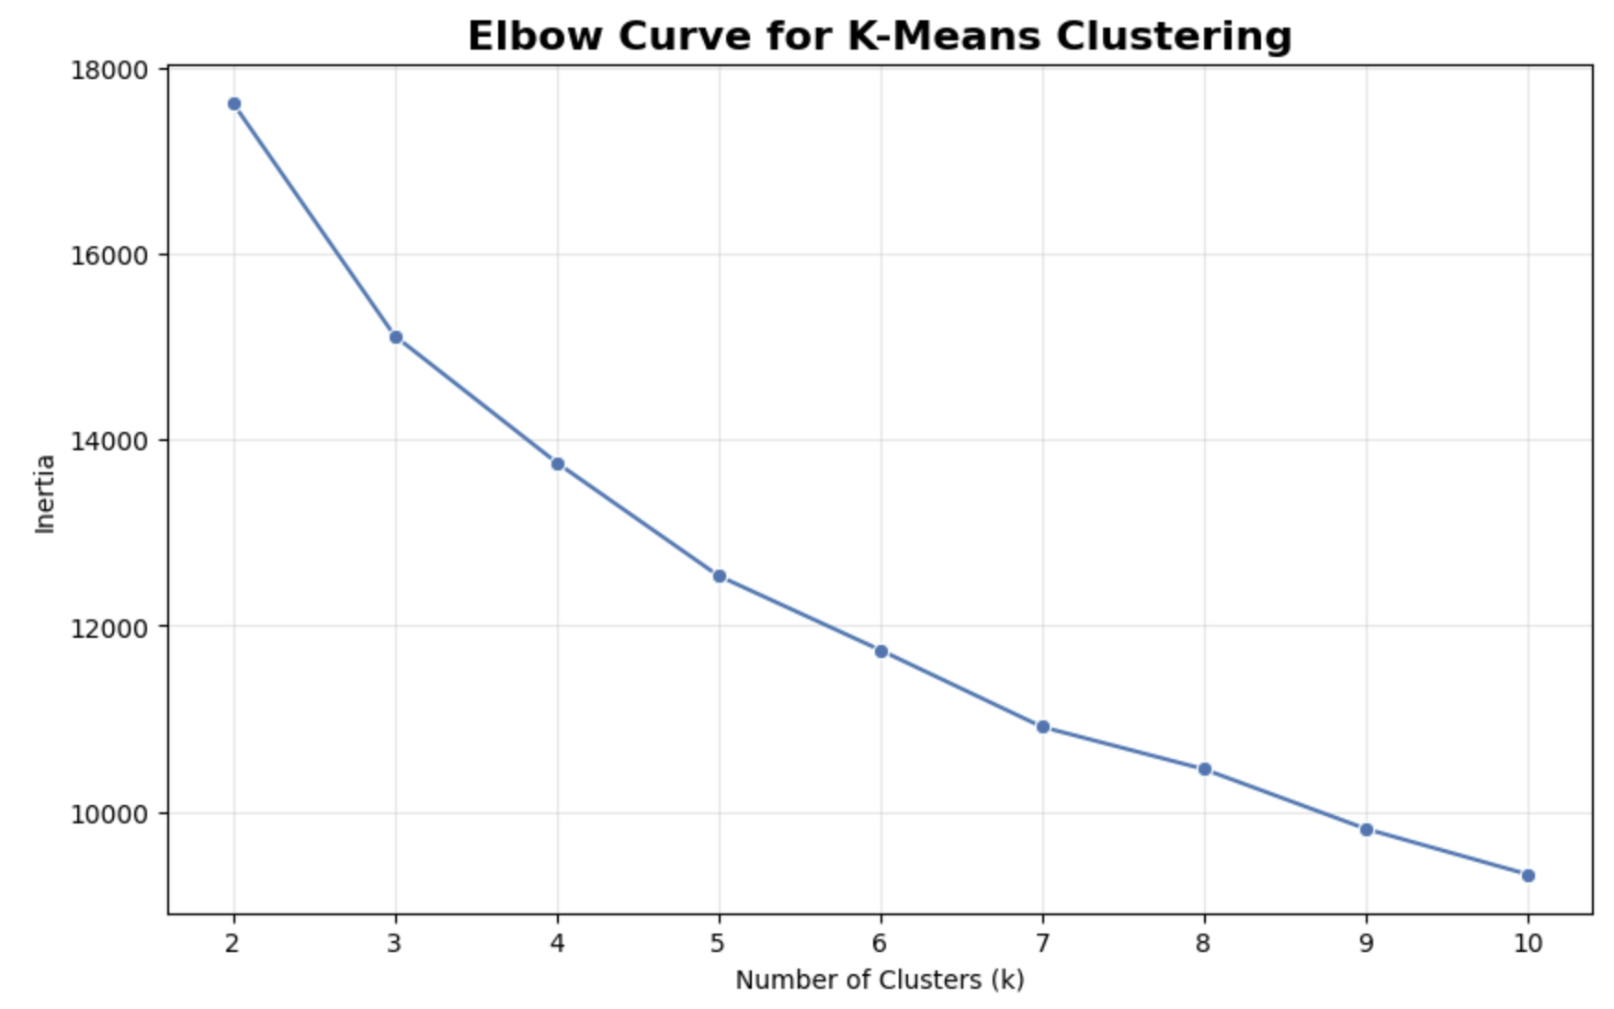
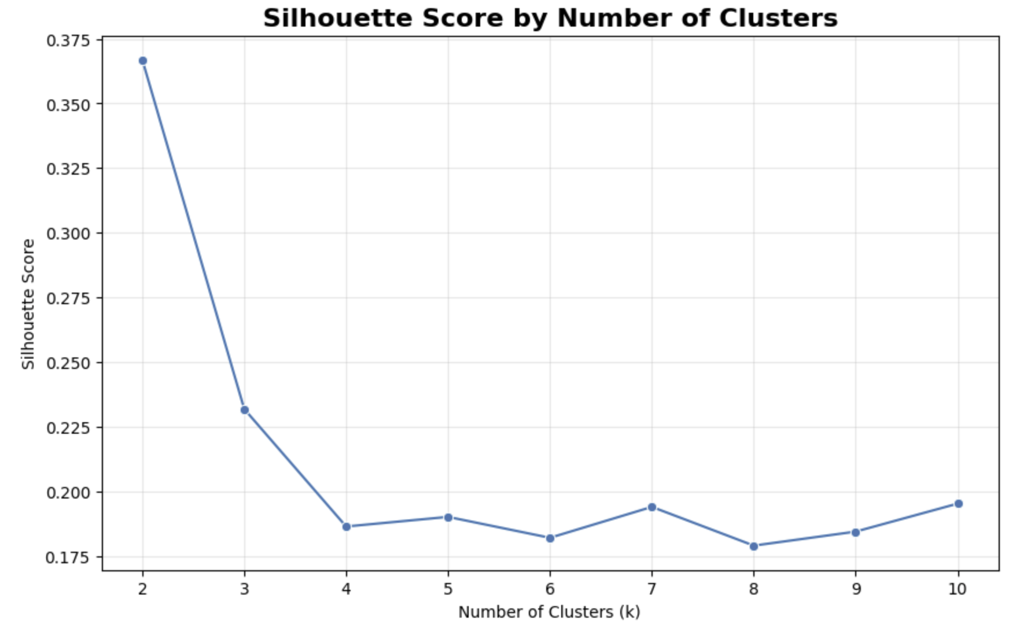

The silhouette score does not say 4 is mathematically the strongest option. It says 2 has the cleanest separation. But 4 is selected because the project goal is to create more useful coaching personas.
I tested cluster counts from k = 2 to k = 10 using the elbow method and silhouette score. The elbow curve showed a strong decrease in inertia until around k = 4, after which the improvement became more gradual. The silhouette score was highest at k = 2, but two clusters would be too broad for creating useful coaching personas. I selected k = 4 because it provides a better balance between statistical structure and business usefulness, allowing Drishti to understand four distinct client behavior groups.

Run K-Means with k = 4 and Assign Cluster Labels
I ran K-Means clustering using k = 4 and assigned each eligible client to one of four clusters. At this stage, the clusters are labeled numerically from 0 to 3. These labels will be profiled using engagement, motivation, check-in behavior, referral behavior, and program outcomes before assigning meaningful business persona names.
I applied K-Means clustering with k = 4 and assigned each eligible client to one of four clusters. The largest cluster contained 1,079 clients, or 37.64% of the clustering dataset, while the smallest cluster contained 429 clients, or 14.96%. These numeric cluster labels will be profiled in the next step to understand the behavioral differences between each client segment.
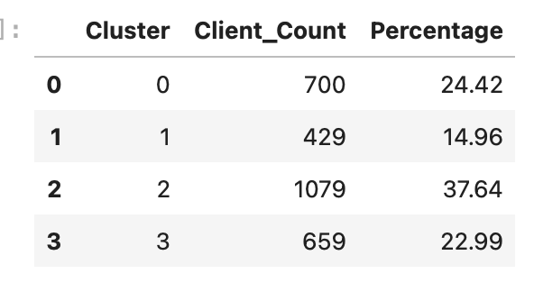

Step 4: Profile Each Cluster
I profiled each of the four K-Means clusters by calculating average client characteristics, engagement behavior, and business outcome rates. This included check-in rate, program duration, payment speed, first engagement timing, motivation level, referral rate, completion rate, goal achievement rate, second round rate, and progress photo sharing rate. This step turns the numeric cluster labels into meaningful business segments that can later be named as coaching personas.

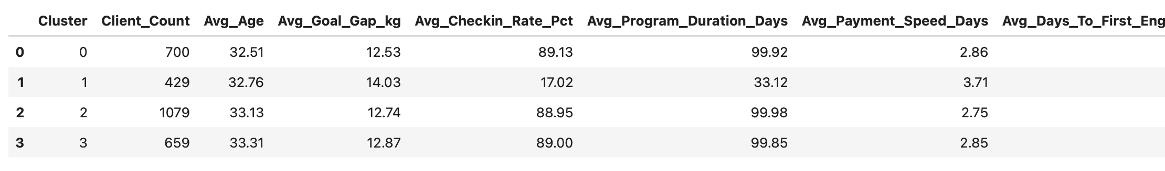
Cluster 0 = Successful non-referral clients
Cluster 1 = Churn / disengagement risk clients
Cluster 2 = Motivated high-success clients
Cluster 3 = Referral + repeat clients
Cluster 1 is the one Drishti needs an early-warning system for.
Cluster 2 and Cluster 3 are the ones she should attract more of.

After profiling the four clusters, I found that three clusters represented high-performing client groups, while one cluster represented a clear disengagement risk group. Cluster 1 had the lowest check-in rate, shortest program duration, 0% completion rate, and 0% goal achievement rate, making it the highest-risk segment. Clusters 0, 2, and 3 showed very high completion rates and strong check-in behavior. Cluster 3 was especially valuable because it had a 100% referral rate and the highest second round rate, showing the importance of referred clients in long-term business growth.

Step 5: Name the 4 Client Personas
These names are based on the actual data, so we are not forcing the example names from the prompt.
We adjusted the names because your data showed:
Cluster 3 is clearly referral-driven
Cluster 1 is clearly the dropout-risk group
Cluster 2 is clearly the motivated high-success group
Cluster 0 is successful but not referral/repeat-driven

I assigned business-friendly persona names to the four K-Means clusters based on their actual behavior and outcome patterns. Cluster 0 was named “The Strong Starters,” Cluster 1 was named “The Early Drop-Offs,” Cluster 2 was named “The Motivated Finishers,” and Cluster 3 was named “The Loyal Referrals.” These names were chosen based on each cluster’s check-in behavior, completion rate, goal achievement rate, referral rate, second-round rate, and progress photo sharing behavior.

The Strong Starters — 700 clients
These clients perform very well. They have a 99.71% completion rate, 89.13% check-in rate, and 79.14% progress photo sharing rate. They are not referral clients and do not usually return for a second round, but they are strong first-time clients.

2. The Early Drop-Offs — 429 clients
This is the risk group. They have only a 17.02% check-in rate, average program duration of only 33.12 days, 0% completion rate, and 0% goal achievement rate. These clients need early intervention.

3. The Motivated Finishers — 1,079 clients
This is the biggest and strongest success group. They have a 99.91% completion rate, 88.95% check-in rate, and the highest average motivation score at 2.00. These are the clients Drishti should attract more of through content.

4. The Loyal Referrals — 659 clients
This is the word-of-mouth group. They have a 100% referral rate, 99.39% completion rate, 81.34% progress photo rate, and the highest second-round rate at 34.75%. These clients are extremely valuable for business growth.
I named the four client segments based on their actual behavior and outcomes. The Strong Starters are successful first-time clients who complete the program but do not usually return or refer. The Early Drop-Offs are the highest-risk segment, with low check-ins, short program duration, and no completions. The Motivated Finishers are the largest high-success group, with strong motivation and excellent completion behavior. The Loyal Referrals are the most valuable word-of-mouth group, with high completion, strong progress tracking, and the highest second-round rate.

# Phase 4 — Part B
Step 6: Persona Descriptions + Coaching Actions + Content Ideas
1. The Strong Starters
700 clients | 99.71% completion rate | 89.13% check-in rate

Who they are
The Strong Starters are successful first-time clients who complete the program, check in consistently, and share progress photos. They are not referral clients and do not usually sign up for a second round, but they are highly capable of getting results during their first program.

What Drishti should do for them
Drishti should focus on turning these successful first-time clients into repeat clients or referral clients. Since they already complete the program, the biggest opportunity is after-program follow-up.

Specific actions:
- Send a graduation message at the end of the 100 days
- Offer a maintenance plan or second-round discount
- Ask them to share a testimonial or transformation story
- Create a simple referral reward after they complete the program
- Check in 30 days after program completion

## Content that attracts more of them
- “What happens in your first 100 days with me”
- “How daily check-ins help you stay accountable”
- “Client transformation journey from Day 1 to Day 100”
- “You do not need to be perfect, you just need structure”

# 2. The Early Drop-Offs
429 clients | 0% completion rate | 17.02% check-in rate

Who they are
The Early Drop-Offs are the highest-risk clients. They start the program but quickly lose consistency. They have very low check-in rates, short program duration, low progress photo sharing, and no completions or goal achievements. These clients need support very early, before they fully disappear.

What Drishti should do for them
Drishti should build an early-warning system for this group. If a client misses check-ins or does not respond within the first few days, they should get extra support immediately.

Specific actions:
- Send a personal reminder if they miss the first check-in
- Create a Day 3 and Day 7 follow-up system
- Ask what is blocking them instead of only reminding them
- Give them a smaller first-week goal
- Send motivational voice notes or simple habit checklists
- Flag them as “risk client” if check-in rate drops below 50%

Content that attracts/fixes this group
- “Struggle with consistency? Start with small habits”
- “What to do if you fall off your diet plan”
- “You do not need motivation every day — you need a system”
- “Busy schedule? Here is how we make your plan realistic”

3. The Motivated Finishers
1,079 clients | 99.91% completion rate | 88.95% check-in rate
Who they are
The Motivated Finishers are Drishti’s biggest high-success group. They start with high motivation, stay consistent, complete the program, and maintain strong check-in behavior. These are the clients most aligned with the coaching system.
What Drishti should do for them
Drishti should actively attract more of this group because they are most likely to follow the program and achieve results. These clients respond well to accountability, structure, and visible progress tracking.

Specific actions:
- Use transformation-focused onboarding
- Give them clear weekly milestones
- Encourage progress photos from the beginning
- Celebrate small wins publicly or privately
- Ask for testimonials after results
- Offer advanced fitness or maintenance plans after completion

Content that attracts more of them
- “If you are serious about changing your body in 100 days…”
- “This is what consistency actually looks like”
- “How my clients stay accountable every week”
- “Progress photos are not for judgment — they are for tracking growth”

4. The Loyal Referrals

659 clients | 100% referral rate | 34.75% second-round rate

Who they are

The Loyal Referrals are one of the most valuable business groups. They come through referrals, complete the program at a very high rate, share progress photos, and are much more likely to sign up for a second round. These clients are strong proof that word-of-mouth is a major growth channel for Drishti.

What Drishti should do for them

Drishti should build a formal referral system around this group. Since they already trust her because someone referred them, they are likely to be more committed from the beginning.

Specific actions:
- Create a referral reward program
- Ask successful clients to refer friends after completion
- Give referred clients a special welcome message
- Track who referred whom
- Offer small bonuses like free follow-up calls or maintenance guides
- Collect testimonials from referred clients

## Content that attracts more of them
- “Your friend got results — now it is your turn”
- “Why clients refer their sisters, friends, and family to me”
- “Real client results from referrals”
- “How accountability becomes easier when someone you trust recommends the coach”

I translated the four K-Means clusters into business personas that Drishti can use for coaching strategy, content planning, and client management. The Strong Starters are successful first-time clients who should be encouraged to refer or return. The Early Drop-Offs are the highest-risk group and need early intervention through reminders, smaller goals, and personal follow-up. The Motivated Finishers are Drishti’s strongest organic success segment and should be targeted through transformation and accountability-focused content. The Loyal Referrals are the most valuable word-of-mouth segment and support the need for a formal referral program.

Step 7: PCA 2D Scatter Plot Colored by Persona
I created a PCA scatter plot to visualize the four K-Means client personas in two dimensions. Since the clustering model used nine features, PCA helped reduce the data into two visual components while preserving as much variation as possible. The chart shows how the client personas separate based on engagement, motivation, referral behavior, payment speed, and program activity. This visualization makes the segmentation easier to explain in the final report and dashboard.
The PCA visualization reduced the nine clustering features into two dimensions and explained 38.41% of the total variation. The chart showed that The Early Drop-Offs formed a clearly separate group, while the three high-performing personas were closer together because they shared similar strong engagement and completion behavior. This confirms that the segmentation is especially useful for identifying disengagement risk, while also separating successful clients by referral, motivation, and repeat behavior.
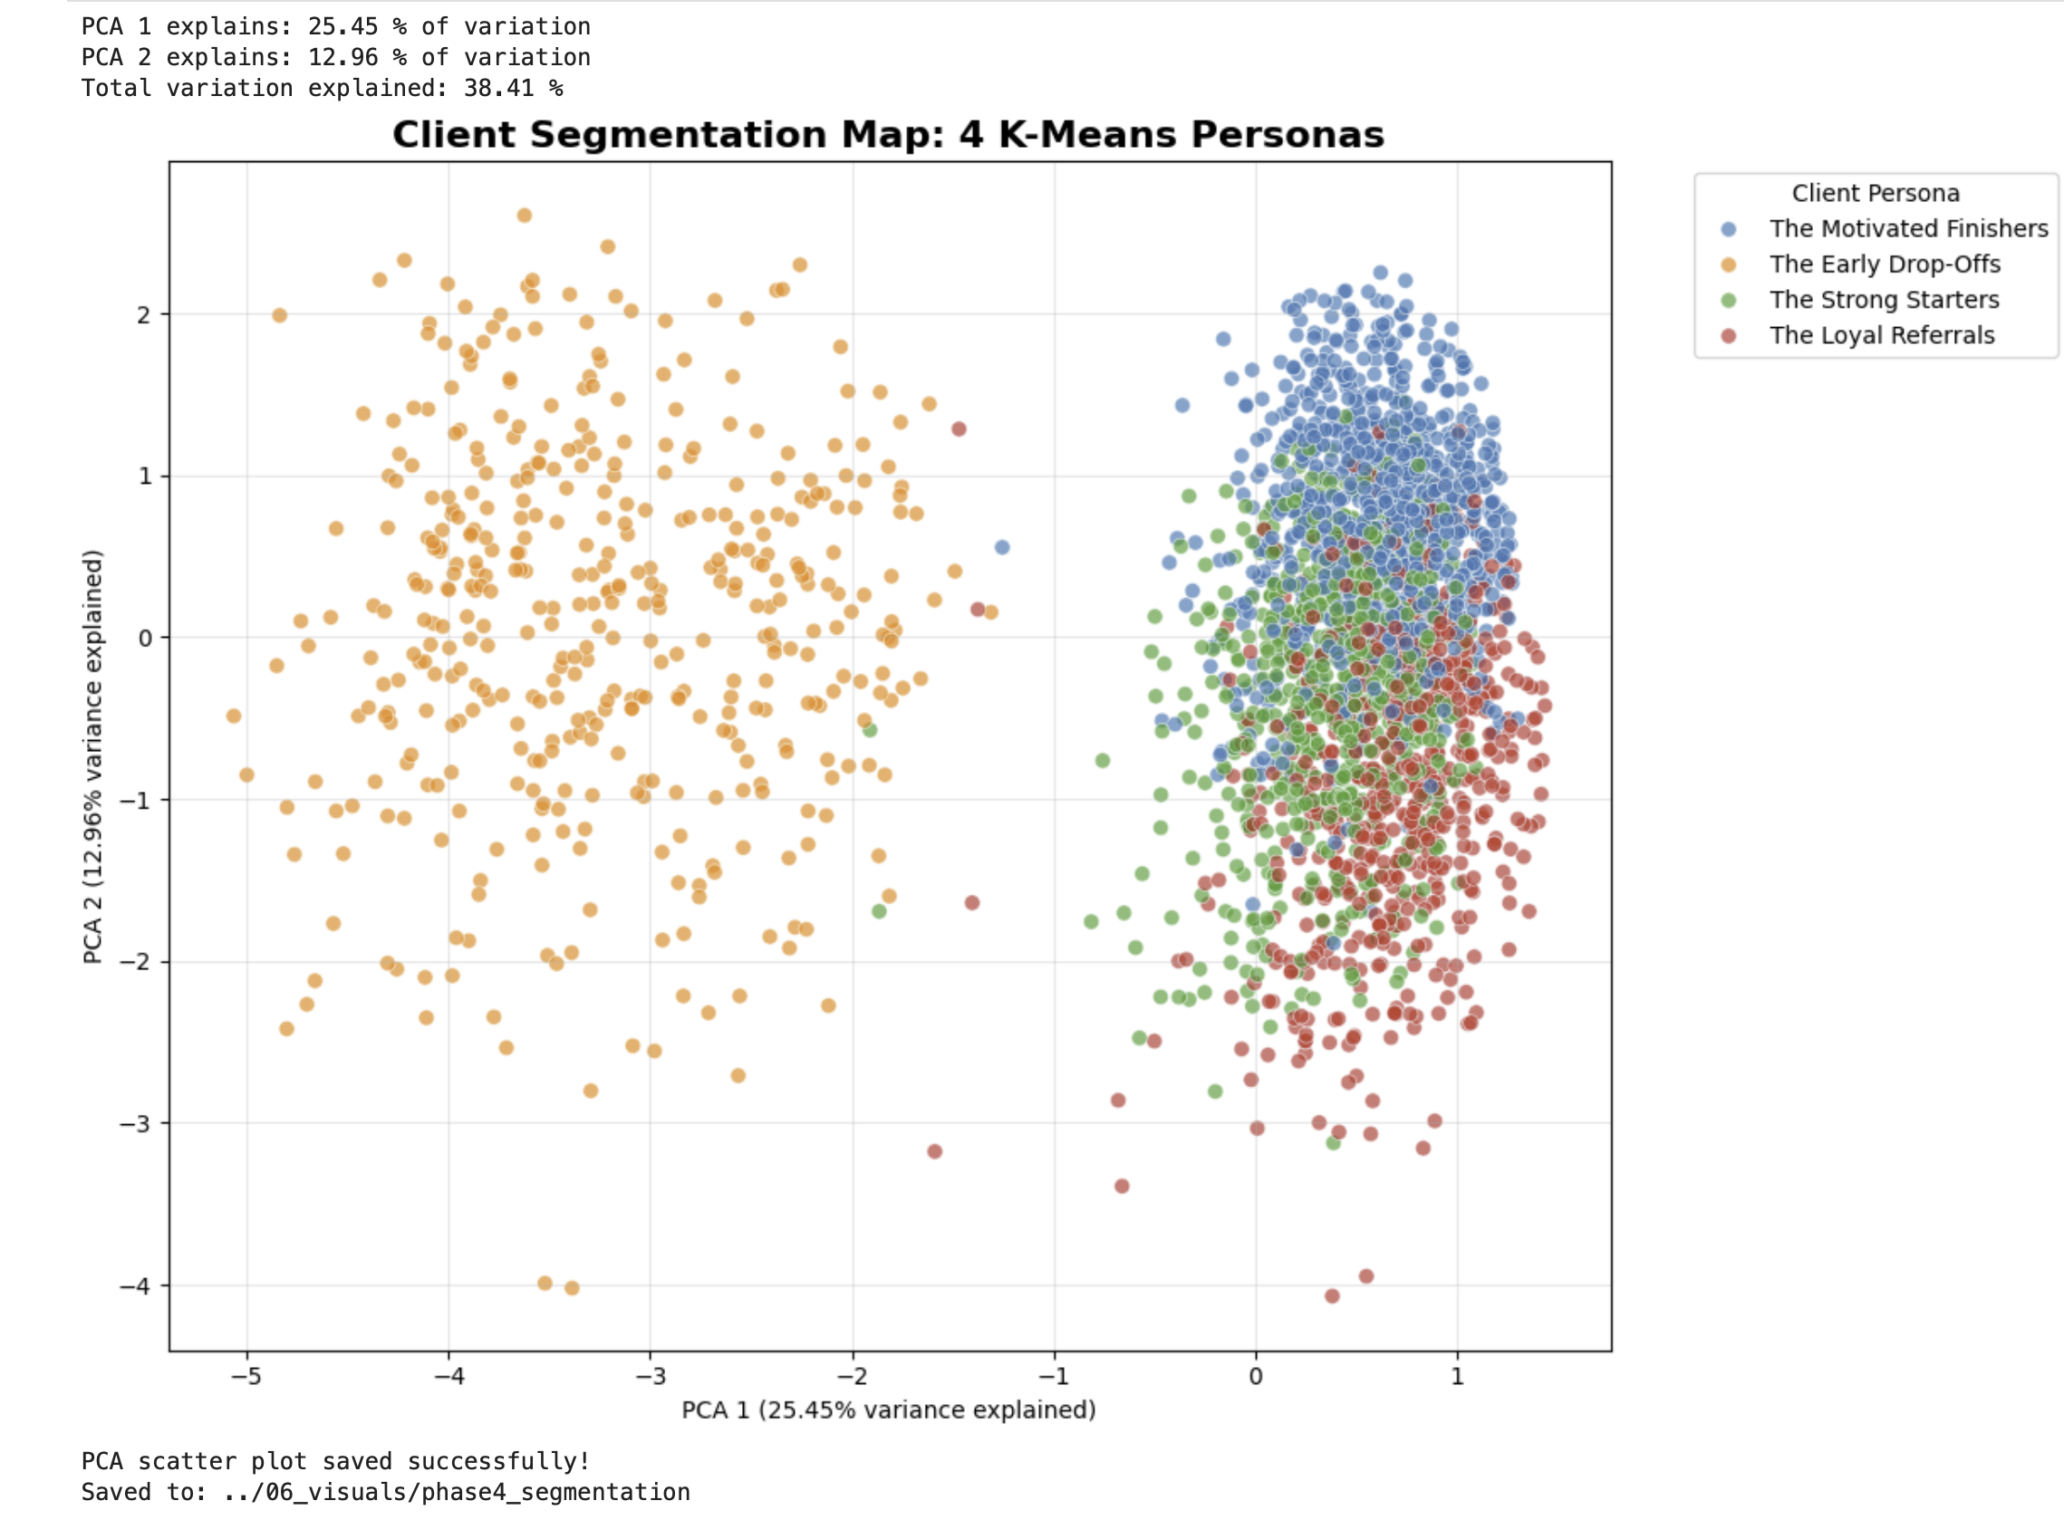

Phase 4 — Part B

Step 8: Radar Chart Comparing 4 Personas
I created a radar chart to compare the four client personas across five key success metrics: check-in rate, completion rate, goal achievement rate, second-round rate, and progress photo sharing rate. The chart made the persona differences easier to understand visually. It showed that The Early Drop-Offs are the weakest group across most success metrics, while The Strong Starters, Motivated Finishers, and Loyal Referrals perform strongly but differ in referral and second-round behavior.
The radar chart compared the four client personas across check-in rate, completion rate, goal achievement rate, second-round rate, and progress photo sharing. The Early Drop-Offs were clearly the weakest segment across most success metrics, confirming them as the highest-risk group. The Loyal Referrals stood out for strong success behavior and the highest second-round rate, while the Strong Starters and Motivated Finishers showed consistently high completion and engagement performance.

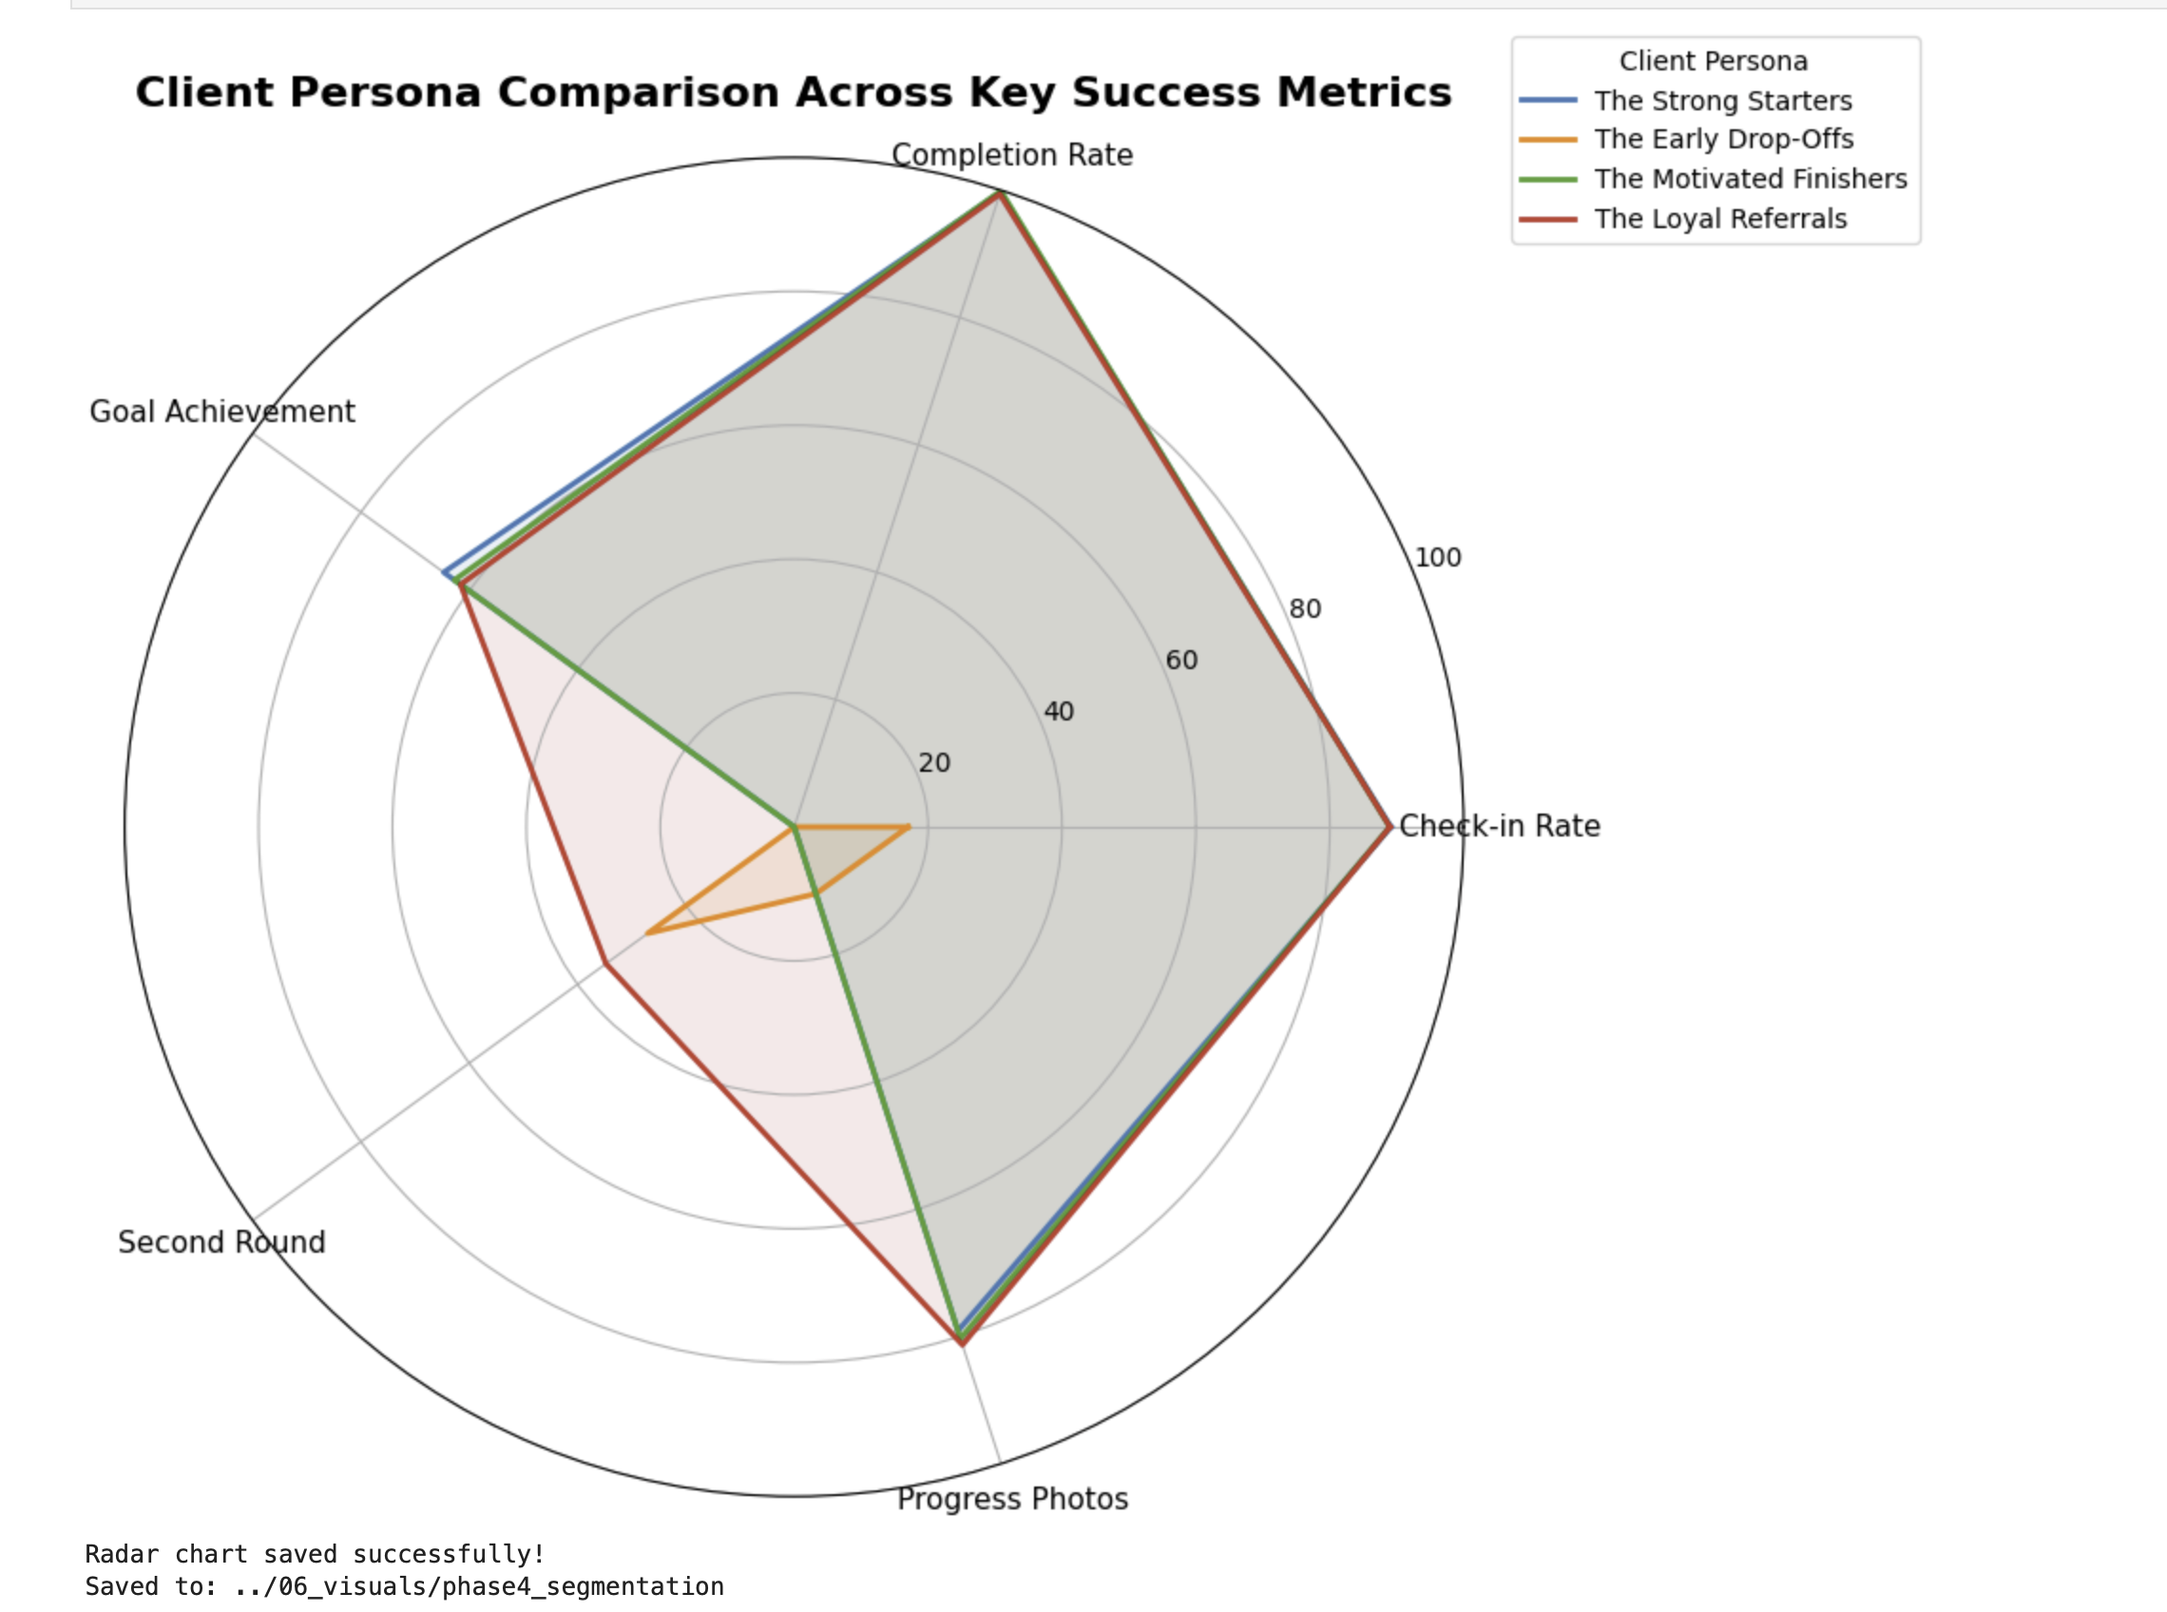

What the radar chart shows
The chart clearly confirms the persona story:

The Early Drop-Offs are the weakest segment
They have very low:
Check-in rate
Completion rate
Goal achievement
Progress photo sharing
This is the group Drishti needs to catch early.

The Loyal Referrals are highly valuable
They perform strongly across completion, check-ins, goal achievement, and progress photos. They also stand out because they have the highest second-round rate.

The Strong Starters and Motivated Finishers are strong success groups
Both show very high completion and check-in behavior. The Motivated Finishers are especially important because they are the largest successful group.

Step 9: Bar Chart — Persona Size + Completion Rate
I created a bar chart showing the size of each client persona along with its completion rate. This made it easy to compare both segment volume and success performance. The Motivated Finishers were the largest persona group, while the Early Drop-Offs were smaller but represented the highest-risk segment because they had a 0% completion rate. This visualization helps Drishti prioritize both growth opportunities and intervention needs.

The persona size and completion rate chart showed that The Motivated Finishers were the largest segment with 1,079 clients and a 99.91% completion rate. The Strong Starters and Loyal Referrals also had very high completion rates above 99%. The Early Drop-Offs were the smallest segment with 429 clients, but they had a 0% completion rate, making them the highest-priority risk group for intervention. This chart helps Drishti understand where her strongest client groups are and where she needs to take action earlier.

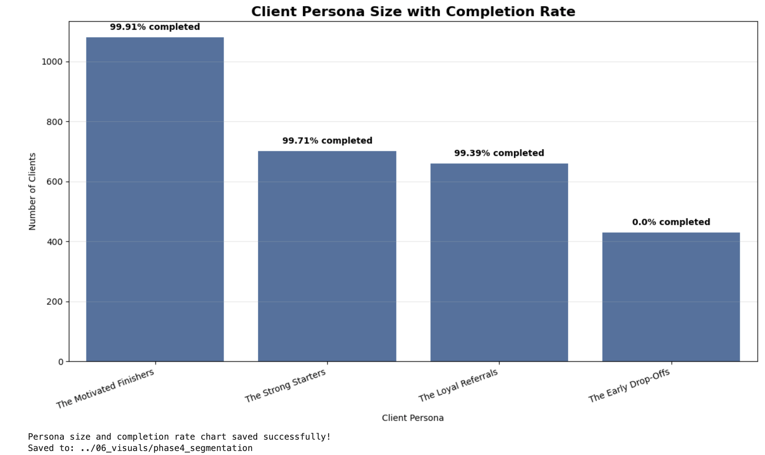

Step 10: Save Segmentation Dataset + Cluster Profile Tables
I saved the K-Means segmentation outputs as reusable CSV files. These included the segmented client-level dataset with persona labels, the persona summary table, the elbow and silhouette score results, and the PCA coordinates used for visualization. Saving these outputs makes the segmentation analysis easier to use later in Tableau, Excel, and the final portfolio report.

In Part B, I used K-Means clustering to segment 2,867 eligible clients into four business personas based on engagement, motivation, check-in behavior, payment speed, referral status, and program activity. The final personas were The Strong Starters, The Early Drop-Offs, The Motivated Finishers, and The Loyal Referrals. The analysis showed that The Early Drop-Offs are the highest-risk group because they had low check-ins, short program duration, and 0% completion. The Motivated Finishers were the largest successful group, while The Loyal Referrals were especially valuable because of their strong completion behavior and high second-round rate. These personas can help Drishti personalize follow-up, improve onboarding, target better clients, and build stronger retention and referral systems.

Phase 4 — Part C

Step 1: Compare Referred vs Non-Referred Clients
I began the Referral DNA analysis by separating clients into referred and non-referred groups. I compared both groups across completion rate, goal achievement rate, average check-in rate, second-round rate, and whether they later referred someone else. This helps evaluate whether referral clients are more valuable not only because they join through word-of-mouth, but because they may also complete more often, stay more engaged, return for another round, and generate future referrals.

What your table shows
Referred clients: 772
Non-referred clients: 2,228

Referred clients perform better
Compared to non-referred clients, referred clients have:
Completion rate: 84.84% vs 79.71%
Goal achievement rate: 52.59% vs 50.72%
Average check-in rate: 77.73% vs 73.95%
Second round rate: 35.49% vs 6.91%
Referred someone else rate: 23.06% vs 22.58%

Biggest insight
The biggest difference is second-round rate.
Referred clients are:
35.49 / 6.91 = 5.14 times more likely to do a second round
That is huge.
The referral clients are only slightly better in completion, goal achievement, check-ins, and referring someone else. But they are much more likely to return for another round.

Business meaning
Referral clients are not just good because they are cheaper to acquire. They are valuable because they are more likely to:
Complete the program
Achieve their goal
Check in more consistently
Buy again
The strongest business case for referrals is:
Referral clients create much higher repeat business.

The Referral DNA comparison showed that referred clients are more valuable than non-referred clients across several success metrics. Referred clients had a higher completion rate, higher goal achievement rate, higher average check-in rate, and a much higher second-round rate. The biggest difference was repeat behavior: referred clients had a 35.49% second-round rate compared to only 6.91% for non-referred clients, making them about 5.14 times more likely to buy again. This shows that referrals are not only a growth channel, but also a strong source of loyal clients.

Step 2: Calculate Referral Lift Automatically
I calculated referral lift to measure how much better referred clients performed compared to non-referred clients. For each success metric, I calculated the percentage-point difference, times-more-likely ratio, and percent lift. This helped quantify the business value of referrals beyond simple client count.

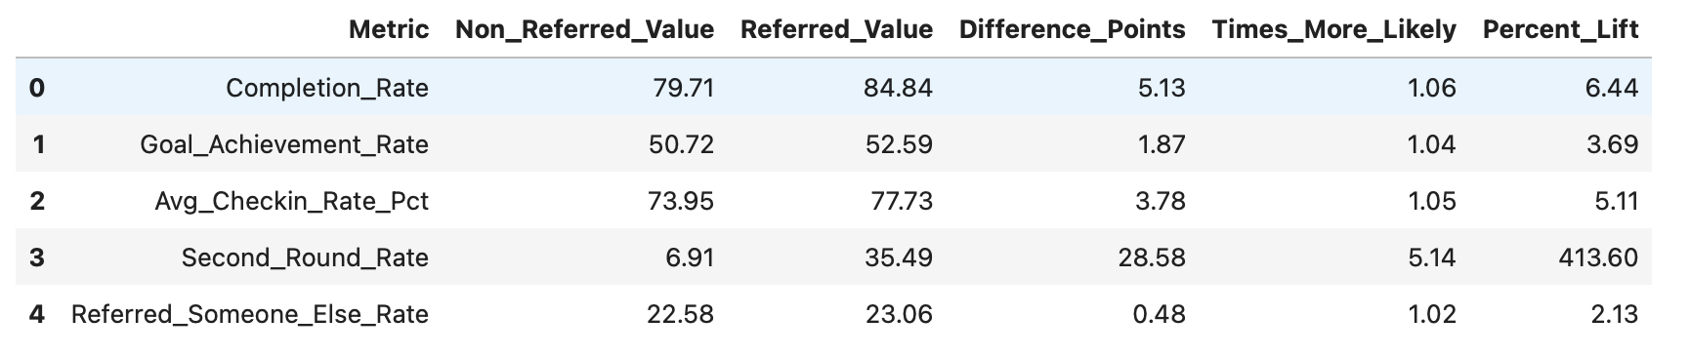

This is one of the strongest business findings in the whole project.

Referral lift interpretation
Your numbers show:
Referred clients are 1.06x more likely to complete the program.
Referred clients are 1.04x more likely to achieve their goal.
Referred clients have a 5.11% lift in check-in rate.
Referred clients are 5.14x more likely to buy a second round.
Referred clients are 1.02x more likely to refer someone else.

Biggest insight
The real referral power is not only completion.
It is repeat purchase behavior.
Referred clients have:
35.49% second-round rate
compared to non-referred clients:
6.91% second-round rate
That means referred clients are 5.14 times more likely to buy again.
That is a very strong business case for Drishti to build a formal referral program.

The referral lift analysis showed that referred clients performed better than non-referred clients across all measured success metrics. The largest difference was in second-round purchases: referred clients had a 35.49% second-round rate compared to 6.91% for non-referred clients, making them 5.14 times more likely to buy again. Referred clients also had slightly higher completion, goal achievement, check-in, and future referral rates. This shows that referrals are not only a source of new clients, but a source of more loyal and repeat clients.

Step 3: Estimate New Clients from a 10% Referral System
I estimated the potential impact of a formal referral program by assuming that every completed client has a 10% chance of referring one new client. I counted completed clients by year and multiplied them by 10% to estimate possible new referral-driven clients. This gives Drishti a simple business case for how many additional clients she could generate each year by consistently asking successful clients for referrals.
I estimated the potential client growth from a formal referral program using a simple 10% referral conversion assumption. Based on completed clients, Drishti could have generated approximately 34 new referral clients in 2022, 80 in 2023, and 129 in 2024. Since completed clients are increasing each year, the referral opportunity is also growing. In 2024 alone, a 10% referral system could have generated about 129 additional clients.

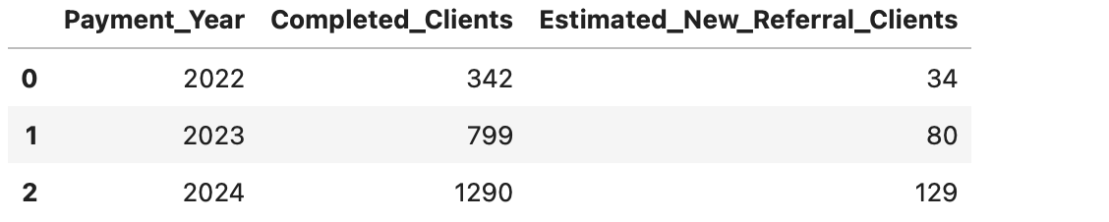

Step 4: Final Referral DNA Business Case.
The data shows that referrals are one of Drishti’s strongest business growth opportunities. Out of 3,000 clients, 772 clients came through referrals. Compared to non-referred clients, referred clients had a higher completion rate, higher goal achievement rate, higher average check-in rate, and a much stronger second-round rate. The biggest difference was repeat behavior: referred clients had a 35.49% second-round rate compared to only 6.91% for non-referred clients, making them 5.14 times more likely to buy again.
This means referrals are not only a way to bring in more clients — they bring in more loyal clients. Referred clients already enter with trust because someone they know has recommended Drishti. That trust likely makes them more willing to follow the plan, communicate consistently, and continue after the first program.
The business case is clear: Drishti should build a formal referral program around completed and successful clients. If only 10% of completed clients referred one new client, the business could have generated approximately 34 additional clients in 2022, 80 in 2023, and 129 in 2024. In 2024 alone, this could mean around 129 new clients from a simple referral system. A structured referral program could turn happy clients into a repeatable growth channel instead of relying only on organic social media discovery.

Recommended referral program actions for Drishti
- Ask for referrals immediately after a client completes the program
- Give successful clients a simple referral message they can forward to friends
- Offer a small reward such as a free follow-up call, maintenance guide, or discount on a second round
- Track who referred whom inside the client dataset
- Create a monthly “client success/referral” campaign on Instagram
- Ask referred clients what made them trust Drishti before joining
I wrote a data-backed business case for building a formal referral program. The analysis showed that referred clients are more likely to complete, achieve their goals, check in consistently, and buy a second round. Most importantly, referred clients were 5.14 times more likely to purchase a second round than non-referred clients. A simple 10% referral conversion from completed clients could have generated 129 additional clients in 2024 alone, showing that referrals can become a repeatable growth channel for Drishti.

Step 5: Save Referral DNA Tables
I saved the Referral DNA analysis outputs as reusable CSV files. These included the referred vs non-referred comparison table, referral lift analysis, estimated new referral clients by year, and the client-level referral dataset. Saving these outputs makes the referral findings easier to use later in Tableau, Excel, the final report, and the business recommendation section.

The strongest business findings were:
1,144 clients / 38.13% were ideal clients.
Ideal clients were 1.39x more likely to share progress photos.
Ideal clients were 1.21x more likely to communicate daily.
The Early Drop-Offs segment had 0% completion and needs early intervention.
The Loyal Referrals segment had the highest second-round behavior.
Referred clients were 5.14x more likely to buy a second round.
A simple 10% referral system could have generated 129 new clients in 2024.

in Phase 4, I analyzed who succeeds in Drishti’s coaching business by building an Ideal Client Profile, running K-Means client segmentation, and studying referral behavior. The analysis showed that successful clients are defined more by behavior than demographics. Ideal clients engage early, communicate daily, share progress photos, and maintain high check-in consistency. K-Means clustering identified four client personas: The Strong Starters, The Early Drop-Offs, The Motivated Finishers, and The Loyal Referrals. The Early Drop-Offs represent the highest-risk group and need early intervention, while The Loyal Referrals are highly valuable because they complete, return, and support word-of-mouth growth. Referral analysis showed that referred clients are 5.14 times more likely to purchase a second round, and a simple 10% referral system could have generated 129 additional clients in 2024.

Phase 5
I started Phase 5 by creating a new notebook for the Retention & Word of Mouth System. I imported the main Python libraries needed for data handling, visualization, and machine learning preparation. This keeps Phase 5 separate from the earlier segmentation analysis and makes the project easier to organize.
I loaded the cleaned Get Fit with Drishti dataset into the Phase 5 notebook from the cleaned data folder. This cleaned dataset will be used as the base for building the churn prediction, win-back, superfan, and engagement timing systems.

I created a churn target column for the early warning model. Clients with Status as Ghost, Inactive, or Quit were marked as churned, while Completed clients were marked as not churned. In my cleaned dataset, 569 clients churned and 2,431 clients completed the program, giving a churn rate of 18.97%.

I selected only first-week and intake-level features for the early warning churn model. This prevents data leakage because the model is not using future outcome columns such as goal achievement, check-in rate, second-round purchase, dropout details, or final results. The final feature set contains 15 early-stage client variables that Drishti can know before or during the first week of coaching.

I checked the selected first-week model features for missing values before preparing the churn model. This step confirms that the input data is clean enough for preprocessing, encoding, scaling, and model training.
The selected model features had missing values only in Health_Condition. I treated these missing values as clients with no reported health condition and replaced them with “No Condition.” This keeps the information meaningful without dropping valid clients from the dataset.
The selected model features had missing values only in Health_Condition. I treated these missing values as clients with no reported health condition and replaced them with “No Condition.” After this fix, all first-week model features had zero missing values and were ready for preprocessing.
I separated the selected first-week features into numeric and categorical groups. Numeric features such as age, goal gap, payment speed, and first engagement timing will be scaled, while categorical features such as gender, country, goal type, diet type, lead source, health condition, and motivation level will be encoded for machine learning.
I created a preprocessing pipeline for the churn model. Numeric features will be scaled so they are treated fairly by the model, and categorical features will be one-hot encoded so text-based client information can be used in machine learning. This preprocessing setup keeps the model workflow clean and reusable.
I created an 80/20 stratified train-test split for the churn prediction model. The training set contains 2,400 clients and the testing set contains 600 clients. Stratification kept the churn rate almost equal in both sets, with about 19% churned clients and 81% completed clients.
I applied preprocessing to the training and testing datasets. Numeric features were scaled, and categorical features were one-hot encoded into machine-readable columns. The 15 original first-week features became 44 processed model columns. I fit the preprocessing only on the training data and then applied the same rules to the testing data to avoid data leakage.
I handled class imbalance in the churn model using SMOTE. Since churned clients were fewer than completed clients, SMOTE created synthetic churn examples in the training data so the model could learn churn patterns more effectively. I applied SMOTE only to the training data and kept the testing data unchanged to make evaluation realistic. I used SMOTE because churned clients were fewer than completed clients. Without balancing, the model could mostly learn to predict completed clients and miss the clients who are actually at risk. SMOTE created synthetic churn examples in the training data so the model could better learn early warning patterns.

I trained the first churn prediction model using Logistic Regression. This model acts as a simple and explainable baseline for predicting whether a client may churn based on first-week and intake information. I trained it using the SMOTE-balanced training data so the model could learn from both completed and churned client patterns.

I evaluated the Logistic Regression churn model on the untouched test dataset. I measured accuracy, precision, recall, F1 score, and AUC-ROC. For this business problem, recall is especially important because the goal is to catch as many at-risk clients as possible before they drop out, even if that means reviewing a few extra clients.
The Logistic Regression model achieved 72.67% accuracy, 36.26% precision, 57.89% recall, 44.59% F1 score, and 73.13% AUC-ROC. Since this project focuses on early churn prevention, recall is the most important metric because it shows how many at-risk clients the model successfully catches before they drop out.
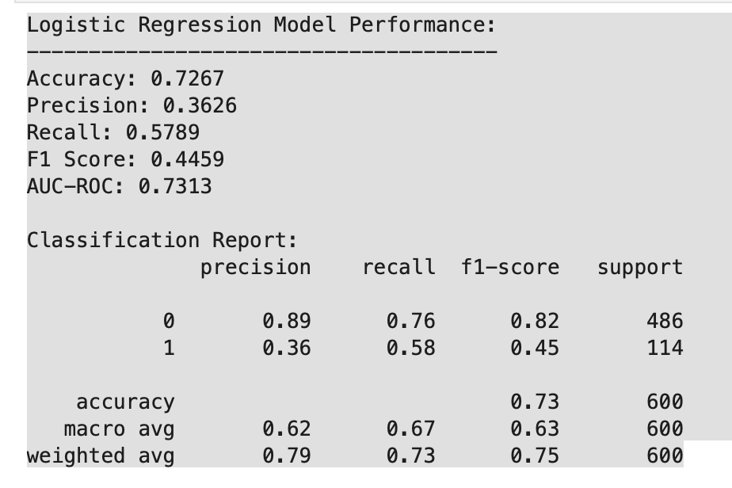

I trained the second churn prediction model using Random Forest. This model uses multiple decision trees to capture more complex churn patterns than Logistic Regression. I trained it on the SMOTE-balanced training data and used balanced class weights so churned clients remained important during model learning.
I evaluated the Random Forest churn model on the untouched test dataset using accuracy, precision, recall, F1 score, and AUC-ROC. This allowed me to compare it against the Logistic Regression baseline and see whether a more advanced model can better identify clients at risk of dropping out.
For Drishti’s business, this matters because:
- Logistic Regression catches more at-risk clients.
- Random Forest is more accurate when it does flag someone.
Since this project is about early intervention, we still care heavily about recall.
The Random Forest model achieved 84.33% accuracy, 63.16% precision, 42.11% recall, 50.53% F1 score, and 80.03% AUC-ROC. Compared to Logistic Regression, Random Forest had stronger overall accuracy, precision, F1 score, and AUC-ROC, but lower recall. This means it was better at making confident churn predictions but missed more actual churned clients.
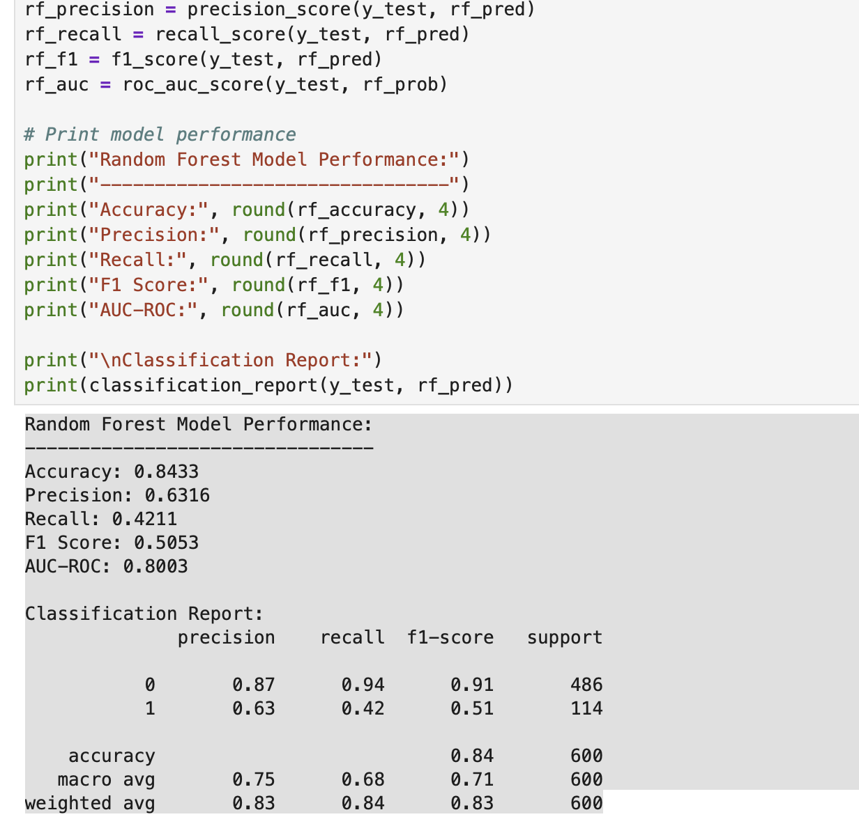
I trained the third churn prediction model using XGBoost. XGBoost is a boosting-based model that learns step by step by correcting previous mistakes. I trained it on the SMOTE-balanced training data so it could learn both completed and churned client behavior patterns.
I evaluated the XGBoost churn model on the untouched test dataset using accuracy, precision, recall, F1 score, and AUC-ROC. This helped compare XGBoost against Logistic Regression and Random Forest to decide which model is most useful for Drishti’s early warning churn system.
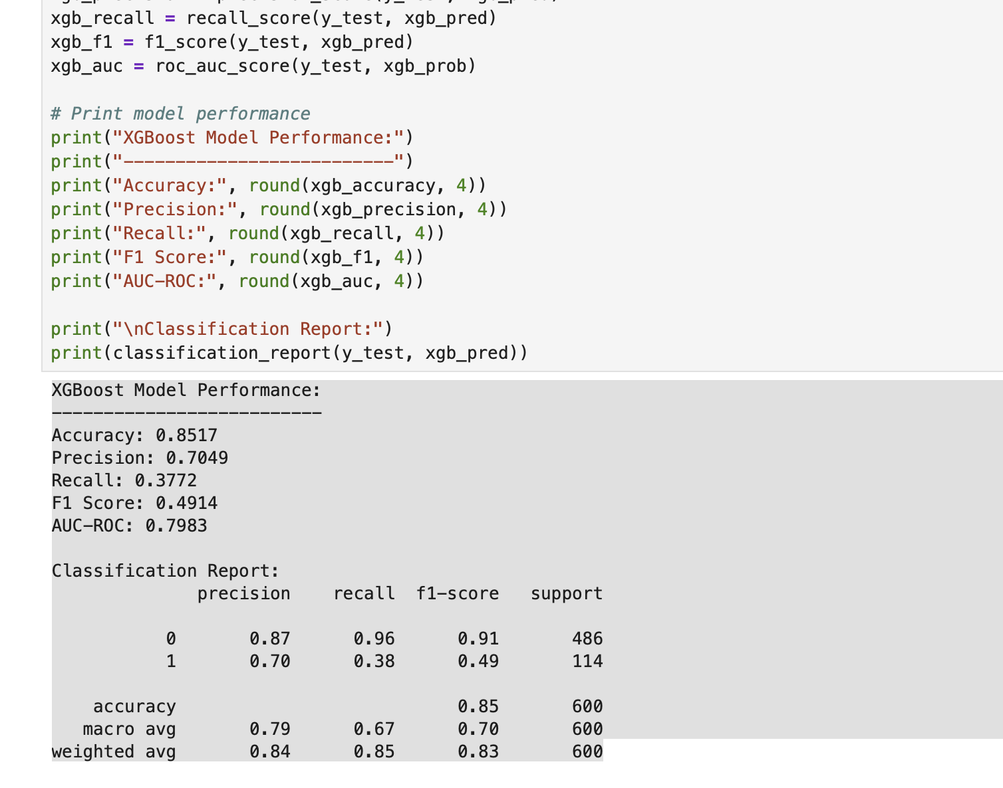
I evaluated the XGBoost churn model on the untouched test dataset using accuracy, precision, recall, F1 score, and AUC-ROC. This helped compare XGBoost against Logistic Regression and Random Forest to decide which model is most useful for Drishti’s early warning churn system.

I compared Logistic Regression, Random Forest, and XGBoost in one model performance table using accuracy, precision, recall, F1 score, and AUC-ROC. I sorted the comparison by recall because the main business goal is to catch at-risk clients early enough for Drishti to intervene before they drop out.
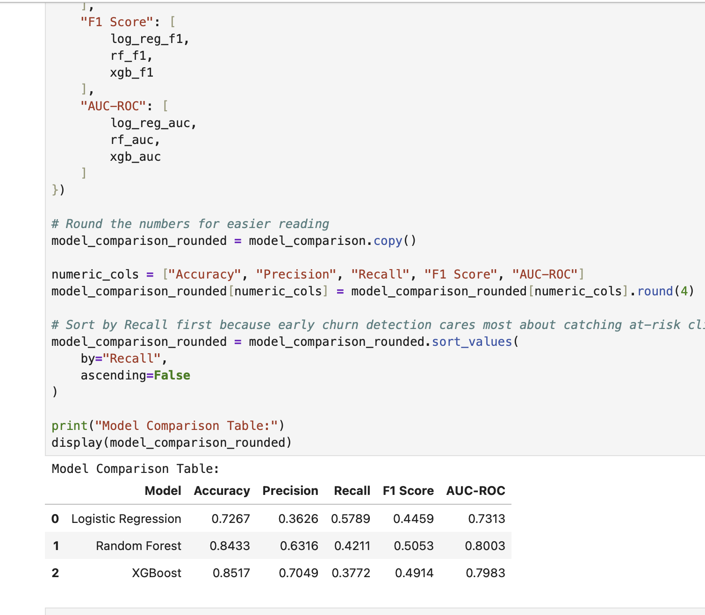
I compared Logistic Regression, Random Forest, and XGBoost in one performance table. Logistic Regression had the highest recall at 57.89%, Random Forest had the strongest F1 score at 50.53%, and XGBoost had the highest accuracy and precision. Since the goal of this system is early churn prevention, recall is the most important metric because it shows how many actual at-risk clients the model catches.
I selected Logistic Regression as the best model for the early warning churn system because it had the highest recall at 57.89%. Even though Random Forest and XGBoost had higher accuracy and precision, Logistic Regression caught more of the clients who actually churned. For Drishti’s business, this is more useful because the goal is to identify at-risk clients early and take supportive action before they drop out. I selected Logistic Regression as the best model for the early warning churn system because it had the highest recall at 57.89%. Even though Random Forest and XGBoost had higher accuracy and precision, Logistic Regression caught more of the clients who actually churned. For Drishti’s business, this is more useful because the goal is to identify at-risk clients early and take supportive action before they drop out.

I extracted the final processed feature names after scaling and one-hot encoding. This step is needed because the original 15 first-week features were transformed into 44 model-ready columns, and these names will help explain which churn signals are most important. I extracted the final processed feature names after scaling and one-hot encoding. This step is needed because the original 15 first-week features were transformed into 44 model-ready columns, and these names will help explain which churn signals are most important.

I analyzed the Logistic Regression coefficients to identify the strongest early churn signals. Positive coefficients indicate factors that increase churn risk, while negative coefficients indicate factors that reduce churn risk. This helps translate the model into practical business insights Drishti can use during the first week of coaching. I analyzed the Logistic Regression coefficients to identify the strongest early churn signals. The strongest signal was Days_To_First_Engagement, meaning clients who take longer to respond or engage early are more likely to churn. Other important churn risk signals included shift work schedule, low starting motivation, PCOS, and occasional exercise history. This helps turn the model output into practical coaching actions.
The top three churn signals from the selected model were delayed first engagement, shift work schedule, and low starting motivation. In business terms, this means clients are more likely to drop out when they do not engage quickly, have unstable daily routines, or begin the program with low motivation. These signals can help Drishti identify which new clients need extra support in the first week.
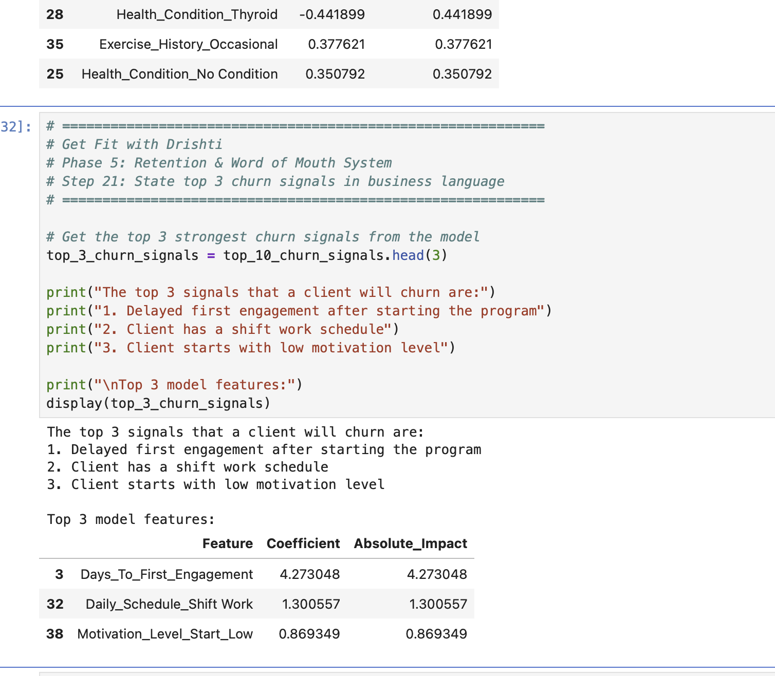

Business interpretation
The model found that clients are more likely to churn when:
1. They take longer to engage after starting.
2. They have shift work schedules.
3. They begin with low motivation.
This makes sense for Drishti’s business.
Clients with delayed engagement may already be mentally disconnected. Shift workers may struggle with routine, meal timing, sleep, and check-ins. Low motivation clients may need stronger emotional support early. The top three churn signals from the selected model were delayed first engagement, shift work schedule, and low starting motivation. In business terms, this means clients are more likely to drop out when they do not engage quickly, have unstable daily routines, or begin the program with low motivation. These signals can help Drishti identify which new clients need extra support in the first week.

I visualized ROC curves for Logistic Regression, Random Forest, and XGBoost to compare how well each model separates churned clients from completed clients. Random Forest and XGBoost had stronger overall AUC scores, while Logistic Regression remained the best choice for the business use case because it caught the highest number of actual churned clients.
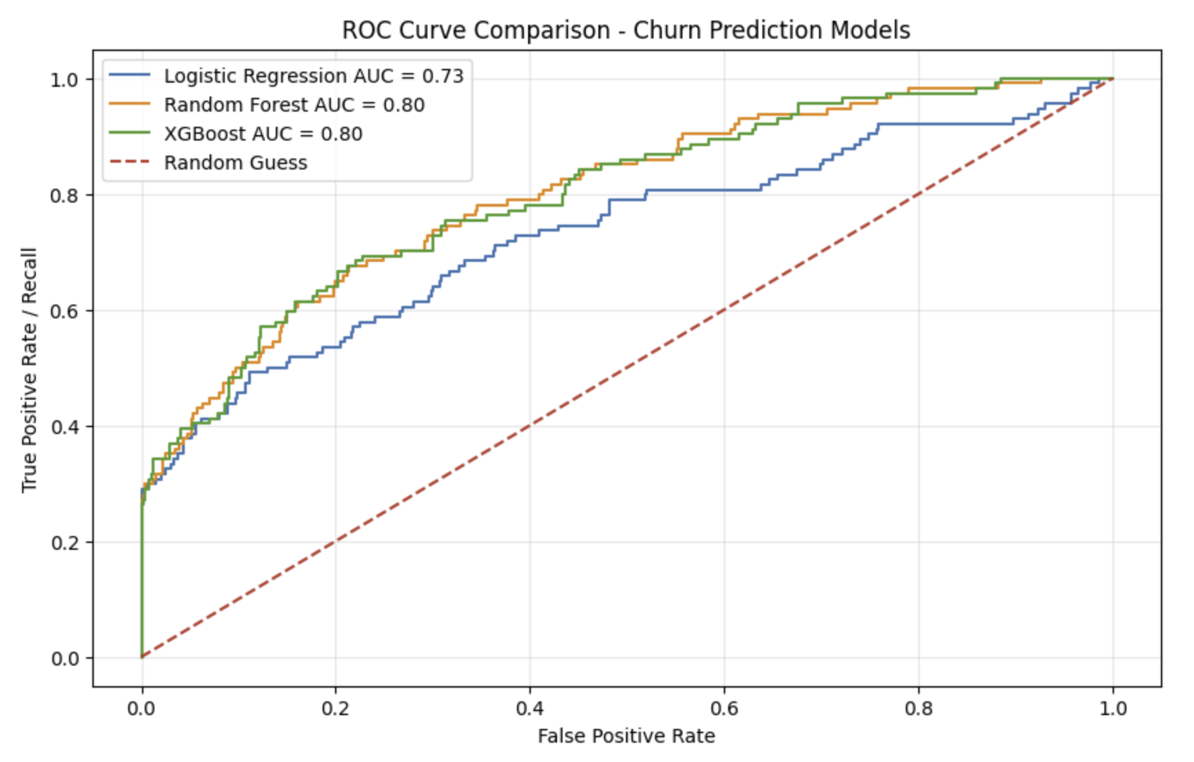

How to read this chart
- The higher the curve goes toward the top-left, the better.
- AUC closer to 1.0 is better.
- AUC around 0.5 means the model is close to random guessing.
- Random Forest and XGBoost should look stronger overall by AUC.
- Logistic Regression is still useful because it had the highest recall.
I visualized ROC curves for Logistic Regression, Random Forest, and XGBoost to compare how well each model separates churned clients from completed clients. Random Forest and XGBoost had stronger AUC scores, showing better overall separation. However, Logistic Regression remained the selected business model because it had the highest recall and caught the most actual churned clients.

I created a confusion matrix for the selected Logistic Regression model to understand its predictions in more detail. The confusion matrix shows how many completed clients and churned clients were correctly or incorrectly classified. This is useful because the business goal is to reduce missed churned clients and identify at-risk clients early enough for Drishti to intervene.
I created a confusion matrix for the selected Logistic Regression model to understand its predictions in more detail. The confusion matrix shows how many completed clients and churned clients were correctly or incorrectly classified. This is useful because the business goal is to reduce missed churned clients and identify at-risk clients early enough for Drishti to intervene. The confusion matrix showed that the Logistic Regression model correctly identified 370 completed clients and 66 churned clients in the test set. It missed 48 churned clients and incorrectly flagged 116 completed clients as churn risks. From a business perspective, the model is useful because it caught 66 out of 114 actual churned clients, giving Drishti a chance to intervene early.

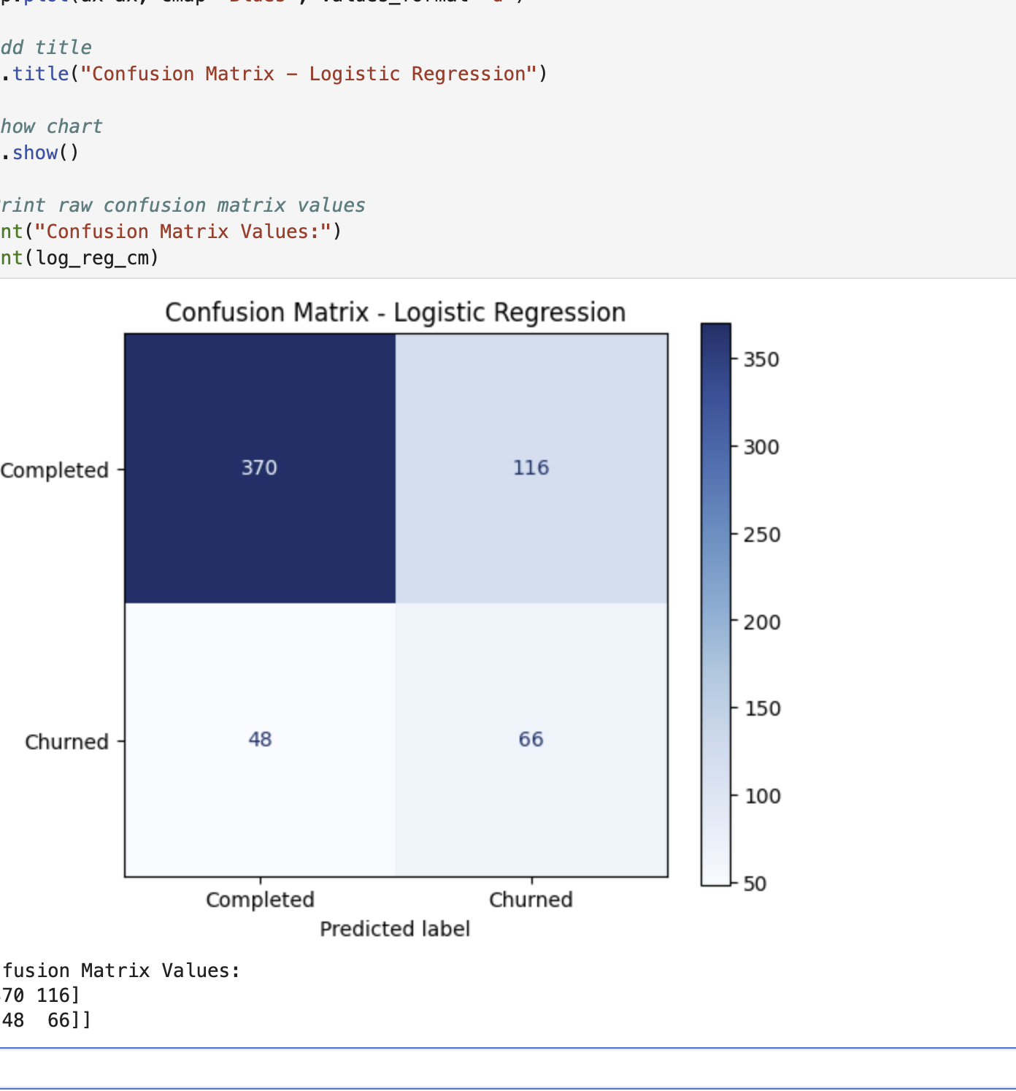

I created a feature importance chart for the top 10 churn signals from the selected Logistic Regression model. This chart shows which first-week client factors had the strongest impact on churn prediction. The strongest signal was Days_To_First_Engagement, showing that delayed early engagement is the biggest warning sign for possible dropout. I created a feature importance chart for the top 10 churn signals from the selected Logistic Regression model. The chart showed that Days_To_First_Engagement was the strongest early churn signal, meaning delayed client response or engagement is the biggest warning sign. This insight is practical because Drishti can monitor new clients closely during the first few days and intervene early.

What this chart shows
The strongest early churn signal is clearly:
Days_To_First_Engagement
That means early response behavior is the biggest warning sign in your model.
The next strongest signals are:
Shift Work schedule
Low starting motivation
Flexible schedule
Homemaker schedule
PCOS
Important reminder: this chart shows strength, not whether the feature increases or decreases churn. For direction, we use the coefficient table from Step 20.

I built a reusable new-client risk-checking function for Drishti’s early warning system. The function takes first-week client information, applies the same preprocessing used during model training, predicts churn probability using the selected Logistic Regression model, and returns a risk level with one recommended action. This turns the machine learning model into a practical weekly business tool.

I tested the new-client risk-checking function using three example clients with different risk profiles. The function returned a churn probability, risk level, and recommended action for each client. This confirmed that the churn model can be turned into a practical tool Drishti can use after intake calls or during the first week of coaching. I tested the new-client risk-checking function using three example clients with different risk profiles. The function correctly returned high, medium, and low risk levels with churn probabilities of 98.11%, 42.55%, and 5.32%. Each result also included a specific recommended action, confirming that the churn model can be used as a practical early warning tool for Drishti’s weekly client management. Business meaning
Drishti can now enter a new client’s first-week information and get:
- Risk level
- Churn probability
- One immediate action
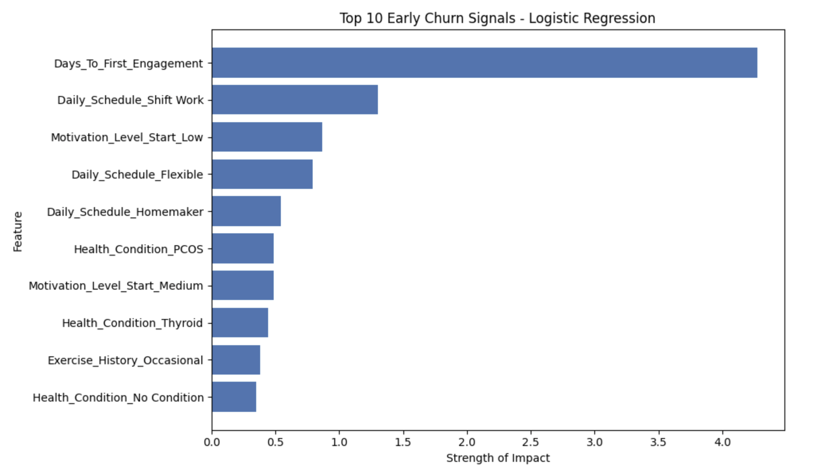
I saved the selected churn prediction model, preprocessing pipeline, feature column list, model comparison table, and top churn signal table into the Phase 5 output folder. This makes the churn system reusable because the model and preprocessing steps can be loaded later without retraining from scratch. I saved the selected churn prediction model, preprocessing pipeline, feature column list, model comparison table, and top churn signal table into the Phase 5 output folder. This makes the churn system reusable because the model and preprocessing steps can be loaded later without retraining from scratch.

I saved the example new-client risk-checking results into a CSV file. The saved table includes high, medium, and low risk examples with churn probabilities and recommended actions. This output demonstrates how the model can be used as a practical early warning tool for Drishti’s weekly client management.

Why this step matters
This gives you a clean output file that proves the churn model can be used like a real tool.
Final report
Portfolio screenshots
Tableau dashboard
Business recommendation section

I saved the example new-client risk-checking results into a CSV file. The saved table includes high, medium, and low risk examples with churn probabilities and recommended actions. This output demonstrates how the model can be used as a practical early warning tool for Drishti’s weekly client management.

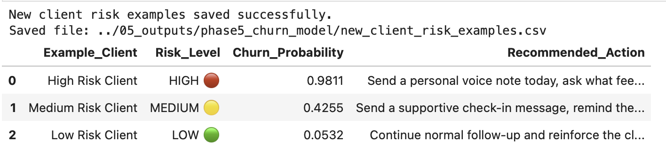

I created a final summary table for Part A of Phase 5. The table summarizes the churn model goal, target variable, selected model, key performance metrics, top churn signals, and the weekly business use case. This gives a clear business-ready overview of the early warning churn system.

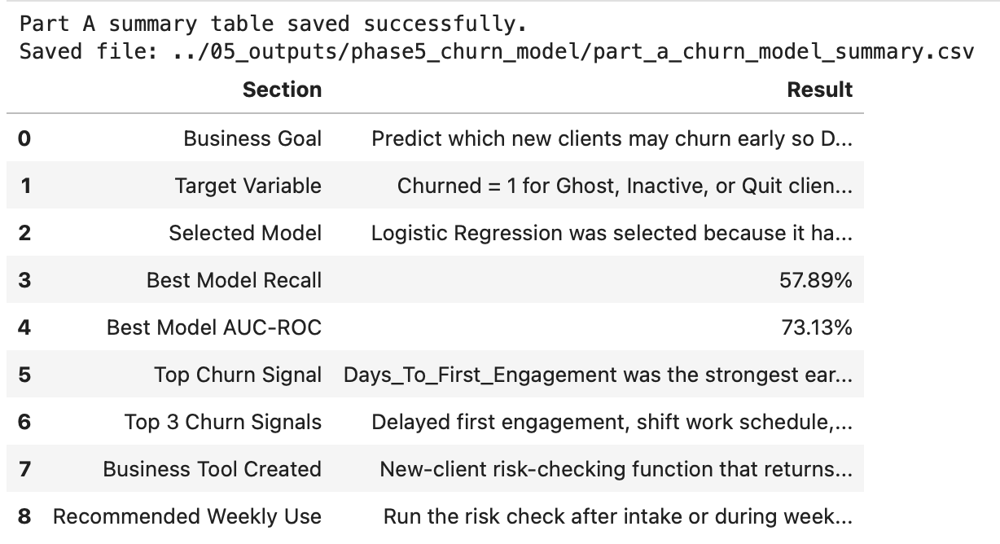

Phase 5-part B
I started Phase 5 Part B by creating a corrected dropout-only analysis table. I loaded the cleaned dataset, selected the important dropout and return columns, and filtered only clients who had a real return status after dropping out. I used Returned_After_Drop instead of Dropout_Day because non-dropout clients had Dropout_Day filled as 0 in the cleaned dataset. This step created a reliable base table for calculating the win-back rate and analyzing why clients return, how long they take, and what follow-up actions Drishti should use. In Phase 5 Part B, I created a corrected dropout-only analysis table for the Win-Back Playbook. I filtered the dataset using Returned_After_Drop because true dropout clients had either “Yes” or “No” in this column. This gave 323 actual dropout clients, with 230 returning and 93 not returning, resulting in a 71.21% win-back rate. This confirmed that many dropped clients can still be recovered, making win-back follow-up an important business opportunity for Drishti.

I analyzed the return triggers for clients who dropped out and later came back. I separated the returned clients from the dropout table, counted each return trigger, calculated its percentage, and visualized the results in a bar chart. This helps identify what type of message or content is most effective for bringing dropped clients back into the program.
I analyzed the return triggers for clients who dropped out and later came back. Out of 230 returned clients, 179 (77.83%) returned after seeing other clients’ progress, while 51 (22.17%) returned after a personal motivation reset. This shows that social proof is the strongest win-back driver, meaning Drishti can improve re-engagement by sending dropped clients transformation stories, progress updates, and real client success examples.
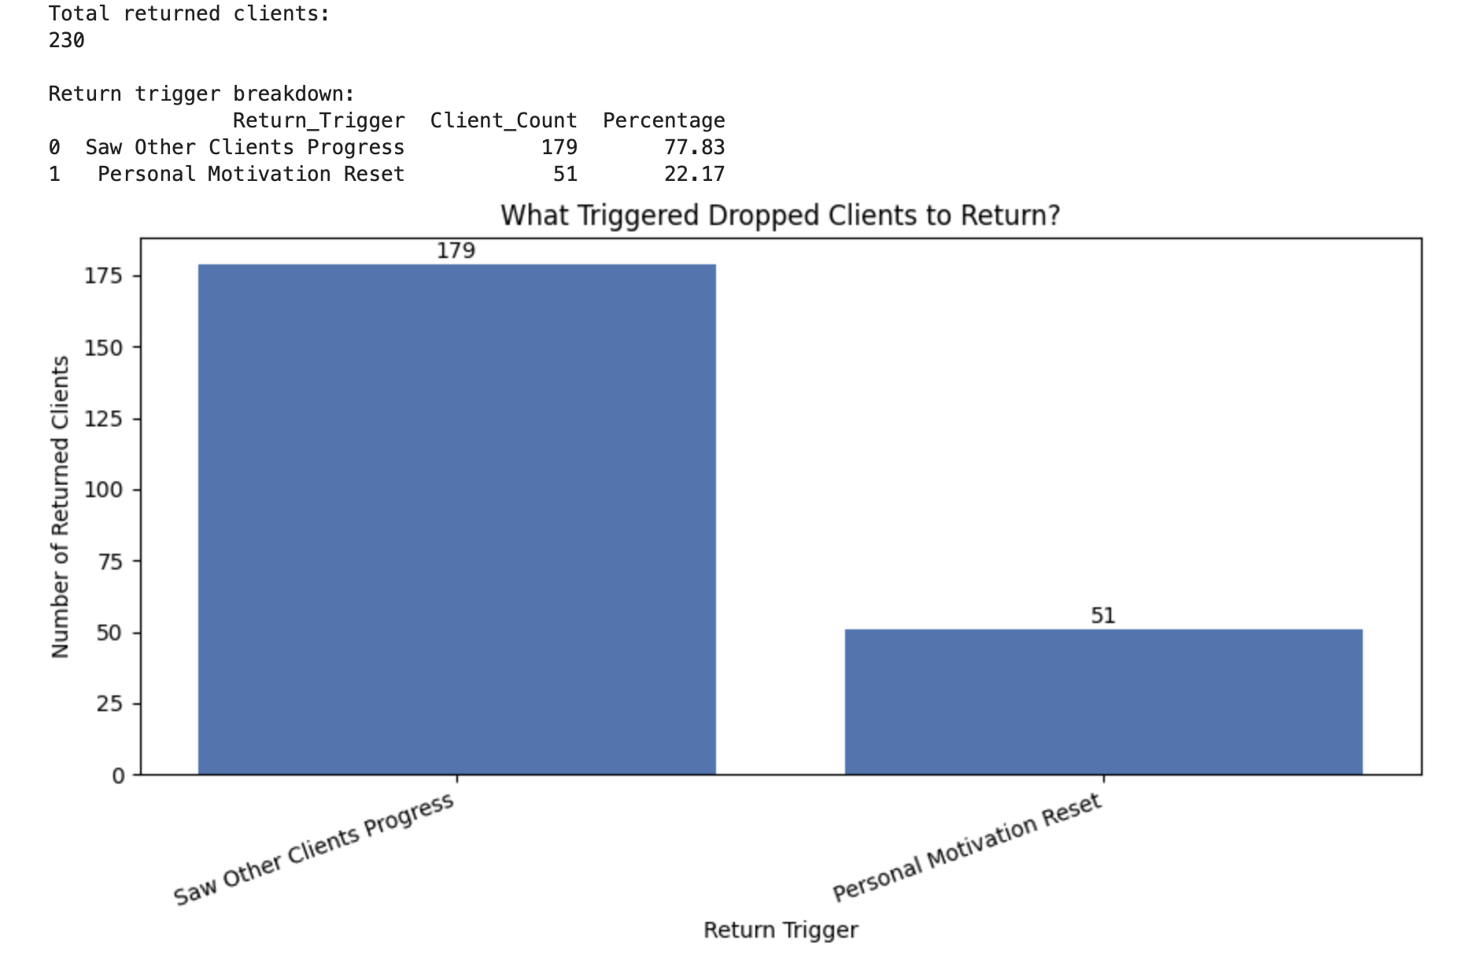
I analyzed how long dropped clients usually take to return after leaving the program. I calculated the average, median, and most common return time, then created a week-by-week distribution chart. This helps convert the win-back process into a timed follow-up system, so Drishti knows when dropped clients are most likely to respond and come back.
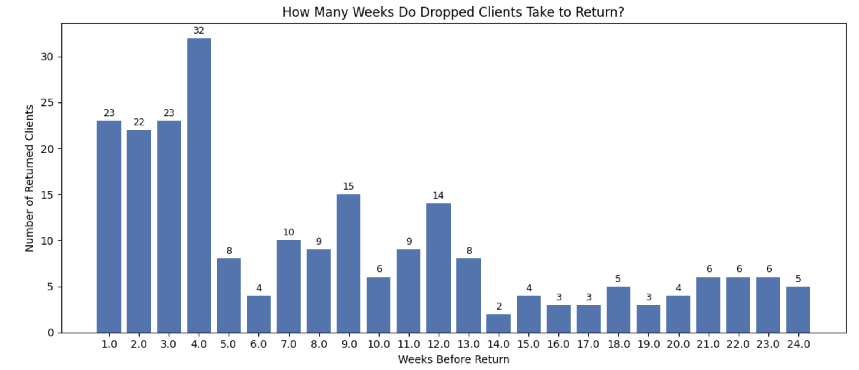
I analyzed how long dropped clients usually take to return after leaving the program. The average return time was 8.55 weeks, the median was 7 weeks, and the most common return point was Week 4. The strongest recovery window was within the first 4 weeks, where 100 out of 230 returned clients came back. This shows that Drishti should use a structured win-back follow-up system during the first month after dropout instead of waiting too long.

I compared goal achievement between clients who returned after dropping out and clients who never dropped. I treated both full and partial goal achievement as success because health and fitness progress is not always all-or-nothing. This comparison helps show whether win-back clients can still get meaningful results after returning, which supports the business value of having a structured follow-up system.

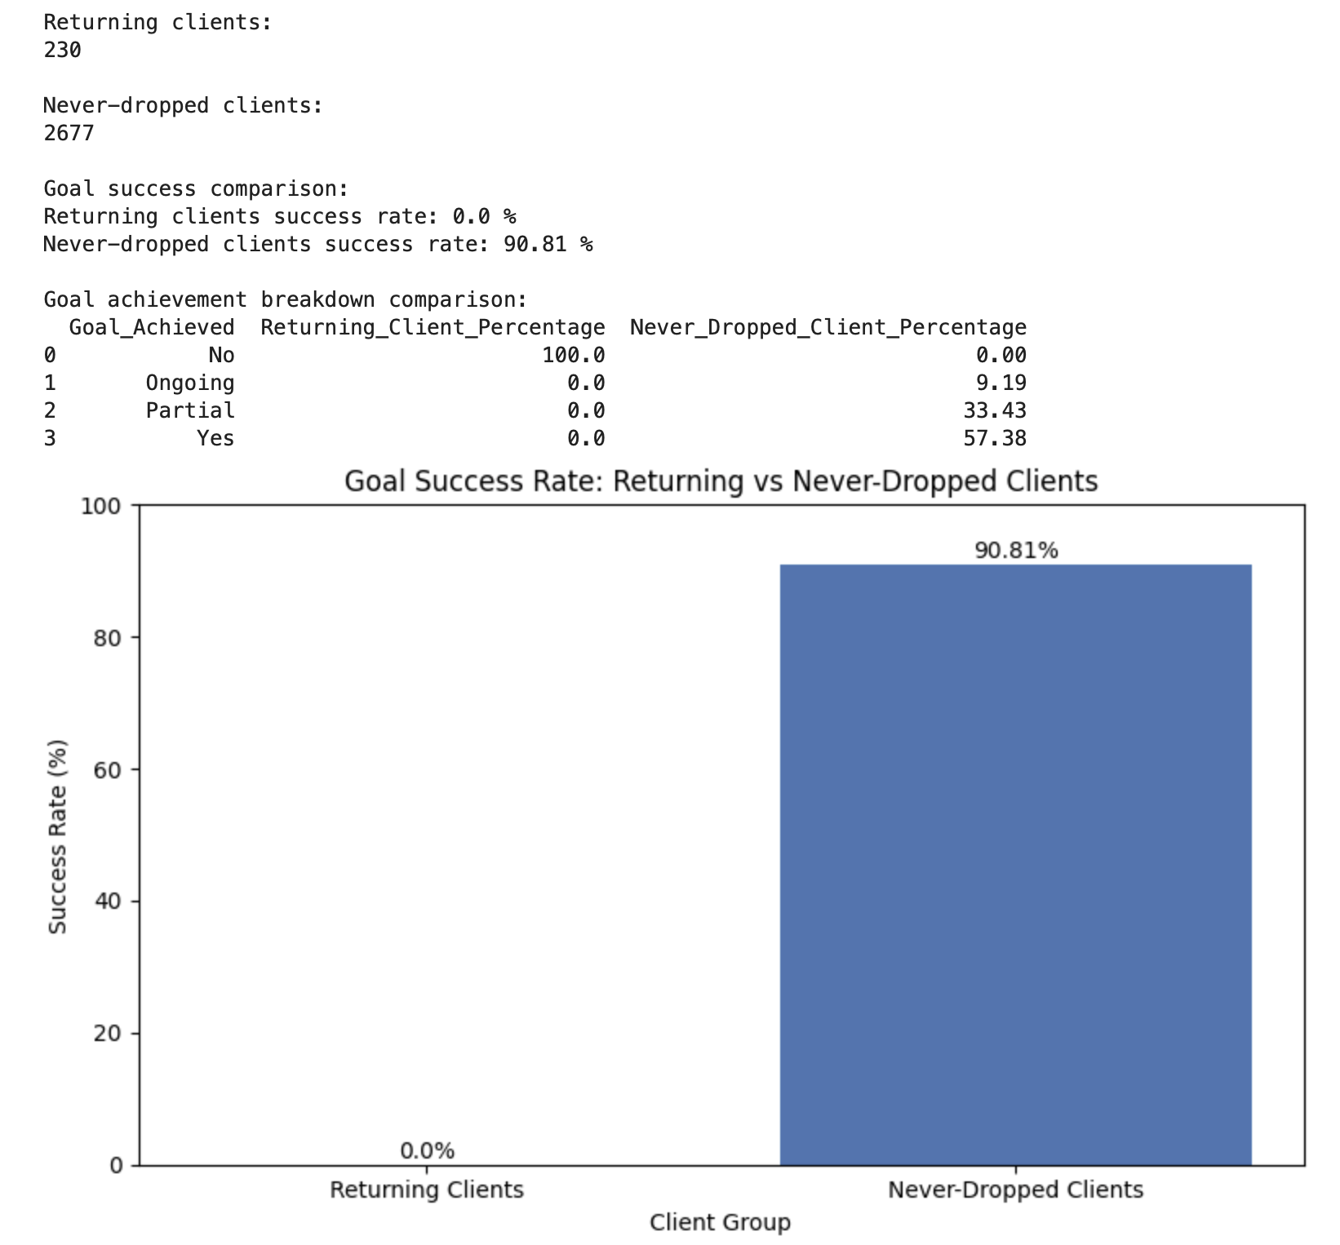

I noticed an important data quality/business interpretation issue while comparing returning clients with never-dropped clients. The initial result showed that returned clients had a 0% goal success rate, which may mean either returning clients did not complete successfully after coming back or the dataset does not update final goal achievement after return. I ran a validation check before making the final business conclusion. I noticed an important data quality/business interpretation issue while comparing returning clients with never-dropped clients. The initial result showed that returned clients had a 0% goal success rate, which may mean either returning clients did not complete successfully after coming back or the dataset does not update final goal achievement after return. I ran a validation check before making the final business conclusion.
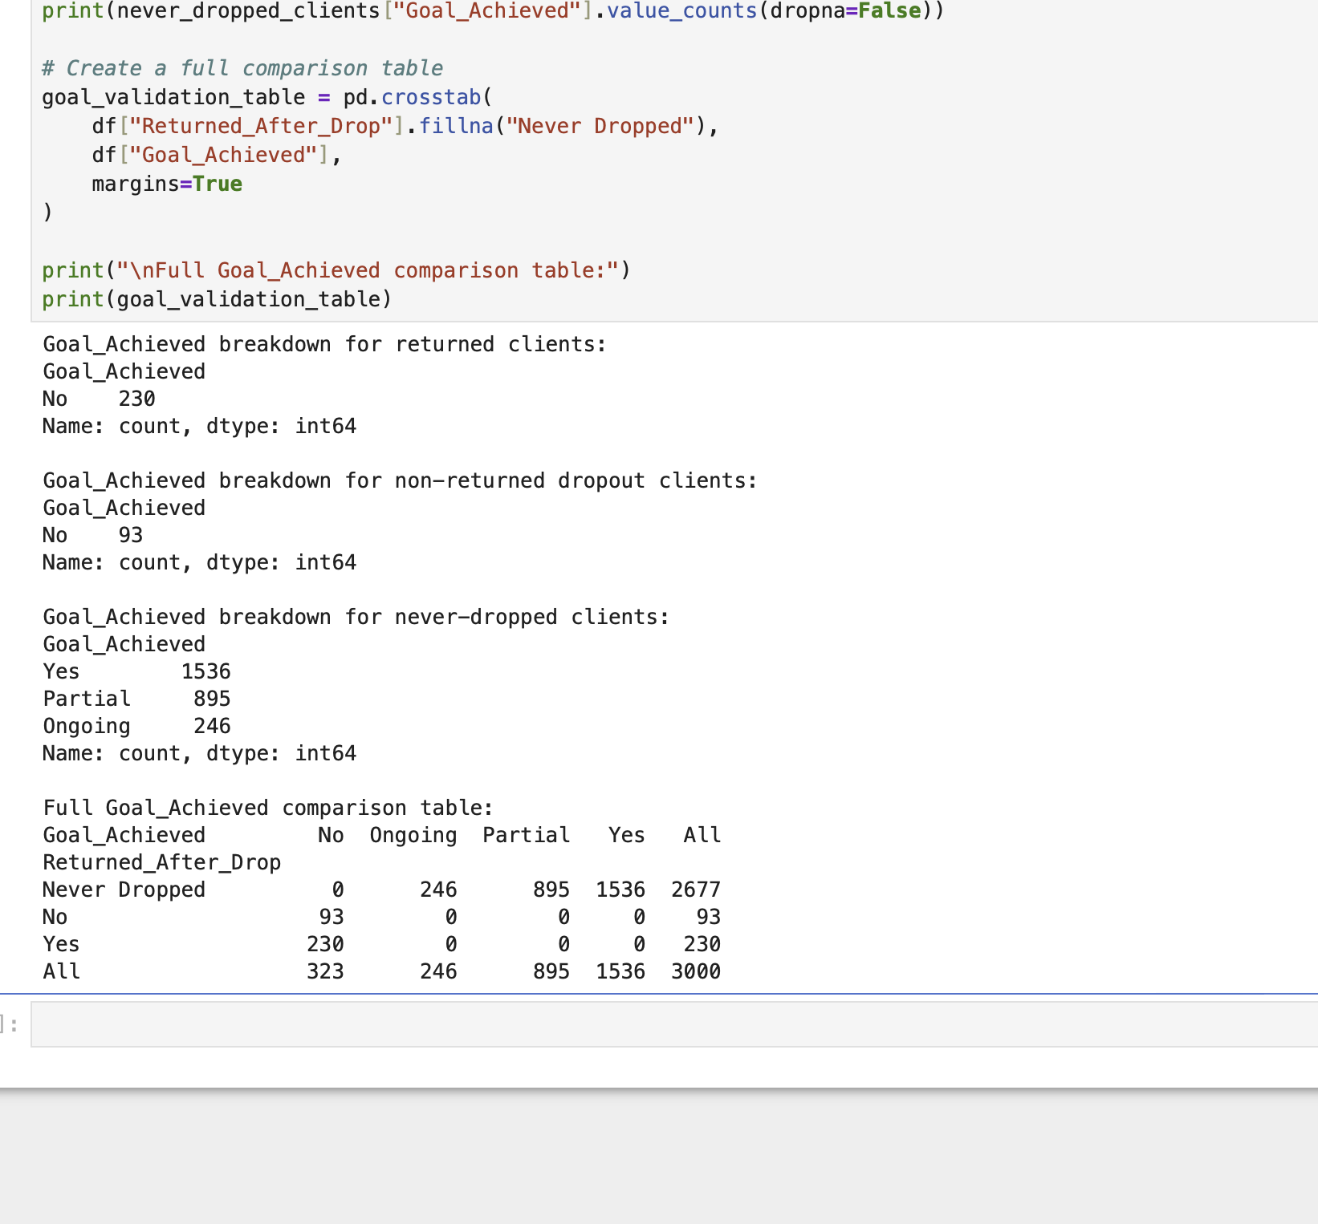

I analyzed win-back rate by dropout reason using only clients who had a recorded dropout reason. I calculated the total number of dropouts, returned clients, non-returned clients, and win-back percentage for each reason. This helps turn the win-back system into a more personalized playbook, where Drishti can choose the right follow-up message based on why the client originally dropped out.

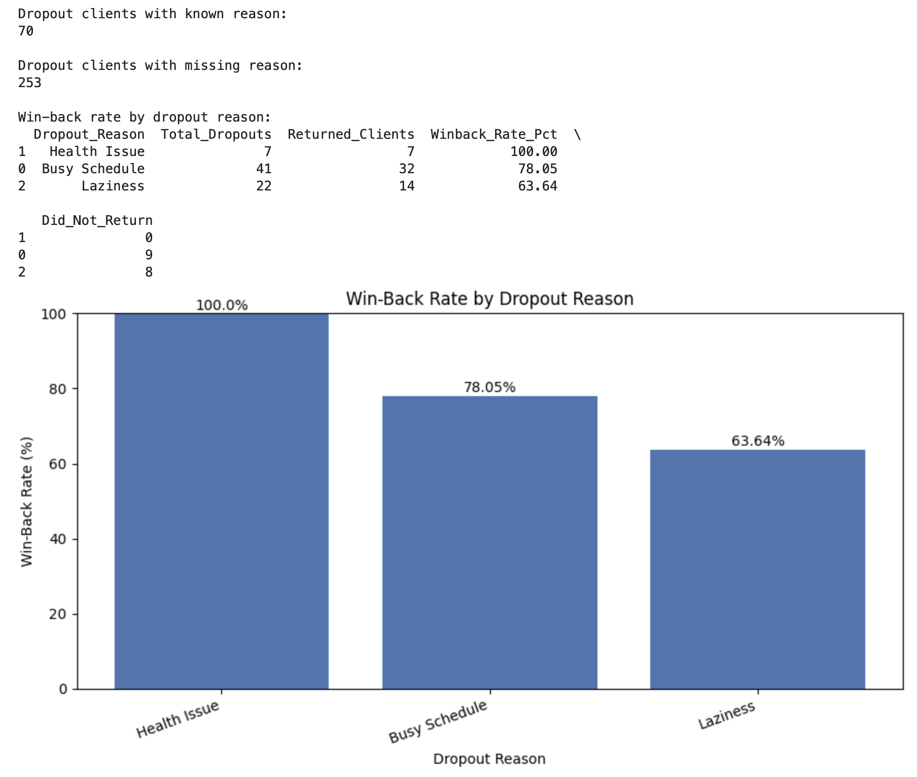

I analyzed win-back rate by dropout reason using only clients who had a recorded dropout reason. I calculated the total number of dropouts, returned clients, non-returned clients, and win-back percentage for each reason. This helps turn the win-back system into a more personalized playbook, where Drishti can choose the right follow-up message based on why the client originally dropped out.

Business meaning
The highest win-back rate is Health Issue, but it has only 7 clients, so we should be careful and not overclaim.
The strongest practical insight is:
Busy Schedule is the most important win-back category because it has the highest volume and still a strong return rate.
That means many busy clients are not lost forever. They may just need a simpler, flexible restart plan.
For “Laziness,” the return rate is lower, so those clients may need stronger accountability, emotional support, and smaller first steps.

I created a printable Win-Back Playbook decision table that connects each dropout reason to the correct follow-up action. The table includes total dropouts, returned clients, win-back rate, typical return time, success after return, recommended message type, and business priority note. This converts the analysis into a practical weekly tool Drishti can use to respond faster and more personally when clients drop out.
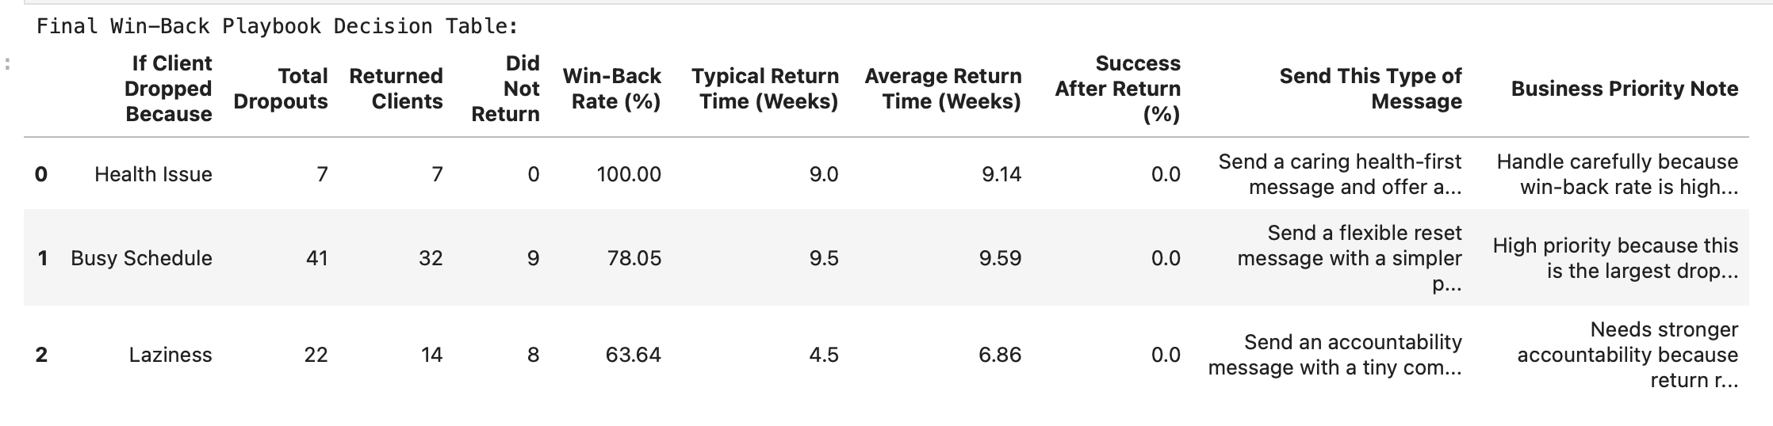
I built the final Win-Back Playbook decision table by combining dropout reason, returned client count, win-back rate, typical return time, success after return, recommended message type, and business priority notes. This table turns the analysis into a practical tool Drishti can use when a client drops out. The biggest opportunity is Busy Schedule clients because they have the highest dropout volume and a strong 78.05% win-back rate. However, success after return was 0% in the dataset, which shows that the business needs a stronger comeback plan after clients return.

Business meaning
The playbook is useful because it gives Drishti a clear action plan based on dropout reason.
The biggest practical opportunity is Busy Schedule because it has the largest number of known dropouts and a strong win-back rate.
The biggest caution is that Success After Return is 0% in the current dataset, so the playbook should not only bring clients back. It should help them restart properly with a stronger comeback plan.

I saved the Phase 5 Part B outputs into a dedicated win-back playbook folder. The saved files include the final printable playbook, return trigger breakdown, return timing distribution, and win-back rate by dropout reason. This makes the analysis reusable for the dashboard, final report, and weekly business decision-making.

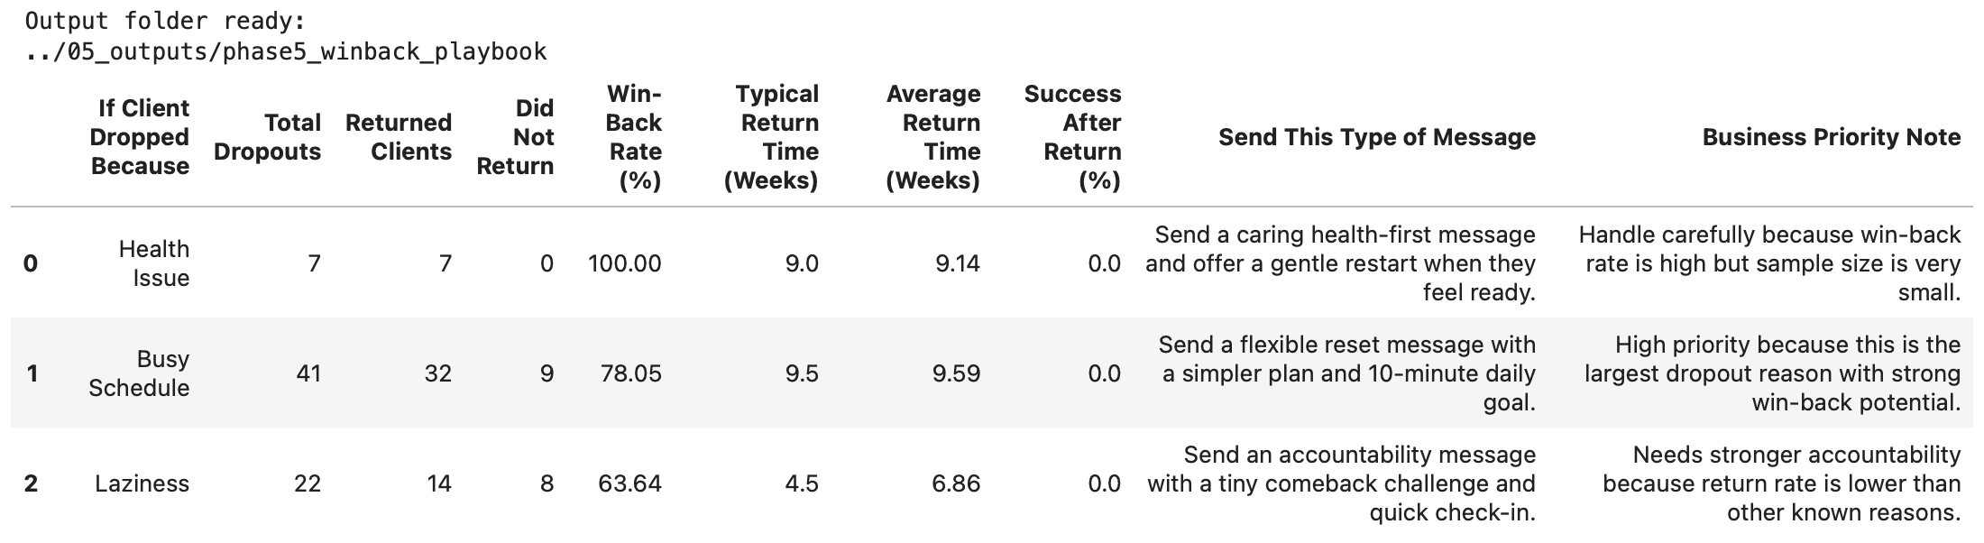
In Phase 5 Part B, I built a Win-Back Playbook to understand why dropped clients return and how Drishti can bring them back more effectively. I created a corrected dropout-only table with 323 dropped clients and confirmed that 230 returned, giving a 71.21% win-back rate. I found that 77.83% of returned clients came back after seeing other clients’ progress, showing that social proof is the strongest return trigger. I also analyzed return timing and found that many clients return within the first 4 weeks, making this the best follow-up window. By dropout reason, Busy Schedule was the biggest practical opportunity because it had the largest known dropout volume and a 78.05% win-back rate. Finally, I created and saved a printable decision table that recommends specific follow-up messages based on each dropout reason. One major insight was that returned clients still had 0% recorded goal success, so Drishti needs a stronger comeback/reset plan after clients return, not just a win-back message.

PART C
I started Phase 5 Part C by building a Superfan Score for every client. The score combines goal achievement, check-in behavior, progress photo sharing, second round signup, and whether the client referred someone else. I also created a Referred_Someone flag by checking whether each client’s ID appeared as a referrer for another client. This score helps identify which clients are strongest word-of-mouth promoters and separates clients into Superfan, Happy, Neutral, and At Risk groups.
created a Superfan Score for every client to measure word-of-mouth potential. The score combines goal achievement, check-in rate, progress photo sharing, second round signup, and whether the client referred someone else. I created the Referred_Someone flag by checking whether each client’s ID appeared in the Referred_By column for another client. The final score grouped clients into Superfan, Happy, Neutral, and At Risk segments. Only 4.23% of clients were Superfans, while 49.90% were Happy, showing a strong opportunity to convert satisfied clients into stronger referral drivers.
I visualized the Superfan Score distribution by rounding each client’s score and counting how many clients fell into each score level. This helped show how many clients are already strong word-of-mouth promoters and how many are in the middle range with potential to become Superfans.
visualized the Superfan Score distribution to understand how clients are spread across the word-of-mouth potential scale. The largest group had a score of 6, with 1,082 clients or 36.07% of the dataset. This shows that many clients are already in the middle-to-high range and can potentially be moved into the Superfan group with small business actions such as encouraging progress photos, asking for referrals at the right time, and promoting second-round plans.
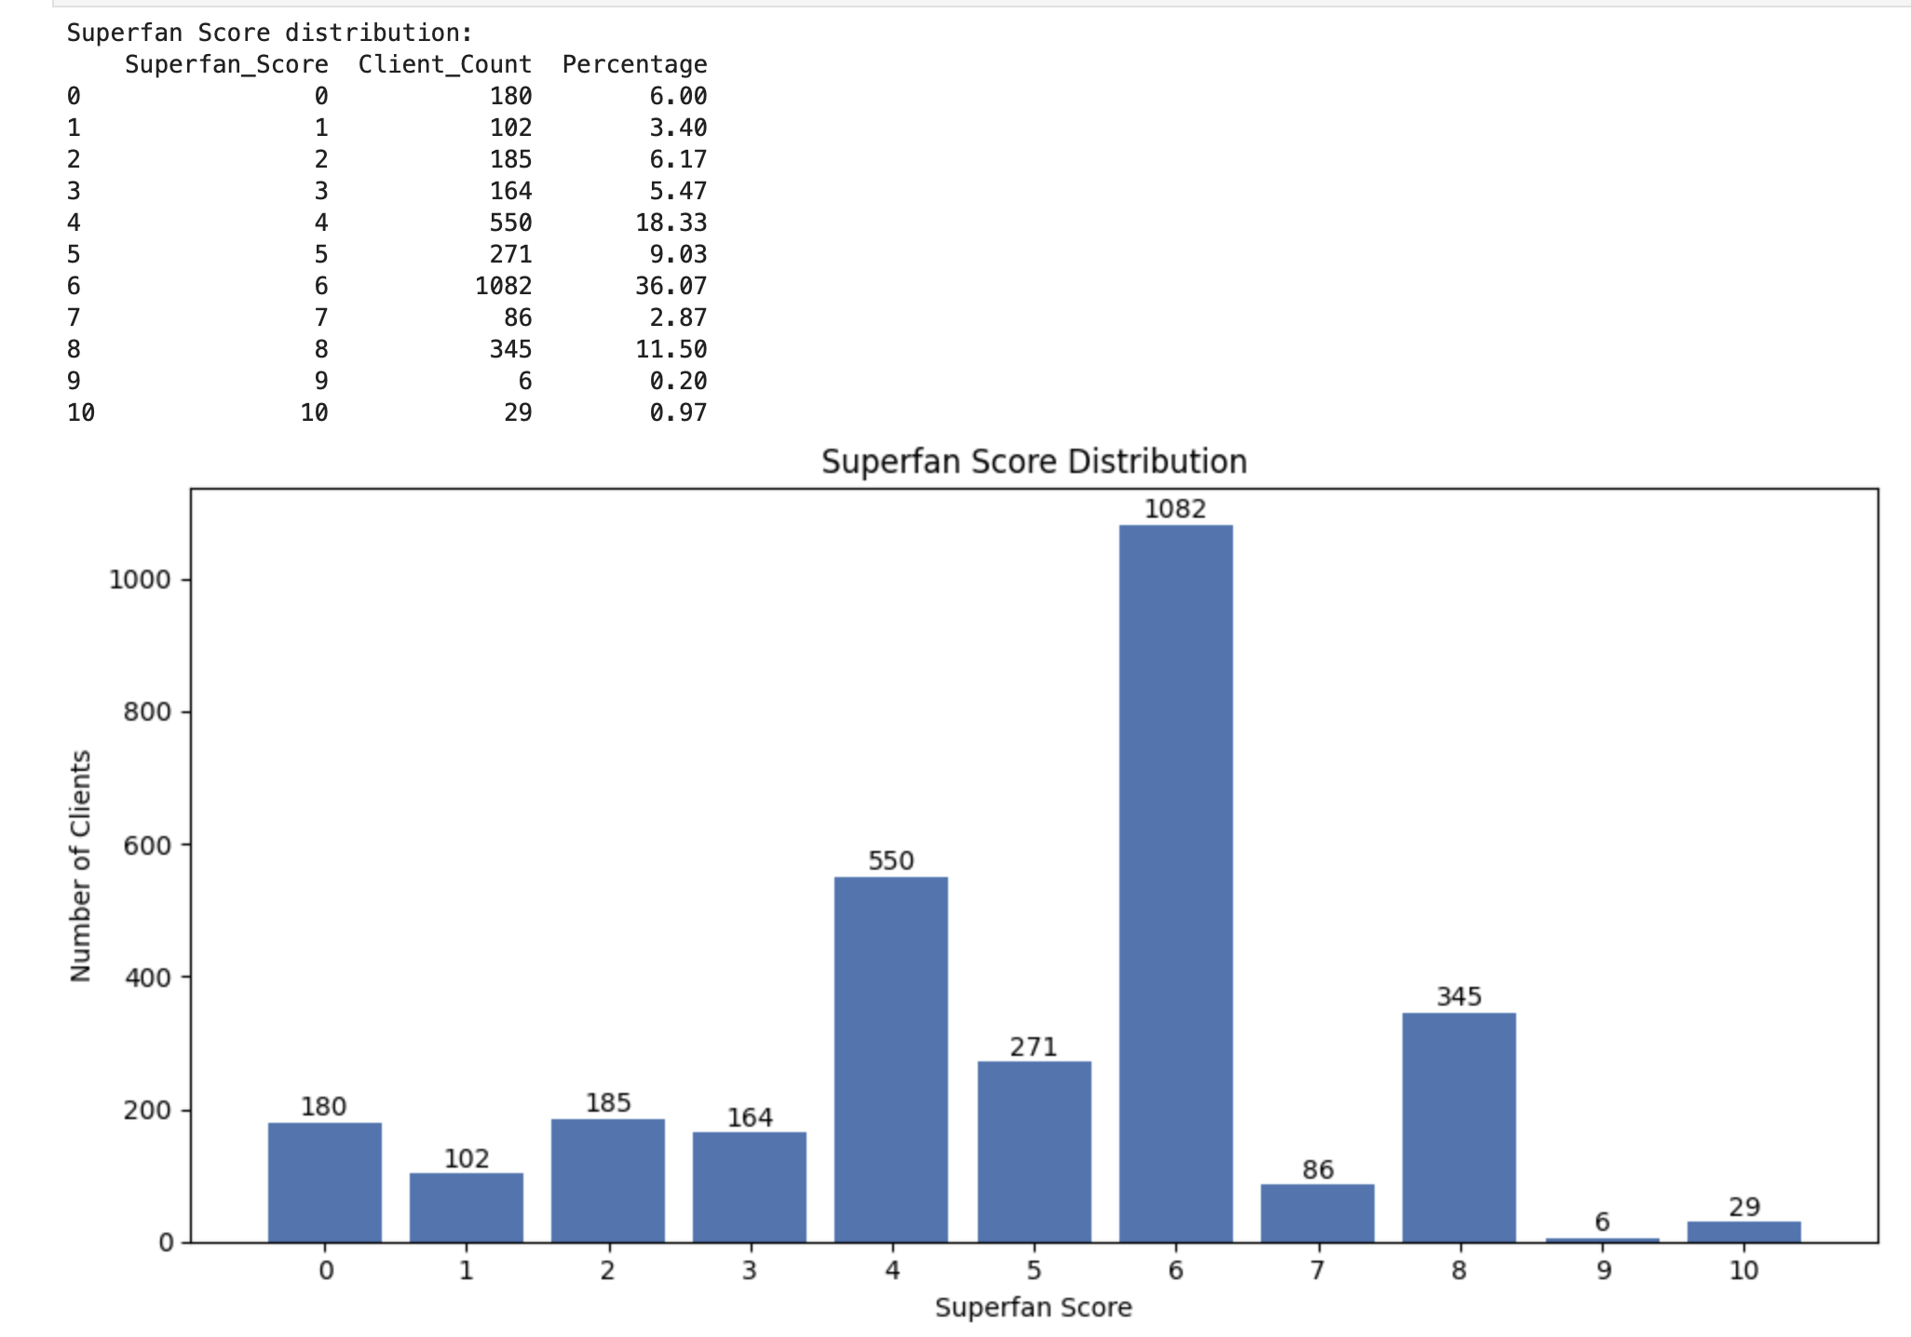

Business meaning
This is actually a good sign. Drishti does not have many extreme low-score clients, and many clients are already close to becoming stronger promoters.
The biggest opportunity is to move Score 5–7 clients into Score 8+ Superfans.
That means Drishti can create more word of mouth by focusing on small actions like:
Encouraging progress photos
Asking happy clients for referrals at the right time
Offering a second-round plan
Celebrating visible progress publicly

Super fans
I compared Superfans against everyone else using five business metrics: goal success, check-in rate, progress photo sharing, second round signup, and referral behavior. This helped profile what makes a Superfan different from the average client and gave clear direction for how Drishti can intentionally create more high-value word-of-mouth clients.
I compared Superfans with everyone else using five key business metrics: goal success, check-in rate, progress photo sharing, second round signup, and referral behavior. The results showed that Superfans had stronger performance across every metric, including 100% goal success, 96.80% average check-in rate, 95.28% progress photo sharing, 45.67% second round rate, and 85.04% referral behavior. This helped clearly define what a Superfan looks like and showed which client behaviors Drishti should encourage more intentionally to increase word of mouth.
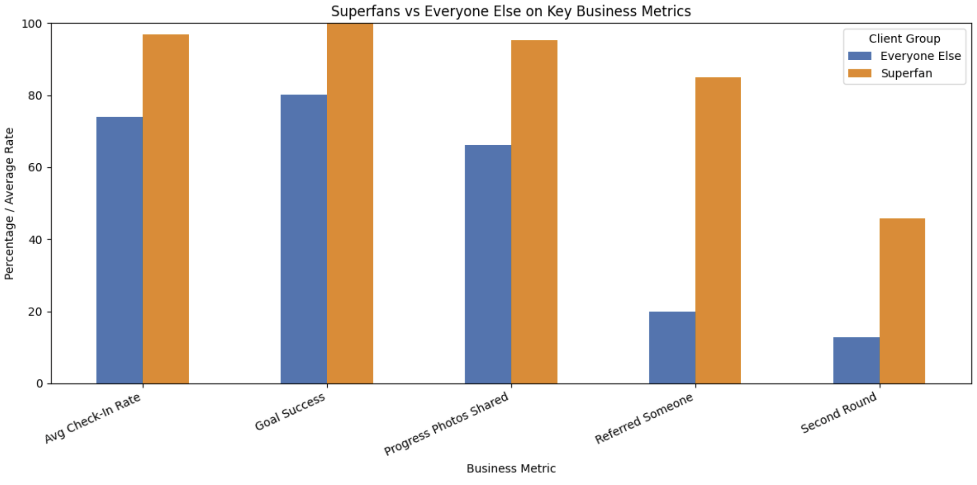
I compared Superfans with everyone else using five key business metrics: goal success, check-in rate, progress photo sharing, second round signup, and referral behavior. The results showed that Superfans had stronger performance across every metric, including 100% goal success, 96.80% average check-in rate, 95.28% progress photo sharing, 45.67% second round rate, and 85.04% referral behavior. This helped clearly define what a Superfan looks like and showed which client behaviors Drishti should encourage more intentionally to increase word of mouth.

Identify the 3 things that turn clients into Superfans
This will help us answer What behaviors are most different between Superfans and normal clients?
I calculated the behavior gap between Superfans and everyone else across the five key word-of-mouth metrics. This helped identify which behaviors most strongly separate Superfans from regular clients. I then selected the top three Superfan drivers and connected each one to a practical business action Drishti can use to create more referral-ready clients deliberately.

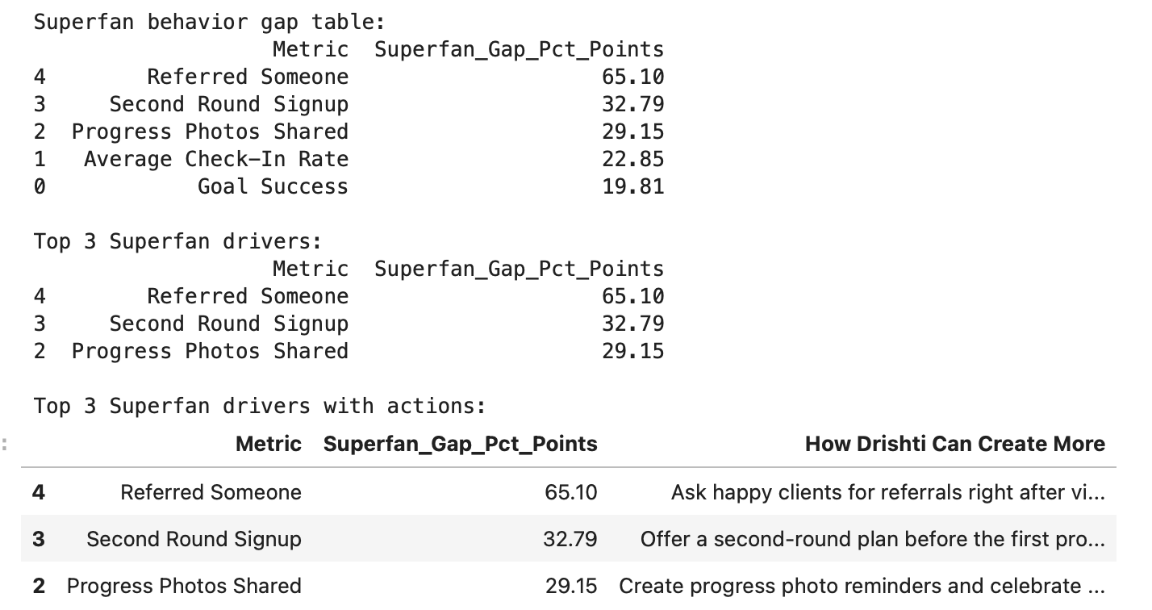

I identified the top three behaviors that separate Superfans from everyone else by calculating the percentage-point gap across key word-of-mouth metrics. The biggest gaps were referral behavior, second round signup, and progress photo sharing. This shows that Superfans are not only successful clients, but clients who continue the relationship, share visible progress, and actively bring others into the business. These insights help Drishti create more Superfans deliberately by asking for referrals at the right time, offering second-round plans before the program ends, and encouraging progress photos with permission.

Business meaning
This tells us the Superfan formula clearly:
Superfans are clients who share the business, continue the relationship, and show visible proof of progress.
So Drishti can create more Superfans by focusing on these 3 actions:
1. Ask happy clients for referrals at the right emotional moment.
2. Offer second-round plans before the first program ends.
3. Encourage and celebrate progress photos with client permission.
The most powerful gap is referral behavior, but practically, Drishti cannot force referrals directly. She can create the conditions that make referrals more likely: visible progress, strong check-ins, emotional wins, and a smooth second-round offer.
In Phase 5 Part C, I built a Word of Mouth / Superfan Score system to identify clients who are most likely to become referral drivers. I scored every client from 0 to 10 using goal achievement, check-in rate, progress photo sharing, second round signup, and whether they referred someone else. I segmented clients into Superfan, Happy, Neutral, and At Risk groups. Only 127 clients, or 4.23%, were Superfans, while 1,497 clients, or 49.90%, were Happy. This shows a strong opportunity to convert happy clients into stronger word-of-mouth promoters. I also compared Superfans with everyone else and found the top three Superfan drivers: referral behavior, second round signup, and progress photo sharing. These insights show that Drishti can create more Superfans by asking for referrals at the right moment, offering second-round plans before the program ends, and encouraging clients to share visible progress with permission.

Part D step 1Engagement Timing Rule.
I started Phase 5 Part D by preparing the engagement timing analysis table. I converted Days_To_First_Engagement into a numeric column and replaced “Never” with 999 so it could be analyzed as a delayed/no-engagement case. I also created completion, churn, and goal achievement flags to compare business outcomes by first engagement timing. This creates the foundation for identifying the exact day when delayed engagement becomes a dropout risk.
I started Phase 5 Part D by preparing the engagement timing analysis table. I checked the distribution of Days_To_First_Engagement and confirmed that the cleaned data already uses 999 for clients who never engaged. I then created numeric engagement timing, completion, churn, and goal achievement flags. This prepared the data for finding the exact point where delayed first engagement becomes a dropout risk.

Step 2

Analyze business outcomes by first engagement day

I analyzed client outcomes by first engagement timing. I grouped clients by the number of days it took them to first engage and calculated completion rate, churn rate, average check-in rate, and goal achievement rate for each group. This helped show whether delayed first engagement is connected to worse client performance and higher dropout risk.

I analyzed client outcomes by first engagement timing and found a clear risk jump after Day 3. Clients who engaged within 0–3 days had churn rates between 10.57% and 12.80%, while clients who first engaged on Day 5 had a churn rate of 35.29%. Clients who never engaged had a 100% churn rate. This shows that delayed first engagement is a strong early warning signal, and Drishti should intervene before a client reaches Day 5 without engagement.

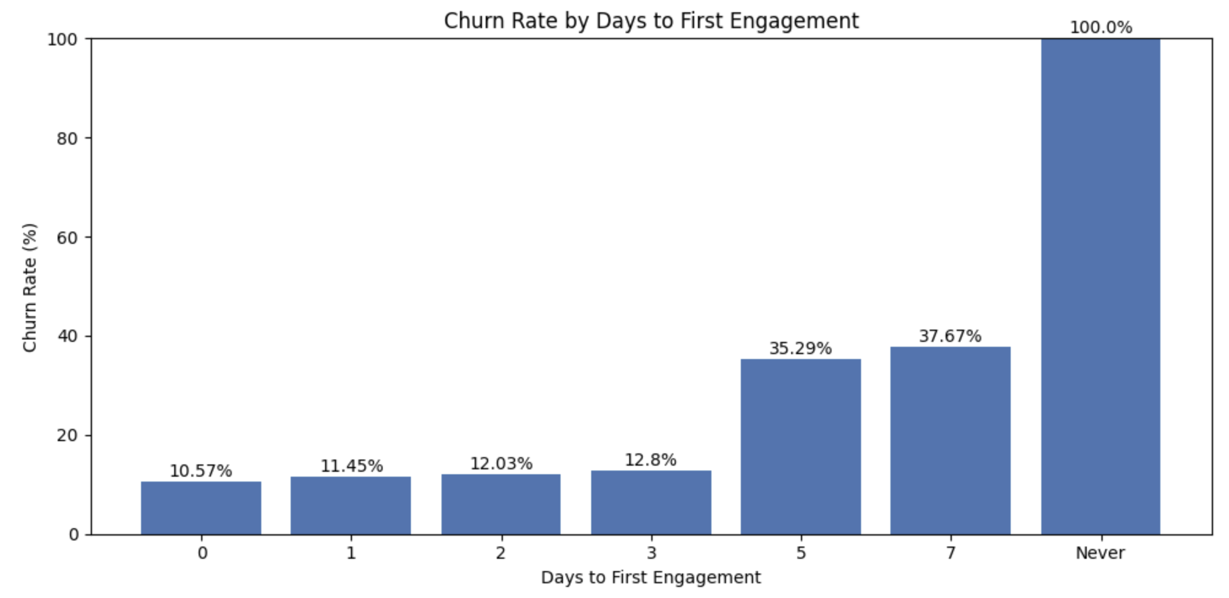
lients who engage within 0–3 days perform very well:
0 days: 10.57% churn
1 day: 11.45% churn
2 days: 12.03% churn
3 days: 12.80% churn
But once first engagement is delayed to 5 days, churn jumps sharply:
5 days: 35.29% churn
7 days: 37.67% churn
Never: 100.00% churn

Business meaning
The biggest risk jump happens after Day 3.
Clients who engage by Day 3 have around 87–89% completion/goal achievement, but clients who first engage on Day 5 drop to 64.71% completion/goal achievement.
That means the early warning rule is likely:
If a client has not engaged by Day 3, intervene before Day 5.

Step 3 Calculate engagement threshold rule
I calculated the engagement threshold by comparing clients who engaged within 3 days against clients who did not. This helped convert the engagement analysis into a simple business rule showing how much more likely delayed clients are to drop out. The threshold is useful because it gives Drishti a clear intervention point before client risk increases sharply.
I calculated the engagement timing threshold by comparing clients who engaged within 3 days with clients who did not. Clients who engaged within 3 days had an 11.47% churn rate, while clients who did not engage within 3 days had a 51.06% churn rate. This means delayed/no-engagement clients were 345.16% more likely to drop out. Based on this, I created a clear business rule: if a new client has not engaged within 3 days, Drishti should send a personal intervention message before the client reaches Day 5.

Part D — Step 4

Create the exact message/action rule by engagement day
Now we will turn the threshold into a simple daily action rule Drishti can actually use.
This will answer:
If a new client has not responded by Day 3, what exact type of message should Drishti send?

I converted the engagement threshold into a practical action rule table. The table gives Drishti a clear response plan based on when a client first engages or fails to engage. Since clients who did not engage within 3 days were 345.16% more likely to drop out, Day 3 became the main intervention deadline. The recommended action is to send a personal accountability message, ask what is blocking the client, and offer a very small restart task before the client becomes fully inactive.
I converted the engagement timing threshold into a practical action rule table. The table shows what Drishti should do based on when a client first engages or fails to engage. Since clients who did not engage within 3 days were 345.16% more likely to drop out, Day 3 became the main intervention deadline. The recommended action is to send a personal accountability message that gently asks what is blocking the client and gives them one small restart step.

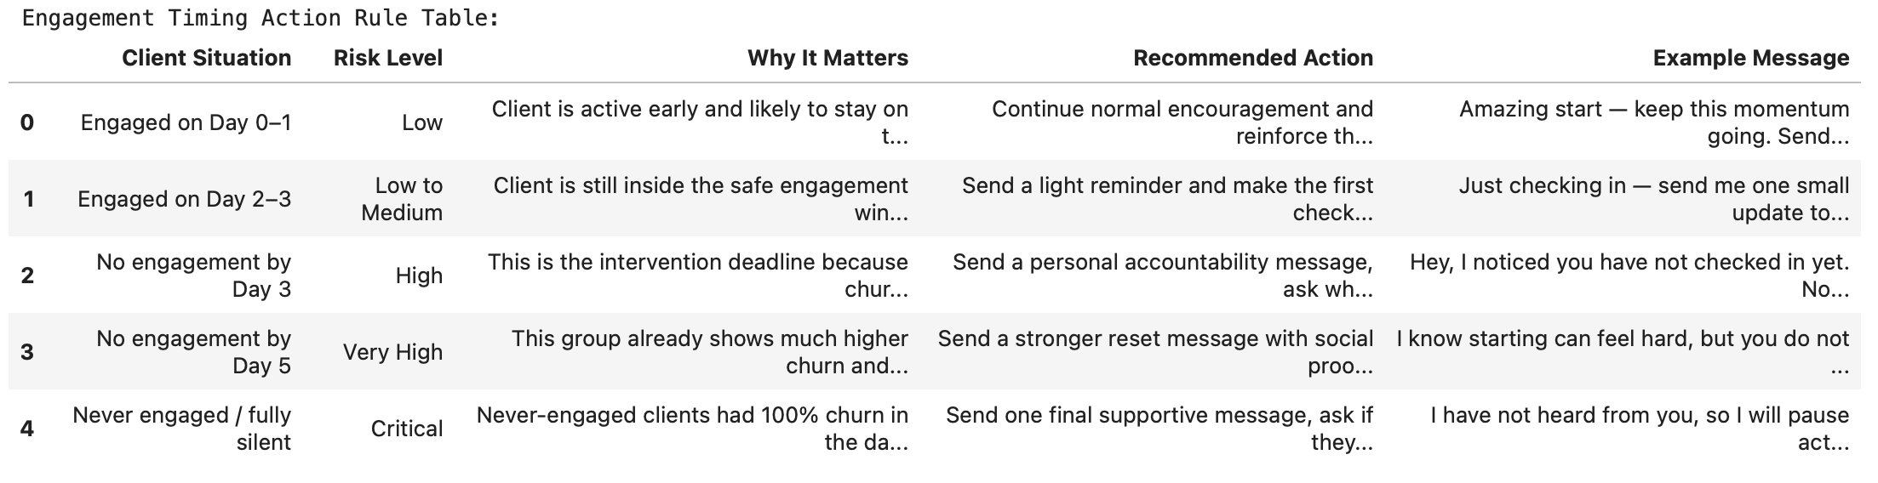
In Phase 5 Part D, I built an Engagement Timing Rule to identify when delayed first engagement becomes a serious dropout risk. I analyzed Days_To_First_Engagement against completion rate, churn rate, check-in rate, and goal achievement rate. Clients who engaged within 3 days had an 11.47% churn rate, while clients who did not engage within 3 days had a 51.06% churn rate. This means delayed/no-engagement clients were 345.16% more likely to drop out. Based on this, I created a clear rule: if a new client has not engaged by Day 3, Drishti should send a personal accountability message immediately before the client reaches Day 5. I also created and saved an action rule table that gives specific follow-up actions and example messages by engagement timing risk level.

In Phase 5, I built a Retention and Word-of-Mouth System for Get Fit with Drishti. Part A created an early warning churn model to identify clients at risk of dropping out during the first week. Part B created a Win-Back Playbook to understand why dropped clients return and what follow-up actions should be used. Part C created a Superfan Score to identify clients most likely to become referral drivers. Part D created an Engagement Timing Rule and found that clients who did not engage within 3 days were 345.16% more likely to drop out. Together, these systems give Drishti a practical weekly decision-making process to reduce ghosting, improve client experience, recover dropped clients, and grow word of mouth more intentionally.

Phase 6
In Phase 6 Part A, I created three Tableau-ready files from the cleaned dataset. I prepared a client-level file, a monthly growth file, and a six-stage funnel file. I also added useful dashboard fields such as churn flag, Superfan Score, churn probability, and encoded goal achievement. This step made the data ready for building a practical Tableau dashboard that can track growth, retention, client success, and word-of-mouth opportunities.

Business impact
- Drishti can see where clients are dropping off.
- She can find risky clients early.
- She can identify happy clients who may refer others.
- She can track monthly growth by TikTok, Instagram, referral, and other sources.
- She gets a practical dashboard instead of only a one-time report.

What we did
- Changed the scatter plot into a bubble scatter plot.
- Used average check-in rate on the x-axis.
- Used average goal achievement level on the y-axis.
- Used bubble size to show number of clients.
- Used color to show client status.

Why this is important
This chart now tells a clear business story: clients who complete the program have much higher engagement and better outcomes. This supports the early warning system because low engagement is connected to weaker outcomes or churn.

I adjusted the Engagement-Success chart to use average check-in rate and average goal achievement level instead of summed values. This made the bubble scatter plot accurate and easier to interpret, with bubble size showing the number of clients in each status group.

Tableau Dashboard Development — Get Fit with Drishti

For the Tableau part of this project, I built a three-dashboard business intelligence system designed to help the business monitor growth, retention, referral quality, client success, and daily action opportunities. The goal was not just to create charts, but to turn the cleaned client dataset into a practical dashboard system that can support real business decisions.

⸻

Dashboard 1 — Business Overview

The first dashboard focuses on the overall health of the business. It gives a high-level view of client volume, completion rate, goal achievement, second-round behavior, and Superfan rate. I used KPI cards at the top so the main business performance indicators are visible immediately.

The acquisition chart shows quarterly new clients by lead source, which helps identify which channels are driving growth over time. I changed the view from monthly to quarterly because monthly labels were crowded and harder to read. This made the trend easier to understand at a glance.

The Goal Type Mix chart shows what clients want most, such as weight loss, body transformation, and weight gain. I improved this chart by showing both client count and percentage, so the business can quickly understand not only how many clients fall into each goal type, but also how important each goal is as a share of total demand.

Business purpose: This dashboard answers, “How is the business performing overall, where are clients coming from, and what do clients want most?”

⸻

Dashboard 2 — Retention & Referral Performance

The second dashboard focuses on client journey, repeat business, and referral quality. This became one of the most important dashboards because it connects retention behavior with referral performance.

I added three dynamic KPI cards at the top:

Second-Round Conversion
Referral Client Rate
Referral Repeat Gap

These KPIs were chosen because they directly match the dashboard’s purpose. Second-Round Conversion shows how many completed clients return for another round. Referral Client Rate shows what share of clients came through referrals. Referral Repeat Gap shows how much more likely referred clients are to return compared with non-referred clients.

A major improvement was rebuilding the Retention Funnel. Originally, the funnel was based on a separate static tableau_funnel file, which meant it would not update automatically when new client data was added. I rebuilt the funnel using the main tableau_clients dataset and dynamic calculated fields. This made the funnel fully refreshable from client-level data.

The dynamic funnel now tracks:

Paid Clients
First Engagement
Active at Week 3
Completed Program
Achieved or Partially Achieved Goal
Second Round

This showed a more accurate client journey, including the fact that not every paid client had first engagement. The funnel was color-coded by stage health to make drop-off points easier to identify.

I also fixed a critical data issue in the Referral Impact chart. The chart originally showed Non-Referred Second Round as 0%, which was incorrect. I checked the calculation logic and Measure Values setup, then corrected it so the chart showed the accurate comparison: non-referred clients had a much lower second-round rate than referred clients. I also renamed technical chart headers like “Completion Flag” and “Second Round Flag” into business-friendly labels such as “Completion Rate” and “Second Round Rate.”

Business purpose: This dashboard answers, “Where are clients dropping off, how strong is repeat business, and do referred clients perform better?”

⸻

Dashboard 3 — Client Success Action System

The third dashboard focuses on daily client-success actions. It is designed to help identify risk signals, strong advocates, and niche opportunities.

I added three dynamic KPI cards:

Total Churned Clients
Strong Superfans
Win-Back Rate

These KPIs summarize the main action areas: clients who need attention, clients who can become advocates, and clients who returned after dropping off.

The engagement-success scatter plot was improved significantly. The earlier version used an encoded goal achievement score, which was harder to explain. I changed it to compare Check-in Rate (%) with Goal Achievement Rate (%), making the chart more business-friendly. This helped show that clients with higher check-in behavior are more likely to achieve their goals.

The At-Risk Signal chart shows how engagement timing affects churn probability. This chart highlights that clients who never engage have the highest churn risk, making it useful for early intervention.

The Superfan Pipeline chart groups clients by advocacy potential, helping the business identify who can be contacted for testimonials, referrals, or transformation stories. The Health Condition Opportunity chart shows which client health conditions appear most often, helping guide content strategy and niche positioning.

Business purpose: This dashboard answers, “Which clients need action, who can become promoters, and what niche opportunities should the business focus on?”

⸻

Dynamic Design Approach

A key focus of the Tableau work was making the dashboards dynamic. I built KPIs and charts using calculated fields, flags, COUNTD, SUM, AVG, and client-level fields instead of manually typed numbers. This means the dashboards can update when the dataset is refreshed.

The most important dynamic improvement was replacing the static retention funnel with a funnel built directly from the main client dataset. This makes the dashboard more reliable for future use because new client rows can flow into the analysis without manually updating a separate funnel summary file.

⸻

Final Tableau Outcome

The final Tableau system has a clear business flow:

Dashboard 1: Understand overall business performance
Dashboard 2: Diagnose retention and referral performance
Dashboard 3: Take daily client-success action

Together, these dashboards turn raw client data into a practical business monitoring system. They help the business understand growth, identify retention gaps, evaluate referral quality, spot churn risk, activate Superfans, and focus on the most valuable client opportunities.

