

SCHOOL OF ADVANCED TECHNOLOGY

ICT - Applications & Programming

Computer Engineering Technology – Computing Science

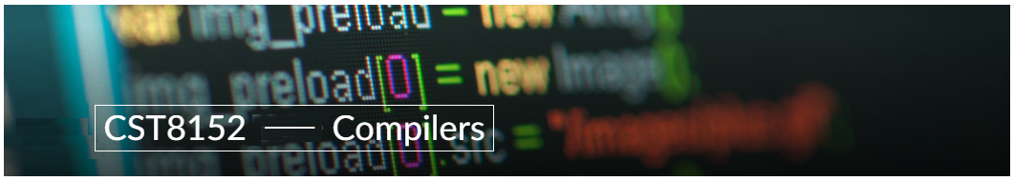

A21
Model Definitions (RE/Automaton)

Lab Professor / Lab Session:
[Prof.Paulo Susa/012]

Team:
[Bivin Job] - Id: [041085068]

Language Name : Celestia Code

This template is suggested (not mandatory) to answer A11 Specification.

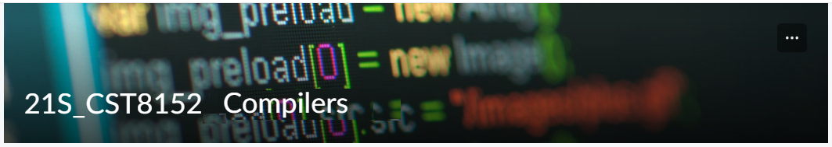

MODEL TASK FOR ASSIGNMENT 2.1 – CelestiaCode

- Note: This task is part of the Assignment 2 from Compilers Course. Any problem, contact your lab professor.

Task 1: Language Symbols (2.0 marks)

List examples: Define main symbols to be used:
- Special symbols (ex: “{“, “(“, “<=”, etc.)
- Comments
- Variables
- Functions
- Literals (numbers, strings)
- Keywords
- Datatypes

Answer:

• Special symbols: #, \n, :, {,}, [, ], (, ), =, +=, - =, *=, /=, %=, ==, !=, <, >, <=, >=, /, %, +, -, <<, >>, &, |, ^, ,,.

• Comments: 1. single-line comments: Start with ‘#’ and continue until the end of the line.
2. multi-line comments: Enclosed within /* multi-line comment */

• Variables: e.g. data, nameOf, val, age, is_valid, _counter.

• Functions: e.g. main(), print(), input(), len(), range(), type(), append(), keys(), split(), max(), min().

• Literals:
- Numbers: [1 to 9],3.12345
- Strings: ‘input data’, “number!”

• Keywords: if, def, else, elif, set, bool, while, for, function, return, int, float, str, complex, in, and, or, not.

• Datatypes: • int: 32-bit signed integer
• float: 64-bit double-precision numbers
• str: Sequence of characters (ascii: – 20 to 128).

Task 2: RE – Regular Expression (3.0 mark)

Lexeme Classes: Define the classes to be used in your regular expression:

Answer:
Letters (L): [A…Z | a…z] - Represents any uppercase or lowercase letter.

Digits (D): [0…9] - Represents any digit from 0 to 9.

Underscore (U): _ - Represents the underscore character.

Operators (OP): [+ - * / = < > ! % ^ & | ~] - Represents various operators like addition, subtraction, multiplication, division, assignment, comparison, etc.

Delimiters (DEL): [; , ( ) { } [ ] .] - Represents common delimiters like semicolon, comma, parentheses, curly braces, square brackets, and period.

String Literals (SL): - Q[^Q]*Q = Q[L|D|U|M|O]*Q

SL delimitator (Q) = “ , Represents the double quote character used to define string literals.

Whitespace (WS): [ \t\b\r] - Represents tab, blank, and carriage return characters.

Comments (H): # for hash for single line.

New Line (N): ‘\n’ - Represents the newline character.

Period (P): ‘.’ - Represents the period or dot symbol.

Single Quote (Q1): ' - Represents the single quote character.

Double Quotes (Q2): " - Represents the double quote character.

MVID Delimitator (M): & - Represents the MVID delimitator.

Parenthesis (B1): ()

Colon (C): ‘:’

Method Identifier (MID): L[L|D|U] *M, Represents a method identifier.

Other (O): [^(HQ1NLDPWQ2CSB1UQOPWS)], Any character that doesn't fall into the above categories.

End of File (EOF): Special marker indicating the end of the source code file.

Define the RE to be used for: variables, literals and keywords:

Answer:
* Comments: H(^N) *N
* Variables: L+
* Methods: L[L|D|U] *B1
* Literals:
- Numbers - 1. Integers: D+
2. Floats: D+PD* + D*PD+
- Strings: Q(H|N|L|D|P|O) *Q

* Keywords: ‘def’ (=SequenceOfLetters): L+

Task 3: TD – Transition Diagram (3.0 marks)

Activity: Starting from the previous lexeme classes and obeying the RE, it is possible to define the automata for your language:

Answer (draw / copy image of the automata):

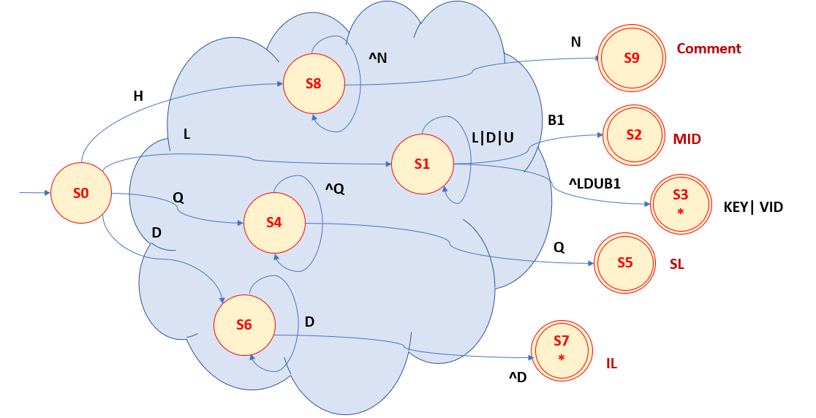

Task 4: TT – Transition Table (2.0 marks)

Activity: Now, it is possible to define the TT for these lexemes:

Answer (Transition Table):
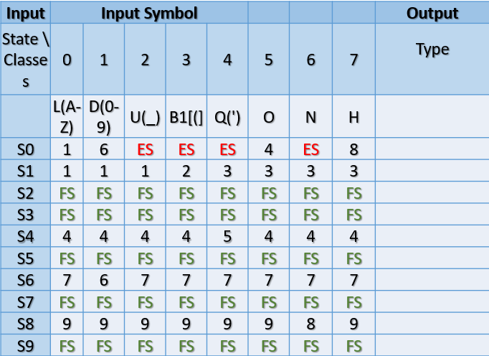

Update: Feb 4th 2024.

Adapted from resources developed by Prof. Svillen Ranev (Algonquin College, 2019)

