TEACHING PRACTICE I REPORT
Name: Faith Wangari Wairimu
Reg. No: E14/00570/24
Programme: Bachelor of Education (Biology & Chemistry)
School: Kanga Primary School
Teaching Practice: 10 April 2026 - 31 August 2026
County: Nakuru

Teaching Practice Report submitted to the faculty of Education and Community studies in Partial Fulfillment of the Award of the Bachelor of Education (Biology & Chemistry) of Egerton University.

EGERTON UNIVERSITY

Date: 6th July 2026

DECLARATION
I declare that this Teaching Practice I Report is my original work and has not been submitted to any other institution for the award of a degree. The report is based on my teaching practice experience at Kanga Primary School undertaken from 10th April 2026 to 31st August 2026 under the Bachelor of Education (Biology and Chemistry) programme at Egerton University.
Student Name: Faith Wangari Wairimu
Registration Number: E14/00570/24
Signature: ______________________
Date: ___________________________

Abstract
This report documents the teaching practice 1 undertaken at Kanga Primary School in Nakuru, Kenya. The teaching practice spanned a period of 12 weeks during which the I was actively involved in various school actives including lesson planning, classroom instruction, assessment, co-curricular actives, and administrative duties.
The report provides a detailed the school’s background, mission, philosophy, physical facilities and organizational structure. It documents the student teacher’s experience in planning and delivering lessons in Chemistry, Biology and CRE utilizing various teaching methodologies and resources.
Key findings indicate that the school maintains a conducive learning environment. The challenges encountered during the practice include time management , adapting to diverse learners need and resource constraints.
The overall experience was transformative. It equipped the student teacher with practical skills and competencies essential for teaching.

TABLE OF CONTENTS
CONTENT | Page
Title Page | i
Declaration | ii
Abstract | iii
Table Of Contents | iv
List Of Tables | v
List Of Figures | vi
Chapter One: Introduction
1.1Background | 1
1.2 Learning Outcomes | 2
Chapter Two: Description Of the School
2.1 Location and Background of the School | 4
2.2 Mission, Vision and Philosophy of the School | 4
2.3 Objectives of The School | 5
2.4 Administrative Structure of the School | 5
2.5 Physical Facilities | 6
2.6 School Population | 7
2.7 Co-curricular Activities | 7
Chapter Three: Teaching Practice Activities | 8
3.1 Introduction | 8
3.2Orientation and Induction | 9
3.3 Lesson Planning | 9
3.4 Lesson Delivery and Induction | 10
3.5 Integration of ICT | 10
3.6 Assessment and Evaluation | 10
3.7 Co-Curricular Activities | 10
3.8 Student Guidance and Counselling | 11
Chapter Four: Skills and Competencies
4.1 Introduction | 12
4.2 School Strengths | 12
4.3 Challenges Encountered | 13
4.4 Professional Growth and Development | 15
Chapter Five: Conclusions and Recommendations
5.1 Summary | 16
5.2Conclusions | 16
5.3 Recommendations | 16
5.4 Final Remarks | 18
References | 19
LIST OF TABLES
Table No. | Title | Page
Table 1 | Administrative structure of the school | 5
Table 2 | Physical Structures | 6
Table 3 | School Population | 7
Table 4 | Learning areas allocated | 10
Table 5 | Assessment methods used | 11
Table 6 | Summary of School Strengths and Challenges | 14

List Of Figures
Figure No. | Title | Page
Figure 1 | Organogram | 6
Figure 2 | Timetables | 20

Chapter One: Introduction
  - Background
Teaching Practice is an important component of teacher education that provides student teachers with an opportunity to apply the knowledge, skills, and attitudes acquired during their university training in a real school environment. It bridges the gap between theory and practice by allowing student teachers to experience classroom teaching, learner management, lesson preparation, assessment, and participation in school activities under the guidance of experienced teachers.
The Teaching Practice programme also enables student teachers to develop professional competencies such as effective communication, classroom management, lesson planning, learner assessment, record keeping, and teamwork. Through this experience, student teachers gain confidence and acquire practical skills necessary for effective teaching and learning.

This report presents the experience gained during the Teaching Practice Period undertaken at Kanga Primary School in Nakuru County from the 10th April to 31st August 2026. During this period, I though Pre Technical and Christian Religious Education(CRE) to learners in grades 7 and 8 under the Competency-Based Curriculum(CBC). Besides the classroom instruction, I participated in co-curricular actives, staff meetings, learner guidance and counselling ,assessment of learners and also coaching in netball games.
The teaching practice provided an opportunity to interact with learners, teachers, school administrators, parents, and the wider community. It enhanced my understanding of the roles and responsibilities of a professional teacher and enabled me to appreciate the importance of ethics, punctuality, teamwork, and effective communication in the teaching profession.
This report documents the activities undertaken during the teaching practice, the skills and competencies acquired, the challenges encountered, and the recommendations for improving future teaching practice programmes.

1.2 Learning Outcomes
1.2.1 Development of Pedagogical Skills
During my Teaching Practice I, I developed practical pedagogical skills that enhanced my effectiveness as a teacher. I prepared professional lesson plans with clear and measurable learning objectives, selected appropriate teaching and learning resources, and delivered lessons using learner-centered teaching methods. I also improved my ability to assess learners' understanding and provide constructive feedback that promoted academic growth.
1.2.2 Understanding the School Environment and Culture
Through my teaching practice, I gained a comprehensive understanding of the school environment and its operations. I familiarized myself with the school's mission, vision, philosophy, organizational structure, and administrative procedures. I also developed an appreciation of the school's culture, values, and traditions, and understood the importance of maintaining positive relationships with learners, teachers, parents, and the surrounding community.
1.2.3 Professional Development and Growth
The teaching practice contributed significantly to my professional growth. I developed professional ethics, improved my communication and interpersonal skills, and gained confidence in carrying out my responsibilities as a teacher. Working closely with experienced teachers enabled me to strengthen my teamwork, leadership, and decision-making skills while cultivating a positive attitude towards the teaching profession.
1.2.4 Classroom Management Competence
During the teaching practice, I developed effective classroom management skills that enabled me to create and maintain a conducive learning environment. I successfully managed learner behavior, organized classroom activities efficiently, maintained discipline, and encouraged active participation during lessons. These experiences improved my confidence in handling different classroom situations effectively.
1.2.5 Assessment and Evaluation Competence
I enhanced my skills in learner assessment by preparing and administering class exercises, assignments, quizzes, and examinations. I maintained accurate learner performance records, analyzed assessment results, and used the findings to improve my instructional approaches. I also provided timely and constructive feedback that helped learners identify their strengths and areas requiring improvement.

1.2.6 Integration of Theory and Practice
The teaching practice enabled me to apply the knowledge and skills I had acquired during my university studies in a real classroom setting. I successfully integrated educational theories, teaching methodologies, and curriculum requirements into my daily teaching activities. This experience strengthened my problem-solving abilities and enhanced my confidence in addressing challenges encountered during the teaching and learning process.
1.2.7 Development of Professional Networks
Throughout the teaching practice period, I established positive professional relationships with teachers, school administrators, learners, and other stakeholders. These interactions enabled me to learn from experienced educators, improve my collaboration skills, and develop a stronger professional identity. I also participated in co-curricular activities, including coaching the school's netball team, which progressed to the Extra County level, further enhancing my teamwork and leadership abilities.

CHAPTER TWO: DESCRIPTION OF THE SCHOOL
2.1 Location and Background of the School
2.1.1 Geographical Location
During my Teaching Practice I, I was attached to Kanga Primary School, located in Rongai Constituency, Nakuru County, Kenya. The school is situated approximately [Distance] kilometers from Nakuru along the [Road Name]. The surrounding community mainly depends on Farming as their primary source of income. The school is easily accessible throughout the year and serves learners from the surrounding villages and neighboring areas.
2.1.2 Historical Background
Kanga Primary School was established in the late 1970s with the objective of providing quality basic education to children within the surrounding community. Over the years, the school has experienced steady growth in enrolment, infrastructure, staffing, and academic performance.
Currently, the school offers education under the Competency-Based Curriculum (CBC) and continues to provide a conducive learning environment that promotes academic excellence, discipline, and holistic learner development. The school operates as a public day school under the Ministry of Education and is staffed by teachers employed by the Teachers Service Commission (TSC).

2.2 Mission, Vision and Philosophy of the School
2.2.1 Vision

2.2.2 Mission

2.2.3 Philosophy
The philosophy of the school is to provide holistic education by nurturing learners academically, morally, socially, spiritually, emotionally, and physically. The school emphasizes discipline, integrity, responsibility, teamwork, respect, and excellence in all its activities while preparing learners to become responsible citizens.

2.3 Objectives of the School
The objectives of Kanga Primary School include:
- To provide quality education that enables learners to achieve their full academic potential.
- To promote discipline, integrity, and moral values among learners.
- To provide a safe and conducive learning environment.
- To encourage participation in co-curricular activities for holistic development.
- To develop learners' talents, creativity, and critical thinking skills.
- To prepare learners for higher levels of education and responsible citizenship.
2.4 Administrative Structure of the School
The school administration comprised the following personnel:
Table 1 :Administrative structure of the school
Position | Name
Headteacher
Deputy Headteacher
Senior Teacher
Academic Master/Mistress
Guidance and Counselling Teacher
Games Teacher
School Bursar
Board of Management Chairperson

The administration was responsible for curriculum implementation, staff supervision, learner welfare, financial management, discipline, and overall school development. During my teaching practice, I observed that the administration worked collaboratively to ensure the smooth running of the school.

Organogram

Figure 1: Organogram
Headteacher

Deputy Headteacher

Senior Teacher

Academic Master

Teachers

Board of Management

2.5 Physical Facilities
During my teaching practice, I observed that the school had the following facilities:
Table 2 :Physical Facilities
Facility | Number | Remarks

2.6 School Population
Table 3: School population
Category | Number
Headteacher | 1
Deputy Headteacher | 1
Teachers
Non-Teaching Staff
Girls
Boys
Total Learners

2.7 Co-curricular Activities
The school actively participated in co-curricular activities such as:
- Football
- Volleyball
- Netball
- Athletics
- Drama and Music Festivals
- Environmental Conservation Activities
During my teaching practice, I participated in coaching the school's netball team, which successfully progressed to the Extra County Level. This experience enhanced my leadership, teamwork, and organizational skills.

Chapter Three: Reporting on Actual Work Done
3.1 INTRODUCTION
This chapter provides a detailed account of various actives I undertook during the teaching practice 1 placement at Kanga Primary School. The chapter includes the orientation into the school environment, lesson planning, lesson delivery, teaching methodologies, classroom management, assessment of learners, record keeping, participation in co-curricular activities, administrative responsibilities and professional development.
The attachment allowed me to apply the theological knowledge acquired in the university training in a real classroom environment. Through this experience I enhanced my professional confidence and understanding of the teaching profession.
3.2 ORIENTATION AND INDUCTION
3.2.1 Arrival and Introduction
I reported to Kanga Primary School on 10th April 2026 to begin my Teaching practice 1 and the other student teachers with me were warmly received by the headteacher, Mr ………………., who welcomed us to the school and introduced us to the teaching staff and other non-teaching staff. We later introduced ourselves to the students in the parade.
During the orientation period, we were taken around the school by one of the non-teaching staff and familiarized ourselves with the classes and other amenities. We were also given the school rules, code of conduct, academic programs and daily routines.
3.2.2 INITIAL MEETINGS AND PLANNING
The headteacher called a meeting and explained the school expectations of us, curriculum requirements, lesson allocations and teaching resources available. We were given textbooks and other materials that would assist in preparing our lessons.
I was guided on lesson planning by my mentor teacher, classroom management, leaner assessment, professional ethics and proper record keeping.

3.3 LESSON PLANNING
3.3.1 IMPORTANCE OF LESSON PLANNING
Lesson planning is the process of preparing and organizing a lesson before it is taught. It involves identifying the learning objectives, selecting appropriate teaching and learning activities and allocating activities for each activity. I designed the lesson plans to :
- Define clear learning objectives and outcomes
- Outline teaching and learning activities
- Provide assessment and evaluation to my students.
- Ensure alignment with curriculum requirements.
3.3.2 Lesson Plan Format

3.3.3 Schemes of Work
I also prepared the schemes of work for the subjects I thought Pre-technical and Christian Religious Education (CRE) for grade 7 and 8. The schemes of work enabled me to organize the content logically and ensure that the syllabus was covered within the allocated teaching period.
3.3.4 Lesson Allocation
I was allocated the following learning areas:

Table 4: Learning arears allocated
Class | Subject | Lessons Per Week
Grade 7 | Pre-Technical
Grade 7 | Christian Religious Education
Grade 8 | Pre-Technical
Grade 8 | Christian Religious Education

3.4 Lesson Delivery and Instruction
Lesson delivery was the most important aspect of my teaching practice because it enables me to interact with the learners and facilitate the leaning process. During the delivery I employed a variety of teaching methods to promote active leaner participation. These methods included:
- Direct Instruction: I led presentation content. Giving notes and explanations
- Discussions: Interactive dialogues with the students to explore ideas and concepts
- Group work: Collaborative learning activities with the learners
- Demonstration: I showed them processes and procedures
- Practice and Application: Hands-on activities and exercises.
- Acting: Students acted on various Biblical stories
I also ensured that every lesson was well managed by maintain discipline, monitoring learners’ participation and assessing their understanding throughout the lesson. At the end of each lesson, I summarized each key concepts before giving the learners a written exercise.
3.5 Integration of ICT
Where possible I integrated information and Communication Technology (ICT) in teaching such as :
- Use of educational videos and multimedia content
- Research activities using the internet
3.6 Assessment And Evaluation
I employed various assessment methods to evaluate student learning:

Table 5: Assesement methods used
Assessment Type | Frequency | Tools Used
Oral Question | Each Lesson | Oral Questioning
Written Exercises | Each Lesson | Exercises
Examinations | Monthly | Written Exercises
Assignments | As appropriate | Research and practical teaks

3.7 Co-Curricular Activities
I actively participated in co-curricular activities as part of the holistic development of the students. I was involved in the coaching of the students in netball where I thought them the netball rules and helped them in practicing. The students participated up to the extra county level.
3.8: Student Guidance and Counselling
I provided guidance and counselling services to students. The support that I gave the students included:
- Academic Counselling: Assisting students with academic difficulties, study skills, and learning strategies
- Personal Counselling: Offering support to students with personal issues, peer conflicts, and emotional challenges.

Chapter Four: Skills and Competencies Acquired
4.1: Introduction
This chapter presents my observations and experiences during the Teaching Practice 1placement at Kanga Primary School.
The teaching practice provided a valuable opportunity to observe and participate in the daily operations of a school, providing a comprehensive understanding of the roles , responsibilities, and challenges of teachers. The experiences documented in this chapter contributed significantly to my professional development and preparation for the teaching profession.
4.2 Strengths of the School
4.2.1 Academic Strengths
Kanga Primary School demonstrated several academic strengths during the teaching practice:
- Qualified and Committed Teachers : Kanga school employs well-qualified teachers who are dedicated to their work. Teachers demonstrated a strong commitment to student learning and were supportive of colleagues, including me.
- Structured Curriculum Implementation: The school follows a prescribed curriculum systematically, with clear plans for delivery and assessments. Schemes of work were developed and implemented consistently
- Supportive Learning Environment: The school provided a conducive learning environment characterized by adequate learning facilities, well-disciplined students, and supportive teachers. Learners demonstrated positive attitudes toward their studies and actively participated in classroom activities, which enhanced the effectiveness of the teaching and learning process.
- Academic Monitoring: The school has effective systems for monitoring learners' academic progress through continuous assessment, regular tests, and examinations. Assessment results are analyzed to identify learners' strengths and areas that require improvement, enabling teachers to enhance instruction and support student achievement.
- Parental Involvement: The school actively involves parents in their children's education through parent-teacher meetings, school events, and regular communication. This partnership promotes learners' academic progress, discipline, and overall well-being.

4.2.2 Co-Curricular Strengths
Active Co-Curricular Programmes: The school offers a variety of co-curricular activities that cater to learners' diverse interests and abilities. Students actively participate in these programmes, promoting holistic development.
Facilities for Co-Curricular Activities: The school provides adequate facilities for sports, arts, and other co-curricular activities, enabling learners to develop their skills beyond the classroom.
Talent Development: The school identifies and nurtures learners' talents in areas such as sports, music, drama, and leadership through regular participation in co-curricular programmes.
4.2.3 Administrative Strengths
Effective Leadership: The school administration provided strong leadership, ensuring smooth operations and supporting both teachers and learners.
Clear Policies: Well-defined policies on discipline, academics, and staff conduct promoted order and consistency within the school.
Resource Management: Available resources were managed efficiently to support teaching, learning, and school programmes.
Community Relations: The school maintained good relationships with parents and the local community, encouraging support for school activities.
4.2.4 Student Strengths
Positive Attitudes: Learners were respectful, cooperative, and actively participated in classroom activities.
Academic Potential: Most students demonstrated the ability to perform well when provided with appropriate guidance and support.
Leadership and Diversity: Students displayed leadership skills through various responsibilities, while the diverse school community promoted inclusive learning.
4.3 Challenges Encountered
4.3.1 Teaching and Learning Challenges
The major challenges included inadequate teaching and learning resources, large class sizes, varying learner abilities, limited ICT facilities, and insufficient time to complete the syllabus while meeting individual learner needs.
4.3.2 Infrastructure Challenges
Some facilities required maintenance and upgrading, particularly classrooms, laboratories, and the library, while occasional water and sanitation issues affected the learning environment.
4.3.3 Staffing Challenges
Heavy teacher workloads, and limited opportunities for professional development affected instructional effectiveness.
4.3.4 Student Challenges
Some learners faced behavioural, health, and socioeconomic challenges that influenced attendance, participation, and academic performance.
4.3.5 Personal Challenges
As a student teacher, I initially experienced challenges in classroom management, adapting to the school culture, and balancing teaching responsibilities with personal commitments. These challenges reduced with experience and guidance from my supervisors.
Table 6: Summary of School Strengths and Challenges
Area | Strengths | Challenges
Teaching and Learning | Qualified teachers, supportive learning environment | Limited resources, large classes
Co-Curricular | Active programmes and talent development | Limited resources for some activities
Administration | Effective leadership and clear policies | Heavy staff workload
Infrastructure | Adequate basic facilities | Maintenance and upgrading needs
Students | Positive attitudes and leadership | Behavioural and socioeconomic challenges

4.4 Professional Growth and Development
4.4.1 Development of Teaching Skills
Teaching practice enhanced my lesson planning, instructional delivery, classroom management, learner assessment, and effective use of available teaching resources.

4.4.2 Personal Development
The experience increased my confidence, strengthened my communication and problem-solving skills, reinforced professional ethics, and helped me develop a strong professional identity as a teacher.
4.4.3 Knowledge Enhancement
Teaching practice deepened my understanding of curriculum implementation, teaching methodologies, subject content, and the day-to-day management of school operations.

CHAPTER FIVE: SUMMARY, CONCLUSIONS AND RECOMMENDATIONS

5.1 Summary

This report presented the experiences and activities undertaken during Teaching Practice I at Kanga Primary school. The teaching practice enabled the student teacher to apply theoretical knowledge in a real classroom environment, develop professional teaching skills, and gain practical experience.

Chapter One introduced the teaching practice and its objectives. Chapter Two described the school's background, organization, facilities, and academic programmes. Chapter Three outlined the teaching practice activities, including lesson planning, lesson delivery, assessment, classroom management, and participation in co-curricular and administrative activities. Chapter Four discussed the school's strengths, challenges encountered, and the professional growth achieved during the teaching practice.

5.2 CONCLUSIONS

The teaching practice was a valuable learning experience that strengthened the my confidence and professional competence. It provided practical experience in lesson preparation, classroom management, learner assessment, and curriculum implementation.

The school demonstrated several strengths, including supportive administration, committed teachers, active co-curricular programmes, and positive learner attitudes. However, challenges such as limited teaching resources, large class sizes, and infrastructure needs affected the teaching and learning process.

The guidance provided by mentor teachers and university supervisors greatly contributed to the success of the teaching practice.

5.3 Recommendations

5.3.1 Recommendations for the School

Improve teaching and learning resources, especially ICT facilities and instructional materials.

Continue maintaining and upgrading school infrastructure.

Strengthen guidance and counselling services.

Provide regular professional development opportunities for teachers.

5.3.2 Recommendations for the University

Enhance preparation of student teachers before teaching practice.

Strengthen supervision and provide regular feedback during the teaching practice period.

Continue collaborating closely with partner schools.

5.3.3 Recommendations for Student Teachers

Prepare adequately before reporting for teaching practice.

Participate actively in teaching, co-curricular, and administrative activities.

Seek guidance from mentors and reflect on their teaching experiences to improve professionally.

5.3.4 Recommendations for the Education Sector

Increase investment in teaching resources and school infrastructure.

Support continuous professional development for teachers.

Strengthen learner support services to enhance academic and personal development.

5.4 Final Remarks

Teaching Practice I provided valuable professional experience that prepared the me for a career in education. The knowledge, skills, and experiences gained during the placement will contribute to future professional growth and effective teaching. Appreciation is extended to the school administration, mentor teachers, university supervisors, staff, and learners for their support throughout the teaching practice.

REFERENCES
Egerton University. (2026). Teaching Practice Guidelines. Egerton University: Faculty of Education and Community Studies.
Kenya Institute of Curriculum Development. (2019). Basic Education Curriculum Framework. Nairobi: KICD.
Kenya National Bureau of Statistics. (2019). Statistical Abstract. Nairobi: Government Printer.
Ministry of Education. (2018). National Education Sector Plan 2018-2022. Nairobi: Government Printer.
Kanga Primary School

APPENDIX

APPENDIX A :TIMETABLE
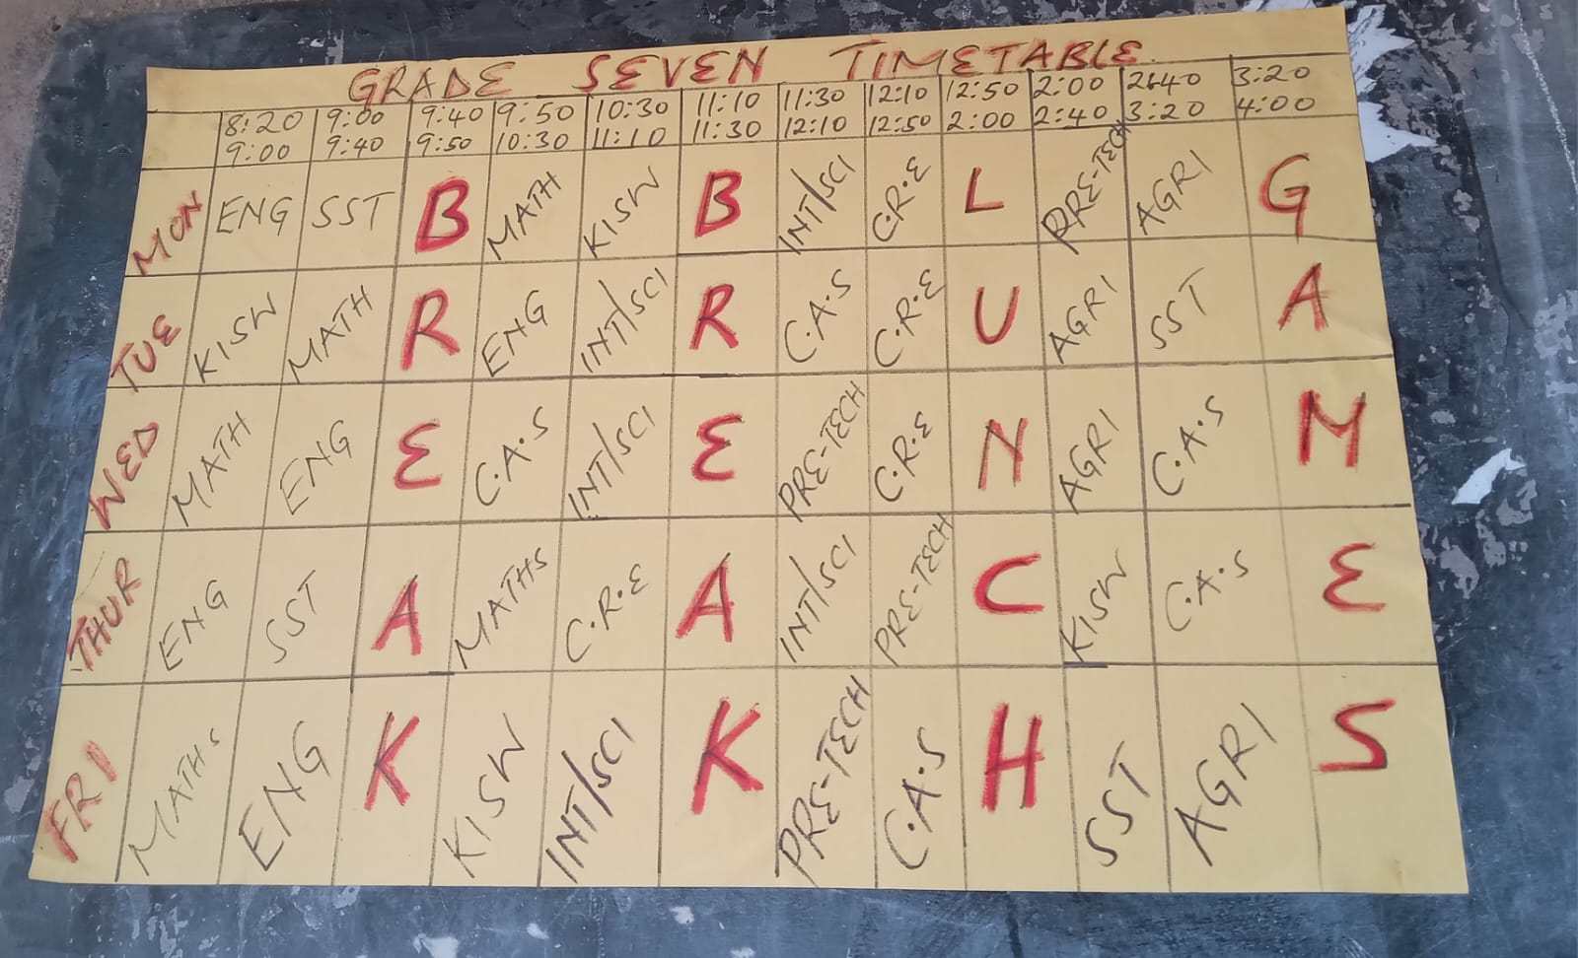
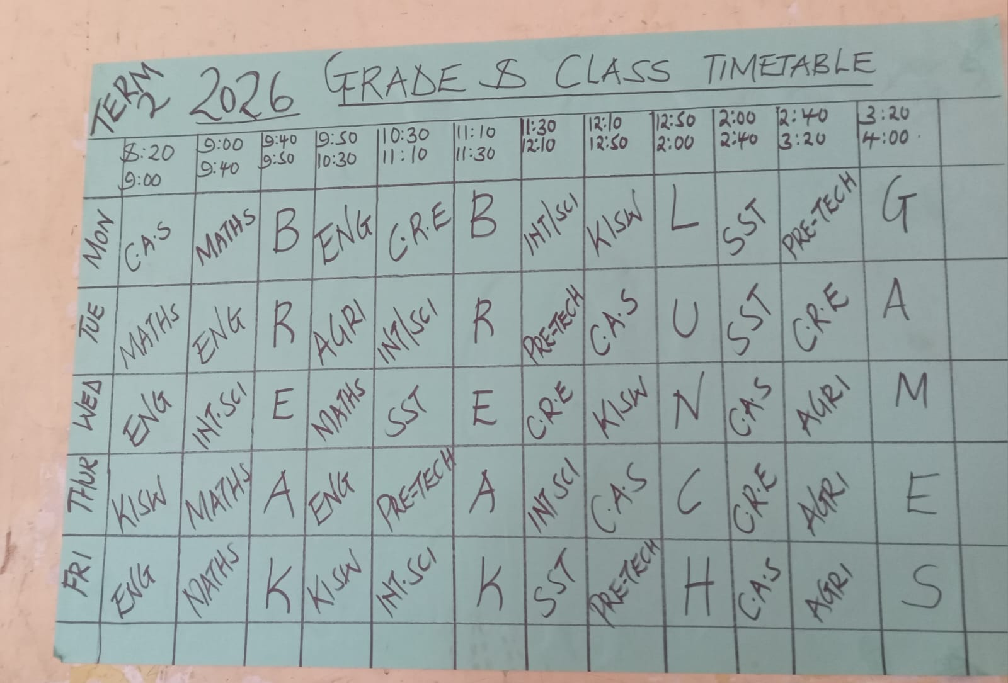
Figure 2 :Timetables

