Q1: Who is the senior most employee based on job title?



Q2: Which countries have the most invoices?

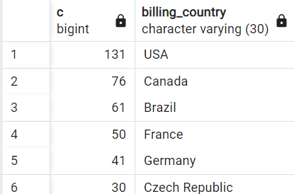

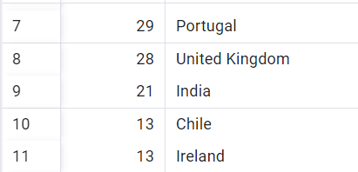

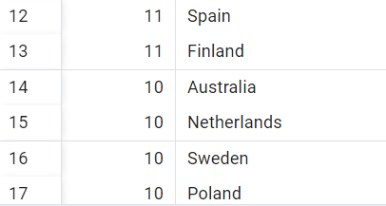

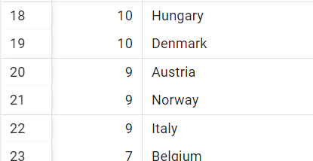



Q3 : What are the top 3 values of total invoice?

SELECT total FROM invoice

ORDER BY total DESC

LIMIT 3;

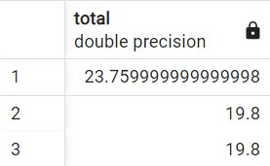

Q4: Which city has the best customers?We would like to throw a promotional Music

Festival in the city we made most money.Write a query that has one city that has

the highest sum of invoice totals.Return both city name and sum of all invoice

totals.

SELECT SUM(total) as invoice_total,billing_city

FROM invoice

GROUP BY billing_city

ORDER BY invoice_total DESC;

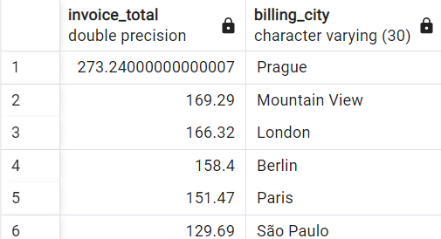

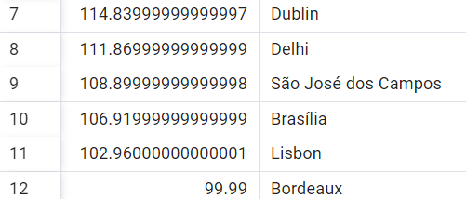

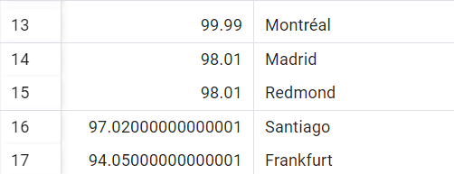

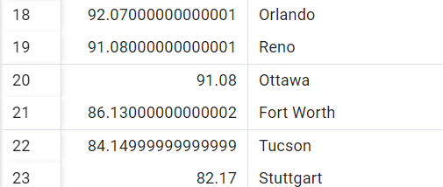

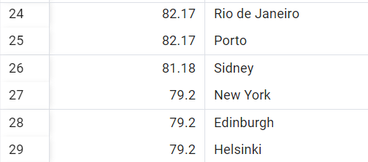

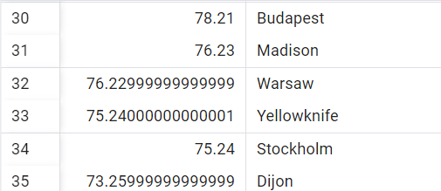

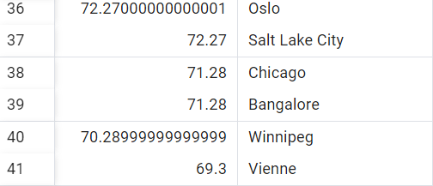

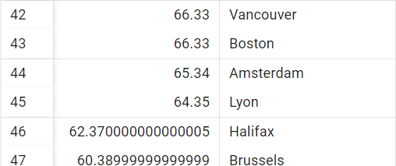

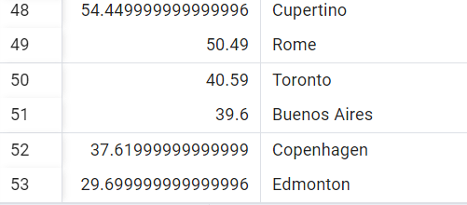

Q5: Who is the best customer?The customer who has spent the most money will be declared

the best customer .Write a query that return the person who has spent the most money.

SELECT customer.customer_id,customer.first_name,customer.last_name,SUM (invoice.total) as total

FROM customer

JOIN invoice ON customer.customer_id = invoice.customer_id

Group BY customer.customer_id

ORDER BY total DESC

LIMIT 1;



Q1: Write query to return the email,first name, last name, & Genre of all Rock music

listeners.Return your list ordered alphabetically by email starting with A.

SELECT DISTINCT email,first_name,last_name

FROM customer

JOIN invoice ON customer.customer_id = invoice.customer_id

JOIN invoice_line ON invoice.invoice_id = invoice_line.invoice_id

WHERE track_id IN(

SELECT track_id FROM track

JOIN genre ON track.genre_id = genre.genre_id

WHERE genre.name = 'Rock'

)

ORDER BY email;

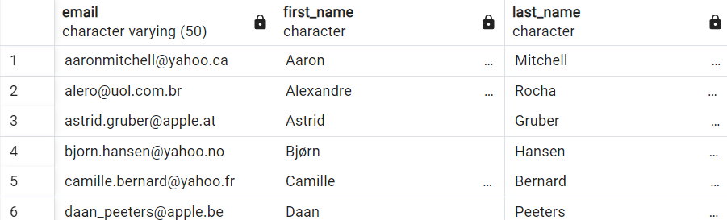

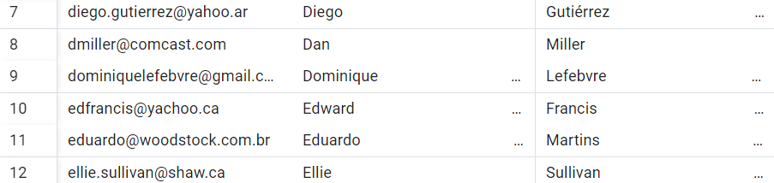

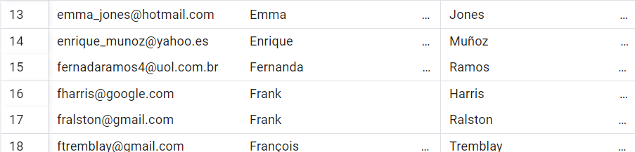

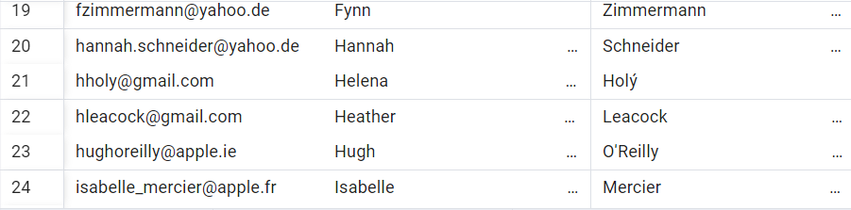

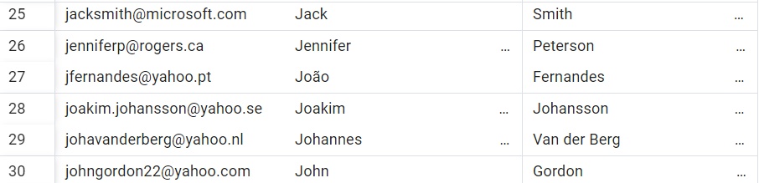

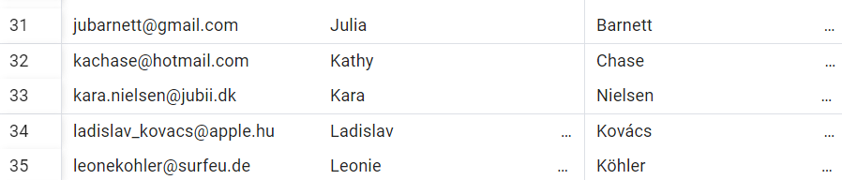



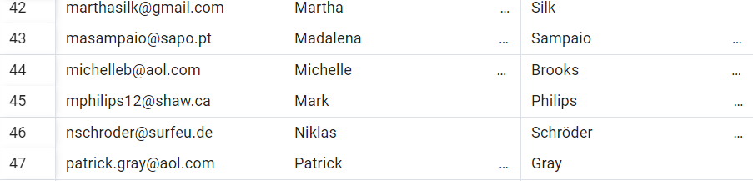

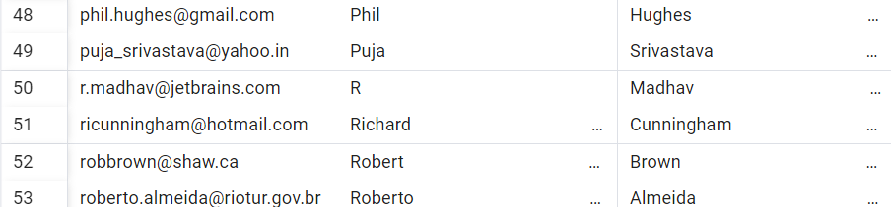

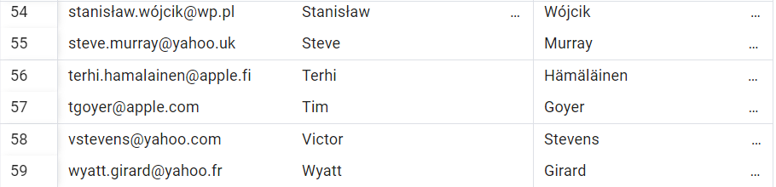

Q2: Lets invite the artists who have written the most rock music in our dataset.

Write a query that returns the artist name and total track count of the top

10 rock bands.

SELECT artist.artist_id,artist.name,COUNT(artist.artist_id) AS number_of_songs

FROM track

JOIN album ON album.album_id = track.album_id

JOIN artist ON artist.artist_id = album.artist_id

JOIN genre ON genre.genre_id = track.genre_id

WHERE genre.name = 'Rock'

GROUP BY artist.artist_id

ORDER BY number_of_songs DESC

LIMIT 10;

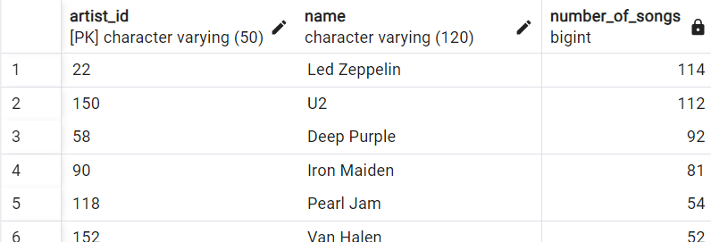

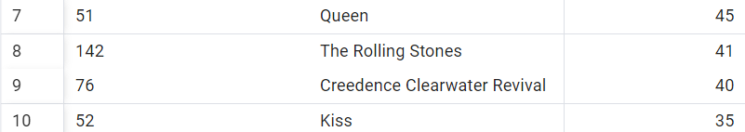

Q3: Return all the track names that have a song length longer than the average song

length.Return the name and milliseconds for each track.Order by the song length with

the longest songs listed first.

SELECT name,milliseconds

FROM track

WHERE milliseconds>(

SELECT AVG(milliseconds) AS avg_track_length

FROM track

)

ORDER BY milliseconds DESC;

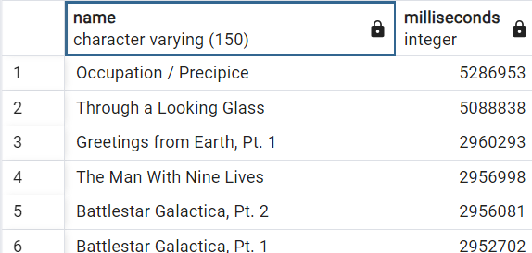

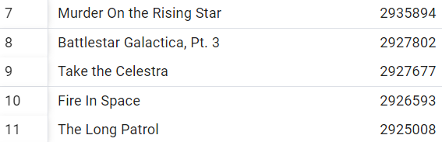

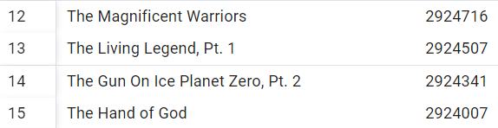

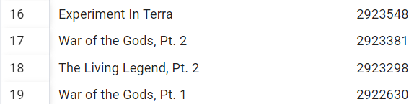

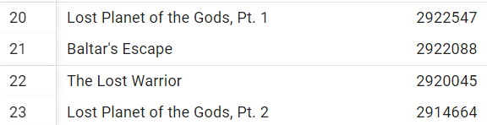

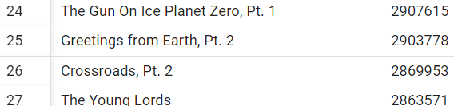

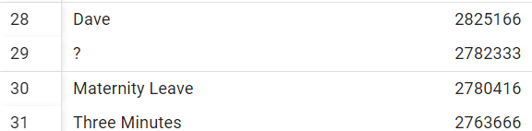

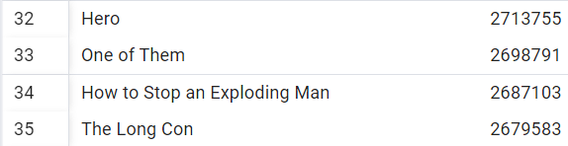

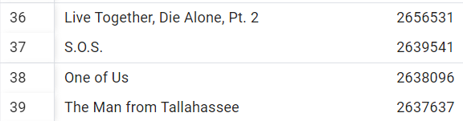

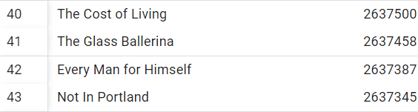

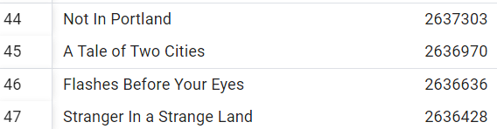

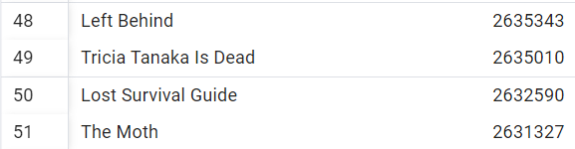

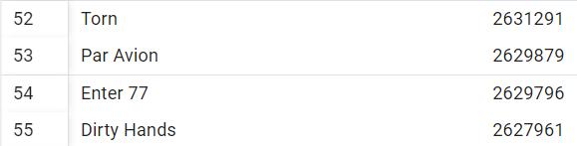

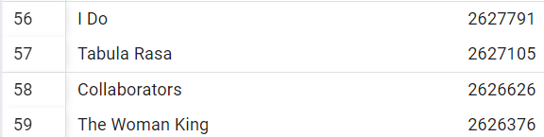

Q1: Find how much amount spent by each customer on artist?Write a query to return

customer name,artist name and total spent

WITH best_selling_artist AS (

SELECT artist.artist_id AS artist_id,artist.name AS artist_name,

SUM(invoice_line.unit_price*invoice_line.quantity) AS total_sales

FROM invoice_line

JOIN track ON track.track_id = invoice_line.track_id

JOIN album ON album.album_id = track.album_id

JOIN artist ON artist.artist_id = album.artist_id

GROUP BY 1

ORDER BY 3 DESC

LIMIT 1

)

SELECT c.customer_id,c.first_name,c.last_name,bsa.artist_name,

SUM(il.unit_price*il.quantity) AS amount_spent

FROM invoice i

JOIN customer c ON c.customer_id = i.customer_id

JOIN invoice_line il ON il.invoice_id = i.invoice_id

JOIN track t ON t.track_id = il.track_id

JOIN album alb ON alb.album_id = t.album_id

JOIN best_selling_artist bsa ON bsa.artist_id = alb.artist_id

GROUP BY 1,2,3,4

ORDER BY 5 DESC;

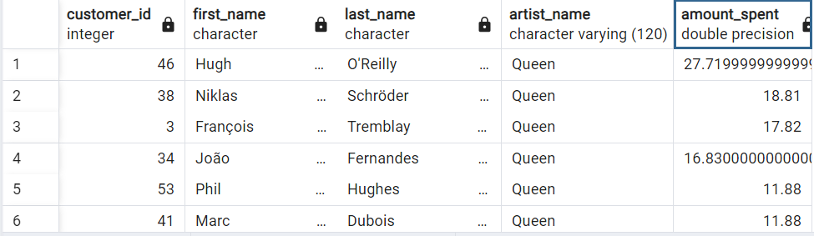

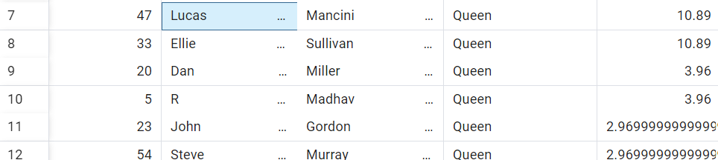

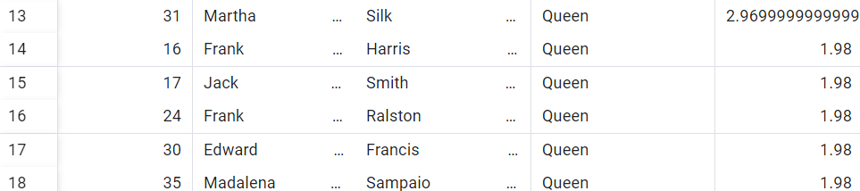

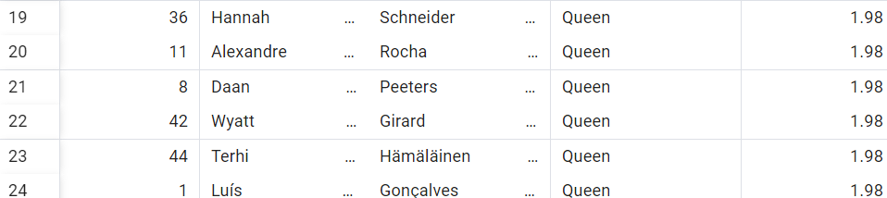

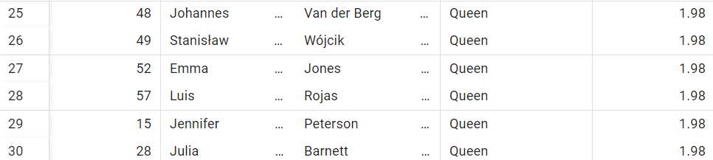

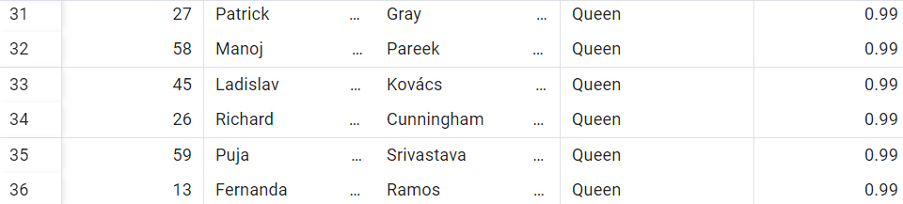

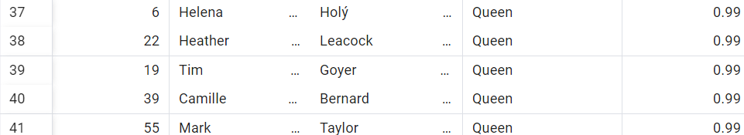



Q2: We want to find out the most popular music Genrefor each country.We determine

The most popular genre as the genre with the highest amount of purchases.Write a query

that returns each country along with top genre.For countries where the maximum number

of purchases is shared return all Genres.

WITH popular_genre AS

(

SELECT COUNT(invoice_line.quantity) AS purchases, customer.country, genre.name, genre.genre_id,

ROW_NUMBER() OVER(PARTITION BY customer.country ORDER BY COUNT(invoice_line.quantity) DESC) AS RowNo

FROM invoice_line

JOIN invoice ON invoice.invoice_id = invoice_line.invoice_id

JOIN customer ON customer.customer_id = invoice.customer_id

JOIN track ON track.track_id = invoice_line.track_id

JOIN genre ON genre.genre_id = track.genre_id

GROUP BY 2,3,4

ORDER BY 2 ASC, 1 DESC

)

SELECT * FROM popular_genre WHERE RowNo <= 1

