Business Request - 1: City-Level Fare and Trip Summary Report

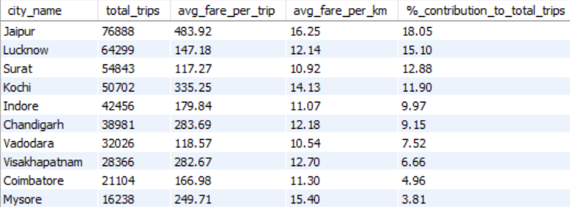

Business Request - 2: Monthly City- Level Trip Target Performance Report

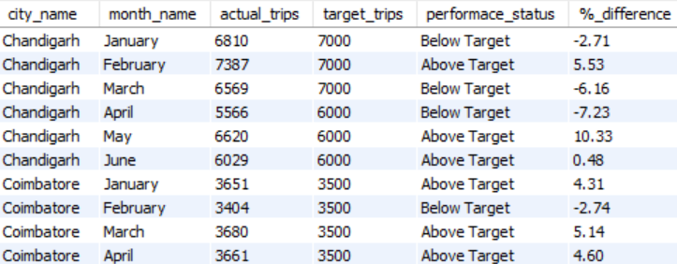

Business Request - 3: City-Level Repeat Passenger Trip Frequency Report

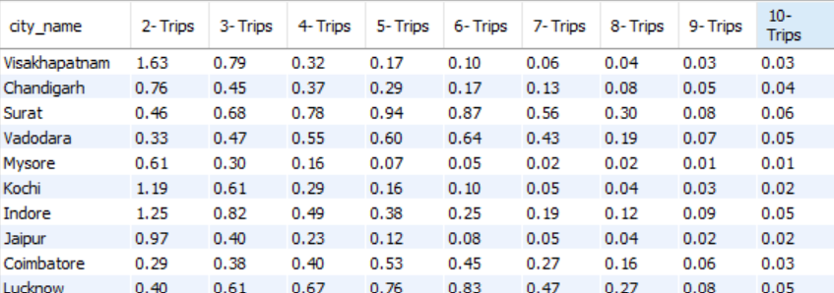

Business Request 4: Identify cities with Highest and Lowest Total New Passengers

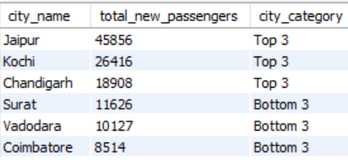

Business Request - 5: Identify Month with Highest Revenue for Each City

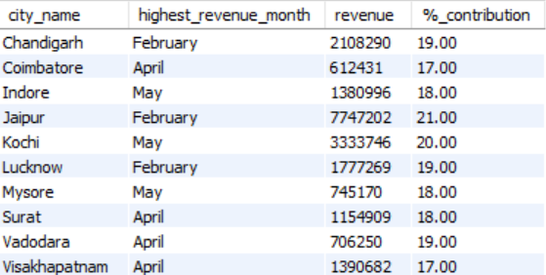

Business Request - 6: Repeat Passenger Rate Analysis

