Business Request - 1: City-Level Fare and Trip Summary Report
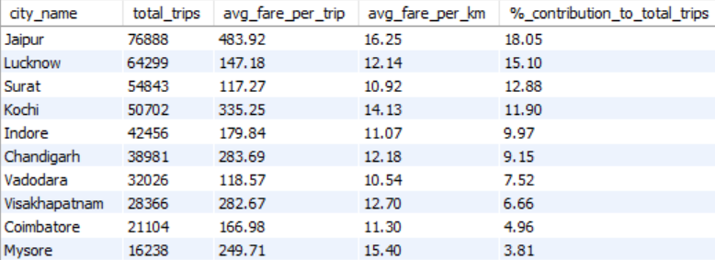

Business Request - 2: Monthly City- Level Trip Target Performance Report
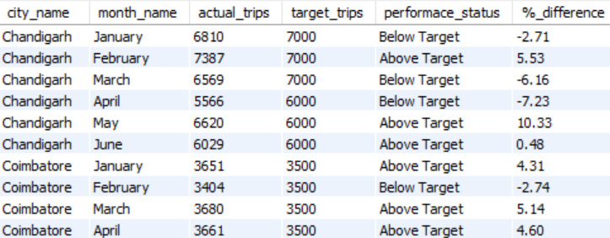

Business Request - 3: City-Level Repeat Passenger Trip Frequency Report
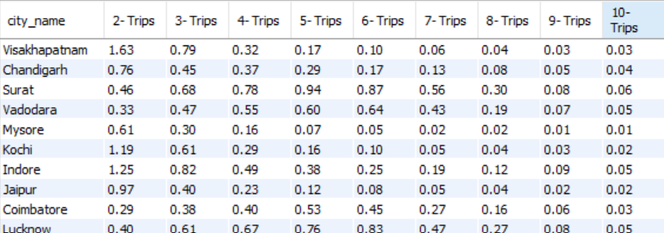

Business Request 4: Identify cities with Highest and Lowest Total New Passengers
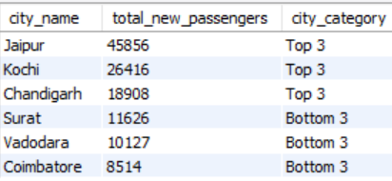

Business Request - 5: Identify Month with Highest Revenue for Each City
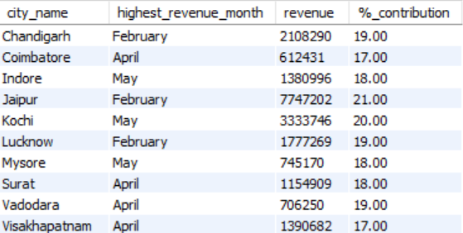

Business Request - 6: Repeat Passenger Rate Analysis
