Q1. Retrieve the total number of orders placed.

SELECT count(order_id) AS total_orders

FROM orders;



Q2.Calculate the total revenue generated from pizza sales.

SELECT

ROUND(SUM(order_details.quantity * pizzas.price),

2) AS total_sales

FROM

order_details

JOIN

pizzas ON pizzas.pizza_id = order_details.pizza_id;

SELECT

ROUND(SUM(order_details.quantity * pizzas.price),

2) AS total_sales

FROM

order_details

JOIN

pizzas ON pizzas.pizza_id = order_details.pizza_id;

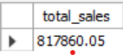

Q3.Identify the highest-priced pizza.

SELECT

pizza_types.name, pizzas.price

FROM

pizza_types

JOIN

pizzas ON pizzas.pizza_type_id = pizza_types.pizza_type_id

ORDER BY pizzas.price DESC

LIMIT 1;

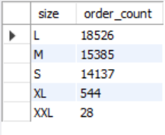

Q4. List the top 5 most ordered pizza types along with their quantities.

SELECT

pizza_types.name, SUM(order_details.quantity) AS quantity

FROM

pizza_types

JOIN

pizzas ON pizza_types.pizza_type_id = pizzas.pizza_type_id

JOIN

order_details ON order_details.pizza_id = pizzas.pizza_id

GROUP BY pizza_types.name

ORDER BY quantity DESC

LIMIT 5;

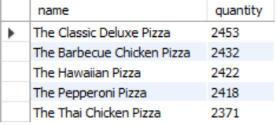

Q5. Join the necessary tables to find the total quantity of each pizza category ordered.

SELECT

pizza_types.category,

SUM(order_details.quantity) AS quantity

FROM

pizza_types

JOIN

pizzas ON pizza_types.pizza_type_id = pizzas.pizza_type_id

JOIN

order_details ON order_details.pizza_id = pizzas.pizza_id

GROUP BY pizza_types.category

ORDER BY quantity DESC;

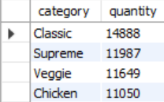

Q6. Determine the distribution of orders by hour of the day.

SELECT

HOUR(order_time) AS hour, COUNT(order_id) AS order_count

FROM

orders

GROUP BY HOUR(order_time);

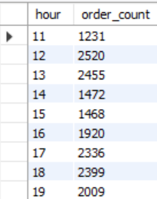



Q7. Group the orders by date and calculate the average number of pizzas ordered per day

SELECT

ROUND(AVG(quantity), 0) AS avg_pizza_ordered_per_day

FROM

(SELECT

orders.order_date, SUM(order_details.quantity) AS quantity

FROM

orders

JOIN order_details ON orders.order_id = order_details.order_id

GROUP BY orders.order_date) AS order_quantity;



Q8. Determine the top 3 most ordered pizza types based on revenue

SELECT

pizza_types.name,

SUM(order_details.quantity * pizzas.price) AS revenue

FROM

pizza_types

JOIN

pizzas ON pizzas.pizza_type_id = pizza_types.pizza_type_id

JOIN

order_details ON order_details.pizza_id = pizzas.pizza_id

GROUP BY pizza_types.name

ORDER BY revenue DESC

LIMIT 3;

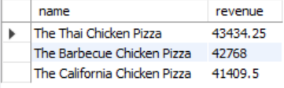

Q9. Calculate the percentage contribution of each pizza type to total revenue

SELECT pizza_types.category,

round(SUM(order_details.quantity* pizzas.price) / (SELECT

ROUND(SUM(order_details.quantity * pizzas.price),2) AS total_sales

FROM order_details

JOIN pizzas ON pizzas.pizza_id=order_details.pizza_id)*100,2) AS revenue

FROM pizza_types

JOIN pizzas ON pizza_types.pizza_type_id = pizzas.pizza_type_id

JOIN order_details On order_details.pizza_id = pizzas.pizza_id

GROUP BY pizza_types.category

ORDER BY revenue DESC;

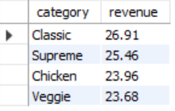

Q10. Analyze the cumulative revenue generated over time.

SELECT order_date,

SUM(revenue) OVER (ORDER BY order_date) AS cum_revenue

FROM

(SELECT orders.order_date,SUM(order_details.quantity * pizzas.price) AS revenue

FROM order_details

JOIN pizzas ON order_details.pizza_id =pizzas.pizza_id

JOIN orders ON orders.order_id = order_details.order_id

GROUP BY orders.order_date) AS sales;

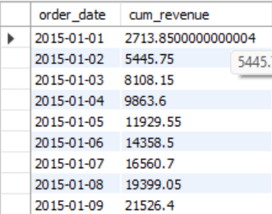

Q11.Determine the top 3 most ordered pizza types based on revenue for each pizza category.

SELECT name,revenue

FROM

(SELECT category,name,revenue,

RANK()OVER(PARTITION BY category ORDER BY name DESC) AS rn

FROM

(SELECT pizza_types.category,pizza_types.name,

SUM(order_details.quantity*pizzas.price) AS revenue

FROM pizza_types

JOIN pizzas ON pizza_types.pizza_type_id = pizzas.pizza_type_id

JOIN order_details ON order_details.pizza_id = pizzas.pizza_id

GROUP BY pizza_types.category,pizza_types.name) AS a) AS b

WHERE rn <= 3;

