PIZZA SALES SQL QUERY

1. KPI’s
2. Total Revenue:

SELECT SUM(total_price) AS total_revenue

FROM pizzasale;

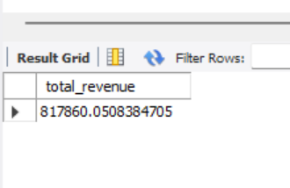

1. Average Order Value:

SELECT SUM(total_price)/COUNT(DISTINCT order_id) AS avg_order_value

FROM pizzasale;

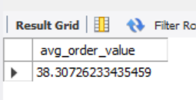

1. Total Pizza Sold:

SELECT SUM(quantity) AS total_pizza_sold

FROM pizzasale;

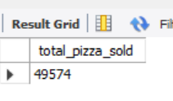

1. Total Orders:

SELECT COUNT(DISTINCT order_id) AS total_order_placed

FROM pizzasale;

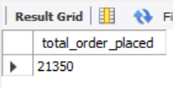

1. Average Pizza per Order:

SELECT ROUND(SUM(quantity)/COUNT(DISTINCT order_id),2) AS avg_pizza_per_order

FROM pizzasale;

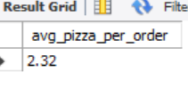

CHARTS REQUIREMENT

1. Daily Trend for Total Orders:

SELECT dayname(order_date) AS order_day,COUNT(DISTINCT order_id) AS total_orders

FROM pizzasale

GROUP BY dayname(order_date) ;

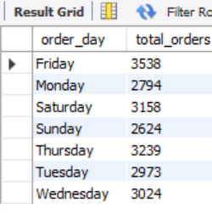

1. Hourly Trend for Total Orders:

SELECT HOUR(order_time) AS order_hours,COUNT(DISTINCT order_id) AS total_orders

FROM pizzasale

GROUP BY HOUR(order_time) ;

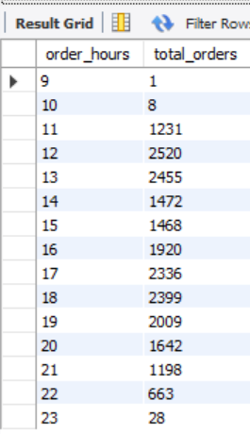

1. Monthly Trend for Total Orders:

SELECT monthname(order_date) AS order_month,COUNT(DISTINCT order_id) AS total_orders

FROM pizzasale

GROUP BY monthname(order_date)

ORDER BY total_orders;

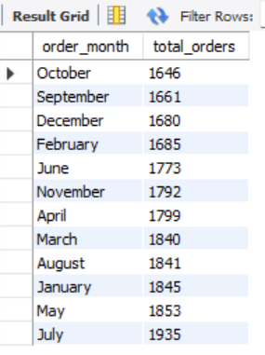

1. Percent of Sales by Pizza Category:

SELECT pizza_category,SUM(total_price) AS total_sales,SUM(total_price) * 100/ (SELECT SUM(total_price) FROM pizzasale) AS PCT

FROM pizzasale

GROUP BY pizza_category;

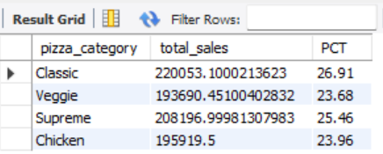

1. Percent of Sales by Pizza Size:

SELECT pizza_size,SUM(total_price) AS total_sales,ROUND(SUM(total_price) * 100/

(SELECT SUM(total_price) FROM pizzasale),2) AS PCT

FROM pizzasale

GROUP BY pizza_size

ORDER BY PCT DESC;

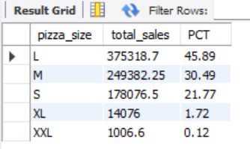

1. Top 5 Best Sellers By Revenue, Total Quantity, and Total Orders

SELECT pizza_name,ROUND(SUM(total_price),2) AS total_revenue

FROM pizzasale

GROUP BY pizza_name

ORDER BY total_revenue DESC

LIMIT 5;

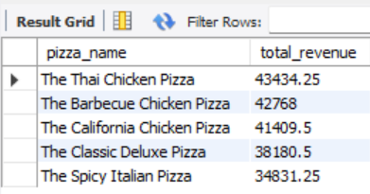

SELECT pizza_name,ROUND(SUM(quantity),2) AS total_quatity

FROM pizzasale

GROUP BY pizza_name

ORDER BY total_quatity DESC

LIMIT 5;

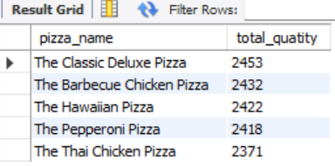

SELECT pizza_name,ROUND(COUNT(DISTINCT order_id),2) AS total_orders

FROM pizzasale

GROUP BY pizza_name

ORDER BY total_orders DESC

LIMIT 5;

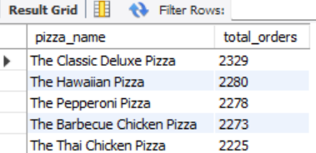

1. Bottom 5 Sellers By Revenue, Total Quantity, and Total Orders

SELECT pizza_name,ROUND(SUM(total_price),2) AS total_revenue

FROM pizzasale

GROUP BY pizza_name

ORDER BY total_revenue ASC

LIMIT 5;

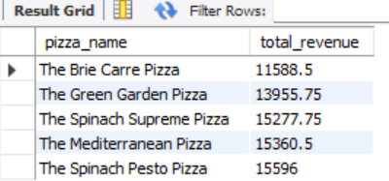

SELECT pizza_name,ROUND(SUM(quantity),2) AS total_quantity

FROM pizzasale

GROUP BY pizza_name

ORDER BY total_quantity ASC

LIMIT 5;

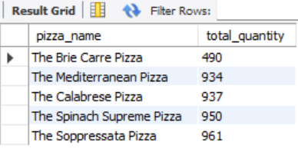

SELECT pizza_name,ROUND(COUNT(DISTINCT order_id),2) AS total_orders

FROM pizzasale

GROUP BY pizza_name

ORDER BY total_orders ASC

LIMIT 5;

