Intensity Transformations and Neighborhood Filtering

Assignment 1

Biyon Fernando - 190178J

March 1, 2022

**Question 1**

To achieve intensity, transform for the image given a lookup table method is used. As the pixel values are in uint8 type those values can directly used as indexes to access mapped values in lookup table. Using NumPy array of 256 elements functionality of lookup table can achieved.

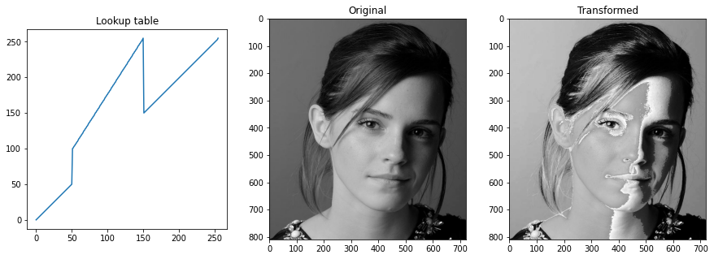

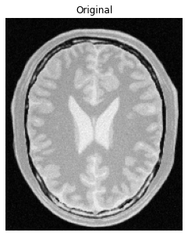**Question 2**

In the question we were given proton density image of the brain. These images show gray color for the white matter and white color for the gray matter. Therefore, we can attenuate white color and dark colors using point function to accentuate gray color and attenuate gray colors and dark colors to accentuate white color as bellow.

Here I have preserved the original variations of the white and gray matter areas. 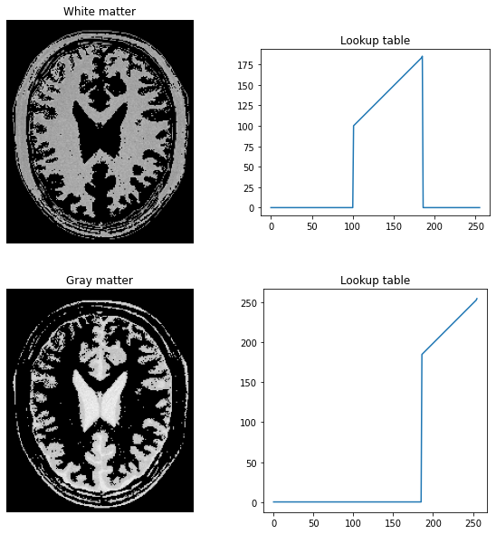

**Question 3**

In L*a*b color space we can manipulate perceptual lightness and red, green, blue, and yellow four unique colors of human vision. L axis contains lightness factor. Appling gamma correction changes the lightness of the image. For gamma< 1 higher lightness can observe while gamma>1 shows lower lightness.

Original image and its histogram is shown below.

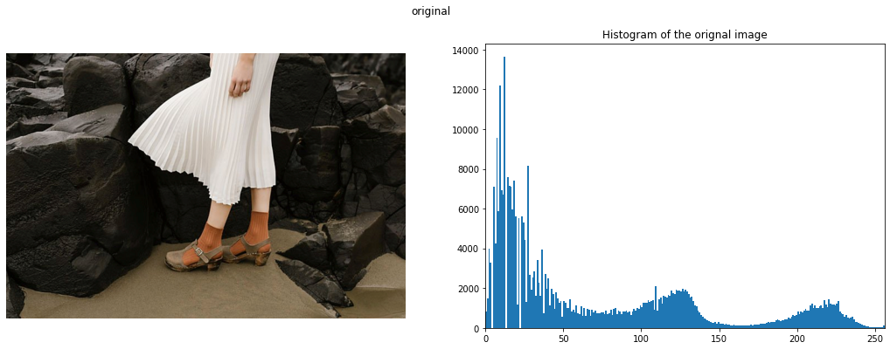



Gamma correction is done using a lookup table as above. This lookup table can visualize as bellow.

After Applying this correction, we can observe the output image and its histogram as bellow.

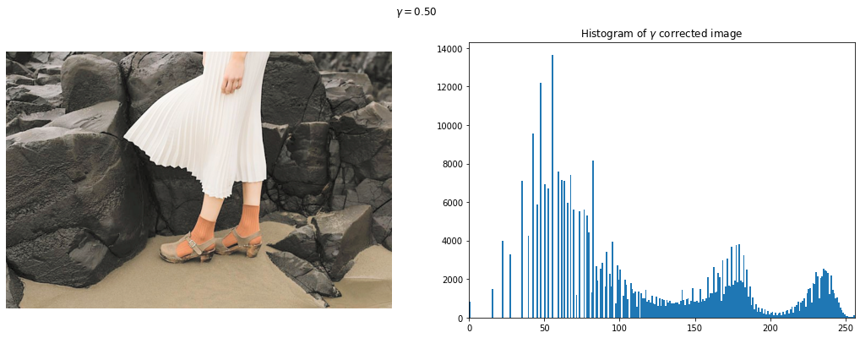

**Question 4**

We can derive pointwise intensity transform for the equalized image using basic probability thermos. The equation of the transform is given bellow.

(Reference – lecture slides)

A python function can write according to this equation as bellow to return a lookup table for transformation.

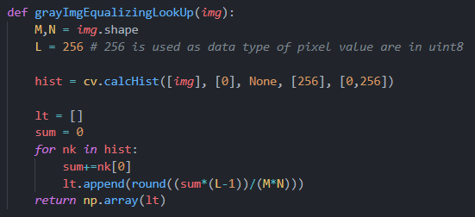

After applying the equalizing transform to a gray scale image, we can observe enhancement of colors as bellow. And the equalized property of colors can significantly observe by comparing original and equalized images histograms. Graphical user interface

**Question 5**

In nearest-neighbor zoom method uses pixel values of the nearest position to the corresponding coordinates in the original image to the zoomed image.

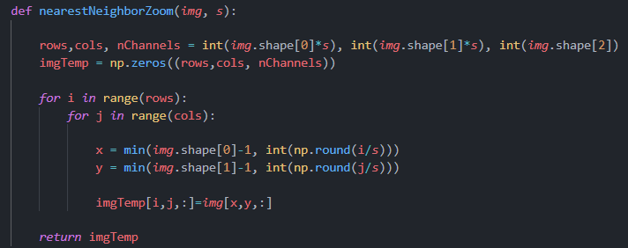

To remove the edge problems original image shape is used as a threshold.

In bilinear interpolation method we interpolate pixel values for the exact coordinate using values in the neighbor pixel values.

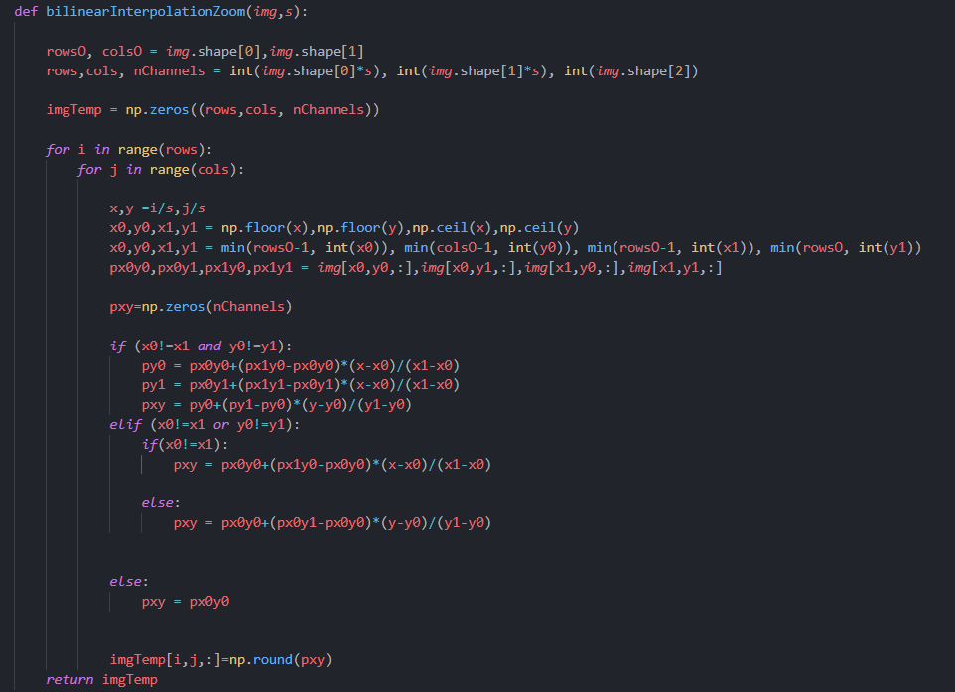

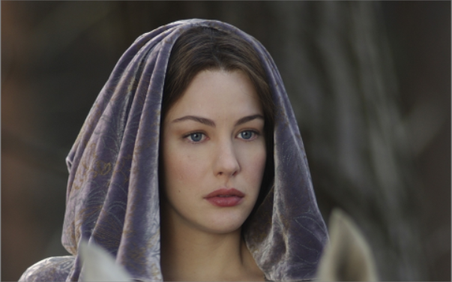After zooming the image shown in right 4 times, using nearest-neighbor and bilinear interpolation algorithms bellow results were able to achieve. Among the two of this algorithm bilinear interpolation method gives more smooth intensity distribution in neighbor pixels.

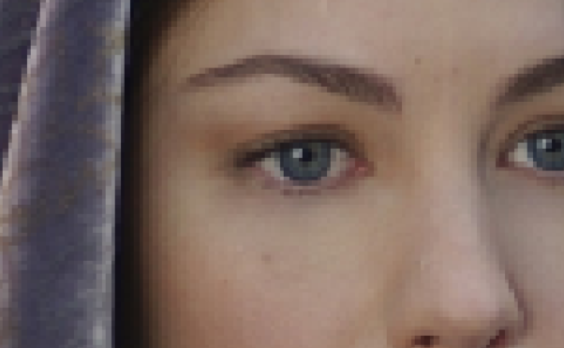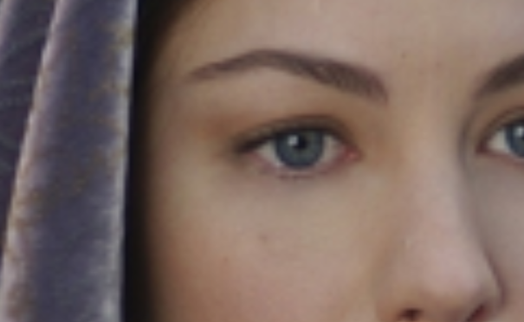

A Cropped part of the zoom image from nearest-neighbor method

A Cropped part of the zoom image from bilinear interpolation method

To calculate the normalized sum of squared difference (SSD) following equation is used.



Normalized SSD values for each algorithm

|  |  |  |
| --- | --- | --- |
| Image number | nearestNeighborZoom | bilinearInterpolationZoom |
| 01 | 40.1117 | 37.7171 |
| 02 | 16.7930 | 16.1221 |

To interpret the above value, we can use square root values of these SSD values. For the above applied algorithms square root value was around 4-6. As we can observe bilinear interpolation method give less error than nearest neighbor method.

**Question 6**

**a)**



Sobel kernels shown above is used.

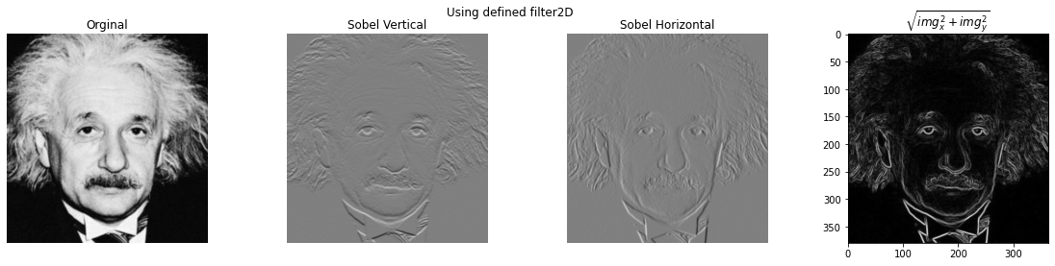

**b)**

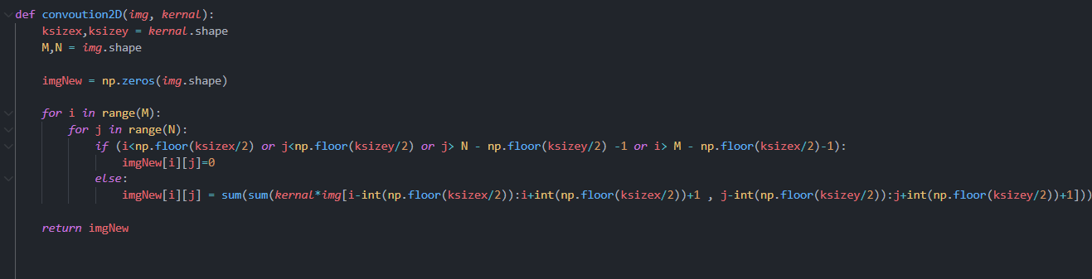

Above code give same results as filter2D. 

**c)**

To apply the same effect as above Sobel filters these A and B 1D matrixes were convolved with the image. This is possible because of the associativity property of convolution. Results obtained are given bellow.

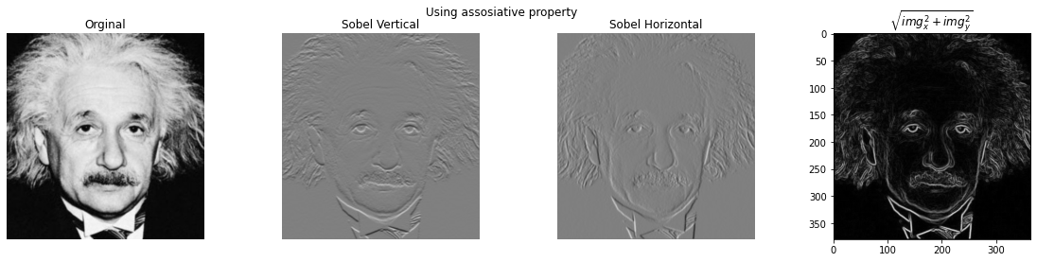

**Question 7**

GrabCut algorithm capable of extract foreground and background of the image by labeling image pixel with its color statistics, edge detection and data provided by user as rectangle or mask.

**a)**

segmentation mask, foreground image, and background image generated by the algorithm given bellow.

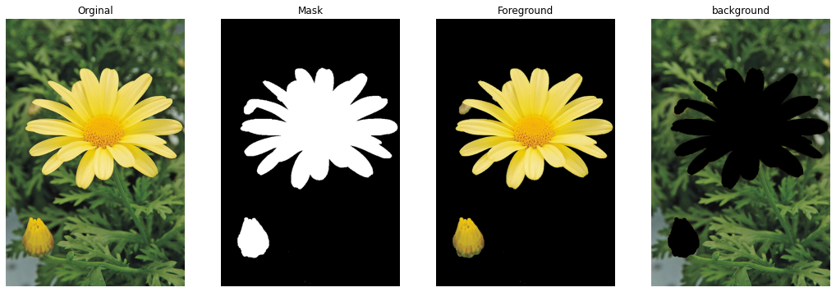

**b)**

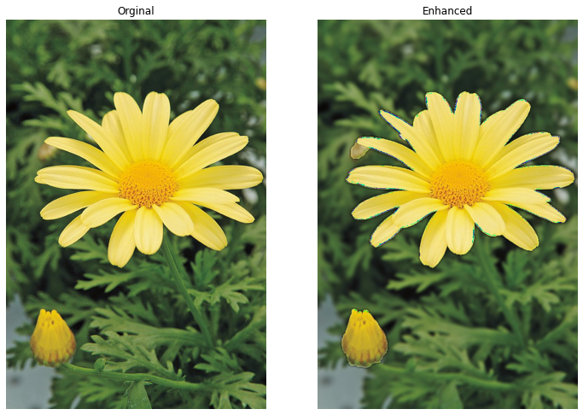By adding gaussian blur to the background image and combine it with the foreground image we can enhance the image.

**c)**

As background image has black area for the foreground parts, convolution results give lower values when we doing the gaussian blurring around those edge areas therefor we can observe quite dark in the enhanced image just beyond the edge of the flower.