**MOTHERBOARD**

**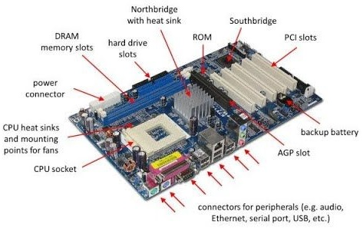**

A **motherboard** (also called **mainboard**, main **circuit board**,[[1]](https://en.wikipedia.org/wiki/Motherboard" \l "cite_note-Engadget-1) or **mobo**) is the main [printed circuit board](https://en.wikipedia.org/wiki/Printed_circuit_board) (PCB) in general-purpose computers and other expandable systems. It holds and allows communication between many of the crucial electronic components of a system, such as the [central processing unit](https://en.wikipedia.org/wiki/Central_processing_unit) (CPU) and [memory](https://en.wikipedia.org/wiki/Computer_memory), and provides connectors for other [peripherals](https://en.wikipedia.org/wiki/Peripherals). Unlike a [backplane](https://en.wikipedia.org/wiki/Backplane), a motherboard usually contains significant sub-systems, such as the central processor, the [chipset](https://en.wikipedia.org/wiki/Chipset)'s [input/output](https://en.wikipedia.org/wiki/Input/output) and memory controllers, [interface](https://en.wikipedia.org/wiki/Interface_(computing)) connectors, and other components integrated for general use.

*Motherboard* means specifically a PCB with expansion capabilities. As the name suggests, this board is often referred to as the "mother" of all components attached to it, which often include peripherals, interface cards, and [daughterboards](https://en.wikipedia.org/wiki/Expansion_card" \l "Daughterboard" \o "Expansion card): [sound cards](https://en.wikipedia.org/wiki/Sound_card), [video cards](https://en.wikipedia.org/wiki/Video_card), [network cards](https://en.wikipedia.org/wiki/Network_card), [host bus adapters](https://en.wikipedia.org/wiki/Host_bus_adapter), [TV tuner cards](https://en.wikipedia.org/wiki/TV_tuner_card), [IEEE 1394](https://en.wikipedia.org/wiki/IEEE_1394) cards; and a variety of other custom components.

**Ram modules**

**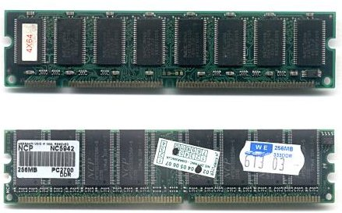**

In [computing](https://en.wikipedia.org/wiki/Computing), a **memory module** or **RAM (**[**random-access memory**](https://en.wikipedia.org/wiki/Random-access_memory)**) stick** is a [printed circuit board](https://en.wikipedia.org/wiki/Printed_circuit_board) on which [memory](https://en.wikipedia.org/wiki/Computer_memory) [integrated circuits](https://en.wikipedia.org/wiki/Integrated_circuit) are mounted.[[1]](https://en.wikipedia.org/wiki/Memory_module#cite_note-1) Memory modules permit easy installation and replacement in electronic systems, especially computers such as [personal computers](https://en.wikipedia.org/wiki/Personal_computer), [workstations](https://en.wikipedia.org/wiki/Workstation), and [servers](https://en.wikipedia.org/wiki/Server_(computing)).

There are two main types of RAM: **Dynamic RAM (DRAM) and Static RAM (SRAM)**. DRAM (pronounced DEE-RAM), is widely used as a computer's main memory. Each DRAM memory cell is made up of a transistor and a capacitor within an integrated circuit, and a data bit is stored in the capacitor.

**DAUGHTERCARD**

**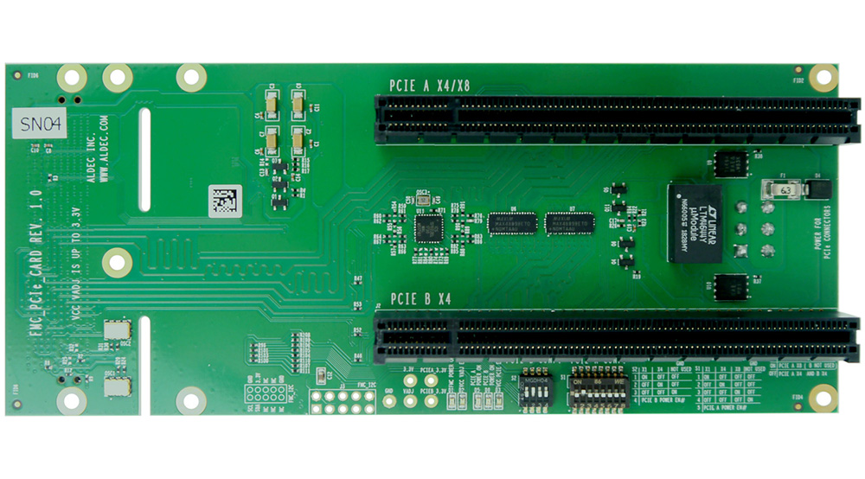**

A daughterboard (or daughter board , daughter card , or daughtercard ) is a circuit board that plugs into and extends the circuitry of another circuit board. The other circuit board may be the computer's main board (its motherboard ) or it may be another board or card that is already in the computer, often a sound card. The term is commonly used by manufacturers of wavetable daughterboards that attach to existing sound cards.

**BUS SLOTS**

**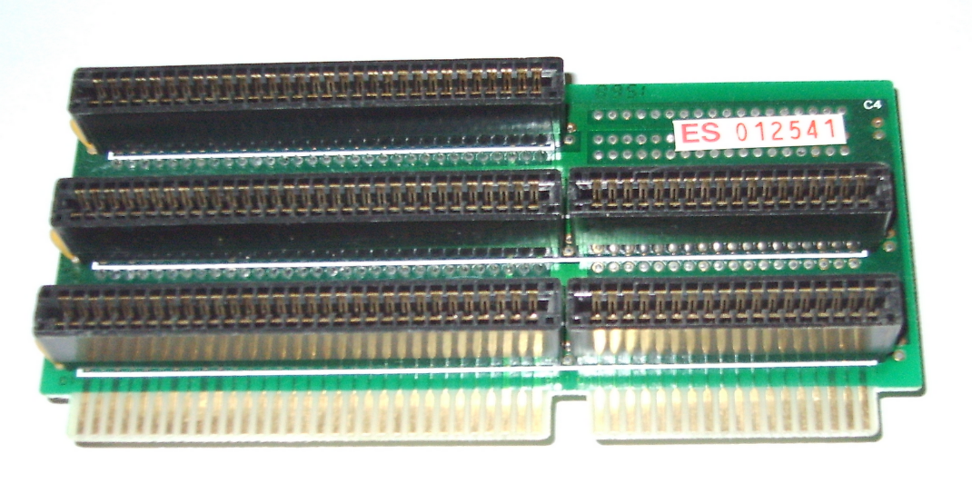**

Alternatively known as a bus slot or expansion port, an expansion slot is a connection or port inside a [computer](https://www.computerhope.com/jargon/c/computer.htm) on the [motherboard](https://www.computerhope.com/jargon/m/mothboar.htm) or [riser card](https://www.computerhope.com/jargon/r/risecard.htm). It provides an installation point for a hardware expansion card to be connected. For example, if you wanted to install a new video card in the computer, you'd purchase a video expansion card and install that card into the compatible expansion slot.

**SWITCHED-MODE POWER SUPPLY (SMPS)**

**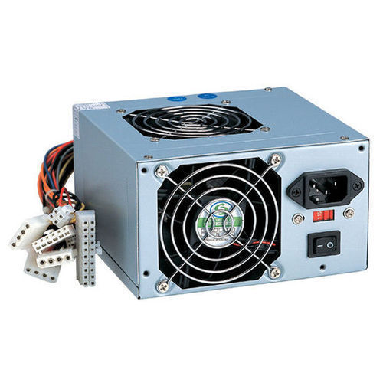**

A switched-mode power supply (SMPS) is an electronic circuit that converts power using switching devices that are turned on and off at high frequencies, and storage components such as inductors or capacitors to supply power when the switching device is in its non-conduction state.

Switching power supplies have high efficiency and are widely used in a variety of electronic equipment, including computers and other sensitive equipment requiring stable and efficient power supply.

A switched-mode power supply is also known as a switch-mode power supply or switching-mode power supply.

**INTERNAL STORAGE DEVICES**

**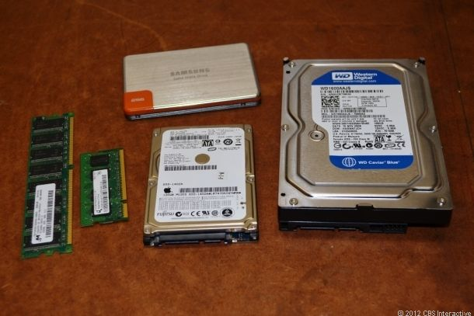**

A storage unit is a part of the computer system which is employed to store the information and instructions to be processed. A storage device is an integral part of the computer hardware which stores information/data to process the result of any computational work. Without a storage device, a computer would not be able to run or even boot up. Or in other words, we can say that a storage device is hardware that is used for storing, porting, or extracting data files. It can also store information/data both temporarily and permanently. Computer storage is of two types:

* **Primary Storage Devices:** It is also known as internal memory and main memory. This is a section of the CPU that holds program instructions, input data, and intermediate results. It is generally smaller in size. RAM (Random Access Memory) and ROM (Read Only Memory) are examples of primary storage.
* **Secondary Storage Devices:**Secondary storage is a memory that is stored external to the computer.  It is mainly used for the permanent and long-term storage of programs and data. Hard Disk, CD, DVD, Pen/Flash drive, SSD, etc, are examples of secondary storage.

**INTERFACING PORTS**

**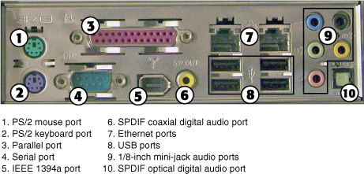**

A **port** is basically a physical docking point which is basically used to connect the external devices to the computer, or we can say that A port act as an interface between the computer and the external devices, e.g., we can connect hard drives, printers to the computer with the help of ports.