**17.Solving systems of equations with numpy**

**One of the more common problems in linear algebra is solving a matrix-vector equation.**

**Here is an example. We seek the vector x that solves the equation**

**A X = b**

**Where** 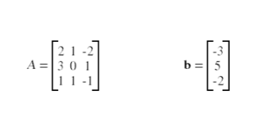

**And X=A -1 b.**

**Numpy provides a function called solve for solving such eauations.**

**Write a program to find out the value of X using solve(), given A and b as above**

print("Sivapriya Rajan")  
print("SJC21MCA-2042")  
import numpy as np  
A = np.array([[2, 1, -2],  
 [3, 0, 1],  
 [1, 1, -1]])  
print("matrix A\n",A)  
  
b = np.array([[-3],  
 [5],  
 [-2]])  
print("matrix b\n",b)  
a=np.linalg.inv(A)  
x= np.linalg.solve(a, b)  
print("Value of X=A -1 b: ")  
print(x)

