**14. Multiply a matrix with a submatrix of another matrix and replace the same in larger**

**matrix.**

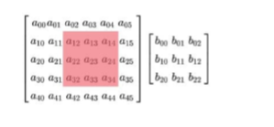

print("Sivapriya Rajan")  
print("SJC21MCA-2042")  
import numpy as np  
np.random.seed(42)  
A = np.random.randint(0, 10, size=(5, 6))  
B = np.random.randint(0, 10, size=(3, 3))  
print("Matrix A:\n{}\n".format(A))  
print("Matrix B:\n{}\n".format(B))  
C = A[1:4, 2:5] @ B  
A[1:4, 2:5] = C  
print("Matrix c:\n{}\n".format(C))  
  
print("Matrix A after sub-matrix multiplication:\n{}\n".format(A))