**5. 100 students were asked what their primary mode of transport for getting to school was. The results of this survey are recorded in the table below. Construct a bar graph representing this information.**

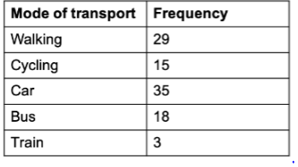

**Create a bar graph with**

**• X axis -mode of Transport and Y axis ‘frequency’**

**• Provide appropriate labels and title**

**• Width .1, color green**

print("Sivapriya Rajan")  
print("SJC21MCA-2042")  
  
import matplotlib.pyplot as plt  
x=['walking','cycling','car','bus','train']  
y=[29,15,35,18,3]  
plt.xlabel('mode of transport')  
plt.ylabel('frequency')  
plt.bar(x,y, width=0.1 ,color="green")  
plt.show()