Program3
Add complex numbers
Program

package complexnum;

import java.util.Scanner;
public class Complexnum {
int real,img;

Complexnum(){

}

Complexnum(int realn,int imgn){
real=realn;
img=imgn;

}

public Complexnum add(Complexnum c1,Complexnum c2){
Complexnum c=new Complexnum();
c.real=c1.real+c2.real;
c.img=c1.img+c2.img;
return c;
}

public static void main(String[] args) {
int real1,img1,real2,img2;

Scanner sc=new Scanner(System.in);

System.out.println("Enter first number real part");
real1=sc.nextInt();
System.out.println("Enter the first number imaginary part");
img1=sc.nextInt();
System.out.println("Enter second number real part");
real2=sc.nextInt();
System.out.println("Enter the second number imaginary part");
img2=sc.nextInt();

Complexnum c1=new Complexnum(real1,img1);
Complexnum c2=new Complexnum(real2,img2);
Complexnum c3=new Complexnum();

c3=c3.add(c1,c2);

System.out.println("\ncomplex no 1:"+real1+"+i"+img1);
System.out.println("\ncomplex no 2:"+real2+"+i"+img2);

System.out.println("\nThe sum of numbers = "+c3.real+"+i"+c3.img);

}

}

Output

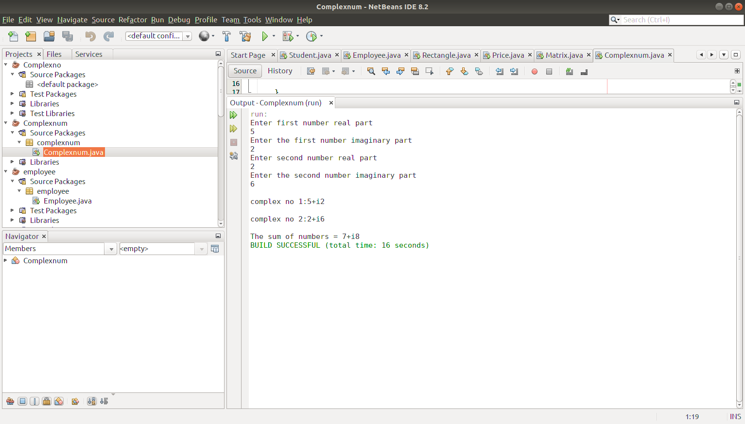

Program4

Create CPU with attribute price. Create inner class Processor (no. of cores, manufacturer)
and static nested class RAM (memory, manufacturer). Create an object of CPU and print
information of Processor and RAM.

Program

package main;

class CPU {
double price;
// nested class
class Processor{

// members of nested class
double cores;
String manufacturer;

double getCache(){
return 4.3;
}
}

// nested protected class
protected class RAM{

// members of protected nested class
double memory;
String manufacturer;

double getClockSpeed(){
return 5.5;
}
}
}

public class Main {
public static void main(String[] args) {

// create object of Outer class CPU
CPU cpu = new CPU();

// create an object of inner class Processor using outer class
CPU.Processor processor = cpu.new Processor();

// create an object of inner class RAM using outer class CPU
CPU.RAM ram = cpu.new RAM();
System.out.println("Processor Cache = " + processor.getCache());
System.out.println("Ram Clock speed = " + ram.getClockSpeed());
}
}

Output

