Quotes

"Simple, correct, fast. In that order."

"Early optimization is the root of all evil."

"Everything should have a singular, clear, and intuitive responsibility."

"Hide the complicated behind the simple."

"Functions should do one thing, and error handling is often one thing."

"Prefer to put data in the objects clearly responsible for it, rather than in one giant container."

"Names must be quick/easy/intuitive to say out loud*, search for*, and say WHAT they are, instead of HOW they got there."

"It is easier to write code than it is to read it."

"An if() is small price to pay for intuitive/well-defined/correct/stable behavior."

"A print/cout/log-entry is a small price to pay compared to hours of confused rage-fueled debugging."

"Think of programming as iterative."

"Do not change the container you are iterating through."

-

If your calculation is any kind of "from" and "to", and you want the difference (Or subtract), then always:
"Take where you're going (To) and subtract where you are (From), and then you get a diff that you add to (From) and get to (To)"

loot=(-100, -100);
lazy=(5, 20);

const sf::Vector2i diff( loot - lazy); //(-105, -120)

lazy += diff; //(-100, -100)

-

Programming Priorities
Your code should be, in this order:

Simple
80% of a programmer's time is spent understanding other code.
It is MUCH easier to SEE and TEST for bugs/assumptions/vulnerabilities in simple code.
Simpler code means less experienced developers can create and maintain it.

Tested/Correct
Code that works perfectly is NOT the first priority.
It is wise to write a first version in very simple code, that either does only ONE thing correctly, or that does everything correctly but is too slow. If this first incomplete version is simple and comes with a test suite that clearly shows what is lacking, then your overall project is VASTLY more likely to succeed, on time, and under budget.
Just the act of taking the time to write tests ALWAYS ends up helping others to understand your code, but also ALMOST always finds and fixes bugs.

Fast
Typically only 1-10% of your code needs to be fast.
Clearly documenting these places in the code is CRITICAL.
Writing faster code ALMOST ALWAYS makes the code more complicated, which makes it MUCH harder to test/maintain. (this kills big projects all the time)
It is MUCH quicker/easier to make pre-existing simple/slow code faster.
Start with a version that is slow, but simple with LOTS of tests, THEN add a new version that is faster and more complex -but still passes all the same tests!

-

Names

Picking good names is difficult, iterative, and partially an art form, but absolutely every programmer must devote themselves to the life-long pursuit of perfect names. Good names make the code simpler, and just look above for all the amazing rewards that brings by itself. Good names also make your code self-documenting with no real need for comments. Finally, good names mean FAR fewer bugs.

All names should be:

Pronouncable
All names should be quick/easy/intuitive to say out loud.

Searchable
Avoid single letter names and anything else that will make it hard to search for.

Remove noisy and redundant stuff:
Such as: info/data/var/manager/member/packet

DON'T put the type in the name:
Such as: vec/vector/int/float
UNLESS it is for convenience/short-hand, such as IActorVec_t, or PilotNameToProfileMap_t

DO put the unit in the name:
Such as: seconds/sec/feet/ft/

These names are code smell that indicates problems with the code:
and/also/might/maybe

Names should reveal intention (the 'what'), not operations (the 'how').
Prefer "ageSum" or "ageTotal" to "agesAddedTogether"

Class names are nouns
Except for pure-virtual interfaces whose names start with a capital 'I' and often include verbs: IActor, IDrawable, etc.

Function names are verbs
Start with "is" if they return a bool.

Avoid plural names as much as you can while still being simple to understand.

-

Class Design

Every class should have a singular, clear, and intuitive responsibility.
That responsibility should translate into member variables and functions that are not accessible or even visible to the user.
You should not be able to use the class the wrong way.

Cohesion
A measure of how related everything in the class is to each other, and to the singular purpose of the class.

Coupling
How many ways can other code connect to or use this class?
How much do users of this class have to know about how it works to use it correctly?

-

Function Design

First, you need to figure out what category of function you are writing:
Making something?
Calculating something?
Controlling or causing something to happen somewhere else?
Acting like a switch, or start/stop pattern?
Orchestrating a long/complicated process under the guise of a short/clear/simple function name?
Error handling?

Second, you need to figure out all the ways the function could fail, and handle them all. (or at least clearly comment them all...)

Consider:
Empty/bad/invalid/non-sensical input/parameters/dependancies
Exceptions
Running out of memory
Looping too many times
Waiting too long for required resources from other code

How to deal with it:
Doing nothing with some early returns at the very top of the function
Returning or creating the one and only obvious default thing
Throw an exception
Assert

-

Why do so many large/experienced/well-funded software projects not just fail, but completely fail with nothing to show for it -nothing.

Software project design/development is ITERATIVE, even if you try to avoid it, and much more difficult than most other kinds of projects.

Usually, you know an iterative project is going well if each iteration is shorter/easier than the last. However, this is NOT the case with software projects. Half of the time this is because the software was not designed/developed/maintained correctly. The other half of the time it is because software 'just works that way'. Adding just one new feature could require most of the code to be changed. This happens (primarily) for these reasons:

1. For every one thing that you can assume will never change, means there are ten-to-a-hundred things you now don't have to write code for.
2. Anyone can make a blueprint/flowchart/UML/etc that shows what some software does, but VERY FEW know how to also show what the design assumes, and thusly, what will be hard/costly to change later.
3. It is VERY tempting for programmers to write more code than is required, because it feels more robust and useful that way. ("Look boss! Now the code also does all this other stuff! Isn't that great?")
4. It is VERY tempting for EVERYONE involved to implement new features by cutting-corners and hacking them into place, instead of taking the time/money to change the whole design in a way that will not easily break when the next change/feature arrives.

So software projects often suffer in time, cost, or just flat-out fail because:

- Everyone makes a ton of huge assumptions that save time/money in the short term, But since they are not documented or known to planners/sales/marketing/managment/etc, new features often end up violating those assumptions costing tons of time/money.

- This is only made worse by programmers who write more code than is required, thinking that they are making the code better, but in the end they just add more bugs, testing time, and worst of all, assumptions.

Design Patterns

Smart pointer

Model/View/Controller Architecture Pattern

+ The point of this architecture pattern is to create a good object oriented design that minimizes coupling and maximizes cohesion.
- Too general, never the final solution. Must be customized.

Model = How the data is laid out in memory (or on the disc, etc.)
View = How we pull data out of the model and change it so it can be output to something else. (Presenter, any kind of output, how it's translated for consumption)
Controller = How data comes in and is given to the model

How to start writing an application (Architecture)

Object Oriented Design (OOD)
Human intuitive way of breaking the code into who's responsible for what

Model/View/Controller
Clearest and simplest way for the different parts of the code to communicate

Finite State Machine
Helps make a fence around the infinite possibilities, helps to see the whole picture

Data Oriented Design (DOD)
More difficult for humans to read

Vectors
In general, vectors are always a “direction” and an “amount.”
Vectors have to support addition/combination and multiplication/scaling.
Addition = changes direction and magnitude (unless those vectors were normalized, then only the direction changes).
Multiplication = changes only the magnitude.

Polar Vectors
“Angle” and “length,” relative to the reference vector.
Pro: What humans imagine when they think of vectors.
Cons: Needs a reference vector, takes more work.
Polar vectors are handy when the reference for all the vectors is the same, or it doesn’t matter.

Physicists love it because:

Our position equation from physics: (posEnd - posBegin) = (vel * t) + (acc * t * t)
Note that BOTH vel and acc can be numbers, or 2d vectors, or 3d -and it still works!
You USUALLY use this physics equation when the vectors don’t change, only time changes.
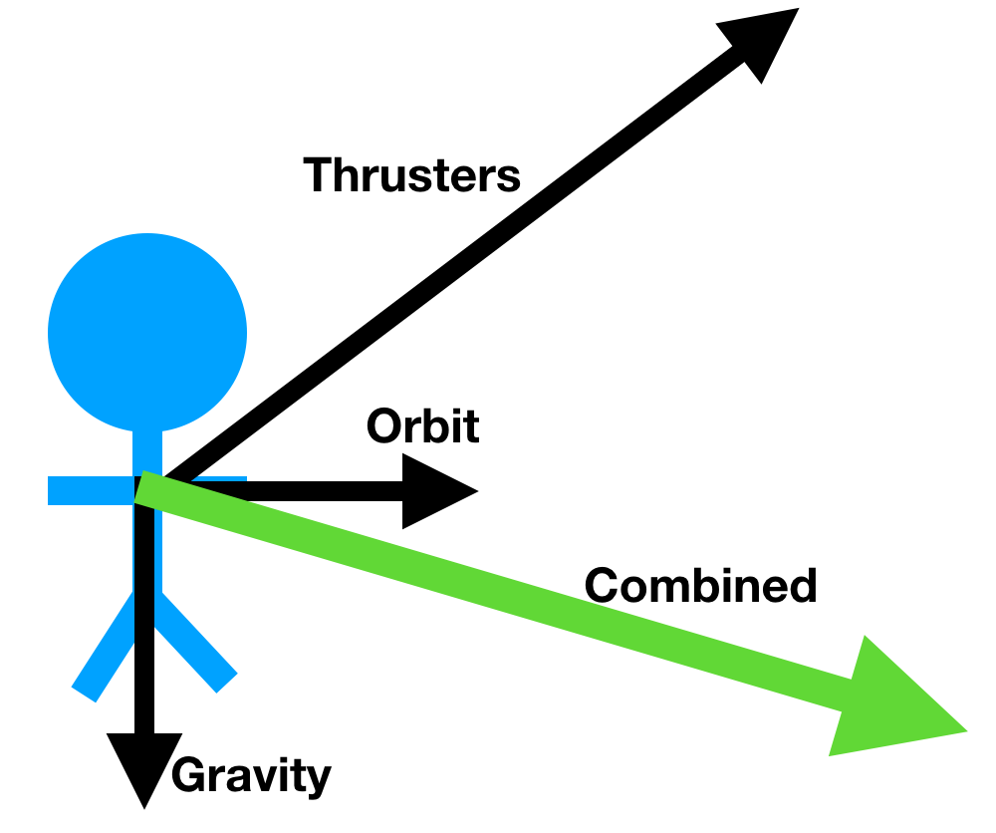
For example, look at this physics situation. Here, we combine many vectors into one resulting vector. Then, simply multiply that combined vector by time and you’re done.

Cartesian/Euclidean Vectors
“Direction” and “magnitude,” expressed with the change/delta in each axis: x/y, horiz/vert etc..
So the two numbers are NOT direction and magnitude, but axis deltas, i.e. sf::Vector2f.
Pros: All of our screens are 2d Cartesian coordinate planes where everything is already x/y.
Cons: If you want direction and magnitude, it takes extra work. It’s also not how humans imagine vectors.

Game Software with Cartesian vectors
Time is a constant, so the vectors change.

//General velocity only game update function
sf::Vector2f updateDelta(vel, time)
{
//Change/Set vel’s direction & magnitude (if needed)
//multiply/scale vel by time (and now it has become the change in position -or whatever)
//Use scaled vel to change pos (add)
}

//Example for WallBouncer (In this example, only the vector’s direction can change.)
sf::Vector2f updateDelta(vel, time)
{
//If it hits a wall, flip velocity’s sign
return (vel * time);
}

//General velocity and acceleration update function
sf::Vector2f updateDelta(vel, acc, time)
{
//Remember, acceleration changes velocity, then velocity changes position.

//Change/Set acc’s direction & magnitude
//multiply/scale acc by time (Becomes change in velocity)
//Add accDelta to vel
//multiply/scale vel by time (becomes the change in position -or whatever is next)
//Use vel to change pos (add)
}

Compiling
How we organize code from top to bottom:
- Libraries
- Files
- Namespace
- Classes
- Functions
- Scope

Compiling is a four step process.
- Preprocessing
- Copies all .hpps into the .cpps that included them
- This eliminates all .hpp file level organization
- Performs all macro replacements
- Compiling
- All .cpps are written and translated into assembly language
- This is the big, time consuming step
- Fancy optimization
- Assembling
- Turns assembly into machine code
- .cpps have been translated into .objs
- Linking
- Copies all of the machine code functions in the .obj files into one executable file or library
- All about ordering the functions

Optimizing Code

Profile to find which code is taking up most of the execution or run time.
Use profiling to find what part of the code you need to optimize.

Try to reduce the number of times a costly function is called.

Get rid of new/delete/heap allocations.

Std::make_unique

Vector reallocation: reserve(), constructor, push_back()

std::string: reserve(), changing size might reallocate.

Big O: (name of a notation for the worst case number of loop iterations in a function)

O(n^2): Two nested loops
O(n): Any loop
O(log(n)): Balanced binary tree traversal.
(Remember: 2^8=256, and log2(256)=8)

Code Snipets

Nested for loops:
- make the first/outer-most loop move vertically by default, if you have the choice
- make the first line of code inside/under each for() one that puts a const reference on the stack of whatever that is looping over
- in the inner-most loop create a variable on the stack of whatever this nested mess was for in the first place.

// clang-format off
const std::vector<std::string> map =
{
"*WWWWWWWWWW*",
"W W",
"W m W",
"*WWWWWWWWWW*"
};
// clang-format on

for(std::size_t vert(0); vert < map.size(); ++vert)
{
const std::string & row(map.at(vert));

for(std::size_t horiz(0); horiz < row.size(); ++horiz)
{
const char mapChar(row.at(horiz));
const sf::Vector2s pos(horiz, vert);

if (mapChar == '*')
{
std::cout << pos << std::endl;
}
}
}

Smart Pointers

RAII = Resource acquisition is initialization #worstnameever
It should have been called Constructors Acquire and Destructors Release
This is one of the most fundamental design patterns ever, because there are a multitude of situations where you have to write code to acquire something and then write code to release it.
(1) These two pieces of code are almost always far apart, and for good reason.
RAII is the solution to this because the C++ language guarantees that for every constructor that is successfully called and run, its destructor is also run (except for crashes and hangs).
Smart pointers are a perfect example of RAII

Pointers into containers are fragile and error prone
Iterators solve that, +no more null we have std::end() instead, +works for ANY containers
The name Iterator is the name of a DESIGN PATTERN.
The names of design patterns convey so much so quickly and easily, they are how to write good code.

class Iteractor
{
operator++()
{}

operator*()
{}

private:
T * m_ptr{nullptr};
};

template<typename T>
void copy(T srcIter, T destIter)
{
while(ptrFrom != std::end())
{
*ptrTo = *ptrFrom;
++ptrFrom;
++ptrTo;
}
}

