Cartesian coordinate system = A way to transform two numbers into one position.
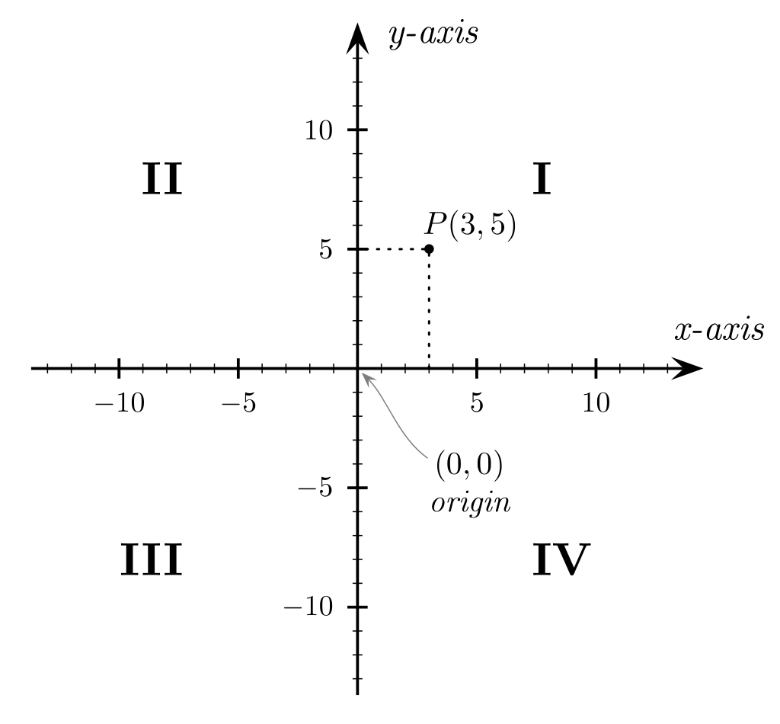

Vectors
The word vector has many different meanings in many different disciplines.

Basically, a vector is a direction and an amount moving in that direction. “Direction + Amount.”

Example: In the military, a fighter jet is called “An ordinance delivery vector.”

Example: In public health, where a virus or a mosquito can be a passive or active genetic delivery vector.

Polar Vector
An angle and a length.
Useful in isolated physics, or when the position doesn't matter.
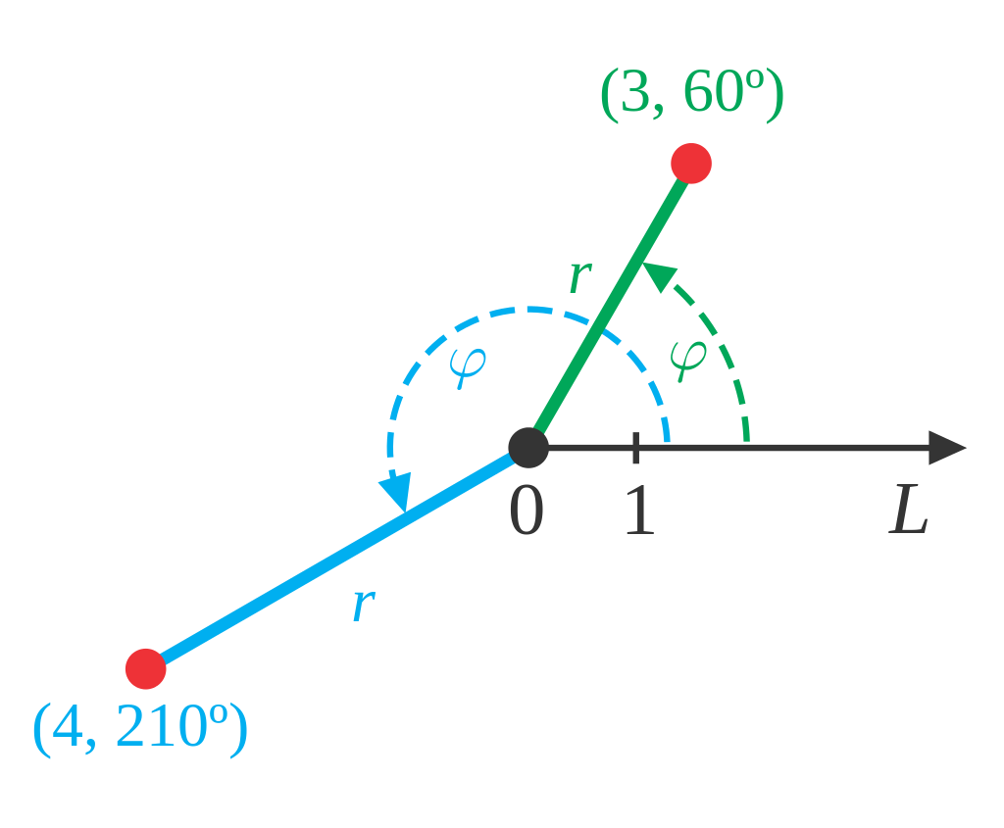

“Cartesian” Vector
A change in x and y axes, represented as a right triangle with the hypotenuse missing.
Nicely contained in sf::Vector2f class as x and y.
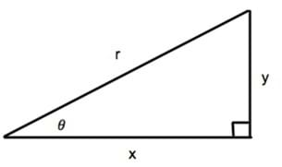
h

