Character Creator 3 Bug Fix Project

Character Creator 3 is a system that assists with Character Creation and offers a Headshot plugin which is overall optimal for my art style. However I have a reoccurring problem that has become annoying to a point where I can no longer afford to ignore this problem.

What’s the core issue if the program overall works ?

The Headshot Plugin is entirely hit or miss either it gets the face import correct which is entirely rare since it mostly only get realistic faces correct if the face was made using 3D software it almost always gets it wrong forcing me to have to create a new face entirely that barely resembles the previous face. While sometimes this is ok if my 1st draft face was bad in the 1st place it entirely sucks if my 1st draft was really good and doesn’t need to change.

Full list of issues:

* Change skin tone button almost never changes the skin tone for the entire body nearly always fails
* Nose placement is almost always off
* Mouth is always wrong and two toned
* Head Morph is always wrong
* Blend Mask (The Black and White mask) is always off and never blends into the actual face accurately creating a natural face I nearly always have to customize to a T annoying
* Eyes are usually off in terms of color
* Facial morph is always completely off

How to reproduce this issue

Let’s say I open character creator 3 and use headshot plugin below is the image I’m going to use.

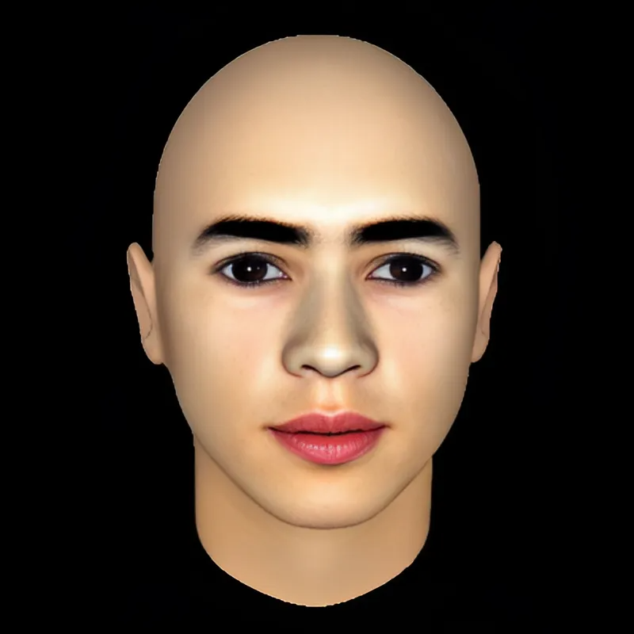

Seems normal right dark reddish eyes pink lips obviously the headshot plugin should read this image no problem fits all the criteria lady is also bald which means it should actually work better it doesn’t as after I run Headshot I get the result below

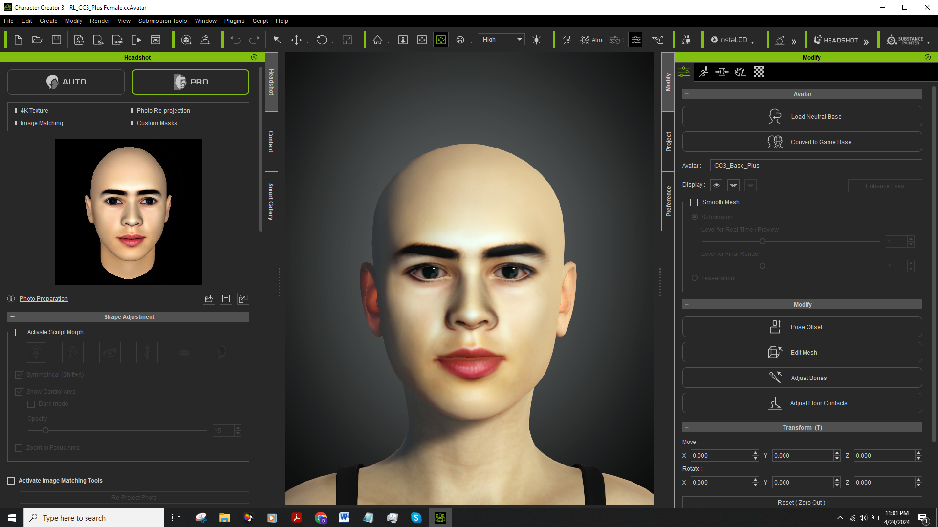

As you can see it looks almost nothing like the image in the photo is barely similar and doesn’t morph correctly at all its almost a completely different character. While I can work around this with my art skills it’s a killer to productivity.

What I need you to do?

Step1: 1st download Character Creator 3 the link is below:

https://drive.google.com/file/d/1XBeeHOo_S6F3Ck5hzIU8KQIC0CewWUWl/view?usp=sharing

NOTICE: DO NOT run Character Creator 3 online turn off your wifi or Ethernet before running this program as while I have a license for this software I can not get you one as this software is no longer under liscense anyway. You will have to run the program offline to test your progress.

Step2: Download the Picture attachment you will need it to test and see if your fix worked.

Step3: Create a python script that fixes the issues on page 2 for the Headshot plugin

Step4: To run the script in Character Creator 3 is made easy for you to test it run the Character Creator 3 program go to script load python select the script you made that’s it very straightforward here.

Main Objective: Is to create a script that fixes the issues on page 2 when the character generated head is at least a 99% match to the photo provided with correct full body skin task is complete you have full creative freedom as long as this is accomplished. I just need some indication that the script you made is active as well which can be very basic.

Also you can keep the script as it’s a script you can sell as well to art professionals.