**Names: Gaby Bizimana**

**Reg no:2209000108**

**Module:Internet Programming and Web Optimization.**

**BIT**

**Individual Home Work**

<!DOCTYPE *html*>

<html>

<head>

    <title>Gaby Ltd</title>

    <link *rel*="icon" *type*="Images/jpg" *href*="Images/24.jpg">

    <style>

*#ha*

{

    font-family:Tahoma, Geneva, Verdana, sans-serif;

    color: rgb(25, 194, 48);

}

*.div*

{

    margin-left: 125px;

    width: 50px;

    height: 50px;

}

body

{

color: black;

background-color: rgb(134, 134, 14);

}

h2

{

    font-size: medium;

    font-family: Tahoma, sans-serif;

}

*#p1*

{

    color: rgb(129, 22, 67);

    font-family:Times, serif;

}

*.unord*

{

background-color: brown;

}

*#better*

{

    font-family: 'Times New Roman', Times, serif;

    color: blueviolet;

}

    </style>

<body>

    <h2>My Comany Purpose</h2>

    <b><p *id*="p1" >Will be providing society chance to choose what they want.</p></b>

    <i><h2>This is my first list </h2></i>

    <ul *class*="unord">

        <li>Applications</li>

        <li>Admissions</li>

    </ul>

    <h2>This my second list</h2>

    <p *id*="better" >Be careful</p>

    <dl *id*="desc" >

      <dt>Medecines</dt>

      <dd>-Clothes</dd>

      <dt>Education</dt>

      <dd>-Basics</dd>

    </dl>

    <div><video *src*="video/ITV.mp4" *controls* *autoplay* *width*="10%"></video></div>

    <div *class*="div"><audio *src*="Audio/myaudi.mp3" *controls* *autoplay*></audio></div>

    <a *href*="work.html">Go to my Work</a>

</body>

</head>

</html>

**Attachment Outputs**

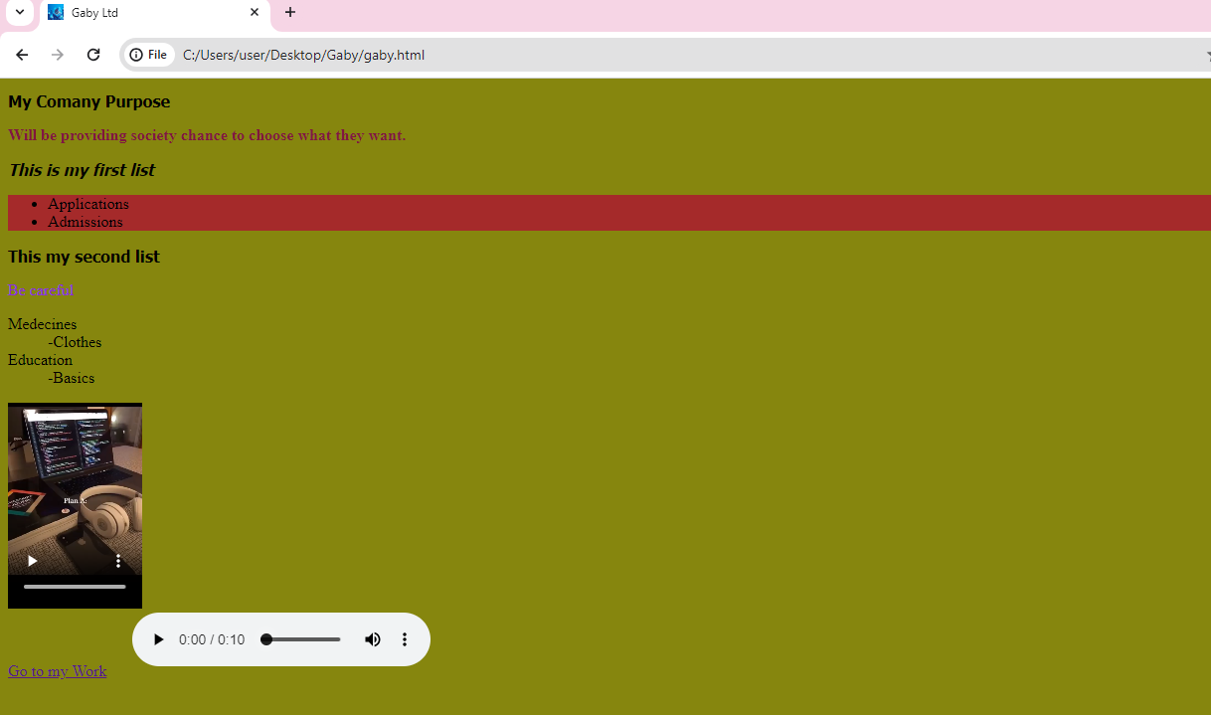

**Question two, HTML with External CSS**

<!DOCTYPE >

<html>

<head>

    <title>Main Me</title>

    <link *rel*="stylesheet" *href*="work.css">

    <link *rel*="icon" *href*="Images/22.PNG">

</head>

<body>

    <h1 *class*="holla" >Hellos Fam</h1>

    <hr *class*="r" >

    <p *id*="reminder" >Remember To Reply</p>

    <a *href*="gaby.html" *id*="Gaby">Go To Gaby</a>

</body>

</html>

**CSS**

.holla

{

    color: aquamarine;

    font-style: italic;

    background-color: blue;

}

body

{

    background-color: black;

    color: white;

}

#Gaby

{

    color: blanchedalmond;

}

#reminder

{

    color: rgb(128, 86, 31);

    font-style: oblique;

}

.r

{

   width: 190px;

   height: 200px;

}

**Outputs**

