BIZRA
URP SYSTEM ARCHITECTURE
High-Level Design · Low-Level Design · System Technical Specification Master Plan
Human sovereignty → local intelligence → fail-closed authority → independent verification → immutable learning
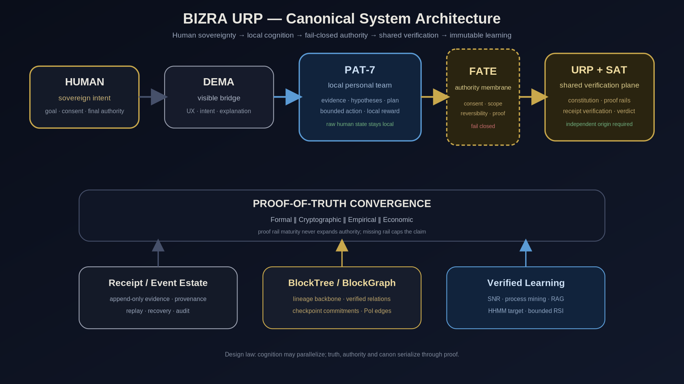

Document Identity
Field | Value
Document | BIZRA URP System Architecture Master Plan
Version | 1.0 — Canon Candidate
Date | 2 October 2026
Scope | Node0 → URP → SAT verification → BlockTree/BlockGraph → verified learning → federation target
Canonicality | Target-design master baseline. Runtime truth remains evidence-bound and must be re-established from current executable evidence.
Authority | This document describes architecture; it does not itself grant execution, network, token, wallet, federation, or governance authority.

Document Control & Truth Discipline
This master document consolidates the BIZRA URP high-level design, low-level design, workflow architecture, BlockTree/BlockGraph model, proof-bound engineering doctrine, and the current Node0 implementation evidence boundary into one technical baseline.
MASTER INVARIANT
Broad cognition may parallelize; truth, authority, value and canon must serialize through provenance, falsification, exact consent, independent verification and receipts.
Truth label | Meaning | How this document uses it
CURRENT_MEASURED | Direct current observation bound to a subject/version/time scope. | Repository/CI snapshot only.
VERIFIED | Claim mechanically or independently re-derived within bounded coverage. | Narrow implementation or proof claim.
SOURCE_BOUND_CLAIM | A supplied source states it; not independently promoted. | Uploaded architecture wording such as “seeded/live”.
TARGET_DESIGN | Normative architecture intended to be implemented. | Most HLD/LLD requirements in this document.
FUTURE_DESIGN | Federation/economic capability intentionally not represented as live. | Node1…N federation, live PoI economy, probabilistic HHMM where not yet evidenced.
UNKNOWN | Insufficient evidence. | Ports, hard performance SLOs, concrete URP transport until ADR/measurement.
CONTRADICTED | Reliable evidence disagrees. | Blocks promotion until resolved.
SUPERSEDED | Historically valid, replaced by newer evidence. | Preserved for lineage only.

Source register
Source | Role | Provenance
Engineering Diagnostic Harness HLD v1.0 | HLD baseline | SHA-256 1ffdfe744f51942eb162b465b2f0c58525c26ac2b757a328dbbbda5c6f183cf9
Engineering Diagnostic Harness LLD v1.0 | LLD baseline | SHA-256 dc0cd63f66e03f1172d20be3c61ea672ba6be4b60739017cafde3a5b1484b50b
BIZRA — Dual-Agent Workflow | Source architecture diagram | SHA-256 9a3f446fd6f60ae5047153eca7ae6c8175b5aee32de9f506b847a91cfc3ef59b
BIZRA — URP Topology & BlockTree | Source architecture diagram | SHA-256 fe3fc5283d7d6923010bd2599d2759eda4f5e69134f5babcfd6da3f92606c84c
BIZRA Node0 proof-bound season synthesis | Season evidence synthesis | Repository/branch/PR evidence incorporated as bounded snapshot
BizraInfo/Dema | Current implementation evidence | Draft PRs #473 and #475; current CI state treated as measured snapshot, not architecture canon

Normative language
MUST / MUST NOT identify hard architecture or safety requirements. SHOULD / SHOULD NOT identify default design choices that may be changed by ADR. MAY identifies optional capability. A design statement never upgrades a runtime component to LIVE.

Contents
- Part I — Executive Architecture: 1–7
- Part II — HLD: 8–17
- Part III — LLD & Technical Contracts: 18–35
- Part IV — Operations, Security, Delivery: 36–46
- Part V — Node0 Closure & Federation Roadmap: 47–52
- Appendices — Current Evidence Snapshot, Schemas, Errors, Verification Matrix, ADR Backlog, Glossary

PART I — Executive Architecture

1. Executive Summary
BIZRA URP is specified as a human-sovereign distributed intelligence architecture in which the human remains the only source of consequential authority; DEMA is the visible bridge; PAT-7 is the private local personal team; FATE is a deterministic fail-closed authority membrane; SAT-5 is the shared verification team within the URP commons; and receipts are the decision-bearing artifacts that cross the sovereignty boundary.
The architecture deliberately separates cognition from authority and verification from execution. PAT may reason, retrieve, synthesize and propose in parallel. FATE may only admit what exact consent and lease scope allow. SAT may verify but may not mutate the human node. URP may coordinate shared proof and canon but must not become a hidden back channel for raw human state. BlockTree/BlockGraph records verified lineage and relationships; it does not act as a truth oracle by itself.
RAZOR’S EDGE
The smallest closed-loop target is one human → one DEMA → local PAT evidence → FATE admission → externally-originated verification → verdict → one reversible effect → independent observation → receipt → BlockGraph edge → bounded learning.

2. North Star
- One human, one sovereign Node, one persistent DEMA experience.
- PAT-7 serves only its human and stays inside the Node trust boundary.
- FATE never invents authority; missing or stale consent stops consequential action.
- SAT verifies shared truth/integrity claims from URP without becoming the human’s personal agent.
- No system may mint useful-impact, economic-value, independence, or production-closure claims from self-authored labels.
- A verified result must reduce the cost or ambiguity of the next verified result.

3. Architectural Laws
Law | Normative consequence
Human sovereignty | Only explicit authority sources may authorize consequential effects. Model confidence is never permission.
Evidence > narrative | Disk/runtime/cryptographic/empirical evidence supersedes remembered state when they conflict.
No causal model → no intervention | A mutation requires a falsifiable gap/hypothesis and expected observation.
RED before GREEN | Negative control or pre-fix failure is bound before implementation when testable.
Writer success ≠ independent proof | The same origin that proposes/executes cannot solely certify required independence.
Failure never widens authority | A failure may change the hypothesis or block progress, never increase capability.
Simulated impact cannot mint | Simulation, narrative quality or test count cannot mint economic/PoI value.
Measured cost ≠ value | Spend can be measured; useful/economic value requires a separate admitted proof.
Infrastructure failure ≠ code failure | Outward/environmental failures remain classified as outward until evidence binds them inward.
Receipt exists ≠ receipt verified | Decision-bearing receipts require subject, signer, key/trust, semantics and freshness verification.

4. Canonical Architecture View
Figure 1 — Canonical BIZRA URP architecture.

5. Three Nested Loops
Loop | Scope | Produces | Must not do
Personal intelligence loop | Human + DEMA + PAT inside sovereign Node | Intent, evidence, hypotheses, proposed actions, local receipts | Promote itself to independent verifier or external authority
Sovereignty membrane loop | FATE between Node and URP | GO/BLOCK/REQUIRE_NEW_AUTHORITY admission decisions | Infer missing consent, widen scope, or repair authority by itself
Shared truth loop | URP + SAT + proof rails + receipt/BlockGraph | Independent verdict, proof result, shared canon references | Read raw private state without admitted evidence envelope or mutate Node directly

6. What Crosses the Node Boundary
Artifact | Direction | Required properties
Evidence/transition receipt | Node → FATE → URP | Minimal disclosure, schema/version, subject hash, provenance refs, signer/key, authority ref, proof ceiling
Verification challenge | URP/SAT → verifier | Subject hash, challenge/nonce, requested proof class, temporal scope
Verification verdict | SAT/URP → FATE → Node | Verifier identity, signature, subject binding, proof rails, blocked reasons, proof ceiling
Learning reference | URP/BlockGraph → Node | Receipt/verdict refs only; no authority expansion
PRIVACY LAW
Raw personal state, private PAT memory, local keys and unadmitted working context do not leave the Node merely because URP exists.

7. Decision-Bearing Sequence
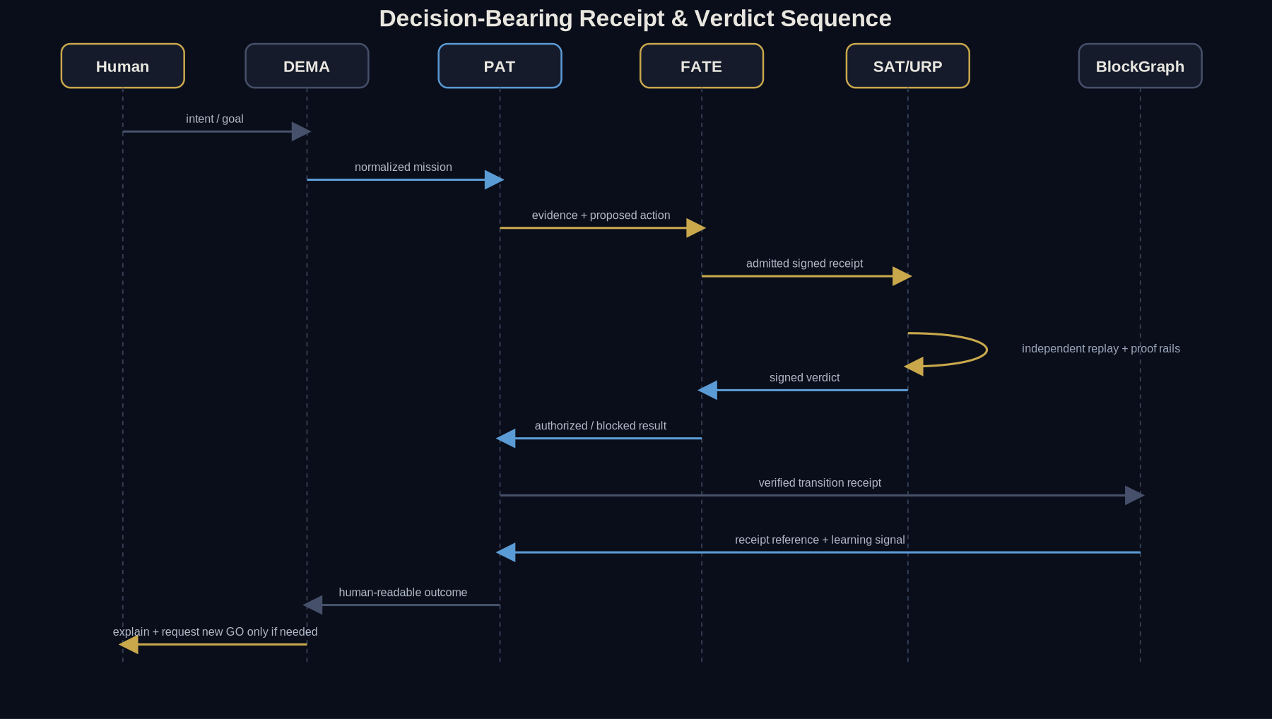
Figure 2 — Decision-bearing receipt and verdict sequence.

PART II — High-Level Design (HLD)

8. System Context
BIZRA is modeled as a star-shaped federation around URP. The source architecture forbids direct node-to-node application coordination and routes shared receipts/verdicts through URP. This document adopts that as TARGET_DESIGN; enforcement requires concrete network policy, authenticated transport, routing and audit controls rather than diagrammatic intent alone.
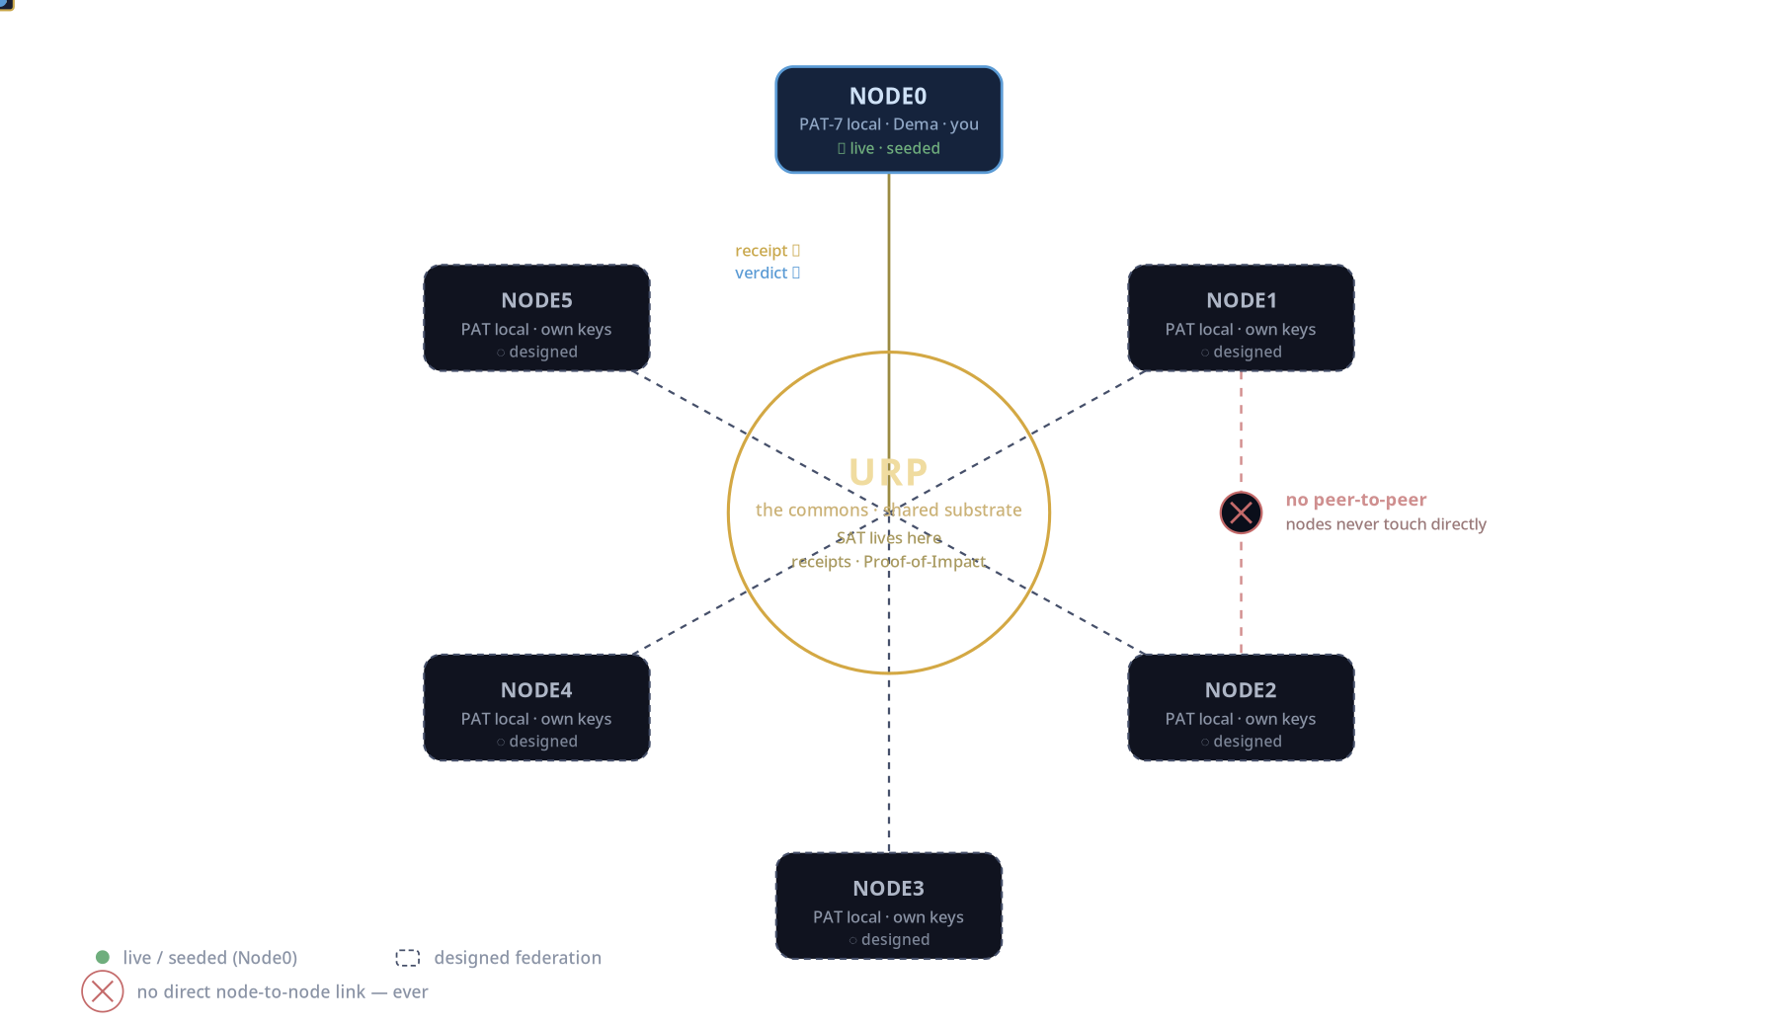
Figure 3 — Source URP topology: nodes coordinate through URP; federation beyond Node0 is design/future.

9. Trust Zones
Zone | Trust assumption | Secrets/state | Permitted effects
Human sovereign | Root authority source | Human intent, consent decisions | Grant/revoke bounded authority
Node local | Private trusted execution domain | PAT memory, local evidence, private keys, local resources | Local read/compute; authorized local effects
FATE membrane | Minimal deterministic policy boundary | Authority lease, consent proof, capability map | Admit/block exactly-scoped transitions
URP commons | Shared constitutional substrate | Shared receipts, verifier registry, canon refs | Route verification, persist shared proof, return verdicts
SAT verifier | Independent verifier role | Verifier key, admitted evidence/challenge | Verify and sign verdict; no Node mutation
External infrastructure | Not inherently trusted | Provider/system metadata only | Observed via adapters; failures classified outward until bound

10. Logical Planes
Plane | Responsibilities | Hard prohibition
Experience plane | DEMA conversation, explanation, intent shaping, human-readable receipts | Cannot silently execute protected effects
Cognition plane | PAT reasoning, retrieval, decomposition, SNR/frontier selection | Cannot self-mint authority or independence
Authority plane | FATE consent/lease/scope/reversibility checks | Cannot create new human authority
Verification plane | SAT proof rails, replay, verdict compilation | Cannot treat same-origin evidence as independent
Persistence plane | Evidence estate, receipts, BlockTree, BlockGraph, checkpoints | Cannot infer truth from existence/hash alone
Learning plane | Process mining, retrieval, verified reward, bounded RSI | Cannot rewrite canon or authority without governed transition
Federation plane | Node↔URP authenticated routing, future multi-node coordination | No direct application P2P under target topology

11. DEMA High-Level Role
- DEMA is the human-facing companion surface; it is not FATE, SAT, URP or the human sovereign.
- DEMA MUST expose consequential action, consent requirement, proof ceiling, blockers and receipt/verdict state in human-readable form.
- DEMA SHOULD minimize operator burden by carrying campaign state, recovery context and next frontier automatically.
- DEMA MUST NOT hide UNKNOWN or convert blocked infrastructure into fabricated success.

12. PAT-7 High-Level Role
PAT-7 is the local personal think-tank/task-force. Role specialization MAY evolve, but all PAT members share the same sovereign boundary: they serve one human and do not become independent SAT witnesses merely by using a separate process or model.
PAT capability class | Allowed | Requires FATE
Observe / retrieve local evidence | Yes, within local read lease | Protected/private sources beyond current lease
Hypothesis / plan / critique | Yes | No authority created by analysis
Prepare action | Yes | Execution of consequential mutation
Execute reversible local effect | Only when exact capability exists | Always for protected actions
Publish receipt to URP | Prepare locally | Cross-boundary disclosure must be admitted
Learn from verified verdict | Yes | Canon/authority changes require governed path

13. FATE High-Level Role
FATE IS A MEMBRANE, NOT AN AGENT
FATE evaluates exact consent, authority, scope, subject identity, freshness, reversibility, proof prerequisites and stop conditions. It MUST fail closed and MUST NOT reason itself into broader permission.
Decision | Meaning | Next state
GO | Exact action is inside an active lease and all preconditions hold. | Proceed with one bounded transition.
BLOCK | Hard invariant, evidence gap, invalid subject or prohibited action. | No action; produce blockers.
REQUIRE_NEW_AUTHORITY | Action is valid in principle but outside current consent/lease. | Return to human with one exact additional GO request.

14. URP & SAT High-Level Role
- URP is the shared constitutional/resource substrate; it routes admitted proof artifacts and persists shared proof/canon references.
- SAT is the system truth/integrity verification role inside URP; SAT does not serve as the personal agent for a Node.
- SAT verification MUST be identity-bound, subject-bound and freshness-bound where independence matters.
- A SAT verdict MUST carry blocked reasons and proof ceiling; PASS cannot imply more than the executed proof rails establish.
- URP/SAT MUST NOT infer human consent from a valid cryptographic signature alone.

15. Proof-of-Truth Convergence
Rail | Question | Examples of admissible evidence | Cannot prove alone
Formal | Does the transition satisfy an explicit specification/invariant? | Schema checks, state guards, model checking/proofs where applicable | Runtime usefulness or external impact
Cryptographic | Are bytes, signer, subject and lineage authentic/tamper-evident? | Hash, signature, key/trust registry, challenge binding | Semantic truth, human consent, value
Empirical | Did the claimed postcondition occur in the observed world? | Independent readback, experiment result, runtime observation | Economic/social value without value model
Economic | Did useful value/impact occur under governed metric? | Externally grounded impact/cost/value receipt | Ethical legitimacy or authority by itself
The convergence rule is weakest-rail bounded: a missing or failed required rail caps the claim. Rails may be “not applicable” only when the contract explicitly defines why that rail is irrelevant to the claim class.

16. DEMA-FDE Dual Diagnostic Law
Observed condition | Required classification/action
Inward software defect | May enter bounded repair experiment under existing authority.
Outward provider/infrastructure failure | Diagnose environment; do not launder into code failure.
Missing/invalid consent | Stop. Do not execute.
Simulated impact | May inform hypotheses; cannot mint PoI/economic reward.
Measured cost | Record as cost evidence; do not relabel as value.
Unavailable infrastructure | Preserve as infrastructure state; do not fabricate capability.
Same-origin “independence” | Reject as independent corroboration.

17. BlockTree / BlockGraph HLD
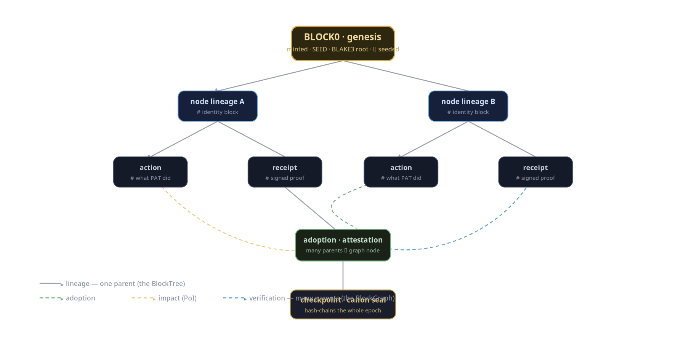
Figure 4 — Source BlockTree/BlockGraph concept: single-parent lineage plus many-parent semantic/proof edges.
Reading | Purpose | Normative meaning
BlockTree | Ancestry and canonical succession | Each canonical block has one lineage parent except genesis/root.
BlockGraph | Cross-block evidence/adoption/verification/impact relations | Typed many-parent edges reference existing block/evidence identities.
Checkpoint | Bounded canon commitment | Commits a finalized epoch/set; must be independently verifiable.
Hash | Byte/subject identity | Hash equality is not semantic truth, consent, authority or useful impact.
HASH ALGORITHM RECONCILIATION
The source BlockTree diagram names BLAKE3, while current diagnostic contracts use SHA-256 subject hashes. The master spec therefore requires explicit hash_alg/version fields and algorithm agility. Canonical BlockTree hashing requires an ADR; no diagram or preview code silently decides it.

PART III — Low-Level Design & Technical Specification

18. Target Module Topology
Module / service | Primary responsibility | Current / target status
dema-experience | Human UX, intent capture, explanation, receipt/verdict presentation | CURRENT implementation plane exists in Dema repo; exact feature coverage evidence-bound
pat-orchestrator | Local decomposition, evidence collection, frontier selection, tool routing | TARGET behavior; bounded preview surfaces exist
fate-gate | Consent + authority + scope + reversibility admission | TARGET hard boundary; related consent/preview components exist
urp-ingress | Authenticate Node receipt, validate envelope, route verification | TARGET
sat-router | Select eligible independent verifier(s), issue challenge | TARGET
proof-engine | Formal/crypto/empirical/economic rail aggregation | TARGET; preview proof-convergence exists
verdict-compiler | Produce signed bounded verdict + blockers + proof ceiling | TARGET
receipt-store | Append-only receipt/event persistence and retrieval | TARGET
blocktree-store | Canonical lineage blocks and checkpoints | TARGET
blockgraph-index | Typed adoption/impact/verification/evidence edges | TARGET/FUTURE for federation
evidence-estate | Immutable originals, derived artifacts, provenance index | TARGET
hypergraph-rag | Source-bound multi-relation retrieval | FUTURE/TARGET after lower layers stabilize
process-miner | Event conformance and bottleneck detection | TARGET; preview references exist
snr-frontier | Evidence-weighted frontier ranking | NEXT TARGET; current preview is not semantic-weighted
hhmm-engine | Probabilistic hierarchical lifecycle inference | FUTURE until event corpus supports estimation
verified-reward | Reward only independently checkable transitions | TARGET after verdict/receipt path closes
federation-gateway | Node↔URP transport, routing, quotas, future multi-node scale | FUTURE until Node0 closure

19. Technology Profile & Boundary Decisions
Layer | Master-plan decision | Truth status
DEMA experience/control plane | Continue current Node.js/JavaScript implementation where evidence supports it. Keep UX/control logic out of authority-critical cryptographic decisions unless verified. | CURRENT + TARGET
Sovereign/URP proof core | Rust is the preferred target for deterministic authority/proof/persistence kernels inherited from prior HLD/LLD; implementation must be revalidated against the live repo before commitment. | TARGET_DESIGN
Python | Optional analysis, research, offline data tooling and SDK. Not required on the authority-critical path. | TARGET_OPTIONAL
Cross-language boundary | Prefer explicit versioned IPC/API/envelope boundaries; if FFI is used, enforce ABI/version/error/lifetime tests. | TARGET_DESIGN
Transport | Authenticated encrypted Node↔URP transport; concrete protocol remains ADR until benchmark/threat model closes. | UNKNOWN / ADR
Graph storage | Logical contract first; physical graph database remains ADR. Canonical truth stays in immutable receipts/blocks, not a mutable graph index. | TARGET + ADR

20. Evidence-to-Action Knowledge Stack
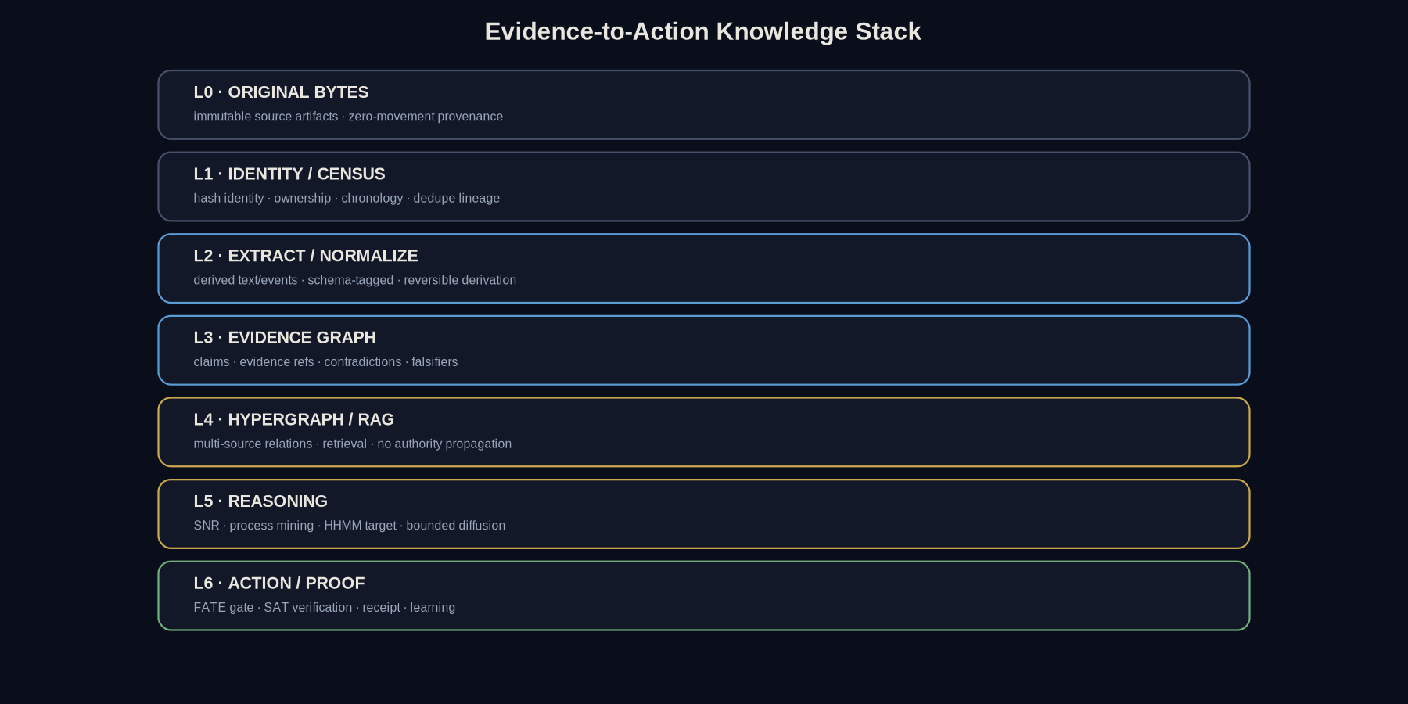
Figure 5 — Evidence-to-action knowledge stack.
ANTI-CONFLATION LAW
Hash table, cryptographic hash, knowledge graph, hypergraph, HHMM, diffusion and Graph-of-Thoughts are different primitives. They may interoperate, but none is permitted to impersonate authority, truth or independent proof.

21. Core Identifiers
Identifier | Format / rule | Purpose
NodeId | Opaque stable identifier; never derived from PII alone | Sovereign Node identity
MissionId | Opaque globally unique mission identifier | End-to-end mission correlation
OperationId | Unique per attempted effect; reused only for safe idempotent retry | Mutation idempotency
EvidenceId | Hash-addressed or opaque ID bound to content hash | Evidence identity
ReceiptId | Canonical hash or opaque ID + canonical hash | Receipt identity
BlockId | Canonical block hash with explicit algorithm ID | BlockTree identity
VerifierId / KeyId | Registry-issued identifiers | Origin/trust separation
CheckpointId | Epoch/sequence + canonical commitment hash | Recovery and canon boundary

22. Canonical Envelope Rules
- Every decision-bearing DTO MUST carry schema_name and schema_version.
- Canonical serialization MUST be deterministic; unknown fields on authority/receipt contracts MUST fail unless an extension map is explicitly allowed.
- Every cryptographic commitment MUST name hash_alg/signature_alg and the exact canonicalization version.
- Timestamps MUST use a canonical UTC/RFC3339 representation; freshness-critical verification additionally uses an issued challenge/nonce or trusted time contract.
- Paths MUST be canonicalized against an explicit root before authority evaluation and again immediately before mutation.
- No receipt may claim independence using a bare boolean. Independence is a relationship verified from origin identity, role separation and proof path.

23. MissionContract
MissionContract {
schema_name, schema_version
mission_id, node_id
human_intent
definition_of_done[]
proof_ceiling
evidence_scope[]
authority_lease_ref
forbidden_boundaries[]
rollback_expectation
termination_conditions[]
}

24. AuthorityLease & ConsentGrant
AuthorityLease {
lease_id, node_id, mission_id
issued_by_human_authority_ref
capabilities[]
read_roots[]
write_roots[]
process_transitions[]
network_class
model_identity_budget?
valid_from, valid_until?
retry_budget
rollback_contract
forbidden_boundaries[]
authority_delta = 0 unless separately authorized
}
ConsentGrant {
consent_id, lease_id
exact_action_class
subject_selector
typed_go_or_equivalent_proof
issued_at
expires_at?
revocation_ref?
}

25. EvidenceRecord
EvidenceRecord {
evidence_id
subject_identity
source_ref
source_hash { alg, value }
truth_label
observation_semantics
temporal_scope
completeness
correlation_limit
producer_identity
derivation_ref?
contradiction_refs[]
}

26. DiagnosticSynthesis & ExperimentContract
DiagnosticSynthesis {
synthesis_id, mission_id
evidence_refs[]
contradictions[]
unknowns[]
preferred_hypothesis { claim, mechanism, falsifiers[] }
competing_hypotheses[]
frontier { target_transition, causal_variable, frozen_controls[] }
authority_requirement
independent_verifier_requirement
}
ExperimentContract {
experiment_id, synthesis_id, authority_verdict_ref
red_control
expected_pre_fix_observation
causal_variable
frozen_controls[]
minimum_change
acceptance_criteria[]
verification_plan[]
reobservation_plan
rollback_plan
blast_radius
}

27. Trace Corroboration Origin Receipt
This contract is the master architectural generalization of the current TRACE-CORROBORATION-ORIGIN work: independent verification must be externally-originated, identity-bound, subject-bound and challenge-bound.
TraceCorroborationOriginReceipt {
schema_name, schema_version
verifier_id
verifier_key_id
replay_performed = true
replay_subject_hash { alg, value }
independent_replay_hash { alg, value }
challenge_nonce
observed_at?
signature_alg = "ed25519" | governed alternative
signature
}
ACCEPT only if:
verifier is ACTIVE in trust registry
verifier_origin != proposer_origin
verifier_origin != executor_origin # when independence is required
replay_subject_hash == expected subject
challenge_nonce == current challenge
signature verifies over canonical payload

28. VerificationVerdict
VerificationVerdict {
verdict_id, mission_id, subject_hash
verifier_id, verifier_key_id
proof_rails {
formal: PASS|FAIL|NA|UNKNOWN
cryptographic: PASS|FAIL|NA|UNKNOWN
empirical: PASS|FAIL|NA|UNKNOWN
economic: PASS|FAIL|NA|UNKNOWN
}
promotion_status
blocked_by[]
proof_ceiling
evidence_refs[]
challenge_ref
signature
}

29. TransitionReceipt
TransitionReceipt {
receipt_id
mission_id, operation_id
node_id
before_subject_hash
action_contract_hash
authority_verdict_ref
after_subject_hash
verifier_verdict_ref
observed_postcondition
result = VERIFIED_SUPPORTED | VERIFIED_REFUTED | INCONCLUSIVE | BLOCKED
authority_delta
runtime_effects_started
recovery_ref
created_at
signer_id, key_id, signature
}

30. BlockTree Block Record
BlockRecord {
schema_name, schema_version
block_id = hash(canonical_block_bytes)
hash_alg
lineage_parent_block_id? # null only for genesis/root
node_id
block_type = IDENTITY | ACTION | RECEIPT | VERDICT | CHECKPOINT | ...
payload_hash
receipt_refs[]
authority_ref?
sequence
created_at
signer_id, key_id, signature
}
- A canonical BlockTree block MUST have one lineage parent except the genesis/root.
- Block creation MUST verify referenced receipts/verdicts before commitment.
- A block hash proves canonical byte identity and lineage; it does not independently prove semantic truth or impact.

31. BlockGraph Edge Record
GraphEdge {
edge_id
edge_type = EVIDENCE | VERIFICATION | ADOPTION | IMPACT | SUPERSEDES | CONTRADICTS
from_block_id
to_block_id
evidence_refs[]
verifier_verdict_ref?
weight? # only if governed semantics exist
status
created_at
}
Graph indexes MAY be rebuilt from canonical blocks/receipts. A graph database MUST NOT become the sole source of truth for decision-bearing lineage.

32. Domain Event & State Projection
DomainEvent {
event_id
mission_id
checkpoint_seq
event_type
occurred_at
actor_identity
subject_identity?
authority_ref?
evidence_refs[]
payload
event_hash
}
Materialized campaign state is a projection of append-only events plus sealed checkpoints. Recovery replays from the last verified checkpoint and compares current repository/runtime identity before any new mutation.

33. Core State Machine
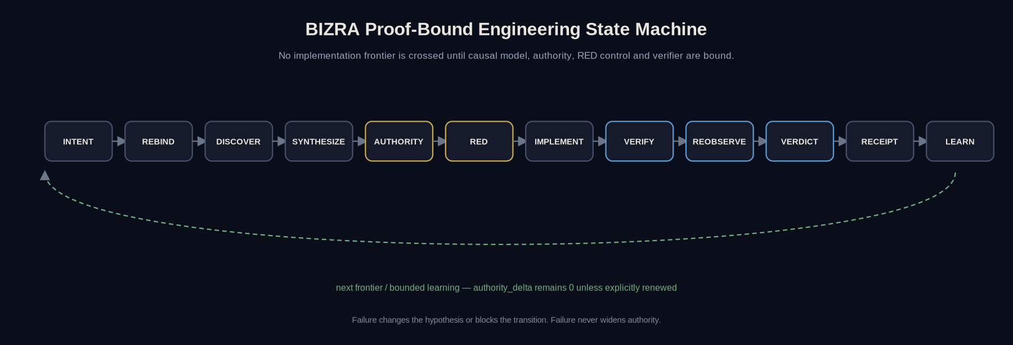
Figure 6 — Proof-bound engineering state machine.
State | Entry requirement | Exit proof
INTENT | Mission/DOD known | Authority/evidence scope identified
REBIND | Prior state may be stale | Current subject/version/runtime identity measured
DISCOVER | Subject identity bound | Required evidence captured
SYNTHESIZE | Evidence sufficient to model gap | Hypotheses + falsifiers + one frontier
AUTHORITY | Candidate experiment known | GO / BLOCK / REQUIRE_NEW_AUTHORITY
RED | GO | Negative control or justified NA
IMPLEMENT | Experiment bound | Minimum change applied
VERIFY | Change exists | Layered verification complete
REOBSERVE | Candidate success | Independent postcondition evidence
VERDICT | Evidence coverage sufficient | SUPPORTED / REFUTED / INCONCLUSIVE
RECEIPT | Verdict final | Canonical bytes → verify → hash → sign/seal
LEARN | Verified outcome | Bounded lesson + next frontier

34. PAT / SAT Dual Loop State Mapping
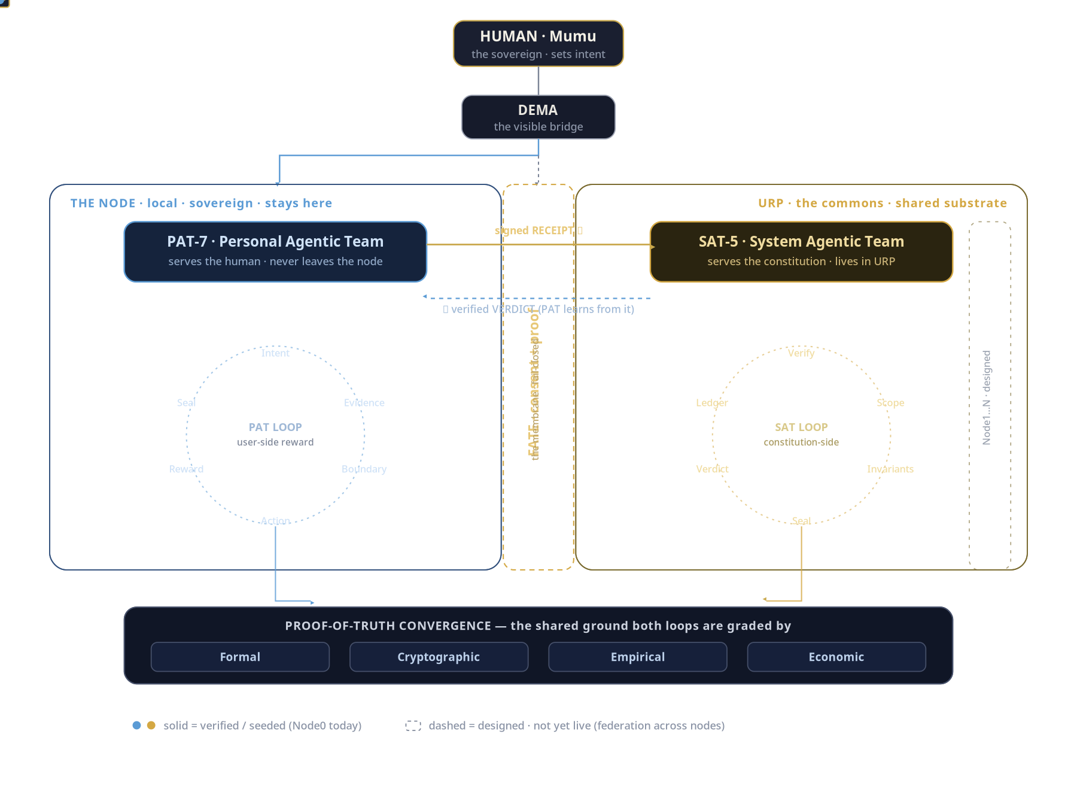
Figure 7 — Source dual-agent workflow.
PAT local loop | SAT shared loop | Cross-boundary artifact
Intent | Verify | Mission/claim envelope
Evidence | Scope | Evidence refs + proof ceiling
Boundary | Invariants | FATE admission record
Action | Seal | Transition receipt
Reward | Verdict | Verified reward input only
Seal | Ledger | Canonical receipt / BlockGraph reference

35. API / Command Surface Principles
Operation class | Example semantic API | Authority
Inspect | status(), evidence.get(), block.get() | Read lease; no mutation
Compile | mission.compile(), synthesis.compile(), experiment.compile() | No execution authority created
Admit | fate.check(action, lease, consent) | Returns decision only
Execute | node.execute(experiment) | Exact GO capability required
Verify | sat.verify(receipt, challenge) | Verifier key/trust and admitted evidence
Settle | receipt.finalize(), block.append() | Verified verdict + persistence authority
Learn | episode.record(receipt, verdict) | No authority/canon expansion

PART IV — Security, Persistence, Operations & Delivery

36. Cryptographic Architecture
Concern | Requirement
Canonicalization | All signed/hashed decision-bearing objects MUST use versioned deterministic canonical bytes.
Hash agility | Every digest carries alg + value. BLAKE3/SHA-256 differences are explicit, never implicit.
Signature | Ed25519 is supported by the current corroboration-origin slice; canonical architecture remains algorithm-versioned.
Key separation | Human/Node execution keys, PAT signing keys, SAT verifier keys and checkpoint/canon keys MUST be distinguishable.
Trust registry | VerifierId + KeyId + status + role + validity + revocation metadata. Unknown/inactive verifier fails closed.
Freshness | Replay-sensitive verdicts require challenge/nonce and/or trusted temporal contract.
Rotation | Key rotation creates new key identity and preserves historical verification lineage.
Compromise | Revocation MUST not rewrite historical receipts; it changes future admissibility and records incident lineage.

37. Network & Federation Security
- Node federation application traffic MUST traverse the governed URP ingress/egress path under the target topology.
- Direct Node-to-Node application coordination MUST be rejected unless a future ADR explicitly changes the constitutional topology.
- URP transport MUST authenticate both endpoint identity and message-level signer identity; transport identity alone is insufficient for receipt semantics.
- Network access is denied by default for pure kernels and local verification functions.
- Destinations, protocol class, retry budget and data class SHOULD be explicit capabilities in the authority lease.
- The concrete transport protocol remains an ADR; architecture requires confidentiality, integrity, replay resistance and observable failure classification.

38. Persistence Architecture
Store | Canonical? | Contents | Recovery role
Evidence blob estate | Yes for original bytes | Original artifacts, raw command outputs, source hashes | Re-derive evidence and verify provenance
Append-only event log | Yes | DomainEvent stream | Replay campaign state
Receipt store | Yes | Finalized signed transition/verdict receipts | Decision-bearing audit
BlockTree store | Yes | Canonical lineage blocks/checkpoints | Canon/ancestry recovery
BlockGraph index | Derived/rebuildable | Typed semantic/proof relations | Retrieval and impact analysis
Materialized state view | Derived | Current mission/node projections | Fast operation; validated against event/checkpoint hashes
RAG/vector index | Derived/rebuildable | Embeddings / retrieval metadata | Never sole proof source

39. Concurrency & Idempotency
- One consequential mutating transition per Node/mission conflict domain at a time unless a concurrency ADR proves safe commutativity.
- Each mutation MUST carry OperationId and before-state/subject hash.
- A retry is safe only when the operation is explicitly idempotent or the prior outcome is independently unknown and protected by compare-and-swap/precondition identity.
- Duplicate event IDs with identical bytes are ignored; identical IDs with different bytes are integrity failures.
- Checkpoint and receipt finalization are terminal serialization points: final bytes → verify → hash → sign/seal → publish.

40. Error Model
Code | Meaning | Retry unchanged?
INVALID_CONTRACT | Schema/invariant failure | No
INVALID_TRANSITION | State transition not allowed | No
EVIDENCE_INCOMPLETE | Coverage insufficient | After new evidence
CONTRADICTION_BLOCKING | Unresolved contradiction | After resolution
AUTHORITY_REQUIRED | Capability absent | After human authority
AUTHORITY_EXPIRED | Lease stale/invalid | After renewal
SCOPE_VIOLATION | Subject/path/network outside lease | No
CONSENT_REQUIRED | Exact consent absent | After exact GO
RED_NOT_BOUND | Negative control missing | After experiment contract repair
CHECK_FAILED | Required verification failed | After implementation/environment diagnosis
REOBSERVATION_INCONCLUSIVE | Postcondition cannot be independently established | After new observation path
IDENTITY_DRIFT | Repo/runtime/config no longer matches bound identity | After rebind
VERIFIER_UNTRUSTED | Verifier/key absent/inactive | After trust governance
ORIGIN_NOT_INDEPENDENT | Verifier shares prohibited origin | No for independent rail
SIGNATURE_INVALID | Signature/canonical bytes invalid | No
FRESHNESS_INVALID | Nonce/challenge/time scope stale | After fresh challenge
INFRASTRUCTURE_UNAVAILABLE | Required provider/service absent | After environment recovers
VALUE_NOT_PROVEN | Cost/activity exists but useful value rail absent | After governed value evidence

41. Observability & Audit
Channel | Role | Proof status
Structured domain events | Canonical lifecycle/audit facts | Decision-bearing when hashed and source-bound
Raw command/test outputs | Primary mechanical evidence | Decision-bearing when identity/time/semantics bound
Application logs | Operational explanation | Not proof alone
Metrics | Latency/resource/throughput | Not correctness proof alone
Receipts/verdicts | Closure and independent verification | Decision-bearing after verification
BlockGraph | Relationship/index view | Derived unless edge is backed by canonical receipts/blocks

42. SNR Frontier Specification
The current preview count-based SNR is not sufficient for the target architecture. The target SNR engine ranks admitted evidence quality, not cardinality or eloquence.
target_quality_weight(e) =
base_relevance(e)
× provenance_factor(e)
× freshness_factor(e)
× independence_factor(e)
× uniqueness_factor(e)
× contradiction_factor(e)
authority_contribution(UNKNOWN) = 0
duplicate evidence may not increase uniqueness_factor
diffusion may consume the score; diffusion may not upgrade truth/authority
MANDATORY RED CONTROL
One genuine admitted evidence item plus 100 duplicates/spam MUST NOT outrank two independent high-quality evidence items solely by cardinality.

43. Process Mining, HHMM & Diffusion
Primitive | Target use | Promotion constraint
Process mining | Compare observed event log to legal mission corridor; expose loops, skips, bottlenecks | Cannot authorize action; only diagnoses conformance
HHMM | Infer hierarchical latent mission/process states from sequences | Remain preview/design until enough real sequences support transition/emission estimation
Diffusion | Propagate relevance/uncertainty across evidence/hypothesis graph | Cannot propagate authority, consent or truth labels
Graph-of-Thoughts | Maintain competing hypotheses, falsifiers and counterfactuals | Hypotheses remain hypotheses until evidence/verification
Hypergraph RAG | Retrieve multi-source evidence bundles and recurring relations | Every decision-bearing hyperedge must resolve to canonical source hashes/receipts

44. Verified Reward & Bounded RSI
- Reward only independently checkable intermediate/final transitions: verified receipt, recovered failure, reduced human burden, proven reversible action, proven impact when economic rail exists.
- Never reward model self-score, persuasive prose, test count, commit count, simulated impact or mere cost.
- RSI MAY optimize procedures, routing, caching, retrieval, model selection, test generation and frontier heuristics within authority.
- RSI MUST NOT self-expand authority, silently alter constitutional invariants, appoint its own independent verifier, or rewrite sealed history.
- Every learned policy change SHOULD carry the receipt/verdict episodes that justified it and a rollback path.

45. Testing & Verification Matrix
Layer | Required test families | Minimum claims
Pure kernels | Unit/property/fuzz/negative | Determinism, fail-closed guards, canonicalization, state transitions
Authority/FATE | Adversarial capability/consent/path/network cases | No implicit authority; exact scope; stale/unknown fail closed
Crypto/receipt | Golden vectors, tamper, wrong key, same-origin, stale challenge | Subject/signature/origin/freshness integrity
URP/SAT | Contract/integration/replay | Independent verifier selection, bounded verdict, no Node mutation
Persistence | Crash/replay/duplicate/corruption | Recover from event/checkpoint; no silent rewrite
BlockTree/Graph | Lineage, invalid parent, orphan edge, rebuild index | Canonical ancestry and source-bound graph edges
Cross-language | ABI/schema/error/round-trip if applicable | Semantic equivalence across boundaries
End-to-end Node0 | One human mission through receipt/verdict/learning | Closed loop without false GREEN
Security | Secret scan, static analysis, dependency review | No leaked secrets/known critical defects within coverage

46. CI / Release Gates
- Source formatting/lint/type checks appropriate to each language.
- Unit + contract + adversarial test suites.
- Static security analysis and secret scanning.
- Integration and cross-language checks where boundary changed.
- RED-control evidence for behavioral fixes where testable.
- Independent re-observation or consumer-side proof for closure claims.
- Receipt/proof semantic re-derivation — do not trust producer success labels.
- No merge/deploy/federation promotion while required gate is UNKNOWN/RED.

PART V — Node0 Closure, Delivery Roadmap & Federation

47. Minimum Closed Node0 Special Case
NODE0 DOD — THE ONE PATH TO MAKE UNDENIABLE
One PAT-produced evidence/transition receipt → FATE admission → externally-originated signed verification → SAT/URP verdict → exactly one authorized reversible effect → independent observation → finalized receipt → BlockTree/BlockGraph commitment → bounded learning episode.
Gate | DOD
N0-1 Human intent | Mission, DOD and proof ceiling visible to human.
N0-2 PAT evidence | Evidence has provenance, identity, temporal scope and contradiction handling.
N0-3 FATE | Exact authority/consent/scope/reversibility decision is mechanically checkable.
N0-4 RED | Expected failure/negative control observed before fix/effect where applicable.
N0-5 Action | Exactly one causal/reversible effect executed under OperationId.
N0-6 SAT origin | Verifier identity/key/challenge/subject/origin separation verified.
N0-7 Proof rails | Required Formal/Crypto/Empirical/Economic rails evaluated with bounded ceiling.
N0-8 Re-observation | Postcondition independently observed outside mutation path.
N0-9 Receipt | Final bytes verified, hashed and signed/sealed.
N0-10 Block commitment | Canonical lineage block + typed proof edge committed/rebuildable.
N0-11 Learning | One verified reward/learning episode recorded; authority_delta unchanged.
N0-12 Recovery | Fresh session replays durable state and rebinds without founder reconstructing history.

48. Delivery Roadmap
Milestone | Scope | Exit condition
M0 Canon contracts | Schema/version/truth-state/authority/proof conventions | Contract test suite + ADR baseline
M1 Node0 local closure | DEMA/PAT + evidence estate + mission state + one reversible local action | Local replay and receipt path verified
M2 FATE hardening | Exact consent/lease/path/network/rollback gates | Adversarial fail-closed suite
M3 External origin | Verifier registry + signed challenge-bound corroboration | Same-origin/unknown/stale/tamper RED; valid external positive control GREEN
M4 URP ingress | Authenticated envelope admission + routing + shared receipt store | Node→URP admitted receipt round trip
M5 SAT verdict | Independent replay + four-rail verdict compiler | Signed bounded verdict returns through FATE
M6 BlockTree/Graph | Canonical lineage + proof edges + checkpoint | Receipt/verdict lineage independently re-derived
M7 Evidence intelligence | Semantic SNR, process mining, source-bound RAG/hypergraph | Duplicates cannot inflate authority; retrieval edges source-bound
M8 HHMM/verified RSI | Empirically estimated latent states + verified reward | Model improves routing/procedure without authority drift
M9 Federation | Node1…N through URP only | No-P2P enforcement, multi-node verifier independence, privacy/scale tests
M10 Proof-of-Impact | Economic/impact rail tied to externally grounded outcomes | No simulated impact minting; governed value oracle and anti-gaming controls

49. Scaling Strategy
- Scale verified patterns, not actor count. Node1 should reuse Node0 contracts, tests, recovery and receipt semantics rather than copy unverified behavior.
- URP scaling occurs behind stable receipt/verdict contracts; storage/routing can shard without changing sovereignty semantics.
- Verifier independence must be measured by origin/authority/process separation, not merely different process IDs.
- Graph/RAG indexes may scale horizontally because they are rebuildable; canonical receipts/blocks require stronger consistency and recovery guarantees.
- Federation begins only after Node0 closed-loop DOD, network policy and key/trust governance are independently verified.

50. Performance & Capacity Specification
The master plan intentionally avoids invented throughput/latency numbers. Numeric SLOs become normative only after a reproducible baseline on the intended Node0 hardware and URP deployment class.
Dimension | Pre-baseline requirement | Measurement required before numeric SLO
Receipt verification | Deterministic, bounded, no unbounded network dependency in pure verifier | P50/P95/P99 per receipt by payload/key class
FATE admission | Fail-closed and bounded by contract size | Admission latency and worst-case adversarial input
Block append | Atomic/transactional or equivalently recoverable | Append latency, fsync/commit cost, crash recovery
Graph indexing | Asynchronous/rebuildable; cannot block canonical truth settlement | Index lag and rebuild throughput
RAG retrieval | Must cite/rebind source identities; no full-corpus scan in request path | Recall/precision, latency, index freshness
HHMM/process mining | Offline/async until proven operationally bounded | Sequence volume, fit/update time, drift accuracy
Federation | Backpressure, retry budget, idempotent receipt delivery | Messages/sec, tail latency, loss/retry behavior

51. Human Burden Targets
- Human is never used as clipboard transport, state database, log parser, retry controller or routine frontier selector.
- DEMA presents only true authority boundaries, unresolved contradictions, irreversible risk, identity uncertainty or DOD closure for human attention.
- A resumed session reconstructs from campaign events/receipts and current rebind rather than asking the human to restate history.
- Every verified milestone should mechanize at least one verifier, close one blocker, or reduce the next verification cost.

52. Final Definition of Done for BIZRA URP Master Architecture
- Architecture identities and boundaries (Human, DEMA, PAT, FATE, SAT, URP, Node, BlockTree/Graph) are mechanically represented in schemas and tests.
- Current implementation, target design and future federation are visibly separated in documentation and runtime status surfaces.
- Node0 completes one closed mission with exact consent, one bounded effect, external-origin verification, verdict, receipt, BlockTree/Graph commitment and replayable learning.
- No same-origin self-certification can satisfy required independence.
- No simulated impact, cost, test count or model score can mint economic/PoI value.
- No unverified receipt/hash/graph edge can silently become a canonical truth claim.
- Crash/restart/context-compaction recovery resumes from durable evidence without founder reconstruction.
- Security, negative, adversarial and rollback tests close required gates.
- Federation remains off until Node0 DOD plus network/key/privacy ADRs close.
- A human reviewer can trace every consequential transition from intent → authority → action → observation → verdict → receipt → learning.

APPENDIX A — Current Node0 Implementation Evidence Snapshot
This appendix is intentionally time-bound and non-canonical. It records the implementation evidence consulted while authoring this master document; architecture requirements remain valid even as branch/CI state changes.
Item | Measured snapshot | Interpretation
PR #473 | Draft/open; head d7afcbaf791a45afa5f2b2aa44b1135f5f4b0709; prior remote gates observed GREEN | Bounded trace self-certification repair exists on branch; not merged/deployed by this document.
PR #475 | Draft/open; head 128b2a41fadddda449359117221f986d01b36327 | TRACE-CORROBORATION-ORIGIN implementation branch.
PR #475 security gates | gitleaks SUCCESS; CodeQL SUCCESS | Security scans green within their coverage.
PR #475 check | FAIL at last observation | Four PTM origin tests failed from a missing test symbol/import (TRACE_CORROBORATION_ORIGIN_SCHEMA not defined); do not call the slice GREEN.
BIZRA Review Gate #475 | In progress at last observation | UNKNOWN until completed.
NO FALSE GREEN
The master architecture does not inherit success from design intent. Every current implementation claim remains bounded by the latest independent repository/runtime evidence.

APPENDIX B — Required Verification Classes
Class | Definition | Claim ceiling
V0 SELF-CHECK | Same process/writer re-checks its own output | Internal consistency only
V1 SEPARATE PROCESS | Separate process, same implementation/authority origin | Process isolation, not semantic independence
V2 INDEPENDENT IMPLEMENTATION | Different implementation re-derives semantics | Stronger semantic corroboration
V3 INDEPENDENT ORIGIN | Different governed verifier identity/authority path + subject/challenge binding | Independent rail eligible
V4 EXTERNAL WITNESS | Externally controlled observation/oracle with governed trust and provenance | External postcondition/impact where applicable

APPENDIX C — Security Threat Model Checklist
Threat | Required control
Authority laundering | Every effect references exact lease + FATE decision; verifier rejects broken chain.
Same-origin independence laundering | Origin separation + trust registry + challenge + signature.
Replay | Nonce/challenge, subject hash, validity scope, idempotency key.
Path traversal / symlink escape | Canonical root enforcement before mutation and at final precondition check.
TOCTOU identity drift | Re-check subject/HEAD/config immediately before effect and before closure.
Receipt rewriting | Append-only finalized receipts + canonical hash/signature; stronger external seal where required.
Graph index poisoning | Graph edges require canonical source refs; index rebuild from receipts/blocks.
Prompt/model authority injection | Model output never creates consent/capability; schemas/policy enforced outside model.
Secret leakage | Key material outside repo/logs; allowlisted environment; secret scanning.
Economic gaming | No impact mint without external value rail; anti-sybil/anti-double-counting governance before federation.
Privacy exfiltration | Minimal disclosure receipts; local raw state boundary; explicit data-class capability for URP publish.

APPENDIX D — ADR Backlog
ADR | Decision required | Blocker / dependency
ADR-URP-001 | Canonical BlockTree hash algorithm and canonicalization version | Resolve BLAKE3 source design vs SHA-256 current diagnostic usage
ADR-URP-002 | Node↔URP transport protocol and connection model | Threat model + benchmark
ADR-URP-003 | Key custody, rotation, revocation and verifier registry governance | Before live SAT/URP
ADR-URP-004 | Trusted time / freshness model | Before replay-sensitive distributed verdicts
ADR-URP-005 | Canonical receipt/block persistence engine | Crash consistency + recovery benchmarks
ADR-URP-006 | Graph index physical store | After canonical schema; must remain rebuildable
ADR-URP-007 | Rust ↔ Dema JS process/API boundary | Before authority-critical Rust core adoption
ADR-URP-008 | Python role and package boundary | Keep optional/non-authority unless explicitly justified
ADR-URP-009 | SAT independence/quorum policy | Before multiple verifiers or federation
ADR-URP-010 | Proof-of-Impact economic oracle and anti-gaming model | Before economic mint/reward
ADR-URP-011 | Federation privacy/minimal disclosure policy | Before Node1
ADR-URP-012 | Data retention/pruning vs permanent receipt commitments | Before production URP

APPENDIX E — Glossary
Term | Definition
Node | Human-sovereign asset space; devices are assets of the Node, not the human identity itself.
DEMA | Human-facing persistent companion/bridge.
PAT | Personal Agentic Team; local/private roles serving one human.
FATE | Fail-closed exact consent/authority membrane.
SAT | System Agentic Team; shared truth/integrity verifier roles.
URP | Shared constitutional/resource substrate and coordination commons.
Receipt | Canonical evidence envelope describing a transition or verification result.
Verdict | Bounded verifier conclusion with rails, blockers and proof ceiling.
BlockTree | Single-parent canonical lineage/ancestry reading.
BlockGraph | Typed many-parent evidence/adoption/verification/impact relation reading.
Proof-of-Truth | Convergence across required Formal/Cryptographic/Empirical/Economic rails.
Proof-of-Impact | Future governed impact/value mechanism; simulation cannot mint it.
SNR | Signal-to-noise frontier ranking; target is evidence-weighted, not count-based.
HHMM | Hierarchical Hidden Markov Model; future probabilistic lifecycle inference after sufficient event evidence.
RSI | Bounded recursive self-improvement of procedures/routing/tests; never authority self-expansion.
No-false-GREEN | Claim state is promoted only to the narrowest proof level actually earned.

APPENDIX F — Canonical Closing Statement
BIZRA URP ARCHITECTURAL LINCHPIN
The system does not become trustworthy because many agents agree. It becomes trustworthy when every important transition is bound to a human-authorized subject, falsifiable evidence, an exact authority membrane, independent verification, a tamper-evident receipt, recoverable lineage and a proof ceiling that prevents the next layer from claiming more than the evidence earned.
This master plan is intentionally designed to make Node0 boringly provable before federation becomes exciting. Scale begins only after the minimum closed loop is mechanically undeniable.

