BIZRA
UNIVERSAL RESOURCE POOL
System Architecture Master Plan
North-Star Manifest • Product Specification • HLD • LLD • Protocol Contract • Definition of Done

Pool capability. Preserve sovereignty.
Every consequential claim stops exactly where its proof stops.

Document | BIZRA URP System Architecture HLD + LLD + Technical Specification Master
Version | 1.1
Date | 3 October 2026
Status | Normative target architecture; current deployment state must be established by separate evidence rebind
Scope | Sovereign Node ↔ URP resource fabric, DEMA/PAT/FATE/SAT, resource protocol, execution, verification, evidence, knowledge, federation and delivery

بذرة · The Shared Substrate of a Sovereign Intelligence Civilization

Document Control & Proof Discipline
This master document preserves the supplied BIZRA URP specification as the normative upper architecture and adds an implementation-grade LLD annex beneath it. It does not convert target design into runtime evidence.
Layer | Meaning | Allowed claim
NORMATIVE TARGET | Intended URP product/protocol/system architecture in this document. | “The target requires X.”
CURRENT MEASURED | What a current repository/runtime observation establishes at a named time/identity. | Only the bounded measured fact.
VERIFIED | A claim re-derived through required mechanical/independent checks. | Only within evidence coverage and proof ceiling.
FUTURE / FEDERATED | Designed multi-node/economic behavior not yet proven by this document. | Design intent, not operational fact.
Canonical source for the upper architecture: “BIZRA UNIVERSAL RESOURCE POOL — The Shared Substrate of a Sovereign Intelligence Civilization”, supplied 3 October 2026. The 59 numbered sections below preserve its terminology, ordering, framing and level of detail.

Contents
Part | Theme | Range
PART I | North-Star & Sovereign Resource Constitution | Sections 0–17
PART II | Agents, Knowledge, Execution, Proof & Economics | Sections 18–33
PART III | Network, Federation, Planes, Security & Recovery | Sections 34–50
PART IV | Technical Stack, Architecture, Invariants, DOD & Acceptance | Sections 51–59
PART V | Implementation-Grade LLD Annex | Sections 60–74
APPENDICES | Traceability, ADRs, glossary and delivery sequence | A–D

PART I
North-Star & Sovereign Resource Constitution
Proof ceiling, resource law, resource contracts, lifecycle, discovery and scheduling.

0. PROOF CEILING
This document describes the intended upper architecture of BIZRA's Universal Resource Pool.
It is a target specification.
It must never be interpreted to mean that every component described here is currently deployed, federated, economically active, independently audited, or operating at network scale.
Each deployed capability must carry its own evidence vector and proof ceiling.
The law is:
Architecture may describe the destination. Evidence determines how far we have actually travelled.

1. OPENING — THE MANIFEST
BLACK.
A single seed appears.
One human.
One sovereign Node.
A laptop.
A phone.
A local model.
Some files.
Some knowledge.
Some compute.
A few tools.
A lifetime of experience.
The seed grows.
Another human appears.
Another sovereign Node.
Different hardware.
Different knowledge.
Different skills.
Different resources.
Neither human owns the other.
Neither machine controls the other.
But something becomes possible between them.
A shared field.
Not a corporation's cloud.
Not a giant central model.
Not a data-harvesting platform.
Not a marketplace where humans become inventory.
A governed common substrate through which useful resources can become discoverable, qualified, leased, combined, verified, compensated, and revoked.
That substrate is the:

UNIVERSAL RESOURCE POOL
URP.

2. THE FUNDAMENTAL IDEA
The URP answers one question:
**How can every sovereign human gain access to far more capability than they personally own, without surrendering ownership, privacy, authority, or identity?**
The answer is not:
Put everything into one server.
The answer is:
Make resources interoperable through one governed resource protocol.
Therefore:
One logical URP ≠ one physical machine
URP is a logically unified, physically distributed, constitutionally governed resource fabric.

3. THE URP PRODUCT PROMISE
A BIZRA Node should eventually be able to say:
I need reasoning.
URP can locate qualified reasoning capacity.
I need GPU compute.
URP can locate qualified compute.
I need a specialized model.
URP can locate it.
I need an agent that understands a specific domain.
URP can locate a qualified capability.
I need verified research.
URP can retrieve admitted knowledge.
I need a reusable skill.
URP can supply a qualified procedure.
I need storage.
URP can locate storage under the required sovereignty boundary.
I need a human expert.
URP can eventually represent human contribution as a governed resource without reducing the person to a commodity.
I need this mission completed privately.
URP can filter out every resource whose data boundary is incompatible.
The human should not need to manually understand the infrastructure beneath these decisions.
DEMA handles that complexity.

4. THE CONSTITUTIONAL EQUATION
The entire URP architecture follows from:
Resource ≠ Capability ≠ Qualification ≠ Availability ≠ Authority
A GPU may exist.
That does not mean it is available.
It may be available.
That does not mean it is qualified.
It may be qualified.
That does not mean this mission may use it.
The mission may be permitted to use it.
That does not mean it may receive all of the human's data.
Every one of these states remains distinct.

5. BIZRA'S SOVEREIGN RESOURCE LAW
Private Node resources do not automatically become URP resources.
A human may own:
CPU
GPU
storage
local models
private datasets
documents
skills
bandwidth
devices
software subscriptions
agent services
knowledge
credentials
These remain:

NODE PRIVATE RESOURCES
until the human explicitly chooses otherwise.
Contribution requires an explicit contribution contract.
Therefore:
Ownership precedes pooling.
And:
Connection does not imply contribution.
And:
Contribution does not imply unlimited use.

6. ONE HUMAN — ONE NODE — ONE URP RELATIONSHIP
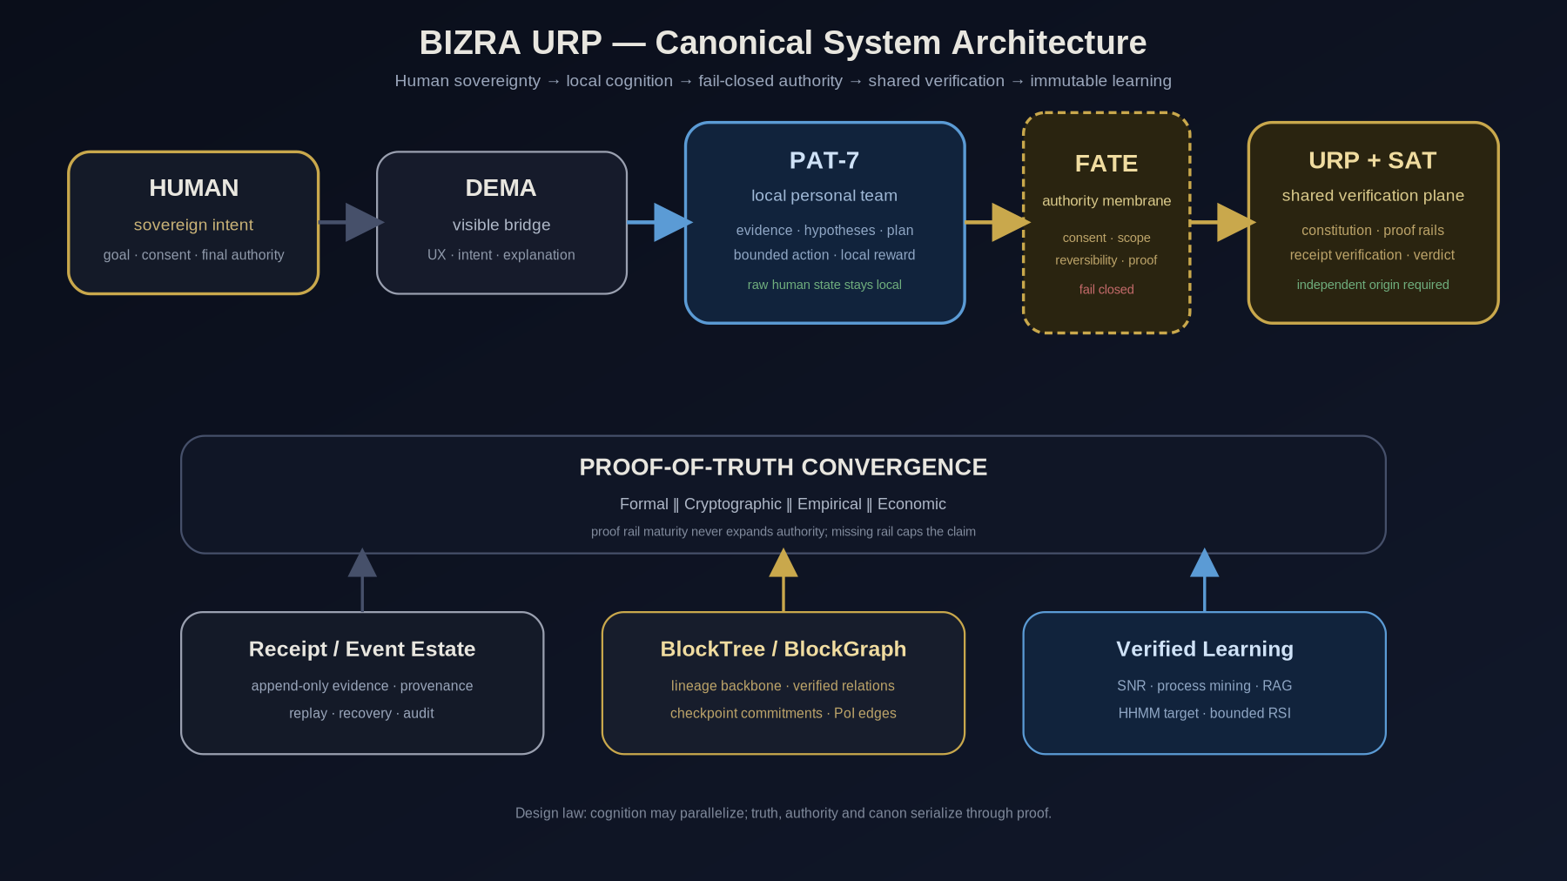
Figure — Canonical BIZRA human/Node/URP architecture
The topology is:
┌──────────────────────────┐
│ HUMAN │
│ meaning + authority │
└────────────┬─────────────┘
│
▼
┌──────────────────────────┐
│ SOVEREIGN NODE │
│ identity + private state │
└────────────┬─────────────┘
│
DEMA
│
mission/resource demand
│
▼
╔══════════════════════════════════╗
║ ║
║ UNIVERSAL RESOURCE POOL ║
║ ║
║ discovery · qualification ║
║ allocation · leasing ║
║ verification · provenance ║
║ accounting · revocation ║
║ ║
╚══════════════════════════════════╝
│ │ │
▼ ▼ ▼
Node A Node B System
resources resources resources
The URP never becomes the human's sovereign Node.
The Node never becomes merely an account inside URP.

7. DEMA'S RELATIONSHIP TO URP
DEMA does not manually pick infrastructure by brand.
DEMA translates human intent into a bounded resource requirement.
Example:

Human
Dema, reproduce this experiment privately.
DEMA derives:
mission:
reproduce experiment
requirements:
GPU >= required capability
Linux-compatible environment
local/private data boundary
Python environment
32 GB memory class
network disabled
reproducible execution
independent result verifier
forbidden:
public provider data upload
persistent external retention
DEMA asks the URP:
Find capabilities satisfying this contract.
Not:
Give me NVIDIA GPU #382.
This gives BIZRA actor independence.

8. URP RESOURCE CLASSES
The target URP can represent several major resource families.
Resource Family | Examples
COMPUTE | CPU, GPU, TPU, NPU, accelerators
MODEL | LLM, VLM, embedding model, specialist model
AGENT | coding agent, research agent, planner, simulator
TOOL | MCP tool, CLI, API, browser capability
STORAGE | object store, database, archive
DATA | datasets, corpora, research collections
KNOWLEDGE | SAT-admitted knowledge objects
SKILL | qualified procedures and workflows
NETWORK | bandwidth, relay, federation connectivity
DEVICE | phone, workstation, sensor, edge node
HUMAN | optional future expert contribution
VERIFICATION | SAT/verifier capability
SECURITY | attestation, sandbox, key-management capability
SIMULATION | economy, protocol, environment simulator
INFRASTRUCTURE | runtime, scheduler, queue, execution substrate
A resource class does not define authority.
The resource's contract does.

9. THE RESOURCE CARD
Every resource entering the URP requires a machine-readable identity.
Conceptual schema:
{
"schema": "bizra.urp.resource.v1",
"resource_id": "...",
"resource_type": "COMPUTE",
"owner_domain": "...",
"capabilities": [],
"interfaces": [],
"locality": {
"node": "...",
"region": "...",
"processing_boundary": "LOCAL | PRIVATE_REMOTE | PUBLIC_REMOTE"
},
"privacy": {
"accepted_classes": [],
"retention_policy": "...",
"egress_policy": "..."
},
"qualification": {
"status": "...",
"evidence_refs": []
},
"availability": {
"status": "...",
"freshness": "..."
},
"economics": {
"pricing_contract": null,
"reward_eligible": false
},
"revocation": {
"supported": true
},
"provenance": {},
"evidence_vector": {}
}
A Resource Card describes.
It does not authorize.

10. THE CAPABILITY CONTRACT
Resources are selected through capability contracts.
A capability contract states:
WHAT CAN THIS RESOURCE DO?
WHAT INPUTS DOES IT ACCEPT?
WHAT OUTPUTS DOES IT PRODUCE?
WHAT SIDE EFFECTS CAN IT CAUSE?
WHAT DATA MAY IT RECEIVE?
WHERE DOES PROCESSING OCCUR?
HOW IS SUCCESS VERIFIED?
HOW DOES IT FAIL?
CAN IT BE CANCELLED?
CAN IT BE RETRIED?
WHAT DOES IT COST?
HOW IS IT REVOKED?
Target structure:
CapabilityContract
identity
version
task_classes
input_schema
output_schema
data_classes_allowed
processing_locality
effect_classes
permission_requirements
cost_contract
latency_contract
health_contract
verification_contract
cancellation_contract
retry_contract
idempotency_contract
retention_contract
recovery_contract
qualification_evidence
This is how DEMA can replace one actor with another without rewriting the mission.

11. URP RESOURCE LIFECYCLE
A resource should not jump directly from discovery into trusted execution.
Proposed lifecycle:
DISCOVERED
↓
REGISTERED
↓
CANDIDATE
↓
QUALIFIED
↓
ADMITTED
↓
AVAILABLE
↓
LEASED
↓
ACTIVE
↓
RELEASED
Exceptional transitions:
DEGRADED
SUSPENDED
REVOKED
SUPERSEDED
OFFLINE
UNKNOWN
But lifecycle remains separate from evidence strength.
A resource might be:
lifecycle: AVAILABLE
evidence: MEASURED
freshness: STALE
consistency: CONSISTENT
scope: NODE_LOCAL
authority: NOT_GRANTED
This multi-axis representation is the:

URP EVIDENCE VECTOR

12. THE URP EVIDENCE VECTOR
Never compress reality into one misleading status.
Every important resource carries independent dimensions:
lifecycle
evidence_strength
freshness
consistency
provenance
locality
privacy_scope
availability
qualification
authority
observation_mode
proof_ceiling
Example:
resource: local-rtx4090
lifecycle: AVAILABLE
evidence_strength: MEASURED
freshness: CURRENT
consistency: CONSISTENT
provenance: NODE0_LOCAL
locality: PRIVATE_NODE
qualification: QUALIFIED_FOR_LOCAL_INFERENCE
authority: NOT_GRANTED_FOR_CURRENT_MISSION
proof_ceiling:
does_not_establish_external_availability

13. RESOURCE CONTRIBUTION CONTRACT
A human may voluntarily make a resource available.
The contribution contract binds:
contributor
resource
capability
permitted task classes
permitted consumers
privacy boundary
maximum utilization
availability window
economic terms
revocation
retention
geography
security requirements
forbidden use
verification requirements
Contribution is explicit and revocable where technically possible.
The human is never assumed to have donated a resource because the resource was detected.

14. URP RESOURCE LEASE
Missions do not obtain ownership.
They receive bounded leases.
{
"lease_id": "...",
"mission_id": "...",
"resource_id": "...",
"scope": {},
"budget": {},
"starts_at": "...",
"expires_at": "...",
"authority_ref": "...",
"fate_ref": "...",
"revocable": true
}
The fundamental lease rule:
Child Authority ⊆ Parent Authority
Delegation can become narrower.
Never broader.

15. MISSION → URP FLOW
The target execution flow:
HUMAN INTENT
↓
MISSION CONTRACT
↓
DEMA
↓
PAT decomposes cognitive work
↓
RESOURCE REQUIREMENT
↓
URP DISCOVERY
↓
QUALIFIED CANDIDATES
↓
PLANNER / ROUTER
↓
FATE + HUMAN AUTHORITY
↓
RESOURCE LEASE
↓
BOUNDED EXECUTION
↓
POSTSTATE OBSERVATION
↓
SAT VERIFICATION
↓
USAGE RECEIPT
↓
MISSION OUTCOME
↓
OPTIONAL IMPACT CLAIM

16. RESOURCE DISCOVERY ENGINE
The discovery engine answers:
Which currently admissible resources can satisfy this requirement?
Filtering happens before ranking.
Hard constraints include:
privacy
authority
locality
capability
qualification
availability
compatibility
budget
security
mission scope
Only then does optimization begin.

17. URP SCHEDULER
The scheduler must not optimize purely for speed or cost.
Conceptually:
R^* = arg max R [ U_v - C - L - Risk - H_b ]
Where:
Uv = expected verified utility
C = resource cost
L = latency
Risk = bounded operational/privacy/security risk
Hb = expected human burden
subject to:
Authority(R,M)=TRUE
Privacy(R,M)=TRUE
Qualification(R,M)=TRUE
Availability(R)=TRUE
Budget(R,M)=TRUE
No amount of utility score may override a hard constraint.

PART II
Agents, Knowledge, Execution, Proof & Economics
PAT/SAT/FATE roles, House of Wisdom, HabitSpec, execution, verification and economic evidence.

18. SMALLEST ADEQUATE TEAM
URP must resist resource inflation.
More agents are not automatically better.
The scheduler prefers:
smallest resource set capable of satisfying the mission contract
Additional workers are introduced only when they add:
parallelism
independent evidence
specialized capability
fault tolerance
meaningful alternative method
Agent quantity is never itself an optimization objective.

19. PAT AND URP
PAT remains personal.
PAT belongs to the human's sovereign Node.
PAT may request URP capabilities.
PAT may use:
local models
remote models
research tools
coding agents
simulators
knowledge
compute
skills
But PAT cannot:
self-authorize
admit shared wisdom
reward itself
verify its own consequential effects
silently export private context
PAT serves the human.

20. SAT AND URP
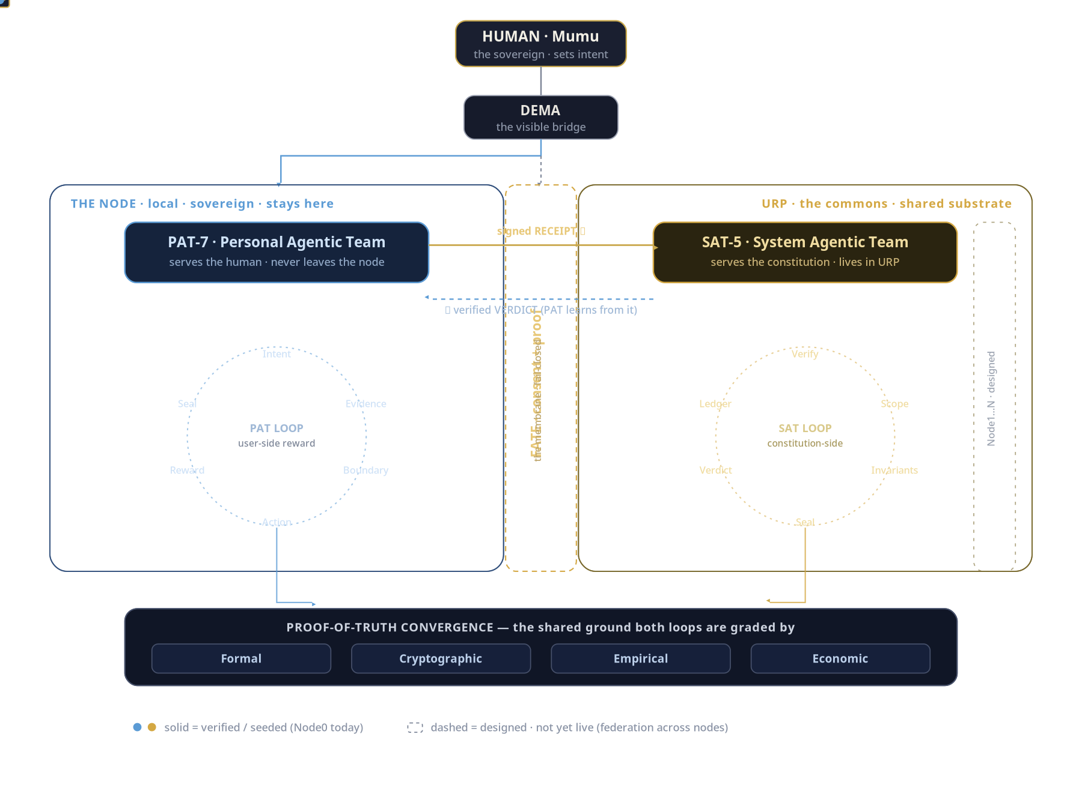
Figure — Dual-agent workflow
SAT is independent of PAT's personal authority.
SAT protects the shared system.
Examples of SAT concerns:
PROVENANCE
CONSENT / AUTHORITY
IMPACT
SECURITY
GOVERNANCE / ADMISSIBILITY
SAT can challenge a resource.
SAT can challenge an outcome.
SAT can challenge an impact claim.
SAT cannot manufacture human permission.

21. FATE AND URP
FATE is the effect membrane.
URP discovery may happen before consequential authority.
URP execution may not.
The sequence is:
candidate resource
↓
candidate operation
↓
mission scope
↓
human grant
+
constitutional checks
↓
FATE admission
↓
lease
↓
effect
Therefore:
Resource availability does not imply permission to use it.

22. HOUSE OF WISDOM INSIDE URP
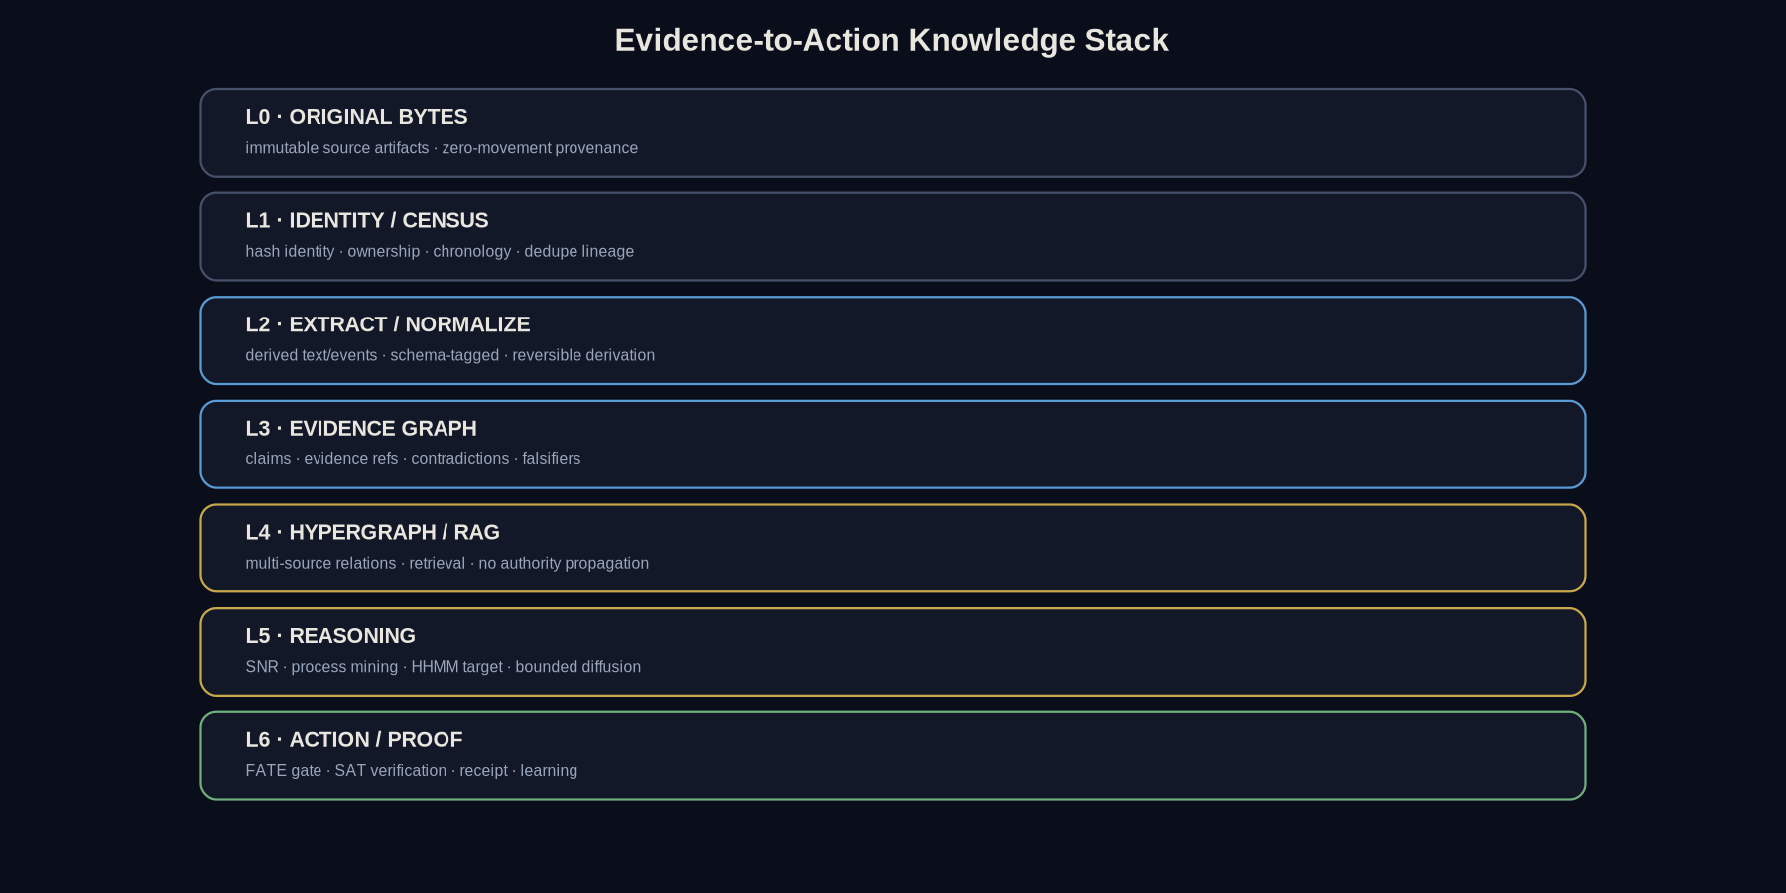
Figure — Evidence-to-wisdom stack
Knowledge is not just another file.
The House of Wisdom becomes the governed knowledge plane of URP.
Source material may enter the system as:
SOURCE
OBSERVATION
CLAIM
EXPERIMENT
ANALYSIS
LESSON
KNOWLEDGE CANDIDATE
But shared wisdom requires stronger admission.
Conceptually:
RAW SOURCE
↓
PAT PROPOSAL
↓
PROVENANCE
↓
CHALLENGE
↓
SAT VERIFICATION
↓
CONSENT / GOVERNANCE
↓
HOUSE OF WISDOM
↓
URP-SHAREABLE
Repeated claims do not become independent evidence merely because many models repeated them.

23. KNOWLEDGE OBJECT
A URP knowledge object should contain:
knowledge_id
claim
source_refs
source_hashes
provenance
scope
evidence_class
independence_class
counterevidence
verification_receipts
admission_state
supersession_links
validity_constraints
proof_ceiling
Truth remains revisable.
History remains preserved.

24. SKILLS IN URP
A skill is not a prompt.
A qualified skill is a reusable procedure with:
trigger
preconditions
inputs
context requirements
steps
capability requirements
authority requirements
expected outputs
success conditions
verification contract
stop conditions
failure modes
recovery procedure
resource budget
version
qualification evidence
This is a:

HabitSpec
The actor may change.
The habit survives.

25. HABIT PORTABILITY
A qualified HabitSpec should be executable through multiple qualified actors.
Example:
Habit: repository security review
Actor A:
Claude Code
Actor B:
Codex
Actor C:
local coding model
The test is not whether outputs look identical.
The test is whether each actor satisfies:
same input contract
same authority envelope
same evidence requirements
same verification contract
same prohibited effects

26. URP EXECUTION PLANE
The execution plane hosts bounded workers.
Every execution should operate inside an explicit sandbox or execution boundary appropriate to its risk.
Potential controls:
filesystem scope
network scope
process scope
memory limits
CPU / GPU quota
wall-clock deadline
credential mediation
output cap
disk-write cap
egress policy
thermal/resource protection
cancellation
The worker receives what it needs.
Not everything the Node knows.

27. CREDENTIAL MEDIATION
Credentials are capabilities.
They should not be exposed to arbitrary actors whenever avoidable.
Target architecture:
worker
│
│ requests operation
▼
credential mediator
│
│ verifies mission + authority
▼
external provider
The worker receives the result.
Not necessarily the credential.

28. DATA-EGRESS POLICY
Every mission classifies information before external delegation.
Example:
PUBLIC
SHAREABLE
MISSION_SCOPED
PRIVATE
LOCAL_ONLY
SECRET
Routing must respect this classification.
A more powerful cloud model cannot override:
LOCAL_ONLY

29. EXECUTION IS NOT VERIFICATION
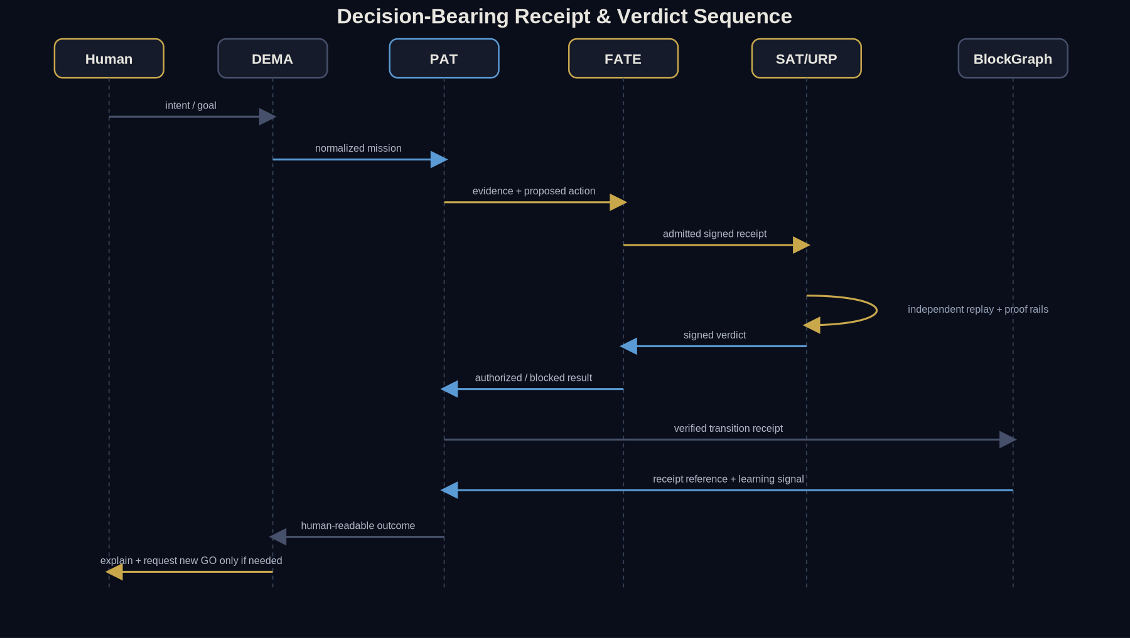
Figure — Receipt and verification sequence
The most important URP integrity rule:
Executor ≠ Verifier
A provider saying:
Completed successfully.
is evidence to inspect.
Not authoritative completion.
The final mission state requires appropriate independent observation.

30. THE DUAL-PROOF MODEL
A consequential URP transition should eventually support two complementary proof layers.

LAYER 1 — STRUCTURAL / CRYPTOGRAPHIC
Answers:
What bytes?
Which actor?
Which version?
Which input?
Which authority?
Which receipt?
Was it altered?

LAYER 2 — SEMANTIC / EMPIRICAL
Answers:
Did the intended outcome happen?
Was it useful?
Was it inside scope?
Did anything unexpected happen?
What remains unknown?
A cryptographically intact failure remains a failure.

31. USAGE RECEIPT
Every significant resource execution can emit a structured usage receipt.
Conceptual:
{
"mission_id": "...",
"lease_id": "...",
"resource_id": "...",
"actor_version": "...",
"authority_ref": "...",
"input_commitment": "...",
"prestate_ref": "...",
"effect_attempt": {},
"poststate_ref": "...",
"verifier_ref": "...",
"result": "VERIFIED | FAILED | UNKNOWN",
"cost": {},
"impact_claimed": false
}
Usage does not automatically imply impact.

32. PROOF OF IMPACT
PoI must sit after verified outcome.
Not before.
The chain is:
CONTRIBUTION
↓
USAGE
↓
VERIFIED OUTCOME
↓
HUMAN / MISSION BENEFIT
↓
IMPACT CLAIM
↓
INDEPENDENT EVALUATION
↓
REWARD ELIGIBILITY
Therefore:
Compute consumed ≠ Impact produced
Cost measured ≠ Value created
Simulation ≠ Mintable impact

33. ECONOMIC PLANE
The URP economic plane should eventually handle:
resource pricing
usage accounting
contributor compensation
budget enforcement
stake / guarantees
impact rewards
penalties
dispute resolution
But economic state must remain downstream of verified evidence.
No resource may reward itself.
No executor may self-certify its economic impact.

PART III
Network, Federation, Planes, Security & Recovery
Federation topology, control/data/evidence/governance planes, zero trust, revocation and recovery.

34. URP NETWORK ARCHITECTURE
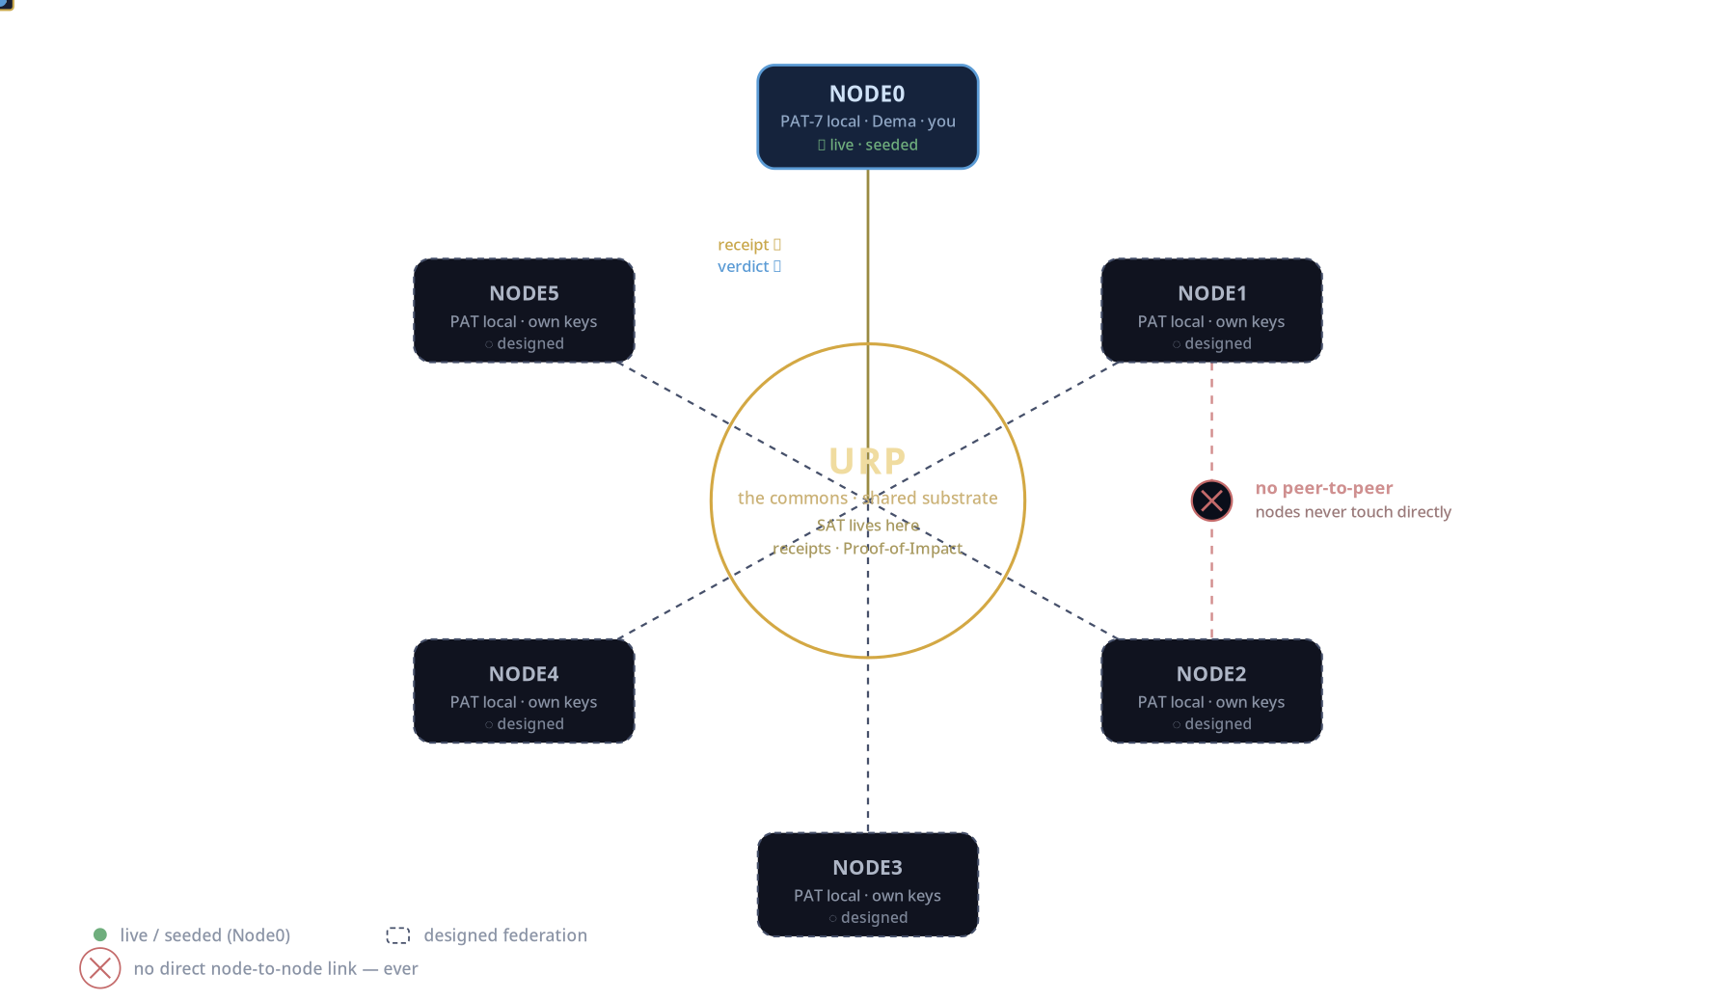
Figure — URP topology
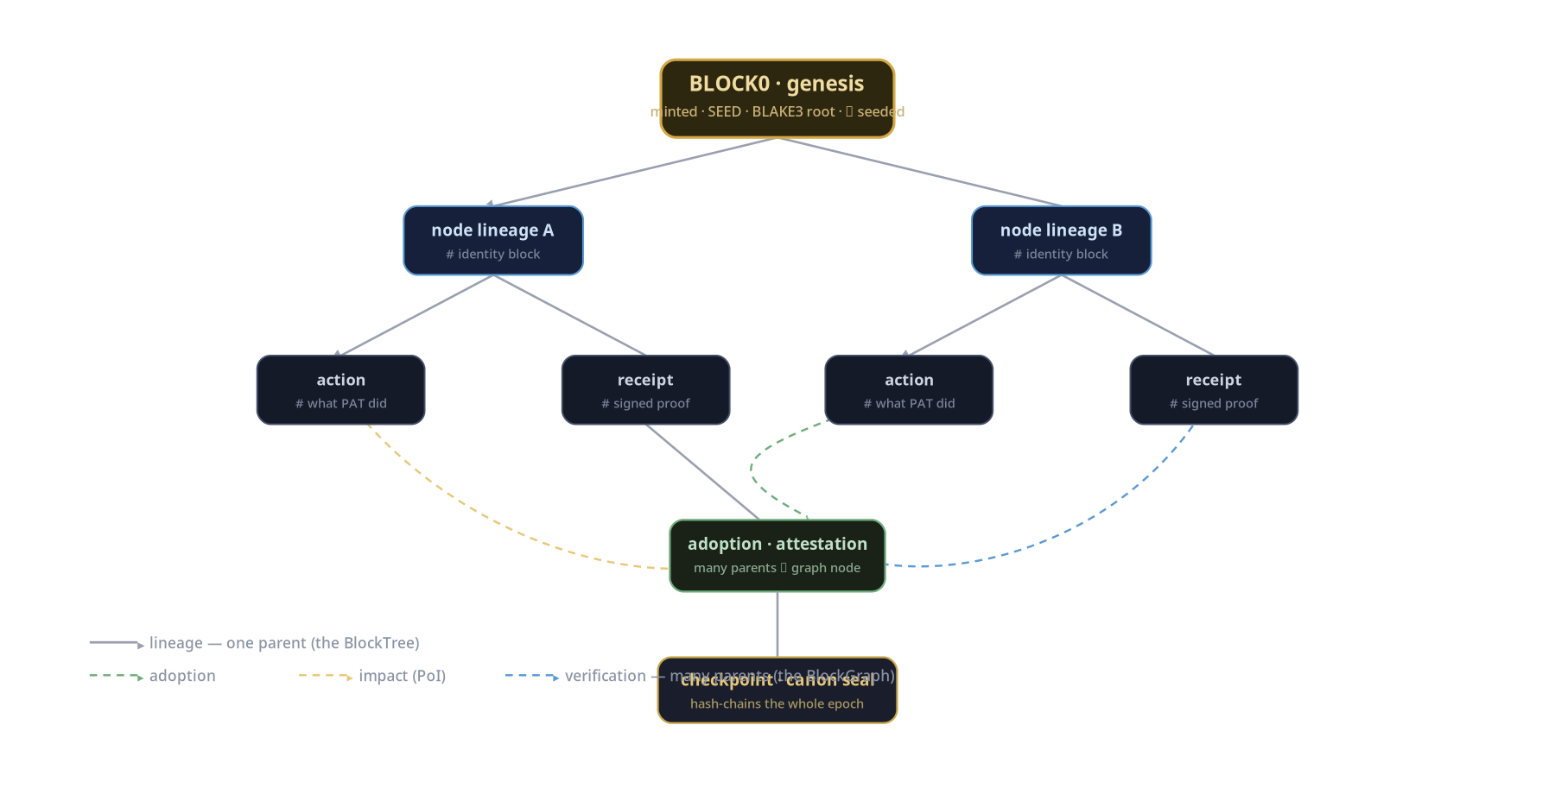
Figure — BlockTree / BlockGraph
One logical URP may eventually span many physical Nodes.
Target topology:
URP LOGICAL FABRIC
┌─────────────────────────────────────┐
│ │
│ resource registry │
│ capability registry │
│ knowledge plane │
│ scheduler │
│ verification fabric │
│ governance │
│ accounting │
│ │
└──────────────┬──────────────────────┘
│
┌──────────────┼──────────────┐
▼ ▼ ▼
Node A Node B Node C
────── ────── ──────
private private private
resources resources resources
selected selected selected
explicit explicit explicit
contribution contribution contribution
│ │ │
└───────────────URP─────────────┘
Nodes do not automatically trust each other.
URP mediates capability use through contracts and evidence.

35. NO DIRECT TRUST PATH
Peer-to-peer transport may eventually exist.
Peer-to-peer trust inheritance must not.
A Node receiving a claim from another Node does not accept it simply because the other Node sent it.
The claim carries evidence.
URP determines what evidence is admissible.
SAT may independently challenge it.

36. FEDERATION MODEL
The architecture can mature through bounded stages:
SEED
single sovereign Node
SPROUT
multiple devices / local resources
TREE
private multi-resource Node
FOREST PILOT
multiple sovereign Nodes
FOREST
federated URP
Each stage must prove the requirements of the previous stage rather than merely add participants.

37. PROTOCOL INTERFACES
Target interfaces should remain transport-independent where practical.
BIZRA can expose resource operations through:
MCP
A2A
JSON-RPC
SSE
HTTP APIs
local IPC
event streams
The logical contract matters more than transport.
Example operations:
resource.discover
resource.describe
resource.qualify
resource.lease.request
resource.lease.revoke
capability.invoke
execution.cancel
execution.observe
receipt.fetch
knowledge.query
knowledge.propose
impact.claim
impact.verify

38. RESOURCE DISCOVERY REQUEST
Example:
{
"mission_id": "mission-123",
"task_class": "CODE_REVIEW",
"requirements": {
"language": ["rust"],
"processing_locality": ["LOCAL"],
"network": false,
"write_access": false
},
"evidence_requirements": {
"qualification": "VERIFIED_LOCAL"
}
}
Return:
{
"candidates": [
{
"resource_id": "...",
"capability_match": true,
"qualification": "...",
"availability": "...",
"authority": "NOT_YET_GRANTED"
}
]
}

39. CONTROL PLANE
The URP control plane manages:
resource identity
resource discovery
capability contracts
qualification
health
lease lifecycle
scheduler
policy
revocation
accounting
governance
It does not need to host resource execution itself.

40. DATA PLANE
The URP data plane carries mission-bounded information between approved components.
Core laws:
minimum necessary context
explicit source
explicit destination
explicit retention
explicit mission
explicit authority

41. EVIDENCE PLANE
The evidence plane stores:
observations
hashes
receipts
qualification records
verifier results
provenance chains
mission outcomes
revocations
supersessions
This becomes the system's proof memory.

42. GOVERNANCE PLANE
Governance decides:
what resource classes exist
qualification requirements
evidence requirements
revocation policy
dispute handling
shared knowledge admission
economic eligibility
constitutional upgrades
Governance cannot retroactively transform an unsupported claim into evidence.

43. SECURITY ARCHITECTURE
URP assumes resources can fail.
Some may also be malicious.
Target threat classes include:
malicious provider
compromised Node
prompt injection
credential theft
data exfiltration
false completion
result fabrication
resource spoofing
receipt tampering
replay
Sybil contribution
collusion
economic gaming
denial of service
stale availability
authority escalation
The security model therefore assumes:
No single resource is trusted merely because it participates.

44. ZERO-TRUST RESOURCE ACCESS
Every resource interaction re-establishes:
identity
mission
scope
authority
freshness
capability
qualification
No permanent trust because:
This model worked yesterday.
No permanent authority because:
This user allowed something similar last week.

45. REVOCATION
The URP must treat revocation as first-class.
A human must eventually be able to revoke:
resource contribution
mission lease
provider access
credential
data permission
skill
knowledge admission
economic participation
Revoking future access does not prove historical deletion from an external provider.
That distinction must remain explicit.

46. FAILURE MODEL
URP failures should be typed.
Example:
CAPABILITY_FAILURE
RESOURCE_UNAVAILABLE
RESOURCE_STALE
AUTHORITY_DENIED
FATE_DENIED
PRIVACY_MISMATCH
BUDGET_EXCEEDED
TIMEOUT
AMBIGUOUS_EFFECT
VERIFICATION_FAILED
PROVIDER_ERROR
INFRASTRUCTURE_ERROR
POLICY_ERROR
UNKNOWN
A timeout is not automatically a failed effect.
It may be:
UNKNOWN_EFFECT
requiring reconciliation.

47. RETRY CONTRACT
Retries must be aware of side effects.
Safe patterns:
read
→ generally retryable
idempotent write
→ retry with idempotency key
non-idempotent effect
→ reconcile before retry
unknown effect
→ DO NOT blind retry

48. RECOVERY
The URP masterpiece must degrade gracefully.
If the preferred actor disappears:
mission preserved
↓
lease terminated
↓
state reconciled
↓
replacement candidates discovered
↓
qualification checked
↓
human authority re-evaluated if necessary
↓
mission resumes
The human should not need to reconstruct the mission.

49. OBSERVABILITY
The URP cockpit should answer:
What resources exist?
Which are currently available?
Which are qualified?
Which are being used?
For what mission?
Under whose authority?
At what cost?
What data did they receive?
What happened?
Was it verified?
What remains unknown?
Without exposing secret internal values.

50. PRIVACY UX
DEMA should explain resource decisions in human language.
Example:
I found a stronger external model, but this mission contains LOCAL_ONLY information, so I kept the task on your workstation.
Or:
Two qualified providers can do this. The faster one retains prompts for 30 days, so I selected the private-local option.
This is sovereignty translated into product experience.

PART IV
Technical Stack, Architecture, DOD & Acceptance
Target technology, software architecture, executable invariants, DOD, acceptance mission and North Star.

51. TECHNICAL STACK — TARGET
The exact implementation can evolve, but the architecture currently points toward:
SYSTEM RUNTIME
Rust
SMART / ECONOMIC CONTRACTS
Move or another formally constrained contract layer where appropriate
LOCAL STORAGE
content-addressed artifacts
SQLite / WAL-class local coordination where appropriate
KNOWLEDGE
graph + provenance + immutable source references
INTEROPERABILITY
MCP
A2A
JSON-RPC
SSE
STATE SYNCHRONIZATION
CRDT-compatible patterns where distributed convergence is required
SECURITY
zero trust
sandboxing
least privilege
capability mediation
CRYPTOGRAPHIC EVIDENCE
canonical serialization
hash commitments
signatures
Merkle-compatible structures
receipts
UI
DEMA as sole human-facing projection
Technology is subordinate to the constitutional contracts.

52. HIGH-LEVEL SOFTWARE ARCHITECTURE
┌────────────────────────────────────────────┐
│ DEMA │
│ Human interaction layer │
└─────────────────────┬──────────────────────┘
│
▼
┌────────────────────────────────────────────┐
│ MISSION ORCHESTRATOR │
│ intent · state · requirements · checkpoint │
└─────────────────────┬──────────────────────┘
│
resource requirement
│
▼
╔════════════════════════════════════════════╗
║ URP ║
║ ║
║ ┌──────────────────────────────────────┐ ║
║ │ Resource & Capability Registry │ ║
║ └──────────────────────────────────────┘ ║
║ │ ║
║ ┌──────────────────────────────────────┐ ║
║ │ Discovery / Scheduler │ ║
║ └──────────────────────────────────────┘ ║
║ │ ║
║ ┌──────────────────────────────────────┐ ║
║ │ Qualification & Policy │ ║
║ └──────────────────────────────────────┘ ║
║ │ ║
║ ┌──────────────────────────────────────┐ ║
║ │ FATE / Lease Boundary │ ║
║ └──────────────────────────────────────┘ ║
║ │ ║
║ ┌──────────────────────────────────────┐ ║
║ │ Execution Fabric │ ║
║ └──────────────────────────────────────┘ ║
║ │ ║
║ ┌──────────────────────────────────────┐ ║
║ │ Observer / SAT Verification │ ║
║ └──────────────────────────────────────┘ ║
║ │ ║
║ ┌──────────────────────────────────────┐ ║
║ │ Receipt / Evidence Plane │ ║
║ └──────────────────────────────────────┘ ║
║ │ ║
║ ┌──────────────────────────────────────┐ ║
║ │ Knowledge / House of Wisdom │ ║
║ └──────────────────────────────────────┘ ║
║ │ ║
║ ┌──────────────────────────────────────┐ ║
║ │ PoI / Accounting │ ║
║ └──────────────────────────────────────┘ ║
╚════════════════════════════════════════════╝

53. MASTER SYSTEM INVARIANTS
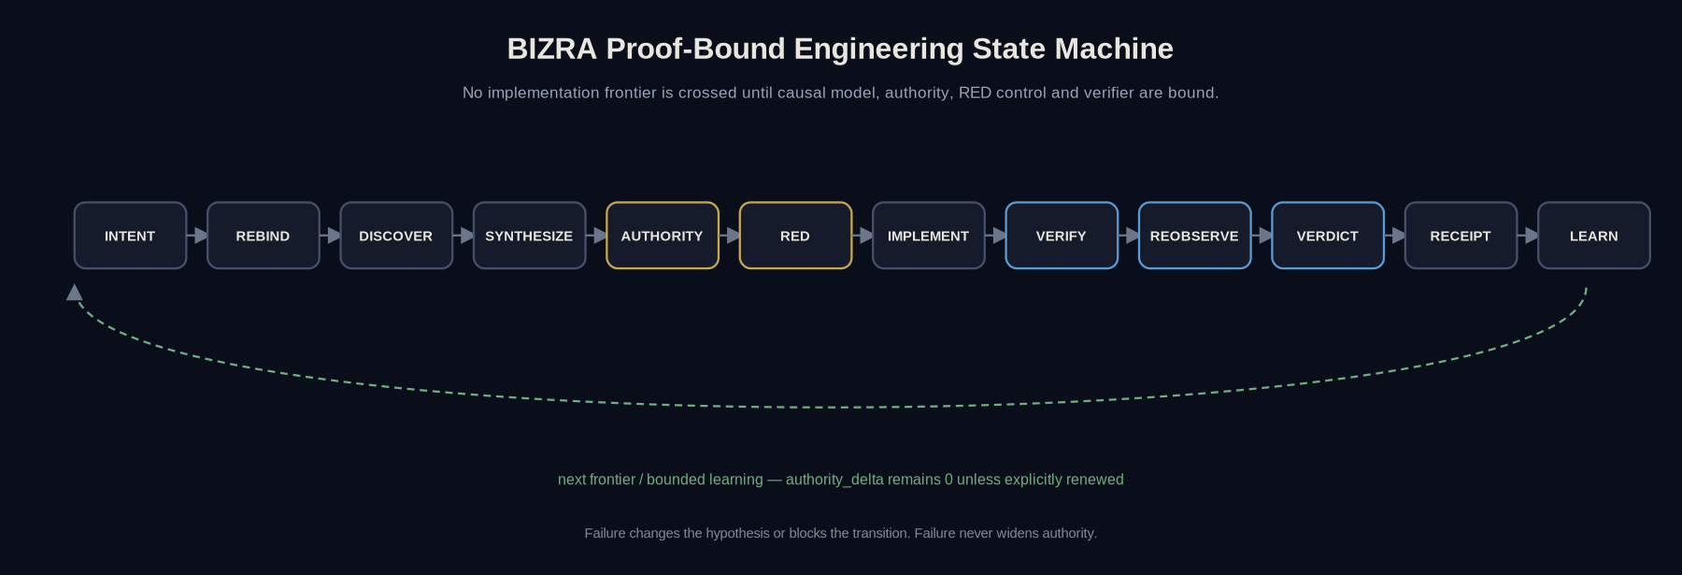
Figure — Proof-state machine
These should eventually become executable assertions.
I1 Private resources are not pooled by discovery alone.
I2 Resource discovery creates no authority.
I3 Qualification creates no authority.
I4 A mission lease cannot exceed its parent authority.
I5 A worker cannot widen its lease.
I6 Execution cannot self-verify.
I7 Unknown effects cannot be blindly retried.
I8 External resource use respects data-egress classification.
I9 Reward requires verified impact.
I10 Simulation cannot create mintable impact.
I11 Resource revocation blocks future leases.
I12 Historical evidence remains after supersession.
I13 Learning cannot self-authorize.
I14 A provider failure cannot destroy mission continuity.
I15 URP membership does not create peer trust.

54. NON-FUNCTIONAL REQUIREMENTS
The masterpiece URP requires more than correctness.

DETERMINISM
Where a decision is expected to be deterministic, equivalent canonical inputs must produce equivalent outputs.

SCALE
Resource discovery and scheduling must remain tractable as Nodes and resources grow.

RESILIENCE
Loss of any single non-authoritative worker must not destroy mission truth.

PRIVACY
Sensitive context must remain minimized and scoped.

OBSERVABILITY
Important transitions must be inspectable without exposing secrets.

PORTABILITY
No indispensable dependency on one AI provider.

REVERSIBILITY
Reversible transitions should provide tested reversal procedures.

AUDITABILITY
Important state changes should produce evidence sufficient for independent review.

ACCESSIBILITY
The complexity of URP must not become the human's burden.

55. URP DEFINITION OF DONE
The upper aim of URP is DONE only when the following are demonstrated.

URP-DOD-01 — LOGICAL UNITY
Multiple physical resources appear through one coherent discovery and capability protocol.
No resource requires DEMA to contain provider-specific mission logic.

URP-DOD-02 — SOVEREIGN CONTRIBUTION
A private Node resource remains private until its owner explicitly contributes it.
Contribution can be scoped.
Future use can be revoked.

URP-DOD-03 — RESOURCE IDENTITY
Every resource has a stable identity, owner domain, capability contract, evidence vector, and version.

URP-DOD-04 — QUALIFICATION
Unqualified resources cannot silently become mission candidates for protected task classes.

URP-DOD-05 — DISCOVERY
Given a mission requirement, URP can return only resources satisfying its hard constraints.

URP-DOD-06 — ACTOR PORTABILITY
A mission procedure can change qualified actor without rewriting mission authority.

URP-DOD-07 — LEASE BOUNDARY
Every consequential resource invocation is bound to an explicit mission lease.

URP-DOD-08 — DATA MINIMIZATION
Resources receive only mission-required context.
Local-only information demonstrably remains local.

URP-DOD-09 — CREDENTIAL MEDIATION
Protected credentials are not unnecessarily exposed to execution workers.

URP-DOD-10 — RESOURCE ISOLATION
One leased worker cannot inspect another mission's private state without authorization.

URP-DOD-11 — FATE INTEGRATION
A resource cannot convert availability into consequential action without the applicable authority boundary.

URP-DOD-12 — INDEPENDENT VERIFICATION
Protected mission classes have an observation/verifier path that is independent of the proposing executor where required.

URP-DOD-13 — HONEST UNKNOWN
Ambiguous outcomes produce UNKNOWN rather than false success.

URP-DOD-14 — RECOVERY
A provider can fail mid-mission and be replaced without losing the authoritative mission state.

URP-DOD-15 — REVOCATION
A contributor can prevent new leases after revocation.

URP-DOD-16 — HOUSE OF WISDOM
Shared knowledge returned as admitted wisdom is provenance-bound and distinguishable from unverified source material or proposals.

URP-DOD-17 — HABIT PORTABILITY
At least one qualified HabitSpec runs through two independent actor implementations while preserving authority and verification contracts.

URP-DOD-18 — ACCOUNTING
Every leased resource operation can be attributed to a mission, resource, duration/cost class, and result.

URP-DOD-19 — VERIFIED IMPACT
Resource usage cannot become reward eligibility without a separately verified useful outcome.

URP-DOD-20 — NO SELF-REWARD
The actor producing an outcome cannot unilaterally certify the reward attached to that outcome.

URP-DOD-21 — FEDERATED RESOURCE PROOF
At least two sovereign Nodes can contribute and consume bounded resources without merging identity or private state.

URP-DOD-22 — PROVIDER FAILURE
Removing a model/provider does not invalidate the underlying mission or qualified HabitSpec.

URP-DOD-23 — HUMAN COMPREHENSION
For every meaningful resource action, DEMA can explain:
why this resource
what it received
what it may do
what it costs
what changed
how the outcome was checked

URP-DOD-24 — BURDEN REDUCTION
On a representative mission set, URP materially reduces manual:
model selection
tool switching
resource configuration
context transfer
failure recovery
verification work
without increasing unauthorized effects.

URP-DOD-25 — ZERO FALSE GREEN
For the defined critical mission acceptance set:
FalseGreen = 0
during the agreed qualification window.

56. MASTER URP ACCEPTANCE MISSION
The final proof should not be a synthetic dashboard.
It should be one real human mission.
Example:

Human
Dema, reproduce this research result privately, compare it with the original, and prepare a verified summary.
The mission requires:
private source files
local GPU
qualified model
Python environment
research retrieval
PAT analysis
SAT verification
artifact creation
URP must:
discover the local GPU;
discover a qualified model;
discover an appropriate execution environment;
reject external actors incompatible with LOCAL_ONLY;
lease resources under the mission;
execute the experiment;
survive one deliberate provider/resource failure;
recover without losing mission state;
independently re-observe the result;
produce a verified artifact;
release resources;
produce usage receipts;
create no impact reward merely because compute was consumed.
Then repeat the same mission shape using a different qualified actor.
If the actor changes while:
mission continuity remains intact;
authority remains unchanged;
privacy remains intact;
verification still succeeds;
human burden falls;
then URP has demonstrated its core thesis.

57. THE TRUE URP KPI
The primary KPI should not be:
number of agents
number of models
GPU count
token count
transactions
resources registered
The North-Star metric is closer to:
Verified Useful Capability Delivered × Human Burden Removed { Cost + Risk + Authority Expansion
With the hard constraint:
AuthorityExpansion = 0
unless explicitly granted by the human through a separate constitutional process.

58. THE URP MASTERPIECE MOMENT
The human asks:
Dema, can we do this?
DEMA responds:
Yes.
Your workstation can perform the private analysis.
Your local model can handle the first stage.
A specialized external capability would improve the second stage, but your current privacy constraint prevents sending it the source data.
I can instead send a derived, non-sensitive representation.
The estimated resource budget is within your mission limit.
Nothing consequential has happened yet.
Shall I proceed with that bounded plan?
The human says:
Proceed.
Behind that simple interaction:
resources discovered
capabilities qualified
privacy checked
authority bound
lease issued
execution isolated
results observed
SAT challenged
receipts produced
resources released
mission advanced
But the human experiences:
One coherent companion helping me accomplish my goal.
That is URP.

59. FINAL MANIFEST
BIZRA does not need one machine powerful enough to solve everything.
It needs a constitution strong enough for many forms of intelligence and capability to cooperate safely.
URP therefore exists to transform:
isolated compute
isolated models
isolated tools
isolated knowledge
isolated skills
isolated human contribution
into:

COOPERATIVE CAPABILITY
without transforming humans into:

SHARED PROPERTY.
The final law is:
Pool capability. Preserve sovereignty.
And beneath it:
Discover broadly. Qualify rigorously. Lease narrowly. Execute minimally. Observe independently. Reward verified benefit.

THE NORTH STAR
Sovereign Nodes → Governed Resource Fabric → Bounded Capability → Verified Outcome → Fair Contribution → Growing Shared Wisdom
The URP masterpiece is not the world's biggest pool of machines.
It is:
**A universal capability fabric where humans can benefit from one another's machines, intelligence, knowledge, and contribution without surrendering sovereignty—and where every consequential claim stops exactly where its proof stops.**
That is the Universal Resource Pool.
PART V
Implementation-Grade LLD Annex
Target module contracts and executable acceptance surfaces derived from the 59-section URP specification. These are target designs, not claims of current deployment.

60. LLD Scope & Implementation Boundary
The LLD turns the URP product/protocol laws into implementable components without changing the sovereignty model. Node-private state remains outside the shared substrate unless an explicit contribution/lease permits bounded use. URP is logically unified but may be physically distributed. The first delivery target is a closed Node0 special case; federation and economic activation remain later proof stages.
LLD invariant: describe interfaces strongly enough to implement and test them, but never describe a target service as LIVE unless a separate evidence rebind proves that exact deployment.

61. Target Service / Module Topology
Domain | Module | Responsibility
Node Sovereignty | dema-ui / mission-orchestrator | Translate human intent into mission state and bounded requirements; no authority creation.
Node Sovereignty | node-private-registry | Inventory local/private resources without pooling them by discovery.
Authority | fate-evaluator | Evaluate human grant + constitutional constraints; mint no permission by inference.
URP Control | resource-registry | Versioned Resource Cards, owner domain, evidence vector, revocation state.
URP Control | capability-registry | CapabilityContract versions and compatibility/verification requirements.
URP Control | qualification-service | Bind qualification status to evidence refs and freshness.
URP Control | discovery-engine | Hard-constraint filter over capability, privacy, locality, qualification, availability and budget.
URP Control | scheduler-router | Select smallest adequate qualified resource set after hard constraints pass.
URP Control | lease-service | Issue/revoke/expire mission-bound resource leases whose authority is a subset of parent authority.
Execution | sandbox-runner | Bound filesystem/network/process/CPU/GPU/time/output/egress under lease.
Execution | credential-mediator | Perform protected provider operations without exposing raw credentials to arbitrary workers.
Execution | egress-guard | Enforce PUBLIC/SHAREABLE/MISSION_SCOPED/PRIVATE/LOCAL_ONLY/SECRET data classification.
Verification | observer-gateway | Collect poststate independently from executor-owned success labels.
Verification | sat-verifier | Challenge provenance, authority, security, impact and admissibility; cannot mint human permission.
Evidence | receipt-service | Canonical usage/verification receipts; deterministic serialization, signatures and replay protection.
Evidence | evidence-store | Append-only observations, receipts, qualification, provenance, revocation and supersession.
Knowledge | house-of-wisdom | Admitted knowledge objects with provenance, counterevidence, independence class and proof ceiling.
Knowledge | habitspec-registry | Qualified reusable procedures whose actor may change while contracts remain stable.
Economic - future | accounting-poi | Usage accounting and reward eligibility only after separately verified impact.
Federation - future | federation-adapter | Transport-independent Node↔URP exchange; no peer trust inheritance.

62. Persistence & Evidence Stores
Store | Required semantics
Node Private Store | Local mission state, private inventory, consent history, private knowledge; never implicitly replicated to URP.
Resource Registry | ResourceCard + CapabilityContract + version + owner domain + evidence vector.
Lease Journal | Append-only lease lifecycle and revocation events keyed by mission/resource/authority.
Evidence Journal | Immutable observation and verifier event references; source bytes/artifacts remain content-addressed.
Receipt Store | Finalized usage/verification receipts with algorithm-tagged commitments and signatures.
Knowledge Store | KnowledgeObject, supersession graph, provenance and admission receipts.
BlockTree / BlockGraph | Canonical ancestry/checkpoint commitments plus typed adoption/verification/impact edges; never a truth oracle by itself.
Target local coordination may use a transactional/WAL-class store while artifacts remain content-addressed. Cryptographic commitments must be algorithm-tagged so hash choices can evolve without ambiguity.

63. Core Data Contracts

63.1 ResourceCard
Field | Type / class | Required | Rule
schema | URI/version | Yes | bizra.urp.resource.v1 or successor; major version is explicit.
resource_id | stable identifier | Yes | Unique within owner domain and globally resolvable through URP.
resource_type | enum | Yes | COMPUTE/MODEL/AGENT/TOOL/STORAGE/DATA/KNOWLEDGE/SKILL/NETWORK/DEVICE/HUMAN/VERIFICATION/SECURITY/SIMULATION/INFRASTRUCTURE.
owner_domain | identity ref | Yes | Ownership precedes pooling.
capabilities | refs[] | Yes | Describes; never authorizes.
locality/privacy | struct | Yes | Processing boundary, accepted data classes, retention and egress.
qualification | struct | Yes | Status + evidence refs + freshness.
availability | struct | Yes | Separate from qualification and authority.
economics | struct | Yes | Reward eligibility defaults false.
revocation | struct | Yes | Future-use revocation semantics.
evidence_vector | struct | Yes | Independent lifecycle/evidence/freshness/consistency/provenance/locality/privacy/authority axes.

63.2 CapabilityContract
Field | Type / class | Required | Rule
identity/version | id + semver | Yes | Actor-independent contract identity.
task_classes | enum[] | Yes | Supported mission/task classes.
input_schema/output_schema | schema refs | Yes | Validated at boundary.
data_classes_allowed | enum[] | Yes | Hard egress constraint.
processing_locality | enum | Yes | LOCAL / PRIVATE_REMOTE / PUBLIC_REMOTE or successor.
effect_classes | enum[] | Yes | Used by FATE and sandbox policy.
permission_requirements | capabilities[] | Yes | No implicit permissions.
cost/latency/health | contracts | Yes | Used only after hard constraints.
verification_contract | contract ref | Yes | Defines poststate and independent verifier needs.
retry/idempotency/cancel/recovery | contracts | Yes | Unknown effects require reconciliation before retry.
qualification_evidence | refs[] | Yes | Qualification never self-mints.

63.3 ResourceLease
Field | Type / class | Required | Rule
lease_id | id | Yes | Stable lease identity.
mission_id/resource_id | refs | Yes | Exact mission/resource binding.
scope | struct | Yes | Narrower than parent authority.
budget | struct | Yes | Cost/time/resource ceilings.
starts_at/expires_at | timestamps | Yes | Freshness and expiry enforced.
authority_ref/fate_ref | refs | Yes | No execution without applicable authority admission.
revocable | bool | Yes | True where technically possible.
idempotency_key | string | Conditional | Required for retryable writes/effects where supported.

63.4 UsageReceipt
Field | Type / class | Required | Rule
mission_id/lease_id/resource_id | refs | Yes | Attribution and replay subject.
actor_version | identity | Yes | Versioned executor.
authority_ref | ref | Yes | Exact authority chain.
input_commitment | hash ref | Yes | Algorithm-tagged canonical commitment.
prestate_ref/poststate_ref | evidence refs | Yes | Outcome re-observation.
effect_attempt | struct | Yes | Attempt does not imply effect.
verifier_ref | identity/receipt ref | Conditional | Required for protected claims.
result | VERIFIED/FAILED/UNKNOWN | Yes | Honest ambiguity.
cost | struct | Yes | Cost measured is not value.
impact_claimed | bool | Yes | Defaults false; downstream of verified outcome.

64. Resource Lifecycle State Machine
DISCOVERED -> REGISTERED -> CANDIDATE -> QUALIFIED -> ADMITTED -> AVAILABLE -> LEASED -> ACTIVE -> RELEASED
Exceptional states: DEGRADED | SUSPENDED | REVOKED | SUPERSEDED | OFFLINE | UNKNOWN
Guards:
- QUALIFIED requires qualification evidence.
- ADMITTED is policy/governance status, not mission authority.
- LEASED requires mission + authority + FATE admission.
- ACTIVE requires lease freshness and sandbox admission.
- REVOKED blocks future leases.
- UNKNOWN blocks blind retry for non-idempotent effects.
Lifecycle is orthogonal to evidence strength, freshness, provenance, privacy, availability, qualification and authority. No implementation may compress these axes into one “green” status.

65. Mission / Lease Execution State Machine
INTENT
-> MISSION_BOUND
-> REQUIREMENTS_COMPILED
-> RESOURCES_DISCOVERED
-> CANDIDATES_FILTERED
-> AUTHORITY_PENDING
-> LEASE_ISSUED
-> EXECUTION_ADMITTED
-> EXECUTING
-> POSTSTATE_OBSERVED
-> SAT_VERIFIED | FAILED | UNKNOWN_EFFECT
-> RECEIPTED
-> RESOURCES_RELEASED
-> MISSION_ADVANCED
Hard stops: AUTHORITY_DENIED | FATE_DENIED | PRIVACY_MISMATCH | BUDGET_EXCEEDED | REVOKED

66. FATE Evaluator Contract
Input: candidate operation + mission scope + human grant + parent authority + resource contract + privacy class + effect class
Output: GO / BLOCK / REQUIRE_EXPLICIT_AUTHORITY plus machine-readable blockers
Subset law: child authority ⊆ parent authority
Fail closed: unknown capability, stale authority, path/scope escape, missing proof or ambiguous effect blocks protected execution
Non-goal: FATE does not decide mission utility, discover resources, grade SAT, or manufacture consent

67. Discovery & Scheduler Algorithm
1. Discover candidate ResourceCards.
2. Reject candidates failing hard constraints:
privacy, authority compatibility, locality, capability, qualification, availability, interface compatibility, budget, security, mission scope.
3. Build smallest adequate candidate teams.
4. Rank remaining candidates by expected verified utility - cost - latency - bounded risk - human burden.
5. Never permit ranking score to override a failed hard constraint.
6. Emit candidate rationale and proof ceiling; selection is still not execution authority.
The scheduler may optimize only after admission constraints pass. Agent/resource count is not itself an objective; additional actors are justified only by parallelism, independent evidence, specialization, fault tolerance or a meaningful alternative method.

68. Verification, Corroboration & Receipt Pipeline
executor output
↓
structural / cryptographic checks
↓
independent poststate observation
↓
semantic / empirical verifier
↓
SAT challenge where required
↓
VERIFIED | FAILED | UNKNOWN
↓
final bytes -> semantic verification -> canonical serialization -> hash -> signature/seal -> persist
↓
optional BlockTree/BlockGraph commitment
↓
optional impact claim (separate evaluation)
Executor ≠ Verifier. A valid signature proves origin/integrity of signed bytes, not correctness, usefulness, authority or impact. Same-origin corroboration cannot satisfy an independence requirement.

69. BlockTree / BlockGraph LLD

69.1 Canonical block record
Field | Type / class | Required | Rule
block_id | hash/id | Yes | Algorithm-tagged commitment over canonical body.
schema/version | string | Yes | Breaking changes are explicit.
lineage_parent | block ref | Yes except genesis | Single parent creates ancestry tree.
subject_refs | refs[] | Yes | Mission/resource/receipt/checkpoint subjects.
artifact_hashes | hash refs[] | Conditional | Finalized artifacts only.
receipt_refs | refs[] | Conditional | Usage/verification/authority receipts.
created_at | timestamp | Yes | Canonical UTC.
signer/seal | identity + signature | Conditional | Required by proof class.

69.2 Typed graph edge
Field | Type / class | Required | Rule
edge_id | hash/id | Yes | Stable deterministic or canonical identifier.
edge_type | ADOPTION/VERIFICATION/IMPACT/SUPERSESSION/PROVENANCE | Yes | Typed semantics; impact remains claim until verified.
from/to | block refs | Yes | No implicit trust inheritance.
evidence_refs | refs[] | Yes | Every decision-bearing edge answers to evidence.
verifier_ref | ref | Conditional | Required for verification/impact edges.
proof_ceiling | text/enum | Yes | Prevents graph topology from becoming a truth oracle.

70. House of Wisdom & HabitSpec LLD
Knowledge admission and reusable procedure qualification are separate registries but share provenance, versioning, challenge and supersession semantics.

70.1 KnowledgeObject
Field | Type / class | Required | Rule
knowledge_id | id | Yes | Stable identity.
claim | text/structured | Yes | Scoped claim, not generic “truth”.
source_refs/source_hashes | refs[] | Yes | Immutable lineage.
evidence_class/independence_class | enums | Yes | Repeated model outputs do not create independence.
counterevidence | refs[] | Yes | Contradictions remain visible.
verification_receipts | refs[] | Conditional | Required for admitted wisdom.
admission_state | enum | Yes | SOURCE/PROPOSAL/CANDIDATE/ADMITTED/SUPERSEDED.
validity_constraints/proof_ceiling | struct | Yes | Truth remains revisable.

70.2 HabitSpec
Field | Type / class | Required | Rule
trigger/preconditions | contract | Yes | When the procedure applies.
inputs/context | schemas | Yes | Minimum required context.
steps | versioned plan | Yes | Actor-portable procedure.
capability/authority requirements | refs | Yes | No actor-specific authority assumption.
verification/stop/failure/recovery | contracts | Yes | Portable proof and recovery.
resource_budget | struct | Yes | Bounded execution.
qualification_evidence | refs[] | Yes | A prompt alone is not a qualified skill.

71. Security & Privacy Enforcement
Threat | Primary controls
Identity spoofing | Signed/versioned ResourceCard and actor identity; independent qualification evidence.
Authority escalation | FATE subset checks; no worker widening; explicit mission lease.
Data exfiltration | Data-class egress guard + least-context routing + network scope.
Credential theft | Credential mediator; worker requests capability, not raw secret.
False completion | Independent observer/verifier; UNKNOWN on ambiguity.
Replay | Nonce/challenge/freshness/idempotency and subject-bound signatures.
Receipt tampering | Canonical serialization + algorithm-tagged hash + signature/seal; append-only journal.
Sybil/collusion | Qualification provenance, independence classes, multiple verification paths for protected claims.
Provider failure | Mission state remains authoritative outside provider; reconcile then route replacement.
Economic gaming | Usage ≠ impact; executor cannot self-certify reward.

72. Deployment Topologies
SEED — Node0 — One human, one sovereign Node, local/private resource registry, one bounded worker, FATE gate, independent observation path, usage receipt. No federation implied.
SPROUT — Multiple explicitly enrolled personal devices/resources remain assets of the same Node unless separately constituted.
TREE — Private multi-resource Node with scheduling, recovery and actor portability.
FOREST PILOT — At least two sovereign Nodes contribute and consume bounded resources through URP contracts without merging identity/private state.
FOREST — Federated URP with mature governance, verification fabric and economic eligibility after the prior stages are proven.

73. Verification, Test & CI Matrix
Test family | Mandatory cases
Contract unit | Schema validation, canonicalization, enum rejection, proof-ceiling preservation.
Authority/FATE | Missing/stale/overscoped authority; child > parent; privacy mismatch; revoked resource.
Resource lifecycle | Illegal transitions, stale availability, revocation, supersession, unknown state.
Scheduler | Hard-constraint rejection before ranking; smallest adequate team; no score override.
Sandbox | Filesystem/network/process/egress/credential boundaries; timeout/cancel.
Receipts | Tamper, wrong subject, unknown signer, replay, challenge mismatch, same-origin verifier.
Recovery | Provider failure mid-mission; unknown effect reconciliation; idempotent retry.
Knowledge/HabitSpec | Provenance, counterevidence, actor portability, independent verification contract.
Federation pilot | Two Nodes, explicit contribution, no identity merge, no trust inheritance.
Economic - future | Usage cannot mint reward; simulation cannot mint impact; verifier independence.
Release rule: a local/unit GREEN never promotes a stronger deployment/federation/economic claim. Every gate states the bounded claim it establishes and what remains unproven.

74. Delivery Sequence & First Executable Slice
Milestone | Proof target
M0 — Rebind | Measure current repo/runtime/resource identity; classify NOW / VERIFIED / TARGET / FUTURE.
M1 — Resource identity | ResourceCard + private inventory + evidence vector; discovery creates no pooling/authority.
M2 — Capability & qualification | CapabilityContract + qualification evidence + freshness.
M3 — FATE + lease | Mission-bound authority subset + lease lifecycle + revocation.
M4 — Bounded execution | One local worker in sandbox with egress and credential mediation.
M5 — Independent observation | Separate observer/verifier path + VERIFIED/FAILED/UNKNOWN.
M6 — Receipt/evidence | Canonical usage receipt + append-only evidence + deterministic seal.
M7 — Actor portability | Run one HabitSpec through two qualified actors with same authority/verification.
M8 — Failure recovery | Deliberate provider/resource failure, reconcile, replace, resume without mission reconstruction.
M9 — Two-Node pilot | Explicit contribution and consumption across two sovereign Nodes; no trust inheritance.
M10 — Impact/economics | Only after verified outcome and independent impact evaluation; no self-reward.
TRUE NEXT SPEARPOINT — minimum closed Node0 special case
One private local resource → ResourceCard → qualified CapabilityContract → explicit FATE/mission lease → sandboxed execution → independent poststate observation → VERIFIED/FAILED/UNKNOWN → finalized usage receipt → release/revocation proof. No federation, token, PoI reward, or shared-knowledge promotion is required to close this slice.

APPENDIX A — DOD Traceability Matrix
The 25 URP Definition-of-Done items remain the normative acceptance set. Implementation teams should trace each DOD to at least one contract, one test/observation path, and one evidence artifact before claiming closure.
DOD range | Theme | Primary implementation proof surface
DOD 01–05 | Logical unity, sovereign contribution, resource identity, qualification, discovery | ResourceCard / CapabilityContract / discovery engine / contribution contract
DOD 06–10 | Actor portability, lease boundary, data minimization, credential mediation, isolation | HabitSpec / ResourceLease / egress guard / credential mediator / sandbox
DOD 11–15 | FATE, independent verification, honest UNKNOWN, recovery, revocation | FATE evaluator / observer + SAT / reconciliation / lease journal
DOD 16–20 | House of Wisdom, HabitSpec, accounting, verified impact, no self-reward | KnowledgeObject / HabitSpec / UsageReceipt / PoI evaluator
DOD 21–25 | Federation, provider failure, human comprehension, burden reduction, zero false GREEN | federation pilot / recovery harness / DEMA explanation / measured UX burden / acceptance suite

APPENDIX B — ADR Backlog
ADR-URP-001 — Canonical serialization and algorithm-tagged hash suite.
ADR-URP-002 — Resource / capability identifier format and owner-domain resolution.
ADR-URP-003 — Node0 local persistence engine and evidence journal durability.
ADR-URP-004 — FATE capability vocabulary and lease-subset evaluator.
ADR-URP-005 — Sandbox technology and cross-platform enforcement model.
ADR-URP-006 — Credential mediation interface and provider adapter contract.
ADR-URP-007 — Independent verifier origin/trust-root governance.
ADR-URP-008 — BlockTree lineage and BlockGraph edge canonicalization.
ADR-URP-009 — Federation transport (MCP/A2A/JSON-RPC/SSE/local IPC) and no-trust-inheritance semantics.
ADR-URP-010 — CRDT or other state-convergence pattern for federated non-authoritative metadata.
ADR-URP-011 — House of Wisdom admission policy and supersession model.
ADR-URP-012 — PoI/economic activation gate and dispute model.

APPENDIX C — Glossary
Term | Definition
Node | The sovereign human-centered boundary; devices are assets, not separate Nodes merely because they exist.
DEMA | Human-facing companion/projection translating intent and explaining bounded plans/effects.
PAT | Personal Agentic Team serving the human; cannot self-authorize or self-verify protected effects.
SAT | System Agentic Team / verifier role protecting shared truth and constitutional integrity; cannot mint human permission.
FATE | Fail-closed effect/authority membrane between candidate action and consequential execution.
URP | Universal Resource Pool: one logical, physically distributed, constitutionally governed capability fabric.
Resource Card | Machine-readable identity/evidence description of a resource; describes, never authorizes.
Capability Contract | Actor-independent description of what a resource can do, what it may receive, effects, verification and recovery.
Evidence Vector | Independent dimensions of lifecycle, evidence strength, freshness, consistency, provenance, locality, privacy, qualification, availability, authority and proof ceiling.
HabitSpec | Qualified reusable procedure with actor-portable authority and verification contracts.
Usage Receipt | Mission/resource/lease-bound record of attempted effect, poststate observation, result and cost.
BlockTree | Single-parent ancestry/lineage backbone.
BlockGraph | Typed cross-links for adoption, provenance, verification, impact or supersession; not a truth oracle.
Proof ceiling | Strongest claim justified by the evidence and verification coverage actually present.

APPENDIX D — Canonical Closing Statement
The URP masterpiece is not the world’s biggest pool of machines. It is a universal capability fabric where humans can benefit from one another’s machines, intelligence, knowledge, and contribution without surrendering sovereignty — and where every consequential claim stops exactly where its proof stops.
Sovereign Nodes → Governed Resource Fabric → Bounded Capability → Verified Outcome → Fair Contribution → Growing Shared Wisdom

