Chapter 10:-NFS

INTRODUCTION TO NETWORK FILE SERVICES.

The Network File System protocol, commonly known as NFS, lets you share filesystems among computers. NFS is nearly transparent to users, and no information is lost when an NFS server crashes. Clients can simply wait until the server returns and then continue as if nothing had happened. NFS was introduced by Sun Microsystems in 1984. It was originally implemented as a surrogate filesystem for diskless clients, but the protocol proved to be well designed and useful as a general file-sharing solution. All UNIX vendors and Linux distributions provide some version of NFS; many use code licensed from Sun. The NFS protocol is now an open standard documented in RFCs Sharing files over a network seems like a simple task, but in fact it’s a confoundingly complex problem with many edge cases and subtleties. As evidence of the complexities involved, numerous issues in the NFS protocol have revealed themselves only as bugs encountered in unusual situations over more than a quarter century of use. Today’s administrators can be confident that the most common file-sharing protocols (NFS and CIFS) will not regularly corrupt data or otherwise induce the wrath of upset users, but it’s taken a lot of work and experience to get to this point.

Configure nfs server
In this example we will configure a nfs server and will mount shared directory from client side.
For this example we are using two systems one linux server one linux clients . To complete these per quest of nfs server
- A linux server with ip address 192.168.0.254 and hostname Server
- A linux client with ip address 192.168.0.1 and hostname Client1
- Updated /etc/hosts file on both linux system
- Running portmap and xinetd services
- Firewall should be off on server
We suggest you to review that article before start configuration of nfs server. Once you have completed the necessary steps follow this guide.
Three rpm are required to configure nfs server. nfs, portmap, xinetd check them if not found then install
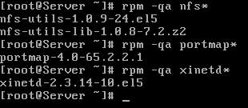
Now check nfs, portmap, xinetd service in system service it should be on
#setup
Select System service
from list
[*]portmap [*]xinetd [*]nfs
Now restart xinetd and portmap service
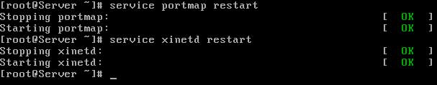
To keep on these services after reboot on then via chkconfig command
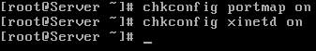
After reboot verify their status. It must be in running condition
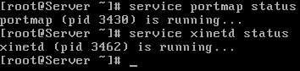

now create a /data directory and grant full permission to it
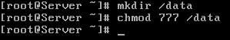

now open /etc/exports file
share data folder for the network of 192.168.0.254/24 with read and write access
save file with :wq and exit

now restart the nfs service and also on it with chkconfig
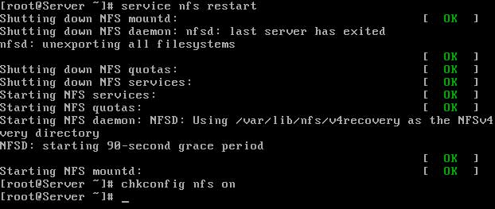
also restart nfs daemons with expotfs
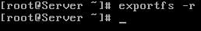
verify with showmount command that you have successfully shared data folder
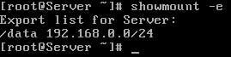

configure client system :-
ping form nfs server and check the share folder
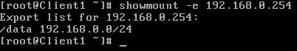
now mount this share folder on mnt mount point. To test this share folder change directory to mnt and create a test file
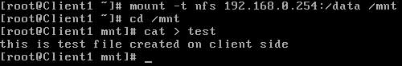
After use you should always unmount from mnt mount point
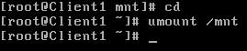
In this way you can use shared folder. But this share folder will be available till system is up. It will not be available after reboot. To keep it available after reboot make its entry in fstab
create a mount point, by making a directory
now open /etc/fstab file
make entry for nfs shared directory and define /temp to mount point
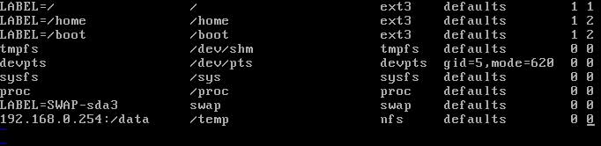
save the with :wq and exit reboot the system with reboot -f command
#reboot -f
after reboot check /temp directory it should show all the shared data
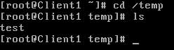

Mounting NFS Exports on NFS Clients
NFS filesystems are mounted in much the same way as local disk filesystems. The mount command understands the notation hostname:directory to mean the path directory on the host hostname. As with local filesystems, mount maps the remote directory on the remote host into a directory within the local file tree. After the mount completes, you access an NFS-mounted filesystem just like a local filesystem. The mount command and its associated NFS extensions represent the most significant concerns to the system administrator of an NFS client. Before an NFS file system can be mounted, it must be properly exported (see Server-side NFS on page 698). To verify that a server has properly exported its filesystems from the client’s perspective, use the client’s showmount command:

$ showmount -e monk

Export list for monk:
/home/ben harp.atrust.com
This example reports that the directory /home/ben on the server monk has been exported to the client system harp.atrust.com. If an NFS mount is not working, first verify that the filesystems have been properly exported on the server with exportfs. (You might have just forgotten to run exportfs -a after updating the exports file.) Next, check the showmount output. TCP wrappers. If the directory is properly exported on the server but showmount returns a error or an empty list, you might double-check that all the necessary processes are running on the server (portmap, mountd, nfsd, statd, and lockd), that the hosts.allow and hosts.deny files allow access to those daemons, and that you are on the right client system. The path information displayed by showmount, such as /home/ben above, is only valid for NFS version 2 and 3 servers. NFS version 4 servers export a single unified pseudo-filesystem. The traditional NFS concept of separate mount points
doesn’t jive with version 4’s model, so showmount isn’t applicable. Unfortunately, there is no good replacement for showmount in NFSv4. On the server, the command exportfs -v shows the existing exports, but of course this only works locally. If you don’t have direct access to the server, mount the root of the server’s pseudo-filesystem and traverse the directory structure manually, noting each mount point.

The Network File System (NFS) is a way of mounting Linux discs/directories over a network. An NFS server can export one or more directories that can then be mounted on a remote Linux machine
Network file system
Port no -2049
File name - /etc/exports
Clint/server

SERVER SIDE
Nfs install –sudo apt-get install nfs-kernel-server
Make directory –makdir test
Make one file in test directory –cat test1
Open exports file –nano /etc/exports
Make change below -/home /mukendra/test(test file path) 192.168.1.130(clint pc ip address)(rw,sync,no_root_squash)
See mounted file –showmount –e
Service restart - /etc/init.d/nfs-kernel-server restart

CLIENT SIDE

Install nfs –sudo apt-get install nfs-kernel-server
Mount the server test file –mount -t nfs 1902.0168.01.129(server ip):/home/mukendra/test(path of the server mounted file) /mnt (mount that file in /mnt in clint pc)
Check mounted file – df –h
Verify –mount | grep nfs
*MOUNT JUST LIKE A LOCAL DIRECTORY
On clint pc
Fs tab – /etc/fstab
Made changes in that file
192.168.1.129:/home/muser/test /mnt nfs rw,user 0 0
*************************************************************************************

