# PHISHING LINK SCANNER

# A PROJECT BY

BIZZA AKHIL

**Index**

1. Introduction .................................................................................................................... 1

2. Objectives .......................................................................................................................2

3. System Overview ............................................. ............................................................. 3

4. Methodology ...................................................................................................................5

5. Features .......................................................................................................................... 6

7. Code Snippet .................................................................................................................. 8

8. Conclusion ..................................................................................................................... 9

9. References .................................................................................................................... 10

**1. Introduction**

In the modern digital era, cyber threats have become increasingly sophisticated, targeting individuals and organizations worldwide. Among these, phishing attacks are one of the most common and deceptive forms of cybercrime. Phishing involves tricking users into clicking on malicious links, often disguised as legitimate websites, with the intent of stealing sensitive information such as usernames, passwords, and financial details.

Phishing links are typically distributed via emails, social media platforms, SMS, and other communication channels. Despite increased awareness, many users still fall victim to these attacks due to the realistic appearance of phishing websites and links.

To combat this issue, the Phishing Link Scanner Project was developed. This tool provides users with a simple yet effective method to analyze and evaluate URLs for potential threats. By scanning the structure, reputation, and known threat databases for a given link, the scanner assists users in identifying and avoiding malicious websites before harm can occur.

The project aims to enhance cybersecurity awareness among users and provide an additional layer of defense against phishing attempts. It is designed with ease of use in mind, featuring a Command-Line Interface (CLI) that guides users through scanning URLs and generating reports on the scan results.

Phishing attacks continue to evolve, often bypassing traditional security measures by exploiting human behavior and trust. This makes proactive tools like the Phishing Link Scanner essential for everyday users who may not possess technical expertise but still require reliable protection when navigating the internet.

The primary focus of this project is to provide a lightweight, fast, and accessible solution that allows users to independently verify suspicious links. By integrating scanning logic with real-time feedback and optional report generation, the Phishing Link Scanner bridges the gap between technical cybersecurity measures and end-user accessibility.

**2. Objectives**

The primary objective of this project is to provide users with a reliable tool to detect and analyze potentially harmful phishing links. With cybercriminals constantly developing new tactics to deceive users, it has become essential to empower individuals with easy-to-use tools for safeguarding themselves against online threats.

This project focuses on creating a lightweight, command-line-based Phishing Link Scanner that performs basic URL analysis and informs users about potential risks. The scanner aims to increase cybersecurity awareness and allow non-technical users to proactively assess suspicious links before interacting with them.

The specific objectives of this project are as follows:

* To develop a user-friendly tool that accepts URL input and performs a real-time threat scan.
* To analyze the structure and domain information of the given URL for known signs of phishing or suspicious behavior.
* To provide users with clear, concise scan results that highlight potential threats.
* To implement an optional report generation feature, enabling users to save scan results for future reference.
* To promote awareness regarding phishing attacks and encourage safe internet practices among everyday users.

Apart from providing a basic level of protection, this project emphasizes accessibility for individuals who may not possess advanced technical knowledge. Unlike complex enterprise-level security solutions, the Phishing Link Scanner is designed to be straightforward and operate within familiar command-line environments. This makes it particularly useful for students, independent users, and small businesses who require basic phishing protection without investing in expensive or complicated software.

Another significant objective is to raise awareness about the subtle techniques used by attackers in crafting phishing links. Often, malicious URLs are crafted to closely resemble legitimate websites, making detection difficult for the average user. By providing immediate feedback after a scan, this tool educates users on potential red flags, thereby fostering better decision-making when interacting with unknown links.

The project also aims to lay the foundation for future scalability and enhancements. While the current version focuses on basic scanning and report generation, the tool is structured to allow future upgrades. Potential enhancements include integrating machine learning for smarter detection, adding blacklist/whitelist features, and developing a graphical user interface (GUI) to further improve usability.

**3. System Overview**

The Phishing Link Scanner is designed as a lightweight, command-line-based tool that enables users to analyze URLs for signs of phishing and potential threats. The system operates by accepting a URL as input, conducting various checks on its structure, domain, and characteristics, and presenting the results to the user in a clear, readable format.

The core of the system is divided into two primary components:

* URL Scanner Module: This module is responsible for analyzing the provided URL. It performs basic validation to ensure proper formatting, checks for suspicious patterns such as the use of misleading characters, unusual domain extensions, or the presence of known phishing indicators. It can also be configured to reference external blacklists or threat intelligence databases for enhanced detection capabilities.
* Report Generation Module: After completing the URL scan, users have the option to generate a report summarizing the scan results. This report can be saved locally for documentation purposes. The report helps users keep records of scanned URLs, making it particularly useful for tracking repeated threats or maintaining audit trails.

The system emphasizes simplicity and efficiency. It is designed to function without requiring complex setup procedures, making it accessible to users with basic computer knowledge. The tool is built using the Python programming language, leveraging its flexibility and readability to ensure the code remains maintainable and scalable for future enhancements.

The Phishing Link Scanner provides real-time feedback and operates entirely offline, meaning no user data or scanned URLs are transmitted to external servers. This local-first approach ensures user privacy and data security while providing immediate results. The system's architecture is intentionally modular, allowing for individual components to be upgraded or replaced without affecting the entire project. This modularity ensures that additional functionalities, such as API integrations with external threat databases or advanced link pattern recognition, can be implemented in future versions with minimal disruption to the existing structure.

At the user interaction level, the system features an intuitive command-line interface that prompts the user to enter the URL to be scanned. Once the scan is completed, the system displays the results in a structured format, highlighting any detected risks or anomalies. Users are then given the option to save the scan results in the form of a detailed report, which serves both as a reference and as documentation for cybersecurity tracking.

The system prioritizes performance and low resource consumption. Since the Phishing Link Scanner is a lightweight application, it can be executed on virtually any computer with Python installed, including older machines with limited hardware capabilities. This makes the tool highly accessible, especially in educational environments, developing regions, or scenarios where users have minimal computing resources.

**4. Methodology**

The methodology employed in the Phishing Link Scanner project focuses on systematically analyzing URLs to identify potential phishing threats. The scanning process involves multiple stages designed to detect suspicious characteristics and patterns that commonly indicate malicious intent.

Initially, the system validates the input URL to ensure it conforms to the standard URL format, including the proper use of protocols such as HTTP or HTTPS. This validation prevents the scanner from processing invalid or malformed URLs that could lead to errors or false positives.

Following validation, the URL undergoes structural analysis where the system inspects components such as the domain name, path, query parameters, and overall length. The scanner looks for signs of deception, including the use of IP addresses instead of domain names, unusual subdomains, and the presence of special characters that might be employed to obfuscate the URL’s true destination.

The next phase involves reputation checks where the scanner compares the URL or its domain against known blacklists and phishing databases. These databases include publicly available threat intelligence sources that catalog malicious websites reported by cybersecurity communities. Matching a URL against these lists helps identify known phishing sites with high accuracy.Additionally, heuristic checks are applied to detect suspicious patterns or anomalies not covered by blacklist lookups. These heuristics may include checking for misleading domain names that mimic popular websites (e.g., slight misspellings), excessively long URLs, or the use of URL shortening services which are often exploited to hide malicious links.

Finally, the system compiles the findings into a comprehensive report detailing the scan results. The report provides users with actionable insights, highlighting specific risks and recommending caution if the URL is deemed suspicious. Users may opt to save this report for record-keeping or further analysis.

**5. Features**

The Phishing Link Scanner incorporates several key features designed to make URL scanning efficient, user-friendly, and reliable for everyday users. These features provide both basic and advanced functionalities aimed at detecting phishing threats effectively.

**1. User-Friendly Command-Line Interface (CLI):**

The tool is operated entirely through a command-line interface, which simplifies user interaction by guiding them step-by-step through the scanning process. The CLI prompts users to input URLs, displays scan results clearly, and offers the option to save reports—all within a familiar and lightweight environment.

**2. URL Validation:**

Before scanning, the system performs rigorous validation to ensure the input URL is properly formatted. This includes checking the presence of protocols (HTTP/HTTPS), domain structure, and eliminating malformed or incomplete URLs that could cause processing errors or false results.

**3. Structural Analysis of URLs:**

The scanner inspects various components of the URL, such as domain name patterns, subdomains, path length, and special characters. This helps identify common phishing tactics like IP address usage in place of domain names, suspicious subdomain patterns, and obfuscated URLs intended to deceive users.

**4. Blacklist Integration:**

The system can be extended to check URLs against publicly available blacklists and phishing databases. This feature allows immediate identification of URLs already reported as malicious, increasing the accuracy and trustworthiness of scan results.

**5. Heuristic-Based Detection:**

In addition to database lookups, the scanner employs heuristic techniques to detect suspicious patterns. This includes identifying domain names that mimic popular brands, excessive URL length, and use of URL shortening services commonly exploited by attackers.

**6. Report Generation and Saving:**

Users can choose to save scan reports locally. These reports summarize the scan findings, including detected threats, URL details, and timestamps. The saved reports help users maintain records for future reference or incident tracking.

**7. Privacy and Offline Operation:**

The scanner is designed to operate fully offline without transmitting user data to external servers. This protects user privacy and ensures sensitive information remains local to the user’s machine.

**6. Code Snippet**

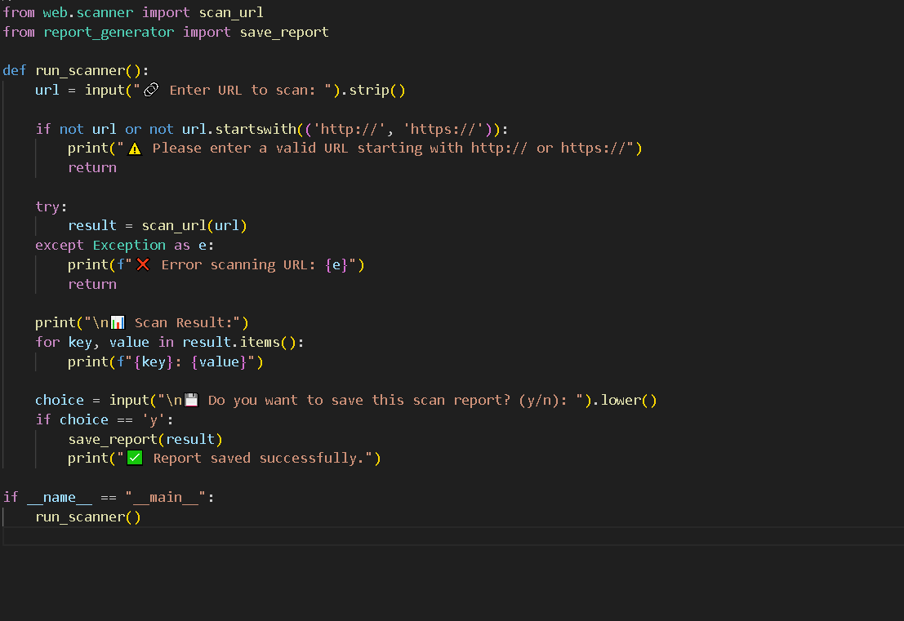

**7. Conclusion**

The Phishing Link Scanner project demonstrates a practical approach to addressing one of the most pervasive cybersecurity threats: phishing attacks. By providing a straightforward tool for analyzing URLs, the project empowers users to proactively identify potentially malicious links before they cause harm.

Throughout this project, the focus has been on creating an accessible, lightweight, and efficient solution that balances simplicity with effective detection techniques. The scanner’s modular design allows it to be easily expanded with additional features, such as integration with more comprehensive threat databases or advanced machine learning algorithms, making it adaptable to evolving cyber threats.

The inclusion of report generation capabilities adds value by enabling users to keep records of their scans, which can be useful for ongoing monitoring or educational purposes. Moreover, the project prioritizes user privacy by ensuring that all operations occur locally without sharing sensitive data externally.

This project contributes to raising cybersecurity awareness and offers a foundational tool that users can rely on to safeguard themselves from phishing threats. Future work will focus on enhancing detection accuracy, improving user interface options, and expanding the scanner’s capabilities to address a wider range of cyber threats.

**8. References**

• OWASP Foundation. (2023). Phishing Prevention Cheat Sheet. Retrieved from https://owasp.org/www-project-cheat-sheets/cheatsheets/Phishing_Prevention_Cheat_Sheet.html

• Krebs, B. (2020). Spam Nation: The Inside Story of Organized Cybercrime—From Global Epidemic to Your Front Door. Sourcebooks.

• Symantec Corporation. (2022). Internet Security Threat Report. Retrieved from https://www.symantec.com/security-center/threat-report

• Python Software Foundation. (2023). Python Documentation. Retrieved from <https://docs.python.org/3/>

• PhishTank. (2023). Phishing Website Database. Retrieved from <https://www.phishtank.com/>

• Microsoft. (2023). Security Intelligence Reports. Retrieved from <https://www.microsoft.com/security/blog/>