Admin Docs

Go to bizzybuzzportal.com
Hit Login
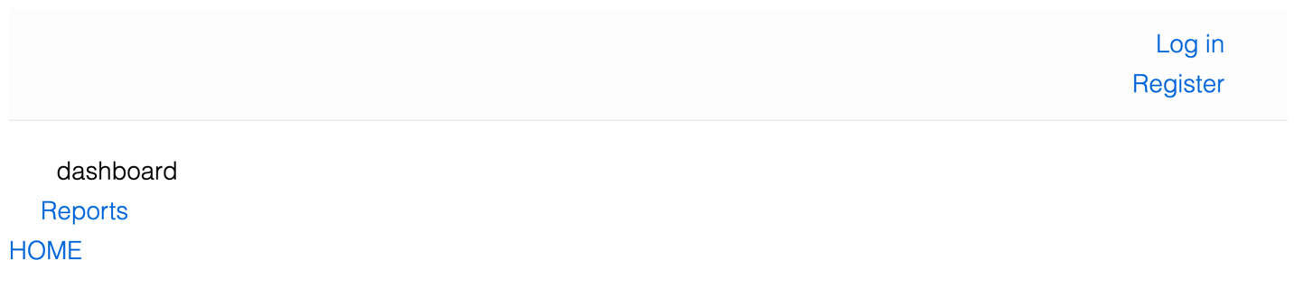

Login with admin credentials
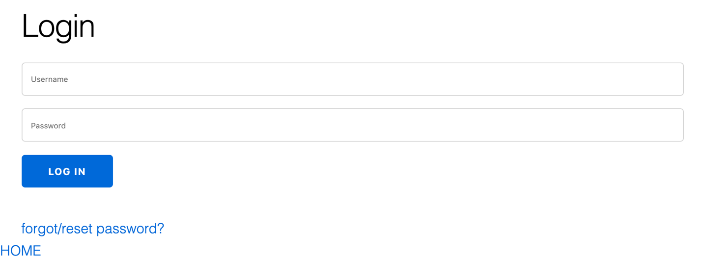

Choose Vendors
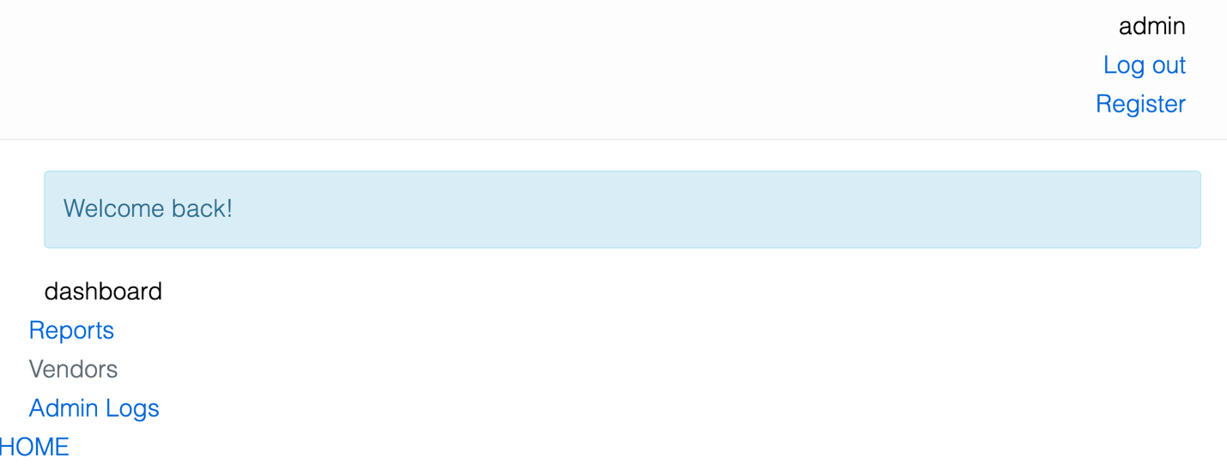

Create vendors by hitting New Vendor

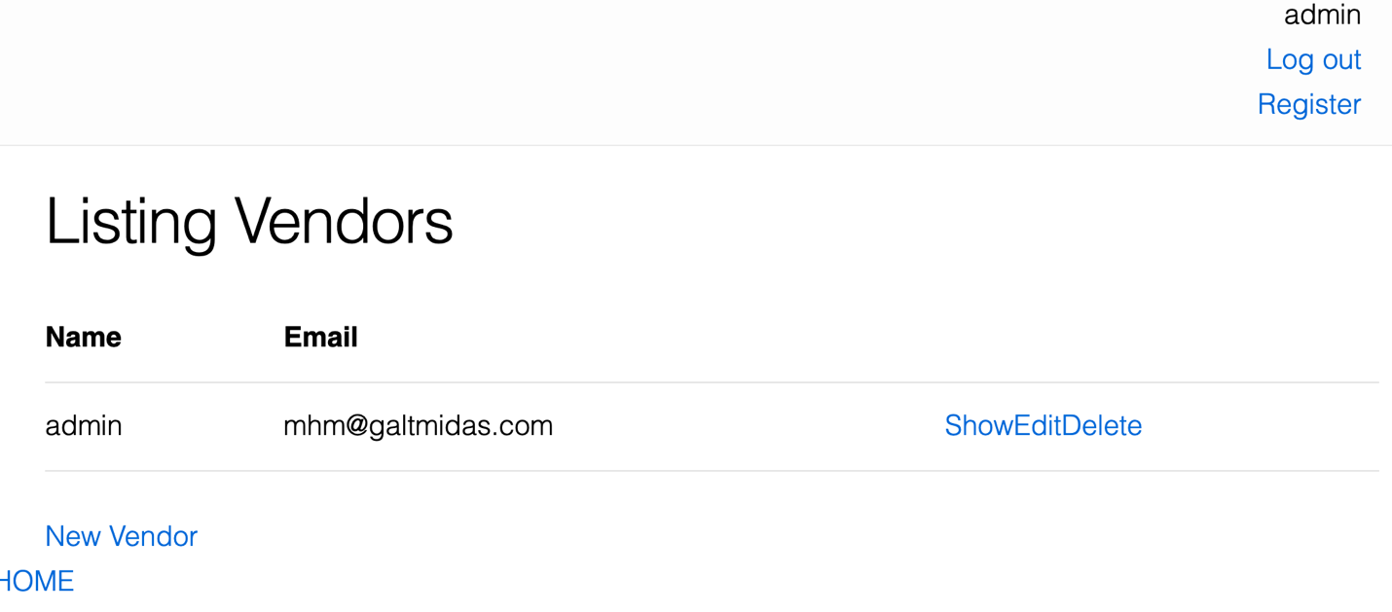

Save new vendor, this allows a user to register with a Vendor Code (BELL1) and an email designated by the admin. (The new user needs these two pieces of information to successfully register and be able to login to the system).
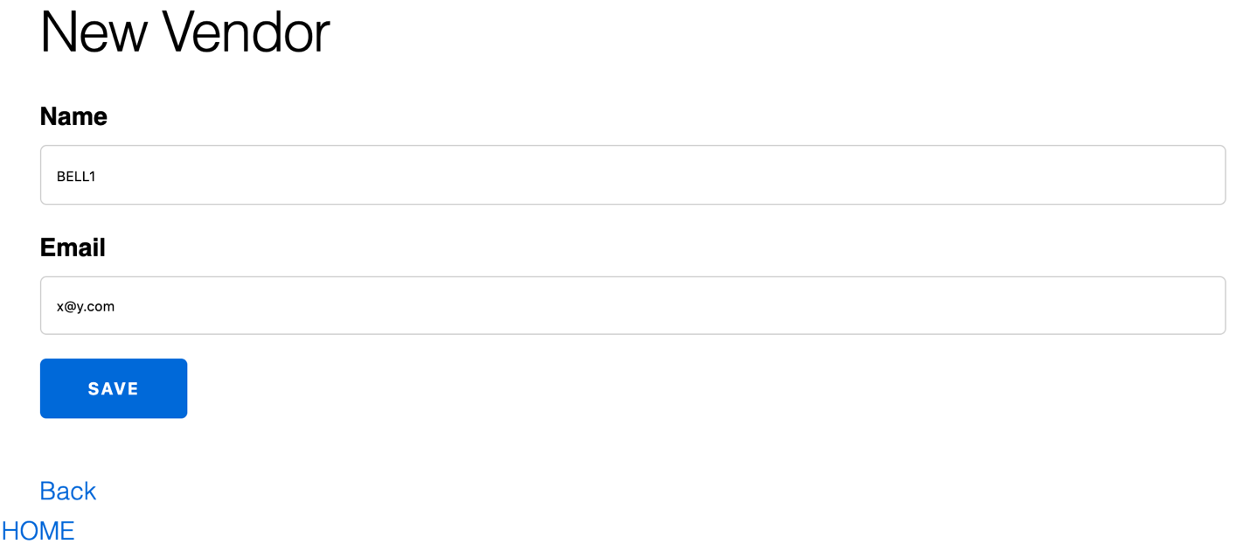

Repeat for all vendor codes and designated emails.

BELL1 | BFL1 | BKAS | BT1 | C1
CBJ | CC1 | CJ1 | CVS1 | DESH1
DETGT1 | DFA1 | DUDS1 | EMDE1 | FP1
FTIM1 | GI1 | HBI1 | HHBF1 | IC1
INK1 | JL1 | JMG1 | KC1 | KR1
LPH1 | MARART | MAWBD1 | MCP1 | MFD1
MVS1 | MW1 | NBF1 | NG1 | NHGC
NWSH1 | NWT1 | OSS1 | PAM1 | PBA1
PBJ | PCRA1 | PNSD1 | PPS1 | RAB1
RCS1 | RHFA2 | SAI1 | SAS1 | SDSMD
SGS1 | SPC1 | TAP1 | TC1 | TES1
TFC1 | TMR1 | TTS1 | UTS1 | WFT1
WPB1 | YC1 | YS1

