User Docs

Go to bizzybuzzportal.com and hit Register.
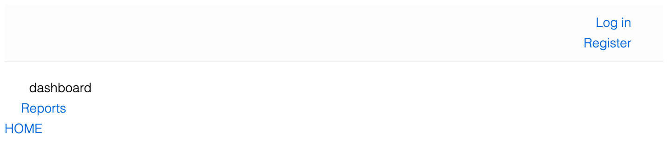

Type in your case sensitive Vendor Code (below, for ex: BELL1) and email, which are both supplied by the admin, and also enter in a password and hit create user.
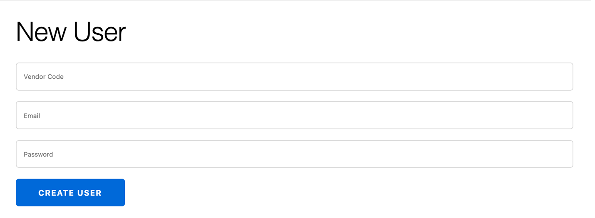

Initial Vendor Codes:
BELL1 | BFL1 | BKAS | BT1 | C1
CBJ | CC1 | CJ1 | CVS1 | DESH1
DETGT1 | DFA1 | DUDS1 | EMDE1 | FP1
FTIM1 | GI1 | HBI1 | HHBF1 | IC1
INK1 | JL1 | JMG1 | KC1 | KR1
LPH1 | MARART | MAWBD1 | MCP1 | MFD1
MVS1 | MW1 | NBF1 | NG1 | NHGC
NWSH1 | NWT1 | OSS1 | PAM1 | PBA1
PBJ | PCRA1 | PNSD1 | PPS1 | RAB1
RCS1 | RHFA2 | SAI1 | SAS1 | SDSMD
SGS1 | SPC1 | TAP1 | TC1 | TES1
TFC1 | TMR1 | TTS1 | UTS1 | WFT1
WPB1 | YC1 | YS1

After you pressed the CREATE USER button, you should see the “created! confirmation email sent.” message in the band across the top. Contact the admin (supplying your Vendor Code and email address) otherwise.
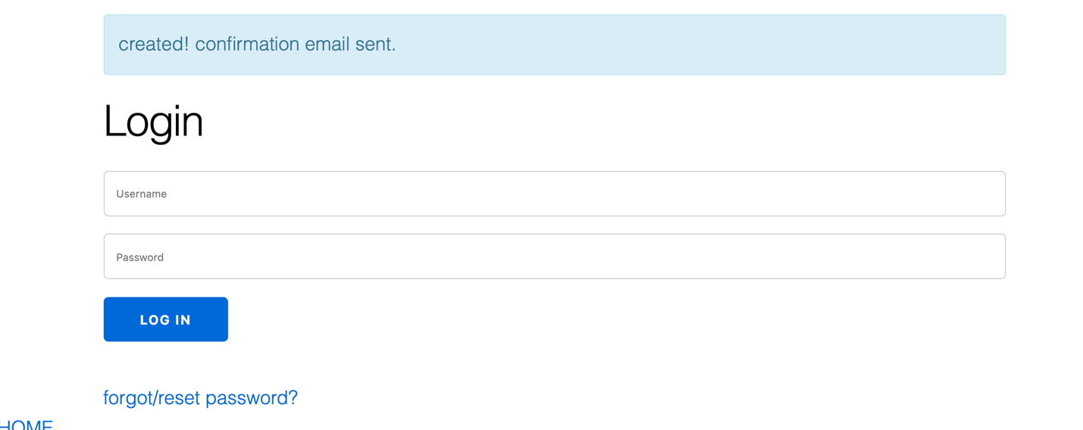

Lastly, go to the designated email and click the link in the email, and then you can login.

