

**General Rule**:-selector{

Property:value;

Anotherproperty:value;

}

**In-line CSS-**

<style =”">

**External CSS-**

<style type="text/css"></style>-----Head section

<link rel="stylesheet" type="text/css" href=""> ---Separate file

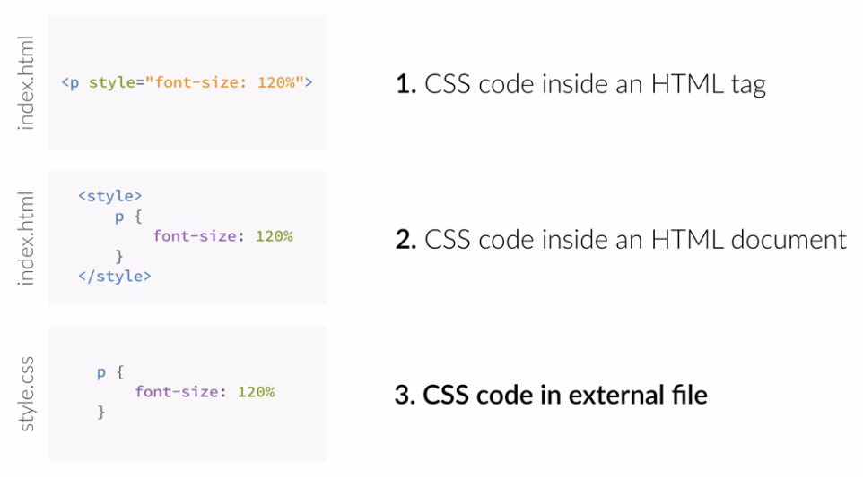

**color:**

H1{

color:red;

}

(or)

H1{

color:#ff0000;

}

(or)

H1{

color:rgb(255,0,0);

}

(or)

H1{

color:rgba(255,0,0,0.5);

}

**Background Tag:**

background:#000000;

Background Image:

background :url(....)

background-repeat:no-repeat;

background-size:cover;

Border tag

border:2px;

border:2px black solid;

(or)

border-width:2px;

border-color:black;

border-style:solid;

**SELECTORS**

1)Element

H1{

text-transform:uppercase;

}

2)id

#body

{

background-color:pink;

}

3)class

.pink{

background-color:pink;

}

4)Star selector—selects all

*{

text-transform:uppercase;

}

5)nth-of-type

Create This:

/* Style the HTML elements according to the following instructions.

DO NOT ALTER THE EXISTING HTML TO DO THIS. WRITE ONLY CSS!

/* Give the <body> element a background of #bdc3c7*/

/* Make the <h1> element #9b59b6*/

/* Make all <h2> elements orange */

/* Make all <li> elements blue(pick your own hexadecimal blue)*/

/*Change the background on every paragraph to be yellow*/

/*Make all inputs have a 3px red border*/

/* Give everything with the class 'hello' a white background*/

/* Give the element with id 'special' a 2px solid blue border(pick your own rgb blue)*/

/*Make all the <p>'s that are nested inside of divs 25px font(font-size: 25px)*/

/*Make only inputs with type 'text' have a gray background*/

/* Give both <p>'s inside the 3rd <div> a pink background*/

/* Give the 2nd <p> inside the 3rd <div> a 5px white border*/

/* Make the <em> in the 3rd <div> element white and 20px font(font-size:20px)*/

/*BONUS CHALLENGES*/

/*You may need to research some other selectors and properties*/

/*Make all "checked" checkboxes have a left margin of 50px(margin-left: 50px)*/

/* Make the <label> elements all UPPERCASE without changing the HTML(definitely look this one up*/

/*Make the first letter of the element with id 'special' green and 100px font size(font-size: 100)*/

/*Make the <h1> element's color change to blue when hovered over */

/*Make the <a> element's that have been visited gray */

Font-family:................;

Font-size:200px;

Font-weight:100-800;

Text-align:center;

Create This:

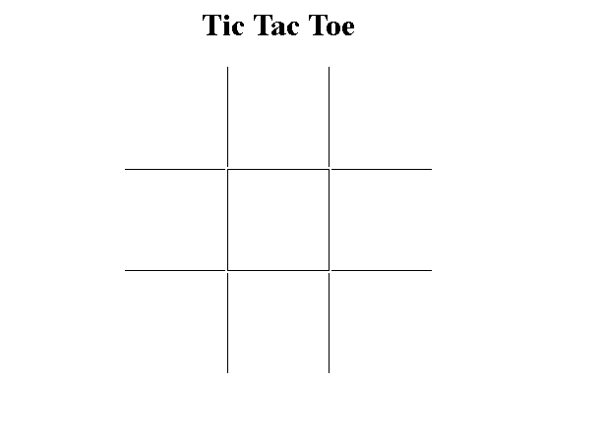

Solution:

<!DOCTYPE html>

<html>

<head>

<title>TTT Board</title>

<style type="text/css">

h1 {

text-align: center;

}

table {

margin: auto;

}

td {

width: 100px;

height: 100px;

}

td:hover {

border: 1px solid grey;

}

.vertical {

border-left: 1px solid black;

border-right: 1px solid black;

}

.horizontal {

border-top: 1px solid black;

border-bottom: 1px solid black;

}

</style>

</head>

<body>

<h1>Tic Tac Toe</h1>

<table>

<tr>

<td></td>

<td class="vertical"></td>

<td></td>

</tr>

<tr>

<td class="horizontal"></td>

<td class="vertical horizontal"></td>

<td class="horizontal"></td>

</tr>

<tr>

<td></td>

<td class="vertical"></td>

<td></td>

</tr>

</table>

</body>

</html>

Create This:

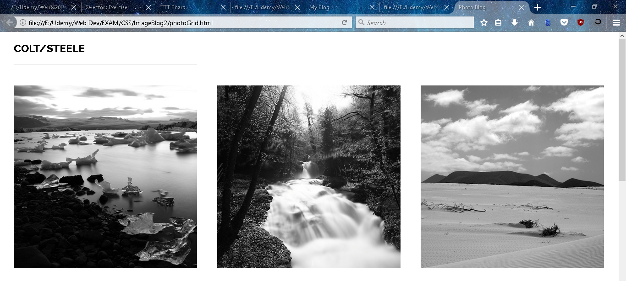

HTML Solution:

<!DOCTYPE html>

<html>

<head>

<title>Photo Blog</title>

<link href='[https://fonts.googleapis.com/css?family=Raleway:400,800](view-source:https://fonts.googleapis.com/css?family=Raleway:400,800)' rel='stylesheet' type='text/css'>

<link rel="stylesheet" type="text/css" href="[photos.css](view-source:file:///E:/Udemy/Web%20Dev/EXAM/CSS/ImageBlog2/photos.css)">

</head>

<body>

<p>Colt/Steele</p>

<!-- Massimo Margagnoni -->

<img src="[http://c1.staticflickr.com/9/8450/8026519634_f33f3724ea_b.jpg](view-source:http://c1.staticflickr.com/9/8450/8026519634_f33f3724ea_b.jpg)">

<img src="[http://c2.staticflickr.com/8/7218/7209301894_c99d3a33c2_h.jpg](view-source:http://c2.staticflickr.com/8/7218/7209301894_c99d3a33c2_h.jpg)">

<img src="[http://c2.staticflickr.com/8/7231/6947093326_df216540ff_b.jpg](view-source:http://c2.staticflickr.com/8/7231/6947093326_df216540ff_b.jpg)">

<!-- Giuseppe Milo -->

<img src="[http://c1.staticflickr.com/9/8788/17367410309_78abb9e5b6_b.jpg](view-source:http://c1.staticflickr.com/9/8788/17367410309_78abb9e5b6_b.jpg)">

<img src="[http://c2.staticflickr.com/6/5814/20700286354_762c19bd3b_b.jpg](view-source:http://c2.staticflickr.com/6/5814/20700286354_762c19bd3b_b.jpg)">

<img src="[http://c2.staticflickr.com/6/5647/21137202535_404bf25729_b.jpg](view-source:http://c2.staticflickr.com/6/5647/21137202535_404bf25729_b.jpg)">

<!-- GÃ¶rlitzPhotography -->

<img src="[http://c2.staticflickr.com/6/5588/14991687545_5c8e1a2e86_b.jpg](view-source:http://c2.staticflickr.com/6/5588/14991687545_5c8e1a2e86_b.jpg)">

<img src="[http://c2.staticflickr.com/4/3888/14878097108_5997041006_b.jpg](view-source:http://c2.staticflickr.com/4/3888/14878097108_5997041006_b.jpg)">

<img src="[http://c2.staticflickr.com/8/7579/15482110477_0b0e9e5421_b.jpg](view-source:http://c2.staticflickr.com/8/7579/15482110477_0b0e9e5421_b.jpg)">

<!-- All Photos Licensed Under Creative Commons 2.0 -->

<!-- https://creativecommons.org/licenses/by/2.0/legalcode -->

</body>

</html>

CSS Solution:

img {

width: 30%;

float: left;

margin: 1.66%;

}

p {

font-family: Raleway;

margin-left: 1.66%;

font-size: 23px;

font-weight: 800;

text-transform: uppercase;

border-bottom: 2px solid #f1f1f1;

width: 30%;

padding-bottom: 20px;

}

Create This:

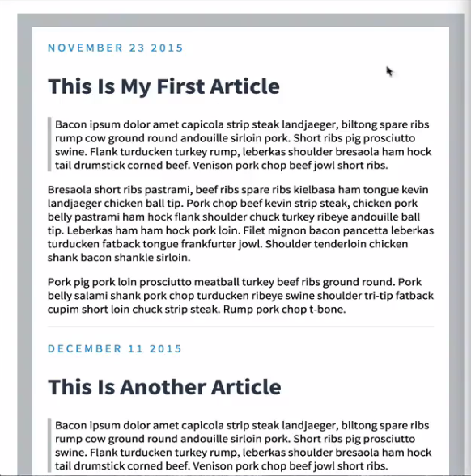

HTML Solution:

<!DOCTYPE html>

<html>

<head>

<title>My Blog</title>

<link rel="stylesheet" type="text/css" href="[blog.css](view-source:file:///E:/Udemy/Web%20Dev/EXAM/CSS/Blog_Solution/blog.css)">

</head>

<body>

<link href='[http://fonts.googleapis.com/css?family=Source+Sans+Pro:400,700,400italic|Source+Code+Pro:400,700](view-source:http://fonts.googleapis.com/css?family=Source+Sans+Pro:400,700,400italic|Source+Code+Pro:400,700)' rel='stylesheet' type='text/css'>

<div class="post">

<div class="date">November 23 2015</div>

<h2>This Is My First Article</h2>

<p class="quote">

Bacon ipsum dolor amet capicola strip steak landjaeger, biltong spare ribs rump cow ground round andouille sirloin pork. Short ribs pig prosciutto swine. Flank turducken turkey rump, leberkas shoulder bresaola ham hock tail drumstick corned beef. Venison pork chop beef jowl short ribs.

</p>

<p>Bresaola short ribs pastrami, beef ribs spare ribs kielbasa ham tongue kevin landjaeger chicken ball tip. Pork chop beef kevin strip steak, chicken pork belly pastrami ham hock flank shoulder chuck turkey ribeye andouille ball tip. Leberkas ham ham hock pork loin. Filet mignon bacon pancetta leberkas turducken fatback tongue frankfurter jowl. Shoulder tenderloin chicken shank bacon shankle sirloin.</p>

<p>Pork pig pork loin prosciutto meatball turkey beef ribs ground round. Pork belly salami shank pork chop turducken ribeye swine shoulder tri-tip fatback cupim short loin chuck strip steak. Rump pork chop t-bone.</p>

<hr>

</div>

<!-- <hr> -->

<div class="post">

<div class="date">December 11 2015</div>

<h2>This Is Another Article</h2>

<p class="quote">

Bacon ipsum dolor amet capicola strip steak landjaeger, biltong spare ribs rump cow ground round andouille sirloin pork. Short ribs pig prosciutto swine. Flank turducken turkey rump, leberkas shoulder bresaola ham hock tail drumstick corned beef. Venison pork chop beef jowl short ribs.

</p>

<p>Shankle beef ribs tongue strip steak flank landjaeger capicola hamburger chuck pancetta kevin. Sirloin landjaeger chicken, bresaola brisket swine short ribs turkey short loin ball tip porchetta ham hock. Capicola frankfurter jowl short loin. Kevin flank hamburger, beef venison shankle short loin bresaola frankfurter</p>

<p>Bresaola short ribs pastrami, beef ribs spare ribs kielbasa ham tongue kevin landjaeger chicken ball tip. Pork chop beef kevin strip steak, chicken pork belly pastrami ham hock flank shoulder chuck turkey ribeye andouille ball tip. Leberkas ham ham hock pork loin. Filet mignon bacon pancetta leberkas turducken fatback tongue frankfurter jowl. Shoulder tenderloin chicken shank bacon shankle sirloin.</p>

</div>

</body>

</html>

CSS Solution:

body {

width: 80%;

border: 20px solid #bdc3c7;

font-family: 'Source Sans Pro', sans-serif;

padding: 20px;

margin: 20px auto;

max-width: 700px;

}

.post {

margin-bottom: 20px;

}

.date {

color: #3498db;

letter-spacing: 0.2rem;

text-transform: uppercase;

}

.quote{

border-left: 5px solid #bdc3c7;

padding-left: 5px;

}

h2 {

font-size: 2.0rem;

font-weight: bold;

color: #2c3e50;

}

hr{

border: 0;

height: 0;

border-top: 1px solid rgba(0, 0, 0, 0.1);

border-bottom: 1px solid rgba(255, 255, 255, 0.3);

}

**CASCADING STYLE SHEETS**