Lab: Find the intrinsic and extrinsic matrix for L515

This folder has the following files
- L515-calibration-class.ipynb – use to acquire data from L515, calibrate camera, find intrinsic and extrinsic matrix
- Sample images of checkerboard
- Checkerboard-A4-28mm-9x6.svg

Task -1 Stream L515 from sdk
- Configure L515 lidar-camera
Follow the link - https://github.com/IntelRealSense/librealsense/releases/tag/v2.54.2
Install: https://github.com/IntelRealSense/librealsense/releases/tag/v2.54.2 (Install Intel.RealSense.SDK-WIN10-2.54.2.5684.exe)

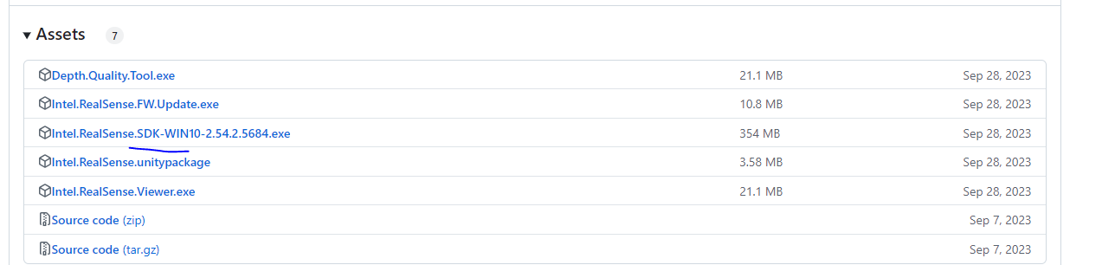
- Connect the L515 to laptop
- Using the real sense viewer make sure that the camera is streaming
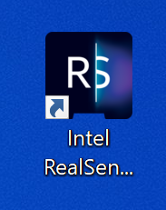
- Close real sense viewer

Python wrapper for L515:
- Home page: https://github.com/IntelRealSense/librealsense/tree/development/wrappers/python
- Install pyrealsense2: pip install pyrealsense2==2.54.2.5684 (https://pypi.org/project/pyrealsense2/ ), https://pypi.org/project/pyrealsense2/2.54.2.5684/ q
- Tutorials: https://github.com/IntelRealSense/librealsense/tree/development/wrappers/python/examples
- Pyrealsense API: https://intelrealsense.github.io/librealsense/python_docs/_generated/pyrealsense2.html
Task – 2 Calibrate L515 camera

- Print the chess pattern – Checkerboard-A4-28mm-9x6.svg
- Measure the approximate distance of checkerboard from camera lens (this is z_c)
- Run L515-calibration-class.ipynb (cell by cell and follow the instructions given in each cell)
- Run MAS512_2023_AUTUMN virtual environment
  - Capture image
    - Focus the camera to the chess pattern so that entire board is visible in the frame
    - Press S to capture the image
    - Rotate the camera and capture another image by pressing S
    - The images will be named with timestamp
    - Take at least 15 -20 images
    - The images will be saved in /captured_images. This folder will have RBG and depth images
    - Copy RGB images in directory where Run L515-calibration-class.ipynb is located

- Intrinsic calibration
  - Run Run L515-calibration-class.ipynb cell wise cell
  - This gives you the intrinsic matrix (mtx)
  - This program also saves the intrinsic matrix as B. npz

- Extrinsic calibration
  - Run L515-calibration-class.ipynb cell wise cell
  - This program gives you rotational (rvec) and translational matrix (tvec)
  - Append rvec and tvec horizontally to get extrinsic matrix

