

Programme Name: BCS
Course Code: CSC 3030
Course Name: Computer Graphics
Group Project
Date of Submission: 2022-04

Submitted By: Submitted To:
Student Name: Peter Karki, Ayush Ojha Faculty Name: Amar Subedi
Bijay Tamang
Semester: 6th Department: P.O
Intake: March 2019

Cellular automaton
Introduction
Cellular automata (CA) are discrete space-time models that often feature cell interactions across homogeneous lattice grids. Cells can adopt a limited number of cell states, which can vary based on simple criteria that each cell follows in regard to its cell neighbours. They are a grid of "colored" cells that evolve over a number of discrete time steps according to a set of rules based on the states of neighbouring cells. The rules are then iteratively implemented for as many time steps as are desired.

We're going to make Conway’s Game of Life for this project. The Game of Life, usually known as Life, is a cellular automaton created in 1970 by British mathematician John Horton Conway. It is a zero-player game, which means that its evolution is defined solely by its beginning condition, with no additional input required. The Game of Life is played by creating an initial configuration and watching it evolve. It is Turing complete and can simulate any Turing machine, including a universal constructor.

Conway's Game of Life is a rectangular grid simulation that simulates the birth and death of cells. According to some simple criteria, the state of a given cell in any generation is determined by the condition of the cell and its eight immediate neighbours in the previous generation: A living cell can only survive if it has two or three neighbours; else, it will die of loneliness or congestion. An empty cell becomes alive if it has exactly three neighbours; else, it remains dead. These laws, as simple as they are, can produce astonishing complexity from seemingly simple initial arrangements.

The Nature of Life / Rule of Simulation
The Game of Life universe is made up of an unlimited two-dimensional orthogonal grid of square cells, each of which can be alive or dead (or populated and unpopulated, respectively). Conway's Game of Life is a rectangular grid simulation that simulates the birth and death of cells. According to some simple criteria, the state of a given cell in any generation is determined by the condition of the cell and its eight immediate neighbors in the previous generation:

- Any live cell with fewer than two live neighbours dies, as if by underpopulation.
- Any live cell with two or three live neighbours lives on to the next generation.
- Any live cell with more than three live neighbours dies, as if by overpopulation.
- Any dead cell with exactly three live neighbours becomes a live cell, as if by reproduction.
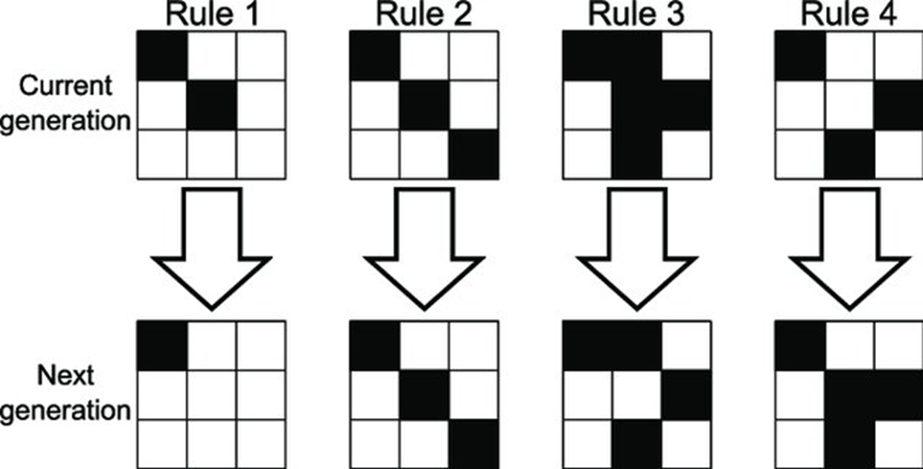

Fig: Rule of Simulation

As simple as these rules may be, they can result in surprising complexity from relatively simple initial configurations.

Common and stable life that form on Conway game of life are:
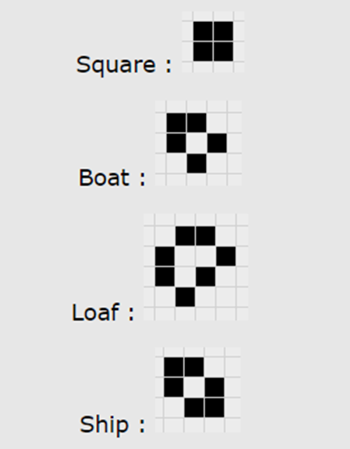
Fig: Common life in Conway Game of life.

Applications of Cellular Automata
- Several biological processes occur or can be simulated by cellular automata. An example of cellular automata in biological processes is the Patterns of some seashells.
- The chemical reaction also can be simulated using cellular automata. One example is the Belousov Zhabotinsky reaction.
- Probabilistic cellular automata are used in statistical and condensed matter physics to study phenomena like fluid dynamics and phase transitions.
- Cellular automata are also being in use to simulate forest fire. One example is FireGIS, which is a computer application that implements the cellular model and evaluation procedures and allows for the viewing of the model's outputs in raster format and as a digital terrain model.

Implementation History of Conway’s Game of Life Simulations
Since the game's inception, computers have been used to follow Game of Life settings. When John Conway first started looking into how different starting configurations emerged, he did so by hand with a go board and black and white stones. The following is a list of a few programs that have a unique claim to fame, such as popularity or uncommon characteristics. Most of these applications include a graphical user interface for pattern modification and simulation, the ability to simulate numerous rules, including the Game of Life, and a vast library of fascinating Game of Life and other cellular automaton patterns.
- M. J. T. Guy and S. R. Bourne created the first interactive Game of Life software for the PDP-7 using an early version of ALGOL 68C. The findings were published in Scientific American in October 1970, along with the comment, "Without it, some discoveries about the game would have been difficult to make." They created this software for the PDP-7 using an early version of ALGOL 68C. The findings were published in Scientific American in October 1970, along with the comment, "Without it, some discoveries about the game would have been difficult to make."
- Malcolm Banthorpe created two early home computer versions of the Game of Life, both coded in BBC BASIC. The originally appeared in Acorn User magazine in January 1984, and Banthorpe followed up with a three-dimensional version in the May 1984 issue. Susan Stepney, of the University of York's Department of Computer Science, followed up in 1988 with Life on the Line, a program that generated one-dimensional cellular automata.
- Andrew Trevorrow and Tomas Rokicki created Golly, a cross-platform open-source simulation system for the Game of Life and other cellular automata (including all Life-like cellular automata, the Generations family of cellular automata from Mirek's Cellebration, and John von Neumann's 29-state cellular automaton). It comes with the Hashlife algorithm for lightning-fast generation, as well as Lua or Python scriptability for modification and simulation.
- Mirek's Cellebration is a freeware viewer, explorer, and editor for one- and two-dimensional cellular automata for Windows. It comes with a scriptable editor and strong tools for simulating and examining a wide range of cellular automaton rules, including the Game of Life.
- Jon Bennett's Xlife is a cellular-automation laboratory. It has long been the standard UNIX X11 Game of Life simulation application, and it has now been converted to Windows. It can deal with cellular automaton rules that have the same neighbourhood as the Game of Life and up to eight potential states per cell.

Tools used for making this game
This code is written using OpenGL. The language used for this game is C++. We have used Visual Studio for creating and running the application. We have used the Glut Library to include OpenGL code for this project. More about the structure of the project and the codes are given below in the Project Code section of this report.

Objective
- To learn and understand OpenGL and cellular automata.
- To simulate a basic life simulation by making the Conway Game of life.
- To exemplify emergent and self-organised behaviour.
- To define an interesting and unpredictable cell automaton.
- To solidify our understanding of 2-dimensional and 3-dimensional arrays.

Snapshots and Description of Project
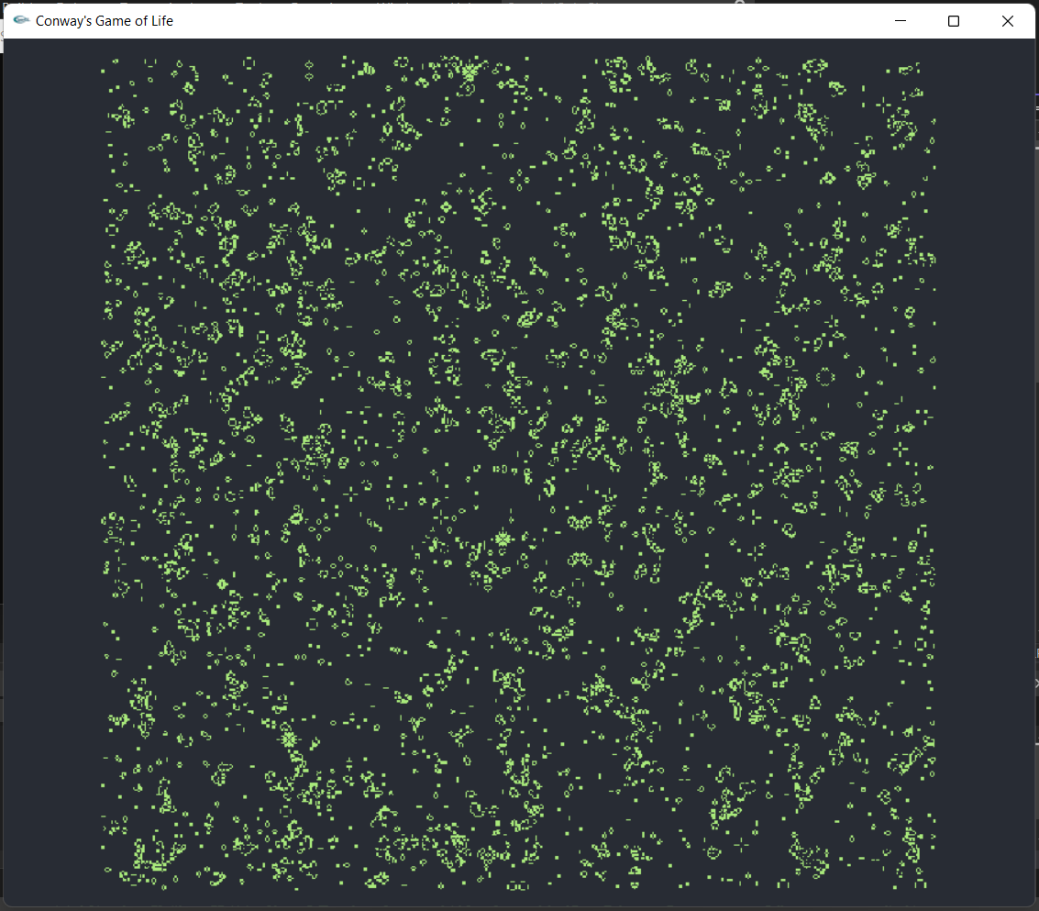

Fig: Gamelife2d
This is the window screen shot after loading the game. The each cell is either dead or alive. Dead cell are gray and alive cell are green. The simulation loop in relative to time and by frame by frame the generation end and start. The generation of cell dead and alive rule is given above in the Rule of simulation section.

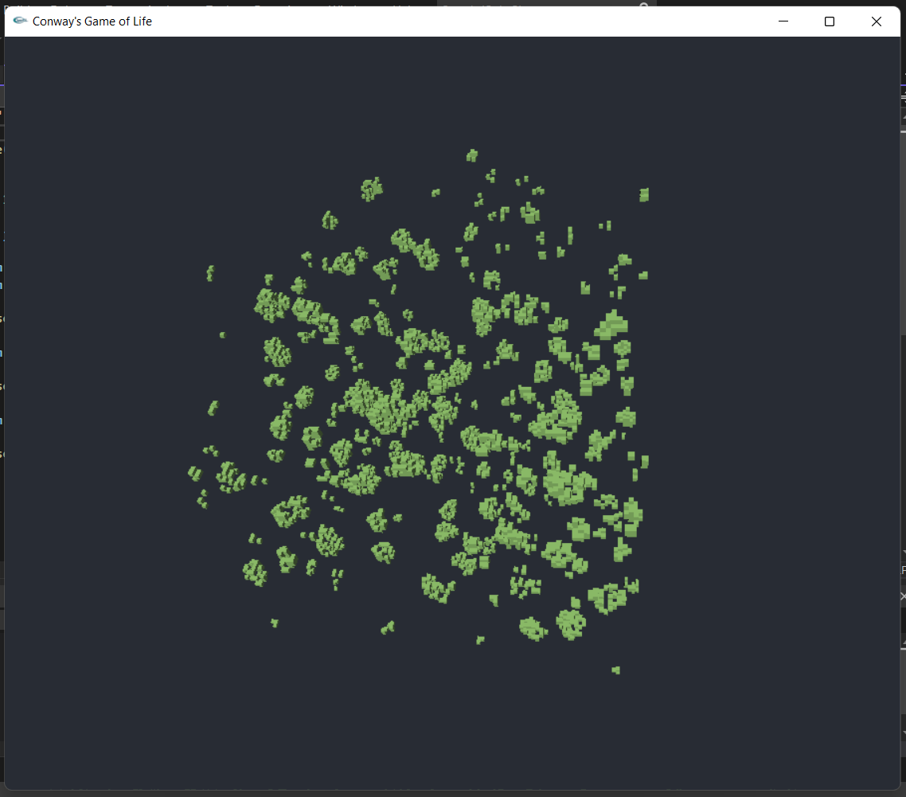
Fig: Gamelife3d
This is the 3d version of life game. The simulation in this window is done in 3d space where as above was done in 2d space. The rule is same in here as well.

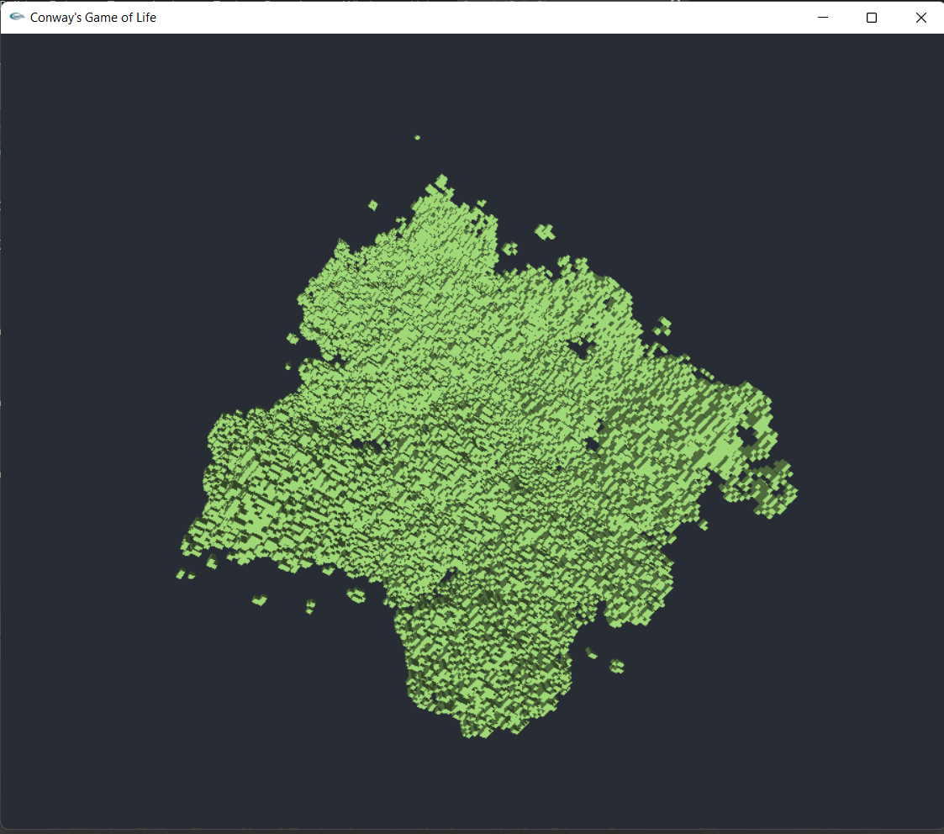

Fig: Increasing Cell Density
With Valid input, we can either increase or decrease cell density size.
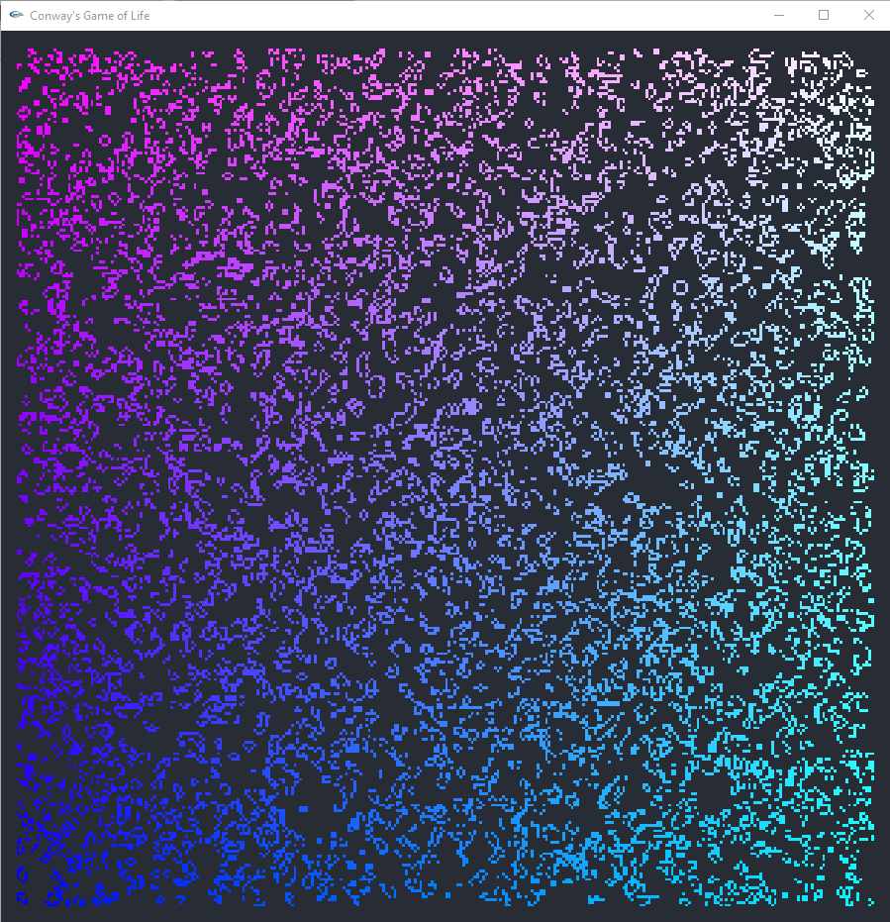

Fig: Gamelife2d with gradient.

The gradient can be toggled on or off in this game using valid input.
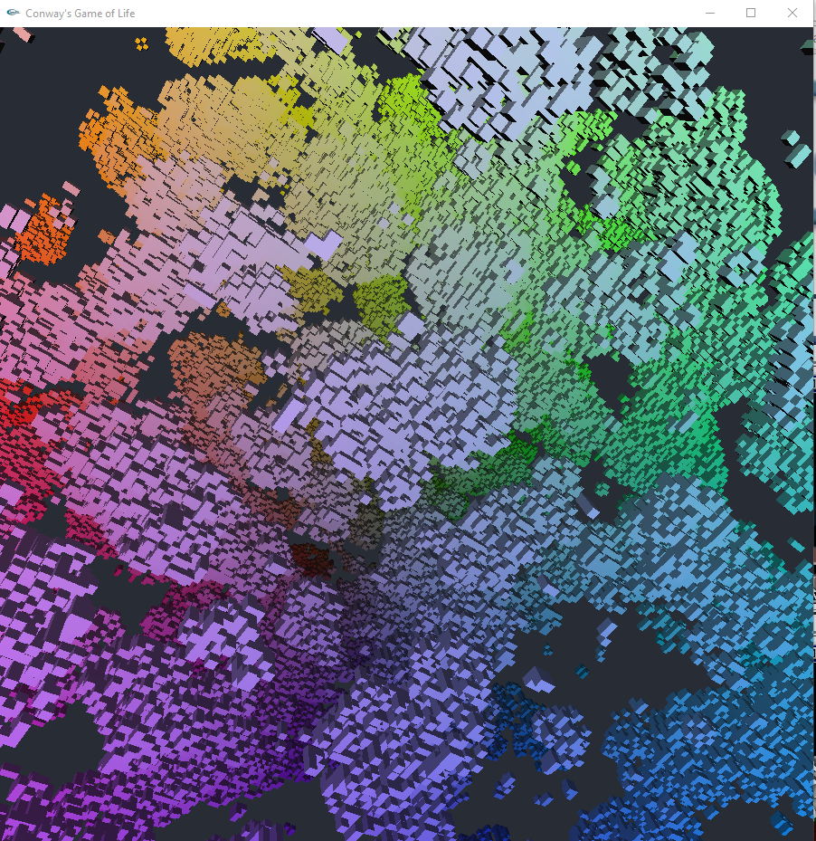

Fig: Gamelife3d with gradient.

The gradient can be toggled on or off in this game using valid input in 3d space as well.

List of key input:
[1...9] : Simulation Size

[Shift + 1...5] Larger Simulation Size

[Tab] : toggle 2D/3D

[Space] : Start/Stop Simulation

[,],[.] : Zoom in/out

[w],[s],[a],[d] : Pan

[r] : toggle rotation

[s] : toggle shading style

Project Code :
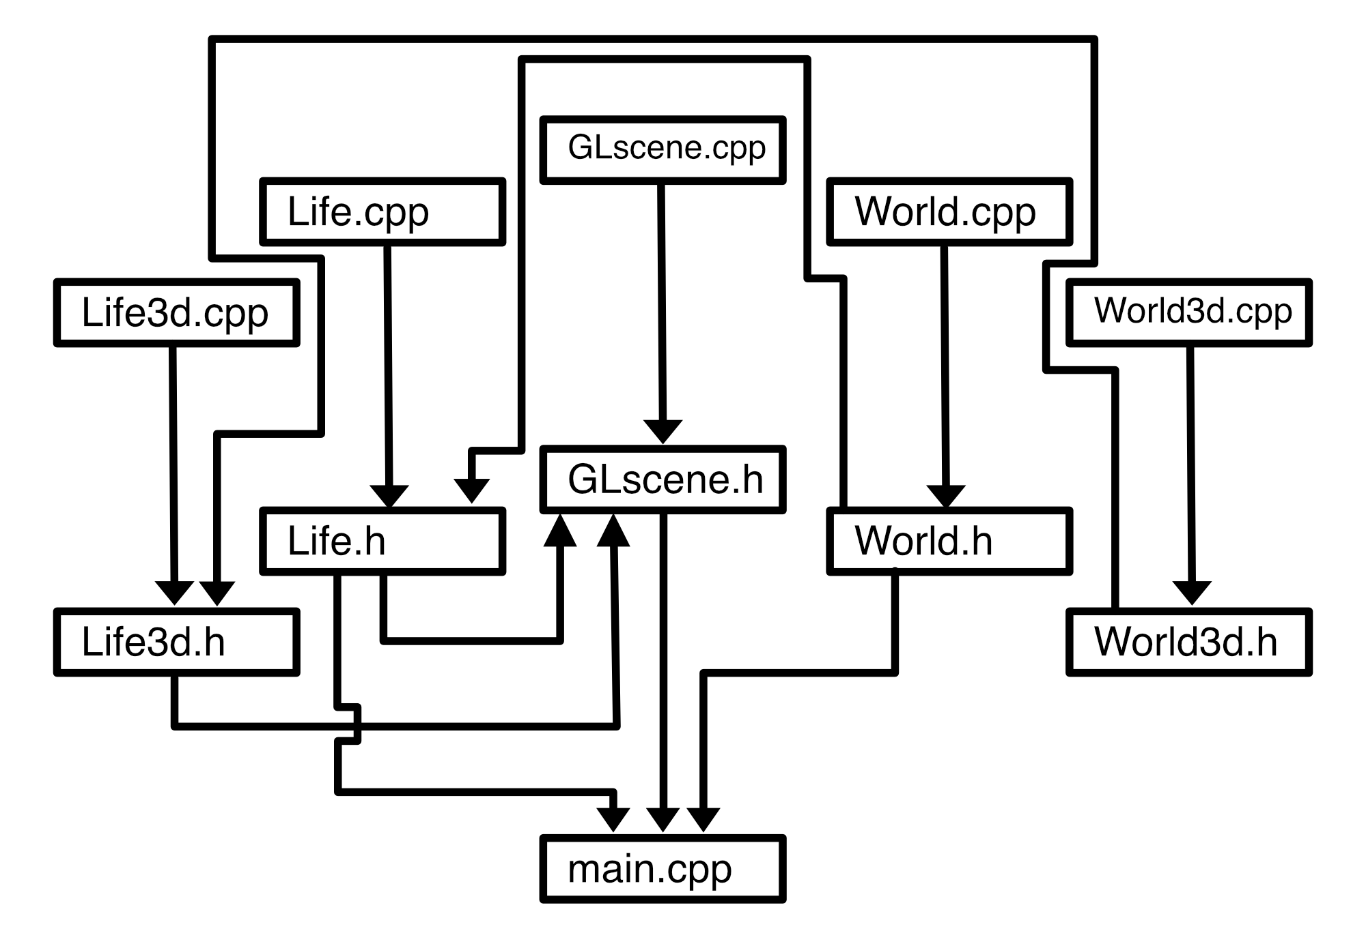
Fig: Structure of code.

The above diagram shows how the code is connected to each other and the arrow indicated Include in c++ programming language.

Code Function:
GLscene.cpp
This code setup up a window for simulation and handle key input. It also calls other functions from other classes to simulate the game. It refreshes the window in an interval of time using a loop to transition between generations in the game.

Life.cpp
This code contains the rule of the simulation game in 2d world space.

Life3d.cpp
This code contains the rule of the simulation game in 3d world space.

World.cpp
This code set the window size and create a grid/cell for simulation in 2d space.

World3d.cpp
This code set the window size and create a grid/cell for simulation in 3d space.
Main.cpp
This is the main code where the final output can be executed. When main.cpp is run all these code functions work together to give a final output simulation.

All of the .h or libraries are created for the basic function to connect all this .cpp code into main.cpp.

Code :

GlScene.cpp
#include "GLScene.h"

int size = 500;

Life3d * life3d = new Life3d(size / 5, size / 5, size / 5);
Life * life = new Life(size, size);

int window_width;
int window_height;
int g_GLUTWindowHandle;
int g_ErrorCode;
float y_offset;
float x_offset;
float scal = 0.0f;

float rot_x = 0.1f;
float rot_y = 0.7f;
float rot_z = 0.3f;
float rot_angle = 0.1f;
bool b_rot = true;
bool sim = true;
bool shade = false;
int time_e = clock();

Scene g_current = scene1;

void GLScene(int argc, char*argv[])
{
GLScene(900, 900, argc, argv);
}

void GLScene(int x, int y, int argc, char*argv[])
{
for (int i = 0; i < 100000; i++)
{
int x = rand() % size + 1;
int y = rand() % size + 1;
life->setLife(x, y, 1);
}
newlife3d();
cout << glutGet(GLUT_ELAPSED_TIME) << endl;
window_height = y;
window_width = x;

glutInit(&argc, argv);

glutInitWindowPosition(30, 30);
glutInitWindowSize(window_width, window_height);

window_width = glutGet(GLUT_SCREEN_WIDTH);
window_height = glutGet(GLUT_SCREEN_HEIGHT);

glutInitDisplayMode(GLUT_RGBA | GLUT_ALPHA | GLUT_DOUBLE | GLUT_DEPTH);

g_GLUTWindowHandle = glutCreateWindow("Conway's Game of Life");
glutInitWindowSize(window_width, window_height);

glutDisplayFunc(DisplayGL);
glutKeyboardFunc(KeyboardGL);
glutReshapeFunc(ReshapeGL);

glClearColor(0.156f, 0.172f, 0.203f, 1.00f);
glClearDepth(1.0f);
glShadeModel(GL_SMOOTH);

}

void Cleanup()
{
if (g_GLUTWindowHandle != 0)
{
glutDestroyWindow(g_GLUTWindowHandle);
g_GLUTWindowHandle = 0;
}
if (false)
{
exit(g_ErrorCode);
}

}

void newLife()
{
life = new Life(size, size);
for (int i = 0; i < .6*size*size; i++)
{
int x = rand() % size + 1;
int y = rand() % size + 1;
life->setLife(x, y, 1);
}
}

void newlife3d()
{
life3d = new Life3d(size / 5, size / 5, size / 5);
for (int i = 0; i < .05*(size / 5)*(size / 5)*(size / 5); i++)
{
int x = rand() % size / 5 + 1;
int y = rand() % size / 5 + 1;
int z = rand() % size / 5 + 1;
life3d->setLife(x, y, z, 1);
}
}

void DisplayGL()
{
glClear(GL_COLOR_BUFFER_BIT | GL_DEPTH_BUFFER_BIT);
if (g_current == 0)
{
render();
}else
if (g_current == 1)
{
render3d();
}
glutSwapBuffers();
glutPostRedisplay();
}

void KeyboardGL(unsigned char c, int x, int y)
{
if (c == ' ')
{
sim = !sim;
}
if (c == 'r')
{
b_rot = !(b_rot);
}
if (c == ' ')
{
if (g_current == scene1)
{
glEnable(GL_DEPTH_TEST);
glEnable(GL_LIGHTING);
glEnable(GL_LIGHT0);
(g_current = scene2);
} else
if (g_current == scene2)
{
glDisable(GL_DEPTH_TEST);
glDisable(GL_LIGHTING);
glDisable(GL_LIGHT0);
g_current = scene1;
}
}
if (c == 'w')
{
y_offset = y_offset - 0.1;
}

if (c == 's')
{
y_offset += 0.1;
}

if (c == 'd')
{
x_offset -= 0.1;
}

if (c == 'a')
{
x_offset += 0.1;
}
if (c == ',')
{
scal -= 0.1f;
}
if (c == 'c')
{
shade = !shade;
}

if (c == '.')
{
scal += 0.1f;
}
if (c == '1')
{
size = 200;
newLife();
newlife3d();
}

if (c == '2')
{
size = 200;
newLife();
newlife3d();
}
if (c == '3')
{
size = 300;
newLife();
newlife3d();
}
if (c == '4')
{
size = 400;
newLife();
newlife3d();
}
if (c == '5')
{
size = 500;
newLife();
newlife3d();
}
if (c == '6')
{
size = 600;
newLife();
newlife3d();
}
if (c == '7')
{
size = 700;
newLife();
newlife3d();
}
if (c == '8')
{
size = 800;
newLife();
newlife3d();
}
if (c == '9')
{
size = 900;
newLife();
}
if (c == '!')
{
size = 1000;
newLife();
}
if (c == '@')
{
size = 2000;
newLife();
}
if (c == '#')
{
size = 3000;
newLife();
}
if (c == '$')
{
size = 4000;
newLife();
}
if (c == '%')
{
size = 5000;
newLife();
}
}

void ReshapeGL(int w, int h)
{
//std::cout << "ReshapGL( " << w << ", " << h << " );" << std::endl;

if (h == 0) // Prevent A Divide By Zero error
{
h = 1; // Making Height Equal One
}

window_width = w;
window_height = h;

glViewport(0, 0, window_width, window_height);

// Setup the projection matrix
glMatrixMode(GL_PROJECTION);
glLoadIdentity();
gluPerspective(60.0, (GLdouble)window_width / (GLdouble)window_height, 0.1, 100.0);

//render();
glutPostRedisplay();
}

void render()
{
glMatrixMode(GL_MODELVIEW);
glLoadIdentity();
float y_t = 0.0f;
float x_t = 0.0f;
float off = 500 / (float)size *0.01f;

//glScalef(1.0f+scal, 1.0f+scal, 1.0f+scal);
glTranslatef(-5.0f + x_offset, -5.0f + y_offset, -9.0f+scal);
//glTranslatef(-0.5f, -0.5f, 0.0f);
if(shade == false) glColor3f((169.0f / 255.0f), (234.0f / 255.0f), (123.0f / 255.0f));
//GLfloat cyan[] = { (169.0f / 255.0f), (234.0f / 255.0f), (123.0f / 255.0f), 1.f };
//glMaterialfv(GL_FRONT, GL_DIFFUSE, cyan);
glBegin(GL_QUADS);
for (int i = 0; i < size; i++)
{
x_t = 0.0f;
for (int j = 0; j < size; j++)
{
if (life->getLifeform(j + 1, i + 1) == 1)
{
if (shade == true) glColor3f(((float)i / (float)size), ((float)j / (float)size), 1.0f);
glVertex2f(x_t - off, y_t + off);
glVertex2f(x_t + off, y_t + off);
glVertex2d(x_t + off, y_t - off);
glVertex2d(x_t - off, y_t - off);
}

x_t += (500/(float)size) * 0.02f;
}
y_t += (500 / (float)size) *0.02f;
}
glEnd();
glPopMatrix();
if (sim == true)
{
life->update();
}

}

void render3d()
{
if (size < 801)
{
float y_t = 0.0f;
float x_t = 0.0f;
float z_t = 0.0f;

glMatrixMode(GL_MODELVIEW);
glLoadIdentity();

if (shade == false)
{
GLfloat green[] = { (169.0f / 255.0f), (234.0f / 255.0f), (123.0f / 255.0f), 1.f };
glMaterialfv(GL_FRONT, GL_DIFFUSE, green);
}
/* clear color and depth buffers */
glClear(GL_COLOR_BUFFER_BIT | GL_DEPTH_BUFFER_BIT);

glTranslatef(0.0f + x_offset, 0.0f + y_offset, -7.0f + scal);
glRotatef(rot_angle/3, rot_x, rot_y, rot_z);
glRotatef(rot_angle/3, rot_z, rot_y, rot_x);
glRotatef(rot_angle/3, rot_x, rot_z, rot_y);
glTranslatef(-2.0f, -2.0f, -2.0f);

glBegin(GL_QUADS);
float sz = 2.0f * 5.0f / size;
for (int i = 0; i < size / 5; i++)
{
y_t = 0.0f;
for (int j = 0; j < size / 5; j++)
{
x_t = 0.0f;
for (int k = 0; k < size / 5; k++)
{
if (life3d->getLifeform(k + 1, j + 1, i + 1) == 1)
{
if (shade == true)
{
GLfloat green[] = { 5.0f * ((float)i / (float)size), 5.0f * ((float)j / (float)size), 5.0f * ((float)k / (float)size) };
glMaterialfv(GL_FRONT, GL_DIFFUSE, green);
}

glNormal3f(0.0F, 0.0F, 1.0F);
glVertex3f(sz + x_t, sz + y_t, sz + z_t); glVertex3f(-sz + x_t, sz + y_t, sz + z_t);
glVertex3f(-sz + x_t, -sz + y_t, sz + z_t); glVertex3f(sz + x_t, -sz + y_t, sz + z_t);

glNormal3f(0.0F, 0.0F, -1.0F);
glVertex3f(-sz + x_t, -sz + y_t, -sz + z_t); glVertex3f(-sz + x_t, sz + y_t, -sz + z_t);
glVertex3f(sz + x_t, sz + y_t, -sz + z_t); glVertex3f(sz + x_t, -sz + y_t, -sz + z_t);

glNormal3f(0.0F, 1.0F, 0.0F);
glVertex3f(sz + x_t, sz + y_t, sz + z_t); glVertex3f(sz + x_t, sz + y_t, -sz + z_t);
glVertex3f(-sz + x_t, sz + y_t, -sz + z_t); glVertex3f(-sz + x_t, sz + y_t, sz + z_t);

glNormal3f(0.0F, -1.0F, 0.0F);
glVertex3f(-sz + x_t, -sz + y_t, -sz + z_t); glVertex3f(sz + x_t, -sz + y_t, -sz + z_t);
glVertex3f(sz + x_t, -sz + y_t, sz + z_t); glVertex3f(-sz + x_t, -sz + y_t, sz + z_t);

glNormal3f(1.0F, 0.0F, 0.0F);
glVertex3f(sz + x_t, sz + y_t, sz + z_t); glVertex3f(sz + x_t, -sz + y_t, sz + z_t);
glVertex3f(sz + x_t, -sz + y_t, -sz + z_t); glVertex3f(sz + x_t, sz + y_t, -sz + z_t);

glNormal3f(-1.0F, 0.0F, 0.0F);
glVertex3f(-sz + x_t, -sz + y_t, -sz + z_t); glVertex3f(-sz + x_t, -sz + y_t, sz + z_t);
glVertex3f(-sz + x_t, sz + y_t, sz + z_t); glVertex3f(-sz + x_t, sz + y_t, -sz + z_t);
}
x_t += sz*2.0f;
}
y_t += sz*2.0f;
}
z_t += sz*2.0f;
}
glEnd();
if (sim == true)
{
//cout << clock() - time_e << endl;
if ((int)(clock() - time_e) > 100 )
{
time_e = clock();
life3d->update();
}
}

if (b_rot)
{
rot_angle++;
rot_x = ((int)((rot_x + 1.0f) * 10.0f) % 10)/10.0f;
rot_y = ((int)((rot_y + 1.0f) * 10.0f) % 10) / 10.0f;
rot_z = ((int)((rot_z + 1.0f) * 10.0f) % 10) / 10.0f;
}
glPopMatrix();
}
}

Life.cpp
#include "Life.h"

void Life::update()
{

for (int i = 1; i <= height; i++)
{
for (int j = 1; j <= width; j++)
{
int m = getNeighbors(j, i, 1);
if (m == 3)
{
setNewLife(j, i, 1);
}
if (m == 2)
{
setNewLife(j, i, getLifeform(j, i));
}
if (m != 3 && m != 2)
{
setNewLife(j, i, 0);
}
}
}
swapGrids();
}
Life3d.cpp
#include "Life3d.h"

namespace life3
{
void Life3d::update()
{

for (int i = 1; i <= height; i++)
{
for (int j = 1; j <= width; j++)
{
for (int k = 1; k <= depth; k++)
{
int m = getNeighbors(i, j, k, 1);
if (m == 5)
{
setNewLife(i, j, k, 1);
}
else
if (m < 3)
{
setNewLife(i, j, k, 0);
}
else
if (m > 5)
{
setNewLife(i, j, k, 0);
}
else if (m == 4 | m == 5)
{
setNewLife(i, j, k, getLifeform(i, j, k));
}
}
}
}
swapGrids();
}
}

World.cpp
#include "World.h"

World::World(int w, int h)
{
width = w;
height = h;
grid = (short *)malloc((width + 2)*(height + 2)*sizeof(short));
new_grid = (short *)malloc((width + 2)*(height + 2)*sizeof(short));

for (int i = 0; i < (width + 2)*(height + 2); i++)
{
grid[i] = 0;
new_grid[i] = 0;
}
}

World::~World(){
free(grid); free(new_grid);
}

int World::getNewLife(int x, int y)
{
return grid[x*(width + 2) + y];
}

void World::setNewLife(int x, int y, int val)
{
new_grid[x*(width + 2) + y] = val;
}

void World::swapGrids()
{
std::swap(grid, new_grid);
}

int World::getNeighbors(int x, int y, int val)
{
int count = 0;

count += grid[(x-1)*(width + 2) + (y)];
count += grid[(x)*(width + 2) + (y-1)];
count += grid[(x - 1)*(width + 2) + (y-1)];
count += grid[(x + 1)*(width + 2) + (y)];

count += grid[(x)*(width + 2) + (y+1)];
count += grid[(x+1)*(width + 2) + (y+1)];
count += grid[(x+1)*(width + 2) + (y-1)];
count += grid[(x - 1)*(width + 2) + (y+1)];

return count;
}

int World::getLifeform(int x, int y)
{
return grid[x*(width + 2) + y];
}

void World::setLife(int x, int y, int val)
{
grid[x*(width + 2) + y] = val;
}

void World::print()
{
for (int i = 1; i <= height; i++)
{
cout << endl;
for (int j = 1; j <= width; j++)
{
cout << getLifeform(j, i) << " ";
}
}
cout << endl;

}

World3d.cpp
#include "World3d.h"

namespace world3
{
World3d::World3d(int w, int h, int d)
{
width = w;
height = h;
depth = d;
grid = (short *)malloc((width + 2)*(height + 2)*(depth + 2)*sizeof(short));
new_grid = (short *)malloc((width + 2)*(height + 2)*(depth + 2)*sizeof(short));

for (int i = 0; i < (width + 2)*(height + 2)*(depth + 2); i++)
{
grid[i] = 0;
new_grid[i] = 0;
}
}

World3d::~World3d(){
free(grid); free(new_grid);
}

int World3d::getNewLife(int x, int y, int z)
{
return grid[y + x*(width + 2) + z*(width + 2)*(height + 2)];
}

void World3d::setNewLife(int x, int y, int z, int val)
{
new_grid[y + x*(width + 2) + z*(width + 2)*(height + 2)] = val;
}

void World3d::swapGrids()
{
std::swap(grid, new_grid);
}

int World3d::getNeighbors(int x, int y, int z, int val)
{
int count = 0;

count += grid[(y+1) + x*(width + 2) + z*(width + 2)*(height + 2)];
count += grid[(y + 1) + x*(width + 2) + (z+1)*(width + 2)*(height + 2)];
count += grid[(y + 1) + x*(width + 2) + (z-1)*(width + 2)*(height + 2)];

count += grid[(y + 1) + (x + 1)*(width + 2) + (z + 1)*(width + 2)*(height + 2)];
count += grid[(y + 1) + (x + 1)*(width + 2) + (z)*(width + 2)*(height + 2)];
count += grid[(y + 1) + (x + 1)*(width + 2) + (z - 1)*(width + 2)*(height + 2)];

count += grid[(y + 1) + (x - 1)*(width + 2) + z*(width + 2)*(height + 2)];
count += grid[(y + 1) + (x - 1)*(width + 2) + (z + 1)*(width + 2)*(height + 2)];
count += grid[(y + 1) + (x - 1)*(width + 2) + (z - 1)*(width + 2)*(height + 2)];
//
count += grid[(y - 1) + x*(width + 2) + z*(width + 2)*(height + 2)];
count += grid[(y - 1) + x*(width + 2) + (z + 1)*(width + 2)*(height + 2)];
count += grid[(y - 1) + x*(width + 2) + (z - 1)*(width + 2)*(height + 2)];

count += grid[(y - 1) + (x + 1)*(width + 2) + (z + 1)*(width + 2)*(height + 2)];
count += grid[(y - 1) + (x + 1)*(width + 2) + (z)*(width + 2)*(height + 2)];
count += grid[(y - 1) + (x + 1)*(width + 2) + (z - 1)*(width + 2)*(height + 2)];

count += grid[(y - 1) + (x - 1)*(width + 2) + z*(width + 2)*(height + 2)];
count += grid[(y - 1) + (x - 1)*(width + 2) + (z + 1)*(width + 2)*(height + 2)];
count += grid[(y - 1) + (x - 1)*(width + 2) + (z - 1)*(width + 2)*(height + 2)];
//
count += grid[(y) + x*(width + 2) + (z + 1)*(width + 2)*(height + 2)];
count += grid[(y) + x*(width + 2) + (z - 1)*(width + 2)*(height + 2)];

count += grid[(y) + (x + 1)*(width + 2) + (z + 1)*(width + 2)*(height + 2)];
count += grid[(y) + (x + 1)*(width + 2) + (z)*(width + 2)*(height + 2)];
count += grid[(y) + (x + 1)*(width + 2) + (z - 1)*(width + 2)*(height + 2)];

count += grid[(y) + (x - 1)*(width + 2) + z*(width + 2)*(height + 2)];
count += grid[(y) + (x - 1)*(width + 2) + (z + 1)*(width + 2)*(height + 2)];
count += grid[(y) + (x - 1)*(width + 2) + (z - 1)*(width + 2)*(height + 2)];

return count;
}

int World3d::getLifeform(int x, int y, int z)
{
return grid[y + x*(width + 2) + z*(width + 2)*(height + 2)];
}

void World3d::setLife(int x, int y, int z, int val)
{
grid[y + x*(width + 2) + z*(width + 2)*(height + 2)] = val;
}

void World3d::print()
{
for (int i = 1; i <= height; i++)
{
cout << endl;
for (int j = 1; j <= width; j++)
{
for (int k = 1; k <= depth; k++)
{
cout << getLifeform(j, i, k) << " ";
}
}
}
cout << endl;
cout << endl;

}
}

GLScene.h
#include "Life3d.h"
#include "life.h"

#include <ctime>

#include <GL\glut.h>

using namespace life3;

#ifndef GLSCENE_H
#define GLSCENE_H

enum Scene
{
scene1,
scene2
};

void GLScene(int argc, char*argv[]);
void GLScene(int, int, int argc, char*argv[]);
void Cleanup();

void newLife();
void newlife3d();

void DisplayGL();
void KeyboardGL(unsigned char c, int x, int y);
void ReshapeGL(int w, int h);

void render();
void render3d();
#endif

Life.h
#pragma once
#include "World.h"
class Life : public World
{
public:
Life(int x, int y) : World(x, y){}

virtual void update();
};

Life3d.h
#include "World3d.h"

using namespace world3;

#ifndef LIFE3D_H
#define LIFE3D_H
namespace life3
{
class Life3d : public World3d
{
public:
Life3d(int x, int y, int z) : World3d(x, y, z){}

virtual void update();
};
}
#endif

World.h
#pragma once
#include <iostream>

using std::malloc;
using std::cout;
using std::endl;

#ifndef _WORLD_H
#define _WORLD_H

class World
{
protected:
short* grid;
short* new_grid;
unsigned int width;
unsigned int height;

int getNewLife(int x, int y);
void setNewLife(int x, int y, int val);
void swapGrids();

public:
World(int, int);
~World();

int getNeighbors(int, int, int);

int getLifeform(int x, int y);
void setLife(int x, int y, int val);
virtual void update(){ }

void print();
};

#endif

World3d.h
#include <iostream>
using std::cout;
using std::malloc;
using std::endl;

#ifndef WORLD3D_H
#define WORLD3D_H

namespace world3
{
class World3d
{
protected:
short* grid;
short* new_grid;
unsigned int width;
unsigned int height;
unsigned int depth;

int getNewLife(int x, int y, int z);
void setNewLife(int x, int y, int z, int val);
void swapGrids();

public:
World3d(int, int, int);
~World3d();

int getNeighbors(int, int, int, int);

int getLifeform(int x, int y, int z);
void setLife(int x, int y, int z, int val);
virtual void update(){ }

void print();
};

}

#endif

Main.cpp
#include "World.h"
#include "Life.h"

#include <iostream>
#include "time.h"

//#include <stdlib.h>
#include <Windows.h>

#include "GLScene.h"

using std::malloc;
using std::cout;
using std::endl;

int main(int argc, char *argv[])
{
GLScene(argc, argv);
glutMainLoop();
}

