

Programme Name: BCS
Course Code: (CSC 3030)
Course Name: Computer Graphics
Assignment No. 3
Date of Submission: 2022-01-04

Submitted By: Submitted To:
Student Name: Bijay Tamang Faculty Name: Amar Subedi
IUKL ID: 041901900007 Department: P.O.
Semester: 6th
Intake: March 2019

- Write the OpenGL commands to display a bridge as displayed below.
Answer:
#include<windows.h>
#include<GL/freeglut.h>
#include<math.h>

//Program to create an empty Widdow
void init(){
glutInitDisplayMode(GLUT_SINGLE|GLUT_RGB); //Line C
glutInitWindowSize(700,600);
glutInitWindowPosition(300,100);
glutCreateWindow("Windows");
}

void display()
{
glClear (GL_COLOR_BUFFER_BIT);//clear all pixels
gluOrtho2D(0.0,1000.0,0.0,1000.0);
glPointSize(5.0f);
glClearColor(1.0,1.0,1.0,0.0); // Windows color of RGBA
glClear(GL_COLOR_BUFFER_BIT);

// First Polygon

glBegin(GL_POLYGON);
glColor3f (0.0, 0.0, 0.0); //Black Color
glVertex2i(30,20);
glVertex2i(60,20);
glVertex2i(60,20);
glVertex2i(60,200);
glVertex2i(60,200);
glVertex2i(30,200);
glVertex2i(30,200);
glVertex2i(30,20);
glEnd();

// Second Polygon

glBegin(GL_POLYGON);
glColor3f (0.0, 0.0, 0.0); //Black Color
glVertex2i(270,20);
glVertex2i(300,20);
glVertex2i(300,20);
glVertex2i(300,200);
glVertex2i(300,200);
glVertex2i(270,200);
glVertex2i(270,200);
glVertex2i(270,20);
glEnd();

// A line Loop

glBegin(GL_LINE_LOOP);
glColor3f (1.0, 0.0, 0.0); //Red Color
glVertex2i(60,50);
glVertex2i(270,50);
glVertex2i(270,50);
glVertex2i(270,70);
glVertex2i(270,70);
glVertex2i(60,70);
glVertex2i(60,70);
glVertex2i(60,50);
glEnd();

//First Triangle

glBegin(GL_POLYGON);
glColor3f (1.0, 1.0, 0.0);
glVertex2i(60,70);
glColor3f (0.0, 1.0, 0.0);
glVertex2i(130,70);
glColor3f (0.5, 1.0, 1.0);
glVertex2i(60,170);
glEnd();

//Second Triangle

glBegin(GL_POLYGON);
glColor3f (1.0, 1.0, 0.0);
glVertex2i(130,70);
glColor3f (0.0, 1.0, 0.0);
glVertex2i(200,70);
glColor3f (0.5, 1.0, 1.0);
glVertex2i(165,170);
glEnd();

//Third Triangle

glBegin(GL_POLYGON);
glColor3f (1.0, 1.0, 0.0);
glVertex2i(200,70);
glColor3f (0.0, 1.0, 0.0);
glVertex2i(270,70);
glColor3f (0.5, 1.0, 1.0);
glVertex2i(270,170);
glEnd();

glFlush();

}
int main(int argc,char **argv)
{

glutInit(&argc,argv);
init();
glutDisplayFunc(display);
glutMainLoop();

return 0;
}
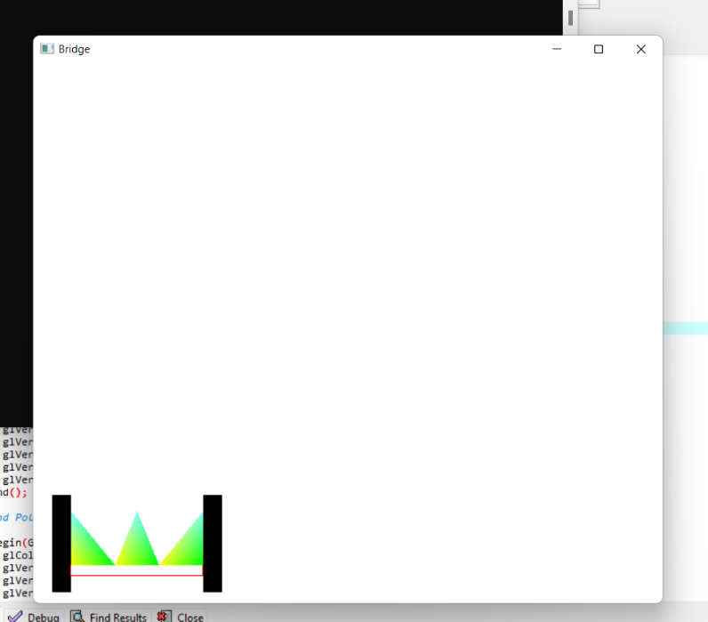
Output:

