CHAPTER 5
TESTING AND RESULT
  - Introduction:
Software testing is an important process to make sure that the software works correctly as per the requirement and able to avoid unsatisfied client. In this project, few software testing techniques has been applied. The outcomes of the project's testing and implementation are presented in this chapter. It explains how testing and assessment are carried out. There are different types of testing that will be conducted during testing period. Some basic and most important software testing is done and explained in this chapter to ensure that our system works as planned and provide the user the actual outcomes. The outcome/result of the system is maintained from testing.
- Unit testing:
Unit testing is most important part of testing. During this project development unit testing is done when the module is completed. Different third-party software were used to test the outcome of the module. Thus, it can examine individual units or operations during software testing. Its primary purpose is to test each unit or function. so, basic operation can be can be performed with error free. The modules that carries unit testing in project are login module, one time password module, voting area module, result module.
The step of the decision table for this project are:
    - Using the activity diagram and use-case description, discovering and building suitable conditions and actions for the developed apps.
    - Use Microsoft office to draw condition and action table
    - For each test scenario, complete the Boolean state of conditions
and actions.

- Component testing:
After unit testing, component testing, also known as program or module testing, is performed. Those test items may be tested separately as a component without integrating with other components in this form of testing.

- User acceptance testing:
The final stage of any software development life cycle is User Acceptance Testing (UAT). This is when real users put the software through its paces to determine if it can do the tasks it was created to in real-world scenarios. When a product passes user acceptability testing, it is ready for production

- Static Analysis:
Static analysis is performed testing without execute the apps to check on requirement, objective, scope and diagrams. Static analysis is a type of testing that checks for various flaws in an application without executing the code. Static analysis can pinpoint a specific flaw in a code area. As a result, it aids in the faster and more efficient correction of faults.

5.2 Decision Module:
5.2.1 Login Module
Condition | Case
Condition | 1 | 2 | 3 | 4 | 5 | 6 | 7 | 8
User Id Validation | F | T | F | T | T | F | T | T
Password Validation | F | F | T | T | T | T | F | T
Click on login | F | F | F | F | T | T | T | F
Action | Case
Action | 1 | 2 | 3 | 4 | 5 | 6 | 7 | 8
Redirect to OTP page | F | F | F | F | T | F | F | F
Display “Incorrect Username or Password” | F | F | T | F | F | T | T | F
Table 5.1.1 Login Module

5.2.2 One Time Password Module:

Condition | Case
Condition | 1 | 2 | 3 | 4
One Time Password Validation | F | T | T | F
Click on submit | F | F | T | T
Action | Case
Action | 1 | 2 | 3 | 4
Redirect to voting arena | F | F | T | F
Display “Incorrect Pin” | F | F | F | T
Table 5.2.2 OTP Module

5.2.3 Vote Module:

Condition | Case
Condition | 1 | 2 | 3 | 4 | 5 | 6 | 7
Authenticated User | F | T | F | F | T | T | T
Choose Candidate | F | F | T | F | T | T | F
Click Submit Button | F | F | F | T | T | F | T
Action | Case
Action | 1 | 2 | 3 | 4 | 5 | 6 | 7
Display Successfully Voted” | F | F | F | F | F | F | F
Display “Failed to Vote” | F | F | F | T | T | F | T
Table 5.2.3: Vote Module
5.2.4 Result Module:

Condition | Case
Condition | 1 | 2 | 3 | 4 | 5 | 6
Username Validation | F | T | T | T | F | T
Password Validation | F | F | T | T | T | F
Click Submit Button | F | F | F | T | T | T
Action | Case
Action | 1 | 2 | 3 | 4 | 5 | 6
Redirect to Admin Result page | F | F | F | T | F | F
Incorrect Credentials | F | F | F | F | T | T
Table 5.2.4: Result Module

5.3 Component Testing
5.3.1 Login Module:
The web page will navigate to the voting site website's home page when the user enters a valid user-email and password in the text box and clicks the submit button. If email and password doesn’t match then the error message is shown as either username or password is incorrect a re-enter the valid credentials.
5.3.2 One Time Password Module:
User with the authorised username and password are required to enter the pin which gets provided in the user mail. If the users pin match with the provided pin in the mail, then the user is authorised to the voting arena where they can vote their desired candidate otherwise if the pin entered is incorrect then the user should enter the correct pin provided.
5.3.3 Vote Module:
In this module, the user with the access to the arena can vote their desired candidate, if they haven’t vote earlier. Otherwise, if they had already voted earlier then the user gets the error message with “Failed to vote” so that they cannot vote twice.
5.3.4 Result Module:
In this module, the user needs to enter the valid admin’s credentials to get access in the system. If the admin enters the valid details, then the admin is redirected to result page, where they can declare the winner according the highest number of votes. Otherwise, if the admin fails to enter the valid details, admin should re-enter the correct credentials.

5.4 User Acceptance Testing (UAT):
In this project, the major goal of user acceptance testing is to validate the end-to-end business flow. It is not concerned with aesthetic flaws, misspellings, or system testing. User Acceptance Testing is performed in a separate testing environment with data that is similar that is used in production. Two or more end-users will be participating in this type of black box testing.
5.4.1 Process of user acceptance testing
1. Planning:
- A list of business processes that will be tested is being developed.
- Defining the conditions for acceptance.
- Choose a testing group.
- Prepare the data for the test. All of the software’s functional situations in real- world use should be covered by the test data.
2. Design:
Create the test. To create the test, we use the information gathered during the planning phase to design the tests.
3. Execution:
Use the test data to run the test and describe the findings. Defects in the system are repaired and the system is retested.
4. Confirmation of business objectives:
Sign-off: This signifies that the software product satisfies the business criteria and is ready for use. Test Plan, UAT scenarios, test cases, test results, and defect log are the deliverable for the whole UAT process.

5.4.1 Analysis of the gathered information:
Application Response Rating
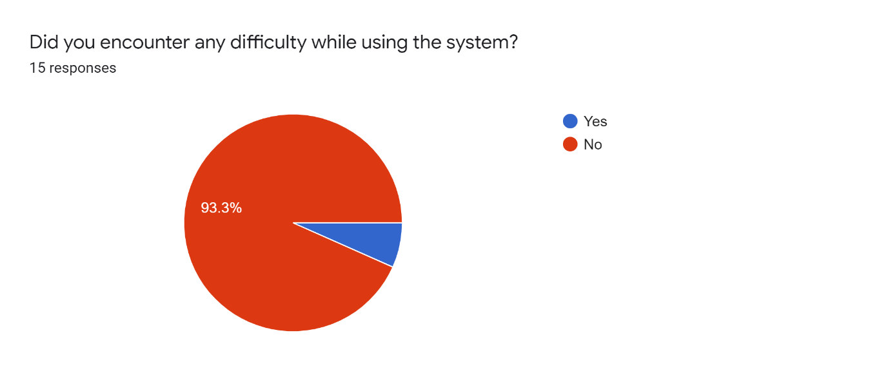
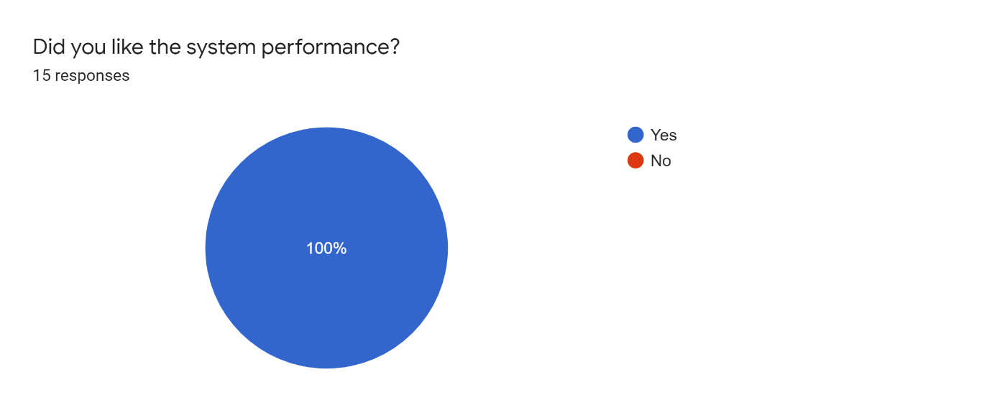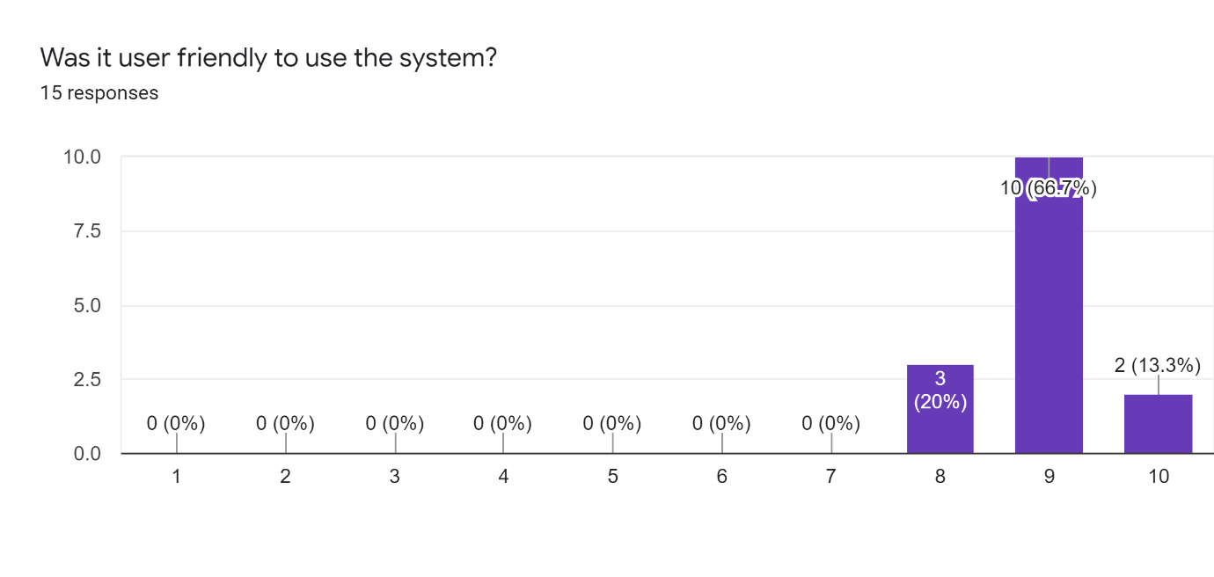

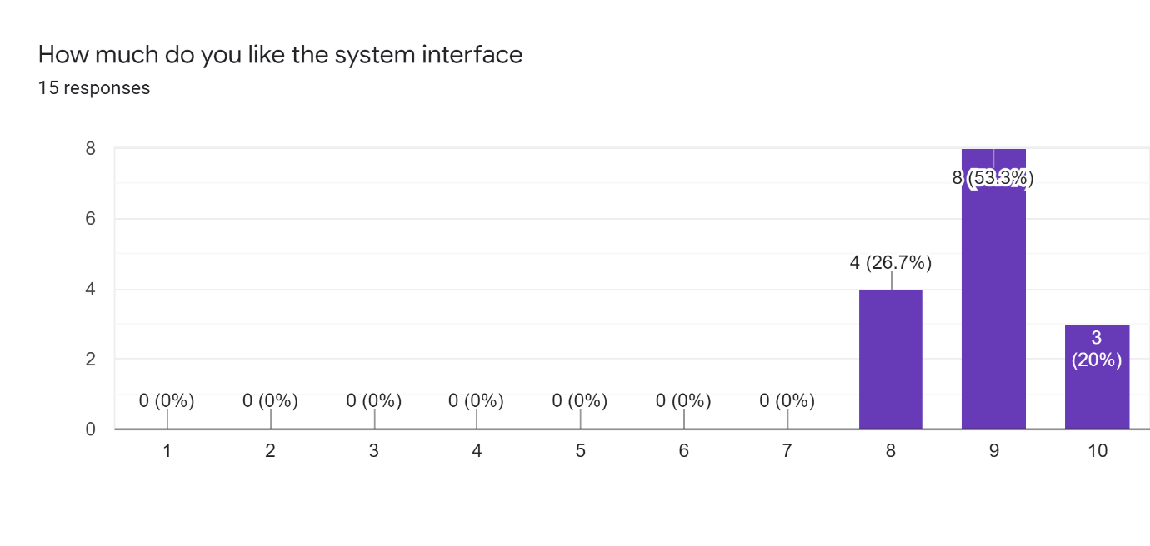
5.4.3 Summary of gathered information
Table 5.7: Acceptance testing result table
Attribute/Rating | Fair | Good | Excellent | Percentage
Interface | 4 | 8 | 3 | 26.7% | 53.3% | 20%
User Friendly | 3 | 10 | 2 | 20% | 66.7% | 13.3%
Performance |  |  | 15 |  |  | 100%
Total | 7 | 18 | 20
From the above table information. 20% of the respondents rate the web application user-friendly was excellent whereas 53.3 % of them rated it as good and 26.7% rated is as fair. Similarly, for interface 20 % of them rated excellent , 53.3% rated it good and 26.7% rated it fair. Likewise, every one of the respondents liked the performance i.e., 100%.
5.5 Conclusion:
In conclusion, the overall testing result is satisfactory, and four testing techniques are employed to check apps in accordance with the document's stated objectives. The first technique is decision table, which is used to ensure that the apps' data and process flow are correct. The second technique is field testing, which is used to ensure that the apps are compatible with various devices. The third technique is user acceptance testing, which is used to distribute apps to respondents and have them complete a questionnaire to determine how they feel about the apps. The last approach is static analysis, which involves checking a text without executing a program, such as checking for grammatical or spelling errors.

