TITLE PAGE

CODITOR: INTERACTIVE CODING PLATFORM IN LEARNING MANAGEMENT SYSTEM

By
BIJAY TAMANG

Dissertation Submitted to School of Information Technology Infrastructure, Kuala Lumpur Infrastructure University College, in Fulfillment of the Requirements for the Bachelor of Computer Science (Hons)
June 2021

ABSTRACT

In every field, programming has become one of the most in-demand skills of a working professional. The demand for a platform that is especially for college students, with the goal of developing a coding culture in them from the beginning has raised. To improve students coding skills on particular field, I aim to develop an online coding platform for students in Learning Management System called a Coditor. This project is focused on developing frontend development coding skills of a student. It can be used by both student and teacher, teacher can assign different task to students and test their skills and can also suggest students their mistakes and also this system will have the similar features of learning management system. This project can help student to Improve their coding efficiency as well. In this report, there are include several chapters to identify and categorize the content of a project document. In first chapter, we have included several topics like introduction of proposed system, its problem statement, its objectives, its constrains, its scope and the tools that we used in our system development. Second chapter contain the literature review of the proposed system, background study of online IDE and Learning Management System, common features of similar system. Different features of similar system and comparison table of similar system. And third chapter is about the software methodology used and the UML (unified modelling language) diagram that contain the Use case, Activity, Sequence and Class diagram design for proposed system.

ACKNOWLEDGEMENT

Fortunately for all the things throughout my journey of knowledge exploration to complete this research.
I would like to express my sincere gratitude to my supervisor Yogendra Bahadur Mahata for his guidance and advices throughout this work to make it successful.
My deepest appreciation to my family especially my parents for their utmost support and My heartfelt gratitude to my family, particularly my parents, for their unwavering support and encouragement; without them, none of this would have been possible. Last but not least, I'd want to express my gratitude to all of my friends for providing me with numerous ideas, incentives, and encouragements.

APPROVAL

We have examined this dissertation and verified that it meets the program and school requirements for the Bachelor of Computer Science (BCS).

Date: Signature: …………….....
Supervisor: Yogendra Bahadur Mahata

AGREEMENT LETTER

Valid Reasons for Late Submission
- Students are required to submit their Chapter Assignments to their Supervisor.
- Students should ensure they are aware of how and when to submit their assignment.
- Students who miss the deadlines because of illness must present an original (not a photocopy) medical certificate to the lecturer on the first day back in classes.
- Students who request compassionate consideration must provide then funeral announcement, obituary, doctor's certificate or death certificate, or relevant documentation.

Student Declaration
- I declare that this project is my own work and does not involve plagiarism or collusion and shall be graded as Failed if proven.
- It does not contain my own previous work without this being stated.
- I am aware that any violation of these rules will be considered cheating and consider as Failed.
- I am aware that all material submission will be accepted after the deadline, but no marks will be given.
- I have made a photocopy and electronic copy of my project, which I can produce if the original is lost for any reason.
- This declaration will be automatically withdrawn once I drop the IT Project subject.


Student Name: Bijay Tamang Student signature:
Student ID: 041901900007 Date: 27/10/2021

DECLARATION

I certify that this project paper and the research to which it refers are the product of my own work and that any ideas or quotations from the work of other people, published or otherwise are fully acknowledge in accordance with the standard referring practices of discipline.

September 10, 2021 Bijay Tamang
041901900007

Table of Contents
ABSTRACT ii
ACKNOWLEDGEMENT iii
APPROVAL iv
AGREEMENT LETTER v
DECLARATION vi
CHAPTER 1 1
1.1 Introduction 1
1.2 Problem Statement 2
1.3 Objectives 2
1.4 Scope 2
1.4.1 User Scope: 2
1.4.2 System Scope: 2
1.4.3 Constraint: 2
1.5 Methodology 3
1.6 Development Tool 3
1.7 Conclusion 3
Chapter 2 4
2.1 Introduction 4
2.2 Background Study 6
2.2.1. Online IDE (Integrated Development Environment) 6
2.2.2. Learning Management System 6
2.3 Common Features of Similar System 7
2.4 Similar System 10
2.4.1 Moodle 10
2.4.2 Google Classroom 11
2.4.3 Canvas 12
2.4.4 CodePen 13
2.5 Comparison Table 14
2.6 Conclusion 14
CHAPTER 3 15
3.1 Introduction 15
3.2 Agile Methodology 16
3.3 Use Case Diagram 19
3.4 Written Use case 20
3.4.1 Registration of User 20
3.4.2 Manage Course Folder 20
3.4.3 Upload file 21
3.4.4 Search Files 21
3.4.5 Compiler 22
3.4.6 Login 22
3.5 Activity Diagram 23
3.5.1 User Registration 23
3.5.2 Manage Course 24
3.5.3 Upload Files 25
3.5.4 Search Files 26
3.5.5 Compiler 27
3.5.6 Login 28
3.6 Sequence Diagram 29
3.6.1 User Registration 29
3.6.2 Manage Course 30
3.6.3 File Upload 31
3.6.4 File Search 32
3.6.5 Compiler 33
3.6.6 Login 34
3.7 Class Diagram 35
3.8 Conclusion 35
Chapter 4 36
4.1 Introduction 36
4.2 Interface Explain 36
4.2.1 Home page 36
4.2.2 User Login Interface 37
4.2.3 Course Activity Page 38
4.2.4 Activity Single Page 39
4.2.5 Activity Submission Page 40
4.2.6 User Profile 41
4.2.8 User Management 43
4.2.9 Create Management 44
4.2.10 Search Page Interface 45
4.2.11 Coding Page Interface 46
4.3 Conclusion 46
Chapter 5 47
5.1 Introduction 47
5.2 Decision Module 48
5.2.1 Login Module 48
5.2.2 Search Module 48
5.2.3 Create User Module 49
5.2.4 Edit User Module 49
5.2.5 Create Course module 50
5.2.6 Edit Course Module 50
5.2.7 Create Assignment Module 51
5.2.8 Edit Assignment Module 52
5.2.9 Submission Module 52
5.2.10 Create Content Module 53
5.2.11 Edit Content Module 53
5.3 Component Testing 54
5.3.1 Login Module 54
5.3.2 Search Module 54
5.3.3 User Create Module 54
5.3.4 User Edit Module 54
5.3.5 Create Assignment Module 55
5.3.6 Assignment Edit Module 55
5.3.7 Course Create Module 55
5.3.8 Course Edit Module 55
5.3.9 Submiison Module 55
5.3.10 Content Create Module 55
5.3.11 Content Edit Module 55
5.4 User Acceptance Testing: 56
5.4.1 Process of Acceptance Testing 56
5.4.2 Analysis of Gathered Informations 56
5.4.3 Summary of gathered information 58
5.5 Conclusion 59
Chapter 6 60
6.1 Introduction: 60
6.2 Challenges 60
6.3 Advantages of the system 60
6.4 Disadvantage of the system 61
6.5 Future Development 61
6.6 Conclusion 61
Reference 62

LIST OF FIGURES
Figure 1 Literature Review Framework 5
Figure 2 File Upload section form Moodle 7
Figure 3 User Registration from Moodle 7
Figure 4 User management from Moodle 8
Figure 5 Assignment setting from Canvas 8
Figure 6 Course Categories management from Moodle 9
Figure 7 Search From Codepen 9
Figure 8 Compiler from Codepen 9
Figure 9 Dashboard of Sunway Extra Period (Moodle) 10
Figure 10 Google Classroom 11
Figure 11 Canvas LMS 12
Figure 12 Codepen 13
Figure 13 Use Case Diagram 19
Figure 14 Activity Diagram of User Registration 23
Figure 15 Activity Diagram of Course Management 24
Figure 16 Activity Diagram of File Upload 25
Figure 17 Activity Diagram of Search File 26
Figure 18 Activity Diagram of Compiler 27
Figure 19 Activity Diagram of Login 28
Figure 20 Sequence Diagram of Course Management 29
Figure 21 Sequence Diagram of Course Management 30
Figure 22 Sequence Diagram of File Upload 31
Figure 23 Sequence Diagram of File Search 32
Figure 24 Sequence Diagram of Compiler 33
Figure 25 Sequence Diagram of Login 34
Figure 26 Class Diagram 35
Figure 27 Home page Interface 36
Figure 28 User Login Interface 37
Figure 29 Course Single Page Interface 38
Figure 30 Activity Single Page Interface 39
Figure 31 Activity Submission Page Interface 40
Figure 32 User Management Interface 41
Figure 33 User Registration Page Interface 42
Figure 34 User Management Interface 43
Figure 35 Course Management Interface 44
Figure 36 Search Page Interface 45
Figure 37 Coding Page Interface 46
Figure 38 Input type error 54

LIST OF TABLES
Table 1 Comparison Table of Similar System 14
Table 2 Login Module Decision Table 48
Table 3 Search Module Decision Table 48
Table 4 Create User page decision table 49
Table 5 Edit User Module Decision Table 49
Table 6 Create Course Module Decision Table 50
Table 7 Edit Course Module Decision Table 50
Table 8 Create Assignment Module Decision Table 51
Table 9 Edit Submission Module Decision Table 52
Table 10 Submission Module Decision Table 52
Table 11 Create Content Module Decision Table 53
Table 12 Edit Content Module Decision Table 53
Table 13 Summary table of gathered information 58

LIST OF ABBREVIATIONS

LMS - Learning Management System
IDE - Integrated development environment
RDBMS - Relational database management System
SQL - Structured Query language
ICT - Information Communication Technologies
SDLC - Software Development Life Cycle
HTML - Hyper Text Markup Language
CSS - Cascading Style Sheets
MOODLE - Modular Object-Oriented Dynamic Learning Environment
PHP - Hypertext Preprocessor

CHAPTER 1

1.1 Introduction
Technology has advanced quickly in recent years among us. In this era of information technology, the internet is easily available and accessible basically in urban areas. The field of education has evolved into one of the most important platforms for technological advancement. The end of 2019 corona virus (Covid-19) spread force us to move virtually in many situations. With the help of internet schools and colleges moves from physically to virtually.
E-learning is a process education in electronic form through internet network or the internet with the use of management system for education (Definition of “E-Learning,” n.d.). Most of the university uses learning management system now a day. The Learning Management System or popularly known as LMS in the community of higher institutions is an online portal that connects lecturers and students. Although many things are shared in LMS, while programming teachers and students are using an IDE (integrated development environment). Programming platform is a software platform that includes all the components, application programming interfaces, and libraries that programmers and developers need to write, create, debug, and run language-specific applications (What Is Programming Platform, n.d.). Online Programming Platform helps to test code without installing a software or IDE (integrated development environment).
The Proposed system basically try to implement an interactive coding platform in Learning Management System. This proposed system focuses on developing ideas and skills of students in front-end development. This system will help teachers to check the code written by students and identify errors.

1.2 Problem Statement
- Learning Management System does not have an online coding platform:
Learning Management System has various function included but does not have online coding platform.
- Time consuming while Installing and configuring the necessary software (Zinovieva et al., 2021):
While Installing the software, user needs to have a certain amount of information to configure the software. And many cases, while configuring the system it takes a lot of time to load in a system.
- Students needs to login into two different systems to access the learning management system and coding platform.

1.3 Objectives
- To create a system, where user can use both learning management system and online
coding compiler at a single system.
- To integrate the online coding compiler in learning management system
- To design a system with an interactive input panels for HTML, CSS and JavaScript.
- To implement a compiler to display outcome of code snippets.
- To develop a system which will help students to improve their coding efficiency.

1.4 Scope

1.4.1 User Scope:
- User able to code online
- User able to check their results/outcome of their code.
- User able to upload their assignments and download courses files.
- User able to edit their work

1.4.2 System Scope:
- System able to display the outcome of code
- System can verify user by their user-id.
- System able to save the uploaded assignments by the user

1.4.3 Constraint:
- While implementing a coding platform in Learning Management System it is only focused for front-end development.
- There are many other sectors and programming languages can add.
- By implementing in Learning Management System, its, basically for teachers and student only.

1.5 Methodology
Agile methodology is a mindset or approach to project management. The agile methodology divides the development process into iterative parts, allowing for flexibility, testing, and modifications throughout the project's lifecycle.
Agile methodology will be used in proposed system, because of the following advantages:
- Agile will be used to breakdown work into different parts which will help in testing and completion of work.
- Agile product change and flexibility is one of the main advantages, it will help to add different features in the middle of the project.
- Agile will be used to improve project predictability which will help to reduced risk in the system.
- Agile will help to improve system quality because of its testing process.

1.6 Development Tool

Visual Studio Code (VS code)
Visual Studio Code is a source-code editor that can be used with a variety of programming languages, including JavaScript, Node.js, Python, PHP and C++. Visual Studio Code will be used as an IDE (Integrated Development Environment) to develop an interface using HTML, CSS, JavaScript and for the backend of the system PHP and PHP framework will be used and for the output panel, web console idea will be used by using JavaScript framework.
MySQL
MySQL is a multi-platform, open source RDBMS (relational database management system). It makes use of SQL (Structured Query Language), which is used for querying the databases. SQL helps in managing the database by allowing the users to create, edit, delete, retrieve or alter the databases. It can be used to store anything from a single record of information to an entire inventory of college.
Draw.io
Draw.io is software used for making charts and diagrams. This software allows user to choose from a layout function and user can also create a custom layout. Draw.io will be used for making different types of UML diagrams like use case diagram, activity diagram, sequence diagram and class diagram.

1.7 Conclusion
In conclusion, while identifying a different problem statements, we develop a different objective to implement a system with the software development methodology called agile will be used to develop a system. Implementing a coding platform for frontend in Learning Management System will helps students to practice. With the help of internet, the students can run this system and practice from anywhere at any time using computer.

Chapter 2
Literature Review

2.1 Introduction
The world of education has become one of the platforms for technology to develop rapidly, therefore we must be able to build positive technology in the world of education (Simanullang & Rajagukguk, 2020). And Programming and computational abilities are extremely important in today's lives. Online coding platform has been an innovative strategy that allows students to solve coding problems from anyplace at any time. Online coding platform has been recognized as a practical tool for addressing and improving coding skills of students (Ramu, 2018). Different university are using a different online IDE to helps students to learn programming in distance learning (Ramu, 2018). Learning management system are viewed as being the starting point of web-based learning platform (Cavus et al., 2006).
Moodle is one of the most used and popular learning management system including the features like: assignment management, course management etc. (Cavus et al., 2006) There are many web platforms for students to practice online and some of them are: Hacker rank, CodeChef, Codewars, Codepen, Codesandbox. It is noted that use of online simulators to consolidate programming skills simplifies the procedure for teachers to check the code written by the students, identify errors and helps to detect in the staring phase (Zinovieva et al., 2021). So, far education institution has been using different ICT to focus on computer education. Student need to possess skills and ability to use of technological tools, and able to have skills, and understanding (Demertzi et al., 2018). An Indian institution used BuildIT online coding platform for the testing the abilities of the students by providing the coding competition (Ramu, 2018).
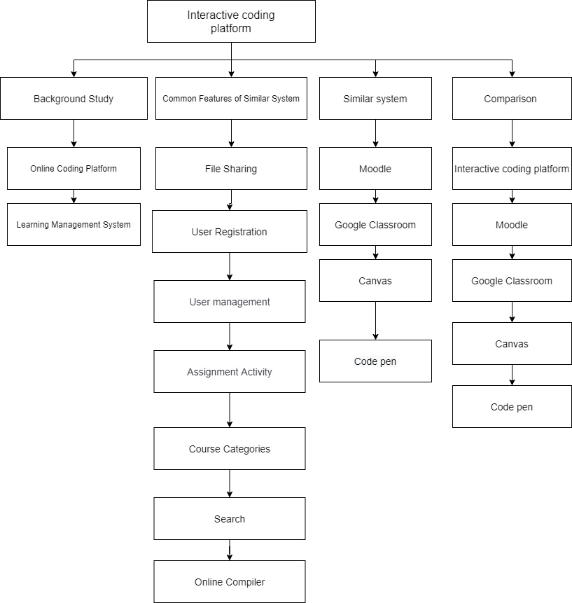
Figure 1 Literature Review Framework

2.2 Background Study
In early 2020 during the lockdown, the E-learning became one of the most effective things in the world and most of the universities are mobilizing faster and accepting the distance learning platforms (Hamaniuk et al., 2020). IDE provide easy access to code libraries, test platforms, text editors, and compilers. Although IDE’s are very useful, there are couple of drawbacks like once the IDE’s are installed on desktop, to use the features of it, it requires much more computer resources, especially CPU and computer memory (Dutta et al., 2014). So, for the easy use of IDE, the Web based IDE are developed. To use the web IDE user must have access to the internet (Dutta et al., 2014). The idea of the proposed system is similar to BuildIT and Coding platform as both of the system is able to use the concept of online IDE to perform a different programming task. As for the use of university, system only allow to register the students whose data are matched in their database and user needs a login ID to access the system (Chandru et al., 2019).

2.2.1. Online IDE (Integrated Development Environment)
Online IDE (Integrated Development Environment) is a browser-based integrated Development Environment that is also known as Web IDE or Cloud IDE. It can also be accessible with any web browser. The functionalities of an online IDE are not always the same as those of a desktop IDE.
Some of the advantages of using Online IDE are as follows:
- Reduced Personal Hardware requirements
- Less Setup effort
- Reduce Build Times

2.2.2. Learning Management System
In E-learning, a Learning Management System (LMS) is a software that aids in the learning process. Two key goals are to make learning more self-contained and to allow LMS users to register, save, manage, publish learning on the web, through the LMS (Adzharuddin, 2013).
Some of the advantages of Learning Management System are as follows:
- Easy access to information: All information is organized and stored in one location, making it available to all users. With only one click, you can access courses, calendars, content, and assessments.
- Personalization: Learning Management allows institutions to fully customize the platform by incorporating the organization's or institution's logo.
- Current and immediate content: Administrators can update, add course content, and resources for students using the Learning Management System.

2.3 Common Features of Similar System
This section will be discussed about the features of the similar system:
- File Sharing:
The most common features of the learning management system are file sharing; the user can upload a file to share with other users. For example: System administrator uploading a course related content for the students. And Students are sharing a file related to their work assigned by the teachers or organizations.
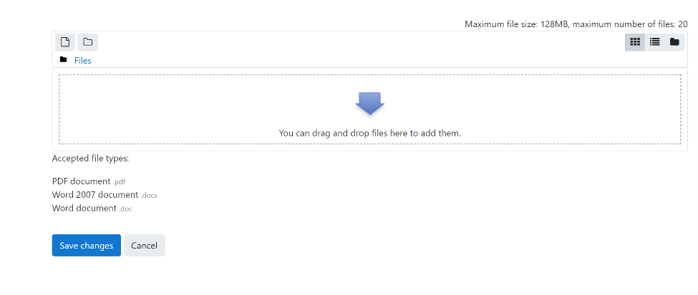
Figure 2 File Upload section form Moodle
- User Registration:
One of the most common features of any websites is user registration, user need to register to use some features in the system. And in learning management system there are three types of user students’ teachers and administration.
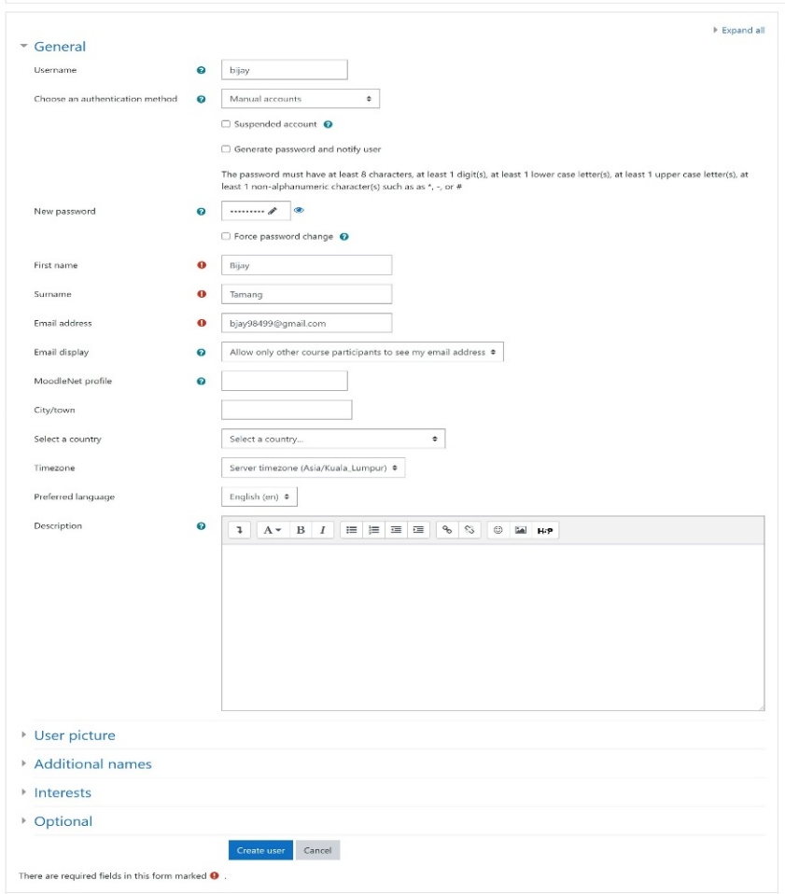
Figure 3 User Registration from Moodle
- User management:
It is also one of the most common features of learning management system is user management, a user management features allow you to create a user update user information and it will allow to assign a task for a user. And also, can assign a role for a user as per system permission.
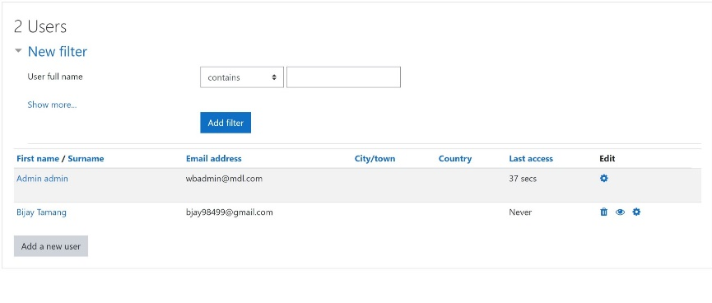
Figure 4 User management from Moodle

- Assignment Activities:
In assignment activities there are two types: One is by uploading an assignment assigned to students by admin panel and another is uploading an assignment for grading by students.
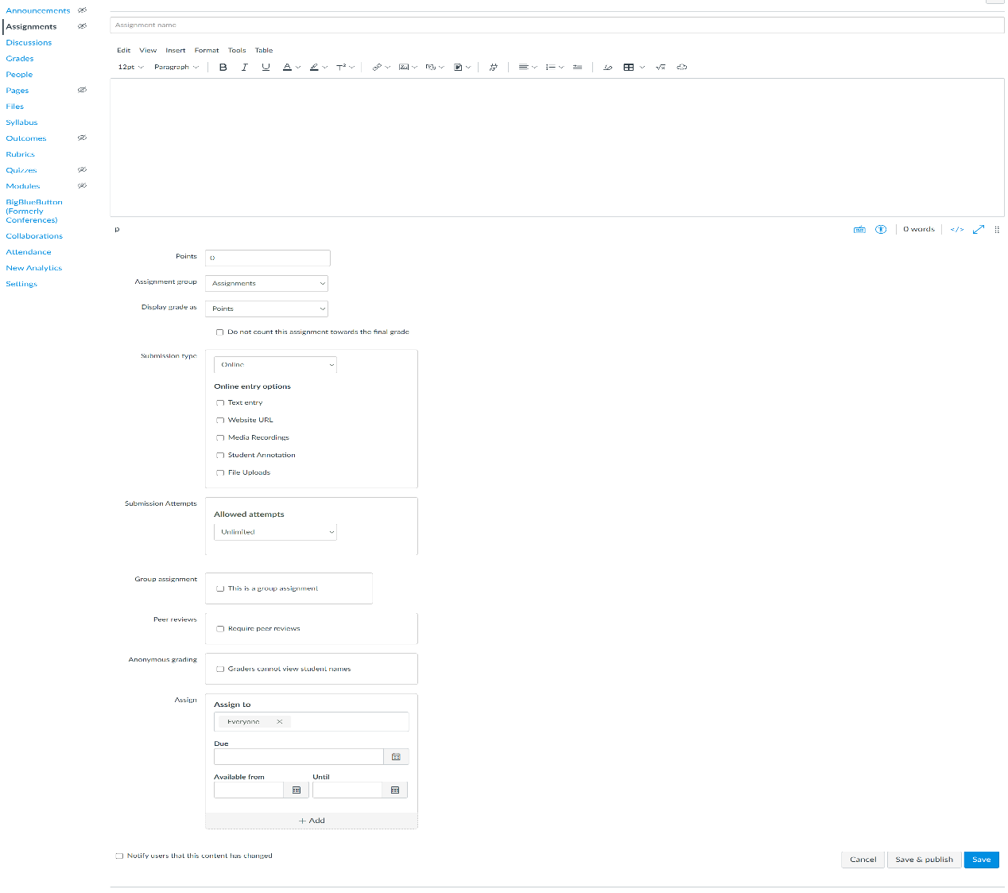
Figure 5 Assignment setting from Canvas
- Course Categories:
Course categories features allow to add course category update course category hiding course category and can assign a user’s role in course category.
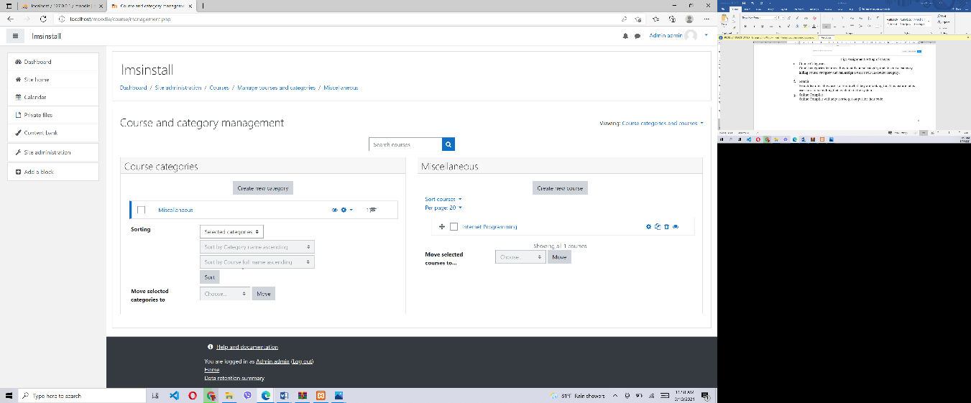
Figure 6 Course Categories management from Moodle

- Search:
Search features allow user to search what they are looking for. This feature helps user to search anything that available in the system.
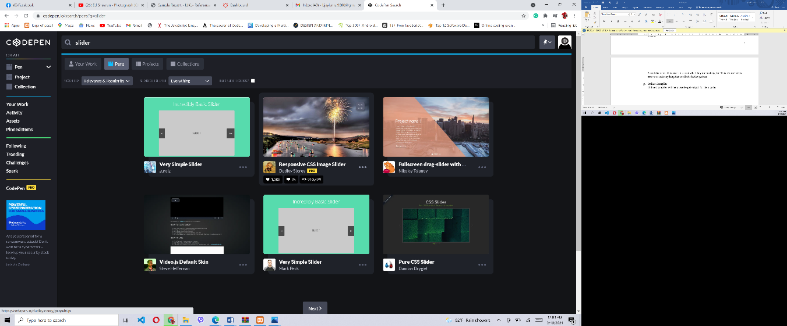
Figure 7 Search From Codepen
- Online Compiler:
Online Compiler will help user to get output for their code.
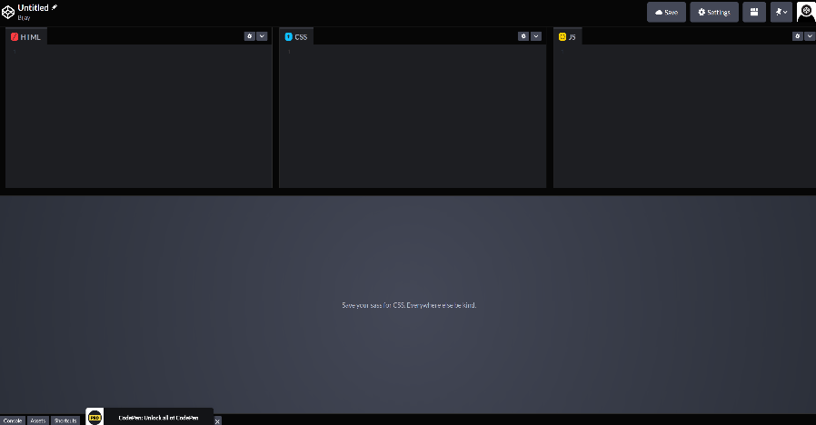
Figure 8 Compiler from Codepen

2.4 Similar System

2.4.1 Moodle
Moodle is a learning platform that allows instructors, administrators, and students to construct individualized learning environments using a single, secure, and integrated system. It is an open-source learning management system. Basically, Moodle is used for distance learning, e-learning in schools, universities. And it was developed by Martin Dougiamas and released on 20 August 2002 (Simanullang & Rajagukguk, 2020).
The Features of Moodle are as follows:
- File sharing
- User registration
- User management
- Assignment Activities
- Course Categories
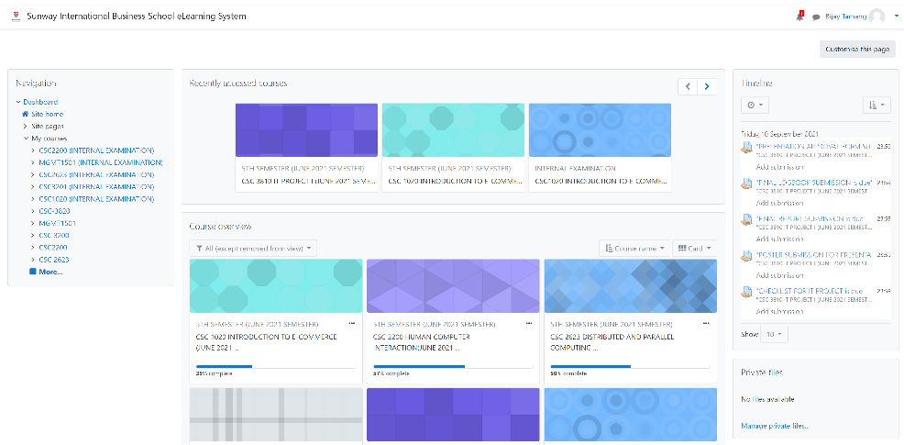
- Search
Figure 9 Dashboard of Sunway Extra Period (Moodle)

2.4.2 Google Classroom
Google Classroom is a free web service for schools built by Google to make creating, sharing, and grading assignments easier. The major goal of Google Classroom is to make file sharing between teachers and students easier. A google classroom was announced on May 6, 2014 for the members of Googles G suite but it was publicly on August 12, 2014.
The features of Google Classroom are as follows:
- File sharing
- User registration
- User management
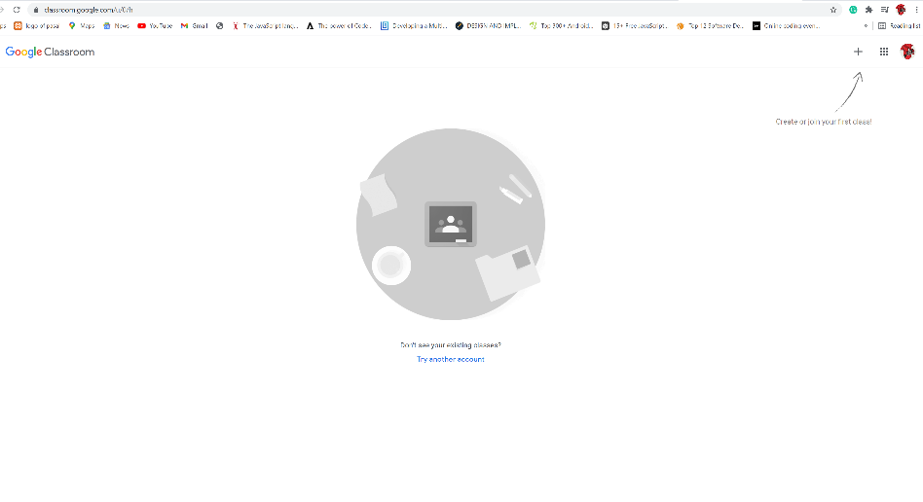
- Assignment Activities
Figure 10 Google Classroom

2.4.3 Canvas
Canvas is also a free and open web-based learning management system like Moodle that enables institutions to manage e-learning, teachers to create and present online learning materials and assess student learning, and to receive feedback on student skill development and learning achievement. It was launched backed in 2011.
The features of canvas are as follows:
- File sharing
- User registration
- User management
- Assignment Activities
- Course Categories
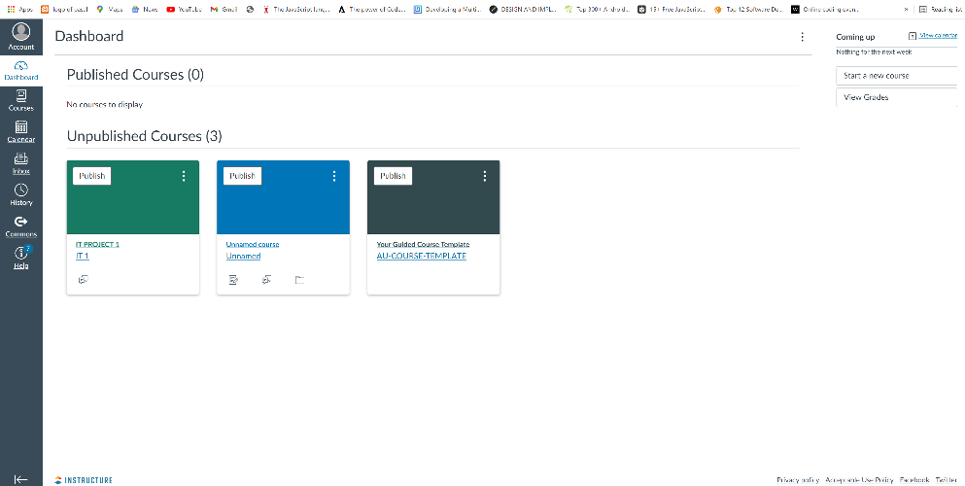
- Search
Figure 11 Canvas LMS

2.4.4 CodePen
CodePen is an online community for testing and displaying a code snippet contributed by users that are used for the frontend development . Codepen is an online code editor and open-source learning environment where designer and developers can generate and test their code snippets. Alex Vazquez, Tim Sabat, and Chris Coyier started it in 2012. It is one of the largest communities for web designers and developers to show their coding skills (Code Pen, n.d.).
The features of the codepen are as follows:
- User registration
- Search
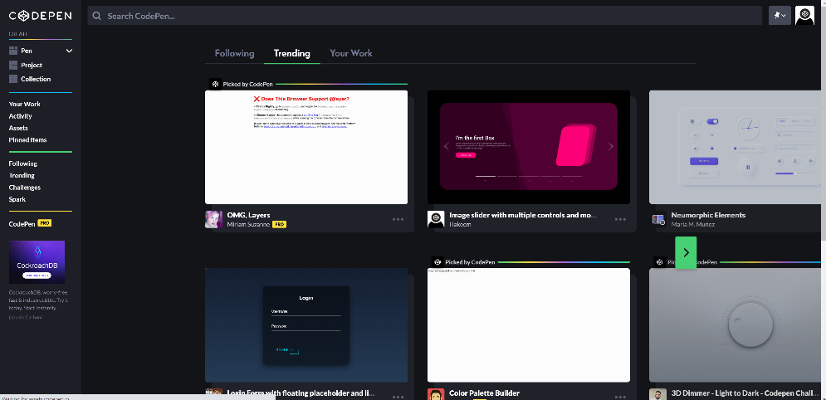
- Online Complier
Figure 12 Codepen

2.5 Comparison Table
Features | Proposed System | Moodle | Google Classroom | Canvas | CodePen
File Sharing | 
User Registration
User Management |  |  |  |  | 
Assignment Activities |  |  | 
Course Categories
Search
Online Compiler
Table 1 Comparison Table of Similar System

2.6 Conclusion
In this chapter, we have done research on various similar system with our proposed system and also done research on similar features of similar system and also compare features of similar system with our proposed system that will be implement in the future while developing of proposed system.

CHAPTER 3
METHODOLOGY

3.1 Introduction
In this chapter we will discuss about the software development lifecycle (SDLC) which is used in our proposed system by research the methodology workflow and its advantage. The used methodology is agile methodology. Other than the methodology, this chapter will include the four types of unified modelling language (UML) diagram design for the proposed system.
The first diagram type is use case diagram. The use case diagram will explain the functionality that perform by the actor when the actor is using the proposed system, in simple word use case diagram is used to define what user can do in the system. And there will have a written use case for every use case to explain the use case control flow.
The second diagram type is activity diagram. The activity diagram is a behavioral diagram to visualize the workflow of sequence activity and action to support iteration, choice and concurrency.
Third diagram is sequence diagram; a sequence diagram is an interaction diagram to show the relationship between object in a time sequence.
The last diagram is a class diagram a structure diagram to describe the structure of the system by knowing the system classes, class attribute, operation and relationship among the object to provide detail modelling that can translate to programming code.

3.2 Agile Methodology
The agile methods have mainly emerged to replace the traditional methods of software development that have many limitations. Agile methodology helps to detect bugs of code in early time because it allows developers to test the system in every iteration able to test the addition requirement in detail because the testing phase is including in iterations. Continuous testing helps the teams to detect the error earlier and fix them before they get more complex. The early detection of error has a significant impact on software development because it provides high quality project that increases the customer satisfaction (Gaurav Kumar, 2012). Iterations are used in Agile methodologies to divide task into small portions with minimal planning. Iteration minimizes overall risk and allows the project to adapt to changes quickly because it involves a team working task that contains software development cycle, including planning, requirements analysis, design, coding, unit testing etc (Gaurav Kumar, 2012).

Agile methodology will be used in proposed system, because of the following advantages:
- Used to breakdown projects in different sections will also help in testing
- Agile product change and flexibility is one of the main advantages, it will help to add different features in the middle of the project.
- Will be used to improve project predictability which will help to reduced risk in the system.
- Agile will help to improve system quality because of the iteration phase.

The project will be divided into 7 separate sprints, and each sprint have the specific outcome to ensure that every sprint achieve the target.

Sprint 1
Plan Phase
Step 1: At first, we will be submitted two different project proposal to our supervisor and the supervisor will give feedback as per the proposal
Step 2: We will do the detail feasibility analysis to every approved project which include schedule and technical feasibility
Step 3: Identify the problem statement of the project by reading various research paper and project report and extract the problem statement, after that identify the software development tool suitable and methodology for our project
Step 4: This process conducts the literature review related to our project, identifying the advantages and disadvantages of interactive coding platform in learning management system.

Design Phase
Step 1: is to conduct the summary of agile model plan to the project
Step 2: is to design UML Diagram for the project which include use case, written use case, activity diagram, sequence diagram and class diagram to obtain design idea for UML.
Review Phase
In this phase, the process is to display of our progress work to our supervisor to check and correction, ensure that the documentation and design have related content
Launch Phase
The process is conduct presentation to the stakeholder about the documentation and design for the project
Sprint 2 to 6
Start implementation of the system, since the system divide to 3 modules, every sprint will complete specific module and testing to the module.
Plan and design phase
This process includes the planning and identify the strategy to complete the proposed system
Build and test phase
The process is to implement IDE using Visual Studio Code according planned designed using the mentioned programming languages like HTML, CSS, CSS Framework, JavaScript and JavaScript framework React JS, PHP and its framework to check that every module is working correctly which is unit testing.
System Administration Module
Step 1 will create the administration interface design
Step 2 is to make the design working module and test the system can perform the features properly.
User Module
Step 1 will create the user module interface design
Step 2 is to make the design working module and test the system that can perform the features properly
Search Module
Step 1 will try to research binary search algorithm to apply in my search module, it will display the files according to yours enter keyword
Step 2 develop the module that can search relevant files in the database.
Output Module
Step 1 will try to research on an editor and compiler, which will help to display the outcome
Step 2 with the help of JavaScript and its library it will able to display the outcome of input code snippet
Sprint 7
Design and test Phase
Step 1 design the test case by using written use case and identify the equivalence partition
Step 2 This process is conduct for user acceptance testing asking potential user to use the proposed system to collect the feedback and testing the proposed system in the actual devices

3.3 Use Case Diagram
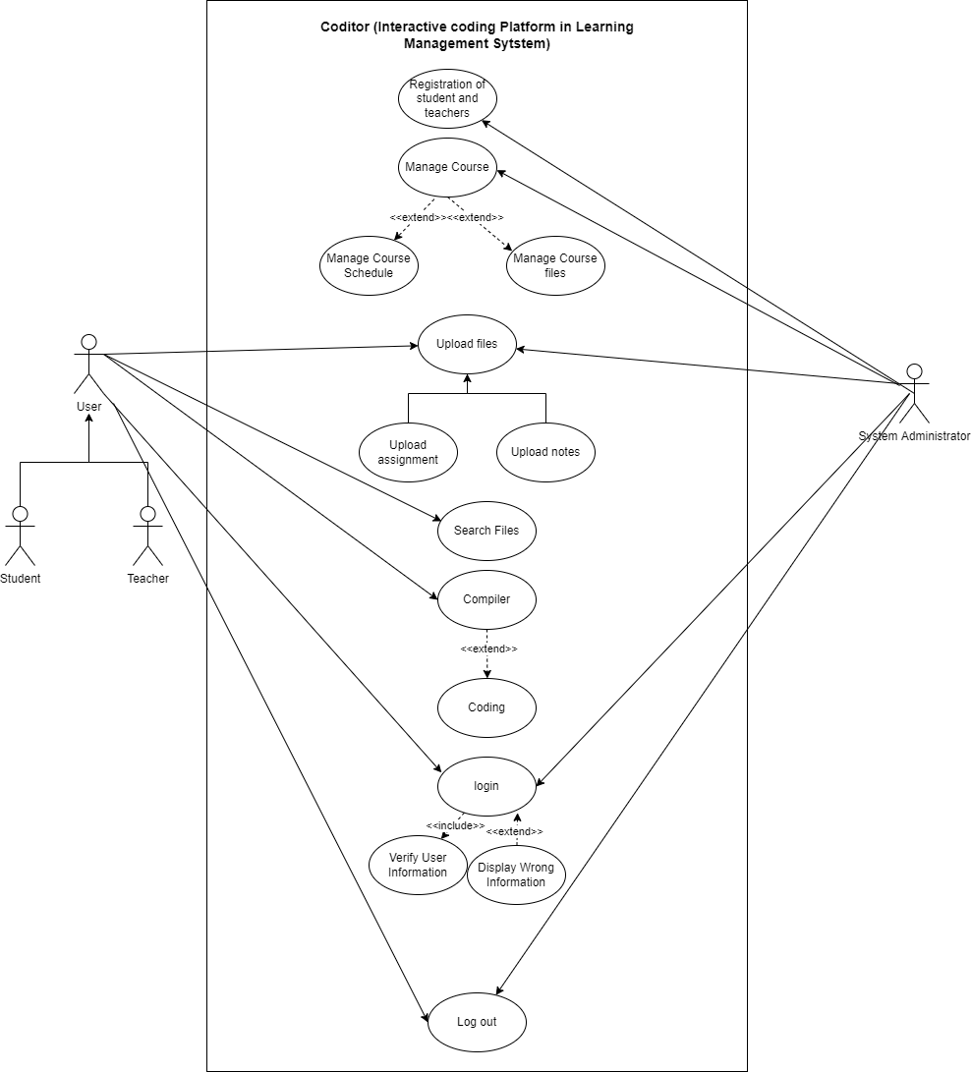
Figure 13 Use Case Diagram

3.4 Written Use case

3.4.1 Registration of User
Use-Case ID: 1
Use-Case Title: Registration of User
Primary Actor: System Administration
Pre-condition: System Administration must login into the system
Post-condition: Server Must Generate user account
Trigger: System administration want to add user
Main Success Scenario:
- System administration create user profile
- System administration need to fill the important details of user (for example: name, e-mail, password etc.)
- System administration provide login information for the user by their role.
Extensions:
- Display error if user details are fill incorrect

3.4.2 Manage Course Folder
Use-Case ID: 2
Use-Case Title: Manage Course Folder
Primary Actor: System Administration
Pre-condition: System Administration must login into the system
Post-condition: Server Must accept the folder,
File must be saved in database

Trigger: System administration want to manage a course folder
Main Success Scenario:
1. System choose course topic to manage folder
- System administration can edit, add, and delete course folder
Extensions:
      - Display message after the system administration edit, delete and add course

3.4.3 Upload file
Use-Case ID: 3
Use-Case Title: Upload file
Actor: System Administration, Student
Pre-condition: Actor must login into the system and actor must have access to upload file
Post-condition: Uploaded file must be store in the database

Trigger: Actor want to upload file
Main Success Scenario:
1. Actor select the category to upload a file
2. Actor upload a file in their chosen folder
3. System will save the uploaded folder in the database
Extensions:
            - If the uploaded file format did not match, system display the information as wrong file format.

3.4.4 Search Files
Use-Case ID: 4
Use-Case Title: Search file
Actor: Teacher and Student
Pre-condition:
Post-condition: System must be able to retrieve the specific data requested by the actor

Trigger: Search button pressed
Main Success Scenario:
1. In order to search, actor need to enter keyword in the search bar
2. System will check requested key-word
3. System will display the list of relevant file according requested key-word
Extensions:
            - No relevant file found, actor need to enter another keyword

3.4.5 Compiler
Use-Case ID: 5
Use-Case Title: Compiler
Actor: Student
Pre-condition: User must be login into the system
Post-condition: User can code in the system

Trigger: Student want to practice the coding
Main Success Scenario:
1. Student can write code
2. Student can check their output
Extensions:
            - System can display the output of the student code.

3.4.6 Login
Use-Case ID: 7
Use-Case Title: Login
Actor: Student, teacher and system administration
Pre-condition: The user is not logged in into the system
Post-condition:

Trigger: Actor want to login into the system
Main Success Scenario:
1. Actor enter valid information for login
2. User enter the login button
Extensions:
            - Enter information is not valid
            - User need to re-enter the information to login

3.5 Activity Diagram

3.5.1 User Registration
Figure 14 Activity Diagram of User Registration
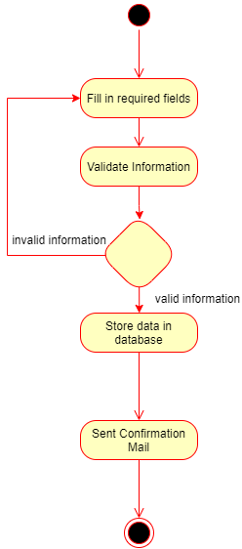

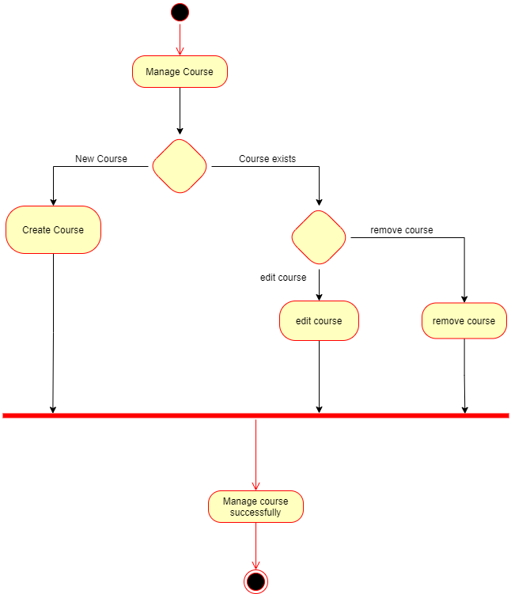
3.5.2 Manage Course
Figure 15 Activity Diagram of Course Management

3.5.3 Upload Files
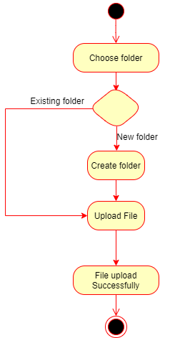
Figure 16 Activity Diagram of File Upload

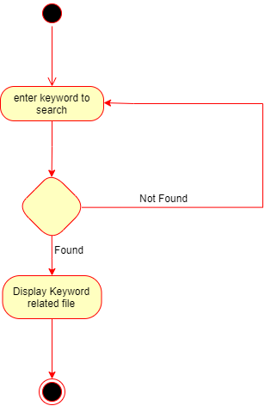
3.5.4 Search Files
Figure 17 Activity Diagram of Search File

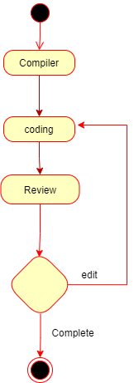
3.5.5 Compiler
Figure 18 Activity Diagram of Compiler

3.5.6 Login
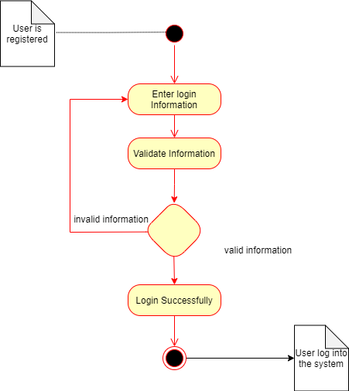
Figure 19 Activity Diagram of Login

3.6 Sequence Diagram

3.6.1 User Registration
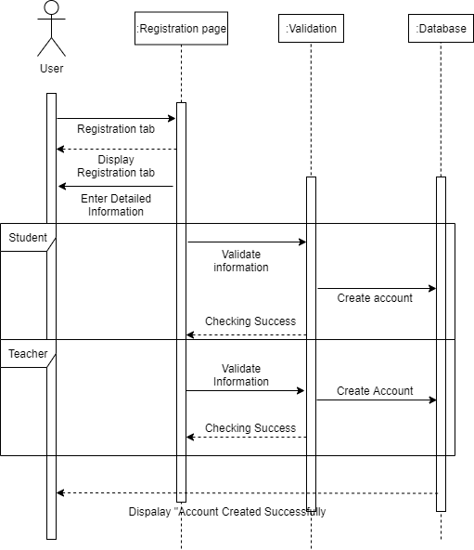
Figure 20 Sequence Diagram of Course Management

3.6.2 Manage Course
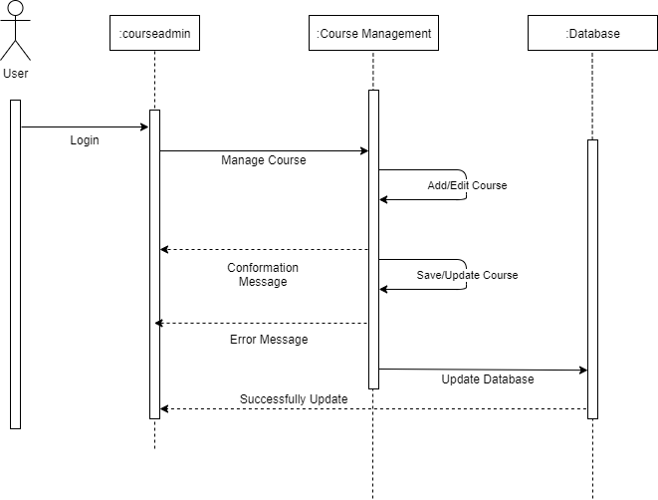
Figure 21 Sequence Diagram of Course Management

3.6.3 File Upload
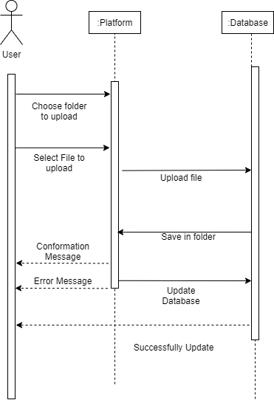
Figure 22 Sequence Diagram of File Upload

3.6.4 File Search
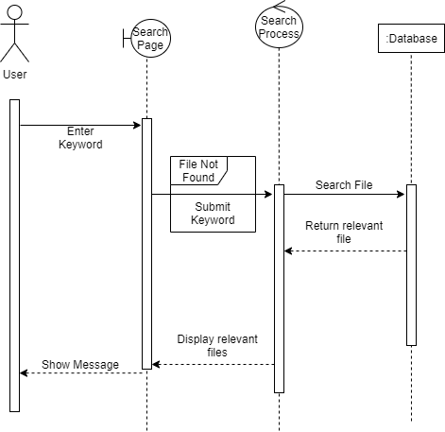
Figure 23 Sequence Diagram of File Search

3.6.5 Compiler
Figure 24 Sequence Diagram of Compiler
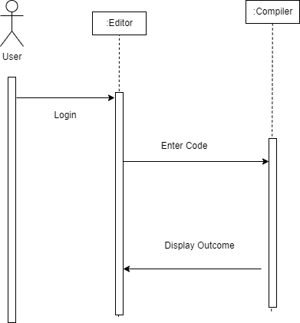

3.6.6 Login
.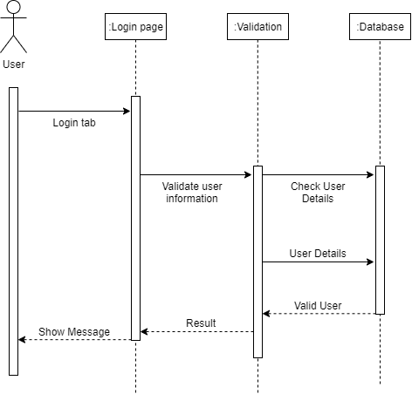
Figure 25 Sequence Diagram of Login

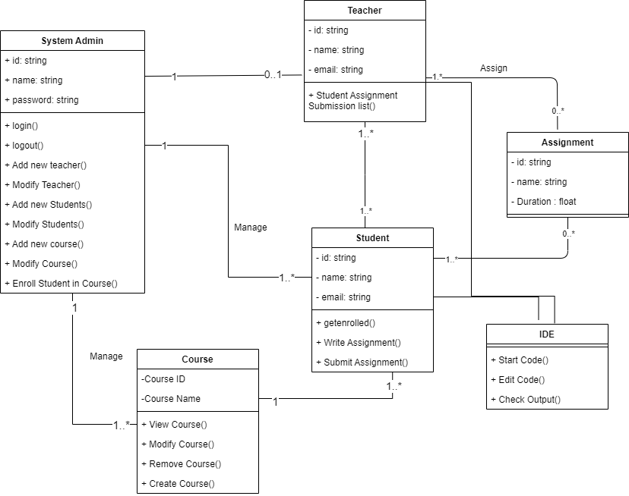
3.7 Class Diagram
Figure 26 Class Diagram

In above class diagram, it provides details information of relationships between classes, its attributes and operations. Above Class diagram shows that how objects and classes interact with each other like system administration can add students, teacher, course manage student, teacher, course can teacher can assign assignment to students, students can use IDE for the coding assignment.

3.8 Conclusion
To conclude, in this chapter we have discussed about the Agile Methodology which will be used during the software development lifecycle. And even various UML diagram like use case diagram, activity diagram, sequence diagram and class diagram are prepared which will be required for designing and development of the system to provide better-quality project for the user with the mentioned development tools in our project.

Chapter 4
Interface

4.1 Introduction
This chapter explains about all the activities which can perform by the user in the system. The system is presented through the user view, who use the system. Through page to page the system will be explain how user can use every function of the different pages.

4.2 Interface Explain

4.2.1 Home page
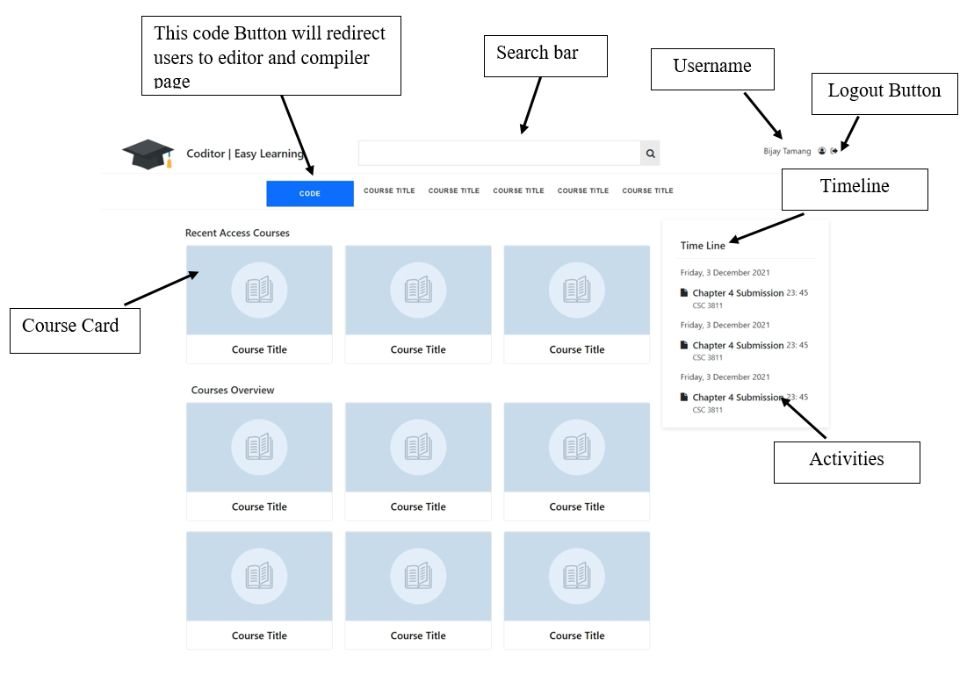
This system home page will have a course list, recently access course and their timeline for their submission. User can see the course details by selecting and clicking the course. User need to login in the system to access the home page of the system.
Figure 27 Home page Interface

4.2.2 User Login Interface
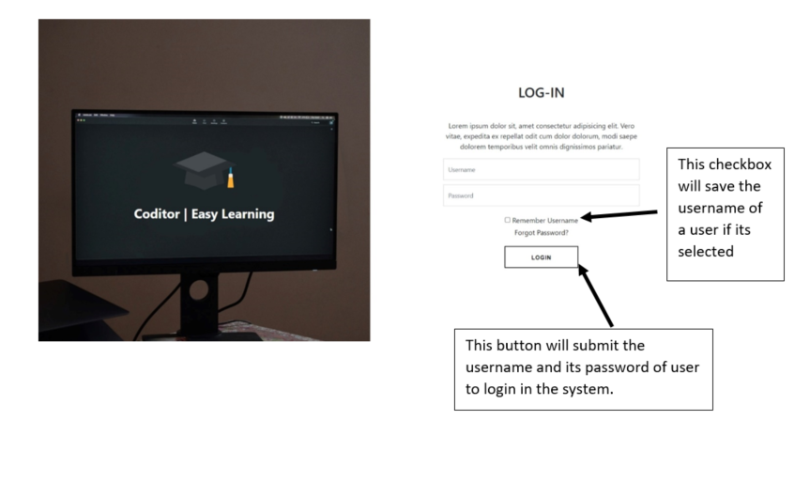
In this user interface user need to enter their username provided in the system and their password to login. If user enter the wrong username or password user cannot login in the system. If user forgot the password user can retrieve the password by clicking the forgot password. User can also save the username after clicking in the check box of remember username. It will save the username for the other time if same user wants to login in the system.
Figure 28 User Login Interface

4.2.3 Course Activity Page
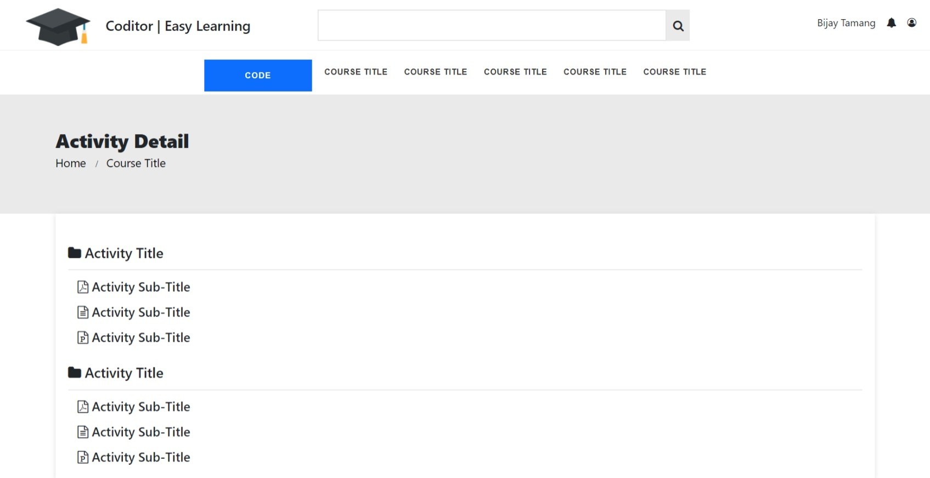
This page will open after clicking the course in our home page. This page of the system will have the course different files and folders, it will display the course activity titles like student’s assignment, chapter slides, student’s projects etc. which are available for students. Students can see activities details by clicking the activity title.
Figure 29 Course Single Page Interface

4.2.4 Activity Single Page
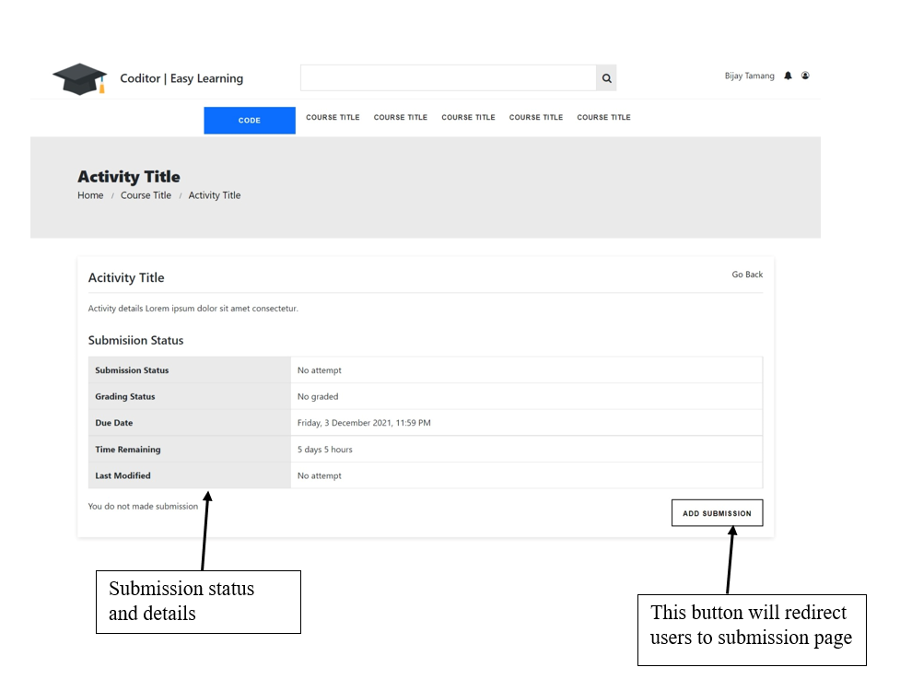
This page will open after clicking the activity title in activity page. In this page, user can able to see the details of the activities. Assignments will have a submit date, submit format, submit status etc. And user can also be able to attempt the submission of activity by clicking the add submission button. Add Submission button will redirect user to submission page.
Figure 30 Activity Single Page Interface

4.2.5 Activity Submission Page
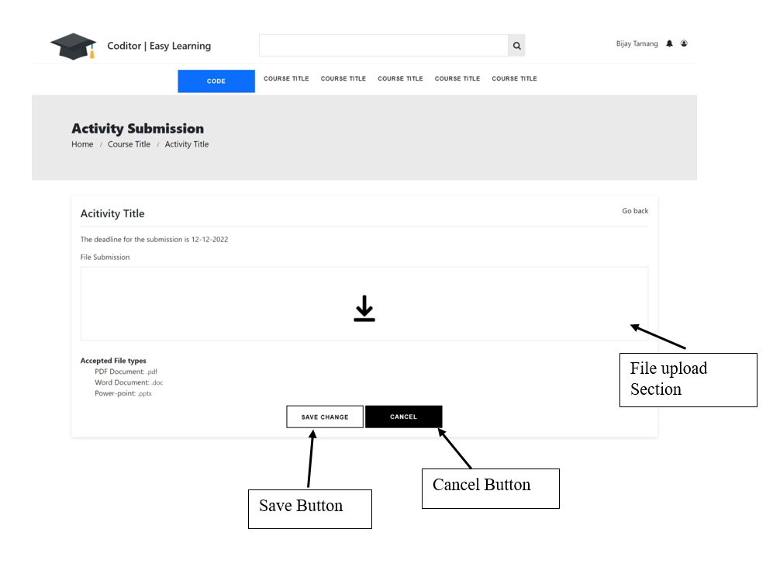
In activity submission page, user can able to submit their activities files. The requirements of submission will be provided in this page. By meeting the submission requirement user can submit their activity files. User will also have the cancel options if any files are been mistaken. while submitting requirements like, maximum file need to fulfill that can upload by users.
Figure 31 Activity Submission Page Interface

4.2.6 User Profile
User information page will be open after clicking my profile by users. In this page, user will be provided the details of their general information’s and their access courses. User will also have the options to edit their general information. They can edit by clicking edit-profile
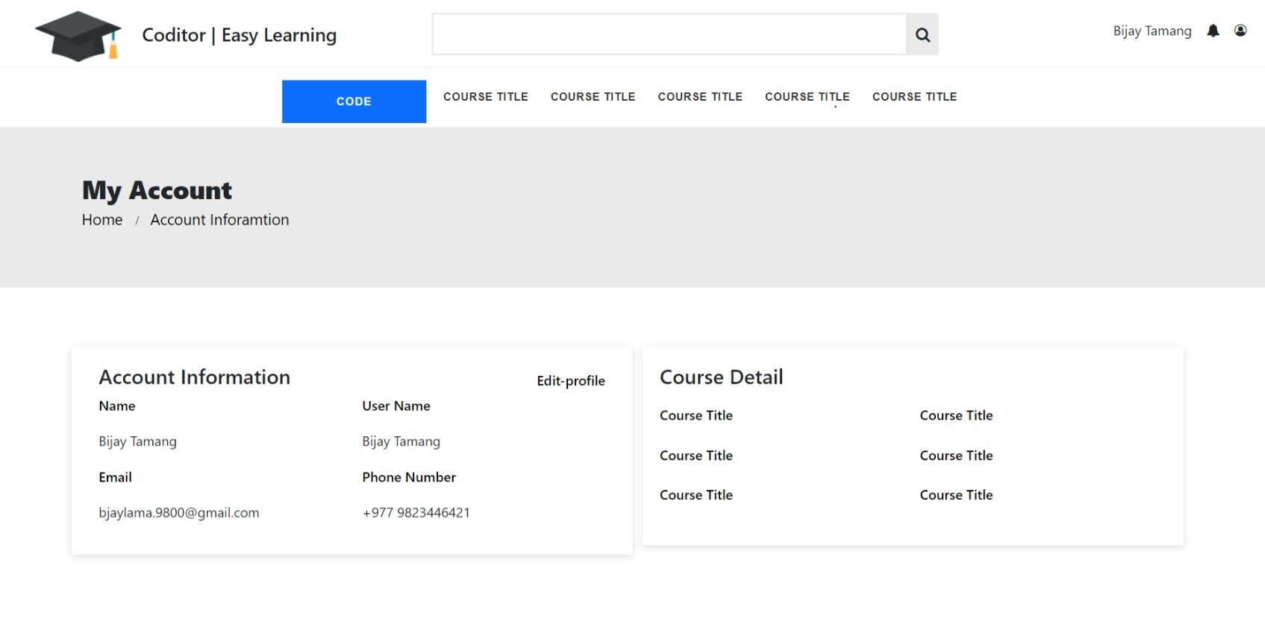
4.2.7 User Registration
Figure 32 User Management Interface
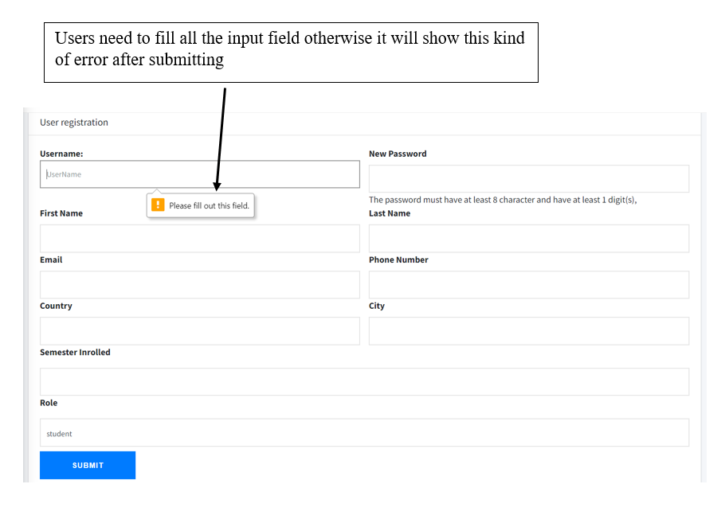
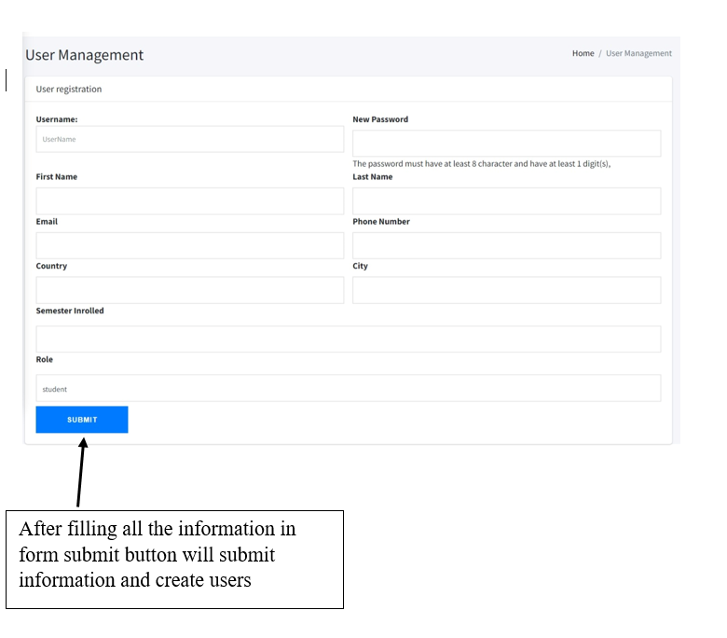
User registration page will have the form for the user’s general information and their username and password to login in the system. To create a user, some of the information are required. So, if any required filled are not filled then form will not submit and user can’t create. After filling all the field, user will be created.
Figure 33 User Registration Page Interface

4.2.8 User Management
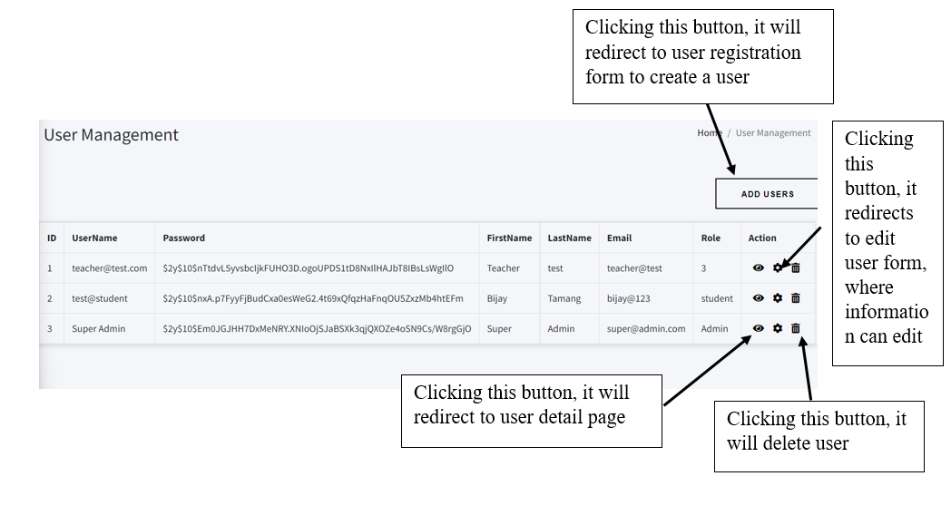
In user management page, system admin and add user, delete user and they can also edit user. By clicking the delete icon system admin get conformation message before deleting the user, and also can edit user by clicking the setting icon.
Figure 34 User Management Interface

4.2.9 Create Management
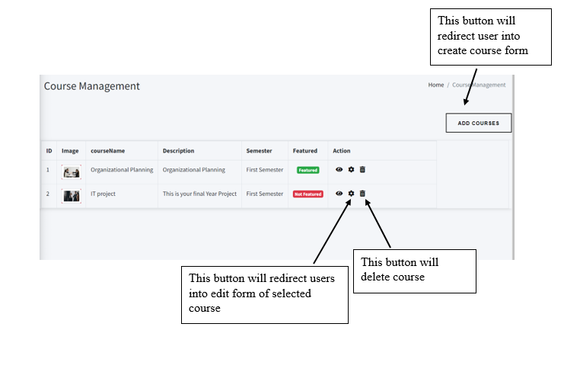
In course page, the created courses will be listed and also there will be a button to edit the course by clicking the edit button, delete the course and view button to see the course. There will be a button also to create a new course.
Figure 35 Course Management Interface

4.2.10 Search Page Interface
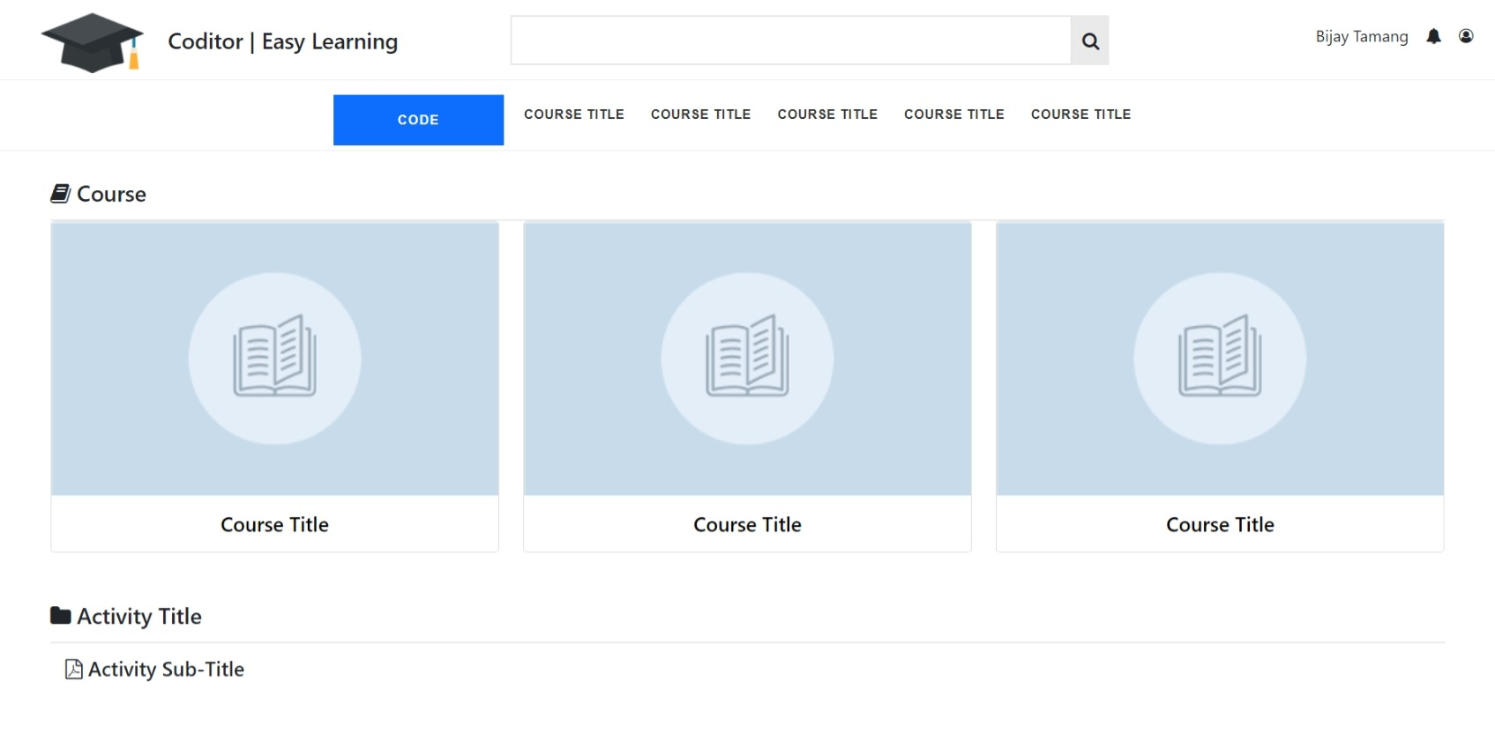
With the help of search, user can search their courses, courses content, activity file etc. using the keyword. For searching, we are using the binary search algorithm, which will show the data related to users enter keyword.
Figure 36 Search Page Interface

4.2.11 Coding Page Interface
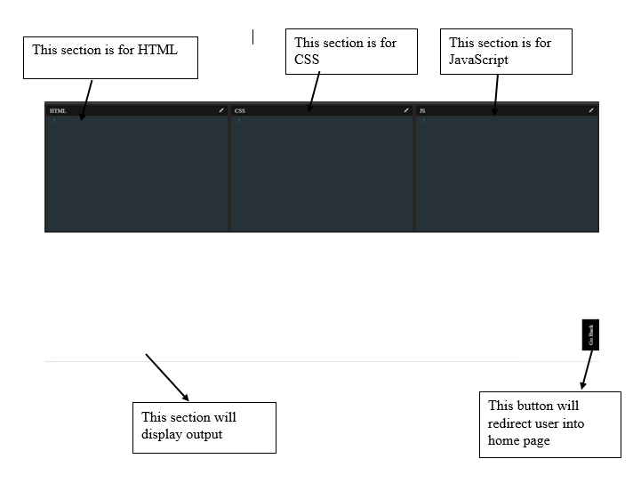
In this page, there are three several coding panel for three different sections. For HTML, CSS and JavaScript. User can code in the panel to get the output in the following sections.
Figure 37 Coding Page Interface

4.3 Conclusion
The above interface met the stated requirement objectives of the previous chapter of the IT project. Every interface is created using a common design principle, such as color consistency and a continuous flow design.

Chapter 5
Testing and Result

5.1 Introduction
Software testing is an important step in ensuring that the software works properly. A few software testing techniques were applied in this project. And this chapter will go over how testing is done. This chapter summarizes the results of the system's testing and implementation.
- Unit testing
Testing separate units or module of the system is unit testing, and it is the most important part of the testing. In the project, there are 11 module using decision table technique to perform unit testing which is login module, search module, create user module, edit user module, create course module, edit course module, create assignment module, edit assignment module, submission module, create content module and edit content module.
The step of the decision table for this project are as follows:
    - Use paper to draw condition and action table.
    - For each test case, to check the different conditions and its action the Boolean status is fill up.
- Component Testing:
Component testing, often known as program or module testing, follows unit testing. In this sort of testing, such test items can be tested individually as components without integrating with other components.

- User Acceptance Testing:
User Acceptance Testing is a type of testing performed by the user. Users are asked to use the complete system and are given a form to provide comments and suggestions in order to better understand the user's satisfaction.

5.2 Decision Module

5.2.1 Login Module
Table 2 Login Module Decision Table
Condition | Case
Condition | 1 | 2 | 3 | 4 | 5 | 6 | 7 | 8
Username Validation | F | T | F | T | T | F | T | T
Password Validation | F | F | T | T | F | T | F | T
Button Click | F | F | F | F | T | T | T | T
Action | Case
Action | 1 | 2 | 3 | 4 | 5 | 6 | 7 | 8
Redirect to Profile page | F | F | F | F | F | F | F | T
Display “These credentials do not match our records.” | F | F | F | F | T | T | T | F

5.2.2 Search Module
Condition | Case
Condition | 1 | 2 | 3 | 4 | 5
Keyword length = 0 | F | T | F | T | F
Keyword length > 0 | F | F | T | F | T
Button Click | F | F | F | T | T
Action | Case
Action | 1 | 2 | 3 | 4 | 5
Redirect to Search page | F | F | F | F | T
Failed To search | F | F | F | F | F
Redirect to same page | F | F | F | T | F
Table 3 Search Module Decision Table

5.2.3 Create User Module
Condition | Case
Condition | 1 | 2 | 3 | 4 | 5 | 6 | 7
User Name | F | F | F | T | T | T | T
Password | F | F | F | F | T | T | T
First Name | F | F | F | T | T | T | T
Last Name | F | F | F | F | T | T | T
Email | F | F | T | T | T | T | T
Semester Enrolled | F | F | T | F | T | T | F
Role | F | F | T | F | T | T | T
Button Click | F | T | T | T | F | T | T
Action | Case
Action | 1 | 2 | 3 | 4 | 5 | 6 | 7
Create New User | F | F | F | F | F | T | T
Display “Validation error” | F | T | T | T | F | F | F
Table 4 Create User page decision table

5.2.4 Edit User Module
Condition | Case
Condition | 1 | 2 | 3 | 4 | 5 | 6 | 7
User Name | F | F | F | T | T | T | T
Password | F | F | F | F | T | T | T
First Name | F | F | F | T | T | T | T
Last Name | F | F | F | F | T | T | T
Email | F | F | T | T | T | T | T
Semester Enrolled | F | F | T | F | T | T | F
Role | F | F | T | F | T | T | T
Button Click | F | T | T | T | F | T | T
Action | Case
Action | 1 | 2 | 3 | 4 | 5 | 6 | 7
Update User Information | F | F | F | F | F | T | T
Display “Validation error” | F | T | T | T | F | F | F
Table 5 Edit User Module Decision Table

5.2.5 Create Course module
Condition | Case
Condition | 1 | 2 | 3 | 4 | 5 | 6
Image type = jpg, png, jpeg | F | F | T | F | T | T
Image type = gif, svg | F | T | F | F | F | F
Course Name | F | T | T | T | T | T
Semester | F | T | T | F | T | T
Display Featured | F | T | T | T | T | F
Description | F | T | T | T | T | F
Button Click | F | T | T | T | F | T
Action | Case
Action | 1 | 2 | 3 | 4 | 5 | 6
Create New Course | F | F | T | F | F | F
Display “Validation error” | F | T | F | T | F | T
Table 6 Create Course Module Decision Table

5.2.6 Edit Course Module
Condition | Case
Condition | 1 | 2 | 3 | 4 | 5 | 6
Image type = jpg, png, jpeg | F | F | T | T | F | T
Image type = gif, svg | F | T | F | F | F | F
Course Name | F | T | T | T | T | T
Semester | F | T | T | T | F | T
Display Featured | F | T | T | T | T | F
Description | F | T | T | T | T | F
Button Click | F | T | T | F | T | T
Action | Case
Action | 1 | 2 | 3 | 4 | 5 | 6
Update Course | F | F | T | F | F | F
Display “Validation error” | F | T | F | T | F | T
Table 7 Edit Course Module Decision Table

5.2.7 Create Assignment Module
Condition | Case
Condition | 1 | 2 | 3 | 4 | 5 | 6
Assignment Name | F | T | T | T | T | T
Course | F | F | T | T | T | T
Semester | F | F | T | T | T | F
Deadline | F | F | T | T | T | F
Display Featured | F | F | T | T | F | F
File Type = word, pptx, pdf, xlsx | F | F | T | F | F | T
File Type = html, ai, psd | F | F | F | T | F | F
Button Click | F | T | T | T | T | T
Action | Case
Action | 1 | 2 | 3 | 4 | 5 | 6
Create New Assignment | F | F | T | F | F | F
Display “Validation error” | F | T | F | T | T | T
Table 8 Create Assignment Module Decision Table

5.2.8 Edit Assignment Module
Condition | Case
Condition | 1 | 2 | 3 | 4 | 5 | 6
Assignment Name | F | T | T | T | T | T
Course | F | F | T | T | T | T
Semester | F | F | T | F | T | T
Deadline | F | F | T | F | T | T
Display Featured | F | F | T | F | T | T
File Type = word, pptx, pdf, xlsx | F | F | F | T | T | F
File Type = html, ai, psd | F | F | T | F | F | T
Button Click | F | T | T | T | T | T
Action | Case
Action | 1 | 2 | 3 | 4 | 5 | 6
Update Assignment | F | F |  | F | T | F
Display “Validation error” | F | T |  | T | F | T
Table 9 Edit Submission Module Decision Table

5.2.9 Submission Module
Condition | Case
Condition | 1 |  | 2 | 3 | 4 | 5
Recent Time =< Deadline | T |  | F | T | T | F
Recent Time > Deadline | F |  | T | F | F | T
File type = word, pptx, pdf, xlsx | F |  | T | T | F | F
File Type = html, ai, psd | F |  | F | F | T | F
Button Click | T |  | T | T | F | F
Action |  | Case
Action | 1 |  | 2 | 3 | 4 | 5
Assignment Submitted | F |  | F | T | F | F
Display “Validation error” | T |  | T | F | T | F
Table 10 Submission Module Decision Table

5.2.10 Create Content Module
Condition | Case
Condition | 1 | 2 | 3 | 4 | 5 | 6
Content Name | F | T | T | T | T | T
Course | F | F | T | T | F | T
Semester | F | F | T | T | F | F
File Type = word, pptx, pdf, xlsx | F | F | T | F | T | T
File Type = html, ai, psd | F | F | F | T | F | F
Button Click | F | T | T | T | T | T
Action | Case
Action | 1 | 2 | 3 | 4 | 5 | 6
Create New Content | F | F | T | F | F | F
Display “Validation error” | F | T | F | T | T | T
Table 11 Create Content Module Decision Table

5.2.11 Edit Content Module
Condition | Case
Condition | 1 | 2 | 3 | 4 | 5 | 6
Content Name | F | T | T | T | T | T
Course | F | F | F | T | T | T
Semester | F | F | F | F | T | T
File Type = word, pptx, pdf, xlsx | F | F | T | T | F | T
File Type = html, ai, psd | F | F | F | F | T | F
Button Click | F | T | T | T | T | T
Action | Case
Action | 1 | 2 | 3 | 4 | 5 | 6
Update Content | F | F | F | F | F | T
Display “Validation error” | F | T | T | T | T | F
Table 12 Edit Content Module Decision Table

5.3 Component Testing

5.3.1 Login Module
User will navigate into the home page of the system if user is logged in into the system. And if user is not logged in into the system user will redirect to the login page. User need to enter their username and password, if the enter credentials are not corrected user will get error message. And if user enter correct credentials user will redirect into their profile page.

5.3.2 Search Module
This Module will help users to search contents that are in system. To use the search module, user need to enter some keyword and need to click search button or click enter that will redirect users into search page, if user enter the button without filling any keyword user will be in same page.

5.3.3 User Create Module
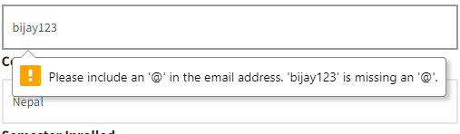
Creating a user is the system administrator role. While creating a user, system administrator need to fill all the required input fields, if all the given required inputs fields are not fill it will show a validation error and while filling the data user need fill correct types of data in input fill otherwise it will also show a validation error. For, example in input filed of email, user enter the data without @ in it, it will throw validation error.
Figure 38 Input type error

5.3.4 User Edit Module
While Updating user, system will display all the previous data that are store in system in their respected field. If user leave any field empty it will show validation otherwise user information can edit and update easily. It will also check the Input filed type and enter data also if any filed contain other types of data it will show validation error same as shown in user create module.

5.3.5 Create Assignment Module
While creating an assignment, user need to fill all the input field to create an assignment. In this module, it has a input file type which only support limited extension files like: doc, docx, xls, pdf, ppt, pptx, xlsx and it also has check the file size and if the uploaded file size are greater than the limtations it will display the validation error. All the input fields are correclty fill and all conditions are meet it will create assignment.

5.3.6 Assignment Edit Module
While updating an assignment all the conditions are same as assignment create module. It will also throw the validation error if any input fileds are empty or insert wrong input types data.

5.3.7 Course Create Module
While creating a course, it has also the requirements same as assignment module but while assignment module has a file input, course module has a input image type and some of the few imgaes extensions can be upload like: jpeg,png,jpg. If any other imgaes are uploaded it will display the validations error.

5.3.8 Course Edit Module
While updating the course detail, it contains the same requirement as the course create module and it will also dipslay the error if any of the inputs fileds are submitt empty and it also the image types.

5.3.9 Submiison Module
In this module, user have a timelimit to submit their assignment. If users are failed to submiited it in the given time, user will not be able to submit after the deadline meet. Assignment also support only some types of files like word file, pdf file, ppt file If user try to upload other than this types of file it will show the validation error on file type. After submitting user can see their submission status on the assignments pages.

5.3.10 Content Create Module
Conent Create Module also has the same requirement as the assignment module. It contain its name, which course, it descriptions and file. While creating a content, user need fill all this information and user need to upload the supported file that are supported by the system. Uploading a file that are not supported by the system will throw the validation error. If all the informations are fill correctly. Conten will be created.

5.3.11 Content Edit Module
Content Edit module also has the same type of requirement as content create module but in edit module user can see the details that are insert while creating the content. If user delete any data any try to submit empty it will show a validation error, and if any information are not change it will save the data as given in the field.

5.4 User Acceptance Testing:
For the user acceptance testing, students having different levels of skills on coding are select and let responder to use the system and give the suggestions or comment about the system. The target responder will be beginner in coding, intermediate and well learned in the coding field.

5.4.1 Process of Acceptance Testing
- Preparing
  - To check the program operation flow is working correctly, different conditions are created and tested it action. After creating different conditions and testing, the decision table is build.
- Planning
  - Prepare questionnaire from using the open-ended question and close ended questions.
- Follow up
  - Analysis all the gathered information and generate analysis report.

5.4.2 Analysis of Gathered Informations
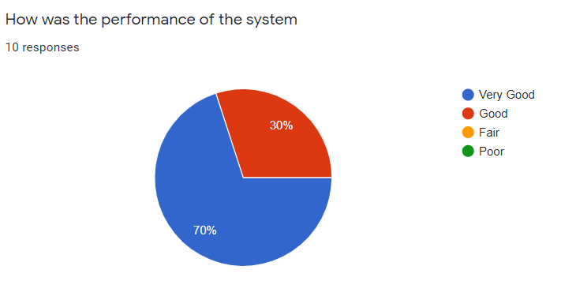
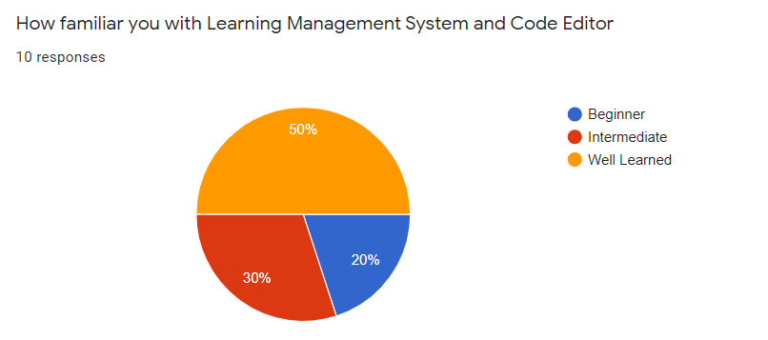
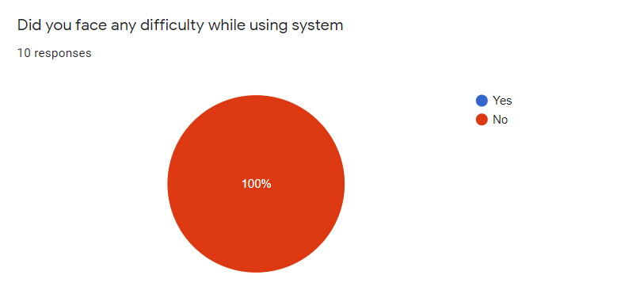
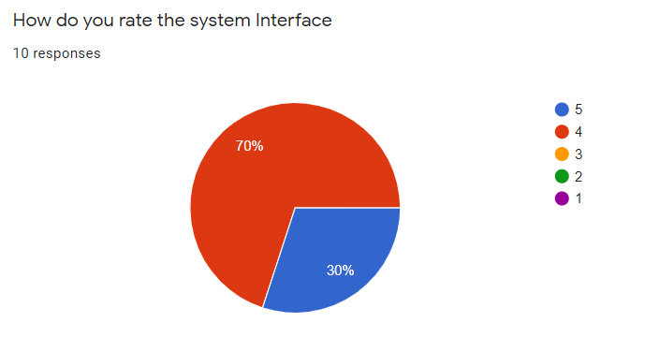

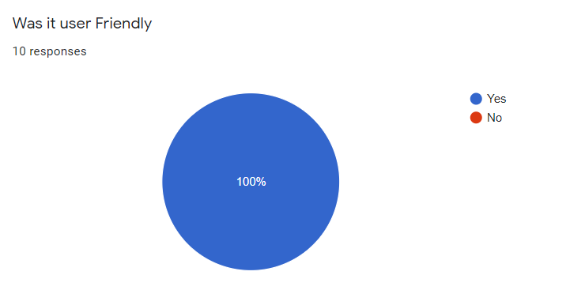

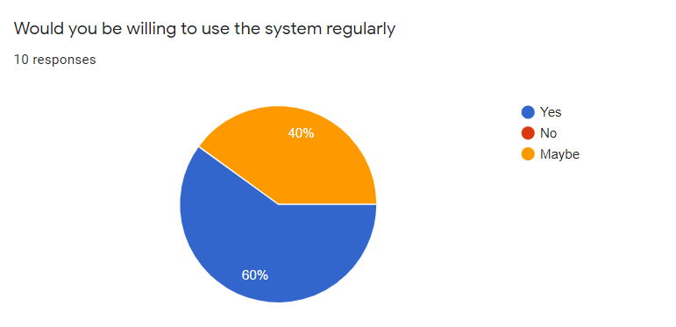
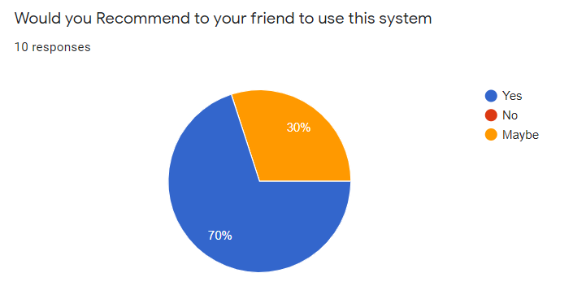

5.4.3 Summary of gathered information
Attribute/Rating | Poor | Fair | Good | Very Good | Percentage
Performance | 0 | 0 | 3 | 7 | 30% | 70%
Interface | 0 | 0 | 3 | 7 | 30% | 70%
User Friendly | 0 | 0 | 0 | 10 | 0 | 100%
Total | 0 | 0 | 6 | 24
Percentage | 0% | 0% | 20% | 80%
Table 13 Summary table of gathered information

Form the table analyzed information, 20% responder rate is good and 80% responder rate is very good. While 100% responder doesn’t face any difficulty while using the system according to the graph. And overall responder were satisfied with the system and some responder give suggestions to add more functionality to the system in the future.

5.5 Conclusion
To conclude, for the testing phase four different types of testing are implements to ensure that the system meets the document's stated objectives. The decision table is the first type of testing used to check that the system's data and process flow are correct. And the second testing is component testing, which is used to check the usability of individual component and the third testing is user acceptance testing which is used to gathered the system review by the responder.

Chapter 6
Conclusion

6.1 Introduction:
In order to improve the software, its need to go through the maintenance and evolution phase. To improve the system quality and prevent the future risk, the process of correcting the problems that occurs in testing phases will help. Overall, the system meets the stated objective and requirement.

6.2 Challenges
There are several challenges are raised during the development process and they are:
- Documentation process:
Many grammatical errors on documentation occurs, while creating a reports due to the lack of English proficiency. And to overcome this error, double checking the documentation is the solution.

- Testing process:
Since the system can have different types of users, users need to correct role permission to access the system features. So, every functionality need to check through the user different roles.

- Implementation process:
Lack of proper knowledge on how to integrate the editor and compiler in the learning management system that will be access able in the single system. Proper research helps to solve those challenges.

6.3 Advantages of the system
- It doesn't require any additional software to run. It can run on a web server if domain name is provided. To use this program, you must have access to the internet.
- The systems can run any device which have access to internet.
- To use Learning management system and a compiler for the HTML, CSS and JavaScript user does not need to access two different sites.

6.4 Disadvantage of the system
- The system is only accessible while user is connected to the internet.
- User cannot register themselves. User need to create by the system administrator and after creating by the system administrator they user can access to the system.
- Only have a compiler for the HTML, CSS and JavaScript.

6.5 Future Development
- Implementing a more compiler for different languages in the system.
- Adding different features on learning management system like chat system to communicate teachers and students directly in the system.
- Improving the user experience to make more interactive system for users.

6.6 Conclusion
This system allow user to use user learning management system and compiler in a single platform. To ensure that all the requirements are met, testing is carried out to guarantee that. This system may not be the best system compare to other similar system but it helps to understand the process how the real systems are developed.

Reference
Adzharuddin, N. (2013). Learning Management System (LMS) among University Students: Does It Work? International Journal of E-Education, e-Business, e-Management and e-Learning, April. https://doi.org/10.7763/ijeeee.2013.v3.233
Bootstrap https://getbootstrap.com/docs/5.0/getting-started/introduction/. (n.d.). https://getbootstrap.com/docs/5.0/getting-started/introduction/
Cavus, N., Uzunboylu, H., & Ibrahim, D. (2006). The Effectiveness of Using Learning Management Systems and Collaborative Tool in Web-Based Teaching of Programming Languages. Online Submission, Iseece, 23–25.
Chandru, T. K., Dinesh Kumar, M., Karthikeyan, S., & Saranya, K. (2019). Interactive coding platform for students. International Journal of Recent Technology and Engineering, 7(4), 295–299.
Code Pen. (n.d.). https://codepen.io/about
Css tricks (https://css-tricks.com/). (n.d.). https://css-tricks.com/
Definition of “E-learning.” (n.d.). https://economictimes.indiatimes.com/definition/e-learning
Demertzi, E., Voukelatos, N., Papagerasimou, Y., & Drigas, A. (2018). Online learning facilities to support coding and robotics courses for youth. International Journal of Engineering Pedagogy, 8(3), 69–80. https://doi.org/10.3991/ijep.v8i3.8044
Dutta, M., Sethi, K. K., & Khatri, A. (2014). Web Based Integrated Development Environment. 10, 56–60.
Gaurav Kumar. (2012). Impact of Agile Methodology on Software Development. Computer and Information Science, 8(2). https://doi.org/10.5539/cis.v8n2p9
Hamaniuk, V., Semerikov, S., & Shramko, Y. (2020). ICHTML 2020-How learning technology wins coronavirus Introduction: from social distancing to distant learning. 0001, 1–22. https://doi.org/10.1051/
Ramu, G. (2018). IARE-BuildIT Tool : A Case Study of an Online Platform Approach to Improve Coding Skills. 13(6), 4464–4470.
Simanullang, N. H. S., & Rajagukguk, J. (2020). Learning Management System (LMS) Based on Moodle to Improve Students Learning Activity. Journal of Physics: Conference Series, 1462(1). https://doi.org/10.1088/1742-6596/1462/1/012067
W3 schools (https://www.w3schools.com/cssref/css_selectors.asp). (n.d.). https://www.w3schools.com/cssref/css_selectors.asp
What is Programming Platform. (n.d.). https://www.igi-global.com/dictionary/mobile-applications-programming-platforms-development/23789
Zinovieva, I. S., Artemchuk, V. O., Iatsyshyn, A. V., Popov, O. O., Kovach, V. O., Iatsyshyn, A. V., Romanenko, Y. O., & Radchenko, O. V. (2021). The use of online coding platforms as additional distance tools in programming education. Journal of Physics: Conference Series, 1840(1). https://doi.org/10.1088/1742-6596/1840/1/012029

