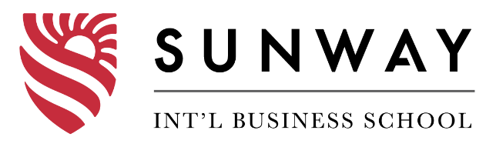

Programme Name: BCS
Course Code: (MDIA 1100)
Course Name: Fundamental of Multimedia
Assignment No. 2
Date of Submission: 2022-01-05

Submitted By: Submitted To:
Student Name: Bijay Tamang Faculty Name: Suman Koirala
IUKL ID: 04190190007 Department: P.O.
Semester: 6th
Intake: 2019 March

Introduction:
A logo is a word and image-based symbol that identifies a company. A good logo communicates a company's mission and objectives. The goal of logo design is to create the ideal visual brand symbol for a company. A logo usually consists of a symbol or brandmark, a logotype, and a tagline, depending on the type. The first modern logo designs appeared in the early 1900s, as mass printing became more common.
Main objectives of the assignment are as follows:
- To learn about logos and its types
- To learn about branding and brand identity
- To learn about designing tools
Task 1
- Logo
Logo means a graphic representation or symbol of a corporate name, trademark, abbreviation, or other symbol, generally made in a unique way for quick recognition.

- Describe the types of logo and discuss about its use i.e. which type of logo are suitable in different situations.
Answer:
The different types of logos are as follow:
- Lettermarks
A lettermark is a typography-based logo made out of a few letters, usually the initials of a company. The lettermark is all about keeping things simple. Lettermark logos are helpful at streamlining any company brand if it has a long name by using only a few letters. For example, how much easier is it to pronounce HBO than the Home Box Office
- Wordmarks (or logotypes)
A wordmark or logotype, like a lettermark, is a font-based logo that concentrates solely on a company's name. Consider the companies Visa and Coca-Cola. When a company has a short and distinct name, wordmark logos function exceptionally effectively. Google’s logo is a great example of this. Because the name is snappy and memorable, the logo, when combined with good typography, aids in brand identification.
- Pictorial marks (or logo symbols)
A graphic-based logo or icon is known as a pictorial mark (also known as a brand mark or logo sign). You probably think of the iconic Apple logo, the Twitter bird, or the Target bullseye when you hear the word "logo." Each of these companies' logos and brands are so well-known that simply viewing the emblem is enough to recognize them.
- Abstract logo marks
An abstract mark is a specific type of pictorial logo. Rather than a recognized image like an apple or a bird, it's an abstract geometric form that represents your brand. Just a few examples include the BP starburst logo, the Pepsi divided circle, and the stripy Adidas flower.
- Mascots
Logos with an illustrated character are known as mascot logos. The mascot logo is an excellent way to create your own business spokesperson. It's frequently colorful, occasionally illustrated, and always entertaining. Famous mascots include the, KFC’s Colonel and Planter’s Mr. Peanut.
- The combination mark
A combination mark is a logo that combines a combined wordmark or lettermark with a pictorial mark, abstract mark, or mascot. The image and text can be placed next to one another, layered on top of one another, or combined to create a single image. Well-known combination mark logos include Doritos, Burger King, and Lacoste, to name a few.
- The emblem
Badges, seals, and crests are examples of emblem logos, which consist of typography inside a symbol or image. These logos have a traditional look to them that can make a big impression, so they're a popular choice for many schools, companies, and government institutions.

- Discuss about the characteristics of a good logo design.
Answer:
Characteristics of good logo are as follows:
- Simple
Simple logos are the ones that are instantly recognizable. The most memorable logos are those that are the most straightforward.
- Scalable
An excellent logo should be simple enough to be scaled up or down without losing its appearance.
- Memorable / Impactful
A great logo should leave a lasting impact on the viewer. You want to capture your audience's attention and leave a lasting impression (a positive impression, hopefully).
- Versatile
With a great logo, any web device and any sort of print medium should look great.
- Relevant
A great logo should be appropriate to your company's needs. It has to be relevant to the work you're doing.
Task 2:
- Determine the requirement of the organization
Introduction and requirement
Great logo tells the rest of the world what you stand for, helps people remember your brand, and helps potential customers determine if your product is right for them. Because it focuses on presenting the most significant aspects of a brand's identity with limited resource, a great logo should be straightforward, relevant, and memorable. This includes paying more attention to details like colors and fonts, as well as simplifying concepts.
The company is a business which wants to redesign its logo and the name of the business is tea junction. This business is selling only a tea in this time. A company wants their logo as a combination mark like a Burger king and Taco bell by using a company name and related illustration. As a tea selling business, the logo looks better if it uses the variant colors of tea and the illustration of the tea and as well as the junction illustration, as per the designer view.
Questionaries’
- What best represents the company?
………………………………………………………………………………….
- What kind of a design you want and why?
………………………………………………………………………………….
………………………………………………………………………………….

- Who is your target audience?
………………………………………………………………………………….

- Pick characteristics that best define your brand
………………………………………………………………………………….

- Do you prefer any specific color, font, or theme?
………………………………………………………………………………….

- What are the main propose of your design and its size?
………………………………………………………………………………….

- Which logos resonate with you?
………………………………………………………………………………….

- Delivery Time?
………………………………………………………………………………….

- Do your company use organization standard font in design?
………………………………………………………………………………….
………………………………………………………………………………….
- Do we need to had the tagline in the LOGO as well?
………………………………………………………………………………….
………………………………………………………………………………….

- Critical Analysis
Tea Junction is a tea shop who only provide the tea to the customer. Tea Junction need the logo with the combination logo because it’s a new company and people will not recognize if it’s only a pictorial. They want to use their company name on their logo because its most common things that user will remember because now a day most of the people will meet their friends on their junctions. And the main theme and concept of logo is to sell a tea for a group of friends, that define same as their company name and its logo.

- Mind Map
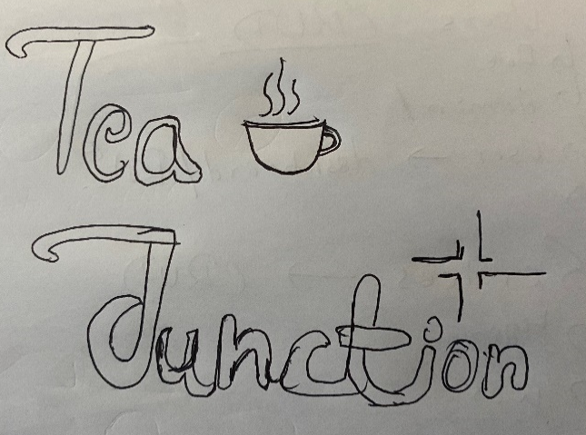
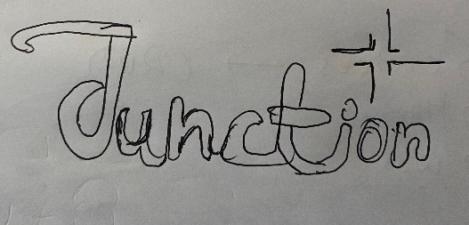
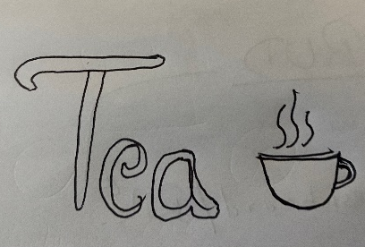
On the basis of requirement, logo needs to be associate with text and image. So, this logo will be a combination mark logo. Client came up with the reference of Burger King, Taco bell, and Dove

- Logo Design
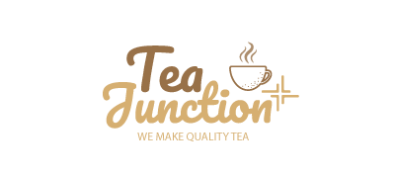
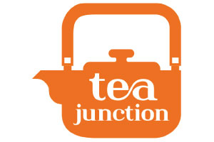
Figure New logo for Tea Junction
Figure old logo from tea junction

- Feed Back
- Did the logo satisfy the customer needs?
…………………………………………………………………..

- Was it Delivered on time?
…………………………………………………………………..

- Was the logo meet the given requirement if yes/no why?
…………………………………………………………………..

- What was the response of the target audience?
…………………………………………………………………..

- Discussion

The main motive of our assignments is to learn what kind of problem is face on the real world organization and the logo design process and how it works. Research have been done in different types of logo which will be suitable in different size and situation. By gathering all the information by providing the questionnaires to the client and with the help of questionnaires answer, the mind map was created. And with the help of the mapping the design of logo is completed. And provided to the client for the feedback of the design. If any update required on design it will be done and deploy to the client.
The logo designed by me is simple and completely represent the company and its objective. By Combination mark type the logo match the company objectives and its logo properly defines the company. It’s a simple and effective logo to use any dimensional banner or a flex.

- Conclusion
To conclude, in this assignment I designed simple and attentive logo for the tea junction by collecting the information and requirement of an organization through various process. After collecting the information and requirement, I create a mind map and design some sample for the logo and improvise it in the logo making software. By completing the logo design it was deployed to client.

Questionaries’
What best represents the company?
A company sells a great quality tea.
What kind of a design you want and why?
I want a logo with a text and the image on it because it’s not a well-known business
Who is your target audience?
Everyone who loves tea.
Pick characteristics that best define your brand
Tea
Do you prefer any specific color, font, or theme?
Its better if use a tea color
What are the main propose of your design and its size?
Main propose of design is that people will remember its name and its size need top flexible
Which logos resonate with you?
A tea selling company.

Delivery Time?
Happy if its delivery under 15 days
Do your company use organization standard font in design?
Yes, we will provide you our brand guide
Do we need to had the tagline in the LOGO as well?
Yes, we need a catchy tagline in our logo.
Feedback
Did the logo satisfy the customer needs?
Yes, it’s satisfy the customer needs and wants

Was it Delivered on time?
Yes, its deliver on time and client was happy

Was the logo meet the given requirement if yes/no why?
Yes, its meet its requirement of a combination marks logo type

