

Programme Name: BCS
Course Code: (MDIA 1100)
Course Name: Fundamental of Multimedia
Assignment No: 1
Date of Submission: 2021-12-26

Submitted By: Submitted To:
Student Name: Bijay Tamang Faculty Name: Suman Koirala
IUKL ID: 041901900007 Department: P.O.
Semester: 6th
Intake: March 2019

There are Five (2) questions in this section. Answer ALL Questions.
Scenario:
A company has approached you to create a banner with their name on it and with a trademark slogan of their own. You are instructed to use only letters and no other graphics for the task. Create a banner following a standard procedure of designing.
Task 1.
- Discuss the importance of text in multimedia presentation.
Answer: In multimedia applications, text is a crucial component. They're the characters that go into making words, phrases, and paragraphs. Text is an excellent medium for conveying basic information. It is the simplest, and often the most successful, method of communicating one's message. Inadequate attention to the presentation and flow of text within a multimedia application might result in the presentation's key point not being communicated.
- Describe fonts and typefaces with examples.
Answer:
Fonts:
A font is a group of characters with a similar appearance. Lowercase and uppercase letters, numbers, punctuation marks, and symbols are among the characters.
A change in font can change the appearance and feel of a block of text. Some fonts are intended to be basic and easy to read, while others are intended to give the text a distinct look. Arial, for example, has a clean, modern design, but Palatino has an older, more traditional style.

Typeface:
A typeface is a collection of similar-looking characters. Letters, numbers, punctuation marks, and symbols are among the characters. Arial, Helvetica, Times, and Verdana are some of the most popular typefaces. There are thousands of typefaces available, despite the fact that most computers only come with a few installed. Typefaces may be scaled quite large and yet seem sharp since they are vector-based (rather than bitmaps). The term "typeface" is frequently mistaken with "font," which refers to a typeface's size and style. Arial, for example, is a typeface and Arial 10 pt (point) bold is a font. It's a minor distinction, but it's useful to be aware of.
- Critically analyses the use of fonts in web.
Answer: People use web fonts for a variety of purposes, one of which is to maintain consistent branding across multiple mediums. Web fonts are scalable and high-DPI friendly, which means they can be displayed on any device, including PCs, tablets, and mobile phones, regardless of resolution.
Use of font in web are as follows:
- To Grab the viewer’s attention:
People's attention spans are rapidly dwindling, and they are now only a few seconds long. In this time of turbulence, brands must get the attention of their target customers. As a result, graphic designers utilize typography to grab the viewer's attention right away.
- To Make text reader-friendly:
The use of careful typography guarantees that visitors can easily browse the material on an online page. A poor font choice might make the presentation hard and unclear for the audience.
- To Builds Recognition
Brand recognition is crucial for businesses to wear down competition. In graphic style, the fonts are the visuals that concentrate on customers or guests detain memory for a protracted time. it's these visuals that facilitate a business build recognition amongst its customers.

- Discuss about font editing and design tools
Answer: These days, there are thousands of commercial and free fonts available on the internet. When we can't discover exactly what we're looking for, however, making our own typeface may be the best option, and we'll have to design and change our own fictional font for a logo, banner, template, and so on.
Use of font editing and design tools are as follows:
- Can be used to make a font that is unique to you.
- A variety of typefaces can be made.
- To develop a unique symbol and use it throughout the text.
Adobe Illustrator used for editing and creating fonts are as follows:
- Text tool: Text is the most basic typographic tool as well. It's used for typing on a single line. The outline scaling in the text tool is dynamic.
- Text box tool: The text box tool is a commonly neglected tool for typing in a specific region. The text never extends beyond the box, and the text is frequently resized dynamically.
- Kerning: Kerning refers to the space between letters. With the shortcut alt + left / right arrow, Illustrator has kerning built in.
- Distort and Warp: Warp and distort text to fill a shape with text. Text can be distorted to resemble a shape.
- Special characters and glyphs: Many typefaces include a variety of alternate characters. These characters generally have flourishes or garlands to make them look like handwriting.

2
- Prepare a set of questionnaires for the client in order to know the requirements such as objective of design, color use, font type, font style, size, deadline of submission.
Answer:
A set of questionnaires for the client are as follows:
    - What kind of design you want?
    - Why you need this kind of design?
    - Who is your target audience?
    - What are the main propose of your design and its size?
    - What kind of color we should use in your design?

- Create a mind map.
Answer: According to my imagination:
- There will be a marvel studio logo.
- There will be a movie name and also there will be a minimal objects supporting our main subjects
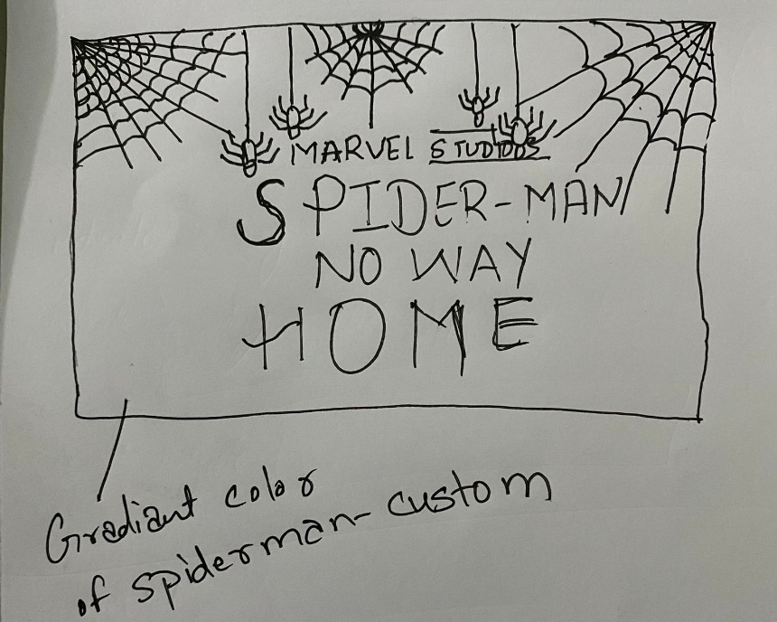
- We are mainly focus on text because it’s for promotions of movie in social media platform, so we are using colors that are available in the character or character suits

- Use any of the available tool to design.
Answer: To design the banner we are using a software adobe illustration and its tools:
- Text tool: Use to write the text in a line.
- Text Box tool: Use to write a ‘Movie name’
- Move Tool: Used to move the picture, text and shapes.
- Transform: Use to scale word, picture and shapes.
- Color tool: Use to give a proper color to text, design
- Magic Wand tool: Use to select the shape for filling color.

- Justify the design according to the need and requirement of the client
Answer:
