**BEFORE STARTING THE GAME**

Open the index.html in the editor and in the <a href> element type the FULL PATH of that index file (change the existing one)

# **STARTING THE GAME**

Since the this version of Connect Four was written in JavaScript programming language there is no compiling because JavaScript is not compiled language but interpreted which means it executes directly, translating each statement into a sequence of one or more subroutines and then into another language which our browser understands.

The only thing for starting this game is to go into the folder called “Game” and open index.html file.

Opening that file, it will switch you to your internet browser were the start page (picture 1.) will be opened and waiting after loading for the click on the button in the progress bar.

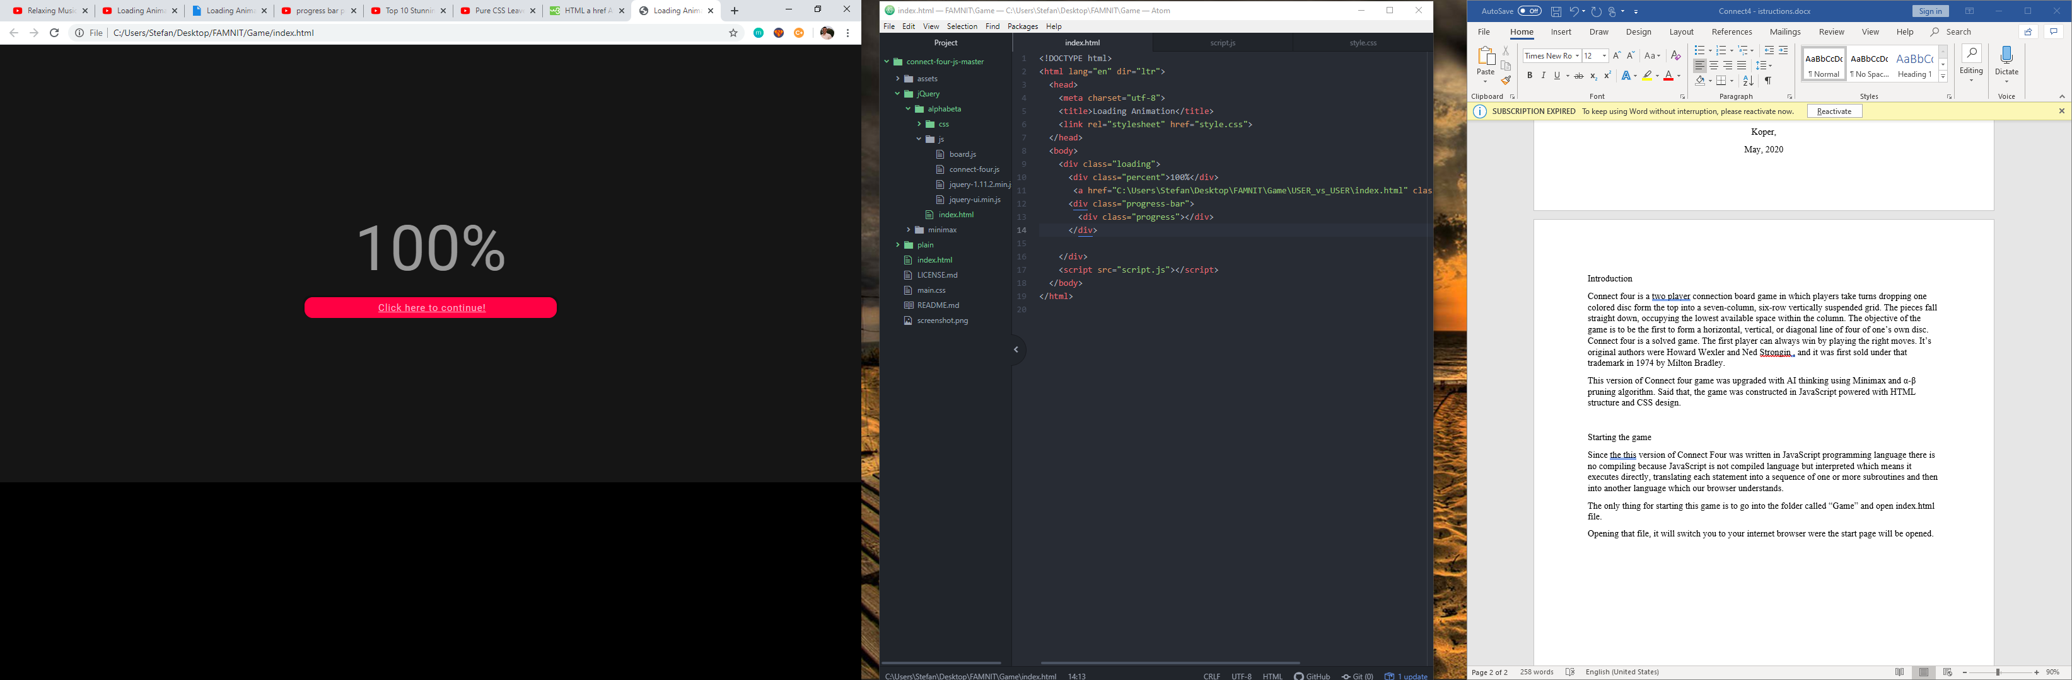

Picture 1. Start page

## USER vs USER

Next, it will open the actual interface of the game (Picture 2.) starting with User vs User mode of the game.

Two users, both yellow and red player, can click on the board, and with each click one of the colored discs will fall down into selected column. On the right side, right next to the board game there is a stat board which is tracking number of moves for both of the players and the total moves in the game. Besides stats, there is a drop down menu, with modes of games (User vs User, User vs AI, AI vs AI).

And on the bottom there is a status bar that has 4 states:

* Running… - indicating that the current game is not over yet
* Yellow player won – indicating that yellow player with the yellow discs won
* Red player won – indicating that red player with the red discs won
* Tie – indicating that there was a draw

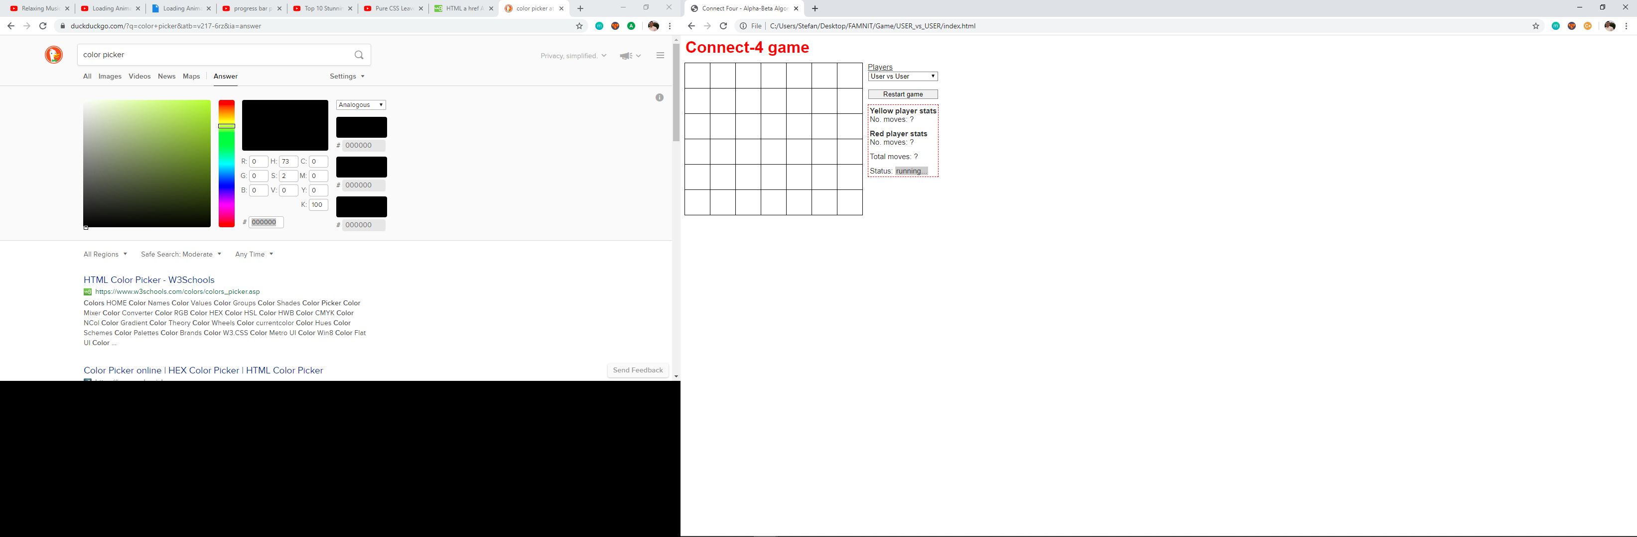

Picture 2. User vs User interface

## USER vs AI

Moving on to the next mode of the game, User vs AI. This mode has 2 options with AI, in term that we can select between two search algorithms, Minimax (Picture 3.) and α-β pruning(Picture 4.), along with the depth od search states indicating how far are we wanting to search through.

The user starts the game first, and AI uses the time to think(to search as many iterations) and then plays. All of the stats are written right next to the board, for user and AI player, number of moves, column which AI chose, time for the move and how many iteration did it went through.

Reset button, resets the game board and the statistics.

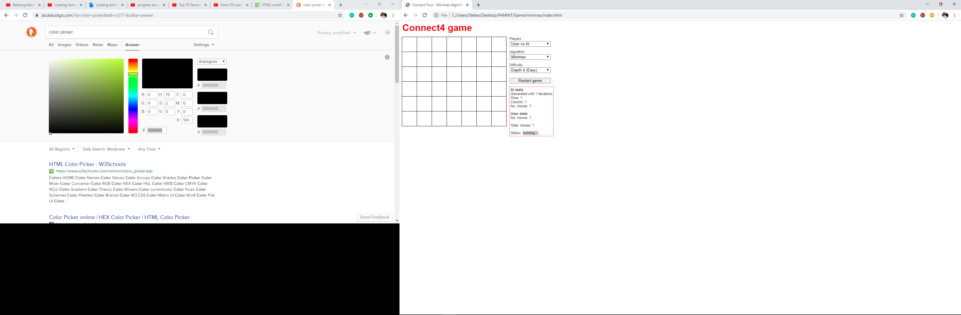

Picture 3. User vs AI (miniax algorithm) interface

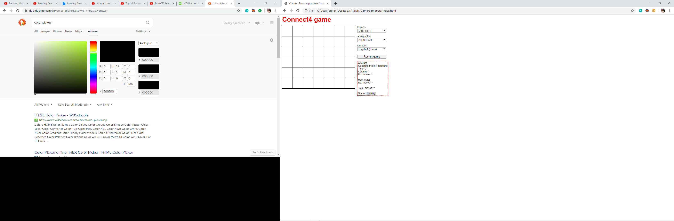

Picture 4. User vs AI (alpha-beta pruning) interface

## AI vs AI

The final part of the game is the AI vs AI mode. When this mode is chosen, just by clicking once on the board with the mouse the game begins and at the end when all the iterations are then, the massage is displayed which AI player won. Both of them run on the same algorithm that can be chosen in the menu on the right and also the difficulty level of both AI.

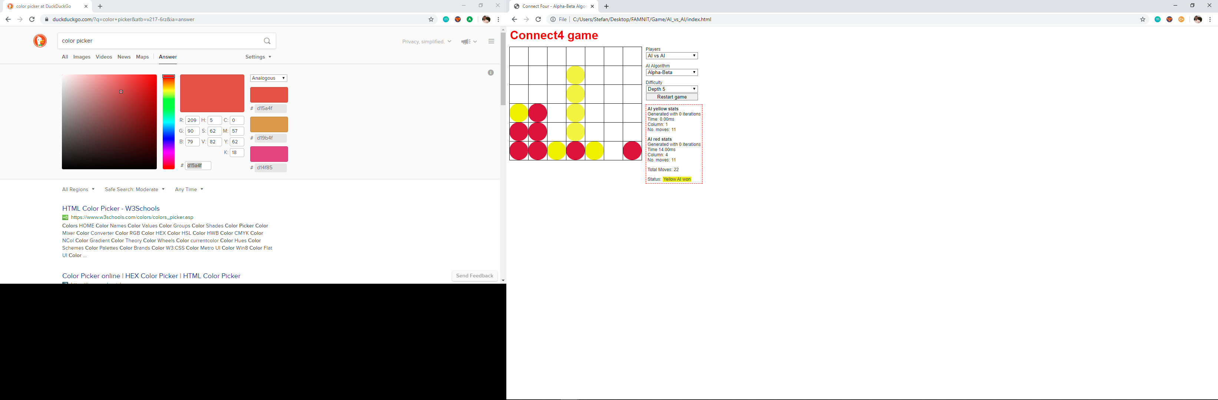

Picture 5. AI vs AI interface