ProOceanus CO2PRO-ATM Atmospheric data processing

**Thanos Gkritzalis, VLIZ**

**2022-09-30**

# Introduction

Scope of this document is to evaluate the quality of the atmospheric xCO2 data from the CO2PRO-ATM sensor that is deployed on the BE-FOS -Thornton Buoy.

# Setup

The data presented here cover the period from 21st of March 2022 until 29 September 2022.

The sensor itself (i.e. the NDIR) is in the CO2PRO-ATM housing, which is deployed on the instrument sensors frame of the buoy. The frame itself is submerged at approx. 0.5 m depth.

The atmospheric intake box, which is provide by ProOceanus is located inside the buoy cabinet (see phot below).

Position of the ATM intake box. When at sea, the door cabinet is closed. The intake box is approx. 2.5 m above the sea surface

The sensor is operating every 4 hours and first takes a seawater sample for 5 min, followed by an atmospheric measurement. Each sample (seawater and atmospheric) is the average of 20 measurements taken at 1 Hz. The atmospheric intake box does have some a water droplet filter and a humidity trap, however these take only a small fraction of the water content that is in the air sample. The system is also equipped with hydrophobic filters before the NDIR as well as humidity, pressure and temperature sensors (also before the NDIR). The system is set to perform a zero every 24 hrs. The zero is a bypass loop via a CO2 absorbent, in our case Ascarite.

# Data from 2022

The system has been successfully deployed in the past 6 years, but with significant periods with gaps in the data, because of a nr of technical issues (either with the mooring, buoy or sensor).

The data that will be presented here are from the current deployment and start n March 2022 until end of September 2022.

The atmospheric xCO2 data from the buoy will be compared against xCO2 data from the ICOS ATM Weybourne station (ICOS ATC NRT CO2 growing time series, Weybourne (10.0 m); <https://meta.icos-cp.eu/objects/3L1Mxp2R0JL_VdshynB7Ojlt>).

The BE-FOS-Thornton Buoy data can be found in <https://meta.icos-cp.eu/objects/m2diDryJTuAoIZBmN4IYYtk4> (note: xCO2 is not available) but also in <https://rshiny.lifewatch.be/buoy-data/>

The location of the 2 stations is presented in the following picture.

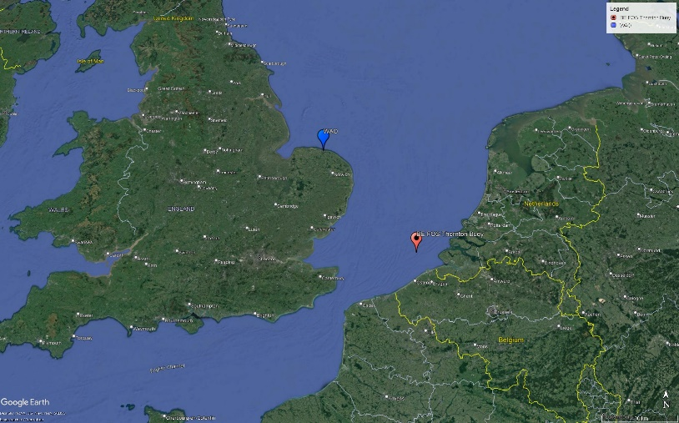

Both stations have received the ICOS label and data are available on the ICOS CP. The graphs presented below are with NRT (L1) data from both stations.

Figure 1: xCO2 data from WAO and Thornton. WAO data are dried xCO2 molar rations. Thornton data are xCO2 data as produced by the sensor (i.e. non dry molar fraction).

**Assumption:** Data from WAO station are considered as the “benchmark” and “True” xCO2 concentration for the wider area.

The graph shows a significant difference between the 2 stations, which can be related to a nr of reasons. Not all of them can be identified and resolved. However the xCO2 Thornton data can be “dried” by taking into account the humidity data. The equation that can be applied is:

$$x{CO}_{2_dry}=\frac{{xCO}_{2_wet}}{\left(1-\frac{P_{H2O}}{P_{TOT}}\right)}$$

Where:

xCO2_dry : “Dry” molar fraction of xCO2

xCO2_wet : xCO2 fraction as produced by the sensor

PH2O : Humidity pressure as reported by the sensor (mbar)

PTOT : Total Pressure measured in the gas stream/NDIR, reported by the sensor (mbar).

The following figure presents the data after this initial correction.

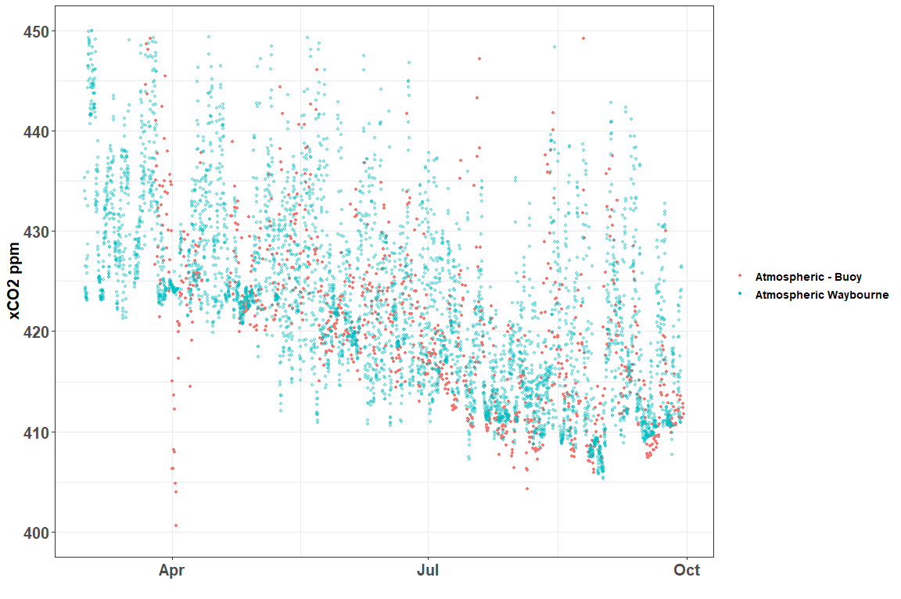

Figure 2: xCO2 from the 2 stations but this time Thornton data have been "dried".

From Fig.2, one can assume that the water content in the buoy atmospheric data is the main contributor to the difference shown in Fig 1. One also needs to acknowledge that the water correction approach used here is very basic. A more thorough analysis of the data and potential introduction of other parameters (e.g. measurements of atmospheric RH, atmospheric pressure, …) might produce a different picture.