**STORY 01 – SHOW TASKS**

As a user

I can retrieve all tasks

So that I can see what I have left to do

**MOCKUP**

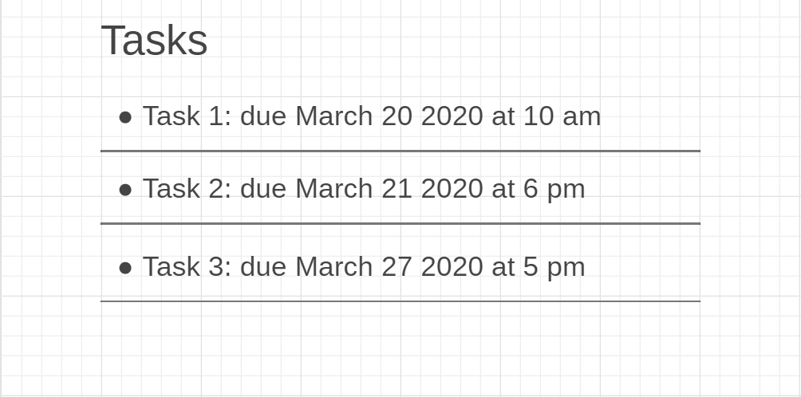

**ACCEPTANCE CRITERIA**

* You will see the list of tasks. For every task the title and due date are shown.
* If there are no tasks, you will see the message “No tasks left to do”.

**TECHNICAL CRITERIA**

* The path of this view is “/tasks”.