**STORY 02 – SHOW TASK DETAIL**

As a user

Given the id of a task

I can retrieve the detail of a task

So that I can see all its values

**MOCKUP**

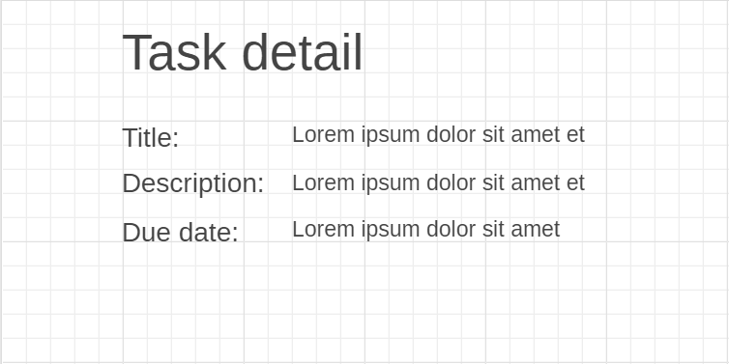

**ACCEPTANCE CRITERIA**

* You will see the detail of the task. For every task the title, description and due date are shown.
* If the task for the id could not be found, you will be shown an error message “Task not found”.

**TECHNICAL CRITERIA**

* The path of this view is “/tasks/{id}”.