**STORY 02 – CREATE TASK**

As a user

I can create a new task

So that I can see it in the task overview

**MOCKUP**

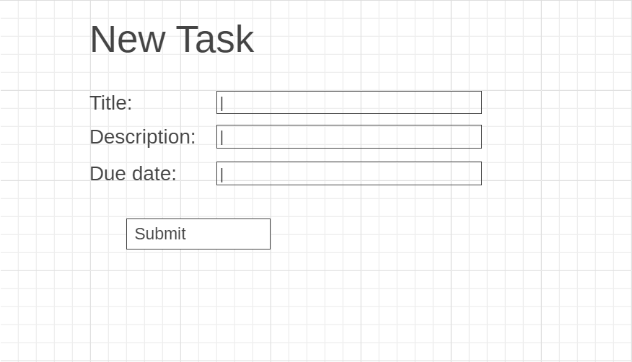

**ACCEPTANCE CRITERIA**

* You will see a form to create a new task, with fields for title, description and due date, and a button to submit the form.
* When the task is successfully created, you will be redirected to the task list where you can see the new task.

**TECHNICAL CRITERIA**

* The path of this view is “/tasks/new”.