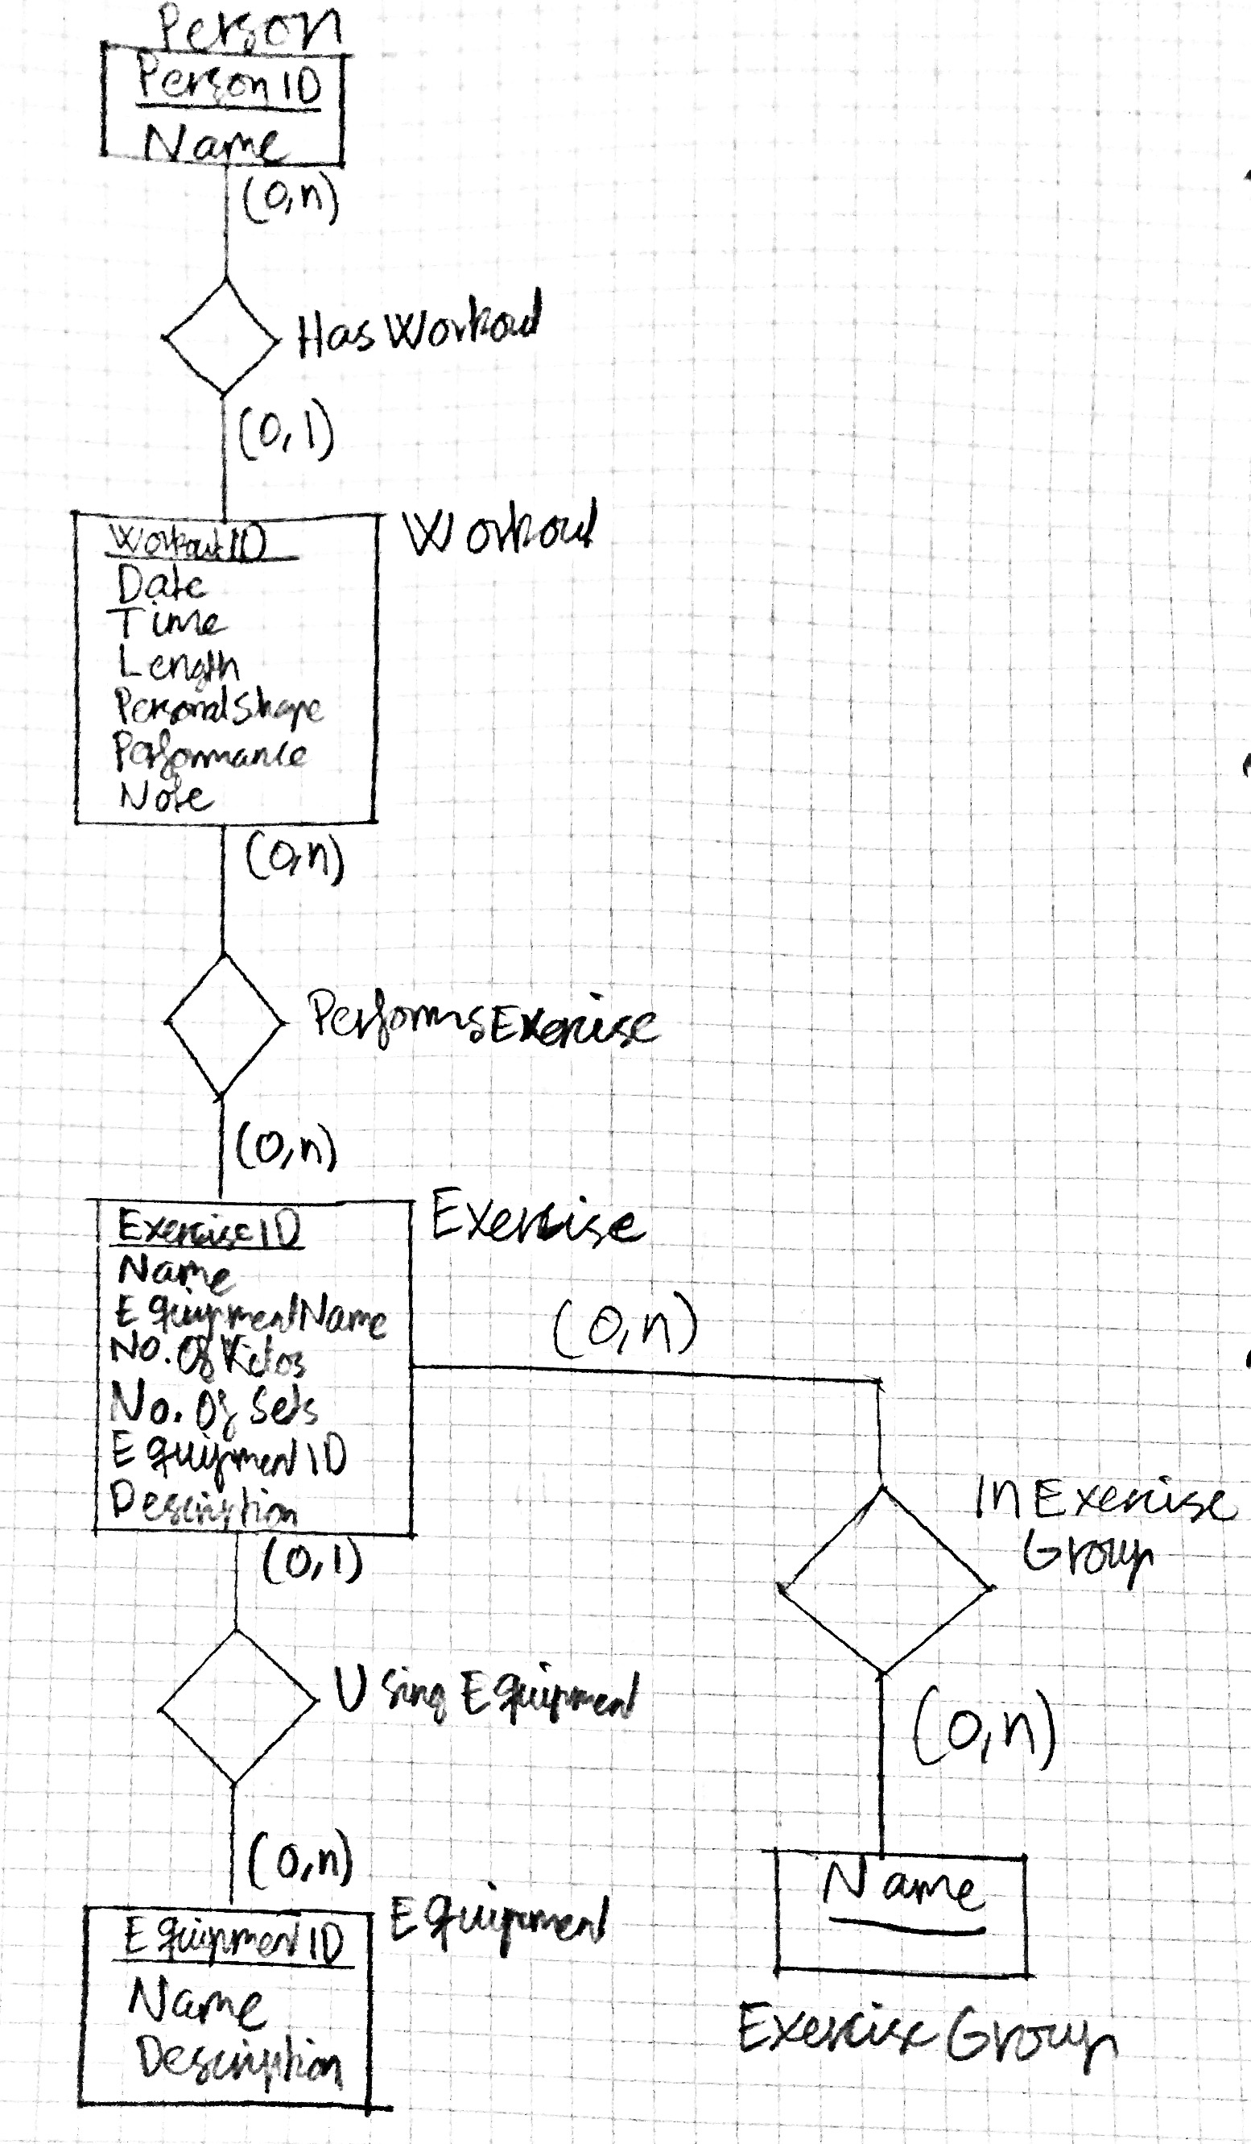**ER-model**

**Relational Schema**

*Strong entity relationships*

**Person**(PersonID, Name)

**Workout**(WorkoutID, Date, Time, Length, PersonalShape, Performance, Note)

**Exercise**(ExerciseID, Name, EquipmentName, # of kilos, # of sets, EquipmentID, Description)

EquipmentID fkey referencing EquipmentID in Equipment. Can be NULL.

**Equipment**(EquipmentID, Name, Description)

**ExerciseGroups**(Name)

*Binary N:M relationships*

**PerformsExercise**(WorkoutID, ExerciseID)

WorkoutID is fkey referencing WorkoutID in Workout

ExerciseID is fkey referencing ExerciseID in Exercise

**InExerciseGroup**(ExerciseID, Name)

ExerciseID is fkey referencing ExerciseID in Exercise

Name is fkey referencing Name in ExerciseGroups