

Problem Set 2 Write-Up
Financial Econometrics 2
Submitted to: Prof. Andreas Fuster
January 20, 2026

Björn Thomas Hunter Jivung
PhD Candidate, Swiss Finance Institute
University of Geneva
Github Link to Project Code
Introduction:
This project studies how households update beliefs about flood risk by analyzing the dynamic response of flood-insurance take-up after a flood event. Using U.S. community-level panel data, the analysis first replicates the event-study design of Gallagher (2014) with a two-way fixed effects framework and then examines the problems of this approach under staggered treatment timing using insights from Baker et al. (2022). To address these issues, the project implements the imputation estimator of Borusyak et al. (2024), following Roth et al. (2023), and compares dynamic and average treatment effects across methods, as well as differences in statistical inference.
Part b)
Figure 1 plots the event-study coefficients from equation (1), estimated with community fixed effects and state-by-year fixed effects; each coefficient summarizes the change in log insurance take-up at relative time r from a flood, normalized to zero in the year before the flood.
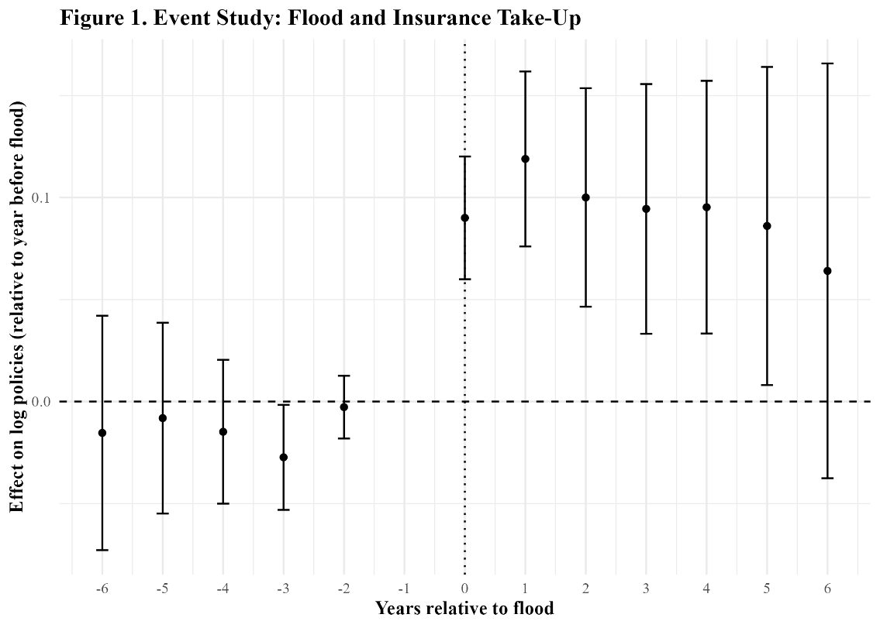
Several judgment calls are required to construct this figure: communities flooded near the start or end of the sample have limited pre- or post-period support, and following common practice in event studies (see Baker et al., 2022, especially Section 5.1), event time is capped at −6 and +6 so that extreme leads and lags—identified from few observations—are binned into endpoint categories rather than driving noisy coefficients. (i) The plotted coefficients should be interpreted as dynamic effects relative to the year before the flood; Figure 1 shows little evidence of systematic pre-trends, a sharp increase in take-up in the flood year, a peak shortly thereafter, and a gradual decline, consistent with the spike-and-decay learning dynamics emphasized by Gallagher (2014). At the same time, as stressed by Baker et al. (2022), under staggered adoption TWFE event-study coefficients can combine multiple underlying comparisons, including those that use already-treated units as controls, so interpretation should be cautious. (ii) Standard errors are clustered at the state level, following Gallagher (2014), to allow for correlated shocks within states, but this choice may be insufficient if correlation is primarily driven by information transmission through media markets that cross state borders; a more conservative alternative would be clustering at the media-market level or using multi-way clustering.
Part c)
Part (c) assesses why the TWFE approach in Part (b) can be misleading under staggered treatment timing by applying the Goodman–Bacon decomposition. Table 1 shows that the overall TWFE estimate (0.1211) is a weighted average of heterogeneous 2×2 comparisons, including treated-versus-never-treated and comparisons across treated cohorts.
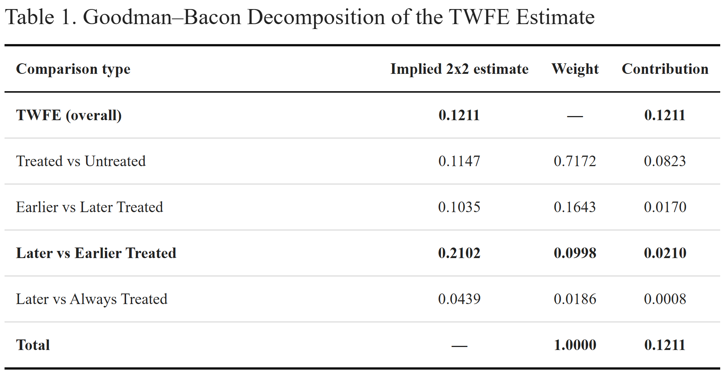
Consistent with Baker et al. (2022), the latter can be problematic when treatment effects are dynamic because already-treated units may serve as controls for later-treated units. In this application, treated-versus-never-treated comparisons receive the majority of the weight (0.717) and imply an effect of 0.1147, but “late-to-early” comparisons receive nontrivial weight (0.0998) and imply an ATT of 0.2102. These late-to-early comparisons contribute 0.0210 to the aggregate estimate, accounting for roughly 17% of the overall TWFE coefficient (0.0210/0.1211). Thus, a meaningful portion of the TWFE estimate is driven by treated-as-control timing comparisons of the type highlighted by the recent staggered-DiD literature, implying that the TWFE estimand reflects a mixture of comparisons rather than a single clean ATT and motivating the use of alternative estimators in Part (d).
Part d)
Part (d) implements the imputation estimator of Borusyak et al. (2024) to address the staggered-adoption concerns highlighted in Part (c). Following the algorithm in the assignment, unit and time effects are estimated using untreated observations only, untreated potential outcomes are imputed for treated observations, and imputed treatment effects are constructed as the difference between observed outcomes and their imputed untreated counterfactuals; dynamic effects are then obtained by regressing these imputed treatment effects on relative-time indicators. Figure 2 plots the resulting imputation-based event-study coefficients, which can be interpreted as the average imputed treatment effect at each event time relative to the year before the flood.
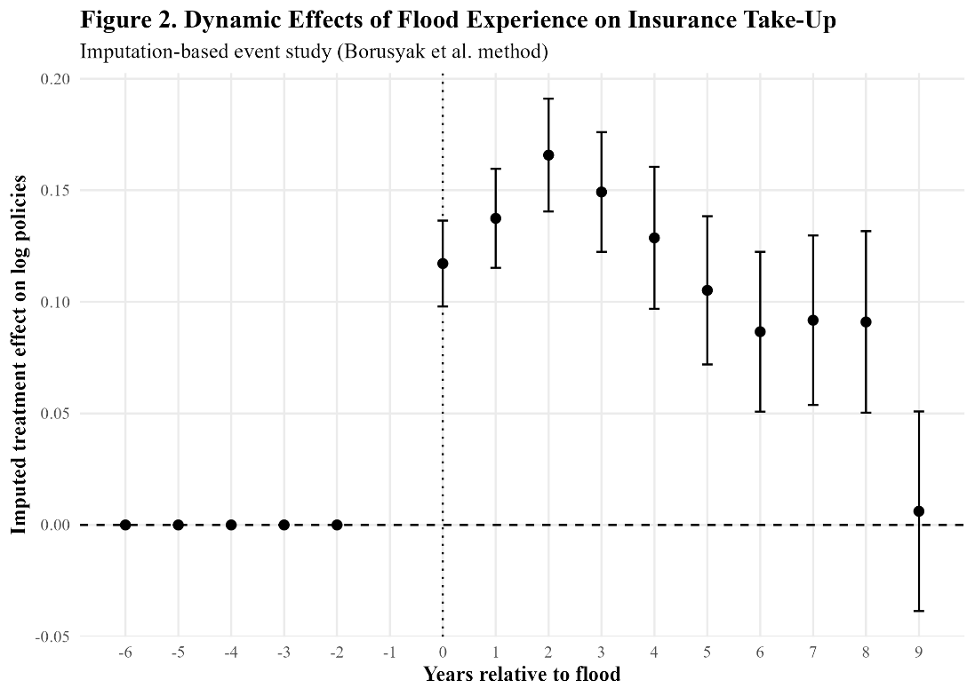
In this implementation, pre-treatment coefficients are (essentially) zero by construction because untreated observations are assigned zero treatment effects, so they should not be interpreted as a conventional pre-trend test. The post-flood path shows a large increase in insurance take-up in the flood year, a peak in the first one to two years after the flood, and a gradual decline thereafter, consistent with the learning-and-salience mechanism emphasized by Gallagher (2014). Unlike the TWFE event study, the imputation approach avoids using already-treated units as controls and therefore delivers a dynamic profile aligned with the ATT-type estimand targeted by the imputation framework (Borusyak et al., 2024; Roth et al., 2023).
Part e)
Part (e) compares the average treatment effect on the treated (ATT) from the manual imputation approach with the estimate produced by the did_imputation package. Table 2 shows that both methods yield the same ATT point estimate (0.0917), confirming that the hand implementation and the package implement the same imputation logic and target the same estimand.
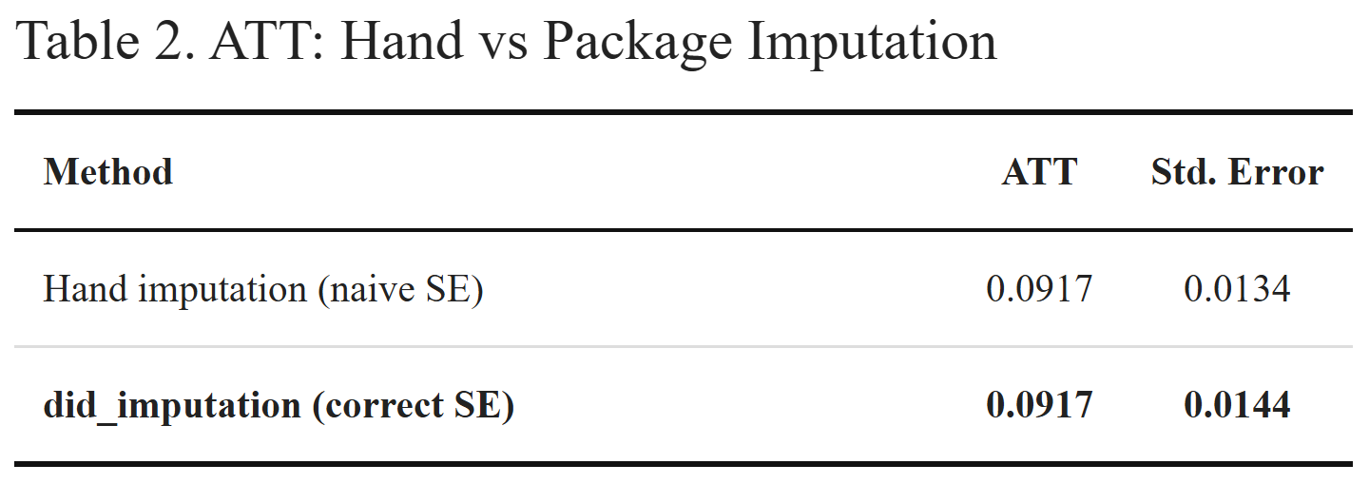
The difference lies in inference: the hand procedure reports a smaller standard error because it treats the imputed components from the untreated-outcome model as fixed and therefore ignores uncertainty from the first-stage estimation and the dependence induced by reusing estimated counterfactuals, whereas the package accounts for the full imputation procedure, as required by Borusyak et al. (2024) and emphasized by Roth et al. (2023). Consequently, the hand standard errors are not valid for formal inference, while the package-based standard errors should be reported. This comparison illustrates the broader point stressed by Baker et al. (2022): addressing staggered-adoption problems requires not only alternative point estimators but also inference procedures consistent with the underlying estimation strategy.

