ypkpathway

Ypkpathway is a software tool for the automated assembly of pathways using the Yeast Pathway Kit.

Installation

Python 2.7 and and the python packages networkx, biopython, pydna, and docutils are required to run ypkpathway. The easiest and most efficient way to install ypkpathway is by first installing the free Anaconda Scientific Python distribution from Continuum analytics. It is a large download, but it installs cleanly in one folder in the users deirectory (regardles of the operating system) and is easily removable if necessary. Anaconda is available for Windows, Mac and Linux.

Anaconda installation
Go to the website of Anaconda at https://store.continuum.io/cshop/anaconda/ (Fig1).

Fig 1

Download Anaconda and follow the installation instructions. Once Anaconda is installed, find and start the Anaconda Command Prompt (see Fig2)
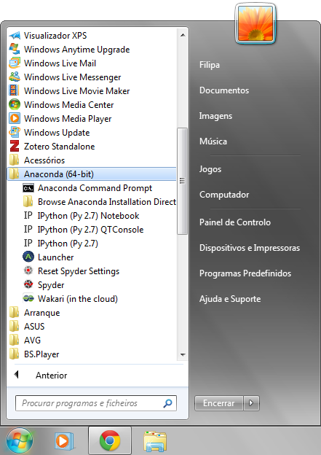Fig 2

The Anaconda Command Prompt starts a terminal window. Write “pip install ypkpathway” at the command prompt (Fig3). This command will download ypkpathway and install it and all dependencies in one go, so make sure you are connected to the internet.
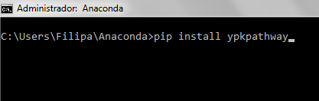Fig 3

The installation process will generate some text output, important is that it ends with “Successfully installed ypkpathway Cleaning up...” (Fig4).

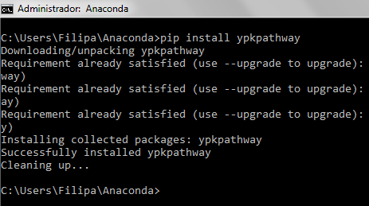Fig 4

Use
Ypkpathway is meant to be used in the terminal. It is most practical to navigate the terminal to where you have the data file that ypkpathway should process. We will assume that the datafile is on the desktop of the computer. Issue the commands in Fig5 (cd .. and cd desktop) to navigate to the Desktop. Be sure to hit return after each command.

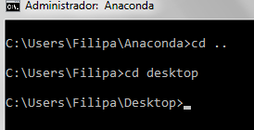Fig 5

The syntax is very simple as ypkpathway takes only one argument whish is the name of the datafile to be processed, in this case four_gene_xylose_pathway1.txt (Fig6).

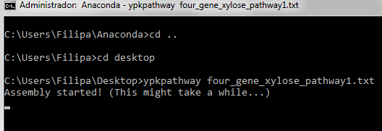Fig 6
The data file can have any name as long as it is a text file containing the sequences to be assembled. See next section “Indata” for proper formatting of this file. The result is a new folder in the same directory called ypk_assembly containing the assembly report.



Indata
The datafile.txt file (which can have a different name) could have the structure depicted in Fig 1.
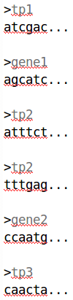Fig 7

The file in Fig1 is simply a list of the Tps and genes that should be assembled. The sequences in Fig 1 are truncated for clarity and could also be given in Genbank format or a mix of FASTA and Genbank formats.
The sequences could be linear fragments (as in the example four_gene_xylose_pathway1.txt file accompanying this document).
The yeast pathway kit was designed for the reuse some of the genetic parts, especially terminator-promoter plasmids, pYPKa_Z_XXX and pYPKa_E_XX. Once cloned, Terminator-promoter plasmids can be reused for other pathways, in which case they do not need to be constructed again.
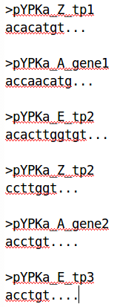Fig 8

We can supply sequences in the form of pYPKa_Z, pYPKa_A or pYPKa_E clones, typically from a previous assembly experiment. These will be recognized by the ypkpathway algorithm and the assembly report will indicate that these were given.

They could be or pYPK0_tp_gene_tp sequences. These sequences can be given to indicate that they already exist and are not to be assembled. In the same way we can supply pYPK0_tp_gene_tp sequences (Fig3), in which the pYPKa vectors needed for their assembly will not needed.

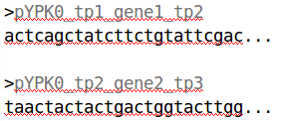Fig 9

Any valid combination of the three kinds of sequences is also permitted (Fig4).

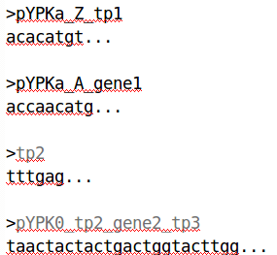Fig 10

In Fig4 we supply two pYPKa sequences, one for the tp1 and one for the gene1. The tp2 was never cloned before, so it is supplied as a linear sequence.
The pYPK0_tp2_gene2_tp3 vector was made in a previous experiment and is also given.

Output
Use the test data file “four_gene_xylose_pathway1.txt” in this manner:
C:>ypkpathway four_gene_xylose_pathway1.txt
followed by return. The ypkpathway program creates a folder in the current working directory (the directory from which ypkpathway was called). The folder is called “ypk_assembly”.

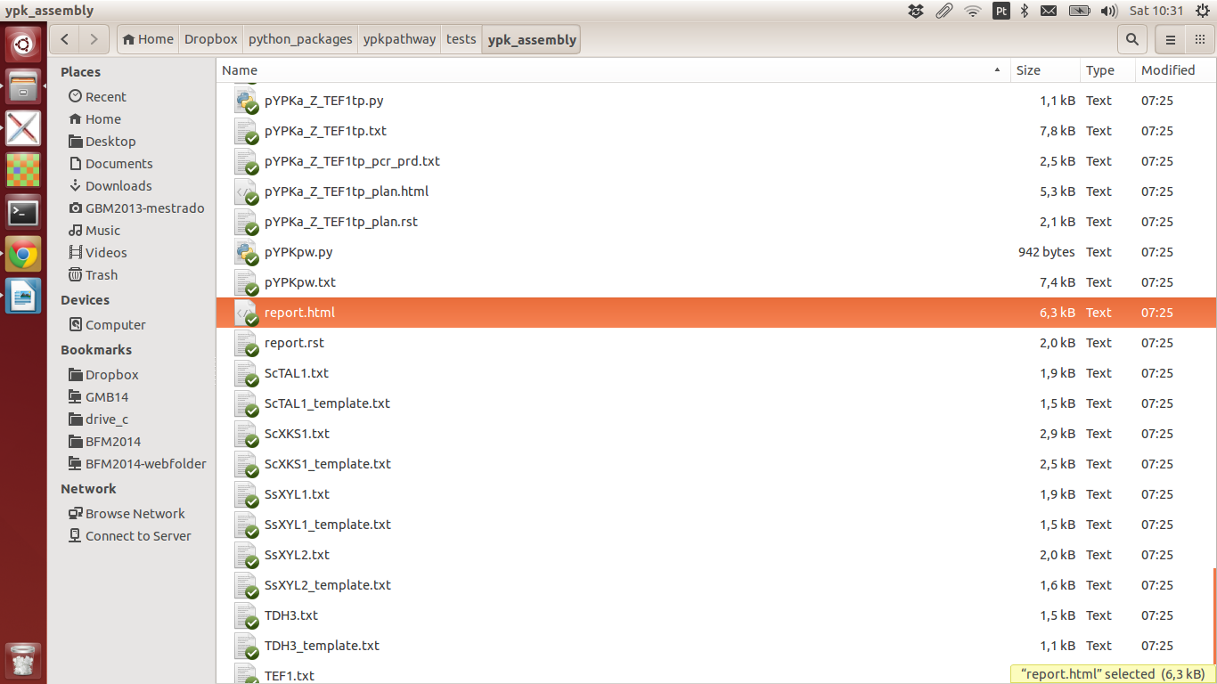Fig 11

Open this folder and open the file “report.html” in your web browser (Fig5). You should now have a web page in your browser looking like Fig 6.

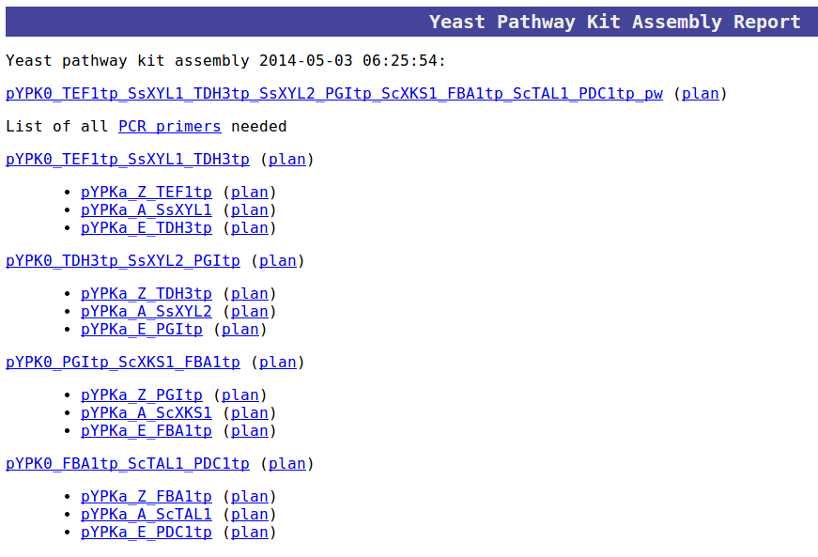
Fig 12:
1
2
3
4

Clicking on the first link “pYPK0_TEF1tp_SsXYL1_TDH3tp_SsXYL2_PGItp_ScXKS1_FBA1tp_ScTAL1_PDC1tp_pw”
(Fig6-1) will display the final sequence of the pathway in the browser, a 14800 bp sequence in this case (Fig7).
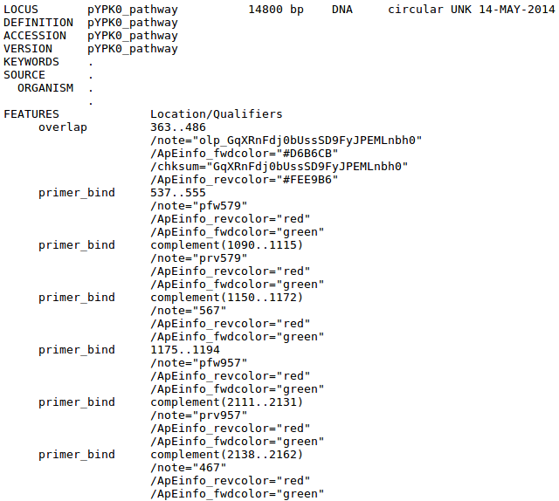Fig 13

The “(plan)” link (Fig6-2) displays a small representation of how the final sequence was assembled (Fig8). This image shows how four PCR fragments were assembled from PCR products derived from pYPK0 tp_gene_tp clones and linearized pYPKpw sequence to form the final circular construct.

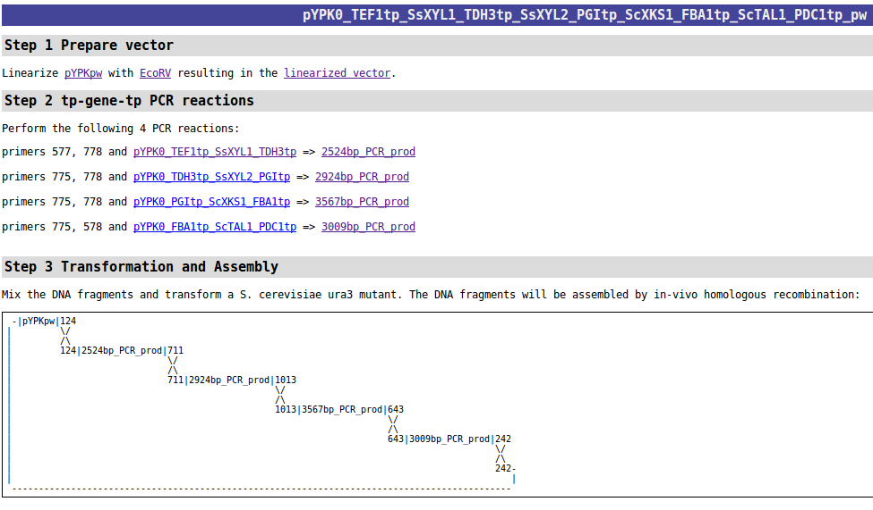Fig 14

The second “(plan)” link (Fig6-3) show a plan for the construction of the first pYPK0_tp_gene_tp clone. These clones are assembled from three pYPKa derived pcr products for each element and and linearized pYPKpw (Fig9).

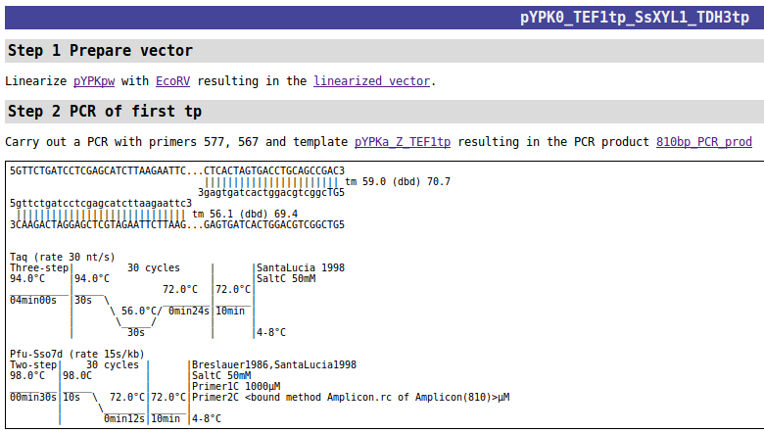Fig 15
The last “(plan)” link (Fig6-4) show a plan for the construction of the first pYPKa clone (Fig10). These clones are made from pYPKa vectors linearized with ZraI, AjiI or EcoRV and a linear PCR product.

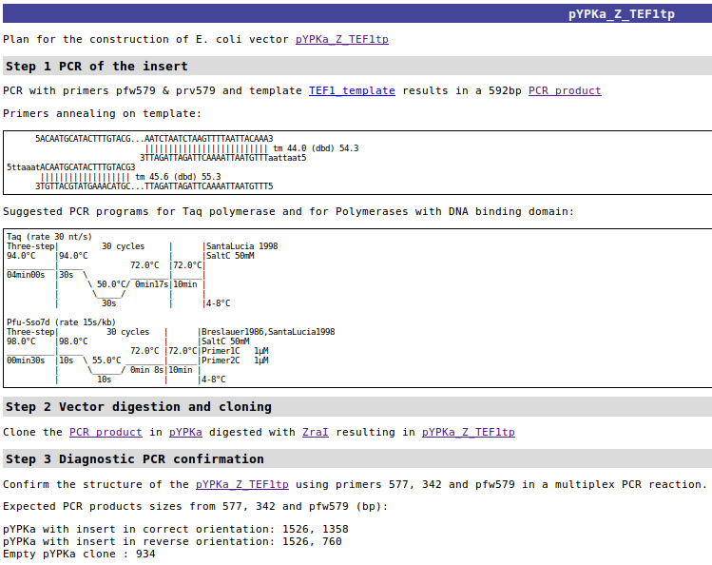Fig 16

