NetworkGT Toolbox
Version 0.1
by Björn Nyberg^{1*}

Department of Earth Sciences, University of Bergen, P.O. Box 7803, 5020 Bergen, Norway.¹
^{Contact: bjorn.nyberg@uib.no}
Contents

1.0 Background 1
1.1 License 2
2.0 Installation 2
2.1 ArcGIS Installation 2
2.2 Python Installation 2
2.3 NetworkGT Toolbox Installation 4
3.0 Workflow 4
1.0 Sampling Strategies 4
2.0 Geometrical Analysis 4
3.0 Topological Analysis 4
4.0 Spatial Visualization 4
4.0 Contact Information & Feedback 5

Background

The NetworkGT (Network Geometry and Typology) Toolbox is a set of tools designed for the geometrical and topological analysis of fracture networks in ArcGIS 10.4 >.

1.1 License

The scripts used in this program are written in the Python programming language under a GNU General Public License V3 which states:

“This program is free software: you can redistribute it and/or modify
it under the terms of the GNU General Public License as published by
the Free Software Foundation, either version 3 of the License, or
(at your option) any later version.

This program is distributed in the hope that it will be useful,
but WITHOUT ANY WARRANTY; without even the implied warranty of
MERCHANTABILITY or FITNESS FOR A PARTICULAR PURPOSE. See the
GNU General Public License for more details.

You should have received a copy of the GNU General Public License
along with this program. If not, see <http://www.gnu.org/licenses/>.”

Installation

ArcGIS Installation

Install ArcGIS by running the installation setup file (setup.exe)

Python Installation

    - Python module installation

The toolset utilizes a set of scientific third-party modules that are typically not available in a standard ArcGIS installation:
To install these modules requires admin rights and the following procedure.
- Unzip the NetworkGT.zip into a permanent working directory that has read/write capabilities.
- Navigate to the Install folder of your working directory (step 1) and find the file Install.py → right click → Edit with IDLE.
- Press F5 to run the file and wait until a message ‘Finished’ is returned

NetworkGT Toolbox Installation

- Unzip the NetworkGT.zip file (step 2.2.1) and keep a note of the working directory
- Open ArcMap
- Find the ArcToolbox by navigating to the tabs Geoprocessing → ArcToolbox
- Right click the ArcToolbox icon →Add Toolbox and navigate to the NetworkGT.tbx file in your working directory (Step 1.).
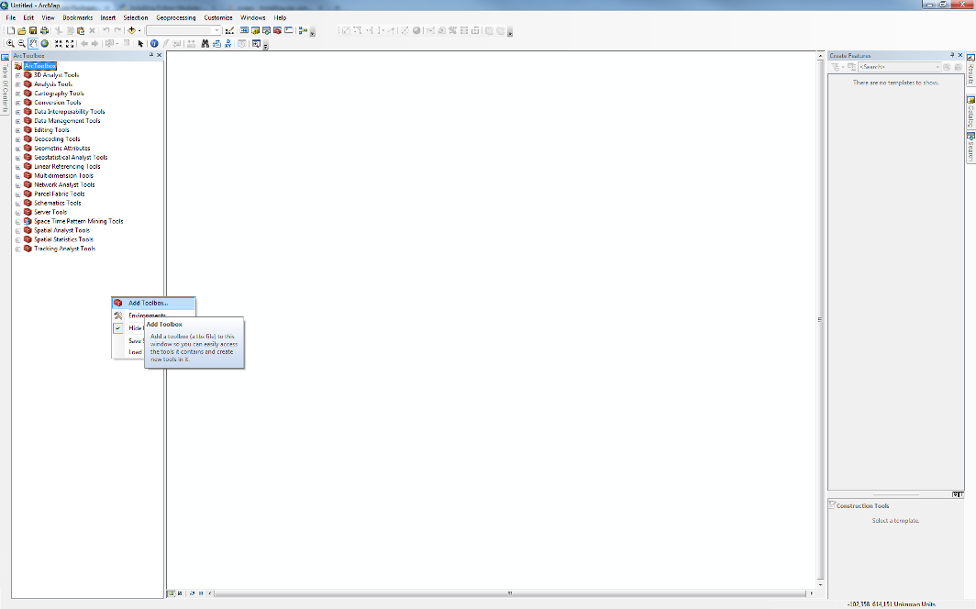
- Right click the ArcToolbox icon → Save Settings → To Default. The toolbox is now saved under the current ArcToolbox settings.
The toolset is now ready for use!

Workflow

Digitizing Fracture Network
  - Interpretation of Fracture Network
  - Repair Fracture Network

Sampling Strategies
  - Polygon and Full Area Sampling
  - Line Grid Sampling
  - Network Grid Sampling

Geometrical Analysis
  - Rose Diagrams
  - Fracture Sets
  - Spatial Heterogeneity
  - Length Distributions

Topological Analysis
  - Nodes and Branches
  - Topological Analysis and Plots
  - Clustering and Block Analysis

Spatial Visualization
  - Contour Plots
  - Contour Analysis

6.0 Key Workflows
6.1 Full Network Analysis
6.2 Line Frequency Analysis
6.3 Spatial Analysis

Contact Information & Feedback

For any assistance or feedback please do not hesitate to contact the author at bjorn.nyberg@uib.no.

