PRESS RELEASE

#FREEBASSEL CAMPAIGN LAUNCHED TO BRING HOME LOVED AND CELEBRATED INTERNET VOLUNTEER DETAINED IN SYRIA

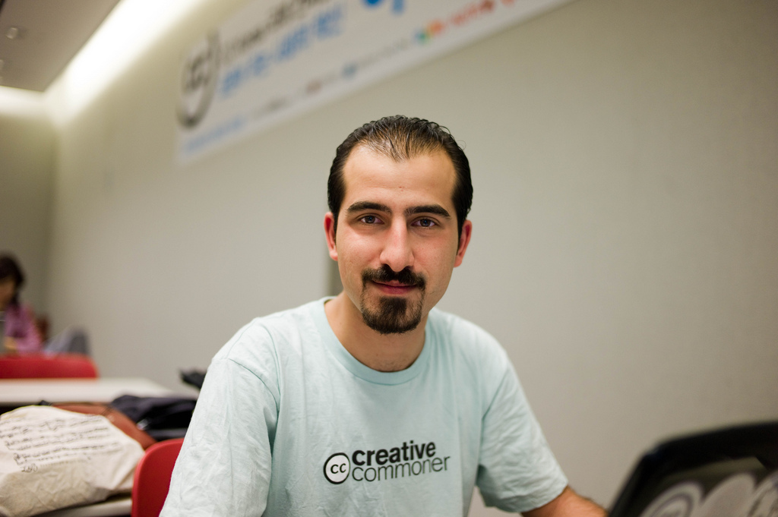

Damascus — Tuesday, 3 July 2012 - Today marks the launch of the #FREEBASSEL campaign to bring about the release of Bassel Khartabil, known widely on the Internet and in technology communities as Bassel Safadi. Bassel is a resident of Damascus, Syria, a technology pioneer and respected community leader. He is a loving family member and friend to countless people at home and around the world. He has been detained since March 15, 2012, without trial. Today the campaign learned Bassel is being held at security detention branch 291 in Kafer Sousa, a facility that was uncovered in the recent Human Rights Watch report “Syria: Torture Centers Revealed.”

The #FREEBASSEL campaign launched today by releasing a letter signed by leading supporters and organizations that Bassel has worked with for some time including support from Joi Ito, Chaiman of the Board for Creative Commons, Lawrence Lessig, Harvard Law School Professor, Jimmy Wales, and already 577 others from around the world who have signed a letter of support to #FREEBASSEL. The letter is directed at the Syrian Government, people living in Syria, Internet citizens and related diplomats worldwide with the goal to raise awareness about Bassel’s situation to see him free once more.

The letter reads:

To Whom it May Concern:

On March 15, 2012, Bassel Khartabil was detained in a wave of arrests in the Mazzeh district of Damascus. Since then, his family has received no official explanation for his detention or information regarding his whereabouts. However, his family has recently learned from previous detainees at the security branch of Kafer Sousa, Damascus, that Bassel is being held at this location known as branch 291.

Bassel Khartabil, a Palestinian-Syrian, 31, is a respected computer engineer specializing in open source software development, the type of contributions the Internet is built upon. He launched his career ten years ago in Syria, working as a technical director for a number of local companies on cultural projects like restoring Palmyra and Forward Syria Magazine.

Since then, Bassel has become known worldwide for his strong commitment to the open web, teaching others about technology, and contributing his experience freely to help the world. Bassel is the project leader for an open source web software called Aiki Framework. He is well known in online technical communities as a dedicated volunteer to major Internet projects like Creative Commons (www.creativecommons.org), Mozilla Firefox (www.mozilla.org), Wikipedia (www.wikipedia.org), Open Clip Art Library (www.openclipart.org), Fabricatorz (www.fabricatorz.com), and Sharism (www.sharism.org).

Since his arrest, Bassel’s valuable volunteer work, both in Syria and around the world, has been stopped. His absence has been painful for the communities that depend on him. In addition, his family, and his fiancée whom he was due to marry this past April, have had their lives put on hold.

Bassel Khartabil has been unjustly detained for nearly four months without trial or any legal charges being brought against him.

We, the signees of the #FREEBASSEL campaign, demand immediate information regarding his detention, health, and psychological state.

We urge the Syrian Government to release the community member, husband-to-be, son to a mother and father, and celebrated International software engineer Bassel Khartabil, immediately.

For More Information

- http://freebassel.org
- http://twitter.com/freebassel
- http://facebook.com/FreeBasselSafadi
- Use the #freebassel hashtag in social media.
- Image of Bassel: http://www.flickr.com/photos/joi/4670781482/sizes/l/in/photostream/ by Joi Ito (Creative Commons Attribution 3.0 licensed).

Background References
- Syria: Torture Centers Revealed. Human Rights Watch. http://www.hrw.org/news/2012/07/03/syria-torture-centers-revealed. Accessed 3 July 2012.
- Torture Archipelago: Arbitrary Arrests, Torture, and Enforced Disappearances in Syria’s Underground Prisons since March 2011. http://www.hrw.org/reports/2012/07/03/torture-archipelago-0. Accessed 3 July 2012.

About #FREEBASSEL

#FREEBASSEL is a campaign to bring about the safe and immediate release of Bassel Khartabil from wrongful detainment in Syria since March 2012. He is a well known contributor to global software and culture communities like Creative Commons, Mozilla Firefox, Wikipedia, Open Clip Art Library, Fabricatorz, and Sharism. He is missed by these communities, his family, friends and loved ones. The campaign says, “We will not stop campaigning for him until we see him as a free global citizen once again.”

Contact

- info@freebassel.org

###

