STUDENT INFORMATION SYSTEM
Software Requirements Specification

Document Version | 4.0
Prepared By | Bjorni Prrini, Bajram Kuqi, Bjorni Pasha, Genti Zenelaj, Henea Daiko, Ergi Sejdi, Ardit Cikalleshi
Date | 3 April 2026
Course | Software Engineering

1. Project Overview

A Student Information System is a software system designed to manage and store information related to students, courses, and academic activities within an educational institution.
The system provides a centralized digital platform where administrators, teachers, and students can access and manage academic information efficiently. Instead of using manual paperwork or separate systems, all information is stored in a single database, allowing easier management, faster access, and improved data accuracy.

1.1 Project Aim
The aim of the Student Information System is to provide an integrated platform that simplifies the management of student-related information and academic processes. The system aims to:
- Store and manage student records in a centralized database
- Allow administrators to manage students, teachers, and courses
- Allow teachers to record grades and attendance
- Allow students to access their academic information
- Manage tuition payments and financial records
- Improve efficiency and reduce manual administrative work

2. General Requirements and User Roles

2.1 Administrator
The administrator has full system access and is responsible for maintaining institutional data and managing the overall platform configuration.
Responsibilities:
- Add, update, and deactivate student and teacher records
- Create and manage courses and academic programs
- Assign teachers to courses and manage enrollment
- Configure user roles and access permissions within the system
- View and generate system-wide reports
- Manage department and faculty structures
- Oversee system configuration, including academic calendar and terms

2.2 Teacher / Professor
Teachers interact with students through the system and are responsible for academic activities in the courses to which they are assigned.
Responsibilities:
- View the list of students enrolled in their courses
- Enter, update, and submit student grades for all assessment types
- Record and maintain student attendance per session
- Mark attendance status: present, absent, late, or excused
- Monitor individual student academic progress and performance
- Send announcements or notifications to enrolled students
- Submit finalized grades to academic administration at end of term

2.3 Student
Students access the system to view their personal academic information, monitor progress, and manage course requests.
Responsibilities:
- View enrolled courses for the current academic term
- Check grades per course and per individual assessment
- Monitor personal attendance records and alert thresholds
- View class timetable and weekly schedule
- Download academic transcripts and grade reports
- View tuition payment history and outstanding balances
- Request enrollment in elective courses
- Receive system notifications for grades, attendance alerts, and deadlines

2.4 Finance Office
The finance office manages all financial transactions and records related to student tuition and fees.
Responsibilities:
- Record and process student tuition payment transactions
- Track outstanding balances and flag overdue accounts
- Apply scholarships, discounts, and financial aid adjustments
- Generate financial reports by term, year, or department
- Send payment reminders and overdue notices to students
- Maintain complete financial history per student

2.5 Dean / Academic Administration
The dean and academic administration have read-only oversight of institutional performance data and academic operations.
Responsibilities:
- Review overall student performance reports by course and department
- Monitor course enrollment statistics and capacity utilization
- Approve final grade submissions from teachers at end of term
- Review attendance trends and identify at-risk students
- Generate and export academic analytics reports for institutional decisions

2.6 Registrar Office
The registrar office manages official academic records, course enrollment processes, and student documentation.
Responsibilities:
- Enroll students into courses for each academic term
- Manage official academic records and student transcripts
- Process student course withdrawal and transfer requests
- Generate course enrollment reports by term and department
- Archive academic records for graduated or withdrawn students

2.7 IT / System Support
The IT and system support team is responsible for maintaining the technical infrastructure, security, and availability of the platform.
Responsibilities:
- Manage automated system backup schedules and recovery procedures
- Monitor system performance, uptime, and error logs
- Manage system security settings and apply vulnerability patches
- Create and deactivate user accounts upon request from administration
- Maintain technical infrastructure and ensure database integrity

2.8 General System Requirements by Domain
Student Management
- Register new students and assign a unique student ID
- Update student personal, contact, and academic information
- Deactivate or archive student records upon leaving the institution
- View complete student profiles including academic history

Course Management
- Create courses with name, code, credit hours, schedule, and department
- Assign one or more teachers to a course
- Set course capacity limits and manage waitlists
- Enroll students in courses per term and track enrollment status

Grade Management
- Teachers enter and update grades per assessment type
- Grades are automatically calculated into final course grades
- Students view grades in real time after teacher submission
- Administrators and deans can view grade statistics by course or cohort

Attendance Management
- Teachers record attendance for each class session
- System calculates and displays attendance percentage per student
- Students receive alerts when attendance falls below the required threshold
- Attendance reports are available to teachers, administrators, and deans

Financial Management
- Finance office records tuition payments and fee adjustments
- System tracks outstanding balances and generates payment history
- Financial reports are generated per term, year, or student
- Students receive automated payment reminders for upcoming or overdue fees

User Authentication & Security
- Users authenticate with a unique username and password
- Role-based access control restricts functionality by user type
- Accounts are locked after repeated failed login attempts
- All sensitive data is transmitted over encrypted connections

3. Functional Requirements

Functional requirements describe the specific behaviors and functions the system must support. Each requirement is expressed in the format: User Role + Verb + Object. A total of 41 functional requirements, organized by user role.

ID | User Role | Verb | Object | Full Requirement Statement
FR-G1 | Administrator, IT Staff | creates / deactivates | user accounts | Administrator and IT Staff create and deactivate user accounts.
FR-G2 | Administrator, Registrar | manages / updates | student academic records | Administrator and Registrar manage and update student academic records.
FR-3 | Administrator | deactivates | student records when a student leaves the institution | Administrator deactivates student records when a student leaves the institution.
FR-4 | Administrator | creates | new courses with associated details | Administrator creates new courses with associated details.
FR-5 | Administrator | assigns | teachers to specific courses | Administrator assigns teachers to specific courses.
FR-6 | Administrator | manages | user roles and system access permissions | Administrator manages user roles and system access permissions.
FR-G3 | Administrator, Finance Officer, Dean, Registrar | generates | system reports academic / financial / enrollment | Administrator, Finance Officer, Dean, and Registrar generate system reports based on their domain.
FR-8 | Teacher | views | the list of students enrolled in their assigned courses | Teacher views the list of students enrolled in their assigned courses.
FR-9 | Teacher | records | student grades for assignments, exams, and final assessments | Teacher records student grades for assignments, exams, and final assessments.
FR-10 | Teacher | updates | previously entered grades before the grading deadline | Teacher updates previously entered grades before the grading deadline.
FR-11 | Teacher | records | daily or per-session student attendance | Teacher records daily or per-session student attendance.
FR-12 | Teacher | marks | students as present, absent, late, or excused | Teacher marks students as present, absent, late, or excused.
FR-G4 | Teacher, Student | views / monitors | student attendance records | Teacher and Student view and monitor student attendance records.
FR-G5 | Teacher, Student | views / monitors | academic performance and grades | Teacher and Student view and monitor student academic performance and grades.
FR-14 | Teacher | sends | announcements or notifications to enrolled students | Teacher sends announcements or notifications to enrolled students.
FR-15 | Student | views | personal academic profile and enrollment status | Student views personal academic profile and enrollment status.
FR-16 | Student | views | all courses currently enrolled for the active term | Student views all courses currently enrolled for the active term.
FR-19 | Student | views | class timetable and weekly schedule | Student views class timetable and weekly schedule.
FR-20 | Student | downloads | academic transcripts and grade reports | Student downloads academic transcripts and grade reports.
FR-21 | Student | updates | personal contact and profile information | Student updates personal contact and profile information.
FR-22 | Finance Officer | records | student tuition payment transactions | Finance Officer records student tuition payment transactions.
FR-23 | Finance Officer | tracks | outstanding balances and overdue payments per student | Finance Officer tracks outstanding balances and overdue payments per student.
FR-25 | Finance Officer | applies | scholarships, discounts, or financial aid adjustments to student accounts | Finance Officer applies scholarships, discounts, or financial aid adjustments to student accounts.
FR-26 | Finance Officer | identifies | students with unpaid tuition fees | Finance Officer identifies students with unpaid tuition fees.
FR-27 | Dean | reviews | overall student performance reports by course and department | Dean reviews overall student performance reports by course and department.
FR-28 | Dean | monitors | course enrollment statistics and capacity utilization | Dean monitors course enrollment statistics and capacity utilization.
FR-29 | Dean | reviews | graduation eligibility reports for final-year students | Dean reviews graduation eligibility reports for final-year students.
FR-30 | Dean | reviews | attendance trend reports across departments | Dean reviews attendance trend reports across departments.
FR-32 | Registrar | enrolls | students into courses for each academic term | Registrar enrolls students into courses for each academic term.
FR-35 | Registrar | processes | student course withdrawal and transfer requests | Registrar processes student course withdrawal and transfer requests.
FR-36 | Registrar | archives | academic records for graduated or withdrawn students | Registrar archives academic records for graduated or withdrawn students.
FR-37 | IT Staff | manages | automated system backup schedules and recovery procedures | IT Staff manages automated system backup schedules and recovery procedures.
FR-38 | IT Staff | monitors | system performance, uptime, and error logs | IT Staff monitors system performance, uptime, and error logs.
FR-39 | IT Staff | manages | system security settings and vulnerability patches | IT Staff manages system security settings and vulnerability patches.
FR-41 | IT Staff | maintains | technical infrastructure and database integrity | IT Staff maintains technical infrastructure and database integrity.

Total Functional Requirements: 41

4. Non-Functional Requirements

Non-functional requirements define the quality attributes and operational constraints the system must satisfy.

4.1 Performance
ID | Requirement
NFR-1 | The system shall load any page or dashboard within 3 seconds under normal load conditions.
NFR-2 | The system shall support at least 500 concurrent users without performance degradation.
NFR-3 | Database queries for report generation shall complete within 10 seconds for datasets up to 10,000 records.

4.2 Security
ID | Requirement
NFR-4 | All user passwords shall be stored using a strong hashing algorithm and never stored in plain text.
NFR-5 | The system shall enforce role-based access control, ensuring users can only access functions authorized to their role.
NFR-6 | All data transmitted between the client and server shall be encrypted using HTTPS.
NFR-7 | The system shall lock a user account after 5 consecutive failed login attempts and require manual unlock by an administrator.
NFR-8 | The system shall maintain a complete audit log of all create, update, and delete operations, including user, timestamp, and changed data.

4.3 Usability
ID | Requirement
NFR-9 | The user interface shall be intuitive enough that a new user can complete core tasks without formal training within 30 minutes.
NFR-10 | The system shall be accessible and functional on modern web browsers without plugin installation.
NFR-11 | The system shall provide descriptive error messages that guide users to correct invalid inputs.
NFR-12 | The interface shall be responsive and usable on desktop, tablet, and mobile screen sizes.

4.4 Reliability & Availability
ID | Requirement
NFR-13 | The system shall achieve at least 99.5% uptime during the academic year.
NFR-14 | Automated database backups shall be performed daily, and backups shall be retained for a minimum of 30 days.
NFR-15 | The system shall recover from an unexpected failure and restore full service within 1 hour.

4.5 Scalability
ID | Requirement
NFR-16 | The system shall be designed to accommodate growth to at least 5,000 student records without architectural changes.
NFR-17 | The system architecture shall allow new modules to be integrated without major restructuring.

4.6 Maintainability
ID | Requirement
NFR-18 | The system source code shall follow a consistent coding standard and include documentation sufficient for a new developer to onboard within one week.
NFR-19 | System updates and patches shall be deployable without requiring more than 30 minutes of planned downtime.

4.7 Compliance
ID | Requirement
NFR-20 | The system shall comply with applicable data protection regulations, ensuring student personal data is collected, stored, and processed lawfully.
NFR-21 | Student financial records shall be retained for a minimum of 6 years in accordance with institutional and legal requirements.

Total Non-Functional Requirements: 21

5. Use case:

5.1 Use case table:
UC ID | Use Case Name | Actors | Description | Preconditions | Postconditions
UC-1 | Create/Deactivate User Accounts | Administrator, IT Staff | The administrator or IT staff creates new user accounts or deactivates existing ones. | User is logged in as Administrator or IT Staff. | User account is created or deactivated; access updated.
UC-2 | Manage Student Academic Records | Administrator, Registrar | The administrator or registrar manages and updates student academic records. | Actor is authenticated with appropriate role. | Student academic records are updated in the system.
UC-3 | Deactivate Student Record | Administrator | The administrator deactivates a student record when a student leaves the institution. | Student record exists and is active. | Student record is marked inactive and archived.
UC-4 | Create New Course | Administrator | The administrator creates a new course with details such as name, code, credits, and schedule. | Administrator is logged in; department exists. | New course is available for enrollment and teacher assignment.
UC-5 | Assign Teacher to Course | Administrator | The administrator assigns one or more teachers to a specific course. | Course and teacher records exist. | Teacher is assigned and can access the course gradebook.
UC-6 | Manage User Roles and Permissions | Administrator | The administrator configures role-based access permissions for all user types. | Administrator is logged in. | User roles and permissions are updated system-wide.
UC-7 | Generate System Reports | Administrator, Finance Officer, Dean, Registrar | Authorized users generate reports based on their domain: academic, financial, or enrollment. | Actor is authenticated with a report-generation role. | Report is generated and available for viewing or export.
UC-8 | View Enrolled Students | Teacher | The teacher views the list of students enrolled in their assigned courses. | Teacher is logged in and assigned to at least one course. | Teacher sees the student roster for their courses.
UC-9 | Record Grades | Teacher | The teacher records student grades for assignments, exams, and final assessments. | Teacher is logged in; grading period is open. | Grades are saved and visible to students after submission.
UC-10 | Update Grades | Teacher | The teacher updates previously entered grades before the grading deadline. | Grades exist; deadline has not passed. | Grades are updated and reflected in student records.
UC-11 | Record Attendance | Teacher | The teacher records daily or per-session student attendance. | Teacher is logged in; class session is active. | Attendance is recorded for the session.
UC-12 | Mark Attendance Status | Teacher | The teacher marks each student as present, absent, late, or excused. | Attendance session is open. | Attendance statuses are saved for each student.
UC-13 | View Attendance Records | Teacher, Student | The teacher or student views attendance records and absence percentages. | Actor is authenticated. | Attendance records are displayed.
UC-14 | Monitor Student Performance | Teacher, Student | The teacher or student monitors academic performance and grade summaries. | Actor is authenticated. | Performance data is displayed.
UC-15 | Send Announcements | Teacher | The teacher sends announcements or notifications to students enrolled in their courses. | Teacher is logged in and assigned to a course. | Announcement is delivered to all enrolled students.
UC-16 | View Enrolled Courses | Student | The student views all courses currently enrolled in for the active academic term. | Student is logged in and enrolled in at least one course. | Enrolled course list is displayed.
UC-17 | View Academic Profile | Student | The student views their personal academic profile and enrollment status. | Student is logged in. | Academic profile and enrollment status are displayed.
UC-18 | Check Grades | Student | The student checks grades for each course and individual assessments. | Student is logged in; grades have been submitted. | Grades are displayed per course and assessment.
UC-19 | Monitor Attendance Record | Student | The student monitors personal attendance record and absence percentage. | Student is logged in. | Attendance record and percentage are displayed.
UC-20 | View Class Timetable | Student | The student views their class timetable and weekly schedule. | Student is logged in and enrolled in courses. | Timetable is displayed.
UC-21 | Download Academic Transcripts | Student | The student downloads academic transcripts and grade reports. | Student is logged in; records exist. | Transcript document is downloaded.
UC-22 | Update Personal Information | Student | The student updates their personal contact and profile information. | Student is logged in. | Personal information is updated in the system.
UC-23 | Record Tuition Payment | Finance Officer | The finance officer records student tuition payment transactions. | Finance officer is logged in; student account exists. | Payment transaction is recorded and balance updated.
UC-24 | Track Outstanding Balances | Finance Officer | The finance officer tracks outstanding balances and overdue payments per student. | Finance officer is logged in. | Outstanding balances and overdue accounts are listed.
UC-25 | Apply Financial Aid | Finance Officer | The finance officer applies scholarships, discounts, or financial aid adjustments. | Finance officer is logged in; student account exists. | Financial aid is applied and student balance updated.
UC-26 | Identify Students with Unpaid Fees | Finance Officer | The finance officer identifies students with unpaid tuition fees. | Finance officer is logged in. | List of students with unpaid fees is generated.
UC-27 | Review Student Performance Reports | Dean | The dean reviews overall student performance reports by course and department. | Dean is logged in. | Performance reports are displayed by course and department.
UC-28 | Monitor Course Enrollment Statistics | Dean | The dean monitors course enrollment statistics and capacity utilization. | Dean is logged in. | Enrollment statistics and capacity data are displayed.
UC-29 | Approve Final Grade Submissions | Dean | The dean reviews and approves final grade submissions from teachers at end of term. | Grades submitted by teachers; dean is logged in. | Final grades are approved and locked.
UC-30 | Review Attendance Trends | Dean | The dean reviews attendance trend reports and identifies at-risk students. | Dean is logged in. | Attendance trends and at-risk student list are displayed.
UC-31 | Enroll Students into Courses | Registrar | The registrar enrolls students into courses for each academic term. | Registrar is logged in; course and student records exist. | Students are enrolled and their course list is updated.
UC-32 | Process Course Withdrawal/Transfer | Registrar | The registrar processes student course withdrawal and transfer requests. | Registrar is logged in; request exists. | Withdrawal or transfer is processed and records updated.
UC-33 | Archive Academic Records | Registrar | The registrar archives academic records for graduated or withdrawn students. | Student has graduated or withdrawn. | Records are archived and removed from active view.
UC-34 | Manage System Backups | IT/System Support | IT staff manages automated system backup schedules and recovery procedures. | IT staff is logged in. | Backup schedules configured; recovery procedures documented.
UC-35 | Monitor System Performance | IT/System Support | IT staff monitors system performance, uptime, and error logs. | IT staff is logged in. | System performance metrics and logs are displayed.
UC-36 | Manage System Security | IT/System Support | IT staff manages security settings and applies vulnerability patches. | IT staff is logged in. | Security settings updated and patches applied.
UC-37 | Maintain Technical Infrastructure | IT/System Support | IT staff maintains technical infrastructure and ensures database integrity. | IT staff is logged in. | Infrastructure maintained and database integrity verified.

5.2 Use case diagram:

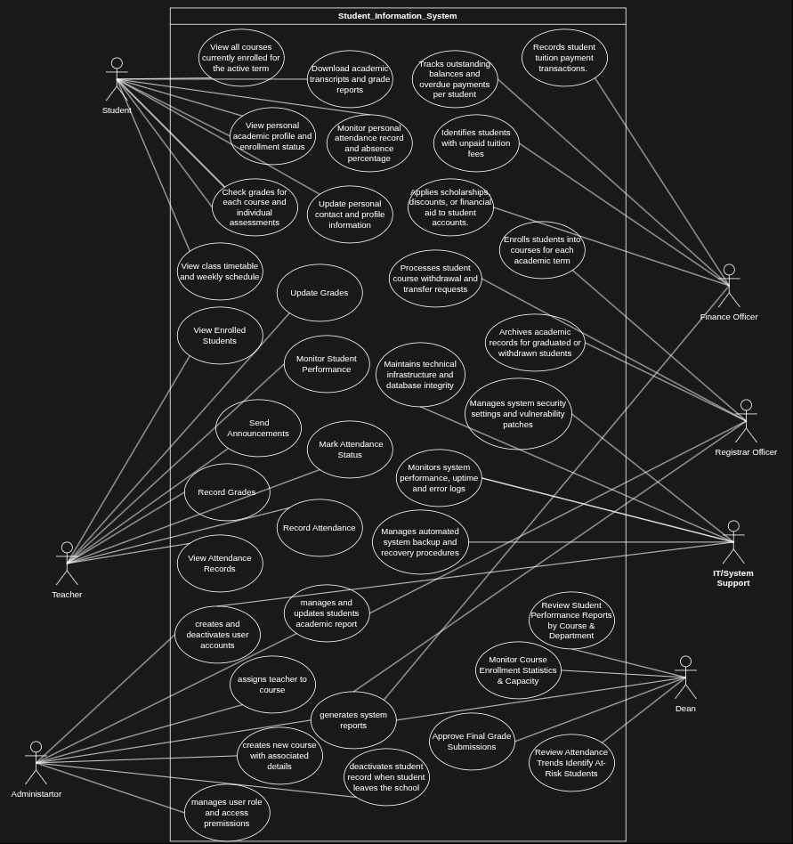

6. Activity diagrams:

6.1 Administrator activity diagrams:

Creates and deactivates users:

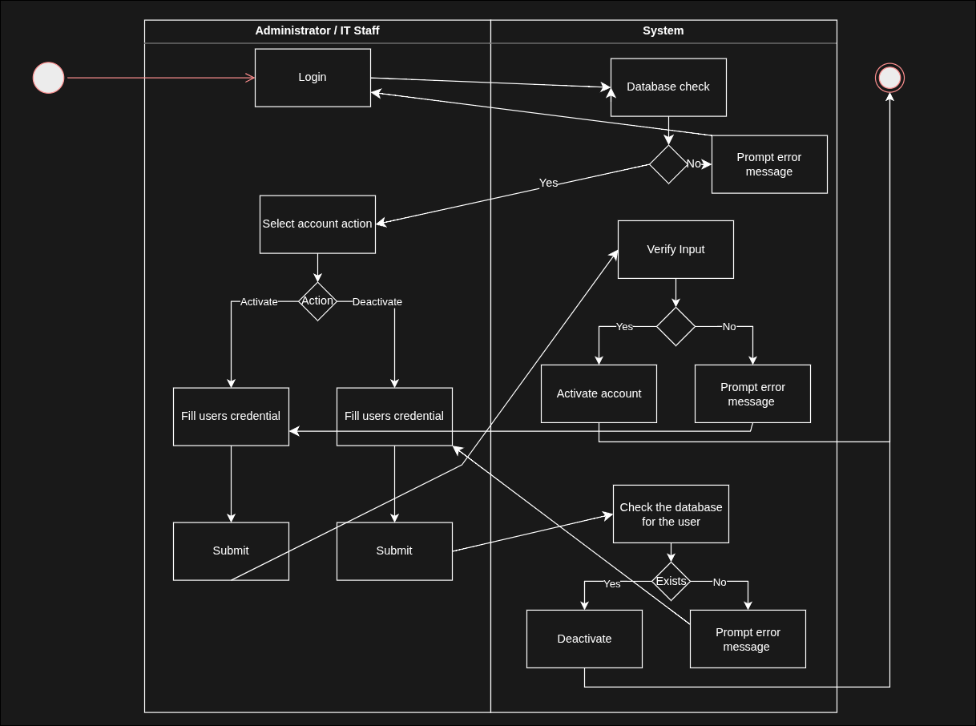

Manages and updates students' academic reports:

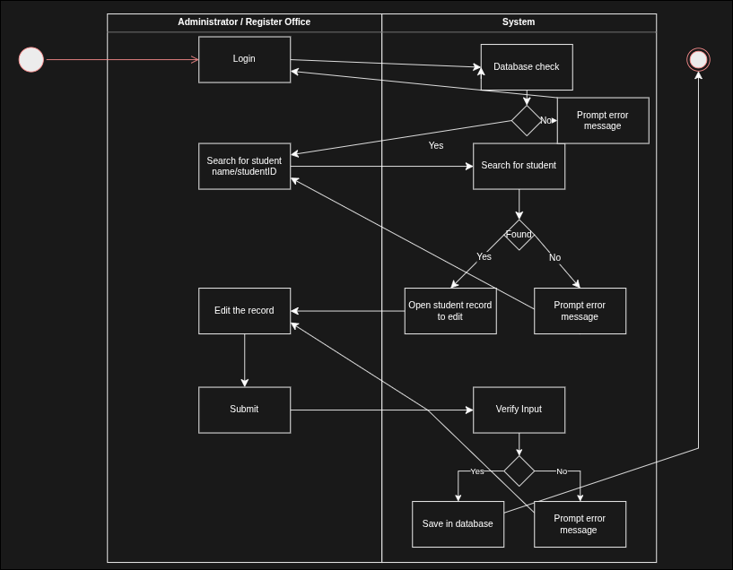

Deactivate the student record when he leaves the university:

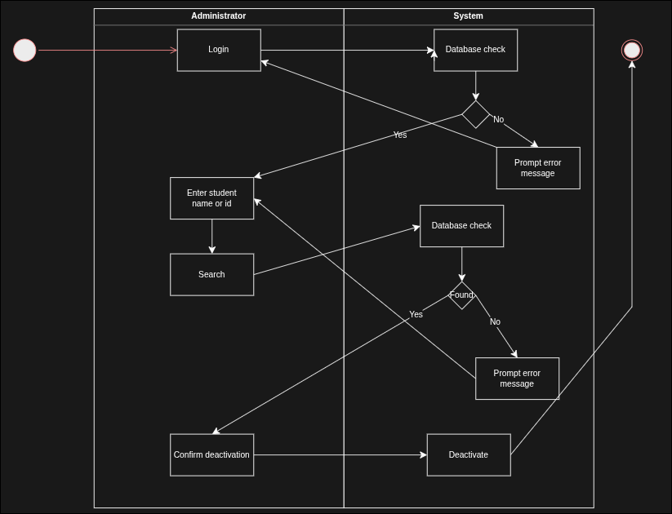

Creates a new course with associated details:

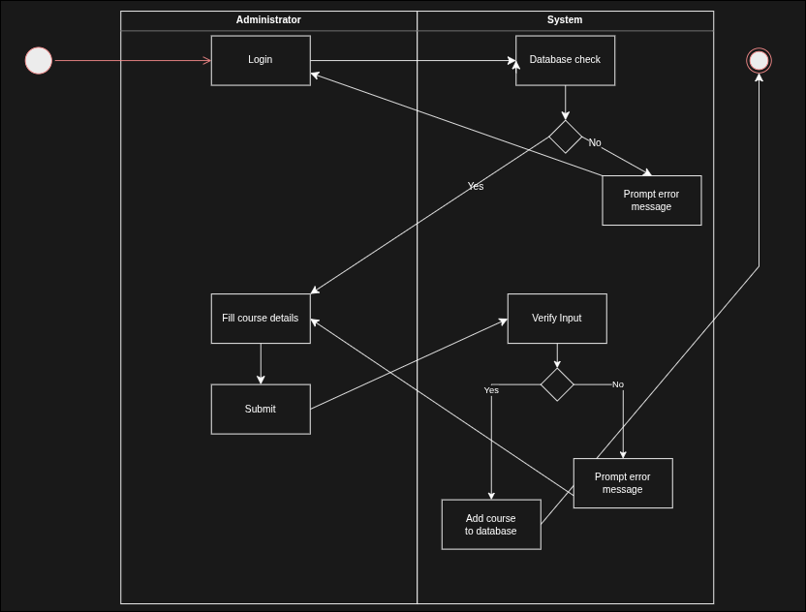

Assigns teacher to course:

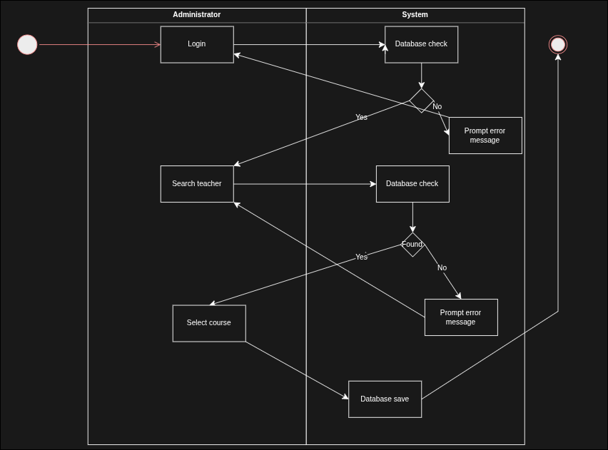

Manages user role and permissions:

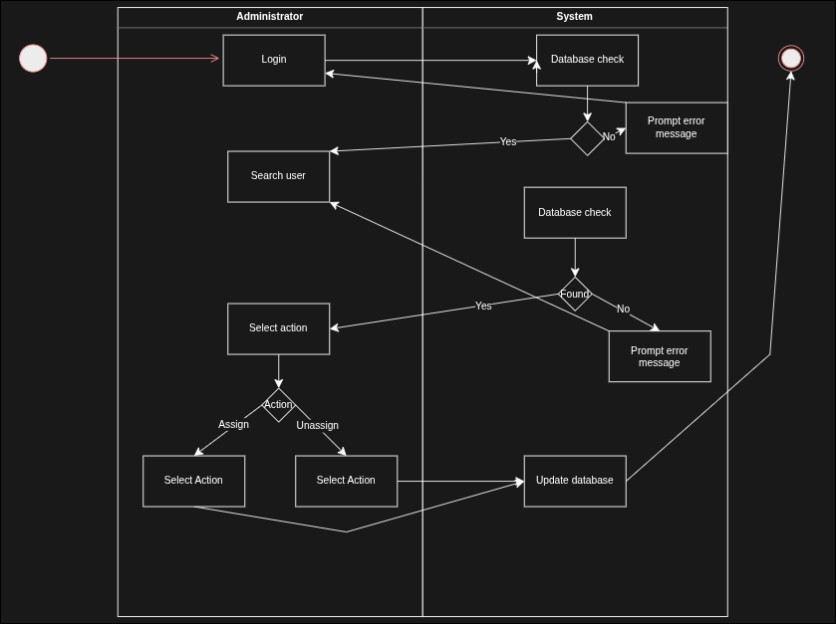

Generate system report:

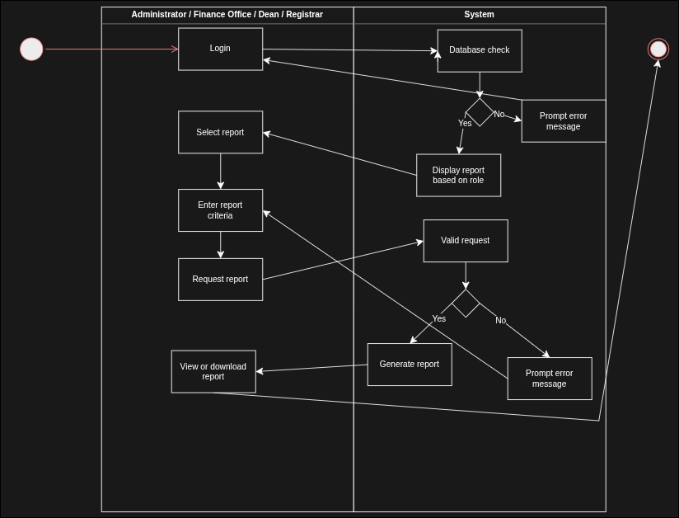

6.2 Teacher activity diagrams:

Enter and submit student grades:

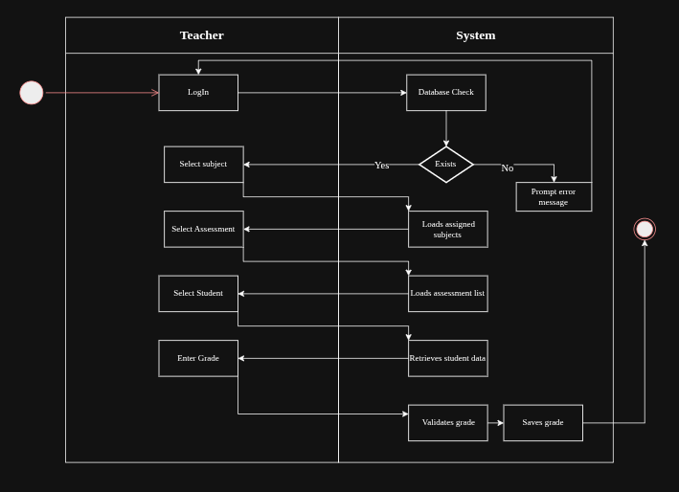

Update student grades:

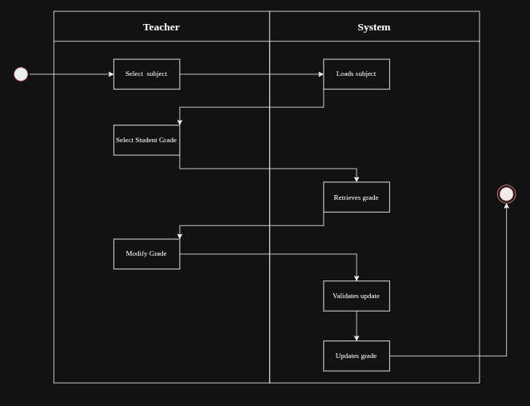

Manage / Select Assessment:

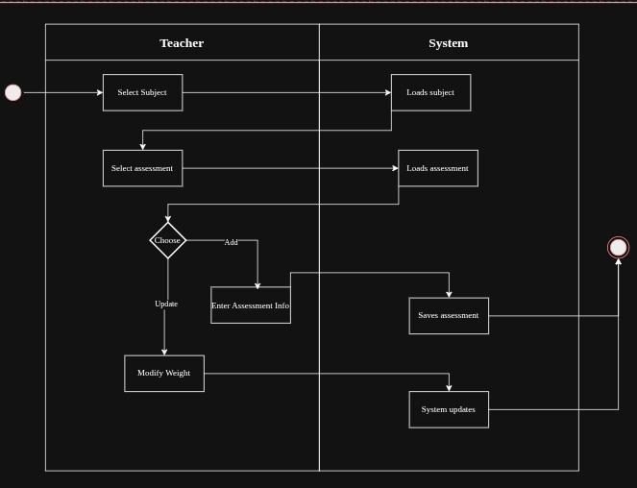

View the list of enrolled students:

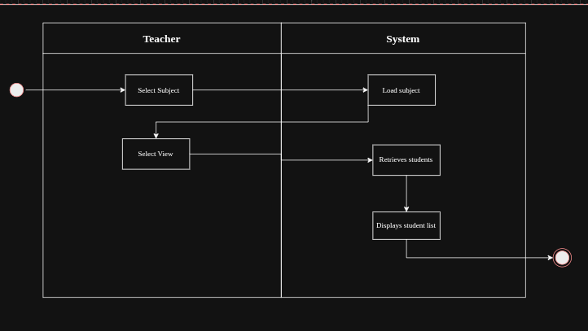

Submit finalised grades to the administration:

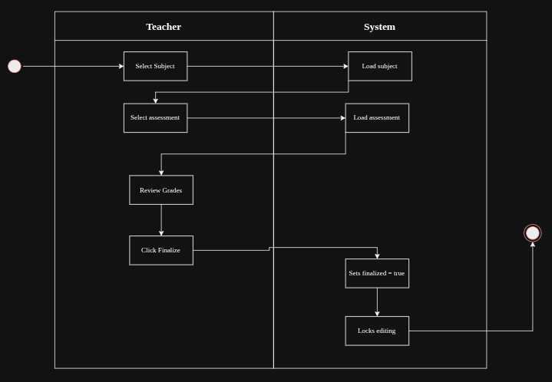

Mark attendance status (present, absent, late, excused:

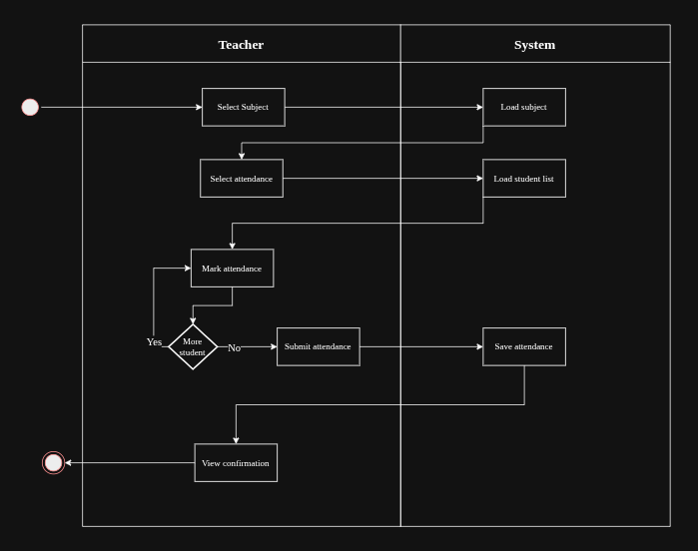

Send announcements / notifications:

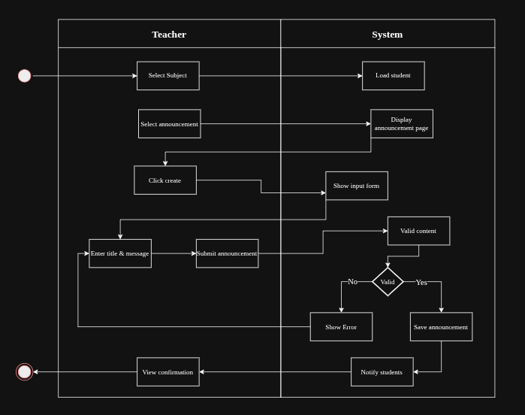

6.3 Student activity diagrams:

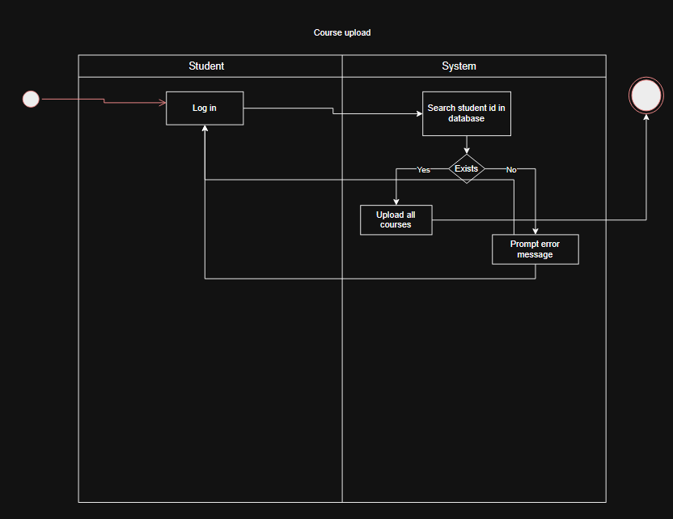

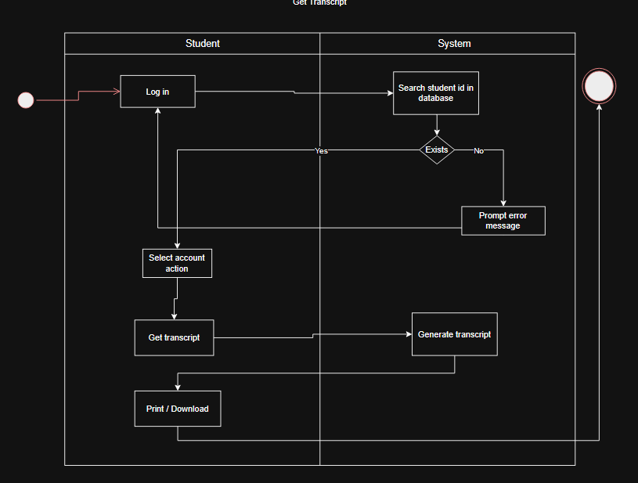

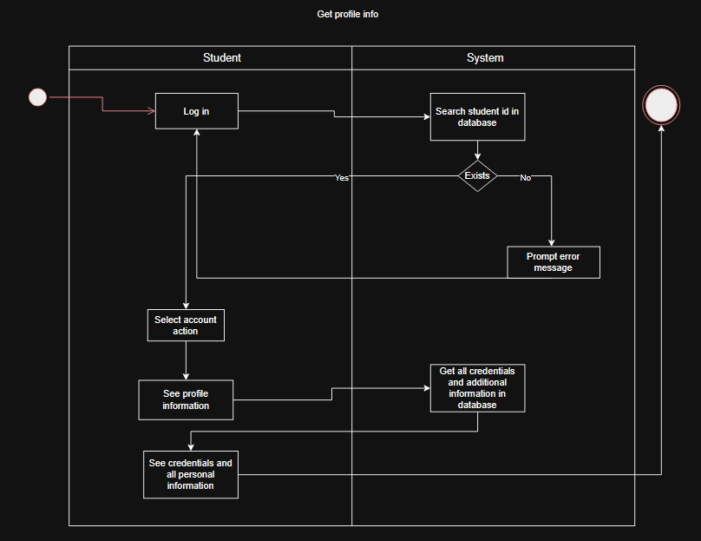

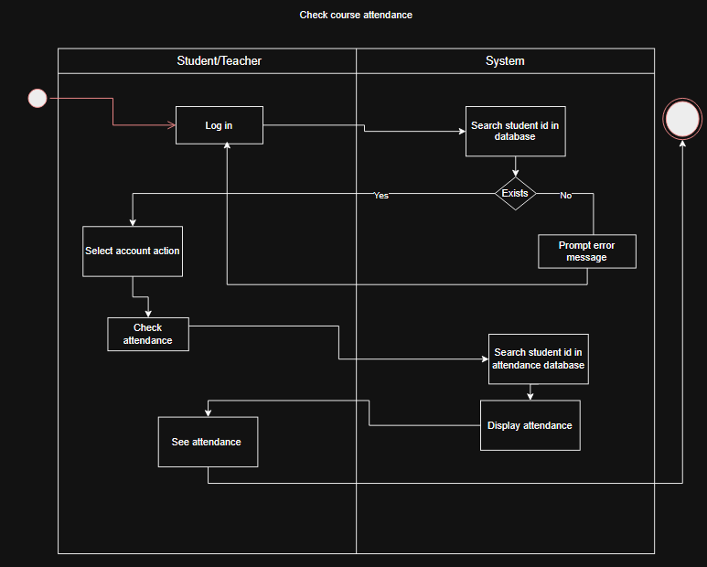

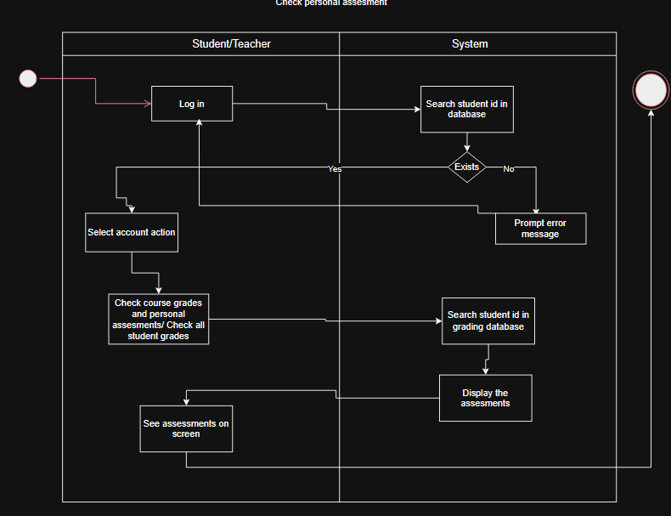

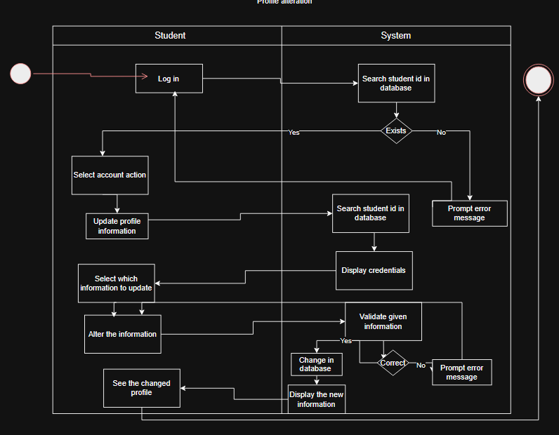

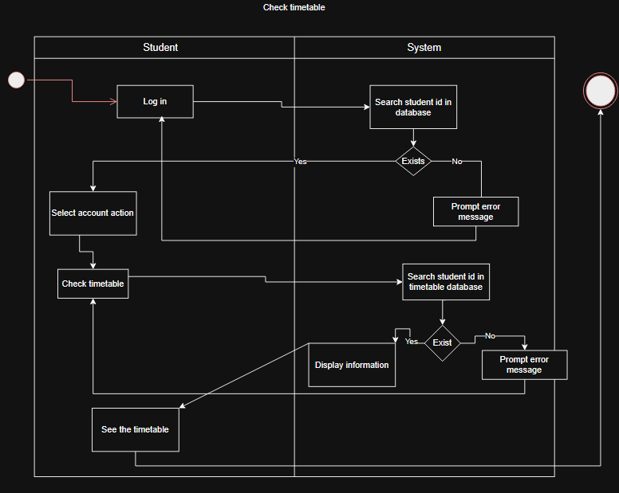

6.4 Finance Office activity diagrams:

Finance Officer records student tuition payment transactions:

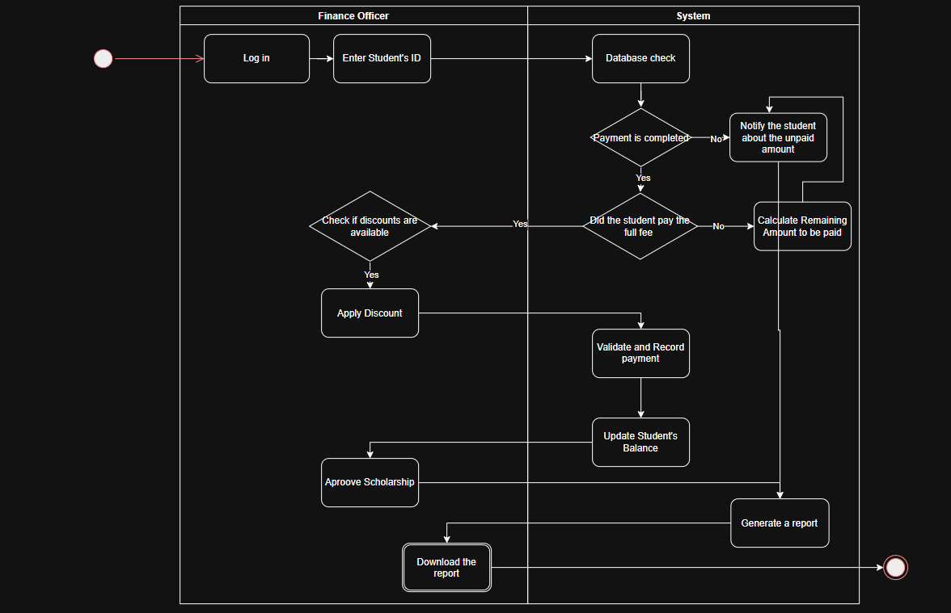

Finance Officer tracks outstanding balances and overdue payments per student:

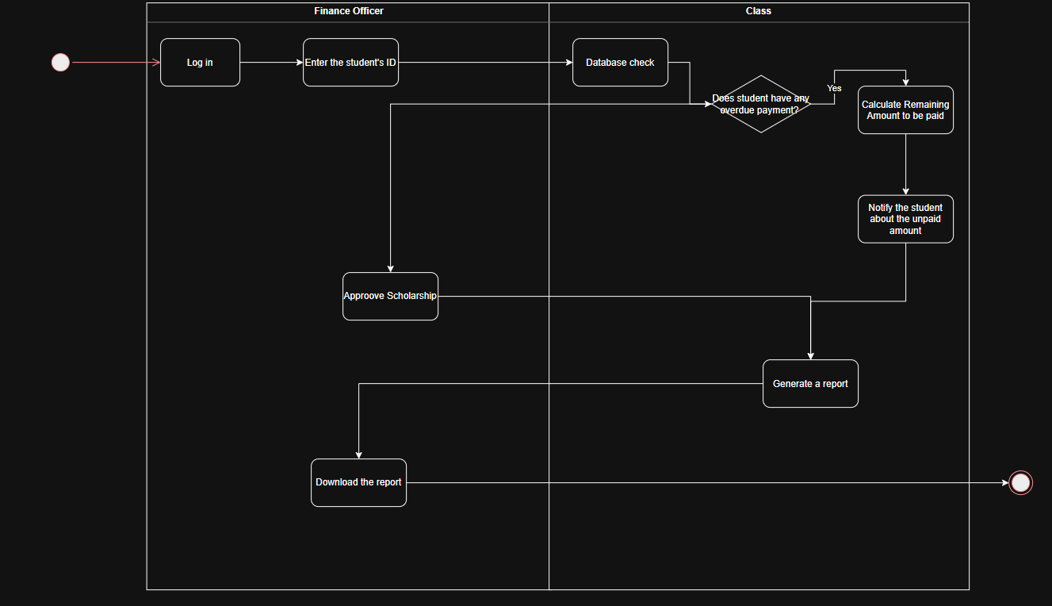

Finance Officer applies scholarships, discounts, or financial aid adjustments to students accounts:

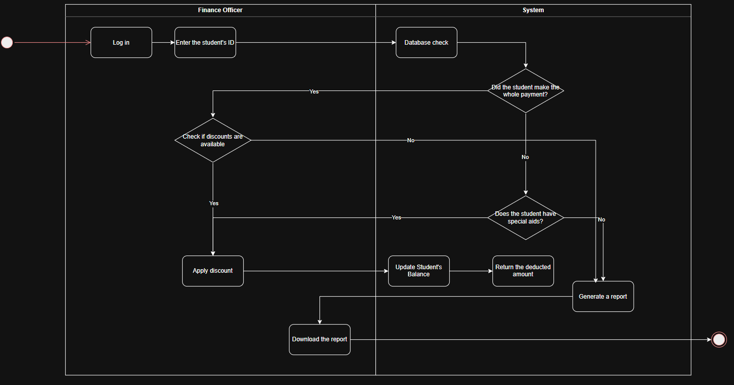

Finance Officer identifies student with unpaid tuition fees:

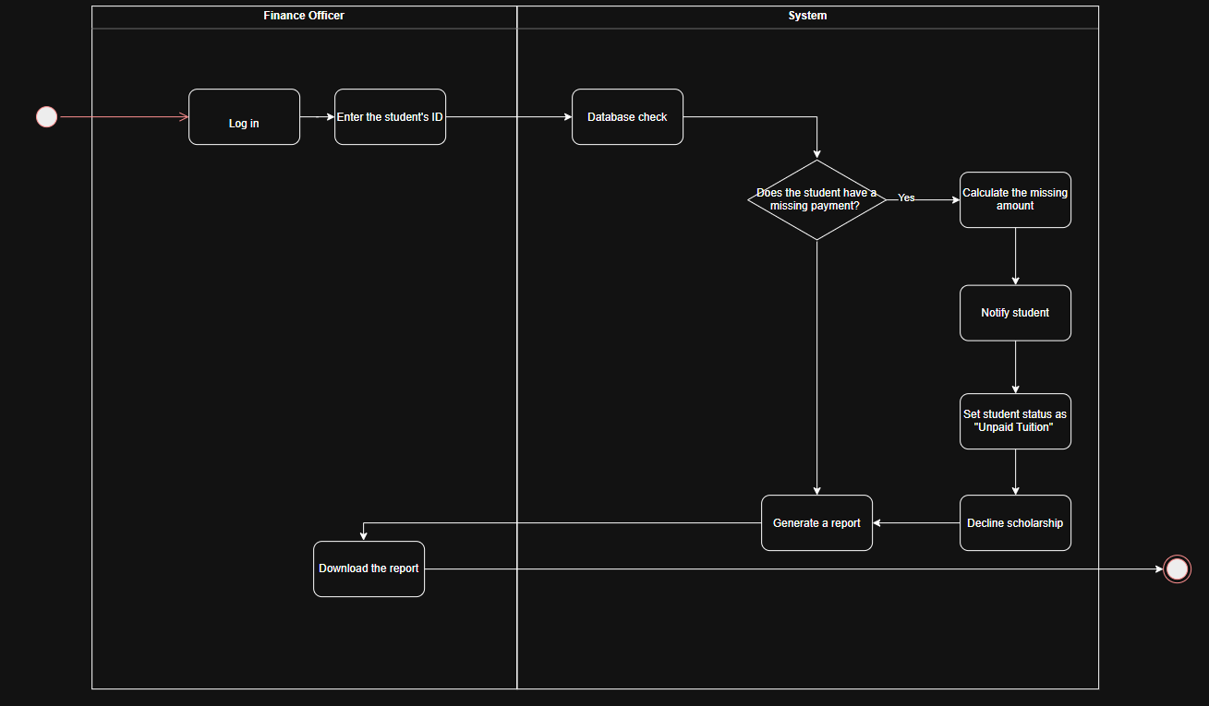

6.5 Dean activity diagrams:

Dean reviews overall student performance reports by course and department:

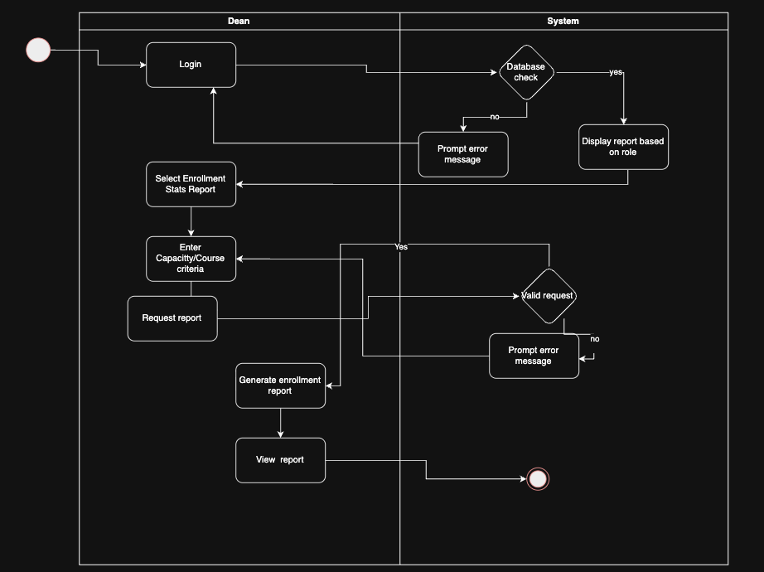

Dean monitors course enrollment statistics and capacity utilisation:



Dean reviews graduation eligibility reports for final-year students:

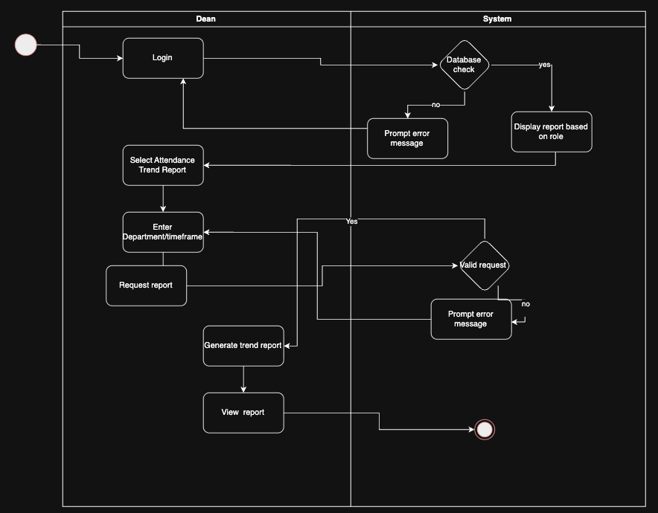

Dean reviews attendance trend reports across departments:

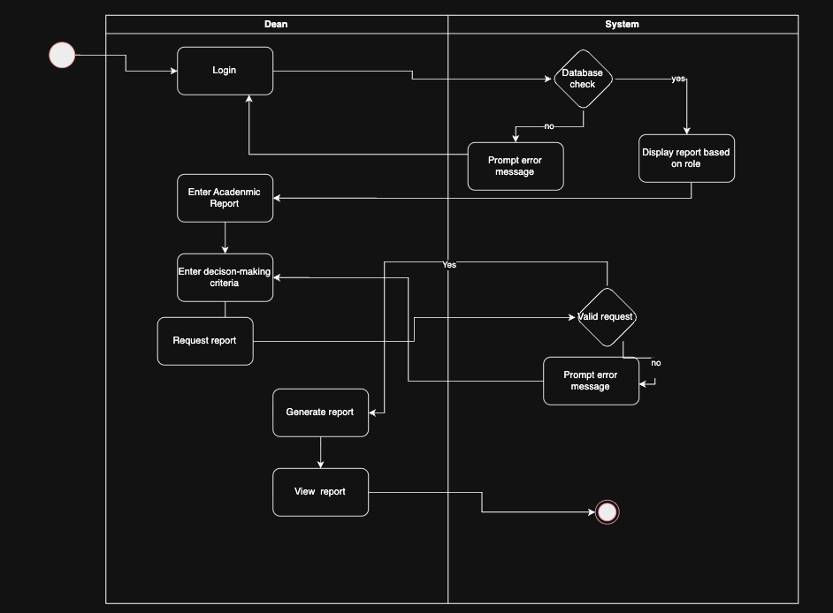

6.6 Registry Office activity diagrams:

Registrar enrols students into courses for each academic term:

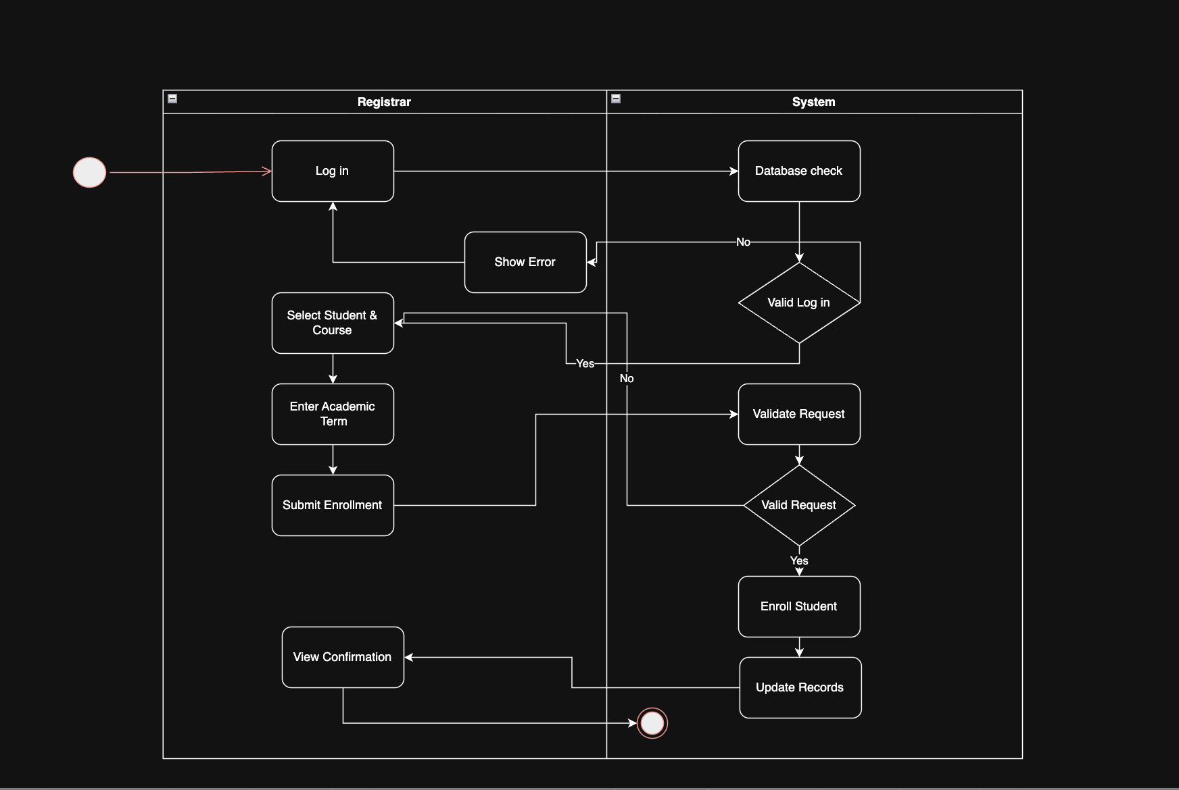

Registrar processes student course withdrawal and transfer requests:

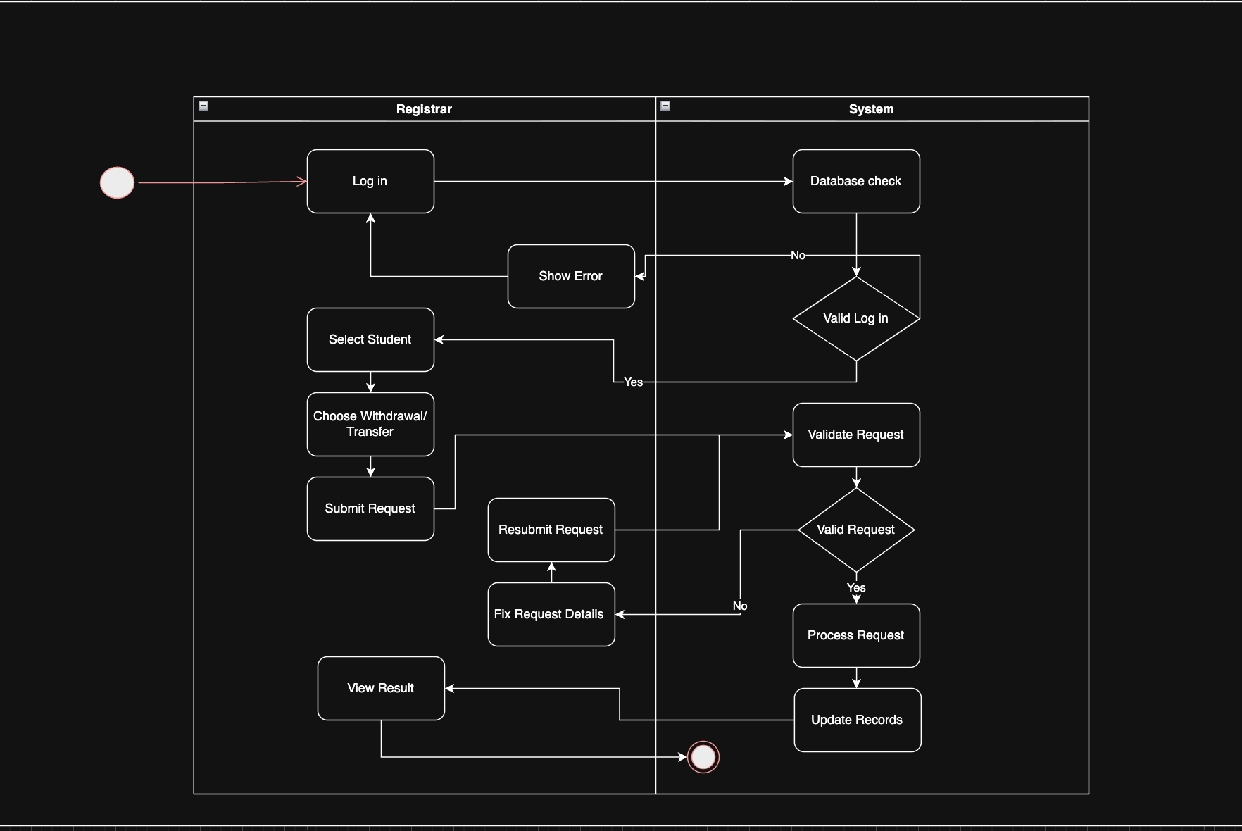

Registrar archives academic records for graduated or withdrawn students:

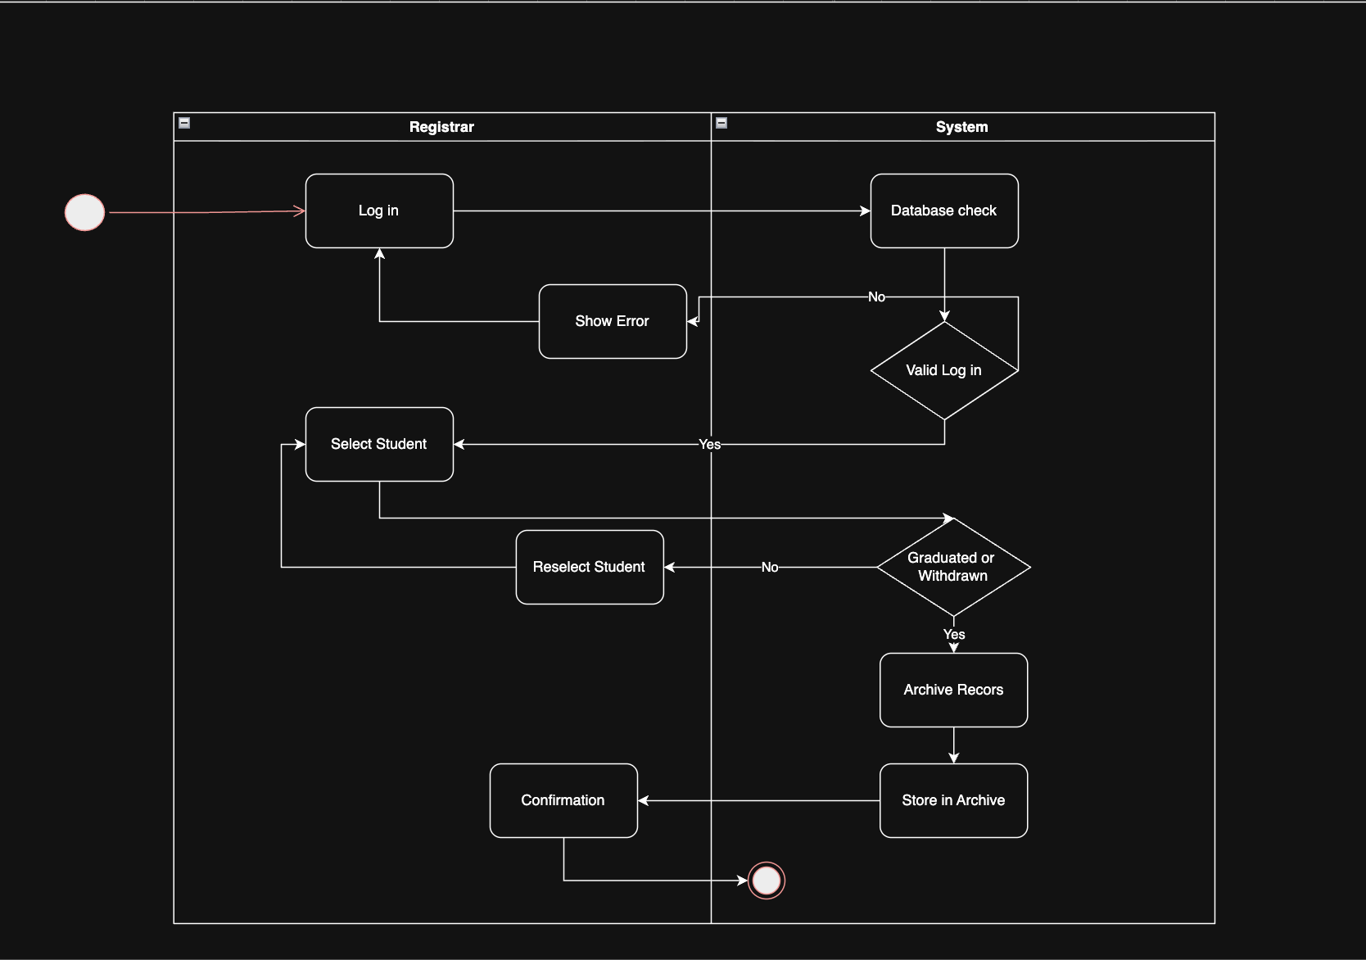

6.7 IT Staff activity diagrams:

IT Staff manages automated system backup schedules and recovery procedures:

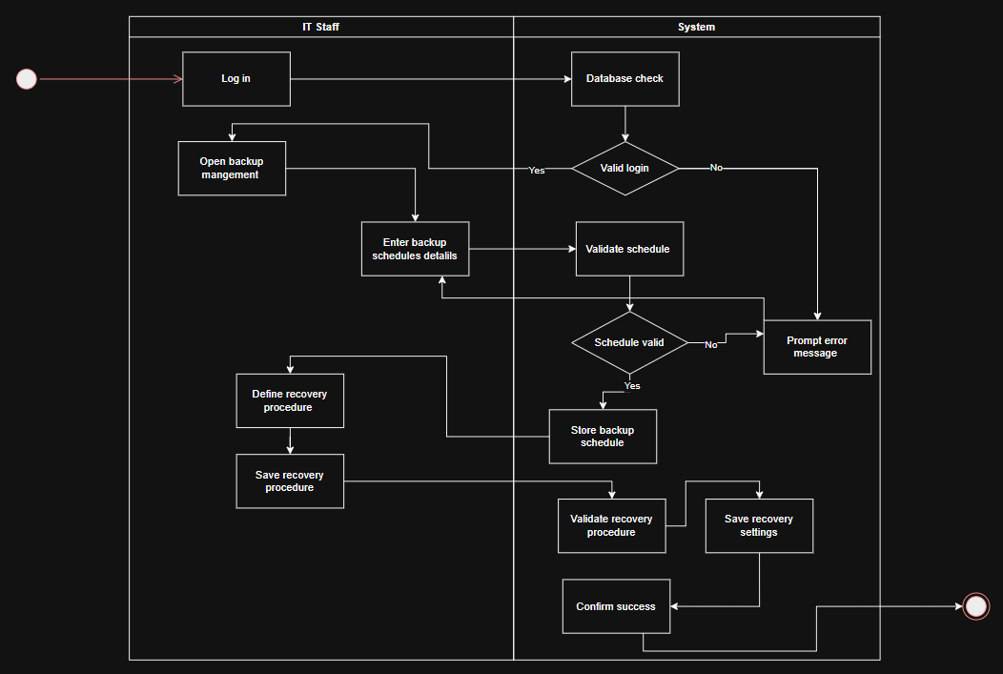

IT Staff monitors system performance, uptime and error logs:

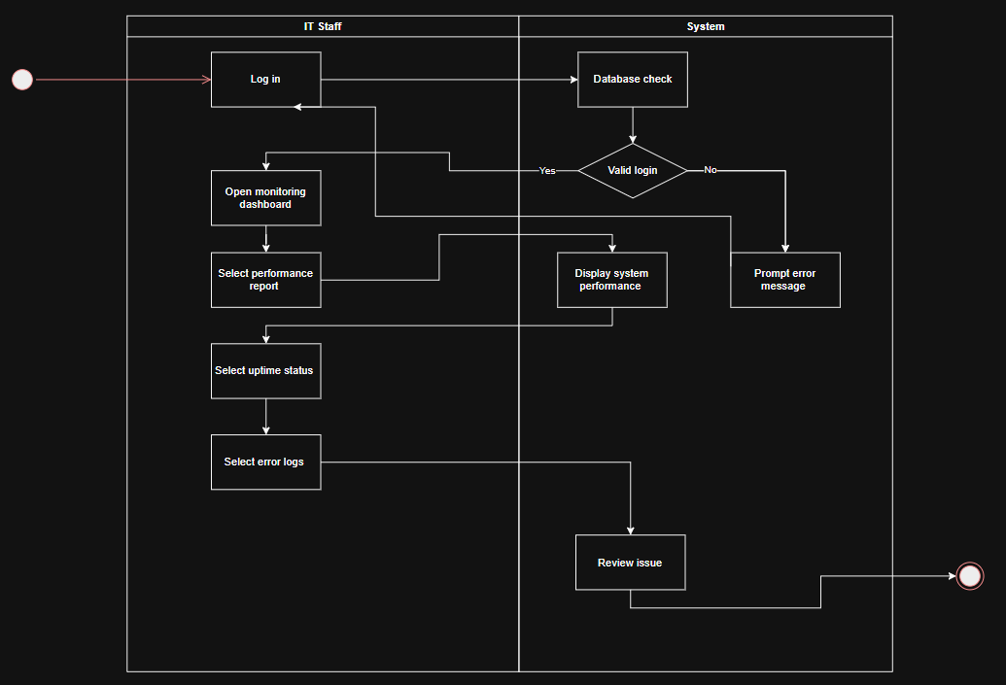

IT Staff manages system security settings and vulnerability patches:

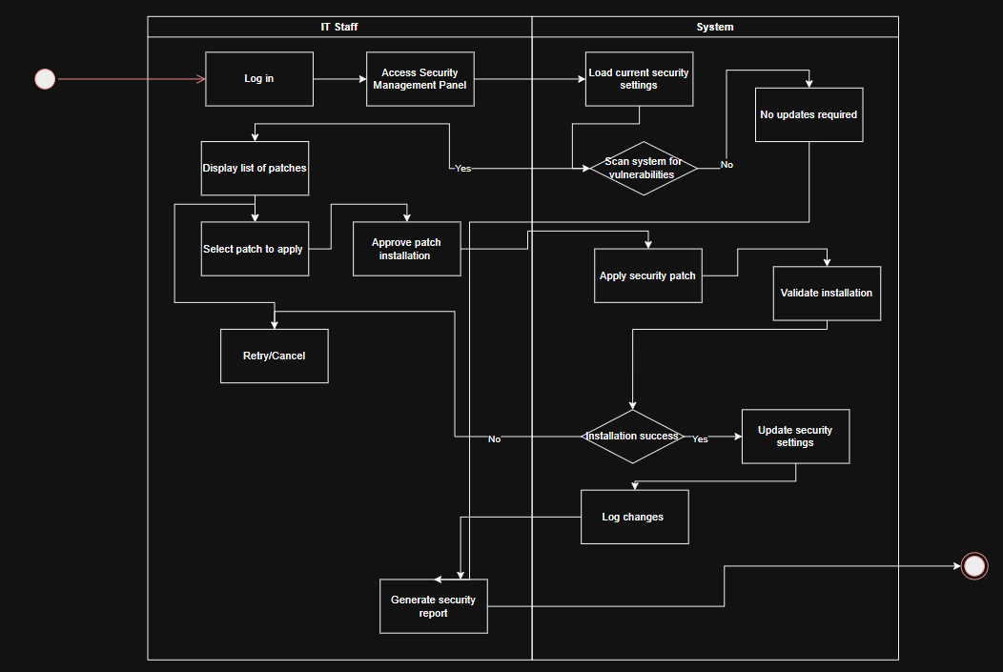

IT Staff maintains technical infrastructure and database integrity:

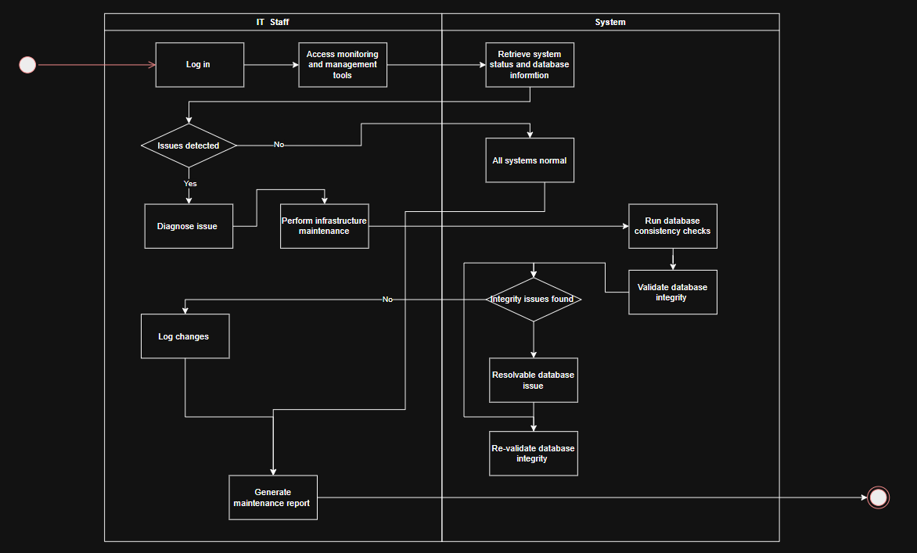

7. State diagrams:

7.1 Administrator state diagrams:

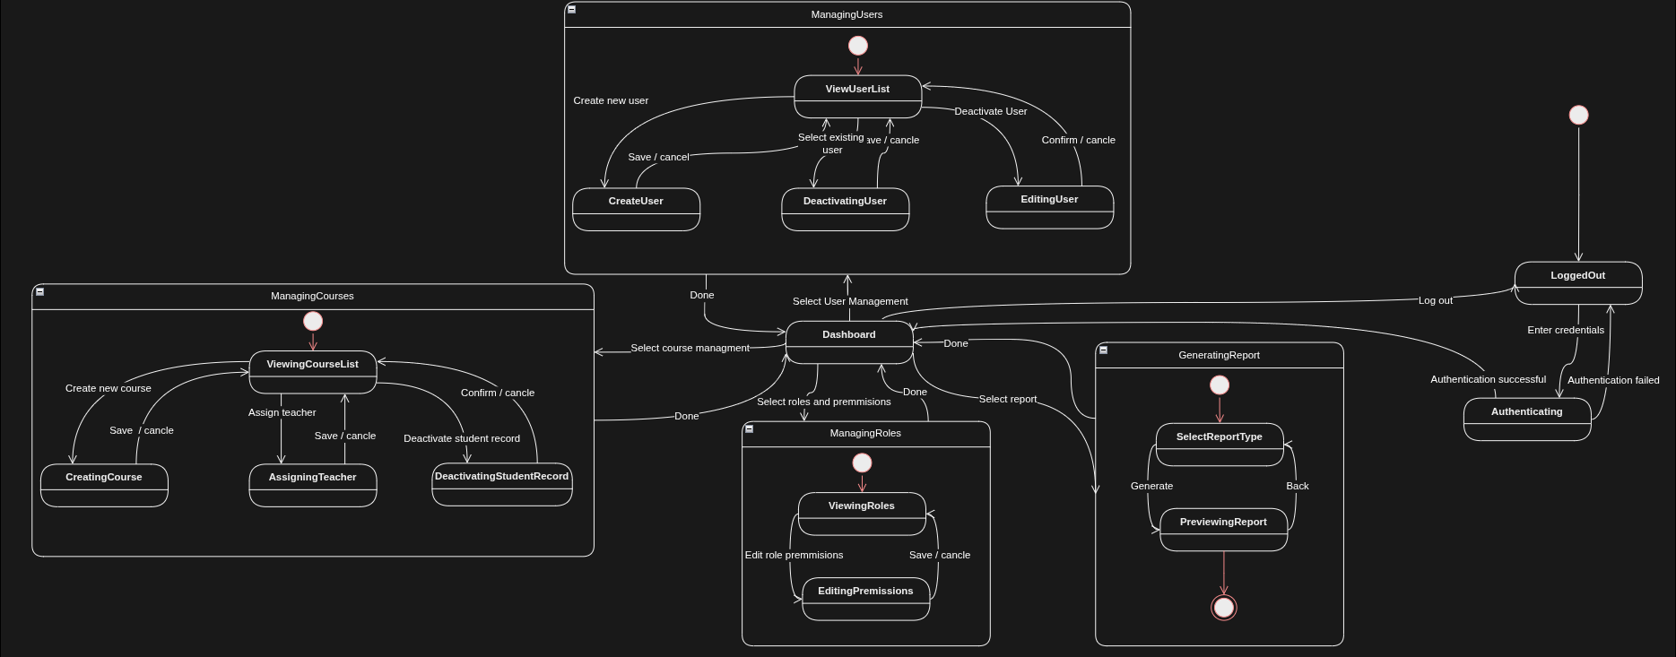

7.2 Teacher state diagrams:

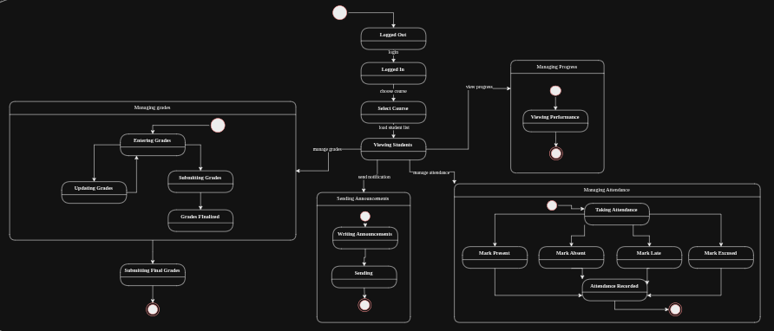

7.3 Student state diagrams:

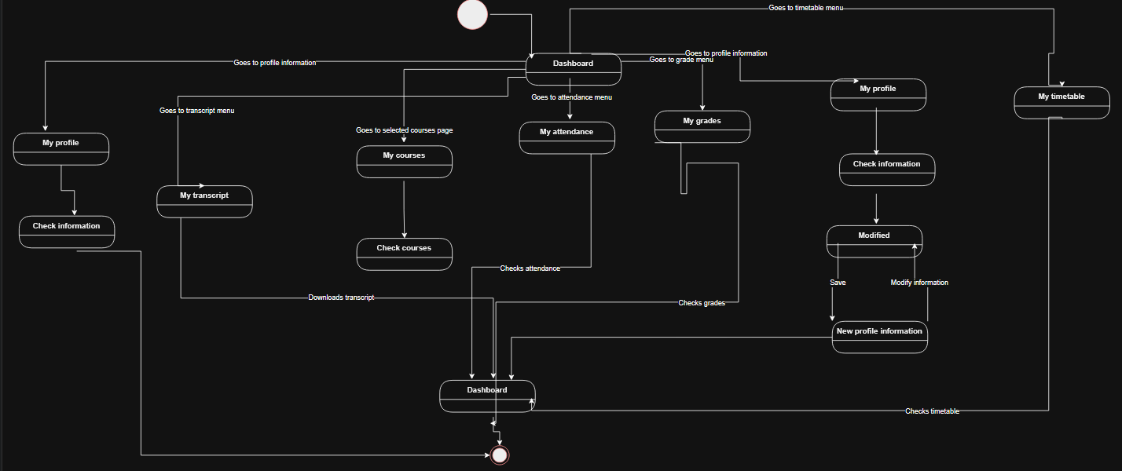

7.4 Finance Office state diagrams:

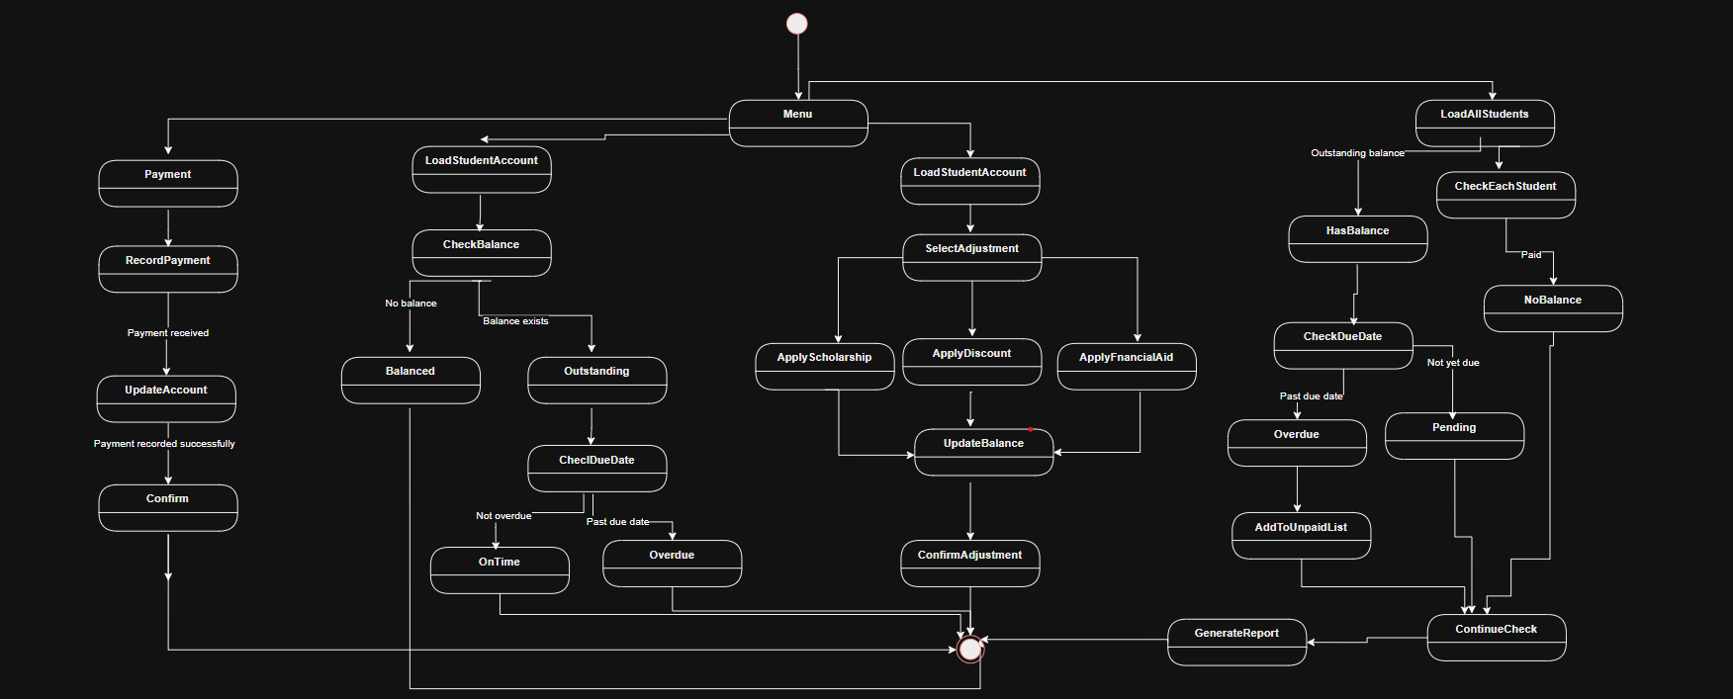

7.5 Dean state diagrams:

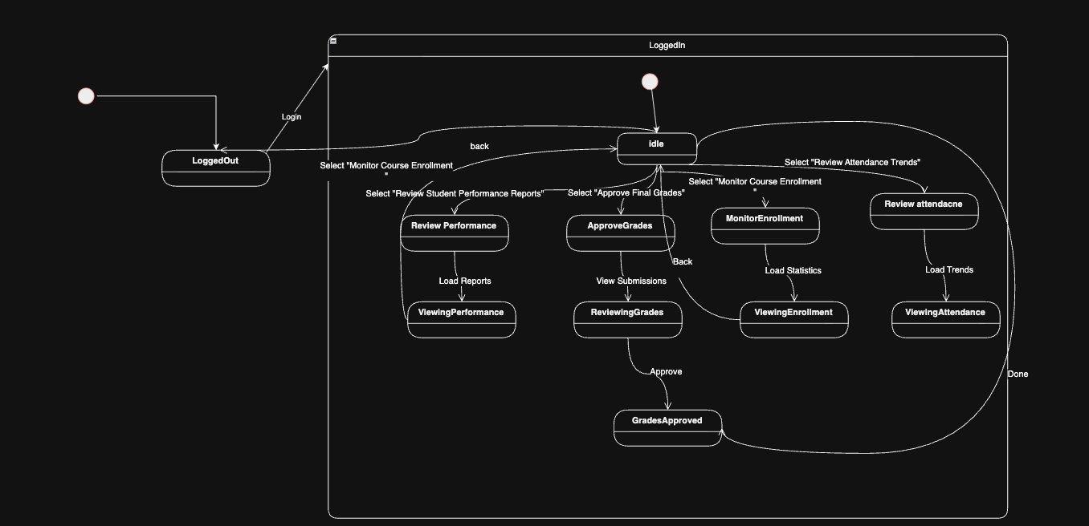

7.6 Registry Office state diagrams:

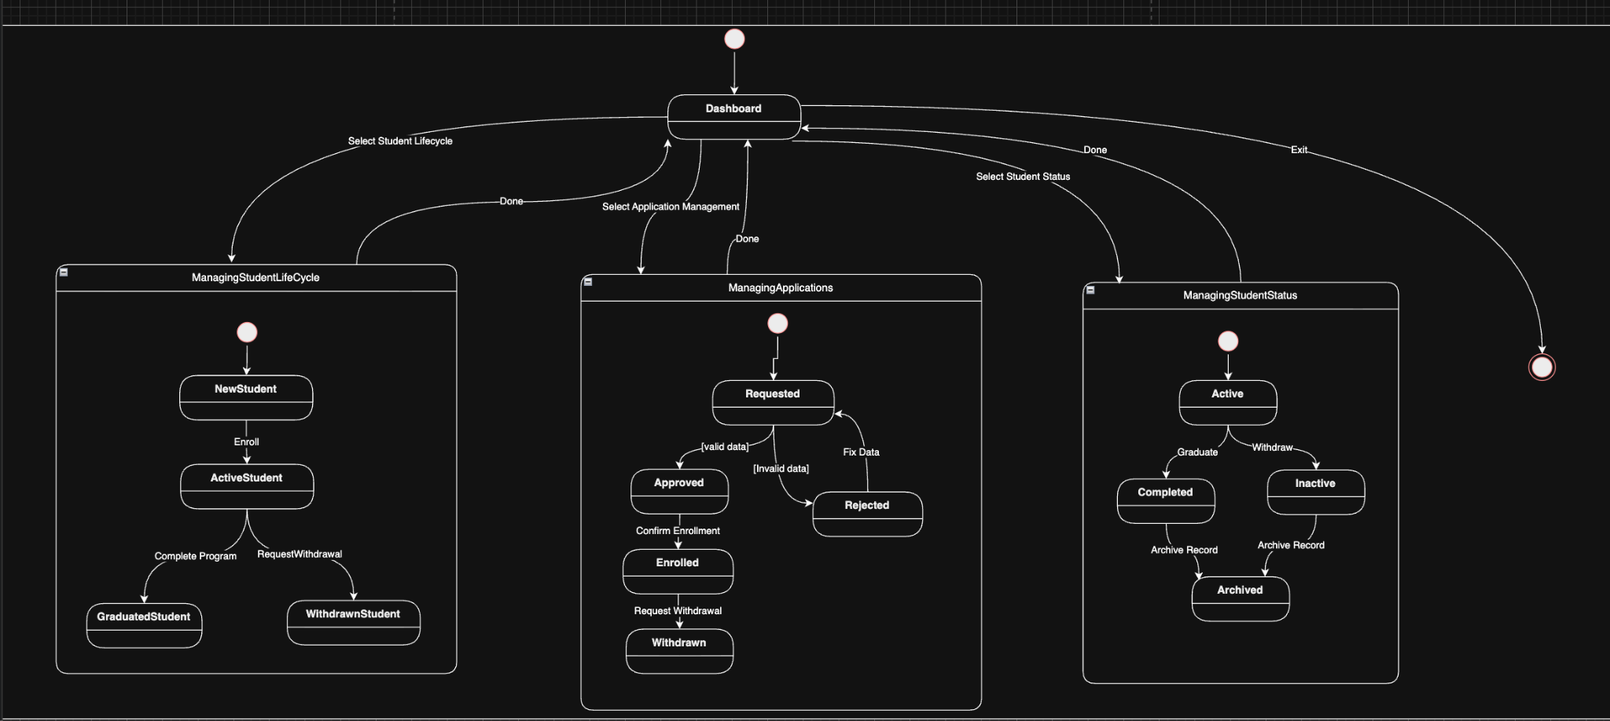

7.7 IT Staff state diagrams:

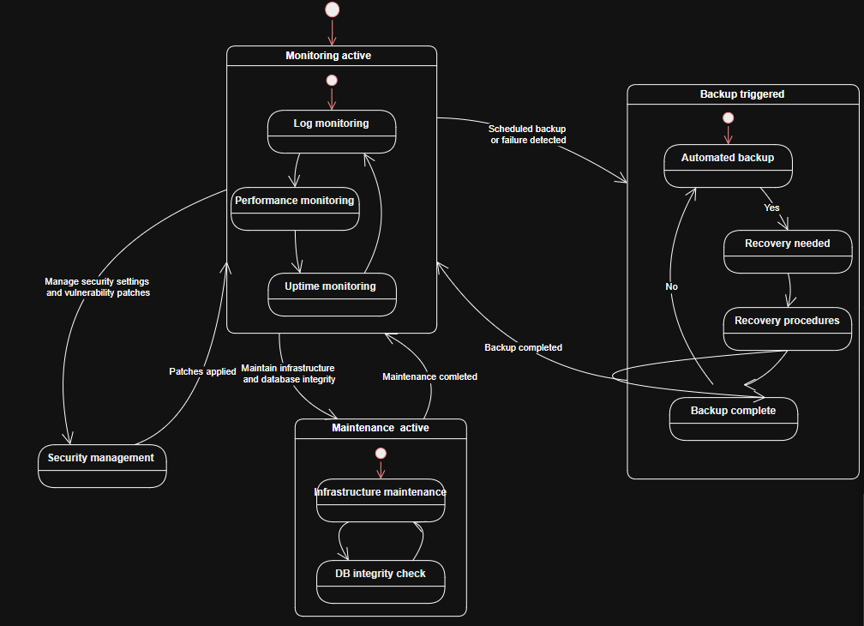

8. ERD diagram:

