**Name: Bakar Abdirisaq Mohamed**

**Reg No: 11713323**

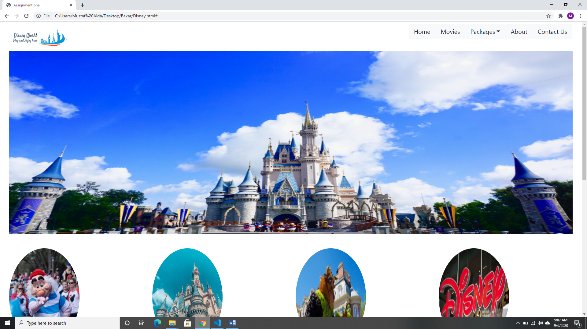

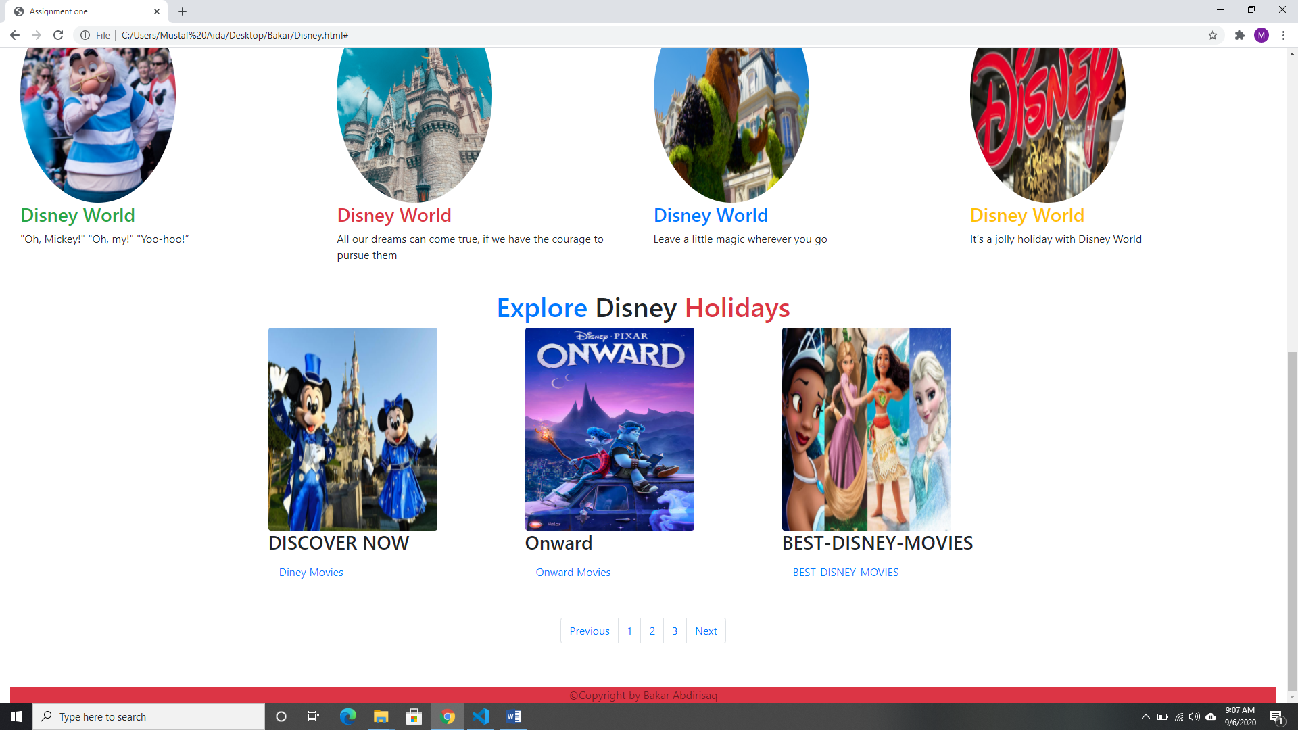

<!DOCTYPE html>

<html lang="en">

<head>

  <title>Assignment one</title>

  <meta charset="utf-8">

  <meta name="viewport" content="width=device-width, initial-scale=1">

  <link rel="stylesheet" href="https://maxcdn.bootstrapcdn.com/bootstrap/4.3.1/css/bootstrap.min.css">

  <link rel="stylesheet" href="https://use.fontawesome.com/releases/v5.6.3/css/all.css" integrity="sha384-UHRtZLI+pbxtHCWp1t77Bi1L4ZtiqrqD80Kn4Z8NTSRyMA2Fd33n5dQ8lWUE00s/" crossorigin="anonymous"></head>

  <script src="https://ajax.googleapis.com/ajax/libs/jquery/3.5.1/jquery.min.js"></script>

  <script src="https://cdnjs.cloudflare.com/ajax/libs/popper.js/1.16.0/umd/popper.min.js"></script>

  <script src="https://maxcdn.bootstrapcdn.com/bootstrap/4.3.1/js/bootstrap.min.js"></script>

 </head>

<body>

<div class="container-fluid">

        <div class="row">

          <div class="col-md-3">

    <ul class="nav ">

          <li class="nav-item"  ><a class="nav-link "  href="#" class="logo">

            <img src="buuuuu.PNG" alt="Logo" style="width:190px;height:80px;" class="rounded-circle" ></a>

          </li>

        </div>

        <div class="col-md-9">

          <nav class="navbar nav justify-content-end">

              <button type="button" class="btn btn-light btn-lg">Home</button>

              <button type="button" class="btn btn-light btn-lg">Movies</button>

              <div class="btn-group">

                <button type="button" class="btn btn-light dropdown-toggle btn-lg" data-toggle="dropdown">

                Packages</button>

                <div class="dropdown-menu">

                  <a class="dropdown-item" href="#">holidays</a>

                  <a class="dropdown-item" href="#">India</a>

                  <a class="dropdown-item" href="#">Tanziana</a>

                  <a class="dropdown-item" href="#">America</a>

                </div>

              </div>

              <button type="button" class="btn btn-light btn-lg">About</button>

              <button type="button" class="btn btn-light btn-lg">Contact Us</button>

          </nav>

    </div>

    </div>

    <div class="container-fluid">

        <img src="slider.jpg" height="600px;" width="100%">

        <br>

    </div>

    <br>

<br>

    <div class="class container-fluid">

      <div class="row">

        <div class="col-md-3">

          <img src="11.jpg" class="rounded-circle" alt="Sorry about the Picture" height="320px" width="230px">

          <h3 class="text-success">Disney World</h3>

          <p>"Oh, Mickey!" "Oh, my!" "Yoo-hoo!”</p>

        </div>

        <div class="col-md-3">

          <img src="122.jpg" class="rounded-circle" alt="Sorry about the Picture" height="320px" width="230px">

          <h3 class="text-danger">Disney World</h3>

          <p>All our dreams can come true, if we have the courage to pursue them</p>

        </div>

        <div class="col-md-3">

          <img src="12.jpg" class="rounded-circle" alt="Sorry about the Picture" height="320px" width="230px">

          <h3 class="text-primary">Disney World</h3>

          <p>Leave a little magic wherever you go</p>

        </div>

        <div class="col-md-3">

          <img src="disney.jpg" class="rounded-circle" alt="Sorry about the Picture" height="320px" width="230px">

          <h3 class="text-warning">Disney World</h3>

          <p>It’s a jolly holiday with Disney World</p>

        </div>

      </div>

      </div>

<br>

      <div class="container">

        <h1 class="text-center"><span class="text-primary">Explore </span>Disney<span class="text-danger"> Holidays</span></h1>

        <div class="row">

          <div class="col-md-4">

            <img src="dis.jpg" alt="Disney world" class="rounded" height="300px;" width="250px;">

            <div class="figcaption">

             <h3>DISCOVER NOW  </h3>

             <a href="#" class="nav-link" >Diney Movies</a>

            </div>

            </div>

            <div class="col-md-4">

              <img src="Onward.jpg" alt="Disney world" class="rounded" height="300px;" width="250px;">

              <div class="figcaption">

               <h3>Onward </h3>

               <a href="#" class="nav-link" >Onward Movies</a>

              </div>

              </div>

              <div class="col-md-4">

                <img src="BEST-DISNEY-MOVIES.jpg" alt="Disney world" class="rounded" height="300px;" width="250px;">

                <div class="figcaption">

                 <h3>BEST-DISNEY-MOVIES </h3>

                 <a href="#" class="nav-link" >BEST-DISNEY-MOVIES</a>

                </div>

                </div>

          </div>

        </div>

      </div>

<br>

<br>

<div class="container">

  <ul class="pagination justify-content-center">

    <li class="page-item"><a class="page-link" href="#">Previous</a></li>

    <li class="page-item"><a class="page-link" href="#">1</a></li>

    <li class="page-item"><a class="page-link" href="#">2</a></li>

    <li class="page-item"><a class="page-link" href="#">3</a></li>

    <li class="page-item"><a class="page-link" href="#">Next</a></li>

  </ul>

</div>

<br>

<br>

    <div class="container-fluid">

      <footer class="page-footer font-small blue-grey lighten-5"></footer>

      <div class="footer-copyright text-center text-black-50 bg-danger ">&copy;Copyright by Bakar Abdirisaq

      </div>

    </div>

</footer>

</div>

</div>

</body>

</html>