Abstract 2

Introduction 3

1.1 Introduction to Survey System 3

1.2 Why Survey System 3

1.3 Survey System System 3

1.4 Project Objective 4

Chapter 2 5

Survey System Literature Review 5

1.1 Survey System Development Process 5

2.2 Survey System Categories 6

2.3 Survey System Applications 7

2.4 Survey System Techniques 8

Chapter 3 9

3.1 Overview 9

3.2 Intended Audience 9

3.3 Project Outcomes 10

Chapter 4 11

3.1 Project Outcomes Prototype 11

3.2 Planning Phase 11

3.2.1 Sponsors 11

3.2.2 Business Need 11

3.2.3 Business Requirement 12

3.2.4 Business Value 13

3.2.5 Special Issues and Constraints 14

3.3 Analysis Phase 15

# Abstract

This project aims to develop an advanced survey solution that addresses the limitations of existing platforms. The initiative focuses on creating a user-centric form builder with AI capabilities, addressing key drawbacks identified in competitors like Google Forms. The development is structured in two main phases. Phase 1 establishes core infrastructure including authentication, basic form building capabilities, and data architecture. Phase 2 enhances the platform with AI integration and custom styling features. Key deliverables include AI-powered question analysis, an intuitive interface with customizable templates, and comprehensive analytics with real-time visualization capabilities.

Introduction

* 1. **Introduction to Survey System**

Survey systems have revolutionized data collection in the 21st century, making it easier than ever before. However, many existing survey platforms focus solely on gathering information—often redundantly.   
Our new approach integrates AI agents to make survey systems more versatile and efficient. Additionally, we offer customizable forms that allow users to add their personal touch.

* 1. **Why Survey System**

Many survey creators lack experience in structuring effective questions, which can result in poor-quality feedback or even misleading responses. Traditional form-building tools often focus solely on data collection rather than guiding users to craft meaningful, high-impact surveys.

Survey System addresses this issue by integrating an AI-driven form builder that not only streamlines survey creation but also enhances the quality of questions using advanced AI models. Our platform ensures that users, regardless of expertise, can generate well-structured, insightful surveys efficiently.

Additionally, while many competitors impose rigid design limitations, Survey System provides a highly customizable form-building experience. Users have the freedom to personalize the look and feel of their surveys, incorporating their personal or company branding without restrictive design constraints. This flexibility allows for greater engagement and a professional touch, making Survey System an innovative and user-friendly solution.

* 1. **Survey System System**

At Survey System, we leverage **AI-driven solutions** to enhance the form-building experience, ensuring that surveys generate **high-quality, insightful questions**. Our goal is to **maximize the return on investment (ROI) of feedback** by helping users craft questions that yield meaningful responses.

One of our key features is an **integrated AI-powered chatbot**, which actively assists users in designing their surveys. By interacting with this chatbot, users can receive **real-time suggestions** for structuring effective questions, making the survey creation process smoother and more intuitive.

Additionally, Survey System offers a **highly customizable** survey-building experience. Unlike many competitors with restrictive design templates, our platform provides **extensive creative freedom**. Users can seamlessly **integrate their personal or company branding**—customizing layouts, colors, and other design elements to match their identity.

* 1. **Project Objective**

Our goal is to create a **next-generation survey system** that goes beyond simply collecting responses. Instead of just offering a service, Survey System actively **empowers users** by leveraging **AI-driven assistance** to help them craft high-quality surveys that generate meaningful insights.

We also recognize the importance of **personal and professional branding**. That’s why Survey System provides a **highly customizable form-building experience**, allowing users to tailor their surveys to reflect their personal or company identity. With our **flexible and intuitive design tools**, users can seamlessly integrate their branding elements, ensuring that every form feels unique and professional.

By combining **AI-powered question optimization** with **unmatched design freedom**, Survey System aims to redefine how surveys are created—making the process more efficient, engaging, and insightful for everyone.

**Survey System Literature Review**

* 1. **Survey System Development Process**

1. **Phase 1: Core Features**

The first phase focuses on establishing a **functional and secure foundation** for the Survey System platform. The key objectives include implementing **user authentication, building a flexible form creator, ensuring secure data handling, and supporting multiple file formats**.

Key features in Phase 1:

* **User Authentication System**

Secure login and user identity management.

* **Basic Form Builder**

Support for fundamental question types.

Expansion to multiple question formats for

* **Milestone Notification System**

Alerts for key user activities and progress updates

* **File Upload Support**

Ability to upload various file formats.

* **Data Storage Architecture**

Secure and scalable database structure for storing responses.

1. **Phase 2: Advanced Question System**

The second phase enhances Survey System by introducing **AI-driven features and advanced customization**, making surveys more intuitive, engaging, and personalized.

Key features in Phase 2:

* **Custom Styling Options**

Users can fully personalize the design of their forms.

* **AI Assistant Deployment**

AI-driven question recommendations for higher-quality survey creation.

By implementing these phases, Survey System aims to provide a **powerful, AI-enhanced survey platform**

* 1. **Survey System Categories**

Survey systems can be categorized based on their purpose, target audience, and data collection method. These categories help in understanding the different applications and functionalities of survey tools, ensuring that the right approach is used for effective data collection.

1. Based on Purpose

Different surveys serve distinct objectives, depending on what data needs to be collected and analyzed. Some common types include:

* Market Research Surveys – Used to gather insights on consumer behavior, preferences, and trends to help businesses improve products and services.
* Customer Feedback Surveys – Focus on collecting opinions from customers regarding their experiences with a product, service, or brand.

2. Based on Target Audience

Surveys can also be categorized based on who the intended respondents are:

* B2B (Business-to-Business) Surveys – Targeted at businesses and industry professionals for insights on market trends and professional services.
* B2C (Business-to-Consumer) Surveys – Designed for direct consumers to collect product feedback, service satisfaction, and user experiences.

3. Based on Data Collection Method

Surveys can be classified based on how data is collected:

* Online Surveys – Digital forms distributed via web platforms (e.g., DMA, Google Forms) for quick and efficient data collection.
* Face-to-Face Surveys – Conducted in person, often through interviews, for more accurate and detailed responses.
  1. **Survey System Applications**

The Survey System survey system is designed to be a versatile tool that can be applied across multiple industries and domains. Its AI-driven approach and customizable features make it valuable for gathering accurate, high-quality feedback in various settings.

**Key Application Areas:**

* Academic Sector – Used for student feedback, research surveys, assessments, and institutional evaluations.
* Business Sector – Applied in market research, customer satisfaction surveys, employee feedback, and performance assessments.

Beyond these core sectors, the Survey System's flexibility allows it to be adapted for healthcare, social research, government policy analysis, and more, making it a dynamic solution for diverse data collection needs.

* 1. **Survey System Techniques**

Survey systems rely on various techniques to design, distribute, and analyze surveys effectively.

1. Question Design Techniques

The quality of survey responses heavily depends on how questions are structured.

* Closed-Ended Questions – Provide predefined answer choices (e.g., multiple-choice, yes/no, Likert scale). These are useful for structured data analysis.
* Open-Ended Questions – Allow respondents to give detailed, qualitative responses. Best for in-depth insights but require advanced analysis.

2. Survey Distribution Techniques

The effectiveness of a survey also depends on how it is delivered to respondents.

* Email Surveys – Directly sent to users via email. Effective for targeted audiences but requires engagement strategies to ensure responses.
* Web-Based Surveys – Hosted on online platforms like DMA, Google Forms, or Typeform, making them accessible and easy to distribute.

3. Data Collection & Analysis Techniques

Once survey responses are gathered, various techniques help process and interpret the data for decision-making and insights generation:

* Descriptive Analysis – Summarizes survey data using percentages, averages, and distribution metrics to identify trends.
* Sentiment Analysis – Uses AI to analyze open-ended responses and gauge the emotional tone of feedback.

DMA integrates AI-driven techniques to enhance survey accuracy, automate analysis, and generate actionable insights, making it a next-generation survey solution.

**Methods**

* 1. **Overview**

DMA is designed to help **individual users and companies** collect **meaningful, high-quality feedback** that is both **efficient and actionable**. By leveraging **AI-driven question optimization**, DMA ensures that responses provide **valuable insights rather than generic or low-quality data**.

Additionally, DMA prioritizes **user experience and branding flexibility** by offering a **customizable, professional front-end interface**. This allows businesses and individuals to create surveys that not only **gather insights effectively** but also **maintain a polished and branded appearance**, enhancing credibility and engagement.

* 1. **Intended Audience**

DMA is designed to serve a diverse range of users across different sectors, ensuring that surveys are tailored to specific needs and objectives. The platform caters to the following key audiences:

1. Academic Sector

DMA provides a valuable tool for educational institutions, enabling structured feedback collection and research applications:

* Teachers – Gather student feedback, conduct assessments, and improve course structures.
* Students – Participate in research surveys, peer evaluations, and project-related data collection.

2. Business Sector

DMA empowers businesses to streamline decision-making by collecting insightful data:

* Managers – Conduct employee engagement surveys and performance evaluations.
* CEOs & Executives – Gather strategic insights, customer feedback, and market research.
  1. **Project Outcomes**

Key Project Outcomes:

* Personalized & Branded Forms – Users can create surveys that reflect their personal or company branding, ensuring a professional and customized image.
* High-Quality Question Generation – AI-driven assistance helps craft clear, structured, and relevant questions, reducing bias and ambiguity while improving response accuracy.
* More Efficient & Actionable Feedback – Surveys designed with AI optimization encourage meaningful responses, leading to higher-quality insights for better decision-making.
* Continuous System Improvement – Feedback loops enable adaptive system enhancements, ensuring that DMA evolves dynamically based on user needs and input.
* Increased Engagement & Business Growth – Enhanced surveys result in better engagement, more informed strategies, and improved decision-making, leading to a noticeable boost in productivity and profitability.

System Analysis

* 1. **Project Outcomes Prototype**

**Landing Page**

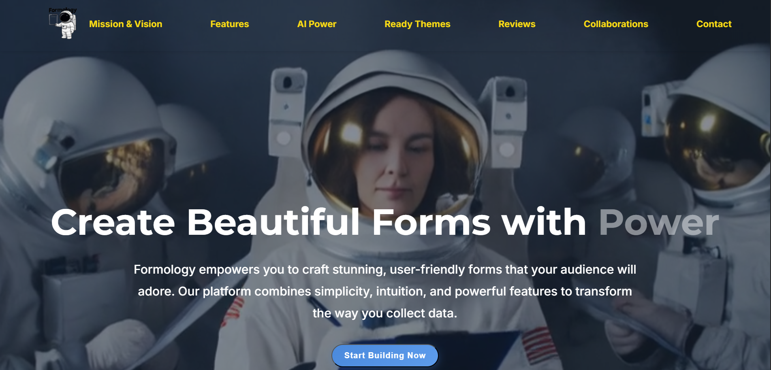

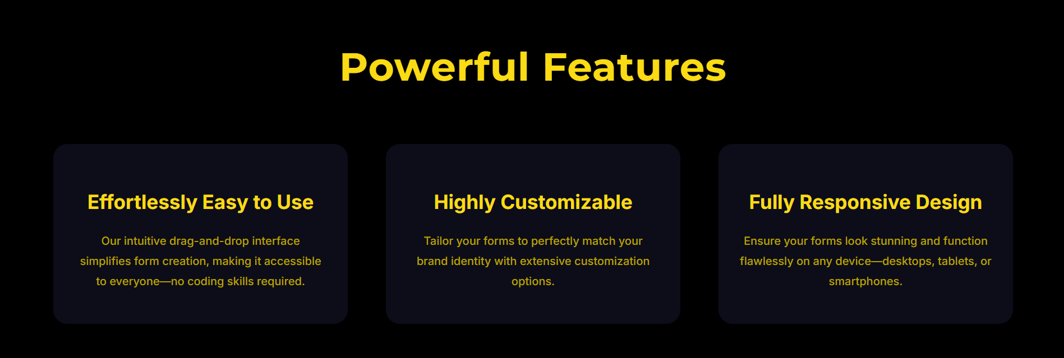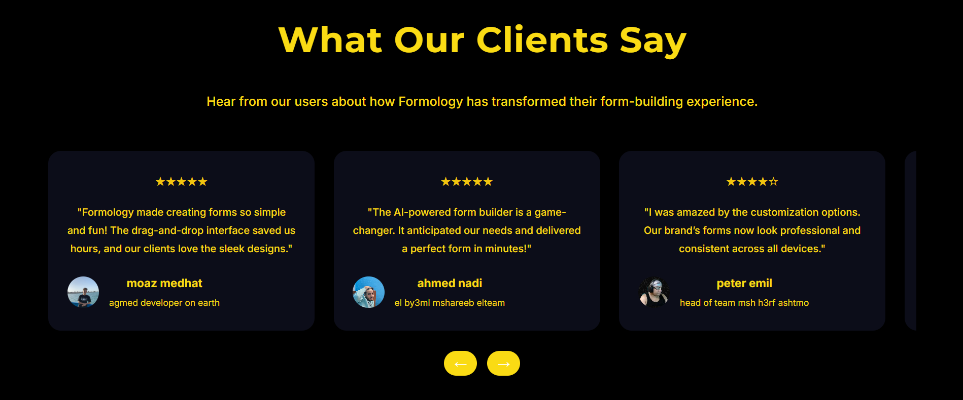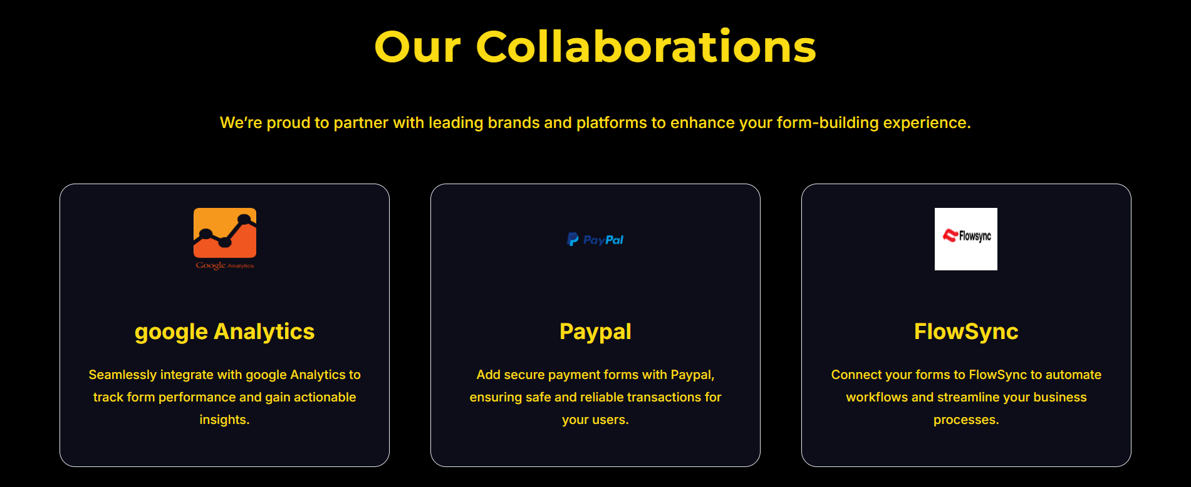

**Home**

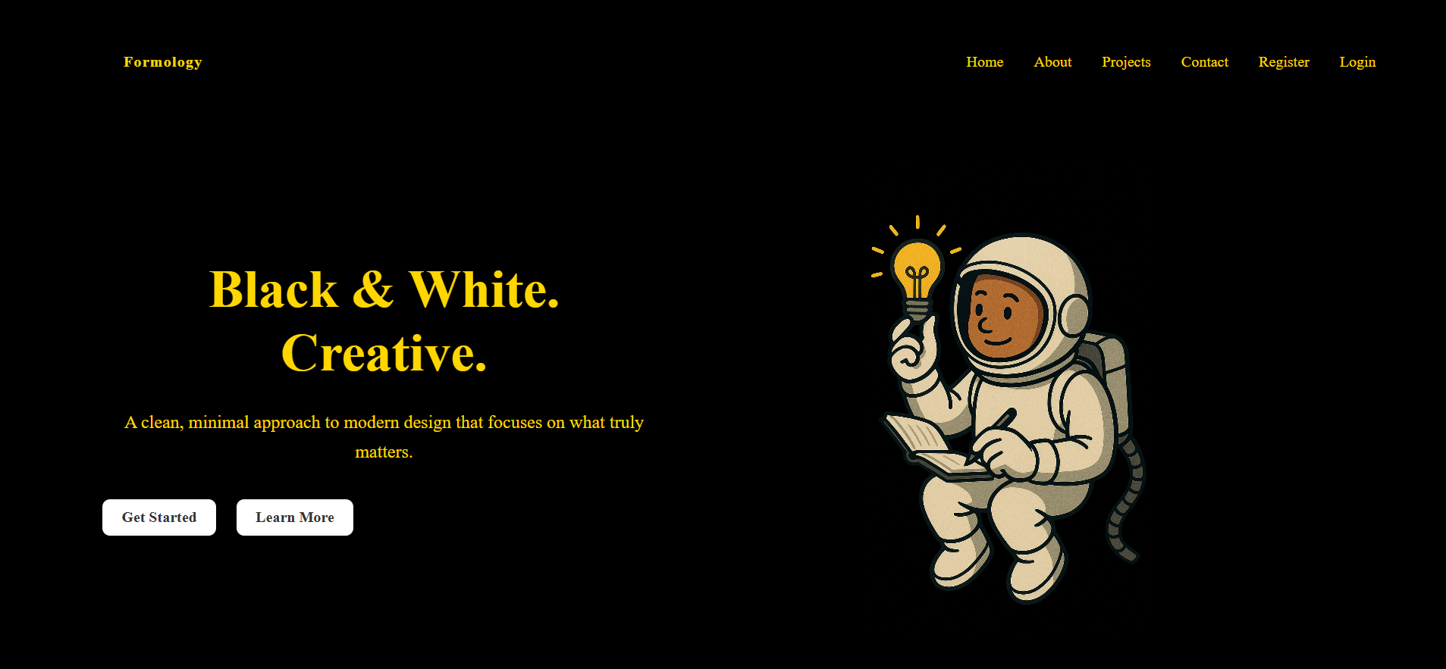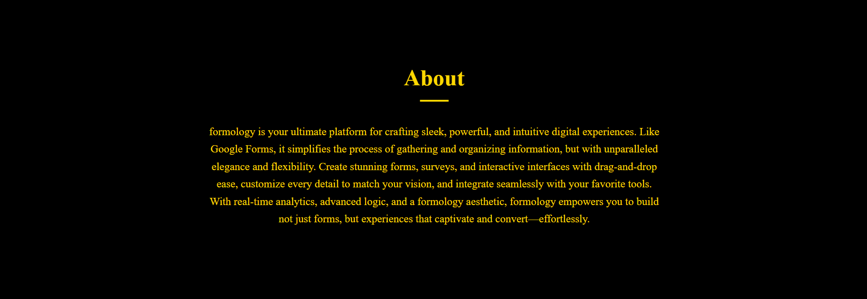



**Login**

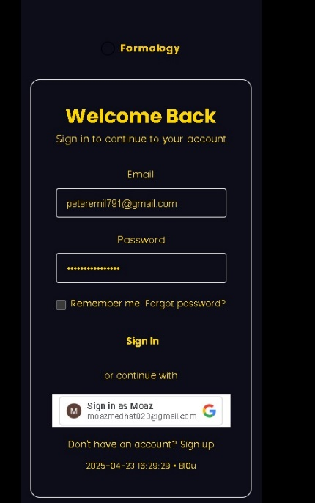

**Register**

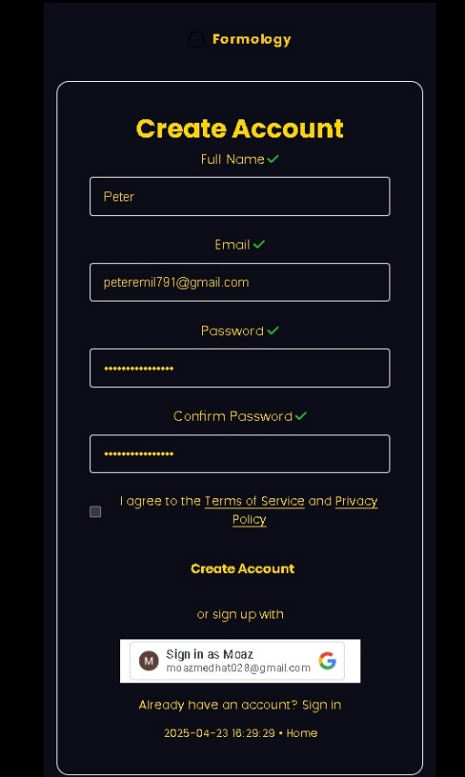

**Start Section**



**Add Question x3**



**Section Review**

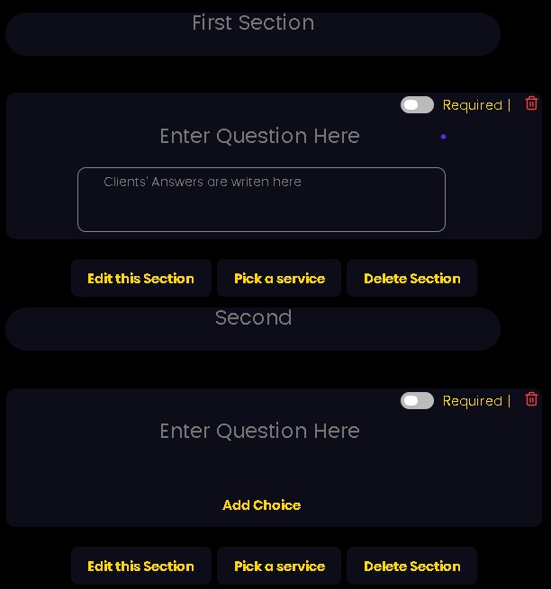

**Ask AI**

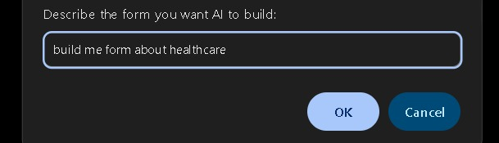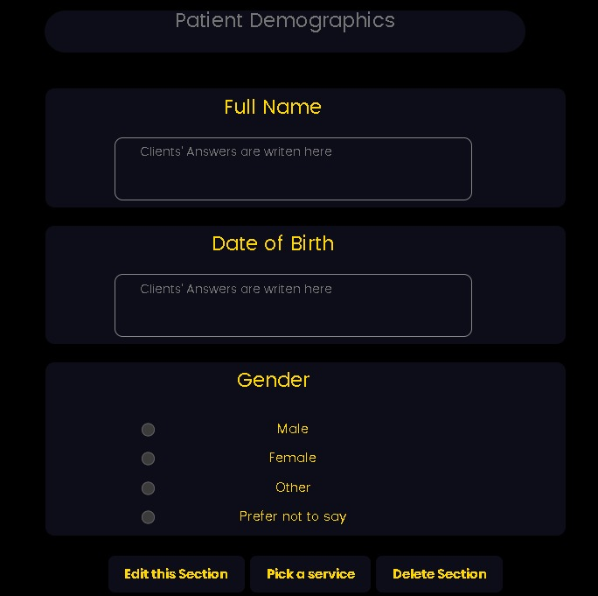

**Publish Form**

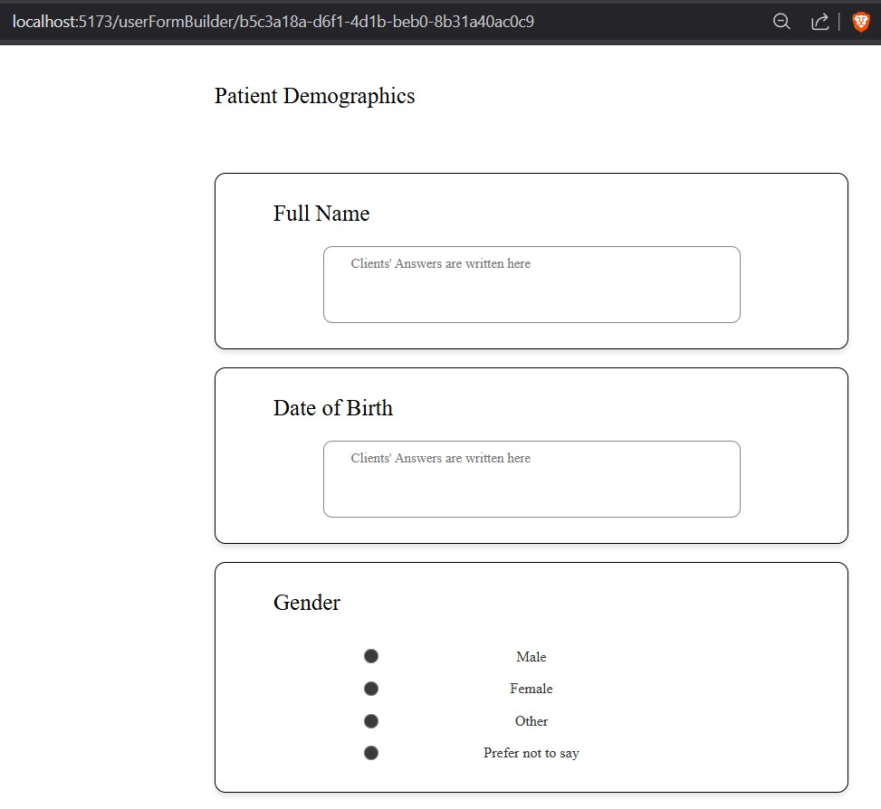

**Dashboard**

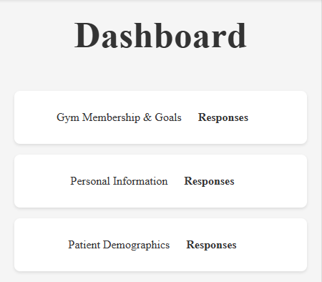

**Responses**

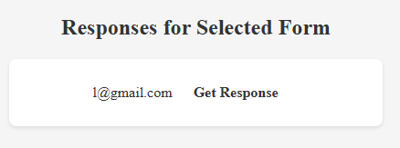

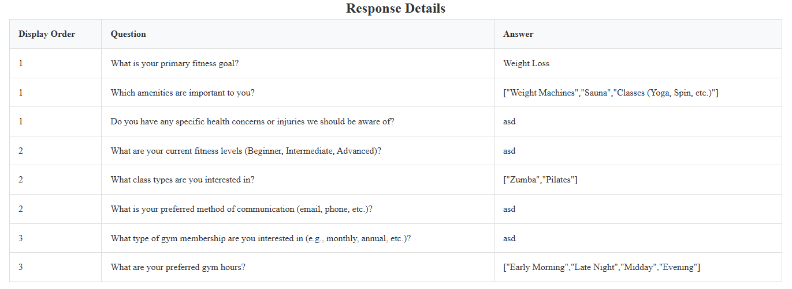

* 1. **Planning Phase**
     1. **Sponsors**

**Sinai University**

WDT Project Instructor: **Dr. Nasser**

WDT Project Illustrator: **Dr. Shereen**

* + 1. **Business Need**

Surveys are a powerful tool for collecting insights, but traditional survey systems often lead to low-quality responses, poorly structured questions, and ineffective feedback loops. Businesses and individuals need a smarter, AI-enhanced approach to ensure meaningful and actionable feedback.

DMA is designed to bridge this gap by offering an intelligent, user-friendly, and highly customizable survey system. Users can:

* Easily create and personalize forms to reflect their brand identity.
* Leverage advanced AI models to generate well-structured, high-impact questions that enhance response quality.
* Improve decision-making by collecting feedback that is accurate, relevant, and efficient.

By guiding users through the survey-building process and ensuring high-quality data collection, DMA empowers businesses, educators, and organizations to make data-driven decisions with confidence.

* + 1. **Business Requirement**

DMA focuses on delivering essential features that ensure usability, efficiency, and high-quality feedback collection. The system provides:

* A highly customizable form builder that allows users to personalize surveys based on their personal or business needs.
* AI-driven assistance for question optimization, ensuring surveys generate reliable and actionable responses.
* A professional and intuitive interface, making survey creation user-friendly for both individuals and companies.
* Advanced analytics and reporting through a real-time data dashboard, empowering users with insights and better decision-making.
* Pre-built, ready-to-use templates to simplify survey creation and improve efficiency.
  + 1. **Business Value**

The development of DMA is expected to generate significant business value by enhancing market presence, driving revenue growth, and establishing the company as a leader in AI-powered survey solutions.

1. Market Growth & Competitive Positioning

* We aim to capture 10% of the market share within the survey system industry, positioning DMA as a strong competitor against existing platforms.
* By introducing AI-driven enhancements and advanced customization, DMA differentiates itself from traditional survey tools, attracting a broader user base.

2. Revenue & Financial Impact

* The successful launch and adoption of DMA are expected to increase company revenue by 5%, creating a new profitable product line.
* Long-term monetization strategies, such as premium features or enterprise solutions, can further enhance financial stability.

3. Innovation & Technological Advancement

* This project marks the first AI-driven implementation in the company’s history, paving the way for future AI-integrated projects.

4. Customer Trust & User Expansion

* By offering a secure, reliable, and highly customizable survey system, DMA enhances customer trust and satisfaction.

5. Large-Scale Software Adoption

* The project will contribute to building a robust and scalable platform, capable of supporting thousands of daily users.
* Establishing a widely adopted software solution increases brand recognition and credibility in the industry.
  + 1. **Special Issues and Constraints**

Developing DMA comes with several challenges and constraints that may impact development timelines, technical execution, and market positioning. These key factors must be carefully managed to ensure the project's success.

1. Competitive Market & Business Limitations

* DMA operates within a highly competitive market, where established players already dominate the survey industry.
* As a small-scale business model, gaining market traction will require strategic differentiation and innovative features.

2. Limited Development Resources & Team Size

* The development team is small, which may affect product timelines and feature scalability.
* Resource constraints could lead to delays in meeting deadlines, requiring efficient task management and prioritization.

3. AI Integration Challenges

* This is the first AI-driven project for the company, meaning additional research and experimental iterations will be necessary.

4. Pre-Development Learning Requirements

* Developers need to learn and adapt to new programming languages and AI frameworks, adding an extra phase before implementation.

5. Strict Delivery Deadline

* The system must be delivered before the midterm, putting additional pressure on development speed and feature prioritization.
* Efficient project management and agile development practices will be crucial to meeting this deadline.
  1. **Analysis Phase**
* **Process-Oriented Functional Requirements**

1. User Authentication & Access Control
   * The system must allow users to create an account and log in securely to access features.
2. Form Creation & AI Assistance
   * The system must allow users to create forms after successfully logging in.
   * The system must provide users with an AI-powered question optimization tool to enhance survey effectiveness.
3. Customization & Professional Branding
   * The system must offer a highly customizable form builder that enables users to personalize their surveys to reflect their personal or company branding.
4. Form Management & Dashboard Accessibility
   * The system must allow users to access a personal dashboard where they can view, manage, and edit their created forms at any time

* **Information-Oriented Functional Requirements**
  1. Secure Form Response Backup & Management
     + The system must automatically back up all form responses and provide users with the option to select which responses to back up or exclude.
  2. Response Handling & Data Management
     + The system must allow users to view collected responses in real time.
     + The system must provide an option to download survey responses for further analysis.

**System Design**

* 1. **Use Case Diagram**

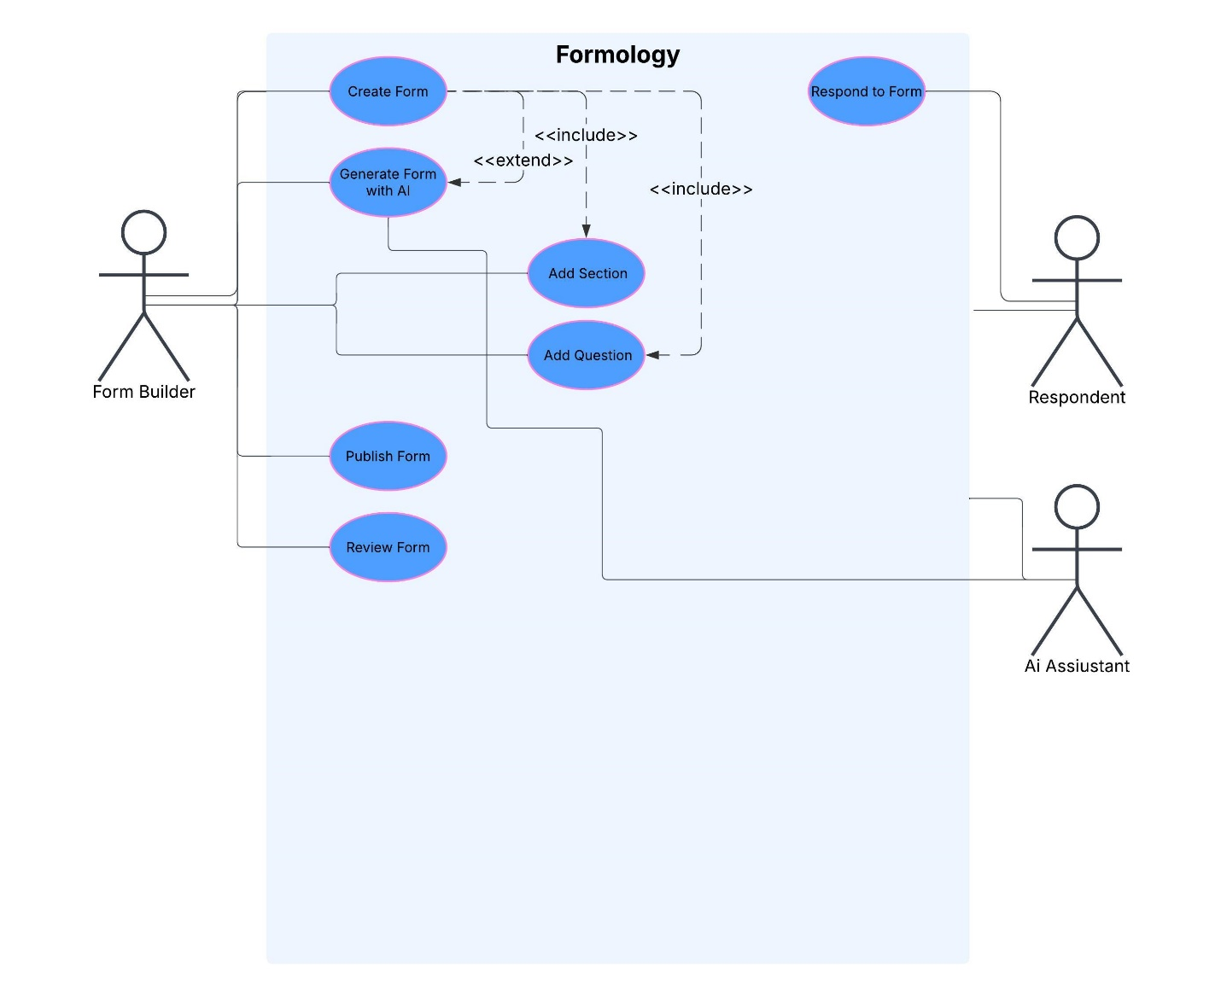

* 1. **Class Diagram**

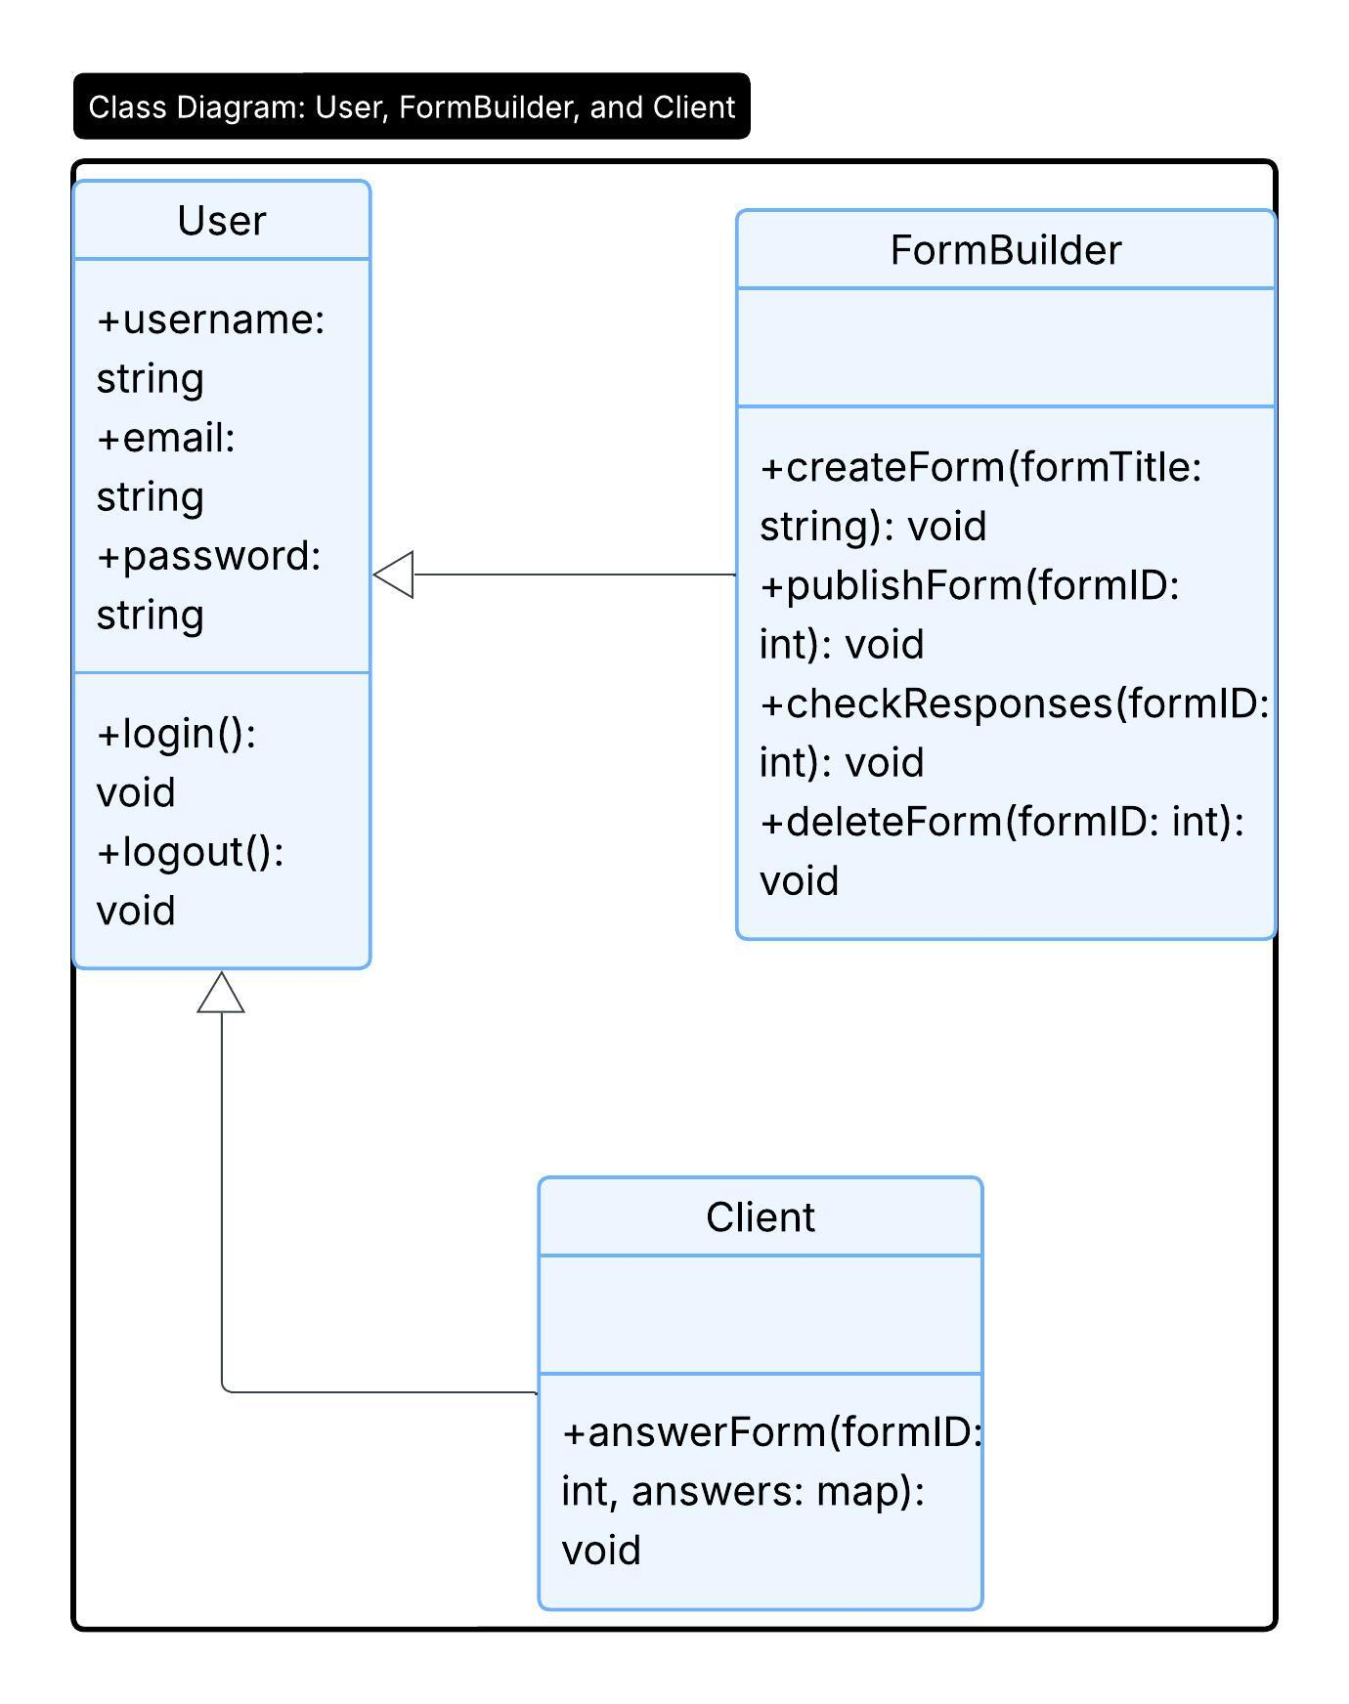

* 1. **ER Diagram**

