INTRODUCTION

This railway reservation system is a comprehensive program designed to manage train details, reservations, and passenger information efficiently. It provides users with the capability to register, log in, book reservations, view statistics, and perform various administrative tasks related to train operations. With features like adding and removing train details, displaying reservation information, and generating graphical representations of passenger data, this system offers a user-friendly and interactive interface. It aims to streamline the process of train management and reservation, ensuring a smooth and convenient experience for both administrators and passengers alike.

System Requirements

- Recommended
Processor: Intel Core i5
Ram: 8 to 16 GB
Disk Space: 512GB to 1TB
Operating System: Windows 11,Mac

- Minimum
Processor: Intel Core i3
Ram: 2 to 4 GB
Disk Space: 128 to 250GB
Operating System: Windows 7 or above

- Required Software: Python 3.11

CSV FILES

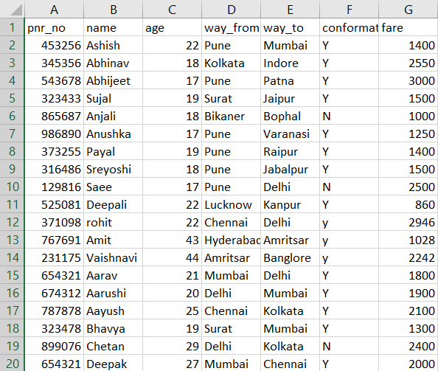
- CSV1(Reservation details)

- CSV2(Train Details)
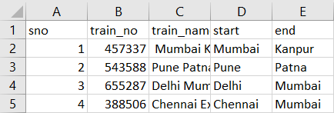

Source Code

import csv
import pandas as pd
import numpy as np
import sys
import random
import matplotlib.pyplot as plt

# User credentials dictionary
user_credentials = {}

# Load user data from a CSV file
def load_user_credentials():
user_credentials = {}
try:
with open("user_credentials.csv", mode="r") as file:
reader = csv.reader(file)
for row in reader:
username, password = row
user_credentials[username] = password
except FileNotFoundError:
pass
return user_credentials

# Function to save user data to a CSV file
def save_user_credentials(user_credentials):
with open("user_credentials.csv", mode="w", newline="") as file:
writer = csv.writer(file)
for username, password in user_credentials.items():
writer.writerow([username, password])

# Load user data from CSV file
user_credentials = load_user_credentials()

def get_user_credentials(username):
return user_credentials.get(username, None)

def register(username, password):
if username in user_credentials:
print("Username already exists. Please choose a different one.")
else:
user_credentials[username] = password
save_user_credentials(user_credentials)
print("Registration successful!")

def login(username, password):
stored_password = get_user_credentials(username)
if stored_password == password:
print("Login successful!")
return True
else:
print("Invalid username or password. Please try again.")
return False

print()
print()
print('#'*86)
print()
print()
print(' ' * 70, ".....Welcome to Train Reservation.....",)
print()
print()

logged_in = False # Flag to track if the user is logged in

while True:
while not logged_in:
print("\n1) Register\n2) Login\n3) Quit")
choice = input("Select an option: ")

if choice == "1":
username = input("Enter a username: ")
password = input("Enter a password: ")
register(username, password)

elif choice == "2":
username = input("Enter your username: ")
password = input("Enter your password: ")
if get_user_credentials(username) is not None:
if login(username, password):
logged_in = True # Set the flag to True after successful login
else:
print("Username doesn't exist. Please register first.")

elif choice == "3":
print("Goodbye!")
sys.exit()

else:
print("Invalid choice. Please try again.")

# The user is now logged in, so they can access the reservation system
df = pd.read_csv("D:\c\csv2.csv", index_col="sno")
lf = pd.read_csv("D:\c\csv1.csv", index_col="pnr_no")

a = print("+++++++++++++++++++++++++++++++++++++++++++++++++++++++++++++++++++++")
b = print("+ 1) Add Train Details +")
print("+ 2) Remove Train Detail +")
print("+ 3) New Reservation +")
print("+ 4) Show All Reservation Details +")
print("+ 5) Show Our Reservation Details +")
print("+ 6) Show Graph for Count of Passengers by Age Group +")
print("+ 7) Analyze and Display Statistics about Passenger Fares +")
print("+ 8) Search for a Train by its Train Number +")
print("+ 9) Logout +")
print("+++++++++++++++++++++++++++++++++++++++++++++++++++++++++++++++++++++")
print()
option = int(input("Select your option: "))

if option == 1:
# code for adding train details
print()
print()
print(pd.read_csv("D:\c\csv2.csv"))
print()
sno = int(input("Enter s.no: "))
print()
train_no = int(input("Enter train no.: "))
print()
train_name = input("Enter train name: ")
print()
start = input("Enter train start station: ")
print()
end = input("Enter train end station: ")
print()
df.loc[sno, :] = [train_no, train_name, start, end]
df.to_csv("D:\c\csv2.csv")
print(' ' * 10, "processing...")
print()
print()

elif option == 2:
# code for removing train details
print()
print(df)
print()
sno = int(input("Enter s.no to be removed : "))
print()
df.drop(sno, axis=0, inplace=True)
df.to_csv("D:\c\csv2.csv")
print('Processing...')
print()
print()
print(df)
print()
print()
print()

elif option == 3:
# code for new reservation
print()
NAME = input("Enter your name: ")
print()
AGE = int(input("Enter your age: "))
print()
WAY_FROM = input("Enter way from station: ")
print()
WAY_TO = input("Enter way to station: ")
print()
pnr_no = random.randint(111111, 999999)
FARE = random.randint(1000, 3500)
CONFIRMATION = 'y'
lf.loc[pnr_no, :] = [NAME, AGE, WAY_FROM, WAY_TO, CONFIRMATION, FARE]
lf.to_csv("D:\c\csv1.csv")
print('Processing...')
print()
print()
print("Your PNR_NO :", pnr_no)
print()
print()
print()
print('Reservation Successful')
print("#######################################################################")

elif option == 4:
# code for showing all reservation details
print()
print(lf)
print()
print()

elif option == 5:
# code for showing reservation details
print(' ' * 10, '*** |__| PNR_NO |__| ***')
print()
print(pd.Series(lf.index))
print()
print()
pnr_no = int(input("Enter your pnr_no.: "))
print()
detail = lf.loc[pnr_no, :]
print()
print(' ' * 10, 'Details related with this', pnr_no, 'is...')
print()
print()
print(detail)
print()
print()

elif option == 6:
# code for showing graph
data = pd.read_csv(r'D:\c\csv1.csv')
age_ranges = ['0-10', '10-20', '20-30', '30-40', '40-50', '50-60', '60-70', '70-80', '80-90', '90-100']
data['age_group'] = pd.cut(data['age'], bins=range(0, 101, 10), right=False, labels=age_ranges)
age_counts = data['age_group'].value_counts().sort_index()
ages = list(age_counts.index)
counts = list(age_counts.values)
plt.bar(ages, counts, align='center',color='r')
plt.xlabel('Age Group')
plt.ylabel('Count')
plt.title('Count of Passengers by Age Group')
plt.show()

elif option == 7:
# code for analysing passenger fares
df_CSV1 = pd.read_csv("D:\c\csv1.csv")
print()
print("Statistics about Passenger Fares:")
print(" ====================================")
print(" | Mean Fare:", df_CSV1['fare'].mean()," |")
print(" | Median Fare:", df_CSV1['fare'].median()," |")
print(" | Minimum Fare:", df_CSV1['fare'].min()," |")
print(" | Maximum Fare:", df_CSV1['fare'].max()," |")
print(" ====================================")

elif option == 8:
# code for searching a train by its number
print(df)
train_number = int(input("Enter the train number: "))
train_info = df[df['train_no'] == train_number]

if not train_info.empty:
print("Train Information:")
print(train_info)
else:
print("Train with train number {} not found.".format(train_number))

elif option == 9:
#code for logout
print("Logging out...")
logged_in = False
user_credentials = load_user_credentials()

else:
print("Invalid option. Please try again.")

print()
input("Press Enter to continue...")

Outputs

1. Register

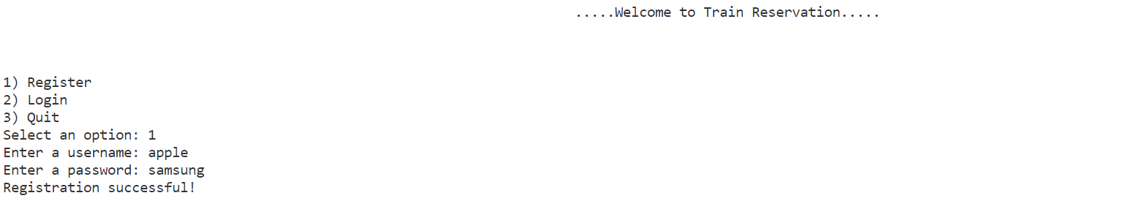

2.Login
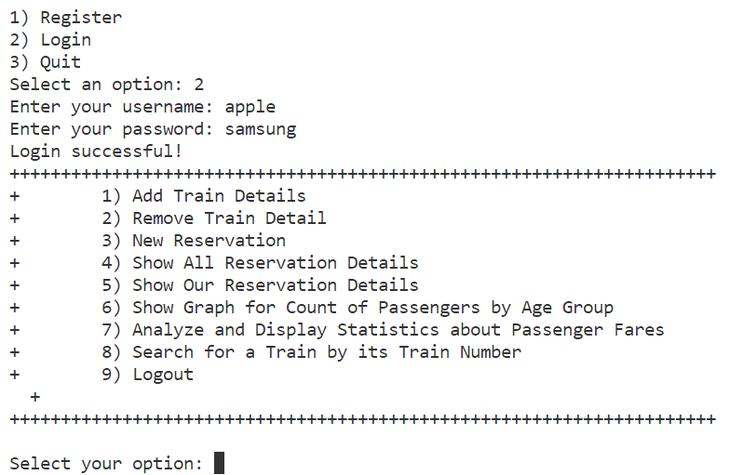

3.Quit
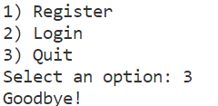

4.Selecting the options


5.Adding Train Details
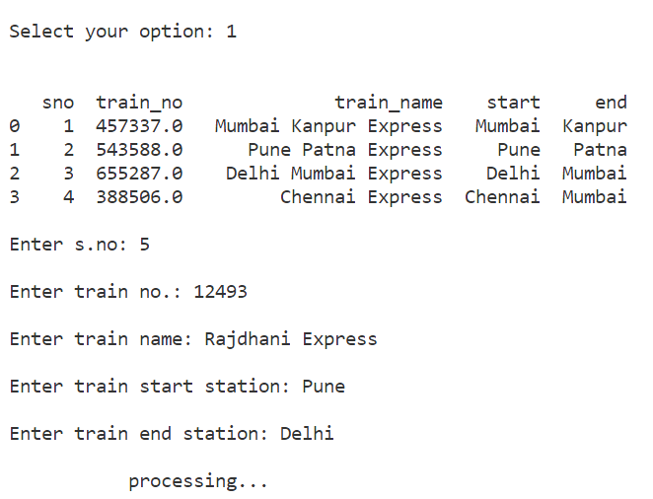

6.Removing Train Details
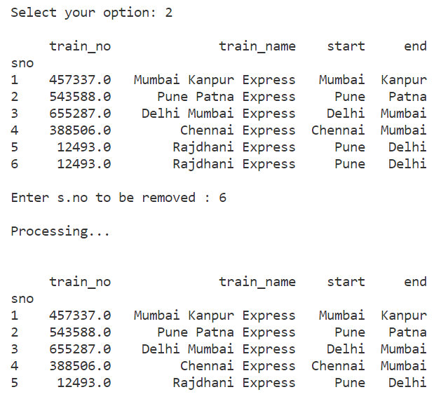

7.New Reservation
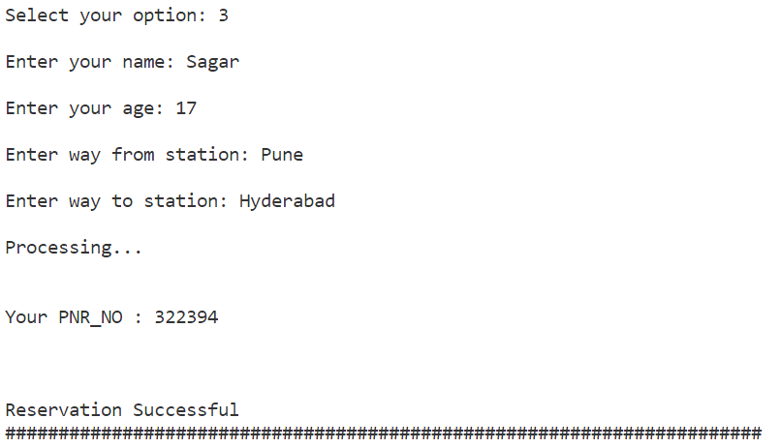

8.Seeing all Reservation Details
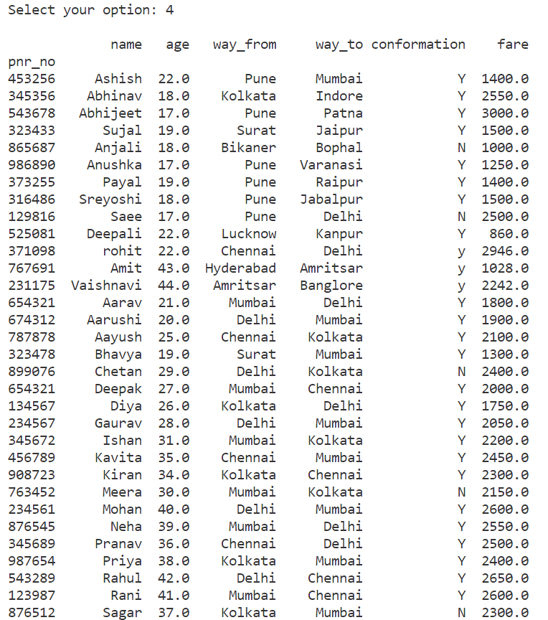

9. Show Our Reservation Details
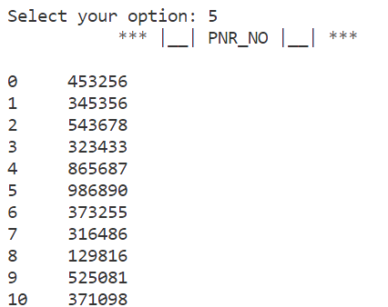
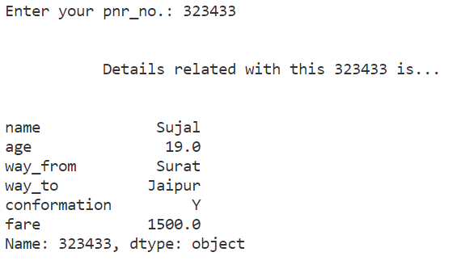

10. Show Graph for Count of Passengers by Age Group
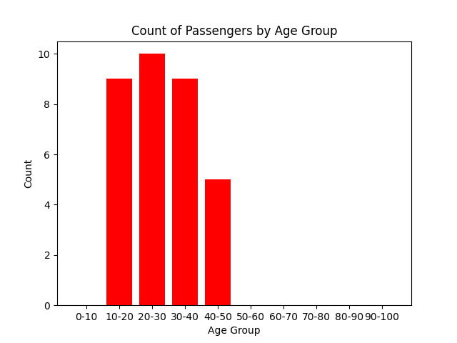
11. Analyse and Display Statistics about Passenger Fares
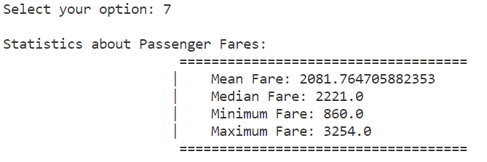
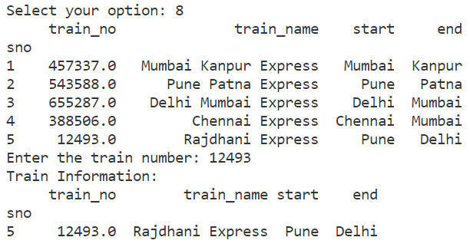
12. Search for a Train by its Train Number

13. Logout
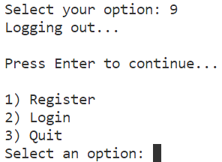

REFERENCES

- Informatics Practices A Text book for Class XI by Sumita Arora.
- Informatics Practices A Text book for Class XII by Sumita Arora.
- Informatics Practices NCERT Text Book Class XII.
- Open Source from Internet.

