**Software Requirements**

**Specifications**

**for**

**G5 – Campus Wellness Portal with Medical System and Fitness Center Integration**

Version: 1.0

Date: 01.05.2025

Group: 5

Ng Jia Hong 1211101788

Danish Haziq 1221302704

Lee Ken Yu 1221303813

# Revisions

| **Version** | **Primary Author(s)** | **Description of Version** | **Date Completed** |
| --- | --- | --- | --- |
| 1.0 |  | This version contains the software and hardware requirement descriptions, system functions and overview. | ??.05.2025 |

**Table of Contents**

Revisions i

1.0 Introduction 1

1.1 Purpose 1

1.2 Scope 2

1.3 Product Overview 4

1.3.1 Product Perspective 4

1.3.1.1 System Interfaces 5

1.3.1.2 User Interfaces 6

1.3.1.3 Hardware Interfaces 6

1.3.1.4 Software Interfaces 7

1.3.1.5 Communication Interfaces 8

1.3.1.6 Memory Constraints 8

1.3.1.7 Operations 8

1.3.1.8 Site Adaptation Requirements 9

1.3.1.9 Interface with Services 9

1.3.2 Product Functions 10

1.3.2.1 Use Case Diagram 10

1.3.2.2 R-1 User Access Management 11

1.3.2.3 R-2 Appointment Management 13

1.3.2.4 R-3 Wellness Monitoring & Suggestion 17

1.3.2.5 R-4 Health Resources & Notification 20

1.3.2.6 R-5 Fitness & Physical Activity 22

1.3.2.7 R-6 Feedback 25

2.0 References 26

3.0 Requirements 27

3.1 Apportioning of Requirements 27

3.1.1 Software Elements Identification 27

3.1.1.1 Cross-Reference Table 27

3.1.1.2 Requirements That May Be Delayed Until Future Versions of the System 28

3.2 Specified Requirements 29

3.2.1 R-1 User Access Management 30

3.2.2 R-2 Appointment Management 31

3.2.3 R-3 Wellness Monitoring & Suggestions 32

3.2.4 R-4 Wellness Goal Tracking 33

3.2.5 R-5 Health Content Delivery 34

3.2.6 R-6 Wellness Analytics and Insights 35

3.3 External Interfaces 36

3.3.1 User Access Management Interface 36

3.3.2 Appointment Management Interface 36

3.3.3 Wellness Monitoring & Suggestion Engine 37

3.3.4 Health Resources & Notification Module 38

3.3.5 Fitness Facility Booking & Tracking System 39

3.3.6 Feedback Interface 40

3.4 Functions 41

3.4.1 R-1 User Access Management 41

3.4.2 Appointment Scheduling and Reminder 44

3.4.3 Fitness Class Registration and Goal Tracking 49

3.4.4 Notifications and Wellness Communication 57

3.4.5 Fitness & Physical Activity 61

3.4.6 R-6 Feedback 71

3.5 Performance Requirements 73

3.6 Usability Requirement 74

3.7 Logical Database Requirements 75

3.8 Design Constraints 80

3.9 Standard Compliance 82

3.10 Software System Attributes 84

3.11 Supporting Information 85

3.11.1 Interview Minutes (with Admin, Medical Staff, Fitness Center Rep) 85

4.0 Verification 86

4.1 Function 86

4.1.1 R-1 User Access Management 86

4.1.2 R-2 Appointment Management 87

4.1.3 R-3 Wellness Monitoring & Suggestions 89

4.1.4 R-4 Health Resources & Notification 91

4.1.5 R-5 Fitness & Physical Activity 92

4.1.6 R-6 Feedback 93

5.0 Appendices 95

5.1 Assumption and Dependencies 95

5.2 Acronyms and Abbreviations 96

Table 1 System Interfaces 5

Table 2 User Interfaces 6

Table 3 Hardware Interfaces 7

Table 4 Software Interfaces 7

Table 5 Modules and Functional Components 8

Table 6 User Roles and Access Levels 9

Table 7 Use Case Specification – Login 11

Table 8 Use Case Specification – Enforce Role Based Access 11

Table 9 Use Case Specification – Manage User 12

Table 10 Use Case Specification – Manage Appointment 13

Table 11 Use Case Specification – Book Appointment 13

Table 12 Use Case Specification – Cancel Appointment 14

Table 13 Use Case Specification – Modify Appointment 14

Table 14 Use Case Specification – View Doctor Availability 15

Table 15 Use Case Specification – Receive Appointment Reminder 15

Table 16 Use Case Specification – Use Wellness Checker 17

Table 17 Use Case Specification – View Progress Summary 17

Table 18 Use Case Specification – Set Health Goal 18

Table 19 Use Case Specification – Get AI-based Wellness Tip 18

Table 20 Use Case Specification – Generate Wellness Report 19

Table 21 Use Case Specification – Access Health Resource 20

Table 22 Use Case Specification – Read Health Article 20

Table 23 Use Case Specification – Receive Notification 21

Table 24 Use Case Specification – Use Fitness Facility 22

Table 25 Use Case Specification – Register for Fitness Class 22

Table 26 Use Case Specification – Join Sports Activity 23

Table 27 Use Case Specification – Track Physical Activity 23

Table 28 Use Case Specification – Book Gym Slot 24

Table 29 Use Case Specification – Submit Feedback 25

Table 30 Cross-Reference Table 27

Table 31 Requirements That May Be Delayed Until Future Versions of the System 28

Table 32 R-1 29

Table 33 R-2 29

Table 34 R-3 29

Table 35 R-4 29

Table 36 R-5 30

Table 37 R-6 30

Table 38 R-1-01 30

Table 39 R-1-02 30

Table 40 R-2-01 31

Table 41 R-2-02 31

Table 42 R-2-03 31

Table 43 R-2-04 31

Table 44 R-2-05 32

Table 45 R-3-01 32

Table 46 R-3-02 32

Table 47 R-3-03 32

Table 48 R-3-04 32

Table 49 R-3-05 33

Table 50 R-3-06 33

Table 51 R-4-01 33

Table 52 R-4-02 33

Table 53 R-4-03 33

Table 54 R-4-04 34

Table 55 R-5-01 34

Table 56 R-5-02 34

Table 57 R-5-03 34

Table 58 R-5-04 34

Table 59 R-5-05 34

Table 60 R-6-01 35

Table 61 User Access Management Interface 36

Table 62 Appointment Management Interface 36

Table 63 Wellness Monitoring & Suggestion Engine 37

Table 64 Health Resources & Notification Module 38

Table 65 Fitness Facility Booking & Tracking System 39

Table 66 Feedback Interface 40

Table 67 Performance Requirements 73

Table 68 Usability Requirement 74

Table 69 Description: Figure 40 76

Table 70 Software System Attributes 84

Table 71 R-1-01 86

Table 72 R-1-02 86

Table 73 R-1-03 86

Table 74 R-2-01 87

Table 75 R-2-02 87

Table 76 R-2-03 88

Table 77 R-2-04 88

Table 78 R-2-05 89

Table 79 R-2-06 89

Table 80 R-3-01 90

Table 81 R-3-02 90

Table 82 R-3-03 90

Table 83 R-3-04 91

Table 84 R-3-05 91

Table 85 R-4-01 92

Table 86 R-4-02 92

Table 87 R-4-03 93

Table 88 R-5-01 93

Table 89 R-5-02 93

Table 90 R-5-03 94

Table 91 R-6-01 94

Figure 1: System Overview Diagram 5

Figure 2 Use Case Diagram 10

Figure 3 Activity Diagram - Login 41

Figure 4 Sequence Diagram - Login 42

Figure 5 User access role set 43

Figure 6 Manage user set 43

Figure 7 Activity Diagram: Appointment Centre 44

Figure 8 Activity Diagram: Booking an Appointment 44

Figure 9 Sequence Diagram: Booking Appointment 45

Figure 10 Activity Diagram: Cancel Appointment Process 45

Figure 11 Sequence Diagram: Cancel Appointment Interaction 46

Figure 12 Activity Diagram: Modify Appointment Flow 47

Figure 13 Sequence Diagram: Modify Appointment Interactions 47

Figure 14 Sequence Diagram – View Doctor Availability 48

Figure 15 Sequence Diagram – Automated Appointment Reminder System 48

Figure 16 Activity Diagram – Daily Wellness Submission 49

Figure 17 Sequence Diagram – Submit Wellness Data 50

Figure 18 Activity Diagram – View Progress Summary 51

Figure 19 Sequence Diagram – Generate Progress Summary 52

Figure 20 Activity Diagram – Wellness Goal Setting and Activation 53

Figure 21 Sequence Diagram – Goal Setting and Conflict Resolution 54

Figure 22 Sequence Diagram – AI Wellness Tip Generation 54

Figure 23 Activity Diagram – Generate Wellness Report 55

Figure 24 Activity Diagram Access Health Resource 57

Figure 25 Sequence Diagram Access Health Resource 58

Figure 26 Activity Diagram Read Health Article 59

Figure 27 Sequence Diagram Receive Notification 60

Figure 28 Activity Diagram Fitness Facility 61

Figure 29 Sequence Diagram Fitness Facility 62

Figure 30 Activity Diagram Register Fitness class 63

Figure 31 Sequence Diagram Register Fitness class 64

Figure 32 Activity Diagram Join Sports Activity 65

Figure 33 Sequence Diagram Join Sports Activity 66

Figure 34 Activity Diagram Track Physical Activity 67

Figure 35 Sequence Diagram Track Physical Activity 68

Figure 36 Activity Diagram Book Gym Slot 69

Figure 37 Sequence Diagram Book Gym Slot 70

Figure 38 Activity Diagram – User Feedback Submission 71

Figure 39 Sequence Diagram – Submit Feedback and Notify Admin 72

Figure 40 UML Class Diagram – Campus Wellness and Appointment Management System 75

# 1.0 Introduction

## 1.1 Purpose

The software is aimed at making it easy for all students and staff to access to tools that support their well-being on campus. Users can book and manage health appointments, sign up for exercise classes, set personal targets for well-being, and receive customized recommendations—all on the same app and website.

In addition, the integration ensures students can easily access their timetables, resources at the Health Center, and their personal info from the SIS. It guarantees users have instant access to current information, making search and support services easier and more efficient.

It also aims to streamline the work that administrative staff do. With such tools, members of staff can deal with bookings, absence from classes, and feedback efficiently. Students evaluate their own progress, get explanations from AI, and are encouraged to pursue their health goals.

The software is designed to encourage students to make use of wellness services, simplify the work of staff, and support a thriving and healthy community on campus.

## 1.2 Scope

The Campus Wellness Portal addresses the need for a cohesive system that manages the fragmented wellness-related services across university departments. It offers a single digital entry point—accessible via both web and mobile—for students and staff to manage health and fitness activities.

**Core Functional Modules:**

* **User Registration and Authentication (R-1):** Role-based login and account management for students, medical personnel, fitness instructors, and admins.
* **Appointment Management (R-2):** Full support for booking, viewing, editing, cancelling appointments, and receiving reminders.
* **Wellness Monitoring & Suggestions (R-3):** Includes health self-assessments, setting health goals, AI-generated suggestions, and visual progress summaries.
* **Health Content Delivery & Notifications (R-4):** Access to curated articles and event notifications delivered through email, push, and in-app messaging.
* **Fitness & Physical Activity (R-5):** Enables registration for fitness classes, gym slot reservations, joining sports activities, and activity tracking.
* **Feedback Collection (R-6):** Users can submit opinions and suggestions related to portal services and wellness offerings.

**System Capabilities:**

* Seamless integration with university systems such as SIS and medical records
* Real-time interaction and updates with backend services
* Responsive and mobile-first UI design
* Cloud-hosted infrastructure with high availability and scalability
* Compliance with PDPA and institutional security protocols

**Expected Benefits:**

* Improved visibility and participation in wellness programs
* Personalized health tracking and AI-driven tips
* Time-saving automation for admin and health staff
* Real-time reporting and wellness trend monitoring

**Goals of the Campus Wellness Portal:**

* Increase student participation in wellness services by 25% within the first semester
* Achieve over 90% user satisfaction on ease of access and service delivery
* Automate at least 60% of manual administrative wellness processes
* Provide a scalable foundation for future expansion such as wearable device integration and virtual consultations

## 1.3 Product Overview

### 1.3.1 Product Perspective

This section gives an overview of the Campus Wellness Portal (CWP). It briefly describes how the system is built with different parts, how people interact with those parts through interfaces and how users navigate throughout the system with the help of different technologies. It provides one place to manage your appointments, keep track of your activities, check your wellness and receive health information.

All individuals (students, staff, medical staff and administrators) will use the same web or mobile platform to access the system. They interact with the backend server with safe and secure internet communication. When a user requests information, the server collects data from cloud-based databases or from the Medical System and Fitness Center System.

After proper authentication, students are redirected to their dashboards from which they can:

* Schedule medical appointments
* Book fitness classes
* Charts of wellness goals such as BMI and Activity logs
* View personalized tips and reminders
* Access health records and a history of visits

There will be another dashboard accessed by administrators and medical staff:

* Appointment management
* Class schedules and attendance monitoring
* User activity logs and analytics
* Health trend reports and metrics about service utilization.

Figure 1: System Overview Diagram

#### 1.3.1.1 System Interfaces

Table 1 System Interfaces

|  |  |  |
| --- | --- | --- |
| Interface ID | Interface Description | Author |
| REQ_SI001 | Medical System Integration Connects the university’s health center to CWP for syncing appointment records, visit logs, and real-time doctor availability. | Ng Jia Hong |
| REQ_SI002 | Fitness Center System Interface Enables booking of gym slots, registration for fitness classes, and real-time updates of physical activities. | Lee Ken Yu |
| REQ_SI003 | SIS Authentication API Allows students and staff to authenticate using university credentials pulled from the Student Information System. | Danish Haziq |
| REQ_SI004 | Firebase Notification Service Sends reminders, appointment alerts, and wellness tips through push notifications and email. | Ng Jia Hong |

#### 1.3.1.2 User Interfaces

Table 2 User Interfaces

|  |  |  |  |
| --- | --- | --- | --- |
| Requirement ID | Description | Priority | Author |
| REQ_UI001 | The login screen will use a minimal interface with clear input fields and branding colours of the university. | High | Lee Ken Yu |
| REQ_UI002 | Dashboards for students and staff will have clearly labelled modules (appointments, goals, classes) with segmented tabs. | High | Danish Haziq |
| REQ_UI003 | A consistent colour palette will be used throughout the application – Blue for active, Green for success, and Red for errors. | Medium | Ng Jia Hong |
| REQ_UI004 | Font family used: “Poppins” for headers, “Roboto” for body text. Size ranges from 14px to 24px for readability. | Medium | Lee Ken Yu |
| REQ_UI005 | Appointment and fitness class pages will use color-coded calendar blocks – Green (Available), Orange (Pending), Red (Booked). | High | Danish Haziq |

#### 1.3.1.3 Hardware Interfaces

**Server Requirements**:

* Processor: Intel Xeon or equivalent
* RAM: 16 GB minimum
* Storage: 1 TB SSD with RAID backup
* Network: 1 Gbps or higher, with redundancy

**Client Devices**:

The system is compatible with a wide range of modern devices. However, performance may degrade on hardware below the recommended specifications.

Table 3 Hardware Interfaces

|  |  |  |
| --- | --- | --- |
| Interface ID | Description | Priority |
| REQ_HI001 | Devices should run on minimum 64-bit architecture with at least 2 GHz processor speed. | High |
| REQ_HI002 | A minimum of 4GB RAM is required for smooth experience using the mobile or web portal. | High |
| REQ_HI003 | At least 500MB of free storage is required for caching user data and media assets locally. | Medium |
| REQ_HI004 | The system must support Wi-Fi and cellular network for cloud synchronization. | High |

#### 1.3.1.4 Software Interfaces

This section outlines software dependencies and integrations for smooth system functioning.

Table 4 Software Interfaces

|  |  |  |  |  |
| --- | --- | --- | --- | --- |
| Category | Software Name | Version | Purpose | Reference |
| Database | Firebase Firestore | Latest | Handles structured data including appointments, wellness logs, and fitness tracking. | Firebase Docs |
| Backend | Node.js | v18.x | Powers API logic for authentication, booking, and notifications. | Node.js Docs |
| Frontend | React.js or Flutter | Latest Stable | UI rendering and client-side logic. | React/Flutter Docs |
| Browser | Chrome / Safari / Edge / Firefox | V90+ | User interface access via supported web browsers. | Browser Official Sites |
| Notification | Firebase Cloud Messaging | v2.0 | Push notifications for reminders, alerts, and tips. | FCM Docs |
| Auth | OAuth 2.0 (via SIS) | Standard | SSO-based university login. | OAuth 2.0 Docs |

#### 1.3.1.5 Communication Interfaces

In addition to the already specified HTTPS and WebSockets usage, the system shall ensure:

* Deployment over secured infrastructure with minimum transfer rate of 1 Gbps between frontend and backend layers.
* Wireless Wide Area Network (WWAN) or institutional LANs are used for communication between client and database servers.
* All transactions, including login, booking, feedback, and data retrieval, are transmitted through secure HTTPS protocols with TLS encryption.
* Authentication and authorization mechanisms are enforced at every client-server communication step.

#### 1.3.1.6 Memory Constraints

Additional constraints to enhance performance:

* The backend database shall support up to 10TB of health and fitness data, logs, and feedback records.
* Each user (student/staff) is allocated up to 5GB of individual storage for medical logs, wellness reports, and fitness history.
* The system is expected to support at least 1000 concurrent active users during peak periods like semester start or exam weeks.
* Message queue and notification services can temporarily cache up to 1GB of unsent events per session.

#### 1.3.1.7 Operations

**Modules and Functional Components**:

Table 5 Modules and Functional Components

|  |  |
| --- | --- |
| Module | Key Functions |
| User Management | Registration, login, role-based access |
| Appointment System | View, book, and manage health center appointments |
| Fitness Registration | Sign up for classes, check availability, view history |
| Goal Tracker | Input and visualize personal health metrics |
| Reminders and Alerts | Automated push/email/SMS notifications |
| Admin Panel | Class setup, appointment slot control, usage reports |

**User Roles and Access Levels**:

Table 6 User Roles and Access Levels

|  |  |
| --- | --- |
| Role | Capabilities |
| Student | Book appointments, join fitness classes, set goals, receive updates |
| Medical Staff | Manage appointment schedules, view visit logs |
| Fitness Instructor | Manage class attendees, log participation |
| Administrator | Oversee system usage, generate reports, manage content |

#### 1.3.1.8 Site Adaptation Requirements

* Cross-Platform: Supports Windows, macOS, Android, iOS.
* Mobile Compatibility: Fully responsive UI for all devices.
* Internet Dependency: Requires reliable internet for real-time features.
* Cloud-Hosted: Backend and database hosted on Firebase or Azure.
* No Special Hardware: Accessible using modern browsers; no proprietary equipment needed.

#### 1.3.1.9 Interface with Services

Besides the previously mentioned SIS, Medical System, Fitness Center APIs, and Firebase:

* The Campus Wellness Portal uses Infrastructure-as-a-Service (IaaS), such as Firebase Hosting or Google Cloud, for real-time scalability, file storage, and push messaging.
* All data interchange across services is conducted via RESTful APIs with OAuth 2.0 for secure and authorized communication.

### 1.3.2 Product Functions

#### 1.3.2.1 Use Case Diagram

Figure 2 Use Case Diagram

#### 1.3.2.2 R-1 User Access Management

Table 7 Use Case Specification – Login

|  |  |  |  |
| --- | --- | --- | --- |
| No. | Section | Label | Explanation |
| ID | 1.2 | Name | Login |
| Management | 2.1 | Author(s) |  |
| Context | 3.1 | Source | Interview Documentation |
| Use Case Definition | 4.2 | Short Description | Allows users to securely log into the system. |
|  | 4.4 | Goal(s) | To authenticate users and redirect them based on roles. |
|  | 4.5 / 4.6 | Actor(s) | 1. Student 2. Staff 3. Medical Staff 4. Admin |
|  | 4.7 | Pre-condition(s) | User must have a valid account. |
|  | 4.8 | Post-condition(s) | User is logged in and taken to their dashboard. |
| Relationships | 5.2 | Relationship to other use cases | Supports access to all user-specific features. |

Table 8 Use Case Specification – Enforce Role Based Access

|  |  |  |  |
| --- | --- | --- | --- |
| No. | Section | Label | Explanation |
| ID | 1.2 | Name | Enforce Role Based Access |
| Management | 2.1 | Author(s) |  |
| Context | 3.1 | Source | Interview Documentation |
| Use Case Definition | 4.2 | Short Description | Applies access permissions based on user roles. |
| 4.4 | Goal(s) | To restrict unauthorized access to certain features. |
| 4.5 / 4.6 | Actor(s) | 1. Admin 2. System |
| 4.7 | Pre-condition(s) | User must be authenticated. |
| 4.8 | Post-condition(s) | Access restrictions are enforced. |
| Relationships | 5.2 | Relationship to other use cases | Included in user management functions. |

Table 9 Use Case Specification – Manage User

|  |  |  |  |
| --- | --- | --- | --- |
| **No.** | **Section** | **Label** | **Explanation** |
| ID | 1.2 | Name | Manage User |
| Management | 2.1 | Author(s) |  |
| Context | 3.1 | Source | Interview Documentation |
| Use Case Definition | 4.2 | Short Description | Admin manages user accounts. |
| 4.4 | Goal(s) | To allow account creation, update, and deletion. |
| 4.5 / 4.6 | Actor(s) | 1. Admin |
| 4.7 | Pre-condition(s) | Admin must be logged in with proper privileges. |
| 4.8 | Post-condition(s) | User account information is updated. |
| Relationships | 5.2 | Relationship to other use cases | Includes role access enforcement and login management. |

#### 1.3.2.3 R-2 Appointment Management

Table 10 Use Case Specification – Manage Appointment

|  |  |  |  |
| --- | --- | --- | --- |
| No. | Section | Label | Explanation |
| ID | 1.2 | Name | Manage Appointment |
| Management | 2.1 | Author(s) |  |
| Context | 3.1 | Source | Interview Documentation |
| Use Case Definition | 4.2 | Short Description | Central control for booking, cancelling, and modifying appointments. |
| 4.4 | Goal(s) | To help users manage their appointments with the health center. |
| 4.5 / 4.6 | Actor(s) | 1. Student 2. Medical System |
| 4.7 | Pre-condition(s) | User is logged in. |
| 4.8 | Post-condition(s) | Appointment state is updated in the system. |
| Relationships | 5.2 | Relationship to other use cases | Includes Book, Cancel, Modify, and View Doctor Availability. |

Table 11 Use Case Specification – Book Appointment

|  |  |  |  |
| --- | --- | --- | --- |
| No. | Section | Label | Explanation |
| ID | 1.2 | Name | Book Appointment |
| Management | 2.1 | Author(s) |  |
| Context | 3.1 | Source | Interview Documentation |
| Use Case Definition | 4.2 | Short Description | Allows students to request an appointment with the health center. |
| 4.4 | Goal(s) | To create a new appointment entry. |
| 4.5 / 4.6 | Actor(s) | 1. Student 2. Medical System |
| 4.7 | Pre-condition(s) | User is logged in and can view availability. |
| 4.8 | Post-condition(s) | Appointment is booked and confirmation is issued. |
| Relationships | 5.2 | Relationship to other use cases | Extended by Receive Appointment Reminder; included in Manage Appointment. |

Table 12 Use Case Specification – Cancel Appointment

|  |  |  |  |
| --- | --- | --- | --- |
| No. | Section | Label | Explanation |
| ID | 1.2 | Name | Cancel Appointment |
| Management | 2.1 | Author(s) |  |
| Context | 3.1 | Source | Interview Documentation |
| Use Case Definition | 4.2 | Short Description | Allows users to cancel a scheduled appointment. |
| 4.4 | Goal(s) | To remove a scheduled appointment from the system. |
| 4.5 / 4.6 | Actor(s) | 1. Student 2. Medical System |
| 4.7 | Pre-condition(s) | User has a valid appointment scheduled. |
| 4.8 | Post-condition(s) | Appointment is cancelled and record updated. |
| Relationships | 5.2 | Relationship to other use cases | Included in Manage Appointment. |

Table 13 Use Case Specification – Modify Appointment

|  |  |  |  |
| --- | --- | --- | --- |
| No. | Section | Label | Explanation |
| ID | 1.2 | Name | Modify Appointment |
| Management | 2.1 | Author(s) |  |
| Context | 3.1 | Source | Interview Documentation |
| Use Case Definition | 4.2 | Short Description | Enables rescheduling or editing appointment details. |
| 4.4 | Goal(s) | To update appointment information. |
| 4.5 / 4.6 | Actor(s) | 1. Student 2. Medical System |
| 4.7 | Pre-condition(s) | User has an existing appointment. |
| 4.8 | Post-condition(s) | Updated appointment details are saved. |
| Relationships | 5.2 | Relationship to other use cases | Included in Manage Appointment. |

Table 14 Use Case Specification – View Doctor Availability

|  |  |  |  |
| --- | --- | --- | --- |
| No. | Section | Label | Explanation |
| ID | 1.2 | Name | View Doctor Availability |
| Management | 2.1 | Author(s) |  |
| Context | 3.1 | Source | Interview Documentation |
| Use Case Definition | 4.2 | Short Description | Shows available time slots for booking appointments. |
| 4.4 | Goal(s) | To check available time slots before booking. |
| 4.5 / 4.6 | Actor(s) | 1. Student 2. Medical System |
| 4.7 | Pre-condition(s) | User is authenticated. |
| 4.8 | Post-condition(s) | Available slots are displayed. |
| Relationships | 5.2 | Relationship to other use cases | Included in Manage Appointment. |

Table 15 Use Case Specification – Receive Appointment Reminder

|  |  |  |  |
| --- | --- | --- | --- |
| No. | Section | Label | Explanation |
| ID | 1.2 | Name | Receive Appointment Reminder |
| Management | 2.1 | Author(s) |  |
| Context | 3.1 | Source | Interview Documentation |
| Use Case Definition | 4.2 | Short Description | System sends reminders for upcoming appointments. |
| 4.4 | Goal(s) | To help users remember their scheduled appointments. |
| 4.5 / 4.6 | Actor(s) | 1. Student 2. Medical Staff 3. Medical System |
| 4.7 | Pre-condition(s) | User has a future appointment. |
| 4.8 | Post-condition(s) | Reminder is sent via the preferred notification method. |
| Relationships | 5.2 | Relationship to other use cases | Extends Book Appointment. |

#### 1.3.2.4 R-3 Wellness Monitoring & Suggestion

Table 16 Use Case Specification – Use Wellness Checker

|  |  |  |  |
| --- | --- | --- | --- |
| No. | Section | Label | Explanation |
| ID | 1.2 | Name | Use Wellness Checker |
| Management | 2.1 | Author(s) |  |
| Context | 3.1 | Source | Interview Documentation |
| Use Case Definition | 4.2 | Short Description | Allows users to evaluate their current health status. |
| 4.4 | Goal(s) | To guide users in understanding their wellness level. |
| 4.5 / 4.6 | Actor(s) | 1. Student 2. Medical System |
| 4.7 | Pre-condition(s) | User is logged in. |
| 4.8 | Post-condition(s) | System provides health check summary. |
| Relationships | 5.2 | Relationship to other use cases | Includes View Progress Summary and Set Health Goal. |

Table 17 Use Case Specification – View Progress Summary

|  |  |  |  |
| --- | --- | --- | --- |
| No. | Section | Label | Explanation |
| ID | 1.2 | Name | View Progress Summary |
| Management | 2.1 | Author(s) |  |
| Context | 3.1 | Source | Interview Documentation |
| Use Case Definition | 4.2 | Short Description | Displays user's tracked wellness progress. |
| 4.4 | Goal(s) | To inform users of trends and improvement areas. |
| 4.5 / 4.6 | Actor(s) | 1.Student 2. Medical System |
| 4.7 | Pre-condition(s) | User has logged relevant health data. |
| 4.8 | Post-condition(s) | Progress summary is shown. |
| Relationships | 5.2 | Relationship to other use cases | Included in Use Wellness Checker. |

Table 18 Use Case Specification – Set Health Goal

|  |  |  |  |
| --- | --- | --- | --- |
| No. | Section | Label | Explanation |
| ID | 1.2 | Name | Set Health Goal |
| Management | 2.1 | Author(s) |  |
| Context | 3.1 | Source | Interview Documentation |
| Use Case Definition | 4.2 | Short Description | Allows users to define personal wellness targets. |
| 4.4 | Goal(s) | To encourage goal-based wellness tracking. |
| 4.5 / 4.6 | Actor(s) | 1. Student 2. Medical System |
| 4.7 | Pre-condition(s) | User is logged in. |
| 4.8 | Post-condition(s) | Health goals are saved to the user profile. |
| Relationships | 5.2 | Relationship to other use cases | Included in Use Wellness Checker. |

Table 19 Use Case Specification – Get AI-based Wellness Tip

|  |  |  |  |
| --- | --- | --- | --- |
| No. | Section | Label | Explanation |
| ID | 1.2 | Name | Get AI-based Wellness Tip |
| Management | 2.1 | Author(s) |  |
| Context | 3.1 | Source | Interview Documentation |
| Use Case Definition | 4.2 | Short Description | System provides personalized health recommendations. |
| 4.4 | Goal(s) | To offer tailored advice for achieving set goals. |
| 4.5 / 4.6 | Actor(s) | 1.Student 2. Medical System |
| 4.7 | Pre-condition(s) | Health goal is defined by user. |
| 4.8 | Post-condition(s) | Recommendations are delivered to user. |
| Relationships | 5.2 | Relationship to other use cases | Extends Set Health Goal. |

Table 20 Use Case Specification – Generate Wellness Report

|  |  |  |  |
| --- | --- | --- | --- |
| No. | Section | Label | Explanation |
| ID | 1.2 | Name | Generate Wellness Report |
| Management | 2.1 | Author(s) |  |
| Context | 3.1 | Source | Interview Documentation |
| Use Case Definition | 4.2 | Short Description | Summarizes user's wellness data into a report. |
| 4.4 | Goal(s) | To enable reflection and further improvement. |
| 4.5 / 4.6 | Actor(s) | 1. Student |
| 4.7 | Pre-condition(s) | User has recorded wellness progress and goals. |
| 4.8 | Post-condition(s) | Report is generated and presented. |
| Relationships | 5.2 | Relationship to other use cases | Extends View Progress Summary and Set Health Goal. |

#### 1.3.2.5 R-4 Health Resources & Notification

Table 21 Use Case Specification – Access Health Resource

|  |  |  |  |
| --- | --- | --- | --- |
| No. | Section | Label | Explanation |
| ID | 1.2 | Name | Access Health Resource |
| Management | 2.1 | Author(s) |  |
| Context | 3.1 | Source | Interview Documentation |
| Use Case Definition | 4.2 | Short Description | Grants users access to health content and resources. |
| 4.4 | Goal(s) | To educate and support users with health materials. |
| 4.5 / 4.6 | Actor(s) | 1. Student 2. Staff 3. Medical System 4. Fitness Center System |
| 4.7 | Pre-condition(s) | User is authenticated. |
| 4.8 | Post-condition(s) | User views selected resources. |
| Relationships | 5.2 | Relationship to other use cases | Includes Read Health Article, Extends Receive Notification. |

Table 22 Use Case Specification – Read Health Article

|  |  |  |  |
| --- | --- | --- | --- |
| No. | Section | Label | Explanation |
| ID | 1.2 | Name | Read Health Article |
| Management | 2.1 | Author(s) |  |
| Context | 3.1 | Source | Interview Documentation |
| Use Case Definition | 4.2 | Short Description | Displays curated health and wellness articles. |
| 4.4 | Goal(s) | To improve user knowledge on wellness topics. |
| 4.5 / 4.6 | Actor(s) | 1. Student 2. Staff |
| 4.7 | Pre-condition(s) | User is logged in. |
| 4.8 | Post-condition(s) | Article content is displayed. |
| Relationships | 5.2 | Relationship to other use cases | Included in Access Health Resource. |

Table 23 Use Case Specification – Receive Notification

|  |  |  |  |
| --- | --- | --- | --- |
| No. | Section | Label | Explanation |
| ID | 1.2 | Name | Receive Notification |
| Management | 2.1 | Author(s) |  |
| Context | 3.1 | Source | Interview Documentation |
| Use Case Definition | 4.2 | Short Description | Delivers health reminders or updates to users. |
| 4.4 | Goal(s) | To inform users of relevant health updates or alerts. |
| 4.5 / 4.6 | Actor(s) | 1. System |
| 4.7 | Pre-condition(s) | User has opted in or has activity generating alerts. |
| 4.8 | Post-condition(s) | User receives and reviews notification. |
| Relationships | 5.2 | Relationship to other use cases | Extended by Access Health Resource. |

#### 1.3.2.6 R-5 Fitness & Physical Activity

Table 24 Use Case Specification – Use Fitness Facility

|  |  |  |  |
| --- | --- | --- | --- |
| No. | Section | Label | Explanation |
| ID | 1.2 | Name | Use Fitness Facility |
| Management | 2.1 | Author(s) |  |
| Context | 3.1 | Source | Interview Documentation |
| Use Case Definition | 4.2 | Short Description | Allows users to access and use campus fitness resources. |
| 4.4 | Goal(s) | To enable structured fitness engagement through system access. |
| 4.5 / 4.6 | Actor(s) | 1. Student 2. Staff 3. Medical Staff 4. Fitness Center System |
| 4.7 | Pre-condition(s) | User must be logged in and have appropriate access. |
| 4.8 | Post-condition(s) | User is allowed entry or access to facility. |
| Relationships | 5.2 | Relationship to other use cases | Includes Register for Fitness Class, Join Sports Activity, Track Physical Activity, Book Gym Slot. |

Table 25 Use Case Specification – Register for Fitness Class

|  |  |  |  |
| --- | --- | --- | --- |
| No. | Section | Label | Explanation |
| ID | 1.2 | Name | Register for Fitness Class |
| Management | 2.1 | Author(s) |  |
| Context | 3.1 | Source | Interview Documentation |
| Use Case Definition | 4.2 | Short Description | Enables users to sign up for scheduled classes. |
| 4.4 | Goal(s) | To let users participate in guided fitness sessions. |
| 4.5 / 4.6 | Actor(s) | 1. Student 2. Staff 3. Fitness Center System |
| 4.7 | Pre-condition(s) | User must be logged in and class must be available. |
| 4.8 | Post-condition(s) | User is registered for the selected class. |
| Relationships | 5.2 | Relationship to other use cases | Included in Use Fitness Facility, Extends Use Fitness Facility. |

Table 26 Use Case Specification – Join Sports Activity

|  |  |  |  |
| --- | --- | --- | --- |
| No. | Section | Label | Explanation |
| ID | 1.2 | Name | Join Sports Activity |
| Management | 2.1 | Author(s) |  |
| Context | 3.1 | Source | Interview Documentation |
| Use Case Definition | 4.2 | Short Description | Allows participation in group sports or wellness events. |
| 4.4 | Goal(s) | To promote teamwork and physical health. |
| 4.5 / 4.6 | Actor(s) | 1. Student 2. Staff 3. Fitness Center System |
| 4.7 | Pre-condition(s) | User is logged in. |
| 4.8 | Post-condition(s) | User is enrolled in a group event. |
| Relationships | 5.2 | Relationship to other use cases | Included in Use Fitness Facility. |

Table 27 Use Case Specification – Track Physical Activity

|  |  |  |  |
| --- | --- | --- | --- |
| No. | Section | Label | Explanation |
| ID | 1.2 | Name | Track Physical Activity |
| Management | 2.1 | Author(s) |  |
| Context | 3.1 | Source | Interview Documentation |
| Use Case Definition | 4.2 | Short Description | Logs physical activity performed by the user. |
| 4.4 | Goal(s) | To monitor and record user’s fitness performance. |
| 4.5 / 4.6 | Actor(s) | 1. Student 2. Fitness Center System |
| 4.7 | Pre-condition(s) | User is engaged in a fitness task. |
| 4.8 | Post-condition(s) | Activity is logged and saved. |
| Relationships | 5.2 | Relationship to other use cases | Included in Use Fitness Facility. |

Table 28 Use Case Specification – Book Gym Slot

|  |  |  |  |
| --- | --- | --- | --- |
| No. | Section | Label | Explanation |
| ID | 1.2 | Name | Book Gym Slot |
| Management | 2.1 | Author(s) |  |
| Context | 3.1 | Source | Interview Documentation |
| Use Case Definition | 4.2 | Short Description | Allows users to reserve a gym session slot. |
| 4.4 | Goal(s) | To manage capacity and ensure equipment availability. |
| 4.5 / 4.6 | Actor(s) | 1. Student 2. Staff 3. Fitness Center System |
| 4.7 | Pre-condition(s) | User is logged in and gym slot is available. |
| 4.8 | Post-condition(s) | Slot is reserved under the user’s name. |
| Relationships | 5.2 | Relationship to other use cases | Included in Use Fitness Facility. |

#### 1.3.2.7 R-6 Feedback

Table 29 Use Case Specification – Submit Feedback

|  |  |  |  |
| --- | --- | --- | --- |
| No. | Section | Label | Explanation |
| ID | 1.2 | Name | Submit Feedback |
| Management | 2.1 | Author(s) |  |
| Context | 3.1 | Source | Interview Documentation |
| Use Case Definition | 4.2 | Short Description | Enables users to provide input on services and experiences. |
| 4.4 | Goal(s) | To gather user insights for system improvement. |
| 4.5 / 4.6 | Actor(s) | 1. Student 2. Staff |
| 4.7 | Pre-condition(s) | User has experienced a service or class. |
| 4.8 | Post-condition(s) | Feedback is recorded and stored. |
| Relationships | 5.2 | Relationship to other use cases | Standalone use case. |

# 2.0 References

# 3.0 Requirements

## 3.1 Apportioning of Requirements

### 3.1.1 Software Elements Identification

The primary software modules identified for the G5 system include:

* User Access Management: Enforces login functionality, role-based access control, and administrative user management.
* Appointment Management: Supports booking, cancellation, and administration of appointments, including real-time availability and reminders through system integration with medical services.
* Wellness Monitoring & Recommendations: Allows students to assess their wellness, set personal health goals, track progress, receive AI-based wellness recommendations, and offer reporting.
* Health Resources & Notifications: Provides access to health articles and wellness resources, and delivers system-alert reminders and notifications.
* Fitness & Physical Activity Management: Manages sign-ups for fitness classes, gym time, sports activities, and tracks physical activity across fitness centers.
* Feedback: Tracks user satisfaction through the submittal of feedback and quality assessment logs.

#### 3.1.1.1 Cross-Reference Table

Table 30 Cross-Reference Table

|  |  |  |
| --- | --- | --- |
| Software Elements | Requirement | Notes |
| User Access Management | System should authorized users with institutional credentials and provide role-based access. | Assigned user-specific access to wellness functions and confidential data. |
| Appointment Management | Should be able to book, cancel, and re-book doctor visits. | Should have real-time doctors’ availability, waitlists, and send automated reminders. |
| Wellness Goal Tracker | System needs to support students in measuring wellness, goal setting, and receiving AI-powered recommendations. | Both milestone tracking and goal progress dashboard are available. |
| Health Resource & Notification | Users should be granted access to well-being resources and reminded of health. | Facilitates email, SMS, and portal-based reminders. |
| Fitness & Physical Activity | System should allow for registration for fitness class, gym booking, and activity logging. | Includes real-time class availability, booking confirmation and activity tracking features. |
| Feedback | System will collect feedback on wellness services, UI experience, and appointment satisfaction. | Helps in quality assurance and feature improvement. |

#### 3.1.1.2 Requirements That May Be Delayed Until Future Versions of the System

Table 31 Requirements That May Be Delayed Until Future Versions of the System

|  |  |  |
| --- | --- | --- |
| Version | Requirement | Reasons for Delay |
| Future Version 2.0 | System will offer real-time virtual consultation. For example, video chat with doctors or trainers. | Requires integration with video conferencing APIs and secure streaming. |
| Future Version 3.0 | System will provide predictive analytics on student health risk and suggest interventions. | Needs sophisticated data modeling, incorporation of machine learning, and additional data sets. |
| Future Version 4.0 | Integration with wearable fitness trackers (e.g., Fitbits) to automatically sync fitness activity. | Requires API partnerships with third-party hardware and data normalization systems. |

## 3.2 Specified Requirements

This segment states the system's functional needs for the G5 system from general to detailed for all major features.

Table 32 R-1

|  |  |  |  |
| --- | --- | --- | --- |
| Requirement ID | R-1 | Version | 1.0 |
| Description | System will have the capability of creating users, authentication, and allow students to customize their profile. | | |
| Author | Ng Jia Hong | | |

Table 33 R-2

|  |  |  |  |
| --- | --- | --- | --- |
| Requirement ID | R-2 | Version | 1.0 |
| Description | System will support scheduling and arrangement of appointments between the students and university health centers. | | |
| Author | Ng Jia Hong | | |

Table 34 R-3

|  |  |  |  |
| --- | --- | --- | --- |
| Requirement ID | R-3 | Version | 1.0 |
| Description | System will support monitoring students wellness progress such as exercise and sleeps. | | |
| Author | Danish Haziq | | |

Table 35 R-4

|  |  |  |  |
| --- | --- | --- | --- |
| Requirement ID | R-4 | Version | 1.0 |
| Description | The system will provide users with handpicked health resources such as articles and wellness content, and offer customized notifications and reminders to make them aware and involve them in health activities. | | |
| Author | Danish Haziq | | |

Table 36 R-5

|  |  |  |  |
| --- | --- | --- | --- |
| Requirement ID | R-5 | Version | 1.0 |
| Description | The system will help users communicate with gyms, register for classes, participate in sports, book time slots at gyms, and track their physical activities to stimulate a healthier life. | | |
| Author | Lee Ken Yu | | |

Table 37 R-6

|  |  |  |  |
| --- | --- | --- | --- |
| Requirement ID | R-6 | Version | 1.0 |
| Description | The system will allow customers to give feedback on their fitness programs, health services, and system features overall experience to improve user satisfaction and service delivery. | | |
| Author | Lee Ken Yu | | |

### 3.2.1 R-1 User Access Management

Table 38 R-1-01

|  |  |  |  |
| --- | --- | --- | --- |
| Requirement ID | R-1-01 | Version | 1.0 |
| Description | System shall allow students and staff to register and login for accounts with secure credentials. | | |
| Author | Danish Haziq | | |

Table 39 R-1-02

|  |  |  |  |
| --- | --- | --- | --- |
| Requirement ID | R-1-02 | Version | 1.0 |
| Description | Make sure the role-based permission are enforced after login. | | |
| Author | Ng Jia Hong | | |

|  |  |  |  |
| --- | --- | --- | --- |
| Requirement ID | R-1-03 | Version | 1.0 |
| Description | System shall allow admin to edit the students’ personal profiles, including contact information and wellness preferences. | | |
| Author | Lee Ken Yu | | |

### 3.2.2 R-2 Appointment Management

Table 40 R-2-01

|  |  |  |  |
| --- | --- | --- | --- |
| Requirement ID | R-2-01 | Version | 1.0 |
| Description | System shall allow students to book appointments. | | |
| Author | Danish Haziq | | |

Table 41 R-2-02

|  |  |  |  |
| --- | --- | --- | --- |
| Requirement ID | R-2-02 | Version | 1.0 |
| Description | System shall allow students to cancel and reschedule their appointment before the appointment date. | | |
| Author | Ng Jia Hong | | |

Table 42 R-2-03

|  |  |  |  |
| --- | --- | --- | --- |
| Requirement ID | R-2-03 | Version | 1.0 |
| Description | System will allow health staff to view, approve, or update appointments. | | |
| Author | Ng Jia Hong | | |

Table 43 R-2-04

|  |  |  |  |
| --- | --- | --- | --- |
| Requirement ID | R-2-04 | Version | 1.0 |
| Description | System shall allow students to view the doctor availability and appointment time slots. | | |
| Author | Lee Ken Yu | | |

Table 44 R-2-05

|  |  |  |  |
| --- | --- | --- | --- |
| Requirement ID | R-2-05 | Version | 1.0 |
| Description | System will send appointment confirmation and reminders via email. | | |
| Author | Danish Haziq | | |

### 3.2.3 R-3 Wellness Monitoring & Suggestions

Table 45 R-3-01

|  |  |  |  |
| --- | --- | --- | --- |
| Requirement ID | R-3-01 | Version | 1.0 |
| Description | System shall enable students to define personal health and wellness goals. | | |
| Author | Lee Ken Yu | | |

Table 46 R-3-02

|  |  |  |  |
| --- | --- | --- | --- |
| Requirement ID | R-3-02 | Version | 1.0 |
| Description | System shall enable students to edit and track progress on their goals. | | |
| Author | Danish Haziq | | |

Table 47 R-3-03

|  |  |  |  |
| --- | --- | --- | --- |
| Requirement ID | R-3-03 | Version | 1.0 |
| Description | System shall enable encouragement messages for achieved goals. | | |
| Author | Ng Jia Hong | | |

Table 48 R-3-04

|  |  |  |  |
| --- | --- | --- | --- |
| Requirement ID | R-3-04 | Version | 1.0 |
| Description | System shall provide AI-powered personalized wellness tips to users. | | |
| Author | Lee Ken Yu | | |

Table 49 R-3-05

|  |  |  |  |
| --- | --- | --- | --- |
| Requirement ID | R-3-05 | Version | 1.0 |
| Description | System shall produce graphical summaries of progress using charts or graphs. | | |
| Author | Ng Jia Hong | | |

Table 50 R-3-06

|  |  |  |  |
| --- | --- | --- | --- |
| Requirement ID | R-3-06 | Version | 1.0 |
| Description | System must export well-being reports in downloadable PDF format. | | |
| Author | Danish Haziq | | |

### 3.2.4 R-4 Wellness Goal Tracking

Table 51 R-4-01

|  |  |  |  |
| --- | --- | --- | --- |
| Requirement ID | R-4-01 | Version | 1.0 |
| Description | System shall display curated health tips and articles on the dashboard. | | |
| Author | Danish Haziq | | |

Table 52 R-4-02

|  |  |  |  |
| --- | --- | --- | --- |
| Requirement ID | R-4-02 | Version | 1.0 |
| Description | System shall personalize content based on user profile and objectives. | | |
| Author | Lee Ken Yu | | |

Table 53 R-4-03

|  |  |  |  |
| --- | --- | --- | --- |
| Requirement ID | R-4-03 | Version | 1.0 |
| Description | System shall allow users to bookmark or save articles for future use. | | |
| Author | Ng Jia Hong | | |

Table 54 R-4-04

|  |  |  |  |
| --- | --- | --- | --- |
| Requirement ID | R-4-04 | Version | 1.0 |
| Description | System shall inform users with key notifications and health reminders. | | |
| Author | Ng Jia Hong | | |

### 3.2.5 R-5 Health Content Delivery

Table 55 R-5-01

|  |  |  |  |
| --- | --- | --- | --- |
| Requirement ID | R-5-01 | Version | 1.0 |
| Description | System shall show fitness classes with date, time, and instructor. | | |
| Author | Ng Jia Hong | | |

Table 56 R-5-02

|  |  |  |  |
| --- | --- | --- | --- |
| Requirement ID | R-5-02 | Version | 1.0 |
| Description | System shall allow students to sign up for fitness classes. | | |
| Author | Danish Haziq | | |

Table 57 R-5-03

|  |  |  |  |
| --- | --- | --- | --- |
| Requirement ID | R-5-03 | Version | 1.0 |
| Description | System shall allow users to cancel fitness class sign-ups. | | |
| Author | Lee Ken Yu | | |

Table 58 R-5-04

|  |  |  |  |
| --- | --- | --- | --- |
| Requirement ID | R-5-04 | Version | 1.0 |
| Description | System shall provide reminders for the upcoming fitness classes through email | | |
| Author | Lee Ken Yu | | |

Table 59 R-5-05

|  |  |  |  |
| --- | --- | --- | --- |
| Requirement ID | R-5-05 | Version | 1.0 |
| Description | System shall allow users to reserve gym slots and track physical activity. | | |
| Author | Danish Haziq | | |

### 3.2.6 R-6 Wellness Analytics and Insights

Table 60 R-6-01

|  |  |  |  |
| --- | --- | --- | --- |
| Requirement ID | R-6-01 | Version | 1.0 |
| Description | System shall allow users to give feedback on services and features | | |
| Author | Ng Jia Hong | | |

## 3.3 External Interfaces

This section provides the definitions of all the inputs and outputs of the software system.

### 3.3.1 User Access Management Interface

Table 61 User Access Management Interface

|  |  |  |  |
| --- | --- | --- | --- |
| **Requirement ID** | R-IO-01 | **Version** | 1.0 |
| **Item Name** | User Access Management Interface | | |
| **Description** | Covers login, role-based access control, and user management including account updates. | | |
| **Purpose** | To securely authenticate users, manage roles, and administer user accounts. | | |
| **Source of Input** | User credentials, admin panel input | | |
| **Format** | Input: Username/password, Role data | Output: Token, access result | **Valid Range** | All system users (Students, Staff, Admin, Medical Staff) |
| **Timing** | On login and when user roles are assigned or modified | **Units of Measure** | Session duration, user ID |
| **Related I/O** | User account database, role matrix | | |
| **Relationships to**  **Other**  **Inputs/Output** | Provides session token used by every user-level module | | |
| **Command Formats** | POST /login, GET /user, PUT /user-role | | |
| **Author** | Access Control Team | | |

### 3.3.2 Appointment Management Interface

Table 62 Appointment Management Interface

|  |  |  |  |
| --- | --- | --- | --- |
| **Requirement ID** | R-IO-02 | **Version** | 1.0 |
| **Item Name** | Appointment Management Interface | | |
| **Description** | Handles full appointment lifecycle: booking, modifying, cancelling, viewing doctor availability, and sending reminders. | | |
| **Purpose** | To manage medical appointments efficiently between students and medical staff. | | |
| **Source of Input** | Student booking requests, doctor schedules, cancellation inputs | | |
| **Format** | Input: Booking data, doctor ID | Output: Confirmation, notifications | **Valid Range** | Registered students with healthcare access |
| **Timing** | Real-time or scheduled | **Units of Measure** | Timestamps, appointment ID |
| **Related I/O** | Doctor availability, appointment DB, notification queue | | |
| **Relationships to**  **Other**  **Inputs/Output** | Triggers reminders, updates calendar and dashboard | | |
| **Command Formats** | POST /appointments, PUT /reschedule, DELETE /cancel | | |
| **Author** | Medical Integration Team | | |

### 3.3.3 Wellness Monitoring & Suggestion Engine

Table 63 Wellness Monitoring & Suggestion Engine

|  |  |  |  |
| --- | --- | --- | --- |
| **Requirement ID** | R-IO-03 | **Version** | 1.0 |
| **Item Name** | Wellness Monitoring & Suggestion Engine | | |
| **Description** | Manages wellness checkers, health goal setting, progress summaries, AI-based tips, and monthly reports. | | |
| **Purpose** | To support students' mental and physical health using logged data and AI suggestions. | | |
| **Source of Input** | Student self-reports, system logs, wearable sync | | |
| **Format** | Input: Wellness logs, goals | Output: Charts, AI tips, reports | **Valid Range** | Students with goal and health monitoring enabled |
| **Timing** | On submission, daily AI run, or monthly report trigger | **Units of Measure** | Mood score, steps, goals |
| **Related I/O** | User profile, progress database | | |
| **Relationships to**  **Other**  **Inputs/Output** | Feeds reports and notification engine | | |
| **Command Formats** | POST /wellness-check, GET /tips, POST /generate-report | | |
| **Author** | AI Wellness Team | | |

### 3.3.4 Health Resources & Notification Module

Table 64 Health Resources & Notification Module

|  |  |  |  |
| --- | --- | --- | --- |
| **Requirement ID** | R-IO-04 | **Version** | 1.0 |
| **Item Name** | Health Resources & Notification Module | | |
| **Description** | Provides access to health resources and manages delivery of notifications. | | |
| **Purpose** | To increase user knowledge and engagement with health updates and alerts. | | |
| **Source of Input** | Admin content upload, system triggers, AI engine | | |
| **Format** | Input: Article files, events | Output: Alerts, resource viewer | **Valid Range** | All authenticated users |
| **Timing** | On content upload or scheduled event | **Units of Measure** | Article reads, notifications sent |
| **Related I/O** | Health article DB, event queue | | |
| **Relationships to**  **Other**  **Inputs/Output** | Notification engine links with AI tip system, events, and appointment reminders | | |
| **Command Formats** | GET /resource, PUSH /notify | | |
| **Author** | Content and Messaging Team | | |

### 3.3.5 Fitness Facility Booking & Tracking System

Table 65 Fitness Facility Booking & Tracking System

|  |  |  |  |
| --- | --- | --- | --- |
| **Requirement ID** | R-IO-05 | **Version** | 1.0 |
| **Item Name** | Fitness Facility Booking & Tracking System | | |
| **Description** | Combines gym slot booking, facility check-in, class registration, sport joining, and physical tracking. | | |
| **Purpose** | To enable and track participation in campus fitness activities. | | |
| **Source of Input** | Student activity logs, bookings, wearable data | | |
| **Format** | Input: Activity selection | Output: Attendance logs, visual tracker | **Valid Range** | All fitness-registered users |
| **Timing** | During and after physical activity | **Units of Measure** | Minutes, calories, class count |
| **Related I/O** | Class DB, booking logs | | |
| **Relationships to**  **Other**  **Inputs/Output** | Feeds progress dashboard, wellness engine | | |
| **Command Formats** | POST /fitness-booking, POST /log-activity | | |
| **Author** | Fitness Center System Team | | |

### 3.3.6 Feedback Interface

Table 66 Feedback Interface

|  |  |  |  |
| --- | --- | --- | --- |
| **Requirement ID** | R-IO-06 | **Version** | 1.0 |
| **Item Name** | Feedback Interface | | |
| **Description** | Captures suggestions, complaints, and experience ratings from users. | | |
| **Purpose** | To support system improvement via community feedback. | | |
| **Source of Input** | Student/staff feedback forms | | |
| **Format** | Input: Text, ratings | Output: Stored feedback | **Valid Range** | All users’ post-interaction |
| **Timing** | On-demand | **Units of Measure** | Rating scale, timestamp |
| **Related I/O** | Feedback DB, user ID | | |
| **Relationships to**  **Other**  **Inputs/Output** | Connects to analytics system | | |
| **Command Formats** | POST /submit-feedback | | |
| **Author** | UX Improvement Team | | |

## 3.4 Functions

### 3.4.1 R-1 User Access Management

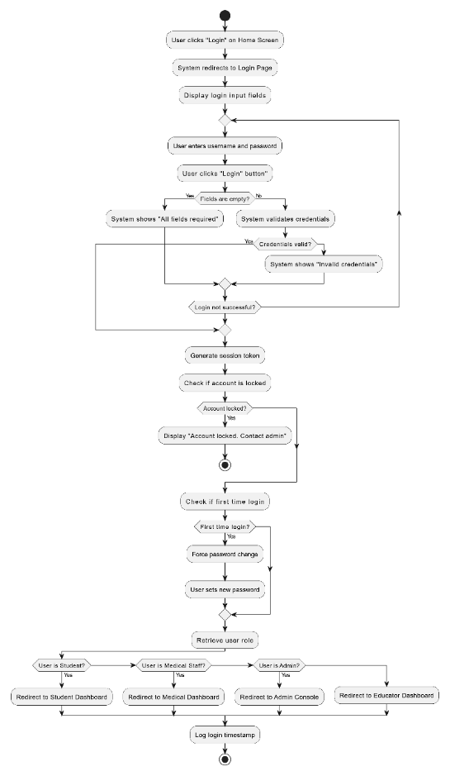

Figure 3 Activity Diagram - Login

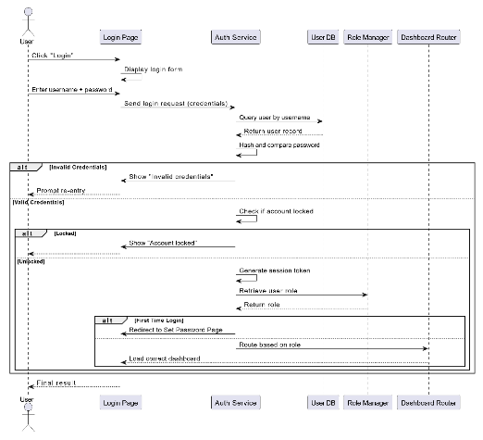

Figure 4 Sequence Diagram - Login

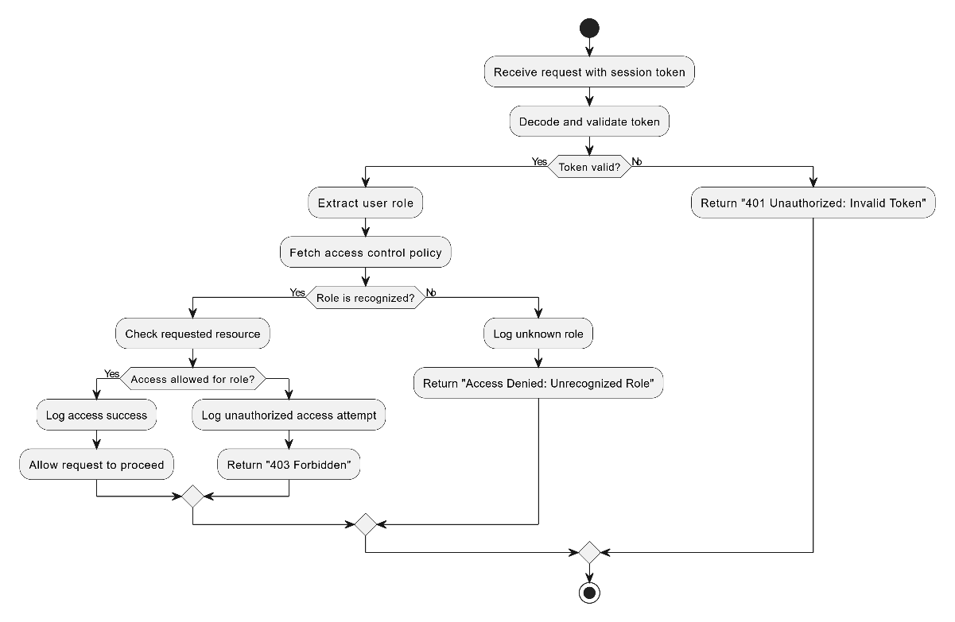

Figure 5 User access role set

Figure 6 Manage user set

### 3.4.2 Appointment Scheduling and Reminder

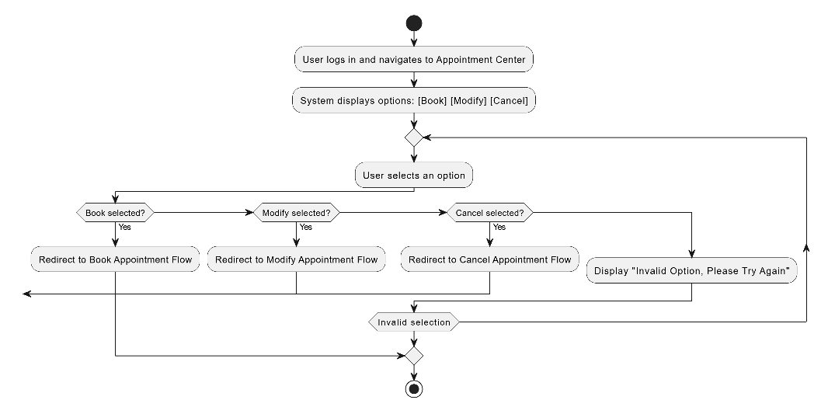

Figure 7 Activity Diagram: Appointment Centre

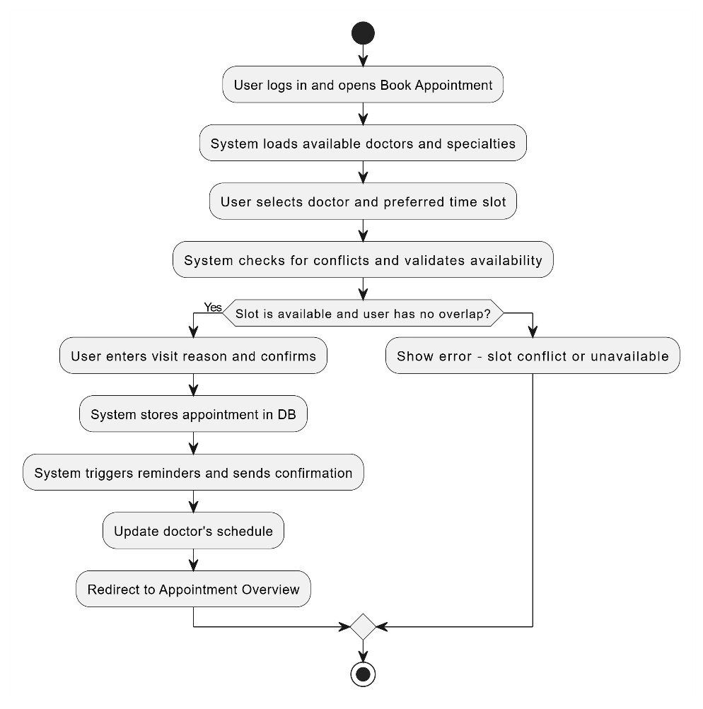

Figure 8 Activity Diagram: Booking an Appointment

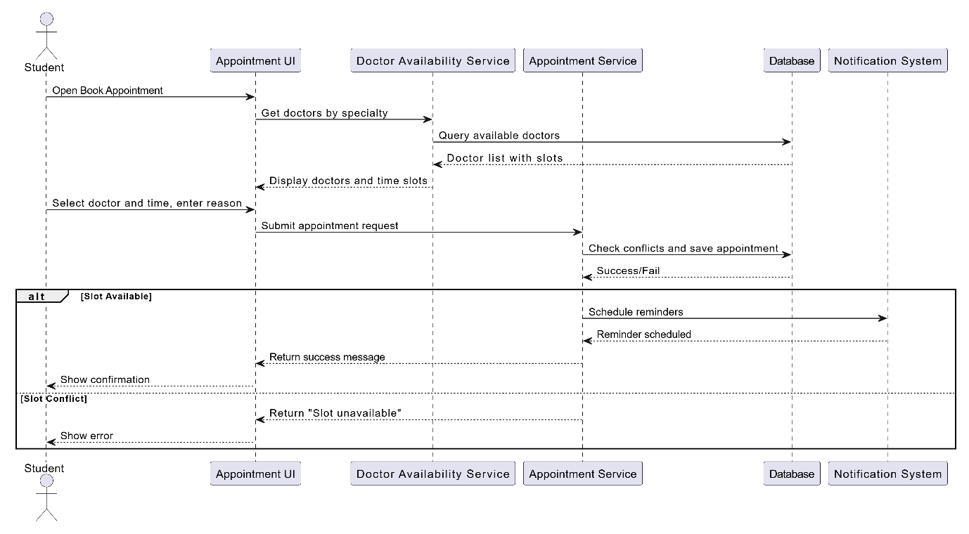

Figure 9 Sequence Diagram: Booking Appointment

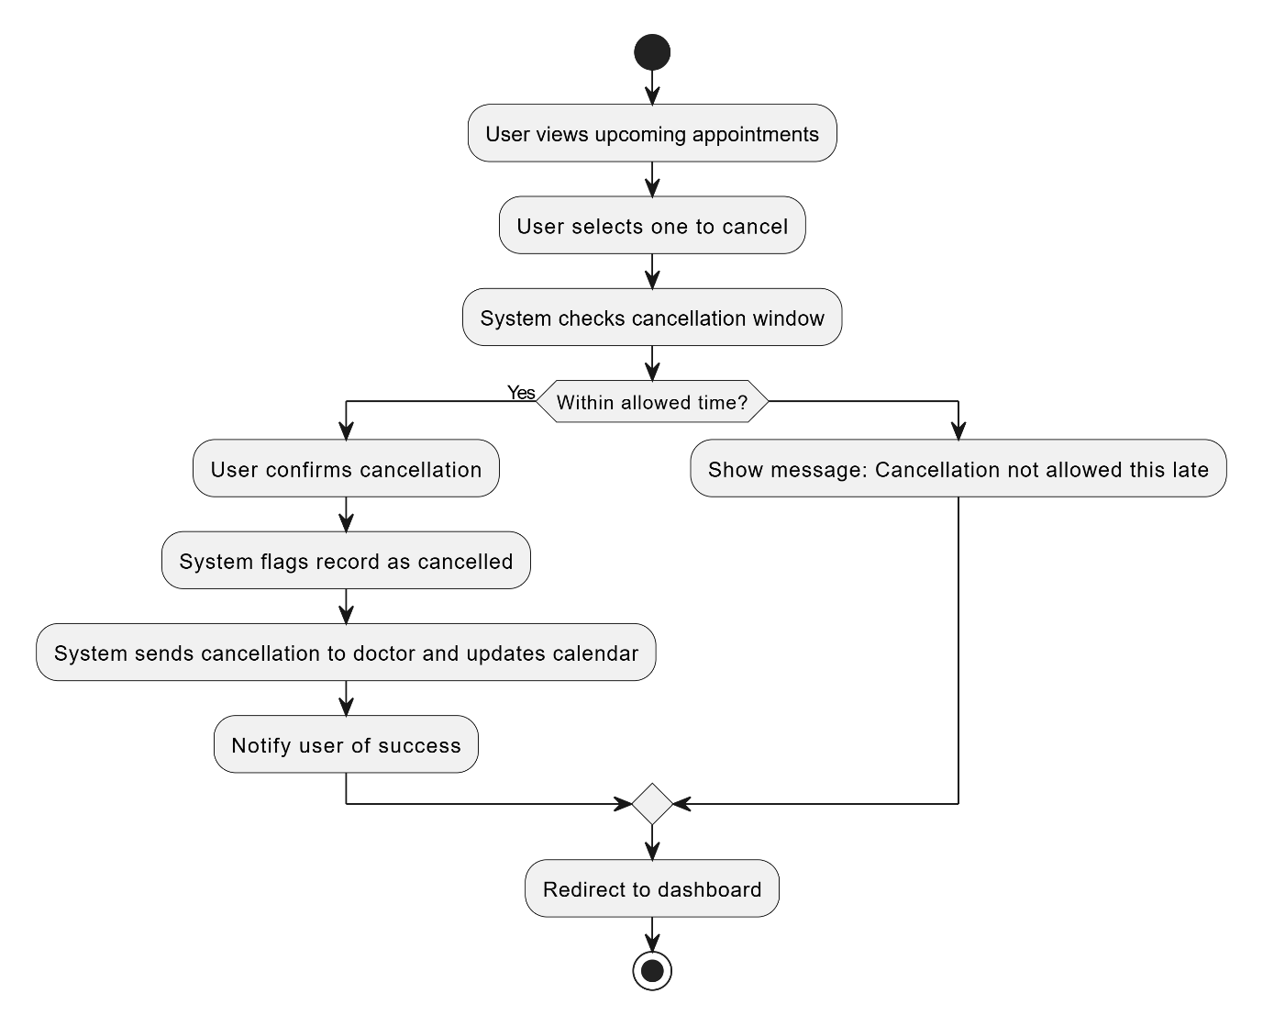

Figure 10 Activity Diagram: Cancel Appointment Process

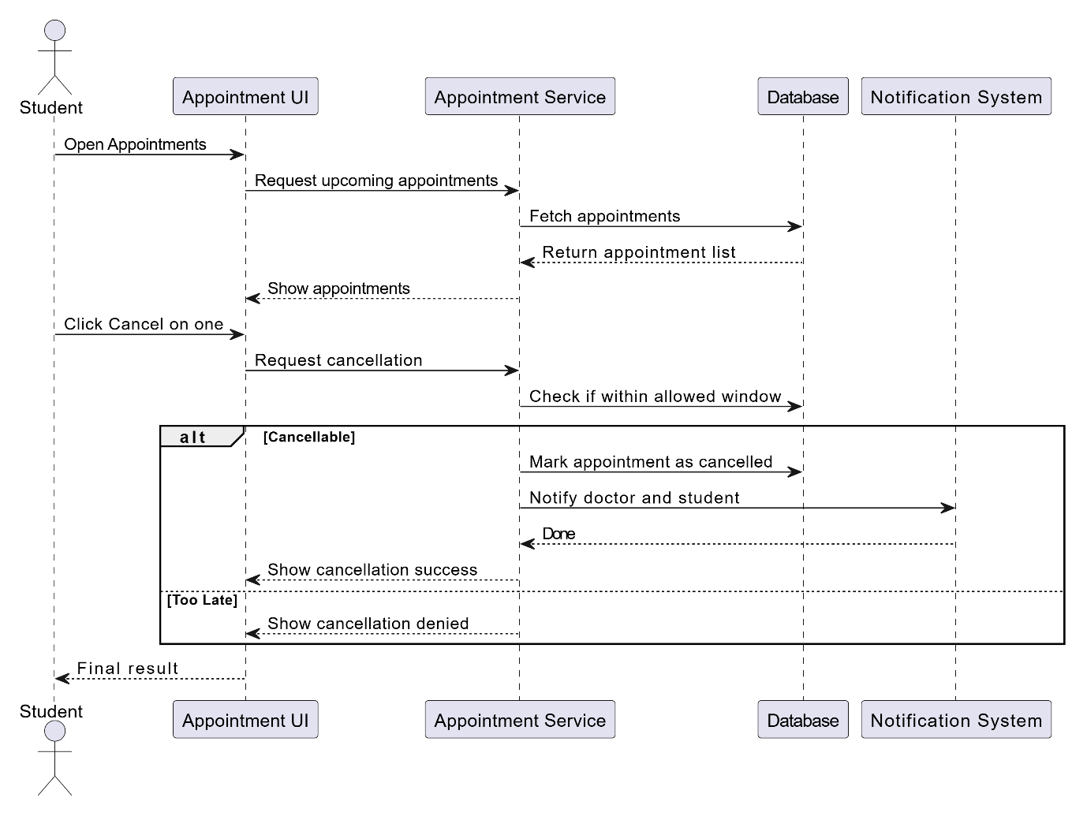

Figure 11 Sequence Diagram: Cancel Appointment Interaction

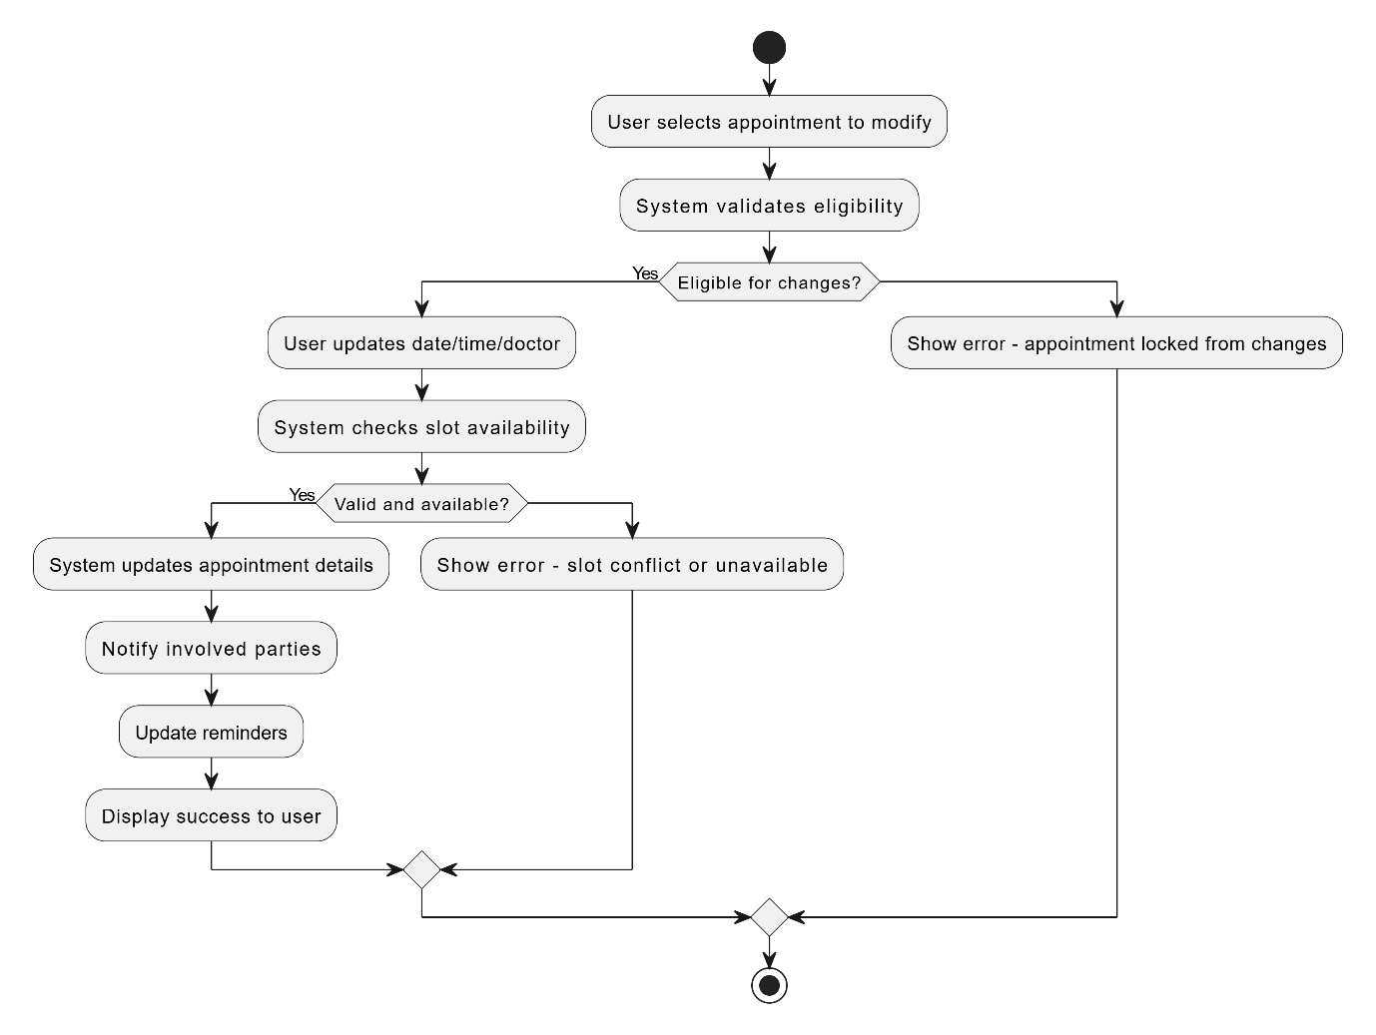

Figure 12 Activity Diagram: Modify Appointment Flow

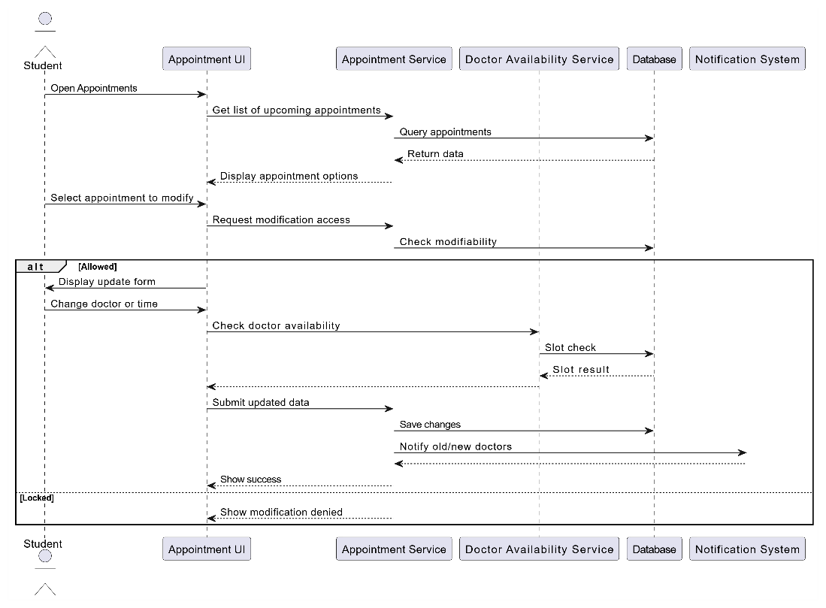

Figure 13 Sequence Diagram: Modify Appointment Interactions

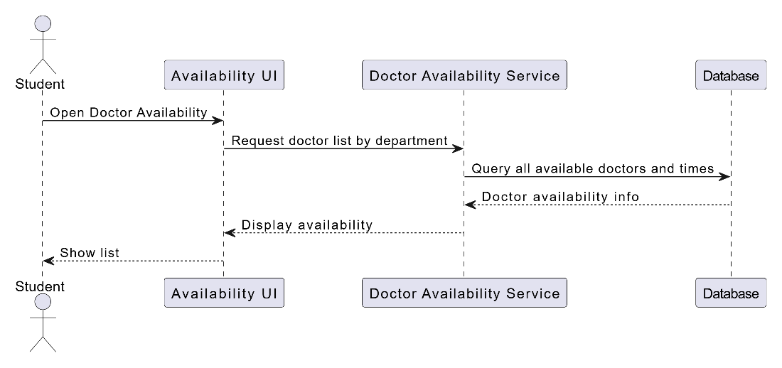

Figure 14 Sequence Diagram – View Doctor Availability

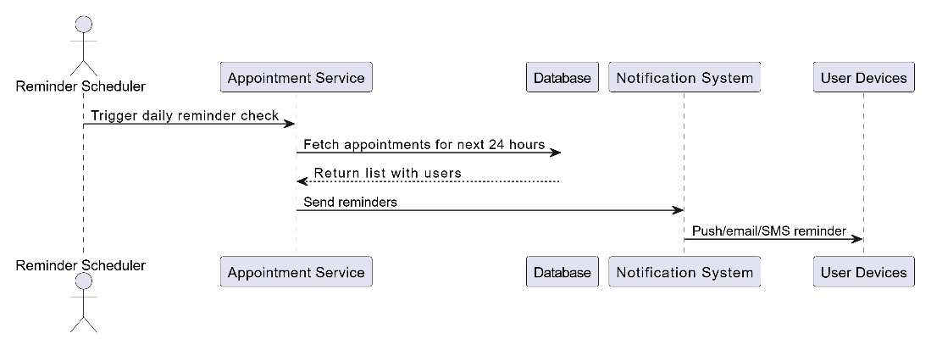

Figure 15 Sequence Diagram – Automated Appointment Reminder System

### 3.4.3 Fitness Class Registration and Goal Tracking

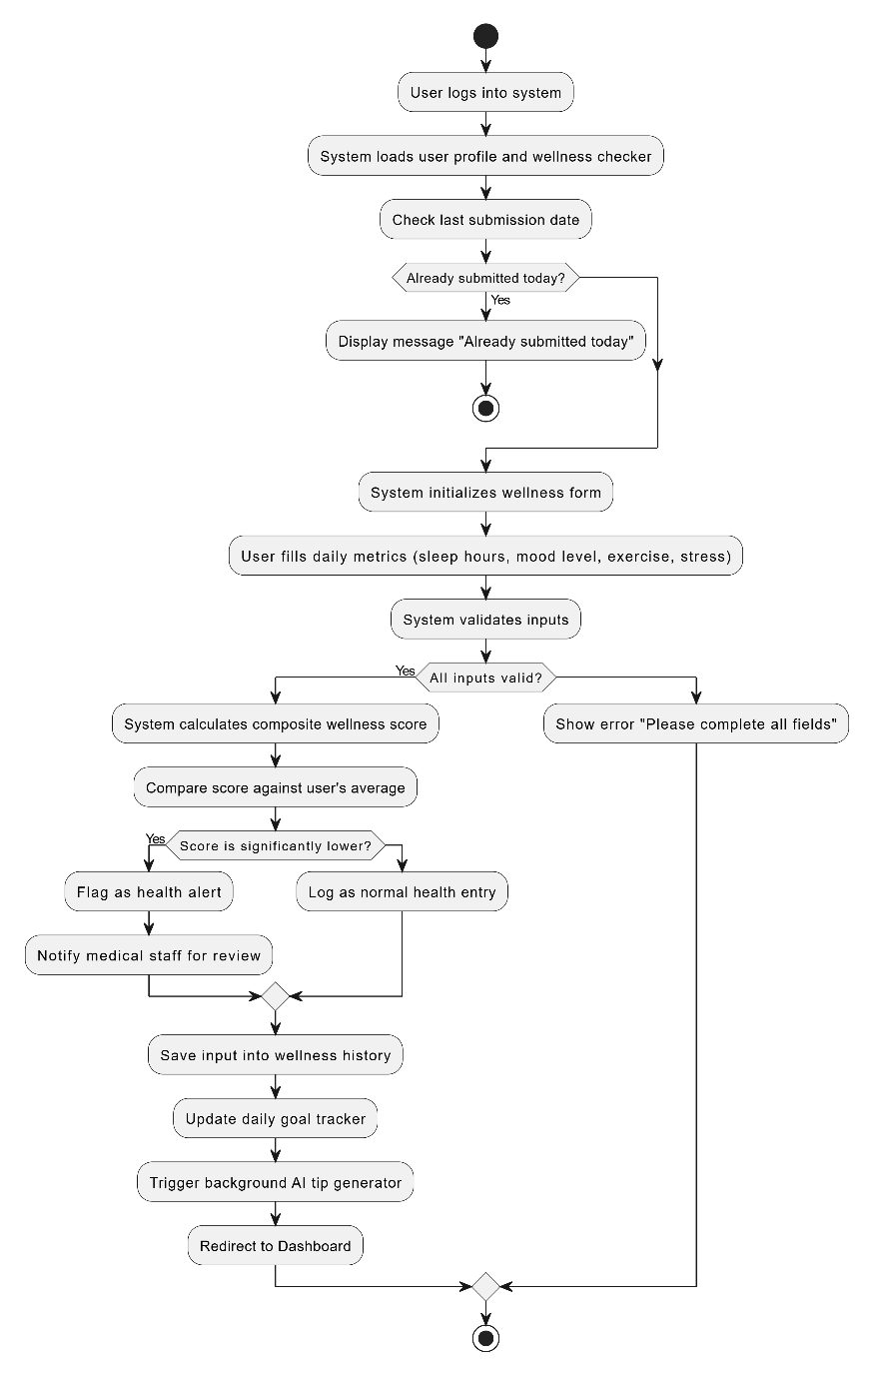

Figure 16 Activity Diagram – Daily Wellness Submission

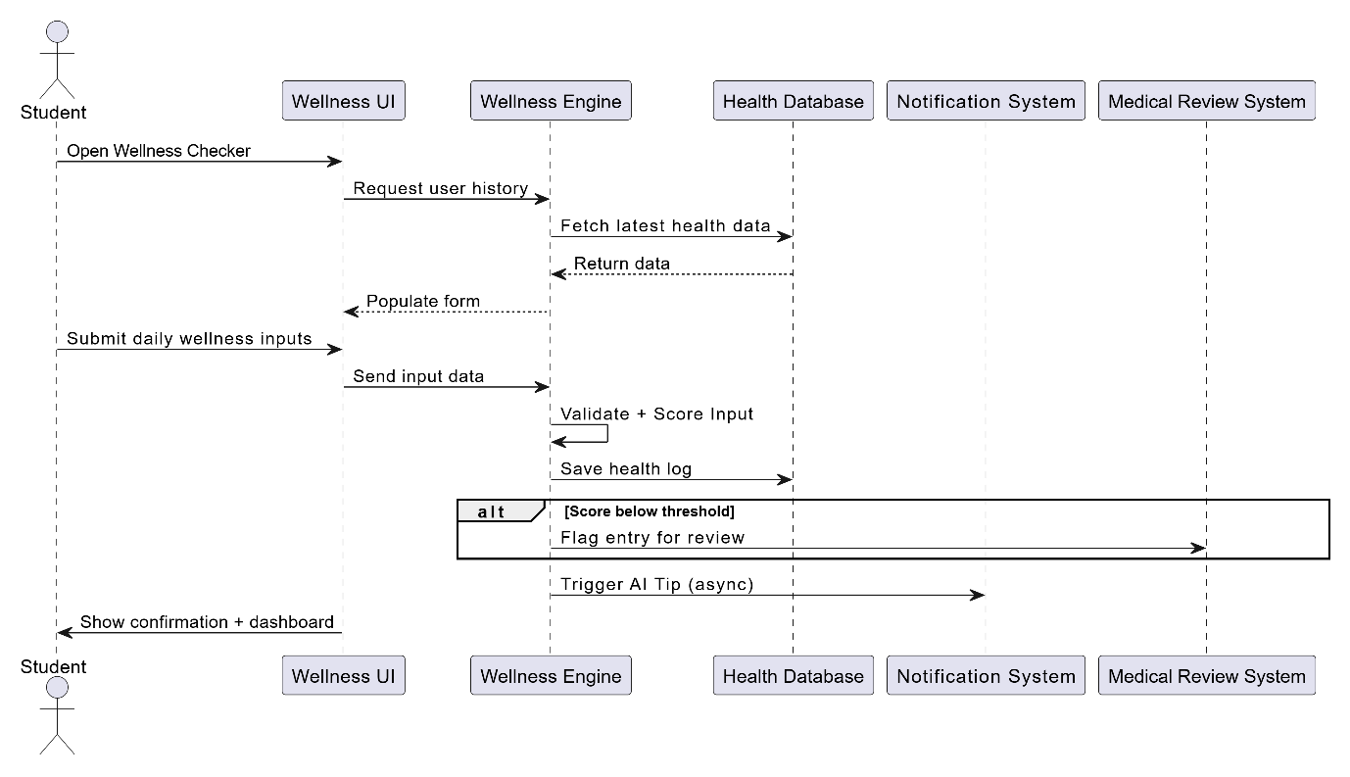

Figure 17 Sequence Diagram – Submit Wellness Data

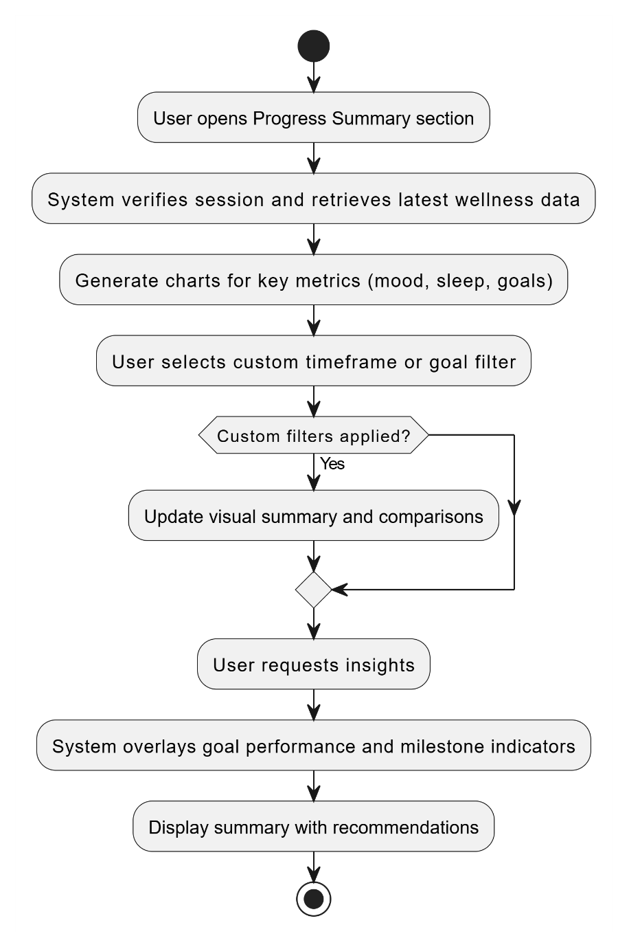

Figure 18 Activity Diagram – View Progress Summary

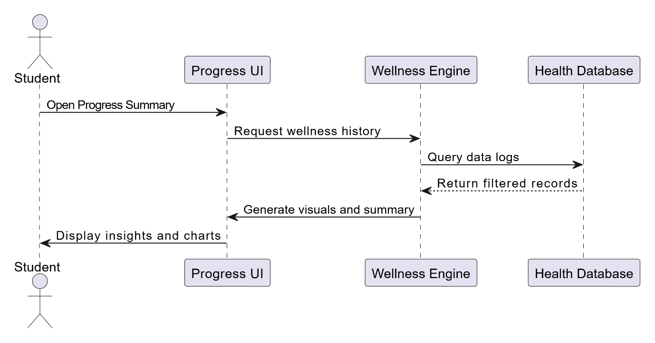

Figure 19 Sequence Diagram – Generate Progress Summary

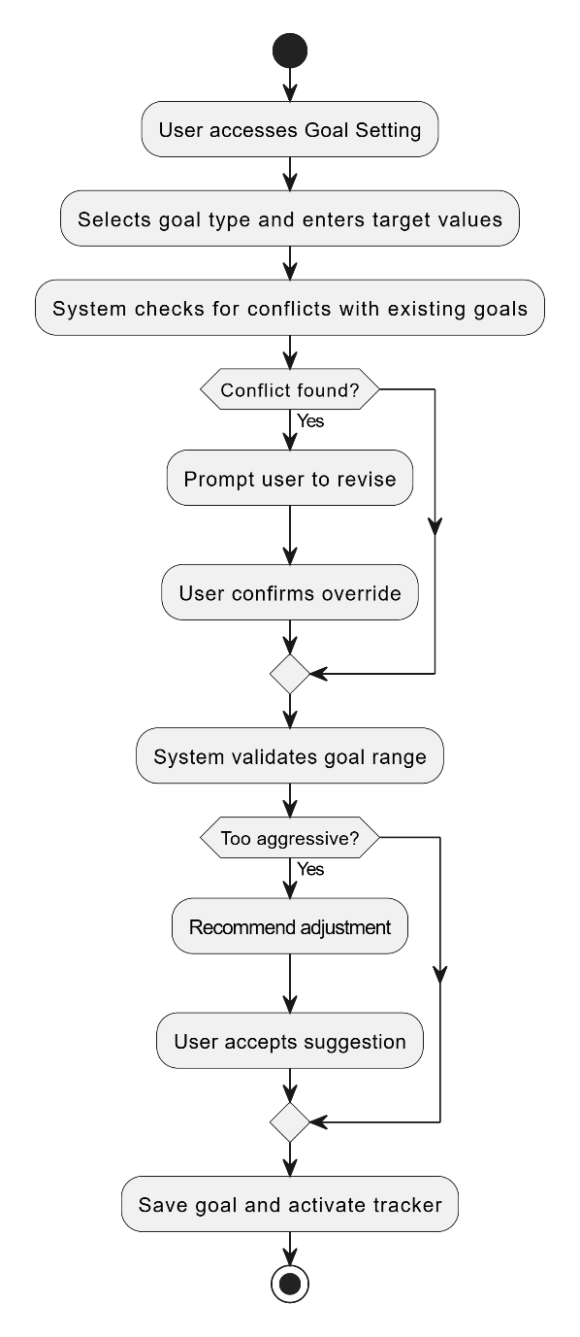

Figure 20 Activity Diagram – Wellness Goal Setting and Activation

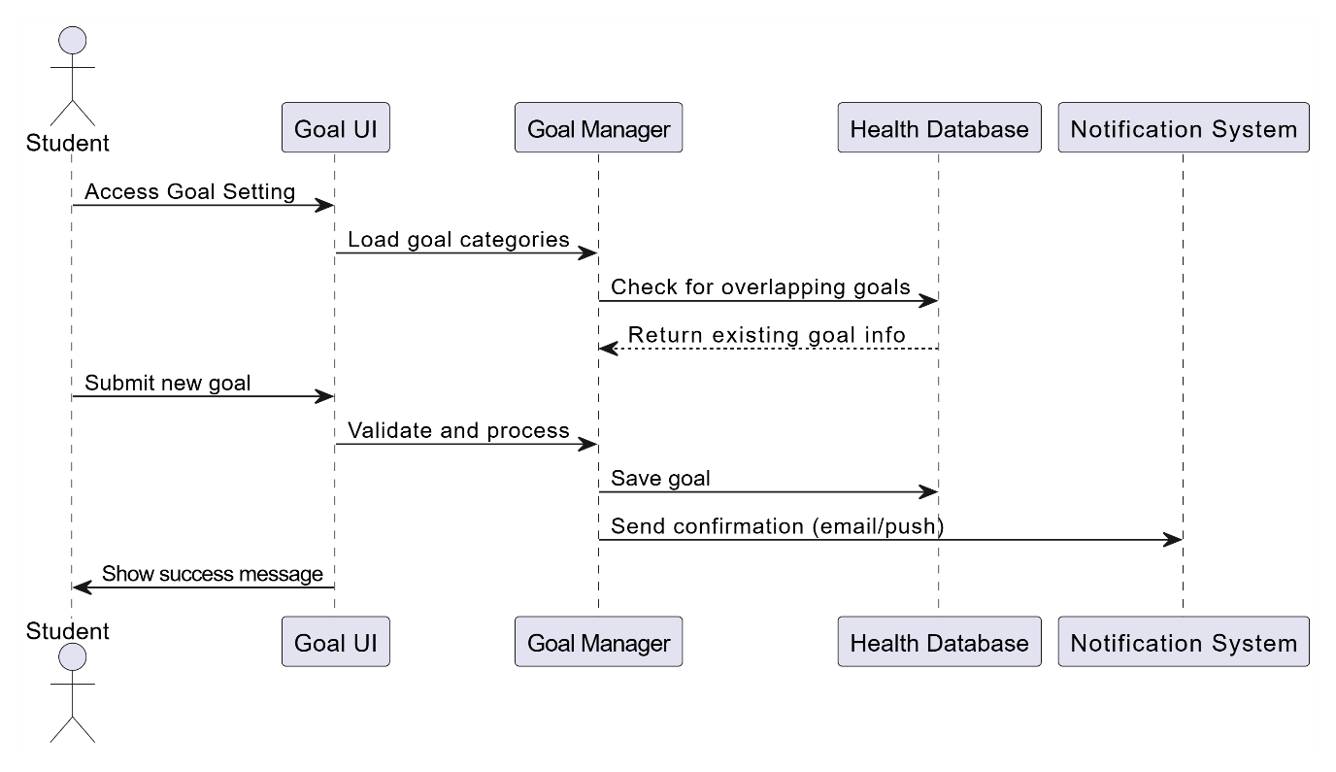

Figure 21 Sequence Diagram – Goal Setting and Conflict Resolution

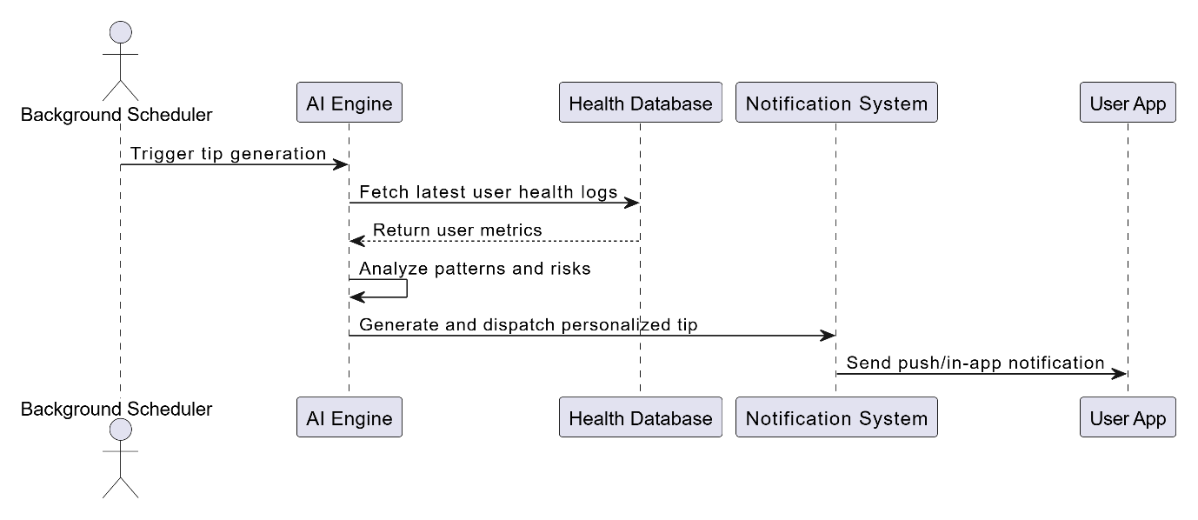

Figure 22 Sequence Diagram – AI Wellness Tip Generation

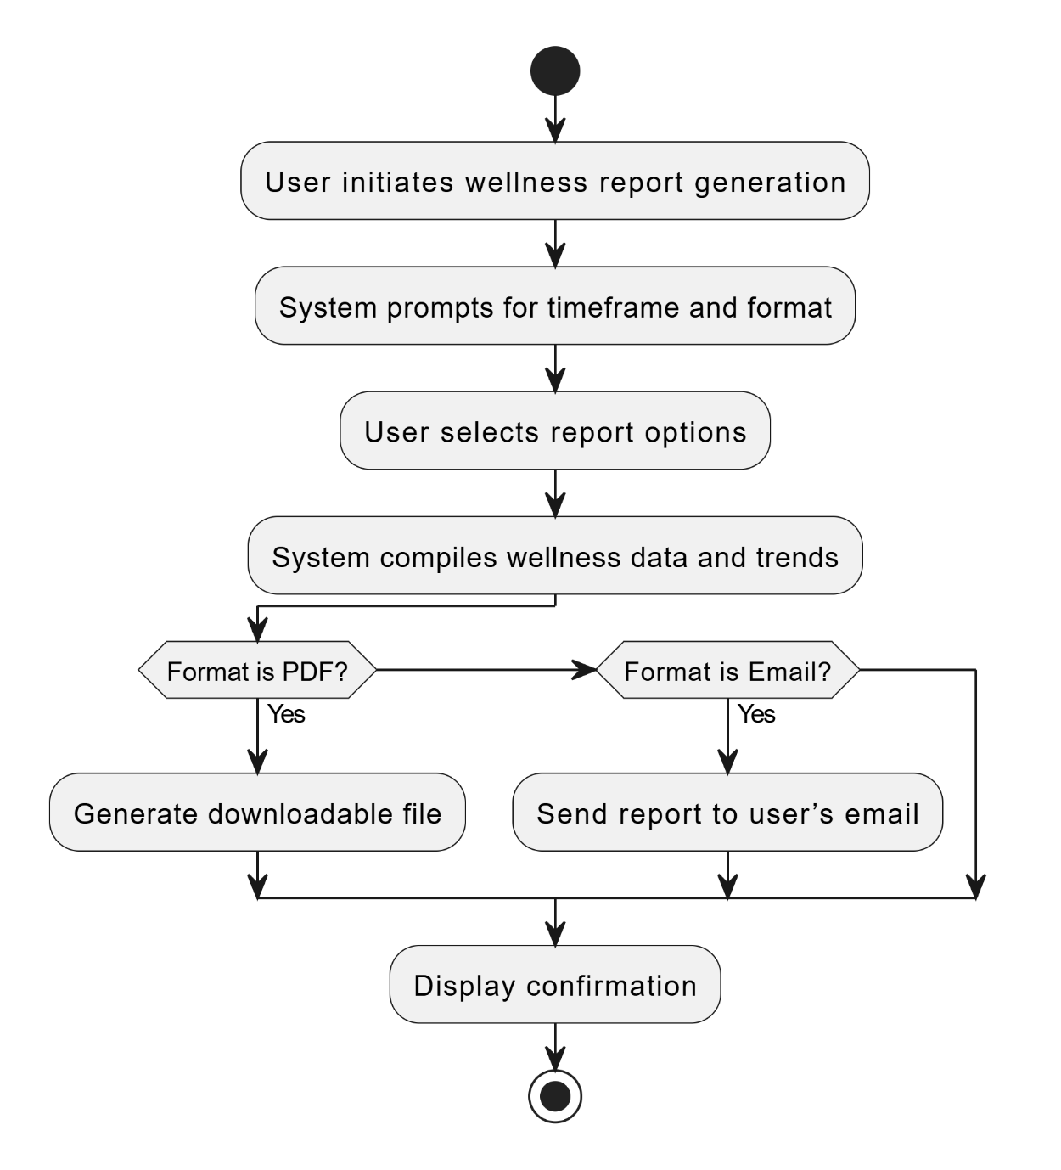

Figure 23 Activity Diagram – Generate Wellness Report

**3.4.3. Sequence Diagram Get AI-Based Wellness**

### 3.4.4 Notifications and Wellness Communication

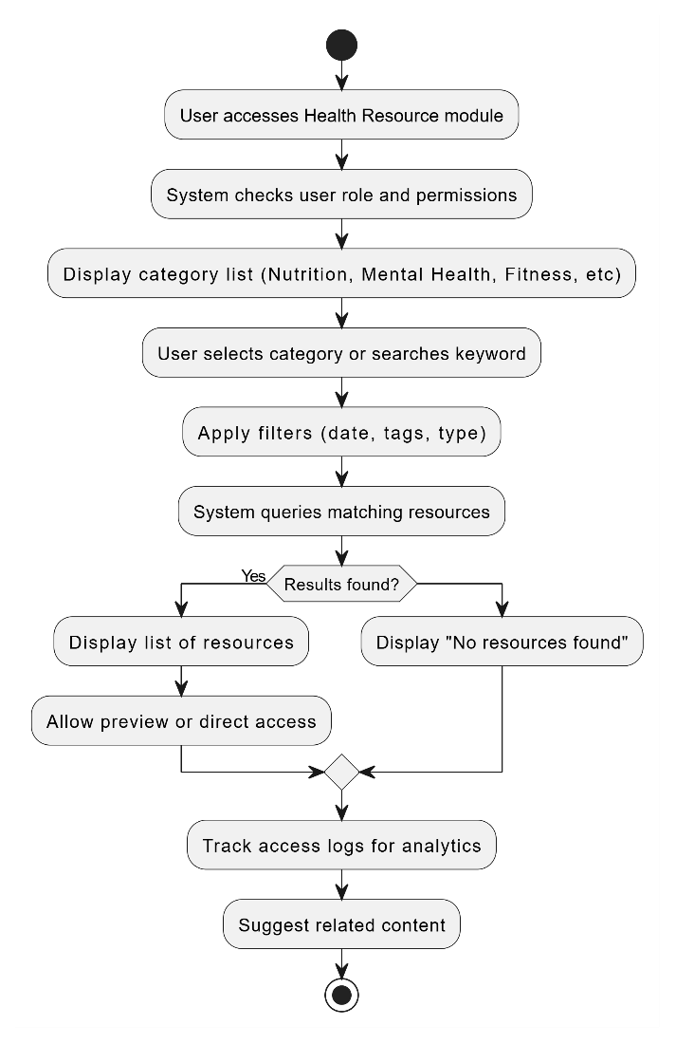

Figure 24 Activity Diagram Access Health Resource

Figure 25 Sequence Diagram Access Health Resource

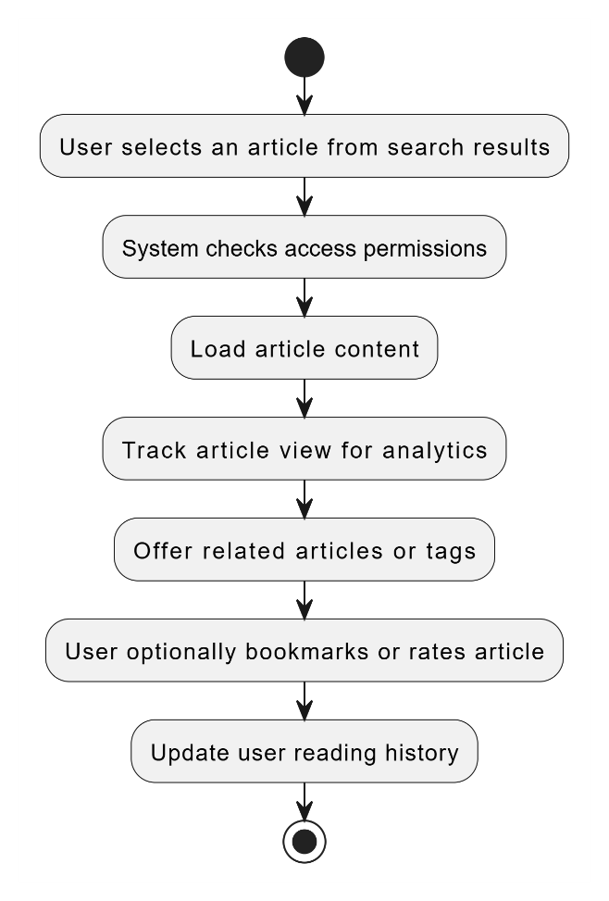

Figure 26 Activity Diagram Read Health Article

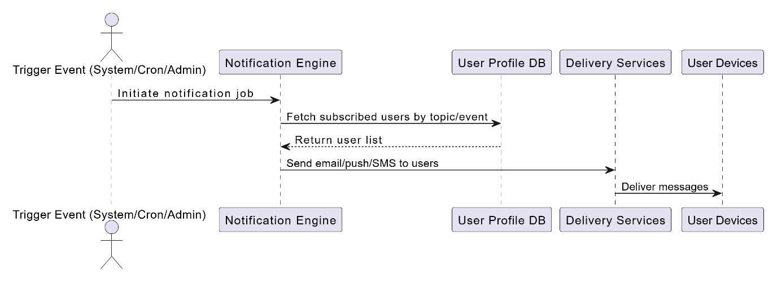

Figure 27 Sequence Diagram Receive Notification

### 3.4.5 Fitness & Physical Activity

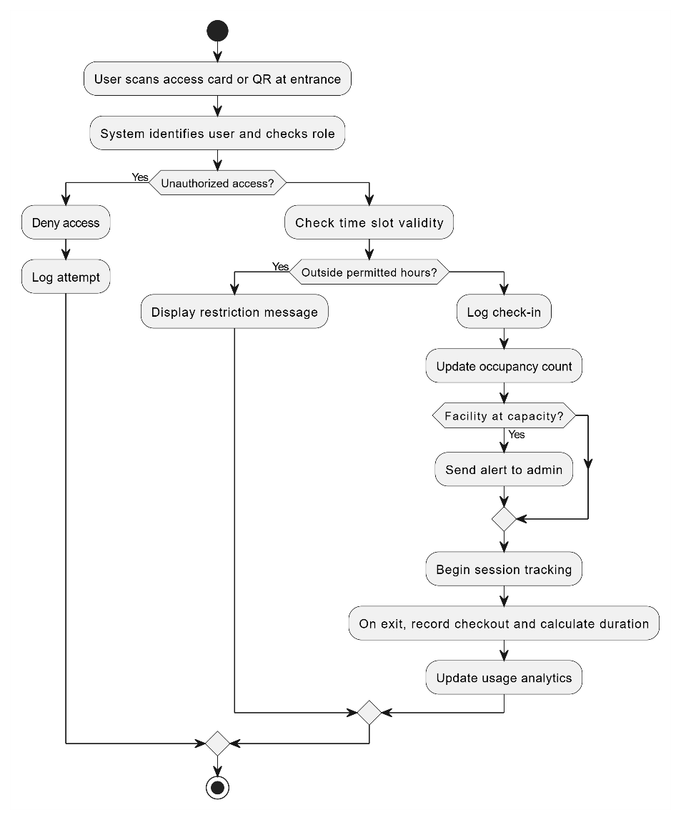

Figure 28 Activity Diagram Fitness Facility

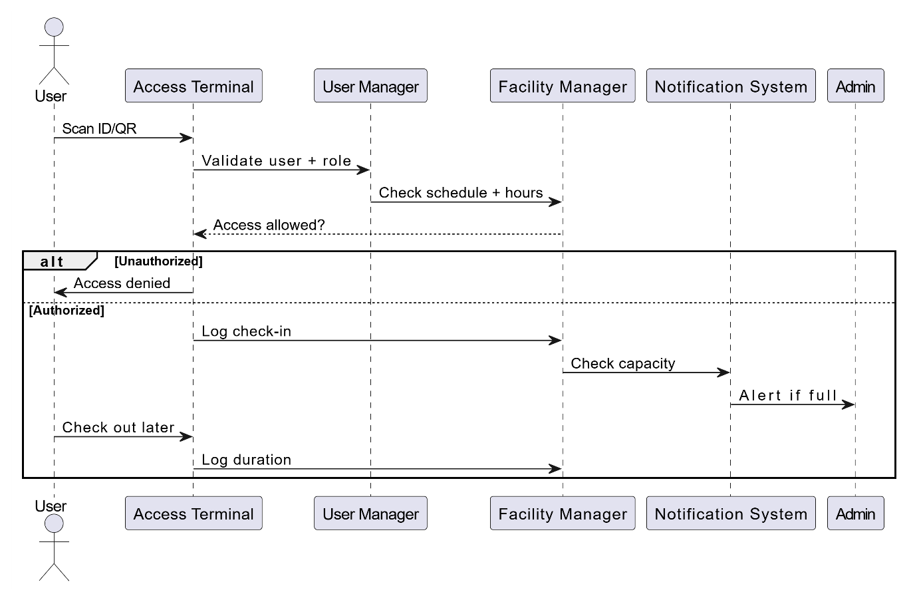

Figure 29 Sequence Diagram Fitness Facility

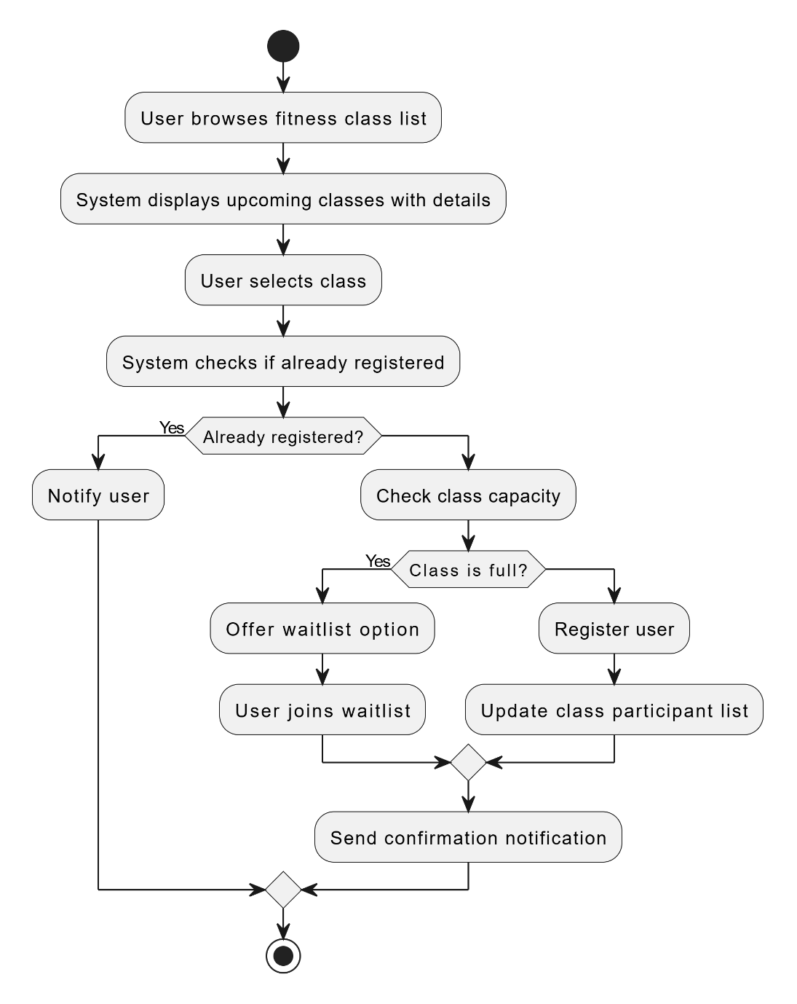

Figure 30 Activity Diagram Register Fitness class

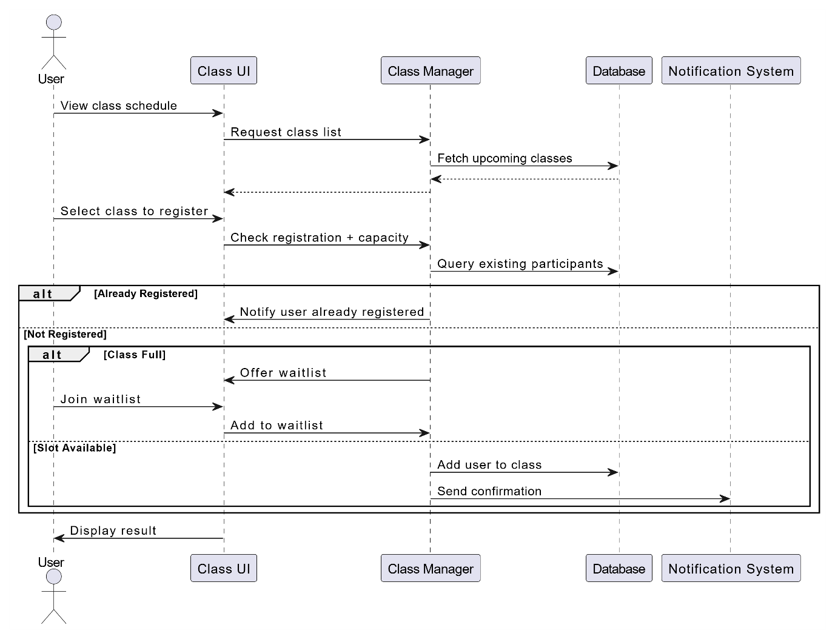

Figure 31 Sequence Diagram Register Fitness class

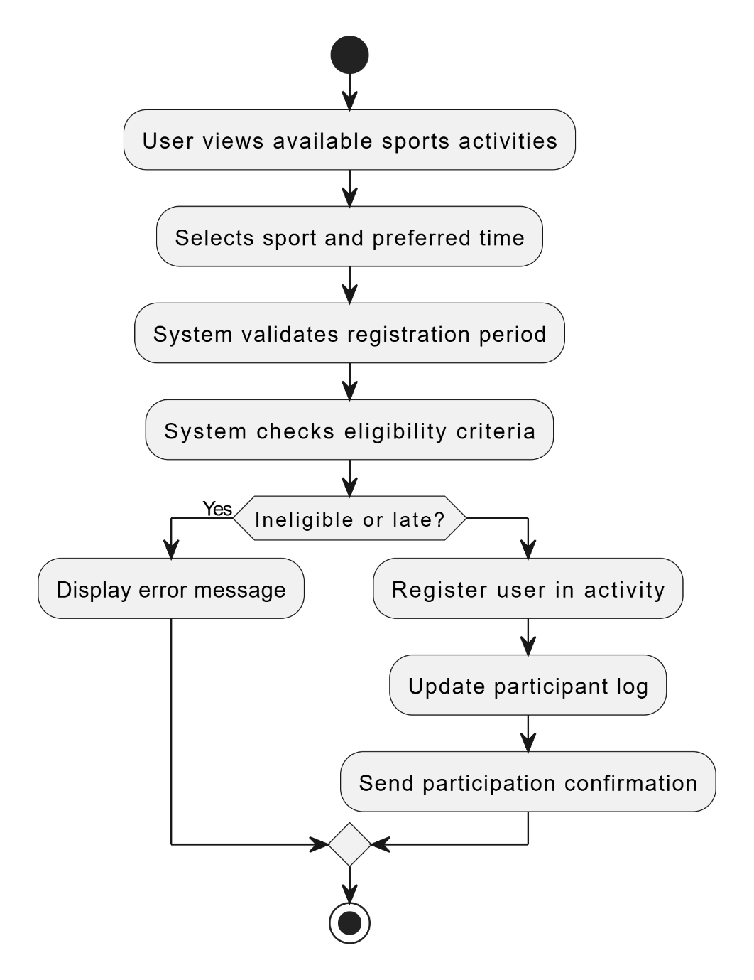

Figure 32 Activity Diagram Join Sports Activity

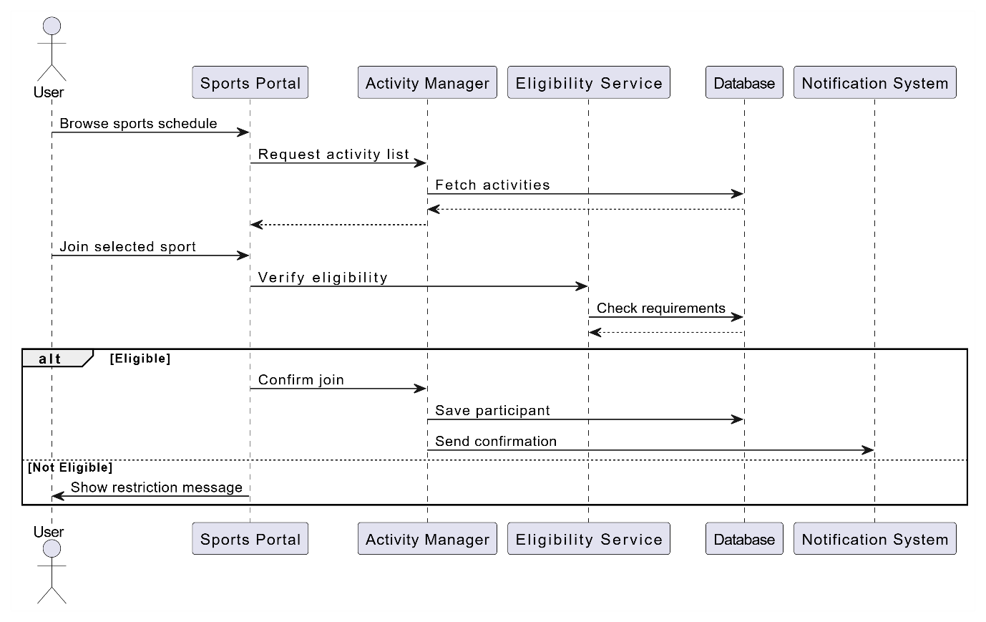

Figure 33 Sequence Diagram Join Sports Activity

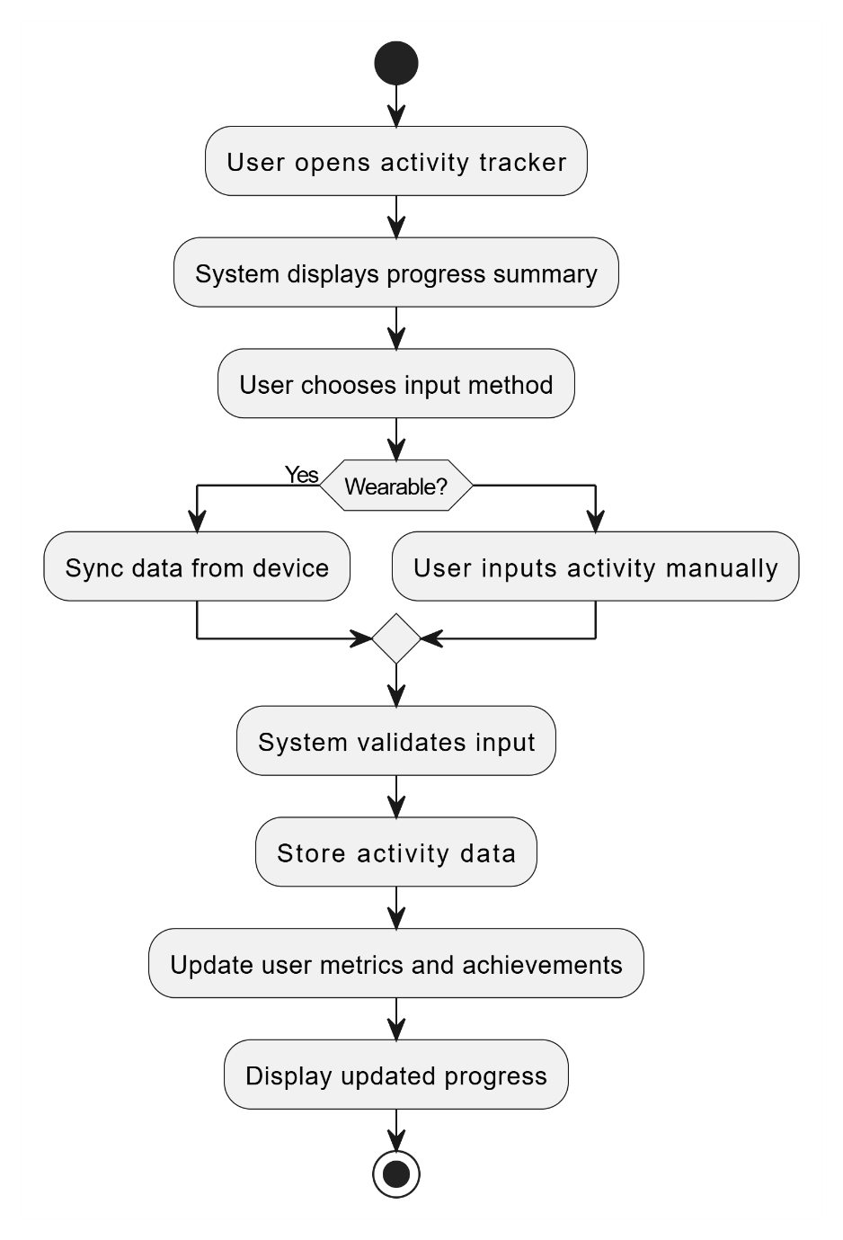

Figure 34 Activity Diagram Track Physical Activity

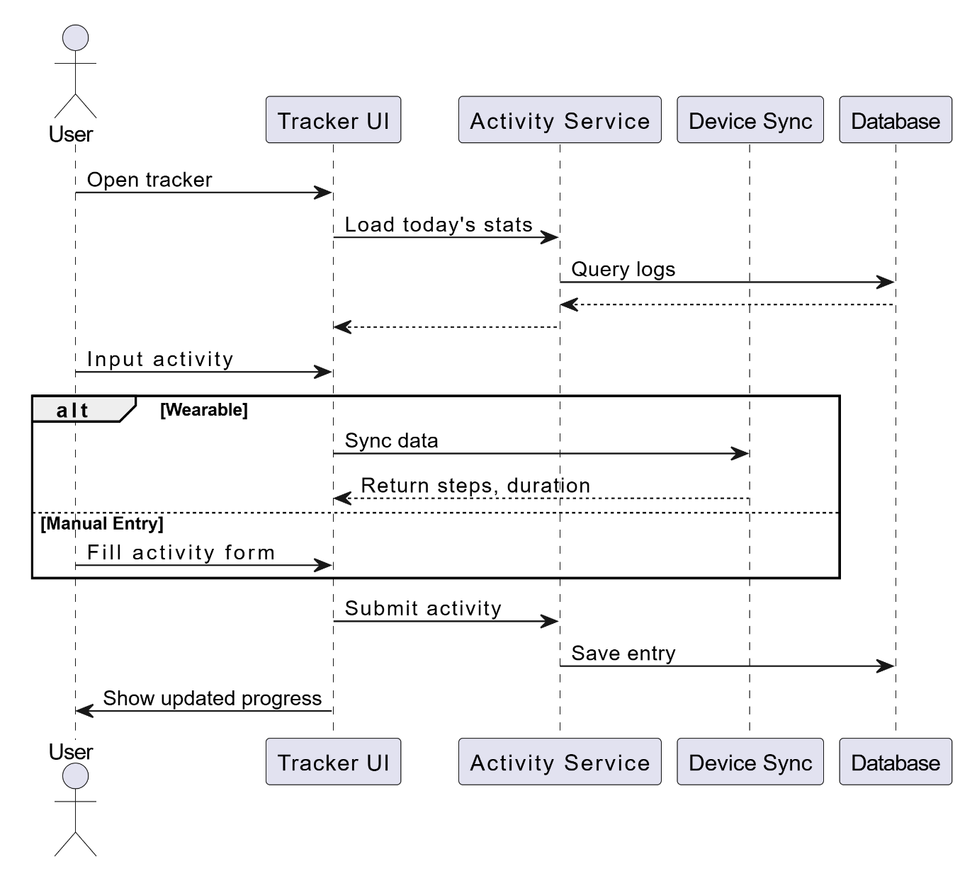

Figure 35 Sequence Diagram Track Physical Activity

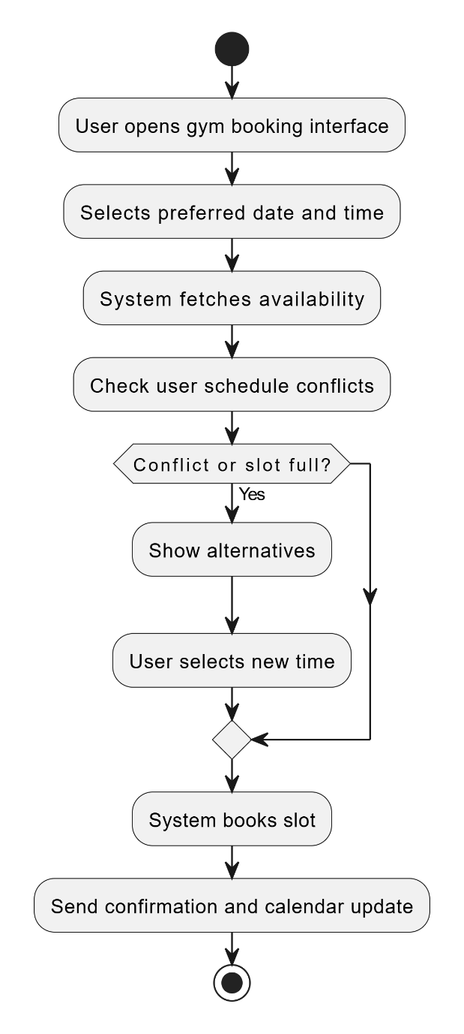

Figure 36 Activity Diagram Book Gym Slot

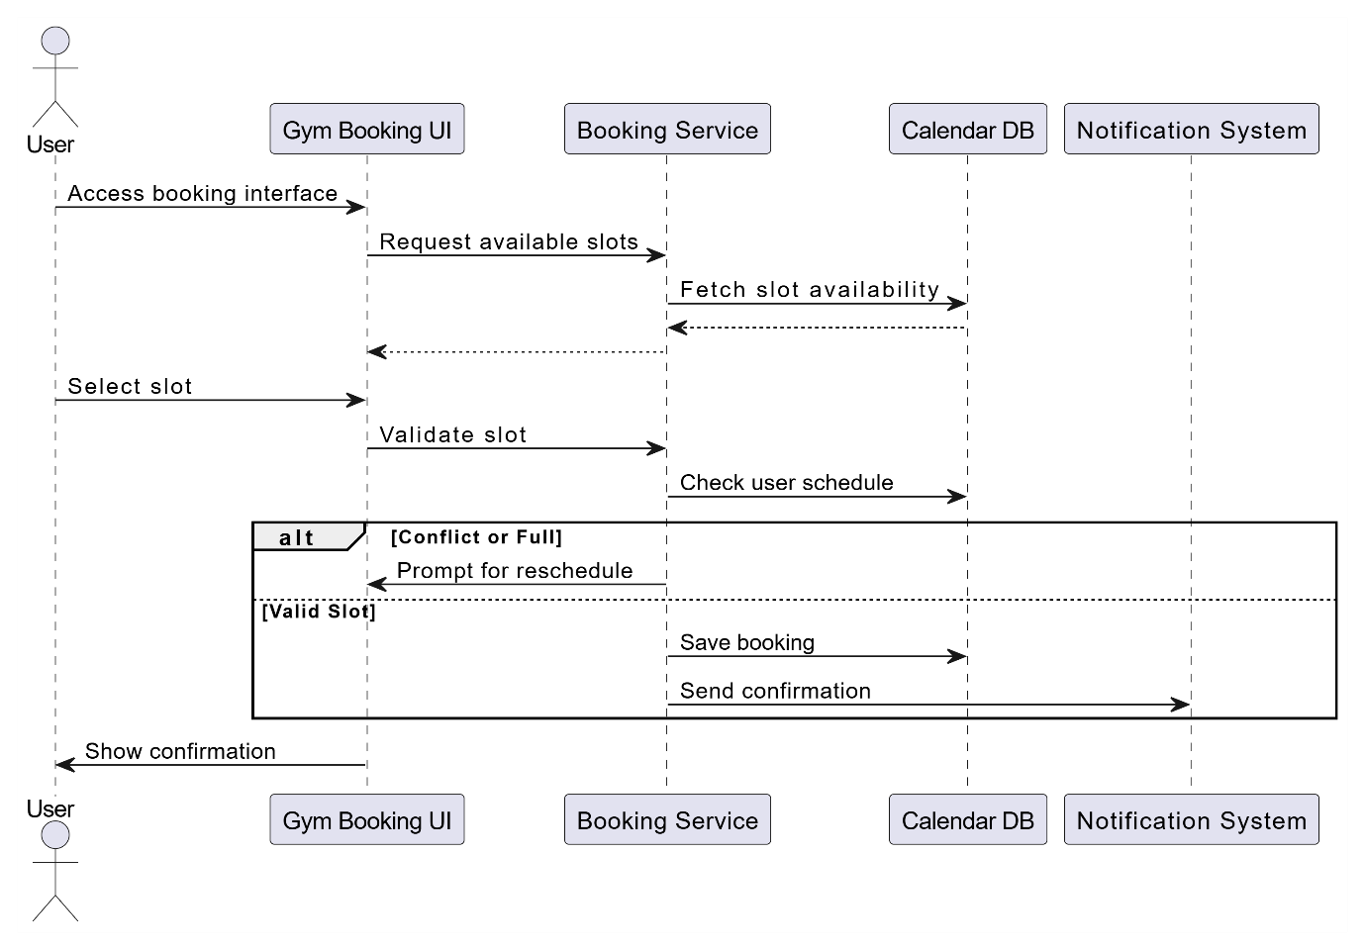

Figure 37 Sequence Diagram Book Gym Slot

### 3.4.6 R-6 Feedback

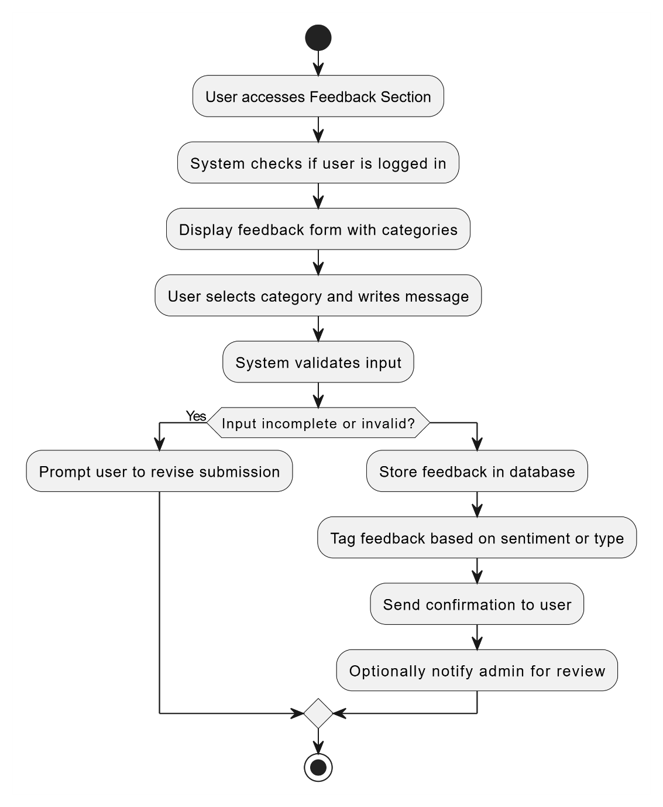

Figure 38 Activity Diagram – User Feedback Submission

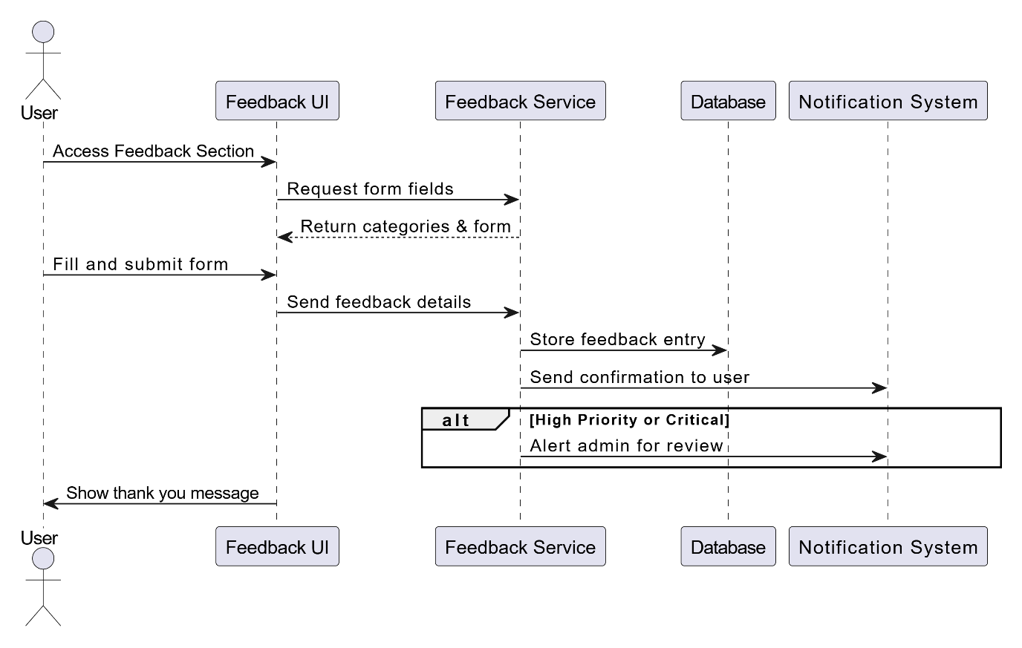

Figure 39 Sequence Diagram – Submit Feedback and Notify Admin

## 3.5 Performance Requirements

Table 67 Performance Requirements

|  |  |  |  |
| --- | --- | --- | --- |
| Requirement ID | Description | Priority | Author |
| R-P-1 | The system will render the user dashboard, wellness content, and goal summaries within 3 seconds of login. | High | Lee Ken Yu |
| R-P-2 | The system shall generate personalized health analytics reports within 5 seconds of user request. | Medium | Ng Jia Hong |
| R-P-3 | The system will process fitness class registrations for 150 concurrent users without any delay. | High | Danish Haziq |
| R-P-4 | The system will send real-time booking confirmation emails within 30 seconds of booking. | High | Ng Jia Hong |

## 3.6 Usability Requirement

Table 68 Usability Requirement

|  |  |  |
| --- | --- | --- |
| Requirement ID | Usability | Description |
| R-U-01 | Navigation | Navigation should be easy, intuitive, and role-based (Student, Staff, Admin, Medical Staff) such that facilities such as appointment booking (UC-05), tracking wellness (UC-11), fitness registration (UC-19), and viewing resources (UC-15) are accessible in a minimal number of steps. |
| R-U-02 | Security | The system will provide secure access by login (UC-01) and role-based access control (UC-02) to permit users to view or access only those features that are pertinent to their role (e.g., Admin vs. Student). |
| R-U-03 | Ease of use | The system will have an intuitive interface and features such as tooltips, context-sensitive help, simplified forms (e.g., in UC-05: Book Appointment, UC-23: Submit Feedback), and a uniform layout for the interface across modules to minimize the learning curve. |
| R-U-04 | Accessibility | The system will have accessibility features such as multi-language support (for UC-05, UC-13, UC-16), screen reader support, and adequate color contrast to enable usability by users of different abilities and orientations. |

## 3.7 Logical Database Requirements

Figure 40 UML Class Diagram – Campus Wellness and Appointment Management System

Table 69 Description: Figure 40

|  |  |
| --- | --- |
| Class | Description |
| User | User class represents individuals who access the system.   * Stores username, password, name, and email. * User is a superclass for Student, Staff, MedicalStaff, and Admin classes. * All system actors authenticate through User credentials. |
| Student | Student class is a subclass of User class.   * Stores studentId, program, healthStatus, and goals. * A student can book, cancel, or modify appointments. * A student can use the wellness checker and track their goals. * A student can register for fitness classes, book gym slots, and log physical activities. * A student can access health articles, receive notifications, and submit feedback. * A student interacts with the AITipEngine to get personalized wellness tips. |
| Staff | Staff class is a subclass of User class.   * Stores staffId and department. * A staff member can register for fitness classes and join sports activities. * A staff member can read health articles and receive notifications * A staff member can submit feedback on services and portal usage. |
| MedicalStaff | MedicalStaff class is a subclass of User class.   * Stores staffId and specialization. * A medical staff can view, approve, and manage appointments. * A medical staff can access student wellness progress. * A medical staff can read health articles and manage resources. |
| Admin | Admin class is a subclass of User class.   * Stores adminId and position. * An admin can manage user accounts: add, edit, or deactivate users. * An admin enforces role-based access control throughout the system. |
| Appointment | Appointment class represents scheduled bookings between students and medical staff.   * Stores appointmentId, date, time, and status. * Linked to students and medical staff. * Can be booked, cancelled, or modified by students. * Connected to the AppointmentReminder for sending alerts. |
| AppointmentReminder | AppointmentReminder class manages automated reminders.   * Sends alerts to users for upcoming medical appointments. * Always associated with a specific appointment. * Delivers reminders via preferred notification methods. |
| MedicalSystem | MedicalSystem class represents the backend interface for managing medical services.   * Provides real-time doctor availability. * Approves or updates appointments as needed. * Interacts with the Appointment module. |
| WellnessGoal | WellnessGoal class stores personal health objectives defined by students.   * Contains goalId, description, and targetDate. * Students can set and track their own wellness goals. * Goals are evaluated by the AITipEngine and tracked in WellnessProgress. |
| WellnessProgress | WellnessProgress class tracks the user’s improvement over time.   * Linked to student goals and activities. * Generates progress summaries and downloadable wellness reports. |
| AITipEngine | AITipEngine class generates personalized tips using AI logic.   * Dynamically provides students with wellness suggestions. * Considers input from WellnessGoal and WellnessProgress. |
| WellnessChecker | WellnessChecker class allows students to evaluate their current health status.   * Takes input from students and provides summary feedback. * Connected to goal setting and progress tracking. |
| HealthArticle | HealthArticle class represents wellness-related reading materials.   * Contains articleId, title, content, and tags. * Accessible to students, staff, and medical staff. * Used to educate and inform users about health topics. |
| Notification | Notification class represents alerts and reminders sent to users.   * Stores notificationId, message content, and timestamp. * Triggered by system events like appointments or new resources. * Delivered through email or in-app messaging. |
| FitnessClass | FitnessClass class represents scheduled exercise sessions.   * Contains classId, title, schedule, and instructor. * Students and staff can register for classes. * Managed and tracked by the FitnessCenterSystem. |
| GymSlot | GymSlot class represents reserved time blocks for gym usage.   * Stores slotId, date, and time. * Students can book slots in advance through the system. |
| SportsActivity | SportsActivity class represents physical wellness events.   * Includes structured team or solo sports activities. * Can be joined by students and staff. |
| ActivityLog | ActivityLog class records student physical activities.   * Includes activity type, duration, and calories burned. * Aggregated under student accounts and reported in WellnessProgress. |
| FitnessCenterSystem | FitnessCenterSystem class manages operations of campus fitness resources.   * Handles gym slot scheduling, class management, and activity tracking. * Acts as the backend for all fitness-related services. |
| Feedback | Feedback class collects user input about portal services and user experience.   * Stores feedbackId, content, rating, and timestamp. * Submitted by students and staff. * Used for system improvement and quality assurance. |

## 3.8 Design Constraints

1. Data Privacy and Security Standards

G5 system should be strictly compliant with data privacy standards in the protection of students' sensitive personal and health information, and employees' personnel and personal information. The highest level of compliance is the General Data Protection Regulation (GDPR) such that:

* All user data gathered must be processed lawfully and transparently.
* Person well-being files, appointment schedules, and doctors' notes authorization access is given to only identified stakeholders.
* SSL/TLS encryption is implemented on data in transit.
* High-level encryption algorithms are used on data at rest, especially on health-related data storage.

Role-Based Access Control (RBAC) and Multi-Factor Authentication (MFA) are utilized to prevent unauthorized access, misuse of data, or breaches from happening.

2. Integration with Campus Systems

Because the portal is located in an electronic campus environment, it must enable integration with a variety of in-campus systems, such as:

* Learning Management Systems such as Moodle or Canvas to synchronize with academic calendar synchronizing students' class schedules with wellness appointment schedules.
* University Authentication Systems implemented with Single Sign-On-based protocols.
* Student Information Systems (SIS) for automatic synchronization of student records.

If there is content to be learned to be shared (e.g., mental health training), the system must be SCORM compliant for tracking and reporting content.

3. Constraints on Performance

Effective student support depends on system performance. The key performance requirements are:

* Response time: Major functionality—appointment booking, viewing dashboards, access to wellness content—must take 2–3 seconds.
* Scalability: The portal must support simultaneous logins by hundreds of students during peak periods (e.g., exam periods or registration periods).
* Stability under load: Activities such as fitness class reservation or access to health records must function without crashing during peak periods.

4. Budget and Timeline Constraints

System development must be accommodated in the existing university IT budget and academic calendar. However,

* It will prioritize the feature implementations by impact and feasibility. For example, appointment scheduling and medical logging before advanced analytics or AI wellness predictions.
* It is a must to ensure that the most important modules for deployment milestones. For instance, medical appointment scheduling and fitness tracking are implemented before classes start to assign incoming students.

5. User Interface and Device Compatibility

The portal must be accessible by many students and staff across various platforms:

* Cross-device compatibility: Available on desktop, laptop, tablet, and smartphone.
* Browser support: Support for Google Chrome, Mozilla Firefox, Safari, and Microsoft Edge.
* Mobile responsiveness and simple, intuitive interface following best UI/UX practices are required to cater to varying levels of tech savviness.

Also, the design should consider accessibility guidelines (like WCAG) to accommodate users with disabilities.

## 3.9 Standard Compliance

The G5 system must adhere to standards and regulations governing educational, medical, and institutional compliance. The standards influence reporting formats, data structuring, record-keeping, and auditability to ensure transparency, interoperability, and accountability.

The system must generate standard reports which are compliant to institution policy and privacy and wellness regulation. The reports must be exportable into general formats such as PDF, CSV, Excel, and Word to facilitate sharing ease, data analysis, and archiving and between departments, and in the case of the need to send to outside organizations.

Some reports required include:

* Health and Wellness Reports: Student participation summaries in wellness activities, fitness tracking, and appointment visits.
* Appointment and Consultation Records: Medical appointment records, date, services rendered, and follow-up remarks available for authorized health professionals.
* Administrative Analytics: Administrator and counselor dashboards to track participation patterns, common health issues, and utilization rates.

For interoperability across systems and consistency of data, the portal has to use standard naming conventions for all stored data. Naming conventions make data easy to read and load, aggregate and store. Examples include:

* Fields for User Data: studentID, studentName, email, program, healthPlanStatus
* Appointment Records: appointmentID, staffID, visitType, visitDate, notes
* Fitness & Wellness Tracking: activityType, duration, caloriesBurned, goalProgress

Descriptive, coded field names minimize database query errors, reports correctly, and simpler to integrate with future systems.

3. Accounting Procedures and Auditing

The system needs accounting-type-processes to monitor the transaction and user activities to facilitate traceable and reliable activity logging in the portal:

* Wellness Activities Logging: Each student reservation, check-in, or completion of an event (e.g., counselling session or exercise class) must be logged with a timestamp.
* Medical Form Submissions: Any uploaded or submitted feedback forms must be dated and stored as separate files.
* Interaction Traceability: All log files must record all interactions when a student opens, submits, or modifies wellness objectives or intake surveys.

The logs support the ability to meet internal as well as external audits with effective performance monitoring.

4. Audit Tracing Standards

The education and healthcare data governance standards issued adapted audit tracing policies which the portal needs to implement immediately:

* User Activity Logs: Documenting profile changes, logins, scheduled appointments, and services rendered are also included.
* Access Logs: Important access to areas such as health records and consultation notes should be logged.
* Modification Tracking: Ensure modification of sensitive information such as diagnosis history, appointment information, and system settings are traced.

Logs must contain a description of the action, be time-stamped, tagged with user IDs, and held in securely sealed tamper-evident containers. Accessible only during probes or audits.

## 3.10 Software System Attributes

Table 70 Software System Attributes

|  |  |
| --- | --- |
| **Attribute** | **Description** |
| Reliability | The system must operate with high reliability as it handles critical modules such as medical appointments, fitness scheduling, and health tracking. Redundant hosting and regular backups will ensure a 99.5% uptime annually. |
| Availability | Accessible 24/7 with core functions such as reminders and tracking always online. Maintenance downtime is scheduled with user alerts. |
| Security | Implements RBAC, JWT authentication, HTTPS encryption, and compliance with PDPA. Sensitive data is logged and access tracked. |
| Maintainability | Modular architecture allows for isolated maintenance. Admin dashboard will include monitoring and bug tracking. |
| Portability | Responsive web app accessible on desktop, tablet, and mobile. Compatible with major browsers and ready for future mobile expansion. |

## 3.11 Supporting Information

### 3.11.1 Interview Minutes (with Admin, Medical Staff, Fitness Center Rep)

|  |  |  |  |
| --- | --- | --- | --- |
| **Identifier** | **INT-01** |  |  |
| **Field** | **Content** |  |  |
| **Date** | 5 April 2025 |  |  |
| **Stakeholders** | Admin Officer, Medical Unit Head, Fitness Center Coordinator |  |  |
| **Objective** | To understand user access needs, feedback requirements, and booking complexities for campus wellness systems. |  |  |
| **Key Points** | - Need for role-based access to prevent misuse  - Doctors should be able to block time slots manually  - Gym slot conflicts are frequent — need real-time updates  - All users want mobile-first layout |  |  |
| **Decisions Made** | - Prioritize booking logic across all modules  - System must alert user when overlapping bookings occur  - Admin should have override permissions for all appointments |  |  |

**3.11.2 Brainstorming Minutes (Team Session on Feature Ideation)**

|  |  |  |
| --- | --- | --- |
| **Identifier** | **INT-03** | **INT-01** |
| **Date** | 10 April 2025 |
| **Participants** | Analyst, System Designer, UI/UX Lead |
| **Goal of Session** | To identify innovative features to enhance wellness engagement |
| **Brainstorm Rules** | - No judgment during idea dump  - All ideas welcome  - Feasibility discussed after initial round |
| **Ideas Collected** | - QR check-in for gym/class  - AI tips based on daily logs  - Monthly progress reports  - Emergency health check shortcut |
| **Voting Results** | Top 3 Selected:  - QR check-in  - AI-based suggestions  - Monthly email wellness report |
| **Final Selected Features** | - Implement QR Check-in system (UC-18, UC-19)  - AI Wellness Engine (UC-13)  - Wellness Report Generator (UC-14) |

# 4.0 Verification

## 4.1 Function

### 4.1.1 R-1 User Access Management

Table 71 R-1-01

|  |  |
| --- | --- |
| Requirement ID | R-1-01 |
| Function | Login |
| Verification Method | Functional Testing |
| Requirement | System will only allow access to those users who have valid credentials. |
| Verification | * Verify successful login with valid credentials for each role (Student, Staff and Medical staff and Admin). * Double check failed login attempts with wrong credentials. * Log in redirection based on the user role. |
| Conducted By | Developer |

Table 72 R-1-02

|  |  |
| --- | --- |
| Requirement ID | R-1-02 |
| Function | Enforce Role Based Access |
| Verification Method | Functional Testing |
| Requirement | System is required to restrict access based on roles assigned to a user. |
| Verification | * Check that Admin can access admin-only modules. * Enforce that the Students and Staff cannot access the unauthorized areas. * Ensure that any role-based limitations are applied throughout the system in uniform manner. |
| Conducted By | Developer |

Table 73 R-1-03

|  |  |
| --- | --- |
| Requirement ID | R-1-03 |
| Function | Manage User |
| Verification Method | Functional Testing |
| Requirement | Admin can be able to perform user management. |
| Verification | * Ensure Admin is able to add, edit as well as deactivate user accounts. * Ensure that all changes are carried over to user records. * Test for error handling for the duplicate or invalid data. |
| Conducted By | Developer |

### 4.1.2 R-2 Appointment Management

Table 74 R-2-01

|  |  |
| --- | --- |
| Requirement ID | R-2-01 |
| Function | Manage Appointment |
| Verification Method | Functional Testing |
| Requirement | System should provide users with an option of checking for the available appointments, booking, canceling, and editing their appointments. |
| Verification | * Ensure student can access appointment dashboard and perform any possible actions. * Medical System displays accurate records of appointment. * Ensure sync between user’s actions and system updates. |
| Conducted By | Developer |

Table 75 R-2-02

|  |  |
| --- | --- |
| Requirement ID | R-2-02 |
| Function | Book Appointment |
| Verification Method | Functional Testing |
| Requirement | Students should be in a position to register for appointments with available doctors. |
| Verification | * Validate that the booking flow is successful if the right inputs are provided. * Ensure booking slots for actual availability at real-time. * Confirm that properly messages are shown in already booked and unavailable slots. |
| Conducted By | Developer |

Table 76 R-2-03

|  |  |
| --- | --- |
| Requirement ID | R-2-03 |
| Function | Cancel Appointment |
| Verification Method | Functional Testing |
| Requirement | The students should be able to cancel appointment. |
| Verification | * Confirm the success of cancellation of chosen appointments. * Confirm whether updates are available after cancellation of the system. * Validate messages of confirmation and error for cancellation attempts. |
| Conducted By | Developer |

Table 77 R-2-04

|  |  |
| --- | --- |
| Requirement ID | R-2-04 |
| Function | Modify Appointment |
| Verification Method | Functional Testing |
| Requirement | Students should be able to re-schedule the existing appointments. |
| Verification | * Ensures that the appointment rescheduling update slot accordingly. * Confirm that the previous slot is released, and the new one is set-aside. * Authenticate conflict management and attempts at invalid modification. |
| Conducted By | Developer |

Table 78 R-2-05

|  |  |
| --- | --- |
| Requirement ID | R-2-05 |
| Function | View Doctor Availability |
| Verification Method | Functional Testing |
| Requirement | Students should be in a position to see available time slots for doctors. |
| Verification | * Ensure correct and real-time display of availability of doctors. * Confirm the data refresh upon chosen date or department. * Does system handle unavailable days and slot conflicts. |
| Conducted By | Developer |

Table 79 R-2-06

|  |  |
| --- | --- |
| Requirement ID | R-2-06 |
| Function | Receive Appointment Reminder |
| Verification Method | Functional Testing |
| Requirement | System automatically should send reminders before scheduled appointments. |
| Verification | * Verify reminders are sent to the student and medical staff on basis of schedule. * Ensure that format, content and method of delivery (e.g., email, SMS) are correct. * Ensure that duplicate or missing reminders are not created. |
| Conducted By | Developer |

### 4.1.3 R-3 Wellness Monitoring & Suggestions

Table 80 R-3-01

|  |  |
| --- | --- |
| Requirement ID | R-3-01 |
| Function | Use Wellness Checker |
| Verification Method | Functional Testing |
| Requirement | System should equip with a wellness checker tool on which to check the current health status of the users. |
| Verification | * Verify that Students are able to fill in wellness checker form. * Ensure that the results are presented according to inputs. * Determine that data is secure, and capable of being viewed on user records. |
| Conducted By | Developer |

Table 81 R-3-02

|  |  |
| --- | --- |
| Requirement ID | R-3-02 |
| Function | View Progress Summary |
| Verification Method | Functional Testing |
| Requirement | The students should be able to access wellness progress summaries. |
| Verification | * Verification of summaries exist that contain historical wellness data and goal tracking. * Confirm that the summaries are updated in accordance with new entry. * Ensure Medical System provides true summaries for reference. |
| Conducted By | Developer |

Table 82 R-3-03

|  |  |
| --- | --- |
| Requirement ID | R-3-03 |
| Function | Set Health Goal |
| Verification Method | Functional Testing |
| Requirement | Students should be able to set personal health goals and update them. |
| Verification | * Confirmation of goals creation and editable by the user. * An assertion that saved goals are available on the dashboard should pass. * Validate validation and error handling for the invalid entries. |
| Conducted By | Developer |

Table 83 R-3-04

|  |  |
| --- | --- |
| Requirement ID | R-3-04 |
| Function | Get AI-based Wellness Tip |
| Verification Method | Functional Testing |
| Requirement | System shall generate AI wellness tips based on the user input and progress. |
| Verification | * Validate tips are dynamically created with reference to wellness data. * Check relevance and accuracy of tips. * Ensure that various inputs result in context-sensitive suggestions. |
| Conducted By | Developer |

Table 84 R-3-05

|  |  |
| --- | --- |
| Requirement ID | R-3-05 |
| Function | Generate Wellness Report |
| Verification Method | Functional Testing |
| Requirement | Students should be able to produce downloadable wellness reports. |
| Verification | * Check if report generation catches up user’s whole wellness history. * Make sure to check the format is user-friendly (PDF, summary charts, etc.). * Confirm whether or not the reports are downloadable and securely stored. |
| Conducted By | Developer |

### 4.1.4 R-4 Health Resources & Notification

Table 85 R-4-01

|  |  |
| --- | --- |
| Requirement ID | R-4-01 |
| Function | Access Health Resource |
| Verification Method | Functional Testing |
| Requirement | System should enable authorized users to access health resources library. |
| Verification | * Ensure that the Students, Staff, Medical System and Fitness Center System can gain access to correct resources. * Ensure categories, filters, and search functionality are working as expected. * Authenticate access control of sensitive resources. |
| Conducted By | Developer |

Table 86 R-4-02

|  |  |
| --- | --- |
| Requirement ID | R-4-02 |
| Function | Read Health Article |
| Verification Method | Functional Testing |
| Requirement | System shall enable Students and Staff to read health related articles. |
| Verification | * Ensure that article contents are rendered properly with the right format. * Ensure that article listing contains titles, dates, and tags. * Validate tracking of read/unread status or recommendation. |
| Conducted By | Developer |

Table 87 R-4-03

|  |  |
| --- | --- |
| Requirement ID | R-4-03 |
| Function | Receive Notification |
| Verification Method | Functional Testing |
| Requirement | System will send notifications, of updates, appointments, or health alerts. |
| Verification | * Ensure detailed notifications are sent as expected by system events (e.g. New article, appointment). * Confirm delivery by the appropriate channels (e.g. in-app, email). * Ensure that the duplicated or irrelevant notifications are eliminated. |
| Conducted By | Developer |

### 4.1.5 R-5 Fitness & Physical Activity

Table 88 R-5-01

|  |  |
| --- | --- |
| Requirement ID | R-5-01 |
| Function | Use Fitness Facility |
| Verification Method | Functional Testing |
| Requirement | System must allow authorized persons to access fitness facilities. |
| Verification | * Test to ensure that Students, Staff, Medical Staff, and Fitness Center System is able to log and keep a record of usage. * Access rights are confirmed before being allowed into the facility. * Ensure usage data entered is correct in reports. |
| Conducted By | Developer |

Table 89 R-5-02

|  |  |
| --- | --- |
| Requirement ID | R-5-02 |
| Function | Register for Fitness Class |
| Verification Method | Functional Testing |
| Requirement | System should allow users to sign up for fit classes that are available. |
| Verification | * Verify the success of registration with valid class choice. * Confirm that update of seat availability is real-time based. * Ensure that full classes and duplicate attempts are otherwise handled correctly. |
| Conducted By | Developer |

Table 90 R-5-03

|  |  |
| --- | --- |
| Requirement ID | R-5-03 |
| Function | Join Sports Activity |
| Verification Method | Functional Testing |
| Requirement | System will enable the clients to participate in structured sporting activities. |
| Verification | * Confirm the success through which the user enrolls in selected activities. * Check that activity schedules and participants’ lists are correct. * The verify system also enforces deadlines and eligibility. |
| Conducted By | Developer |

### 4.1.6 R-6 Feedback

Table 91 R-6-01

|  |  |
| --- | --- |
| Requirement ID | R-6-01 |
| Function | Join Sports Activity |
| Verification Method | Functional Testing |
| Requirement | System shall provide an opportunity for Students and Staff to provide feedback on services and facilities. |
| Verification | * Confirm that Feedback form is available to Students and staff. * Ensure submission is saved appropriately and is related with the user. - Ensure validations of proper form (ex – mandatory fields, input restrictions). * Confirmation message is displayed when submitted. |
| Conducted By | Developer |

# 5.0 Appendices

## 5.1 Assumption and Dependencies

Assumptions

1. The Student Wellness Portal is made to be used in the setting of higher education or universities. It is thought that these features and processes are created for academic use and might not work well in different fields.
2. Users (students, staff, medical persons, and admins) should log in only with correct credentials. The system depends on the accuracy of personal information, records about health, and all booking data given by users. Incorrect or old data could cause various issues within the system and keep users from using essential services.
3. The system works thanks to access to accurate, prompt, and updated information, for example, when doctors are available and when fitness classes are still open. If the data in the system is incorrect or outdated, you might end up with incorrect advice, not attend some important meetings, or trust the system less.

Dependencies

1. A good performance from the system requires servers on campus, a solid internet connection, and good cloud services. Real-time booking, health monitoring, and notification services require the system to have the right server support and a reliable internet connection.
2. Technical problems, security loopholes, and new user needs have to be constantly dealt with in the system. Updating the system from time to time makes sure students’ information is protected, maintains compatibility with various devices, and introduces features that help students.

## 5.2 Acronyms and Abbreviations

| **Acronym** | **Description** |
| --- | --- |
| **SRS** | System Requirements Specification |
| **SSO** | Single Sign-On |
| **SIS** | Student Information System |
| **LMS** | Learning Management System |
| **UI** | User Interface |
| **UX** | User Experience |
| **QR** | Quick Response (Code) |
| **API** | Application Programming Interface |
| **MFA** | Multi-Factor Authentication |
| **GDPR** | General Data Protection Regulation |
| **PDF** | Portable Document Format |
| **CSV** | Comma-Separated Values |
| **HTML** | HyperText Markup Language |
| **WCAG** | Web Content Accessibility Guidelines |
| **RBAC** | Role-Based Access Control |
| **AI** | Artificial Intelligence |