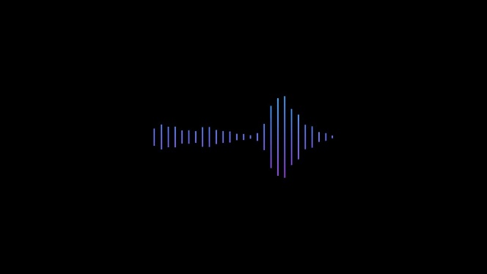

Mentorship Project 01 Barn

**Overview and Setup**

**Engine Versions:**

* Unreal Engine: Version 5.2
  + <https://www.audiokinetic.com/en/download/>
* Wwise: Version 2022.1.5.8242
  + <https://www.unrealengine.com/en-US/download>

**Wwise Soundbank Path:**

* Wwise: Once installed, open Wwise Project Settings and navigate to the SoundBanks Tab.
  + Locate the Root Output Path and click on the … widget.
* When the window opens, navigate to … **Mento01_ScifiBase 5.2\Content\WwiseAudio\GeneratedSoundbanks**
* Select the **GeneratedSoundbanks** folder and click **Select Folder**
  + This will set/check the location of your Soundbanks when they are generated.

**Wwise Installation Path in Unreal Engine:**

* Once the Unreal engine has been installed:
  + Open Edit > Project Settings.
    - Navigate to User Settings at the bottom under the Wwise section.
    - Change the Wwise Windows Installation Path to the location of the your local install of Wwise 2202.1.4.8242
    - This will be something like **C:/Program Files (x86)/Audiokinetic/Wwise 2022.1.5.8242**

* Open Integration Settings and ensure that the Wwise Project Path and Generated Sound Banks Folder is correct.
* This will look something like this: **Mentorship Projects\Mento01_ScifiBase 5.2\Content\WwiseAudio\GeneratedSoundbanks**
* GeneratedSoundBanks will always/should live in this location.