1-Wire ® (Protocol)

Company: Dallas Semiconductor/Maxim
Linus Wong

What is it?
- Protocol: to digitally communicate over twisted-pair cable with 1-Wire components over a 1-Wire network
- network is defined with an open-drain (wired-AND) master/slave multidrop architecture with resistor pull-up to a nominal 5V supply at the master
- 1-Wire net’s 3 components:
- a bus master with controlling software (e.g. TMEX™ iButton® viewer)
- wiring and associated connectors
- 1-Wire devices

Features/Benefits
- each 1-Wire slave has stored in ROM a unique 64-bit serial number that acts as its node address → device to be individually selected from among many that can be connected to the same bus wire
  - This globally unique address is composed of eight bytes divided into three main sections. Starting with the LSB, the first byte stores the 8-bit family codes that identify the device type. The next six bytes store a customizable 48-bit individual address. The last byte, the most significant byte (MSB), contains a cyclic redundancy check (CRC) with a value based on the data contained in the first seven bytes. This allows the master to determine if an address was read without error. With a 2⁴⁸ serial number pool, conflicting or duplicate node addresses on the net are never a problem.
- 1-Wire devices can be formatted with a file directory like a floppy disk → files can be randomly accessed and changed without disturbing other records
- Maximum data security can be provided by 1-Wire chip implementation of the US government-certified Secure Hash Algorithm (SHA-1)
- uses a single wire (plus ground) to accomplish both communication and power transmission.
- A single bus master can feed multiple slaves over a single twisted-pair cable
- simplify design with an interface protocol that supplies control, signaling, and power over a single-wire connection.

About the Protocol
- 1-Wire protocol uses conventional CMOS/TTL logic levels (maximum 0.8V for logic “zero” and a
- minimum 2.2V for logic “one”) with operation specified over a supply voltage range of 2.8V to 6V.
- Both master and slaves are configured as transceivers permitting bit sequential data to flow in either direction, but only one direction at a time (halfduplex); Master initiates and controls all devices
- Data is byte-sequential and bit-sequential with data read and written least significant bit (LSB) first
- signal is transferred in time slots
- System clock is not required; each 1-Wire part is self-clocked by an internal oscillator synchronized to the falling edge of the master

4 basic protocol operations:
(http://www.maxim-ic.com/appnotes.cfm/appnote_number/522/ln/en App126)

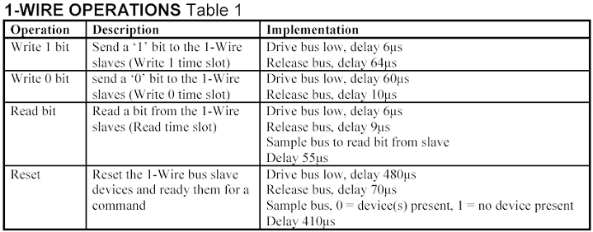
- All device commands are built off these!
- Libraries implementing these and higher order functions available.

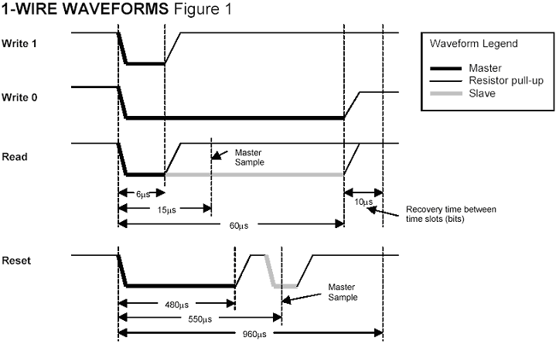

Typical 1-Wire Communication Flow
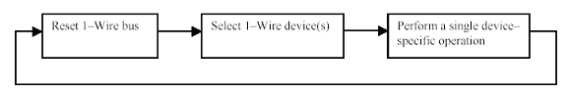
The first part of any communication involves the bus master issuing a “reset” which synchronizes the entire bus. A slave device is then selected for subsequent communications. This can be done by selecting all slaves, selecting a specific slave (using the serial number of the device), or by discovering the next slave on the bus using a binary search algorithm. These commands are referred to collectively as “network” or ROM (Read-Only-Memory) commands. Once a specific device has been selected, all other devices drop out and ignore subsequent communications until the next reset is issued.

Once a device is isolated for bus communication the master can issue device-specific commands to it, send data to it, or read data from it. Because each device type performs different functions and serves a different purpose, each has a unique protocol once it has been selected. Even though each device type may have different protocols and features, they all have the same selection process and follow the command flow as seen in Figure 1 (above).

How power is supplied in the most common cases (w/ diagrams)
3 primary ways:
- Sourcing power whenever the line is above 3.5V.
  - Since 1-Wire devices can operate with a 3V supply, the energy available between the bus supply levels of 3.5V and 5V can be tapped.
  - equivalent to operating the load in shunt mode (permanently across the bus, or preferably under bus master control)

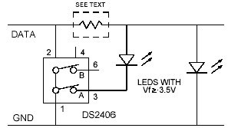

(Powering methods continued)
- Sourcing power when line is high by transferring charge to a capacitor (or rechargeable battery) through a blocking diode
  - During idle periods when the bus is at 5V, the circuit ‘steals’ power from the line to charge the capacitor and power the load.
  - Disadv: adds both capacitive load and leakage that reduce the range and capability of the 1-Wire network. Can fix by can be isolating it between two addressable switches controlled by the line master.
  - Adv: simple and economical; used internally by 1-Wire devices
    - Parasitic power:
    - concept of "stealing" power from the net by a half-wave rectifier
    - When data line is pulled high, the diode in the half-wave rectifier turns on and charges an on-chip capacitor.
    - When the voltage on the net drops below the voltage on the capacitor, the diode is reverse biased, which isolates the charge. The resulting charge provides the energy source to power the slave during the intervals when the net is pulled low. The amount of charge lost during these periods is replenished when the data line returns high.

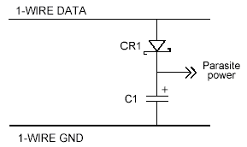

- Sourcing power with a strong pull-up during idle communication time.
  - can be accomplished by using a MOSFET to pull the bus directly to the rail
  - E.g. DS18S20-PAR (digital thermometer, during temperature conversions)

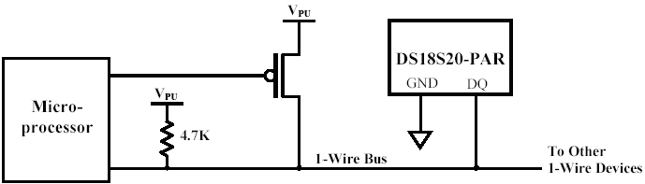
http://pdfserv.maxim-ic.com/arpdf/DS18S20-PAR.pdf

http://www.maxim-ic.com/appnotes.cfm/appnote_number/949/ln/en (App147: Supplying power via 1-wire bus)
http://www.maxim-ic.com/appnotes.cfm/appnote_number/857/ln/en (App148: Guidelines for Reliable 1-wire networks)

Some Topologies
(see http://www.maxim-ic.com/appnotes.cfm/appnote_number/523/ln/en)

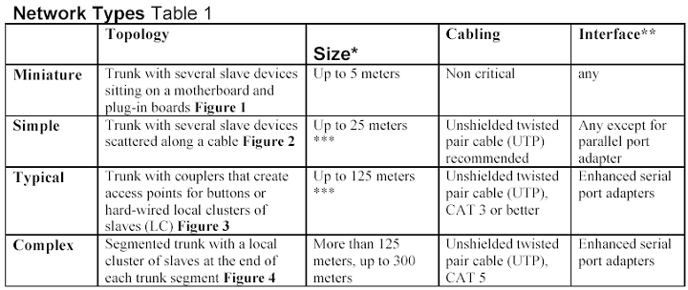

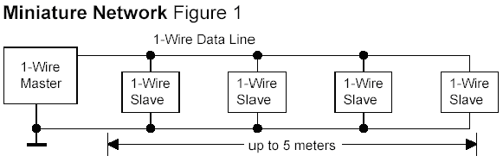

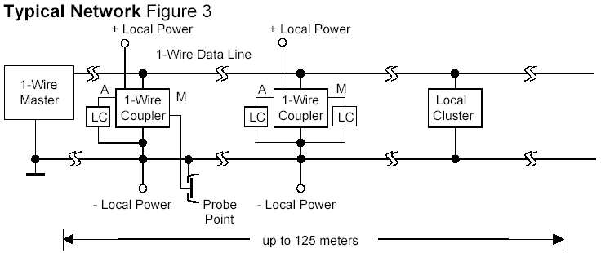

General Ways to Communicate
- Software methods via microprocessor: 1-Wire API for Windows (TMEX), 1-Wire COM interface (OWCOM), 1-Wire Public Domain (PD), and 1-Wire API for Java™ (OWAPI)
- a predefined 1-Wire master chip in Verilog and VHDL
- DS2480B Serial 1-Wire Line Driver to communicate with any UART
- DS1481 provides a 1-Wire master with a parallel interface.
(http://www.maxim-ic.com/appnotes.cfm/appnote_number/522/ln/en last page)

Closing Remarks
- DS9091K 1-Wire MicroLAN Evaluation Kit
  - http://www.maxim-ic.com/quick_view2.cfm/qv_pk/2973
  - $49.00
  - examples: Window/door monitor, Temperature logger, Simulated room temperature control, Burglar alarm system
- 37 1-Wire devices, 48 iButtons and accessories (sensors, clocks, adapters, memory, etc.)

* http://www.maxim-ic.com/1-Wire (main page)

http://www.maxim-ic.com/appnotes.cfm/appnote_number/1796/ln/en (overview)

http://www.maxim-ic.com/appnotes.cfm/appnote_number/1189/ln/en (App214: Using a UART to Implement a 1-Wire Bus Master)

http://www.maxim-ic.com/appnotes.cfm/appnote_number/855/ln/en (App155: overview and selection guide to available APIs/resources for communicating with the variety of devices)

* http://www.maxim-ic.com/an_prodline2.cfm/prodline/21 (ALL Application Notes and Tutorials for 1-Wire devices)

* http://www.maxim-ic.com/appnotes.cfm/appnote_number/523/ln/en (App132: Quick Guide to 1-Wire net Using PCs and Microcontrollers)
http://www.brianlane.com/digitemp.php (“DigiTemp is a simple to use interface to the Dallas Semiconductor DS18S20 (DS18S20-PAR), DS1822, (DS1822-PAR) and DS18B20 (DS18B20-PAR) digital temperature sensors”)

